Instructions for Asthma State Grantees:

“How to Use CDC NACP Document Sharing application to Submit 2014 Hospital Discharge (HD)
and Emergency Department (ED) Data to CDC”

February 5, 2015

Logistics:
- Only conduct the HD and ED visit data submission process using the CDC NACP Document Sharing application starting with 2014 HD and ED visit data.
- Please do not send any data through email unless it is for a previous year (prior to 2014) that was missing or corrected, or if you have any specific issues/questions.

How to access HD and ED visit spreadsheet templates and upload final data
    - Access the CDC NACP Document Sharing application by going to the link: https://partner.cdc.gov/Sites/NCEH/NCEH/DEEHS/NACP/. Log on as an External Partner with your CDCJoin Username and Password.
- Navigating to the appropriate folder to access template spreadsheets for data uploads
  - Navigate to the “Hospital and Emergency Department” Library where every asthma state grantee has a folder with its respective HD and ED visit data for the years 2014 and forward.

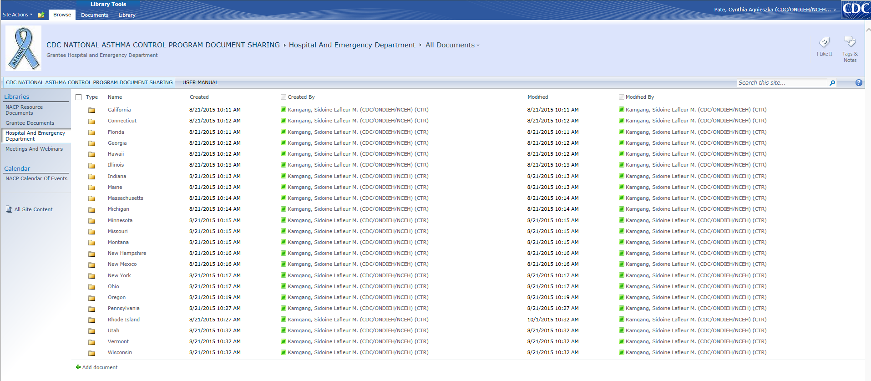
Note: you should only see one folder- your own state Folder
  - In your state’s folder, go to the appropriate subfolder for either HD or ED data. California is used as an example.
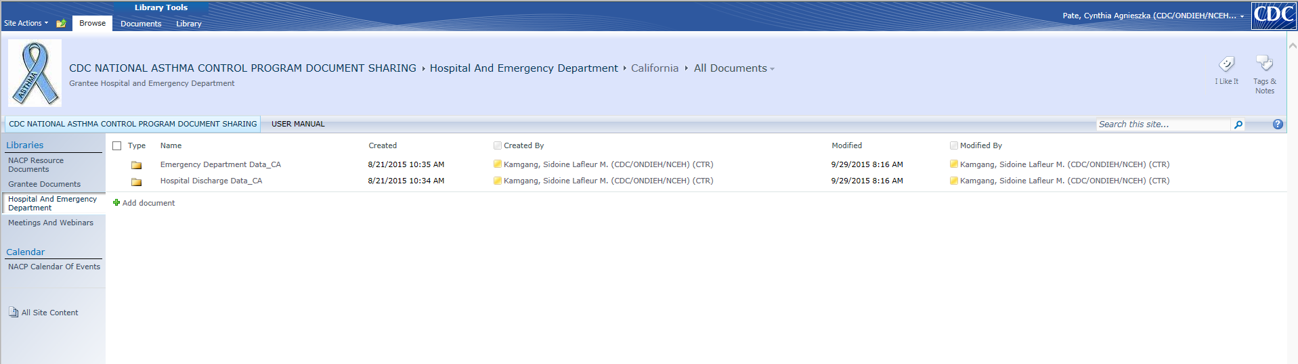
  - The following example will address ED visit data. Please follow the process similarly for submitting HD data. To access the data spreadsheet templates, go to the folder with the year of data submission. In this case, the 2014 data spreadsheets are located in “2014 ED Data_CA”.
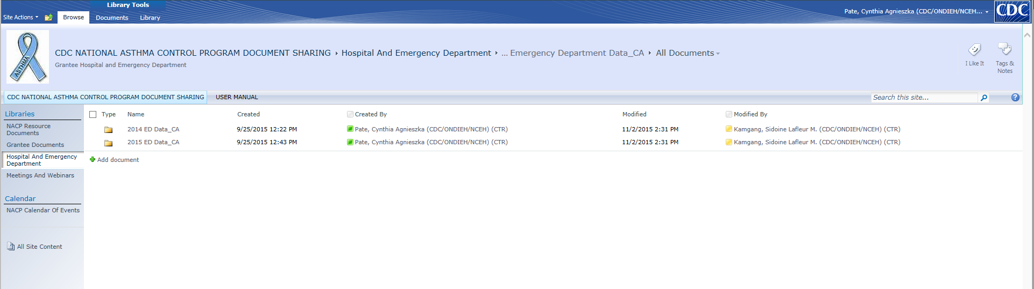

  - Hover your mouse over the file named “CA_EDvisits_2014”, and click the arrow that appears at the right of the cell. Select and click on “Edit in Microsoft Excel”. Then the Excel spreadsheet template will appear in a separate window.
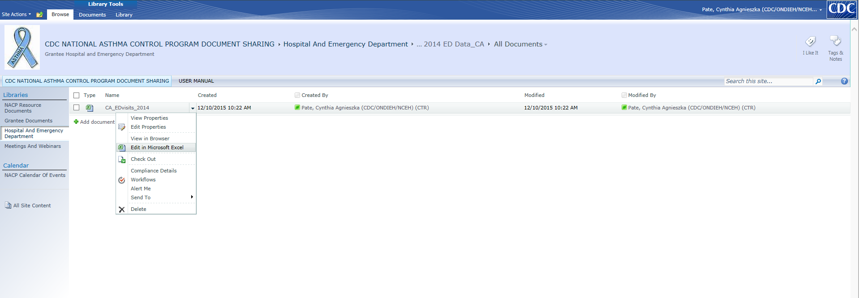
  - Complete data entry following instructions in the word document, “Instructions_2014_HD_ED_Data_Submission.doc”.
  - Save the spreadsheet in the same drive. Click on the file to open it one more time to confirm that all the data has been entered properly into the spreadsheet.
Note: After completing the HD and ED data spreadsheets, CDC will receive automatic alerts through the application. Therefore, there is no need to contact us unless you have any specific questions or issues to address.

