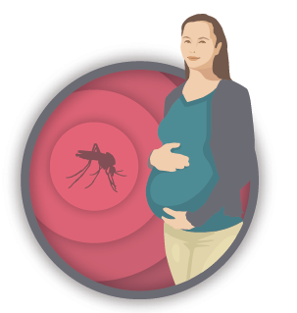
US Zika Pregnancy Registry
What Pregnant Women Need to Know
What is the purpose of the registry?
CDC developed the US Zika Pregnancy registry to:
- Learn more about the effects of Zika virus infection (Zika) during pregnancy
- Learn more about the growth and development of babies whose mothers had Zika while pregnant

CDC will collect information about Zika among pregnant women and babies across the United States for the registry. CDC and health departments will use the information from this registry to help pregnant women and families affected by Zika. The knowledge gained from this registry will help doctors and other healthcare providers care for pregnant women and their babies.

Who is being included in the registry?
Women living in the United States who have been infected with Zika during pregnancy and their babies can be included in the registry.*
What will be done with the information collected?
The identity of people in the registry will be kept private and secured. The information your doctor or other healthcare provider shares will be added to the registry with information about other pregnant patients with Zika, and the babies born to these mothers, to help CDC and state health departments develop a clearer picture of how Zika affects pregnant women and their babies.
What do I have to do to be in the registry?
You will not need to do extra paperwork, go to extra appointments, or have extra tests to be part of the registry. If your healthcare provider is participating in this Registry, she/he will share information about your health with your health department and CDC, the public health authorities that are trying to understand, prevent, and control disease. Your health department and CDC will work with your doctor and other healthcare providers to collect all of the information needed. For this registry, your health department and CDC will:
- Collect information about your pregnancy
- Collect information about you and your baby around the time the baby is born, and
- Contact the baby’s doctor or other healthcare provider to collect information about the baby’s growth and development up to his or her first birthday.

If you change doctors or healthcare providers, please request that your new provider contact registry staff through the email address below.
As established in the HIPAA Privacy Rule (45 CFR 164.522, 164.524, 164.526, and 164.528), you have the right to request from your healthcare provider restrictions to, access to, amendments to, and accounting of the disclosure of your protected health information at any time.
How much does this cost?
Being in the registry will not cost you any money.
What if I have questions about being in the registry?
For more information, call 770-488-7100, visit CDC’s registry webpage or send questions to ZIKApregnancy@cdc.gov.

*Puerto Rico is establishing a separate Zika Active Pregnancy Surveillance System (ZAPSS)

