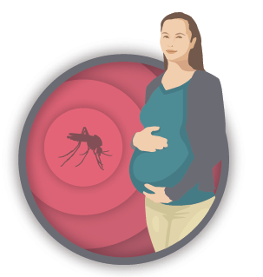
US Zika Pregnancy Registry
Obstetric Healthcare Providers: How to Contribute
Zika virus infection during pregnancy has been linked to adverse outcomes including pregnancy loss and microcephaly, absent or poorly developed brain structures, defects of the eye and impaired growth in fetuses and infants. Despite these observations, very little is known about the risks of Zika virus infection during pregnancy. Information about the timing, absolute risk, and spectrum of outcomes associated with Zika virus infection during pregnancy is needed to direct public health action related to Zika virus and guide testing, evaluation, and management.

US Zika Pregnancy Registry
To understand more about Zika virus infection, CDC established the US Zika Pregnancy Registry and is collaborating with state, tribal, local, and territorial health departments to collect information about pregnancy and infants outcomes following Zika virus infection during pregnancy. The data collected through this registry will provide additional, more comprehensive information to complement notifiable disease case reporting and will be used to update recommendations for clinical care, to plan for services for pregnant women and families affected by Zika virus, and to improve prevention of Zika virus infection during pregnancy.
How to Participate
CDC and state, tribal, local, and territorial health departments request that healthcare providers participate in the US Zika Pregnancy Registry by:
- Reporting cases of pregnant women with laboratory evidence of Zika virus to their state, tribal, local, or territorial health department.
- Collecting pertinent clinical information about pregnant women and their infants on the Pregnancy and Zika Virus Disease Surveillance forms.
- Providing the information to state, tribal, local or territorial health departments or directly to CDC Registry staff if asked to do so by local health officials.
- Notifying state, tribal, local, or territorial health department staff or CDC registry staff of adverse events (e.g., spontaneous abortion, termination of pregnancy).
Who to Report to the Registry
Healthcare providers should report eligible cases to the health department in accordance with applicable state, tribal, local and territorial laws. Cases of Zika virus infection among pregnant women in the United States with laboratory evidence of Zika virus infection (positive or inconclusive test results, regardless of whether they have symptoms) and infants born to these women, including infants with congenital Zika virus infection are eligible for inclusion in the registry. See https://www.cste2.org/docs/Zika_Virus_Disease_and_Congenital_Zika_Virus_Infection_Interim.pdf.
Healthcare providers practicing in Puerto Rico should report eligible cases to the Puerto Rico Zika Active Pregnancy Surveillance System (ZAPSS) rather than to the US Pregnancy Registry.*
How To Report to the Registry
- Healthcare providers should contact their state, tribal, local, or territorial health department to arrange for laboratory testing for Zika virus infection in pregnant women and infants who meet the clinical criteria for testing as outlined in the CDC guidelines.
- Through existing national surveillance of arboviral diseases, CDC may learn about pregnant women and infants with laboratory evidence of Zika virus infection. Healthcare providers can also contact the CDC Zika Pregnancy hotline (available through EOC Watch Desk at 770-488-7100, ZikaMCH@cdc.gov or ZikaPregnancy@cdc.gov or fax 404-718-2200) to discuss women with laboratory evidence of Zika virus infection. If healthcare providers contact CDC for clinical consultation, registry staff will ensure that state, tribal, local, or territorial health departments are notified.
How the Data are Collected
Depending on the preference of the state, tribal, local, or territorial health department, either health department staff or CDC Registry staff will contact healthcare providers caring for pregnant women and their infants for data collection.
Time points for data collection
Initial Identification of case
2nd and 3rd trimester
At delivery
Infant: Months 2, 6, and 12
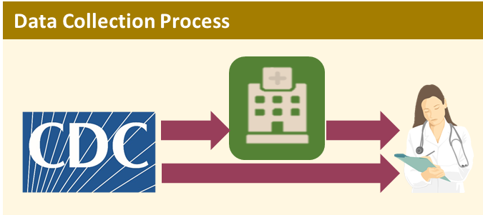
.

CDC is requesting the collection of clinical information in identifiable form as a public health authority. As defined in the Health Insurance Portability and Accountability Act (HIPAA) and its implementing regulations, Standards for Privacy of Individually Identifiable Health Information (45 CFR § 164.501)] (“Privacy Rule”), covered entities (e.g., healthcare providers) may disclose protected health information without patient authorization to a public health authority that is authorized by law to collect or receive such information for the purpose of preventing or controlling disease (42 CFR 164.512). Data to be collected include clinical information pertaining to the pregnant woman’s health, monitoring, and testing during pregnancy, results from evaluation and testing conducted at birth, and clinical/developmental information from the infant through the first year of life. As established in the HIPAA Privacy Rule (45 CFR 164.522, 164.524, 164.526, and 164.528), individuals have the right to request from covered entities (i.e., you, the healthcare provider) disclosing their PHI certain restrictions, access, amendments, and accounting of the disclosures of their protected health information.
More Information about Zika
For more information or to contact CDC Registry staff, call the CDC Emergency Operations Center watch desk at 770-488-7100 and ask for the Zika Pregnancy Hotline or email ZikaPregnancy@cdc.gov. More information on caring for pregnant women, infants, or children with Zika virus infection is available at http://www.cdc.gov/zika .
CDC Guidance Materials
- Interim Guidelines for Health Care Providers Caring for Pregnant Women and Women of Reproductive Age with Possible Zika Virus Exposure – United States, 2016 (Feb. 5, 2016)
http://www.cdc.gov/mmwr/volumes/65/wr/mm6505e2.htm

- Interim Guidelines for Healthcare Providers Caring for Infants and Children with Possible Zika Virus Infection – United States, February 2016 (Feb. 19, 2016)
http://www.cdc.gov/mmwr/volumes/65/wr/mm6507e1.htm

- Zika Virus: Collection and Submission of Fetal Tissues for Zika Virus Testing
http://www.cdc.gov/zika/hc-providers/tissue-collection-submission.html

- Collection and Submission of Body Fluids for Zika Virus Testing
http://www.cdc.gov/zika/hc-providers/body-fluids-collection-submission.html
Thank you for your interest and participation in the US Zika Pregnancy Registry.

