8.5 PHS 398 Training Budget
For application to most institutional training grant programs (e.g., T15, T32, T34, T35, T36), use the PHS 398 Training Budget form pages and follow the instructions below. Refer to the relevant FOA or consult the PHS awarding component for current stipend levels and allowable costs.
The PHS 398 Training Budget form pages are not applicable for K12, T37, D43, D71, and U2R. Applicants to these grant programs must refer to the FOA for instructions regarding which Budget Form pages to use and how to complete them.
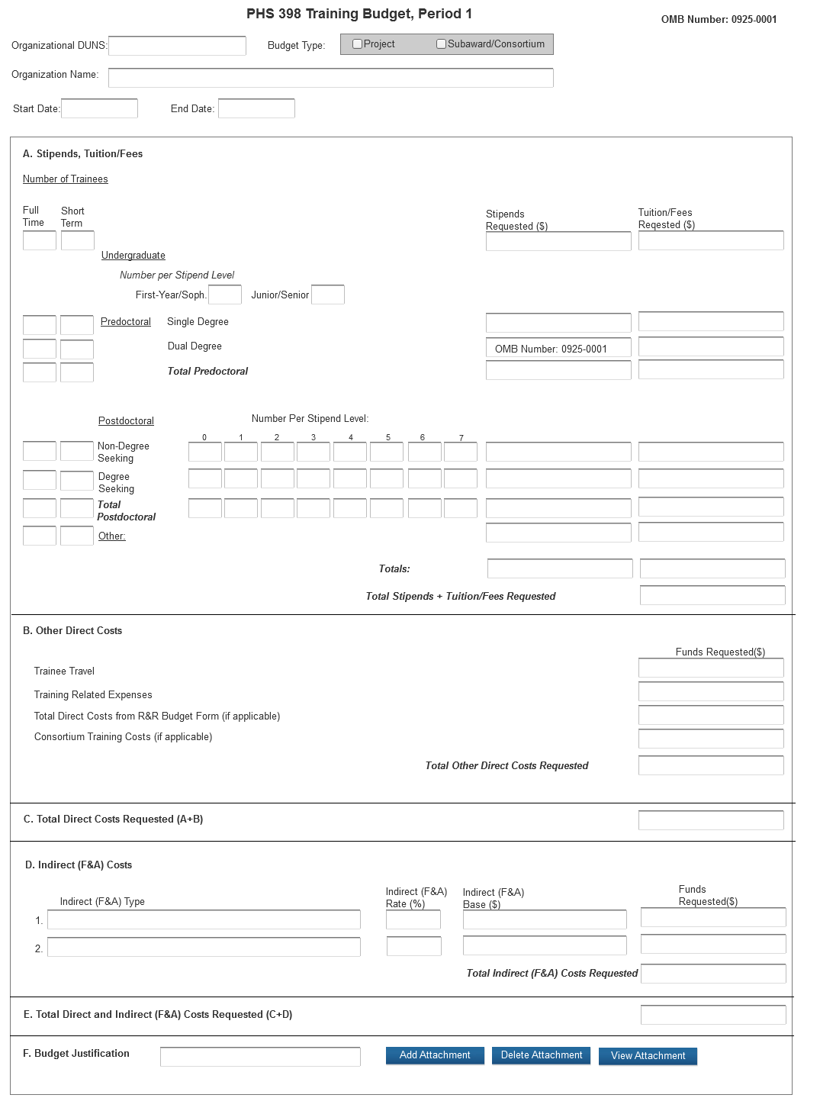
If you are requesting a budget of $500,000 direct costs or more for any year, contact the awarding component to determine whether you must obtain prior approval before submitting the application. Some Institutes/Centers do not require prior approval. (See Policy on the Acceptance for Review of Unsolicited Applications That Request $500,000 or More in Direct Costs.)
PHS 398 Training Budget, Periods 1 through 5
Part A. Stipends, Tuition/Fees
Enter the number of trainees, total stipend amount and total tuition/fees for each trainee category as appropriate. Use the current Institutional Kirschstein-NRSA stipend schedule, (http://grants.nih.gov/training/nrsa.htm). If a category contains different stipend levels, e.g., for varying levels of postdoctoral experience and/or varying appointment periods, itemize in the appropriate blocks. Enter the total stipends for all categories.
See http://grants.nih.gov/grants/guide/notice-files/NOT-OD-10-073.html for NIH policy regarding payment of tuition and fees. Tuition at the postdoctoral level is limited to that required for specified courses that are to be described in the Budget Justification (Part F.). Tuition and fees may be requested only to the extent that the same resident or nonresident tuition and fees are charged to regular non-Federally supported students and postdoctoral fellows. Where applicable, trainees should be divided into non-degree-seeking and degree-seeking categories. Note that health insurance is not included as part of this budget category. See the Training Related Expenses category below. Grantees should request full needs. The formula currently in effect will be applied by the NIH awarding component at the time an award is calculated.
Part B. Other Direct Costs
Enter the total costs for Trainee Travel, Training Related Expenses, Total Direct Costs from R&R Budget Form (if applicable) and Consortium Training Costs (if applicable).
Trainee Travel
Some NIH awarding components pay a flat rate per trainee for trainee travel for all long-term trainees. See the appropriate FOA and/or contact the awarding component to determine the amount provided for travel. In the budget justification, state the purpose of any travel, giving the number of trips involved, the destinations, and the number of trainees for whom funds are requested. PHS policy requires coach class air travel be used. Justify foreign travel in detail, describing its importance to the training experience. Enter the total amount requested in the Trainee Travel column.
Training Related Expenses (TRE)
Funds to defray other costs of training, such as health insurance (self-only or family), staff salaries, consultant costs, equipment, research supplies, staff travel, etc., are requested as a lump sum based on the amounts specified in the FOA and at http://grants.nih.gov/grants/guide/notice-files/NOT-OD-10-073.html for each predoctoral and postdoctoral trainee. Based on the number of trainees at the predetermined rate, enter the total dollar figure.
Health insurance (self-only or family, as applicable) is an allowable cost that may be requested as part of training related expenses, but only to the extent that the same health insurance fees are charged to regular non-Federally-supported students and postdoctoral fellows. The allowable TRE amount will be awarded as a lump sum. No further itemization or explanation is required.
The awarding Institute/Center will apply the Training Related Expenses level established for NRSA Institutional programs for the relevant fiscal year at the time of award.
Total Direct Costs from R&R Budget Form (if applicable)
Certain FOAs allow funds to cover costs for items other than those specified above. Use Research & Related Budget Pages, Sections A through I and K, to submit those costs. Total Direct Costs from the Research & Related Budget page should be inserted here. This line should not include any applicant indirect costs.
Consortium Training Costs (if applicable)
If training is occurring at more than one institution, and any transfer of funds between institutions occurs, the Training Subaward Budget Attachment Form should be used. (See Section 4.8). Total the direct costs from the Subaward Budget Attachment Forms and insert here. The applicant institution is responsible and accountable for any arrangements, expenditures, and submission of all required forms when more than one institution is involved in the research training program.
Part C. Total Direct Costs Requested
Total dollar amount of other direct costs requested (automatically calculated).
Part D. Indirect (F&A) Costs
Facilities and Administrative (F&A) costs under Institutional Kirschstein-NRSAs, other than those issued to U.S., state, or local government agencies, will be awarded at 8%, excluding tuition/fees, equipment, and sub-grants and contracts in excess of $25,000. Equipment and consortium costs are also excluded from the F&A costs on those training grants where Training Related Expenses are not calculated and awarded on a lump-sum basis, such as the Minority Access to Research Careers Program (MARC) or Career Opportunities in Research (COR) Undergraduate Research Training Program. State and local government agencies will receive the full F&A cost rate.
Indirect F&A Type: Enter “F&A”
Indirect (F&A) Rate (%): Enter “8”
Indirect (F&A) Base ($): Enter the sum of Stipends and Total Other Direct Costs requested, regardless of whether those direct costs were listed on the PHS 398 Training Budget page or Research & Related Budget page. Indirect costs are not paid on Tuition/Fees, equipment, and sub-grants and contracts in excess of $25,000.
Funds Requested ($): Enter the product of Indirect Cost Rate multiplied by Indirect Cost Base.
Part E. Total Direct and Indirect (F&A) Costs Requested (C+D)
The sum of Total Direct Costs Requested and Total Indirect Costs Requested will be calculated automatically.
Part F. Budget Justification
A detailed justification is to be attached only for the first budget period, but should reflect the entire budget period. Explain in detail the composition of any of the above items, as necessary. Itemize tuition and individual fees. If tuition varies, (e.g., in-state, out-of-state, student status) identify these separately. If tuition is requested for postdoctoral trainees, the specific courses must be described in the application. If trainee travel is not paid at a flat rate per trainee by the awarding component, state the purpose of any travel, giving the number of trips involved, the destinations, and the number of individuals for whom funds are requested, bearing in mind that PHS policy requires coach class air travel be used. Justify the number of training slots (predoctoral and/or postdoctoral) requested. For postdoctoral training slots, justify the stipend levels requested.
Any foreign travel must be justified in detail, describing its importance to the training experience and considering the type of opportunities available for training, how those opportunities differ from and complement those offered by the grantee institution, and the relationship of the proposed off-site training experience to the career stage of the grantee.
This budget justification should apply only to funds requested on the PHS 398 Training Budget form. When the Research & Related Budget Form is also used, two separate budget justifications are required, each covering the costs required in the particular budget form. Combining the information into a single upload is acceptable; however, each budget form requires a budget justification attachment so the same budget justification will need to be included in both budget forms.
PHS 398 Training Budget, Cumulative Budget
All values on this form are calculated automatically. They present the summations of the amounts that you have entered previously, for each of the individual budget periods. Therefore, no data entry is allowed or required.
If any of the amounts displayed on this form appears to be incorrect, you may correct it by adjusting one or more of the values that contribute to that total. To make any such adjustments, you will need to revisit the appropriate budget period form(s) to enter corrected values.

