4.1.2 Assignment Request Form OMB#0925-0001 Exp:date 8/2015
The optional Assignment Request Form may be used to communicate specific application assignment and review requests to the Division of Receipt and Referral (DRR) and to Scientific Review Officers (SROs). This information will not be part of your application and not made available to program staff or provided to reviewers. It is used specifically to convey additional, optional information about your preference(s) for assignment and review of your application to DRR and SROs. Much of this information was previously allowed in the Cover Letter Attachment but now, if you wish to make such requests, that information must be provided on the Assignment Request Form and not in the Cover Letter Attachment.
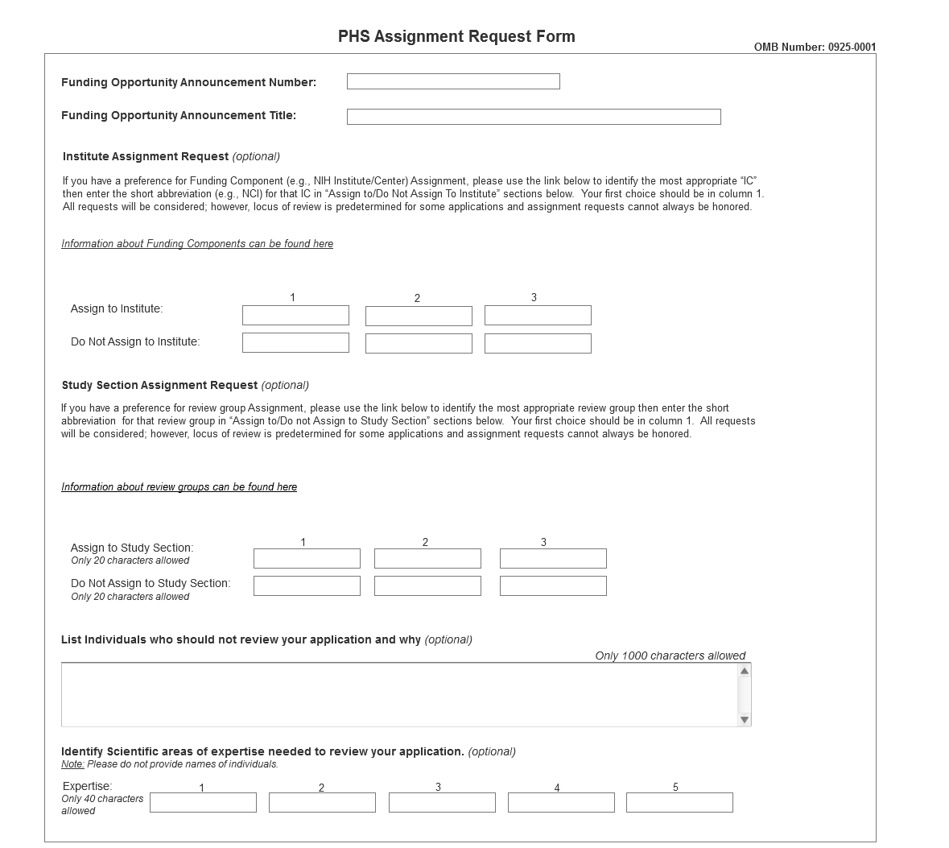
The Division of Receipt and Referral (DRR), Center for Scientific Review (CSR) is responsible for assigning applications to NIH institutes/centers (ICs) and other PHS agencies for funding consideration. DRR also assigns application to NIH scientific review groups (SRGs) and special emphasis panels (SEPs). DRR will be utilizing knowledge management approaches as an adjunct to the work of referral scientific experts as part of an overall plan to shorten the time from submission to review. Analysis has shown that requests made by investigators are a valuable source of information in this process. In order to facilitate the use of these requests in conjunction with knowledge management analysis of the content of the application, applicants are requested to use the following fields in the Assignment Request Form to convey assignment requests to DRR and SROs.
Institute Assignment Request (optional)
This section of the form is optional. You may, however, request up to three institutes/centers for assignment of your application. Enter preferences for NIH IC assignment in the boxes in the “Assign to” row. Use the column labeled “1” to enter your first choice. Similarly, you may request that your application not be assigned to a specific NIH IC by entering that information in the boxes in the “Do Not Assign To” row. In most cases, you will only want to make one or two requests; there is no need to make an entry in all six boxes. The hyperlink in this section of the form (http://XXXXX) will take you to a web site where descriptions of the science covered by all NIH institute/centers can be found, including links to other PHS agency information. To facilitate accurate communication of your request to NIH referral and review staff, please use the short abbreviation for the requested NIH IC (e.g., NCI for the National Cancer Institute). While NIH staff will seriously consider all assignment requests, in some cases the locus of review is pre-determined and assignment requests cannot be honored.
Study Section Assignment Request (optional)
This section of the form is optional. You may, however, request up to three SRGs or SEPs for assignment of your application. For this section, you will need to accurately type in the short abbreviation of the SRG / SEP you wish to request. The hyperlink in this section of the form (http://xxxxxx) will take you to a site where you can find more information about how to identify CSR and NIH SRGs and SEPs, including their short abbreviations. For example, you would enter “CAMP” if you wish to request assignment to the Cancer Molecular Pathobiology study section or enter “ZRG1 HDM-R” if you wish to request assignment to the Healthcare Delivery and Methodologies SBIR/STTR panel for informatics. Be careful to accurately capture all formatting (e.g., spaces, hyphens) when you type in the request.
Enter the short abbreviations(s) for SRGs / SEPs to which you would like your application assigned in the “Assign to” row. Use one box per individual SRG/ SEP request. Type your first choice in the column labeled “1”. If you wish to request that your application not be assigned to a particular SRG/SEP, enter that information in the boxes found in the “Do Not Assign To” row. In most cases, you will only want to make one or two requests; there is no need to make an entry in all six boxes.
Please note that while the majority of NIH research grant and fellowship applications are reviewed by the Center for Scientific Review (CSR), some are assigned to individual institute/center review groups and some applications are clustered for review in SRGS / SEPs without flexibility for honoring review requests. However, it is standard practice to honor such requests whenever possible, depending on existing locus of review agreements within NIH and other PHS agencies
Field Name | Instructions
List individuals who should not review your application and why (optional) | Provide sufficient information (e.g., name, organizational affiliation) so that the SRO can correctly identify the individual, and provide sufficient information so that the SRO can confirm a conflict of interest for the review. Simply stating “Dr. John Smith is in conflict with my application” is not helpful. Maximum 1000 characters.
Identify expertise needed to review your application (optional) | Five fields are provided if you wish to identify general or specific types of expertise needed for the review of your application. Maximum 40 characters/field. Do not enter names of individuals you would like to review your application.
This form is optional and may be omitted from the application packet if you do not wish to make any specific assignment or review requests. There is no requirement that all fields in the form are completed; you have the flexibility to enter a single request or provide extensive information using this form.
Upload the Assignment Request Form using the “Assignment Request Form” field on page XX of the application packet.

