Survey Screenshot

[All participants]
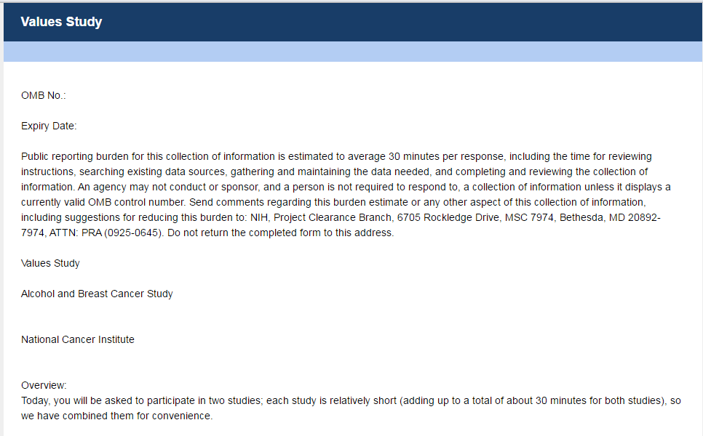
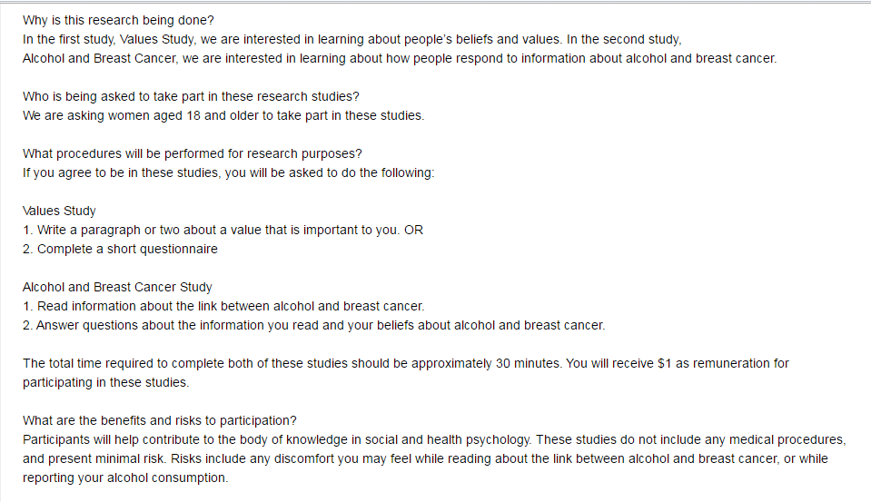

[Participants in Condition 1 Only]
[Participants in Condition 1 Only]
[Participants in Condition 2 Only]
[Participants in Condition 2 Only]
[Participants in Condition 3 Only]
[Participants in Condition 3 Only]
[Participants in Condition 4 Only]
[Participants in Condition 5 Only]
[Participants in Condition 5 only]
[Participants in Condition 6 Only]
[Participants in Condition 6 Only]
[Participants in Condition 7 Only]
[Participants in Condition 7 Only]
[Participants in Condition 8 Only]
[Participants in Condition 8 Only]
[Participants in Condition 9 Only]
[Participants in Condition 10 Only]
[Participants in Condition 10 Only]
[Participants in Condition 11 Only]
[The rest of the study is viewed by all participants]

