Screen Shots Document
Grouped by Scenario

Electronic Access Multi-Factor Authentication

Table of Contents
Scenario 1: Create LOA2 Account 1
S1-P1 - Sign In 1
S1-P2 - Terms of Service 2
S1-P3 - Verify Identity 3
S1-P4 - Secure Identity 4
S1-P5 - Create Account 5
S1-P6 – Provide Cell Phone Number_Create Account 6
S1-P7 - Enter Texted Security Code 7
S1-P8 – Confirmation 8
Scenario 2: Create LOA3 Account 9
S2-P1 - Sign In 9
S2-P2 - Terms of Service 10
S2-P3 - Verify Identity – User Chooses to Upgrade to LOA3 11
S2-P4 - Secure Identity 12
S2-P5 - Create Account 13
S2-P6 – Provide Cell Phone Number – Create Account 14
S2-P7 - Enter Texted Security Code_Create Account 14
S2-P8 - Confirmation_Set Up New Account_With Upgrade Selected 16
S2-P10 - Second Sign In, After Receiving Upgrade Code Letter 17
S2-P11 – Verify Cell Phone Number 18
S2-P12 - Enter Texted Security Code_No Steps 19
S2-P13 - Do You Have Your Upgrade Code Letter? 20
S2-P14 - Enter Upgrade Code 21
S2-P15 - Confirmation_Upgrade to LOA3 22
Scenario 3: Collect Cell Phone Number (2nd Factor) for Existing Account 23
S3-P1 - Sign In 23
S3-P3 - Provide Cell Phone Number_Grandfathered Account_No Steps 24
S3-P4 - Enter Texted Security Code_No Steps 24
S3-P5 – Confirmation – Set Up Account 26
Scenario 4: Update Cell Phone Number 27
S4-P1 - Sign In 27
S4-P2 – Verify Cell Phone Number 28
S4-P4 - Update Phone Number - Provide Info 29
S4-P5 - Confirmation of Letter 30
S4-P7 - Sign In After Receiving Cell Phone Reset Code Letter 31
S4-P9 – Do you have your cell phone reset letter? 32
S4-P10 - Provide New Cell Phone Number 33
S4-P11 - Enter Texted Security Code_No Steps 34
S4-P12 - Confirmation_New Cell Phone Number 35
Scenario 5: Update Cell Phone Number on Account with Expired Password 36
S5-P1 - Sign In 36
S5-P3- Provide Cell Phone Number_Grandfathered Account_No Steps 37
S5-P4 - Enter Texted Security Code_Phone Added Immediately Prior 38
S5-P5 - Expired Password 39
S5-P6 - Confirmation of Password Change 40
Scenario 6: Update Cell Phone Number on Account, User Has Forgotten Password, Uses Reset Questions 41
S6-P1 - Sign In 41
S6-P3 - Forgot Password_Grandfathered User_ Verify Identity 42
S6-P4 - Forgot Password_Grandfathered User_Provide Answers 43
S6-P5 - Provide Cell Phone Number_ Grandfathered User_ Forgot Password 44
S6-P7 - Update Password_Grandfathered User 46
S6-P8 - Confirmation of Password Change 47
Scenario 7: Update Cell Phone Number on Account, User Has Forgotten Password and Reset Question Answers 48
S7-P1 Sign In 48
S7-P3 - Forgot Password_Grandfathered User_ Verify Identity 49
S7-P4 - Forgot Password_Grandfathered User_Provide Answers 50
S7-P5 - Forgot Password - Send Temporary Password 51
S7-P6 - Email Confirmation 52
S7-P9 - Provide Cell Phone Number_ Grandfathered User_ Forgot Password 53
S7-P10 - Enter Texted Security Code_Grandfathered User_Forgot Password 54
S7-P11 - Update Password_Grandfathered User 55
S7-P12 - Confirmation of Password Change 56
Scenario 8: Login Happy Path (All Users) 57
S8-P1 Sign In 57
S8-P2 Verify Cell Phone Number 58
S8-P3 Enter Texted Security Code 59
S8-P4 my Social Security Terms of Service 60
Security Feature FAQs 61
my Social Security - Security Settings 62
Standard Account 62
Enhanced (Pending) Account 63
Enhanced Account 64

- Document Version Information
Version  Number | Date | Content Revisions | Page  # | Revised by
- (Draft) | 11/04/2015 | Initial Version |  | Beth Hanst
0.2 (Draft) | 11/05/2015 | Minor wording changes to Having Trouble containers on screens where user has added cell phone number immediately prior. |  | Beth Hanst
0.3 (Draft) | 11/20/2015 | - Globally changed formatting of “my Social Security”.  - Globally masked first 6 digits of user’s cell phone number.  - On pages collecting address, removed link for user to add a street address line and removed square brackets from State/Territory label.  - Added bullet about SMS-enabled cell phone to Sign In and Create Account ToS.  - Fixed capitization of “Do” in footer on Sign In screen.  - On Verify Info page, remove “add another line” from Address input areas where it is not applicable.  - On all Provide Your Cell Phone Number screens, updated message in yellow container to emphasize that a cell phone number is required to access, rather than secure, your account.  - On Provide Your Cell Phone Number screens for existing accounts, added link to block access.  - Modified heading and text on the Do You have Your Upgrade Code Letter? screen to remove references to the user’s cell phone.  - Removed Having Trouble container from Enter Upgrade Code screen.  - Added sign-in happy path screens |  | Beth Hanst
0.4 (Draft) | 12/02/2015 | - Added hyphen to “SMS-enabled” on Sign In (S1-P1, S2-P1, S2-P10, S3-P1, S4-P1, S4-P7, S5-P1, S6-P1, S7-P1) and Create Account (S1-P2, S2-P2, S2-P11, S3-P2, S4-P2, S4-P8, S5-P2, S6-P2, S7-P2, S7-P8) screens.  - Removed Previous buttons from Provide Cell Phone Number screens (S1-P6, S2-P6, S3-P3, S5-P3, S6-P5, S7-P3, S7-P9) and Update Password screens (S6-P7, S7-P11).  - Corrected steps on Entered Texted Security Code for grandfathered account when user has forgotten password (S6-P6, S7-P4, S7-P10).  - Updated language on Update Phone Number screen (S4-P4) to refer to cell phone update code letter consistently. |  | Beth Hanst
0.5 (Draft) | 12/17/2015 | - Globally modified capitalization of container (gray box) titles, except on Reset Password Questions screen (which mirror production screen). Generally, the first word is capitalized, the follow words are not.  - Globally changed “email” to “E-mail”.  - Changed “SMS-enabled cell phone” to “cell phone that can receive text messages” on Sign In and Create Account Terms of Service screens.  - Removed “SMS” from Enter Texted Code screens.  - Removed “We use their fraud prevention services…theft.” on Create Account Terms of Service screen.  - Changed container heading from “Upgrade your security” to “Add extra security” on Verify Identity screen.  - Removed “For your protection,” from second sentence in yellow container on Provide Your Cell Phone Number screens.  - In What If??? Container on Provide Your Cell Phone Number screens, made slight wording changes and changed order of questions.  - When first 6 digits of cell phone number is masked, added a space before and after the hyphen, e.g. “(***) *** - 1234. Affects Verify Cell Phone Number screen and Enter Security Code from Text Message screen.  - Globally revised references to “upgrading security level” to “adding extra security”, and “upgrade code letter” to “extra security letter”. Affects Add Extra Security screens.  - Removed steps on Add Extra Security screens.  - Globally revised “update cell phone number” to “change cell phone number”, and “update code” to “reset code”. Affects Change Cell Phone Number screen and related Confirmation of Letter screen.  - Modified capitalization of “your” in steps on Forgot Password screens to mirror production screens.  - Added FAQs screen.  - Removed screen S4-P9. |  | Beth Hanst
0.6 (Draft) | 12/23/2015 | - Updated text for S1-P6 confirmation notification  - Added “I don’t have a phone number” to primary phone number box on S4-P4  - Added page S4-P9 into scenario 4  - Updated text for new requirements on S4-P9 |  | Kirk Crawford
0.7 (Draft) | 1/8/2016 | - Updated text for S1-P6 and S2-P6 notification.  - Removed screen S4-P3.  - Removed “I don’t have a phone number” link from primary phone number field on S4-P4.  - Corrected font of progress steps in Scenarios 6 and 7 (S6-P4, S6-P5, S6-P7, S7-P4, S7-P9, S7-P11).  - Removed FAQs screen, pending feedback from OCOMM and OEST. |  | Beth Hanst
0.8 (Draft) | 1/11/2016 | - Added FAQs screen into package, reflecting language provided by OCOMM on 1/11/2016.  - Added my Social Security – Security Settings screens. |  | Beth Hanst
0.9 (Draft) | 1/12/2016 | - Added explanatory language to page containing screen S4-P4.  - Changed the title of the page containing screen S4-P7.  - Corrected S4-P9, replacing “update” with “reset”. Also, added the word “code” to the container heading. |  | Beth Hanst
0.10 (Draft) | 1/13/2016 | - Removed “Why?” link from Provide Cell Phone Number screens. |  | Beth Hanst
1.0 (Final) | 2/22/2016 | Per feedback received during AC review:  - Updated Security Feature FAQ screen  - Changed container title from “New Security Features” to “New Security Feature”.  - In first sentence, changed “my Social Security has…” to “The Social Security Administration has…”  - In second sentence, changed “This … my Social Security account…” to “This … personal my Social Security account…”  - Changed link on following screens from “… Security Features FAQ” to “… Security Feature FAQ”  - S1-P6  - S2-P6  - S3-P3  - S5-P3  - S6-P5  - S7-P9  - Updated “features” to “feature” on following screens  - S2-P14  - S2-P15 |  | Beth Hanst

Scenario 1: Create LOA2 Account

S1-P1 - Sign In

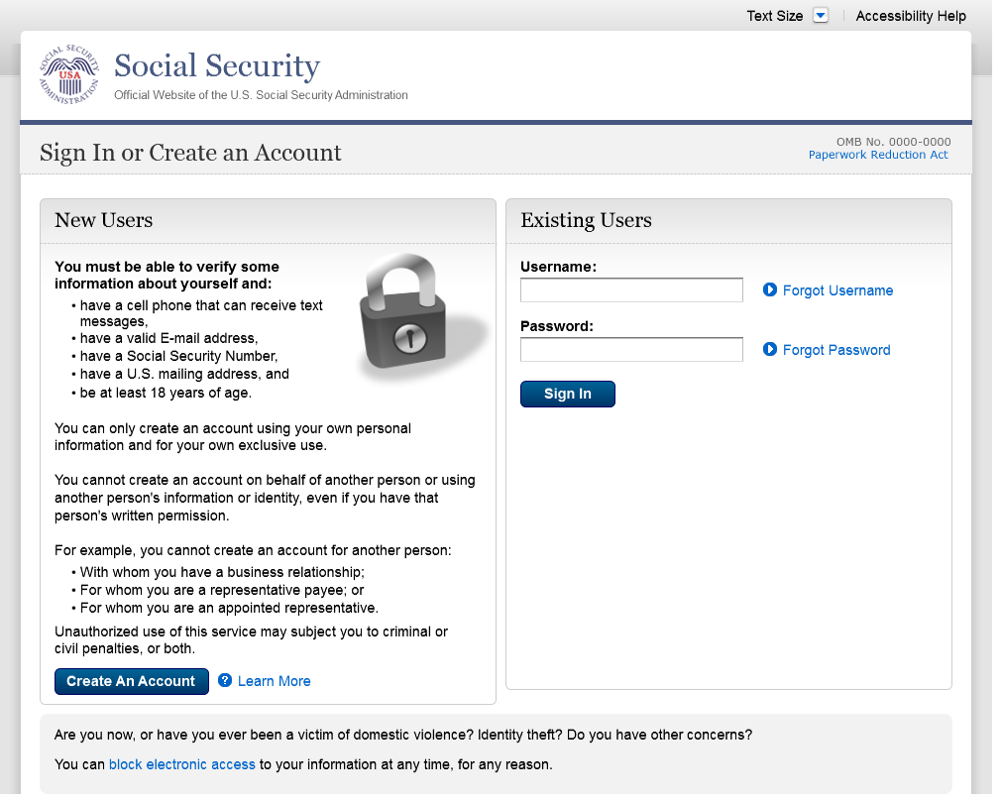
Changed “email” to “E-mail” on 12/17/2015.
Added 1st bullet on 11/19/2015. Added hyphen to “SMS-enabled” on 12/02/2015.
Modified wording on 12/17/2015.

S1-P2 - Terms of Service

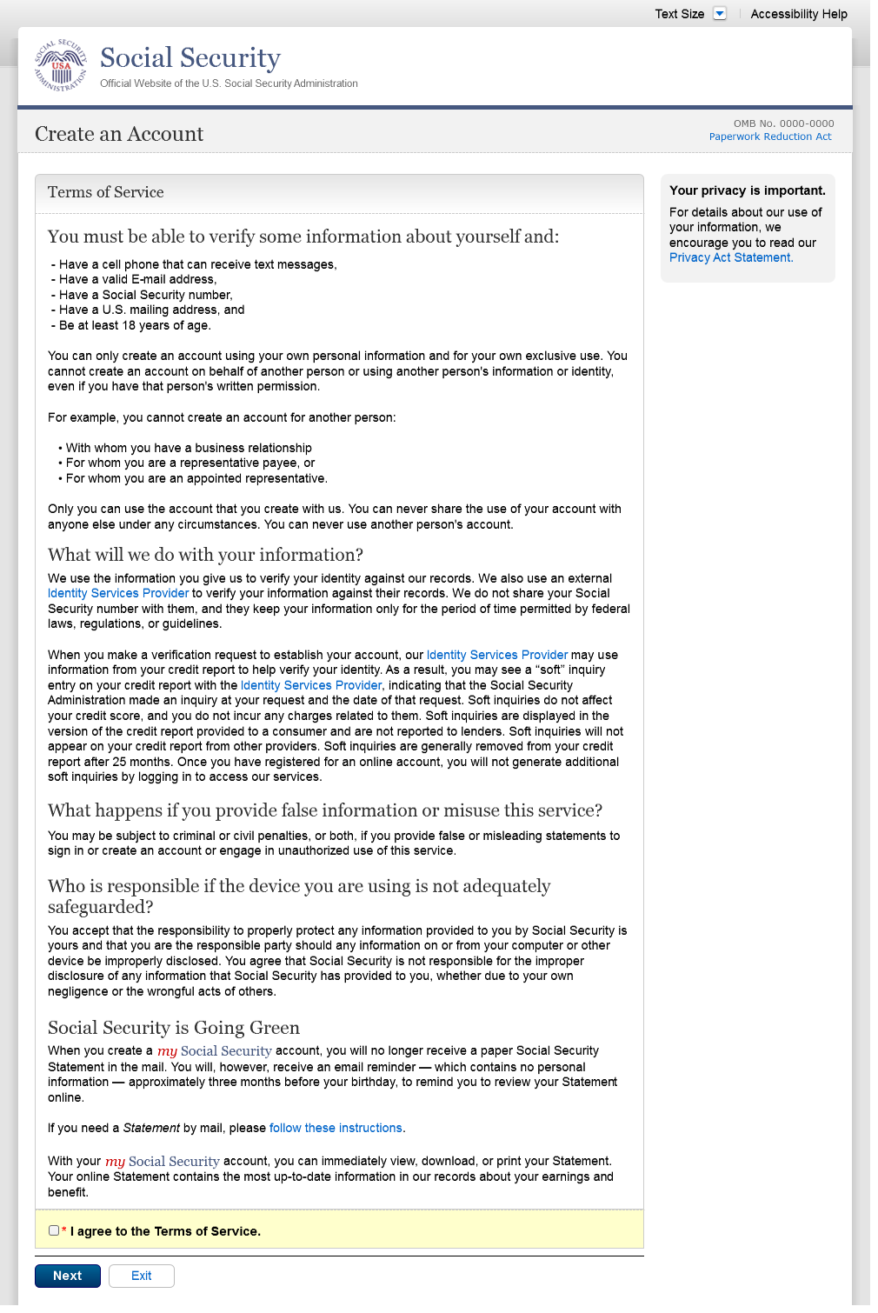
Added 1st bullet on 11/19/2015. Added hyphen to “SMS-enabled” on 12/02/2015. Modified wording on 12/17/2015.
Corrected spacing on 12/17/2015.
Removed “We used their fraud prevention services…theft.” on 12/17/2015.
Changed “email” to “E-mail” on 12/17/2015.

S1-P3 - Verify Identity

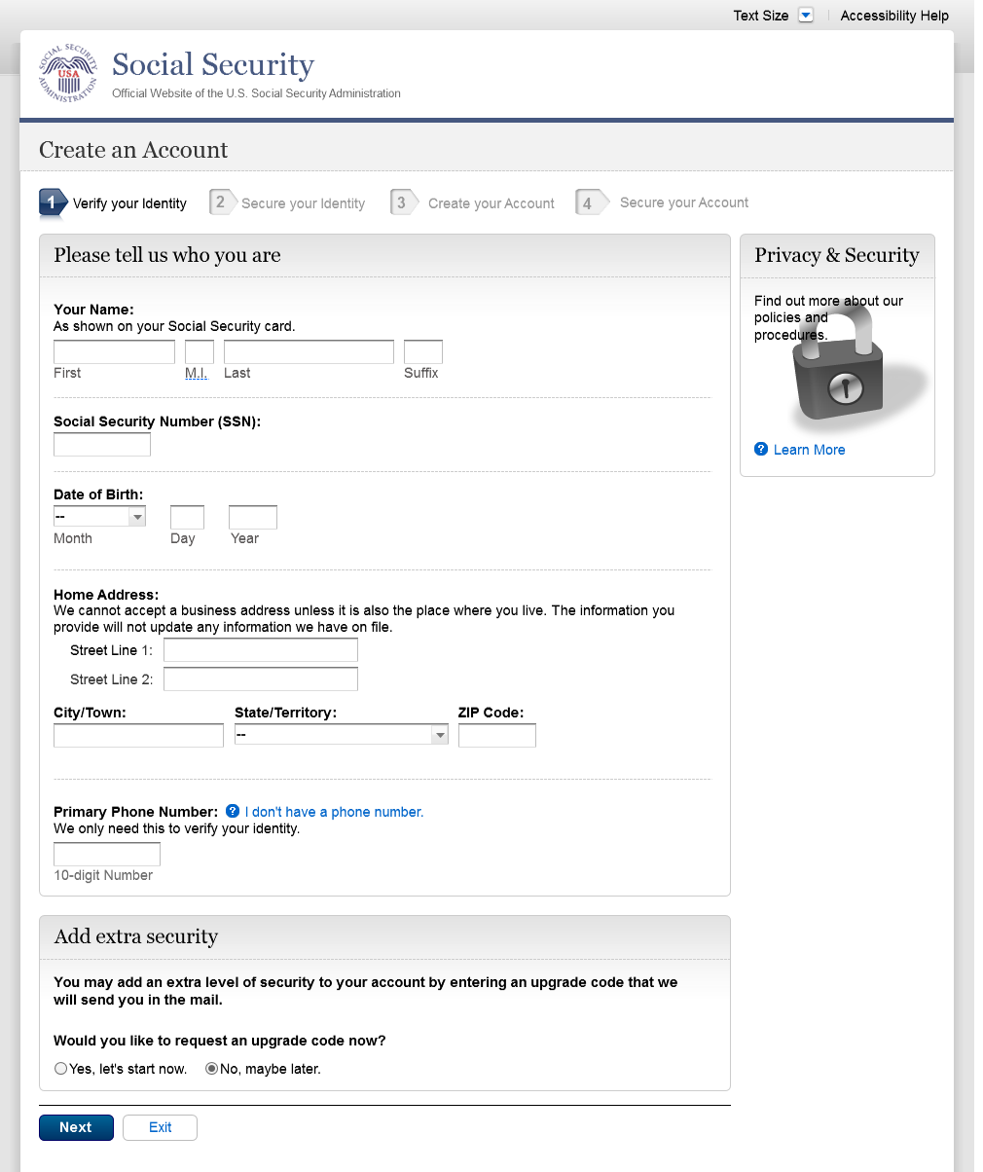
Changed from Action Link to Help link on 12/17/2015.
Text change
Restored container heading to “Add extra security” on 12/17/2015.
Added Step 4

S1-P4 - Secure Identity

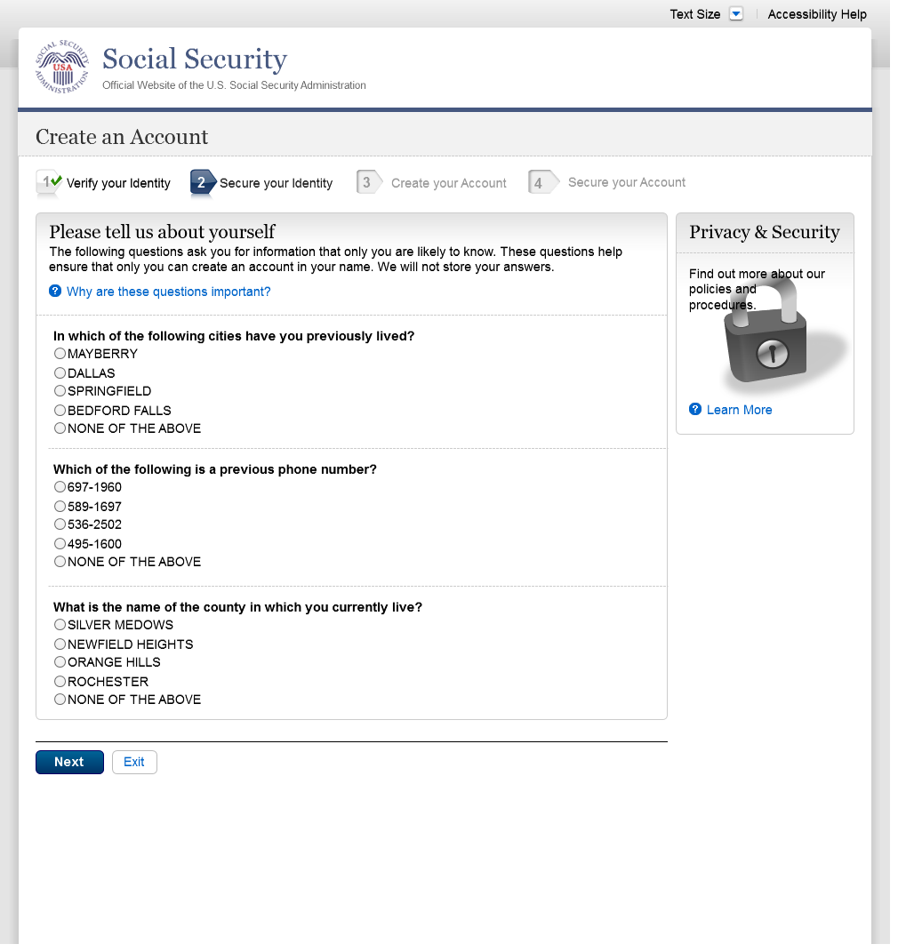
Added Step 4

S1-P5 - Create Account

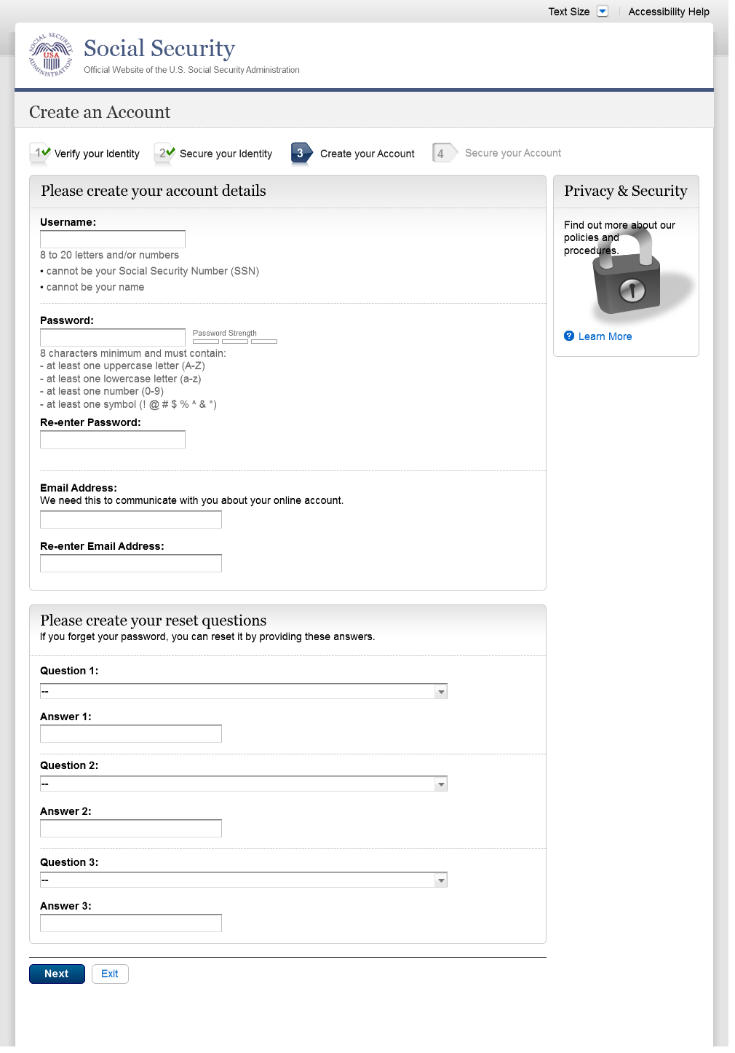
Added Step 4

S1-P6 – Provide Cell Phone Number_Create Account

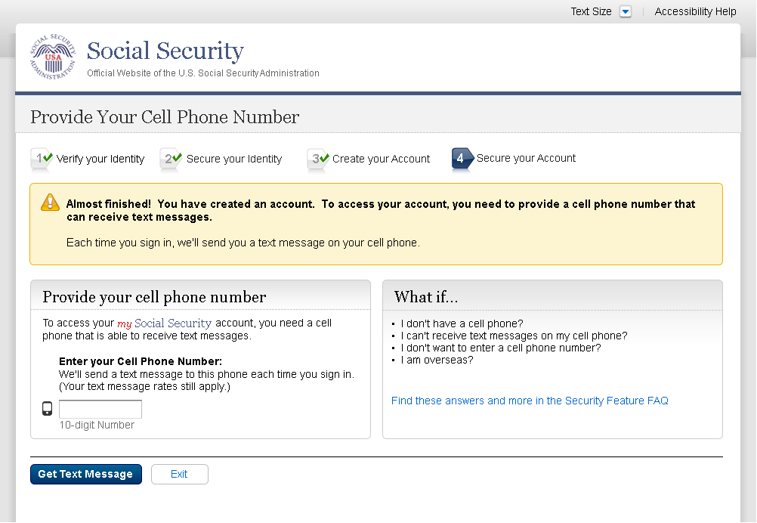
Added container
Changed “Security Features FAQ” to “Security Feature FAQ” on 2/22/2016.
Removed Previous button on 12/02/2015.
Removed “Why?” link on 1/13/2016.
Changed wording
Revised wording on 1/7/2016.
Added Step 4
Changed “own” to “have”, “cannot” to “can’t” and reordered questions on 12/17/15.
Changed wording
Added warning notice. Revised on 11/19/2015. Removed “For your protection,” on 12/17/2015.

S1-P7 - Enter Texted Security Code

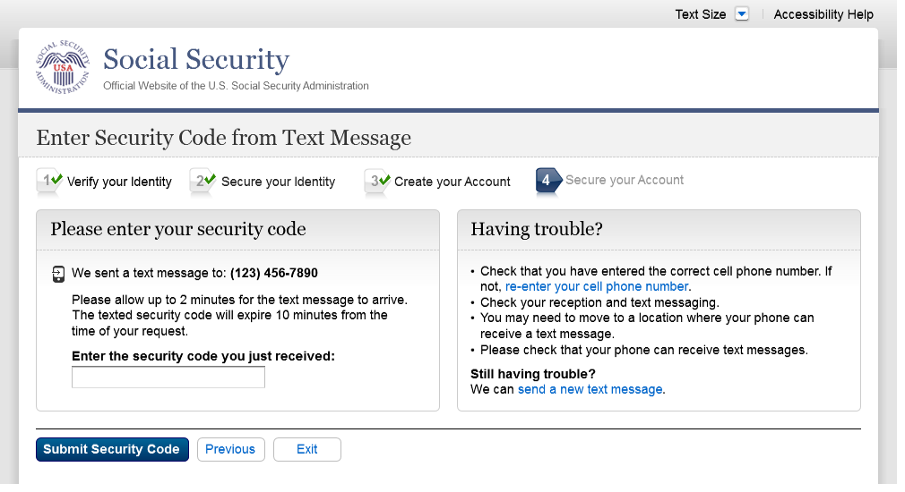
Removed “SMS” from 2nd bullet on 12/17/2015.
Added 1st bullet on 11/19/2015.
Added Step 4
Changed text

S1-P8 – Confirmation

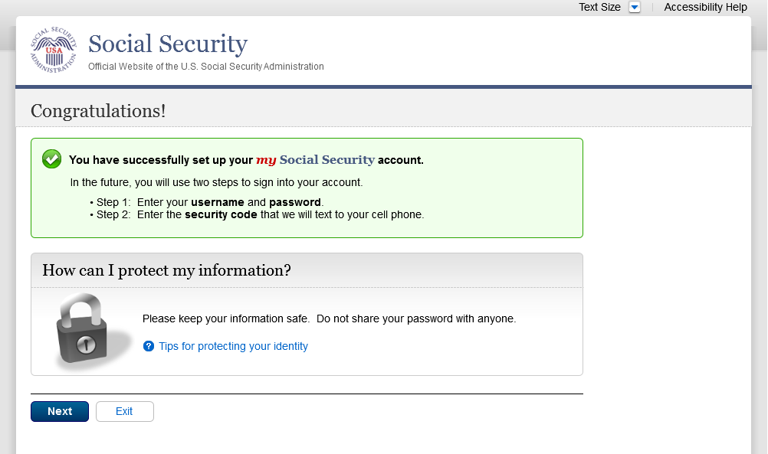
Modified text in container
Modified confirmation message

Scenario 2: Create LOA3 Account
Please see S1-P1 for description of changes.

S2-P1 - Sign In

S2-P2 - Terms of Service
Please see S1-P2 for description of changes.

S2-P3 - Verify Identity – User Chooses to Upgrade to LOA3

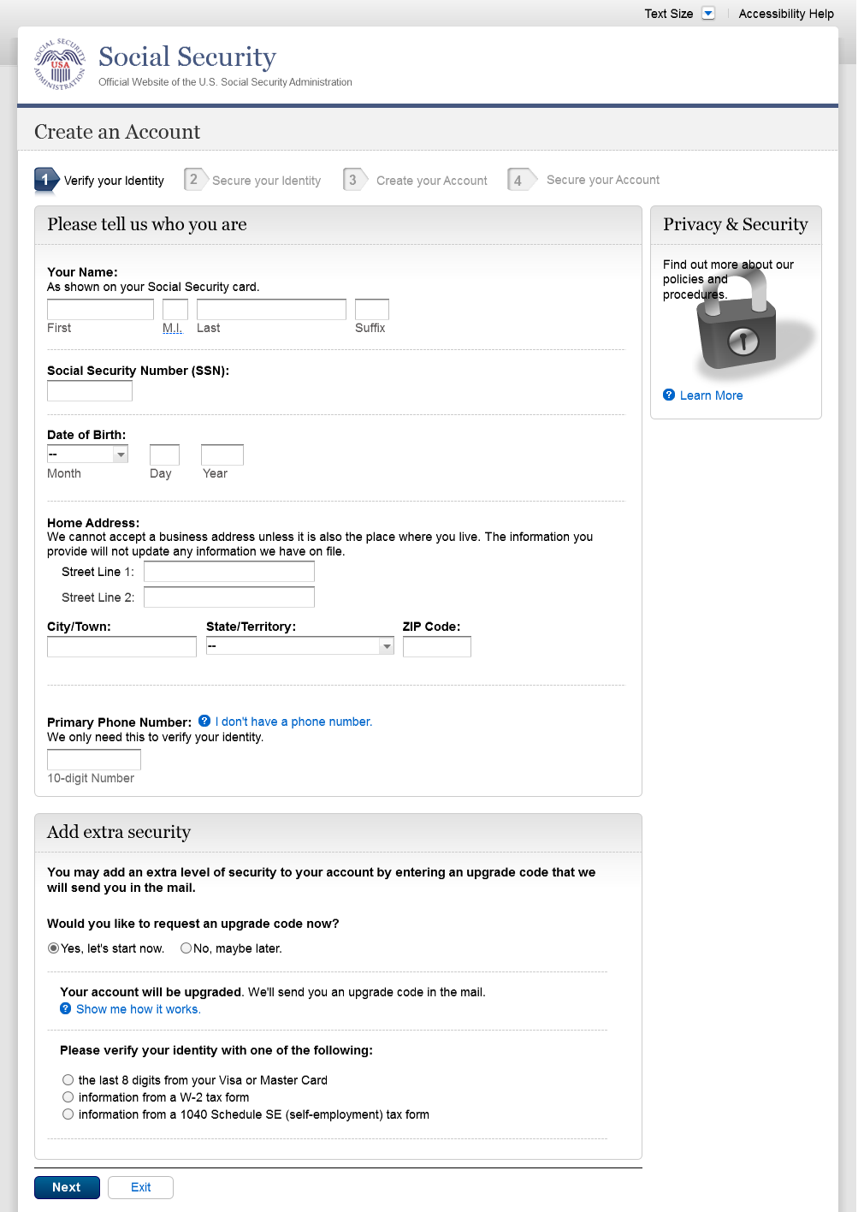
Text change
Restored container heading to “Add extra security” on 12/17/2015.
Changed “upgrade code” to lower case on 12/17/2015.
Added Step 4

S2-P4 - Secure Identity

Added Step 4

S2-P5 - Create Account

Added Step 4

S2-P6 – Provide Cell Phone Number – Create Account

Changed “Security Features FAQ” to “Security Feature FAQ” on 2/22/2016.
Changed wording
Revised wording on 1/7/2016.
Changed “own” to “have”, “cannot” to “can’t” and reordered questions on 12/17/15.
Changed wording
Added warning notice. Revised on 11/19/2015. Removed “For your protection,” on 12/17/2015.
Added Step 4

S2-P7 - Enter Texted Security Code_Create Account
Removed Previous button on 12/02/2015.
Removed “Why?” link on 1/13/2016.
Added container

Removed “SMS” from 2nd bullet on 12/17/2015.
Added 1st bullet on 11/19/2015.
Added Step 4
Changed text

S2-P8 - Confirmation_Set Up New Account_With Upgrade Selected

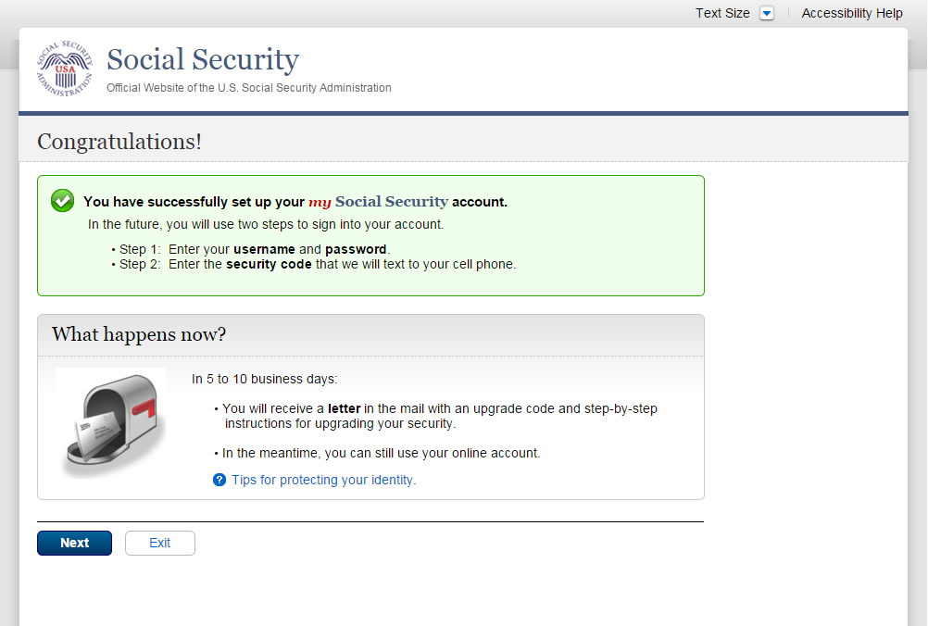
Modified confirmation message

S2-P10 - Second Sign In, After Receiving Upgrade Code Letter

Please see S1-P1 for description of changes.

S2-P11 – Verify Cell Phone Number

New screen

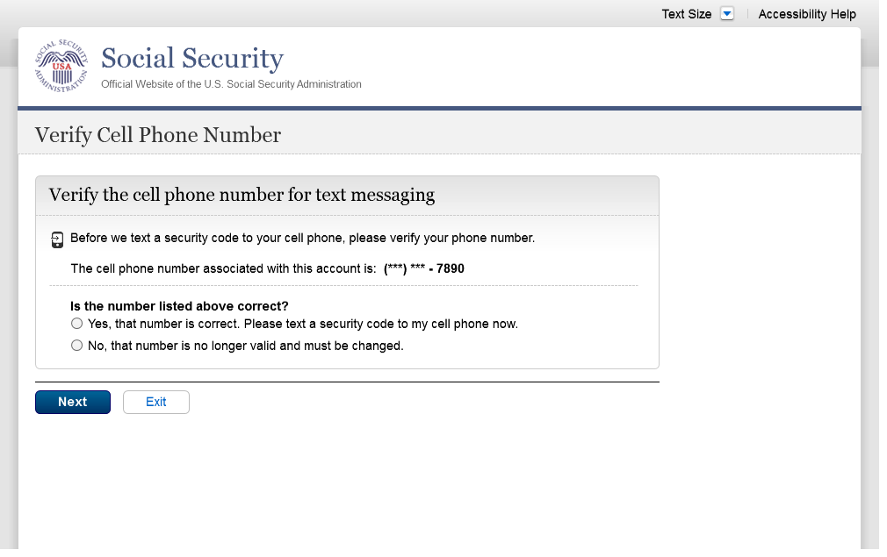
Added screen on 11/19/2015.
Modified wording on 12/17/2015.
Modified wording on 12/17/2015.
Added space before and after hyphen on 12/17/2015.

S2-P12 - Enter Texted Security Code_No Steps

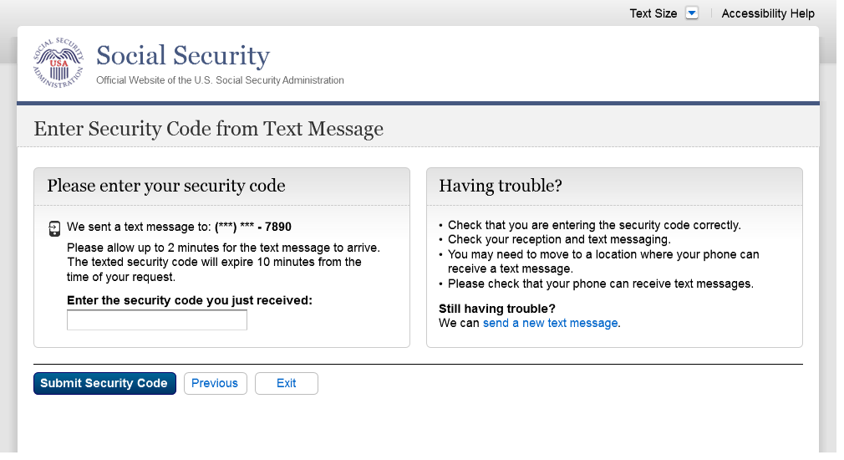
Removed “SMS” from 2nd bullet on 12/17/2015.
Masked 1st 6 digits of cell phone number on 11/19/2015. Added space before and after hyphen on 12/17/2015.
Changed text

S2-P13 - Do You Have Your Upgrade Code Letter?

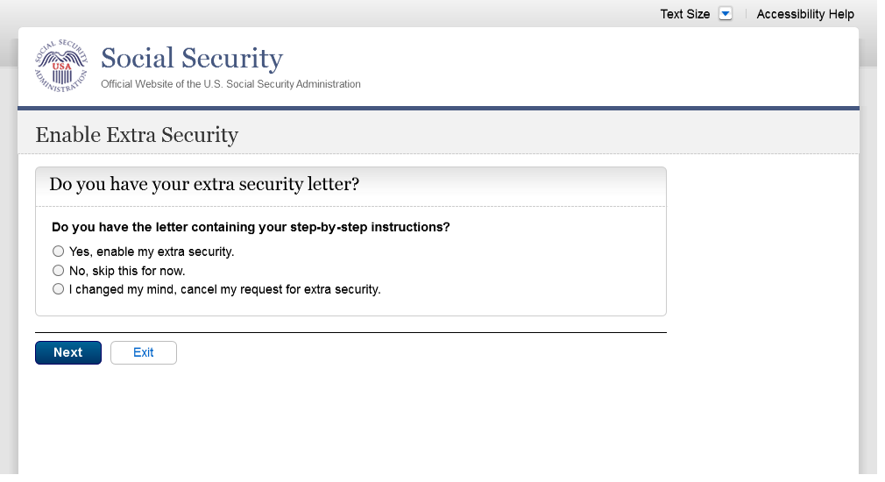
Modified wording in radio button labels to use “extra security” on 12/17/2015.
Changed “upgrade code letter” to “extra security letter” on 12/17/2015.
Modified page heading on 12/17/2015.
Removed steps on 12/17/2015.

S2-P14 - Enter Upgrade Code

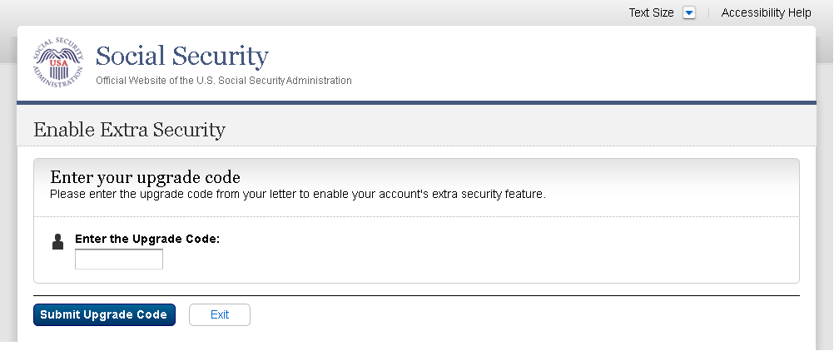
Removed 2nd container on 11/19/2015.
Changed “features” to “feature” on 2/22/2016.
Modified wording to use “extra security features” on 12/17/2015.
Modified page heading on 12/17/2015.
Removed steps on 12/17/2015.

S2-P15 - Confirmation_Upgrade to LOA3

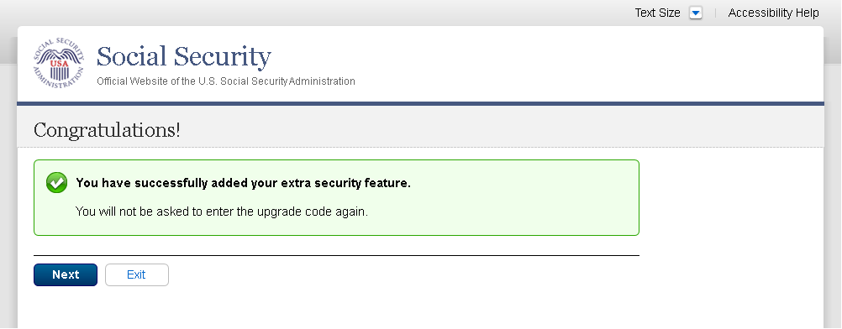
Changed “features” to “feature” on 2/22/2016.
Modified confirmation message
Modified confirmation message to “… added your extra security features” on 12/17/2015.

Scenario 3: Collect Cell Phone Number (2nd Factor) for Existing Account

S3-P1 - Sign In

Please see S1-P1 for description of changes.

S3-P3 - Provide Cell Phone Number_Grandfathered Account_No Steps

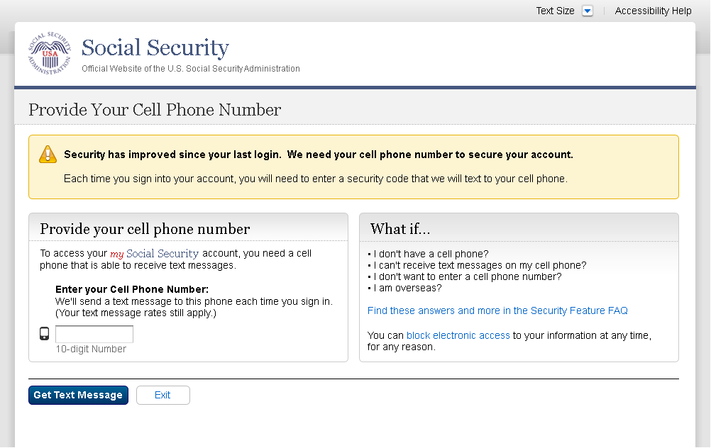
Changed “Security Features FAQ” to “Security Feature FAQ” on 2/22/2016.
Changed wording
Changed “own” to “have”, “cannot” to “can’t” and reordered questions on 12/17/15.
Changed wording
Added warning notice. Revised 11/19/2015. Removed “For your protection,” on 12/17/2015.

S3-P4 - Enter Texted Security Code_No Steps
Added text on 11/19/2015.
Added container
Removed Previous button on 12/02/2015.
Removed “Why?” link on 1/13/2016.

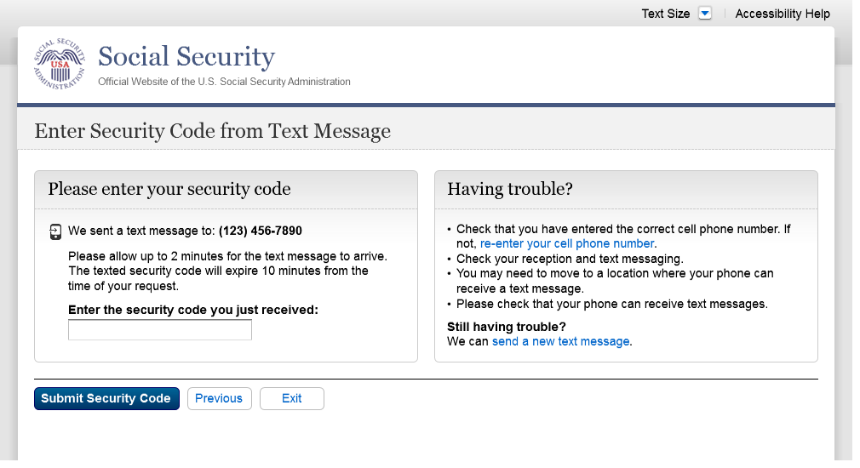
Removed “SMS” from 2nd bullet on 12/17/2015.
Changed text

S3-P5 – Confirmation – Set Up Account

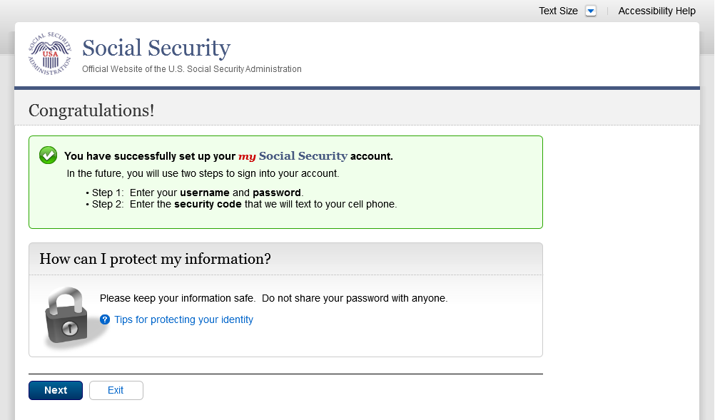
Modified text in container
Modified confirmation message

Scenario 4: Update Cell Phone Number

S4-P1 - Sign In

Please see S1-P1 for description of changes.

S4-P2 – Verify Cell Phone Number

Screen added on 11/19/2015.

Please see S2-P11 for changes.

S4-P4 - Update Phone Number - Provide Info

This screen is displayed only if the user selects “No…” to the question “Is the number listed above correct?” on screen S4-P2, thereby indicating that they need to change their cell phone number in SSA’s records.

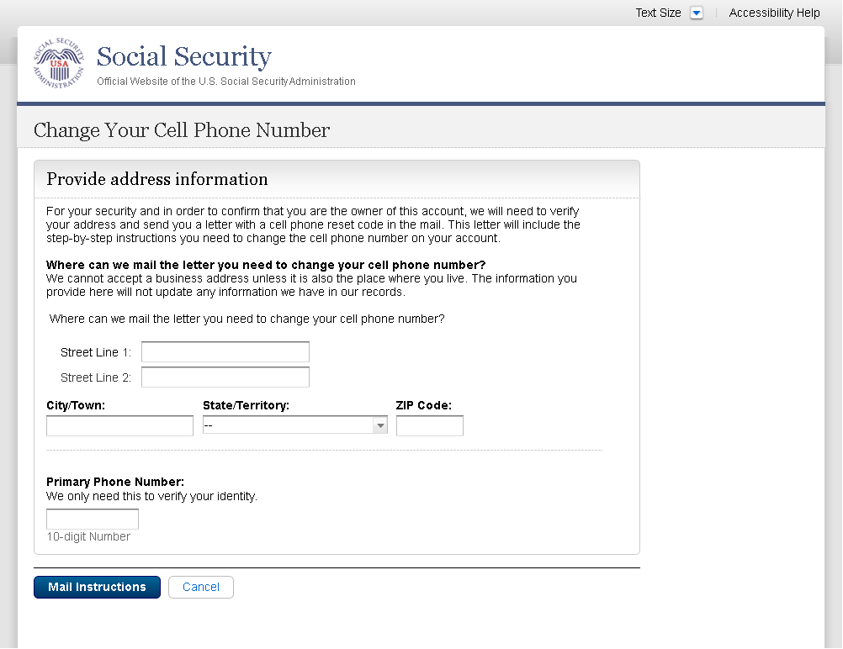
Removed “I don’t have a phone number” link on 1/7/2016.
Modified to use “change”, rather than “update”, and “reset code”, rather than “update code” on 12/17/2015.

Modified question to refer specifically to cell phone on 12/02/2015. Modified to reference cell phone number on 12/17/2015.
Added paragraph on 11/19/2015. Modified paragraph to refer to updating a cell phone consistently on 12/02/2015.
Modified page title on 12/17/2015.

S4-P5 - Confirmation of Letter

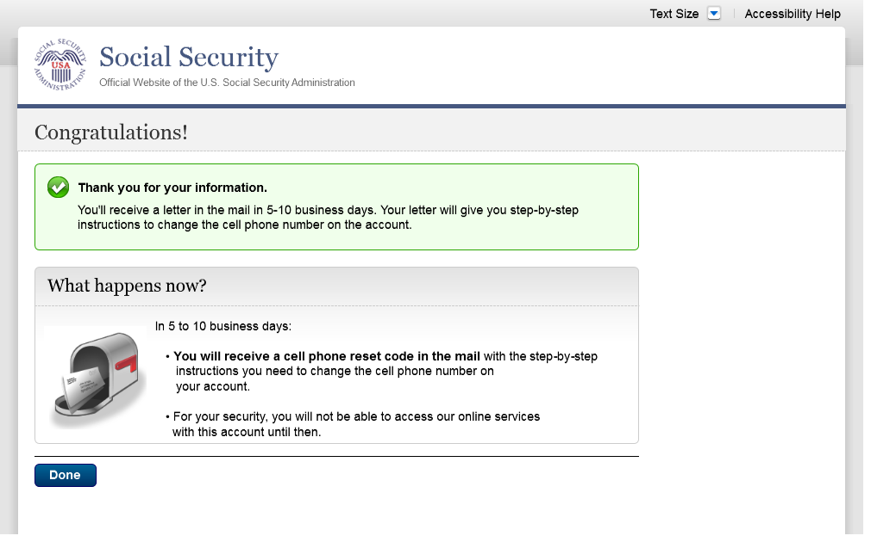
Changed “update code” to “reset code” on 12/17/2015.

S4-P7 - Sign In After Receiving Cell Phone Reset Code Letter

Please see S1-P1 for description of changes.

S4-P9 – Do you have your cell phone reset letter?

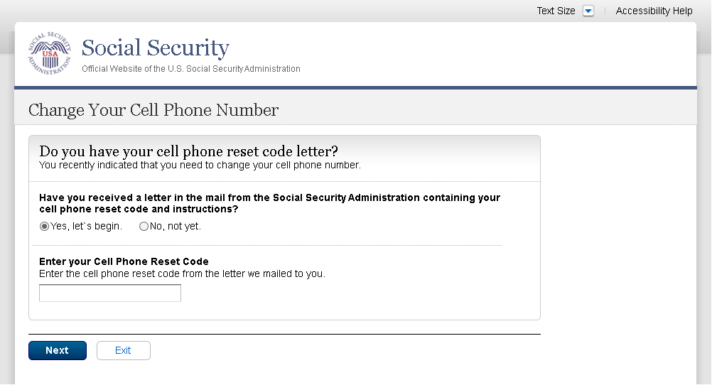
Updated language on 1/12/2016.
Updated language on 1/12/2016.
“Enter your cell phone reset code” section is hidden until the user selects “Yes, let’s begin.”

S4-P10 - Provide New Cell Phone Number

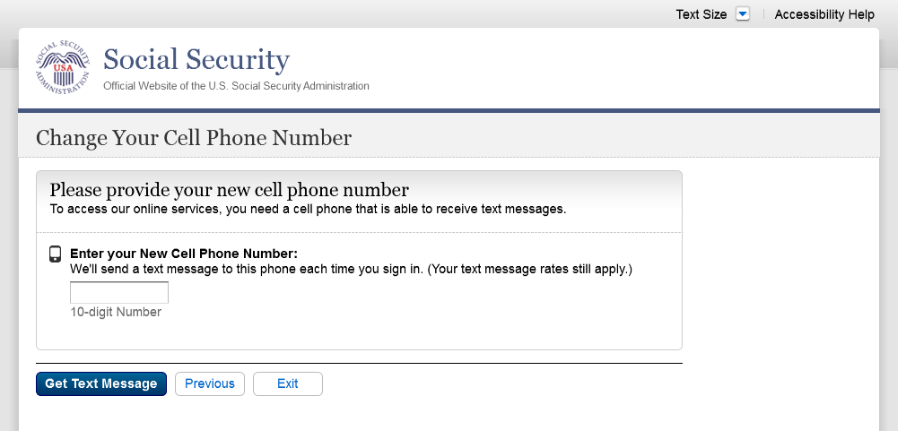
Modified text. Revised “Update” to “Change” on 12/17/2015.
Removed warning message.

S4-P11 - Enter Texted Security Code_No Steps

Removed “SMS” from 2nd bullet on 12/17/2015.
Changed text

S4-P12 - Confirmation_New Cell Phone Number

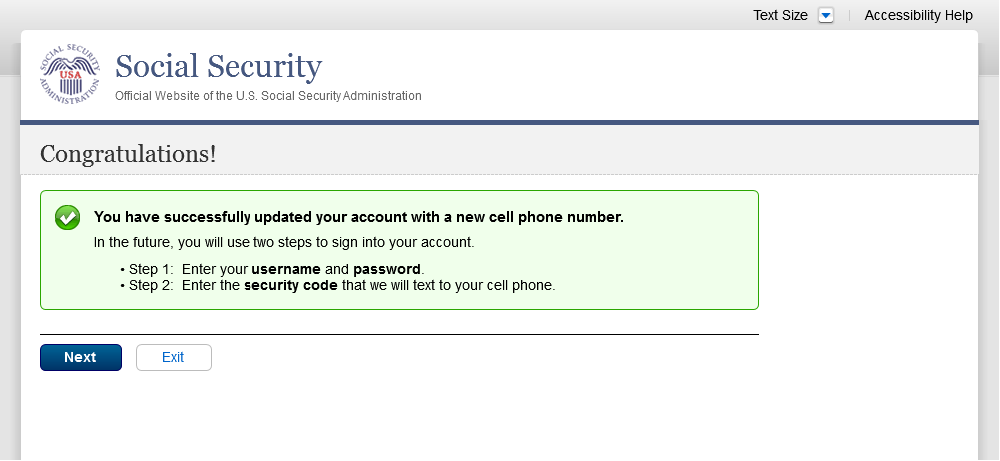
Changed wording in 1st sentence on 11/19/2015.

Scenario 5: Update Cell Phone Number on Account with Expired Password

S5-P1 - Sign In

Please see S1-P1 for description of changes.

S5-P3- Provide Cell Phone Number_Grandfathered Account_No Steps

Changed “Security Features FAQ” to Security Feature FAQ” on 2/22/2016.
Added container
Added text on 11/19/2015.
Removed “Why?” link on 1/13/2016.
Removed Previous button on 12/02/2015.
Changed wording
Changed “own” to “have”, “cannot” to “can’t” and reordered questions on 12/17/15.
Changed wording
Added warning notice. Revised 11/19/2015. Removed “For your protection,” on 12/17/2015.

S5-P4 - Enter Texted Security Code_Phone Added Immediately Prior

Removed “SMS” from 2nd bullet on 12/17/2015.
Changed text

S5-P5 - Expired Password
No changes in this release.

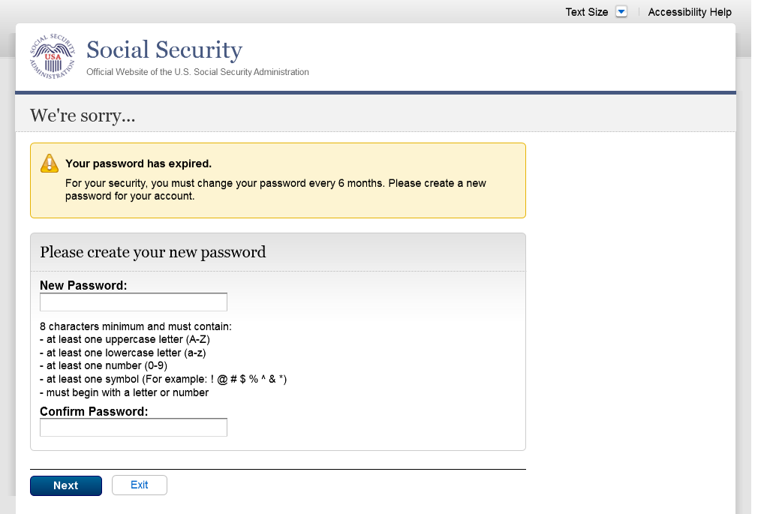

S5-P6 - Confirmation of Password Change

Modified confirmation message

Scenario 6: Update Cell Phone Number on Account, User Has Forgotten Password, Uses Reset Questions

S6-P1 - Sign In

Please see S1-P1 for description of changes.

S6-P3 - Forgot Password_Grandfathered User_ Verify Identity

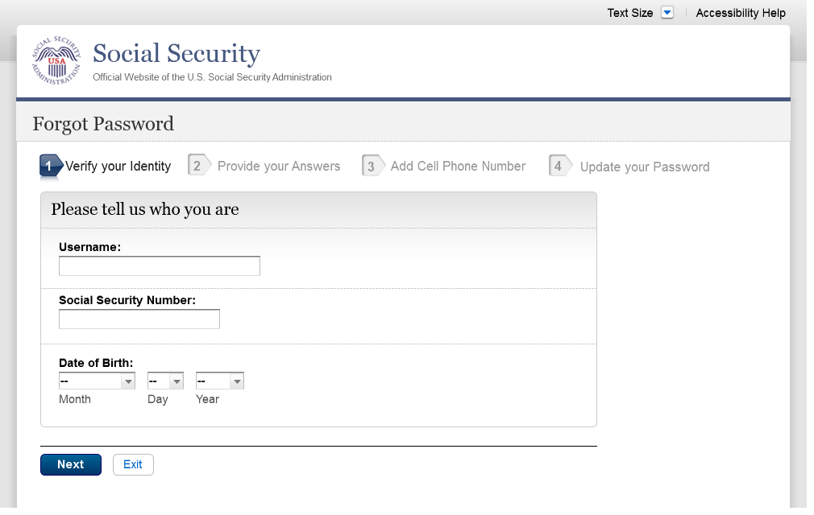
Corrected capitalization of “your” on Step 2 on 12/02/2015.
Added Step 3.

S6-P4 - Forgot Password_Grandfathered User_Provide Answers

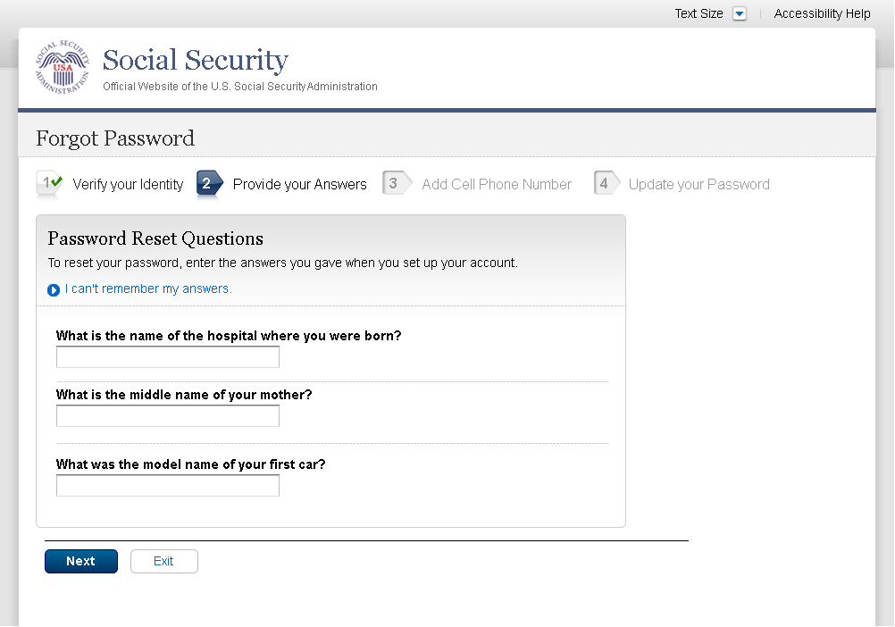
Modified font on Step 1 on 1/8/2016.
Added Step 3

S6-P5 - Provide Cell Phone Number_ Grandfathered User_ Forgot Password
Modified font on Steps 1 and 2 on 1/8/2016.
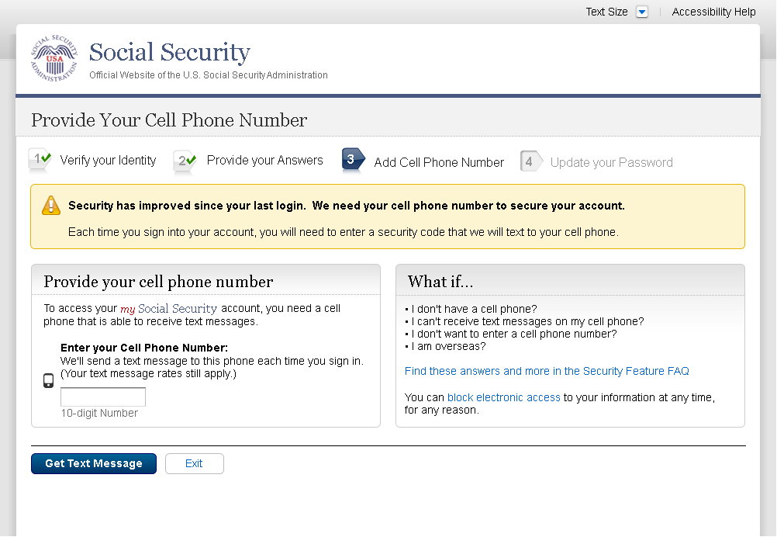
S6-P6 - Enter Texted Security Code_Grandfathered User_Forgot Password
Removed Previous button on 12/02/2015.
Removed “Why?” link on 1/13/2016.
Added text on 11/19/2015.
Changed “Security Features FAQ” to “Security Feature FAQ” on 2/22/2016.
Changed “own” to “have”, “cannot” to “can’t” and reordered questions on 12/17/15.
Changed wording
Added warning notice. Revised on 11/19/2015. Removed “For your protection,” on 12/17/2015.
Changed wording
Added Step 3

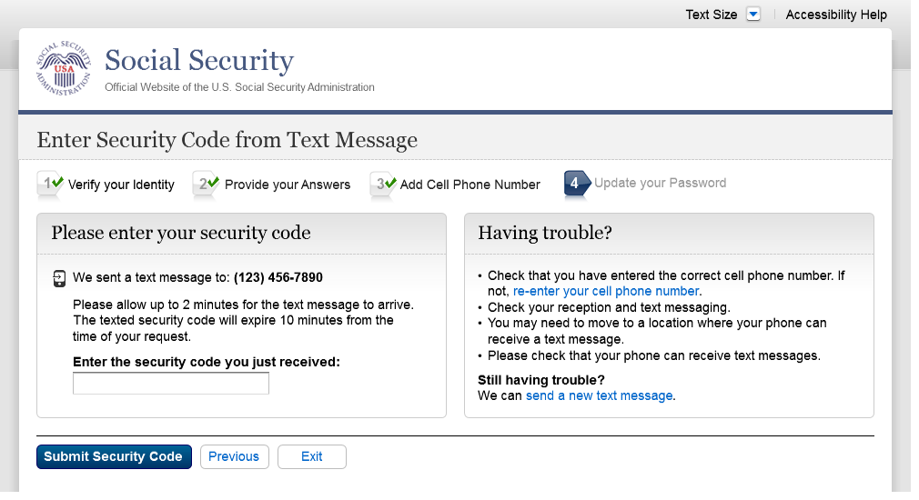
Removed “SMS” from 2nd bullet on 12/17/2015.
Corrected steps on 12/02/2015. Changed capitalization of “your” on 12/17/2015.

S6-P7 - Update Password_Grandfathered User

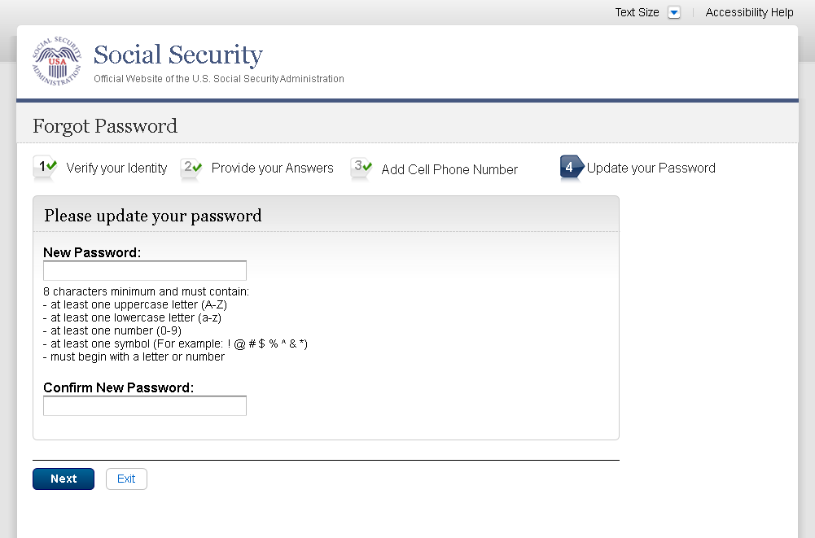
Modified font on Steps 1, 2, and 3 on 1/8/2016.
Added Step 3
Removed Previous button on 12/02/2015.
Changed capitalization of “your” on 12/17/2015.

S6-P8 - Confirmation of Password Change
Modified confirmation message

Scenario 7: Update Cell Phone Number on Account, User Has Forgotten Password and Reset Question Answers

S7-P1 Sign In

Please see S1-P1 for description of changes.

S7-P3 - Forgot Password_Grandfathered User_ Verify Identity

Corrected capitalization of “your” on Step 2 on 12/02/2015.
Added Step 3

S7-P4 - Forgot Password_Grandfathered User_Provide Answers

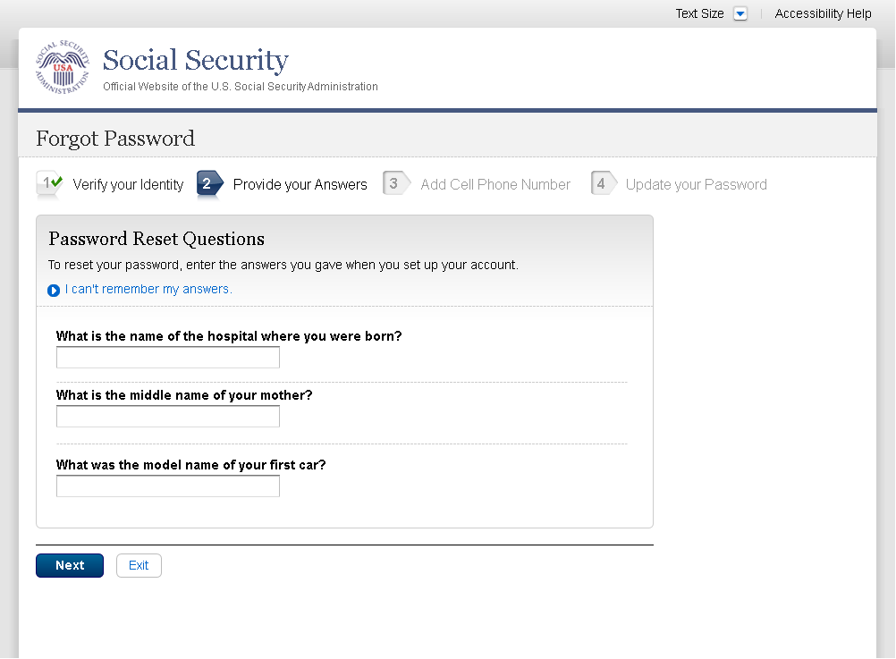
Modified font on Step 1 on 1/8/2016.
Added Step 3
Removed Previous button on 12/02/2015.

S7-P5 - Forgot Password - Send Temporary Password
No changes in this release.

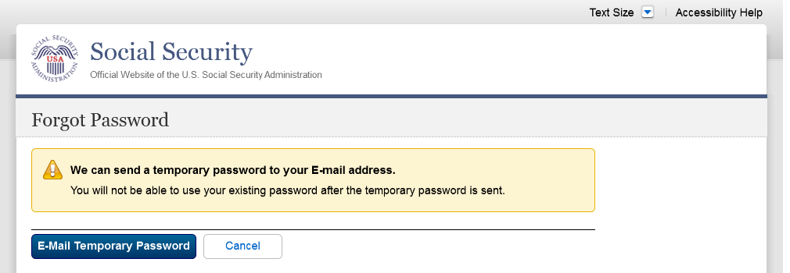

S7-P6 - Email Confirmation
No changes in this release.

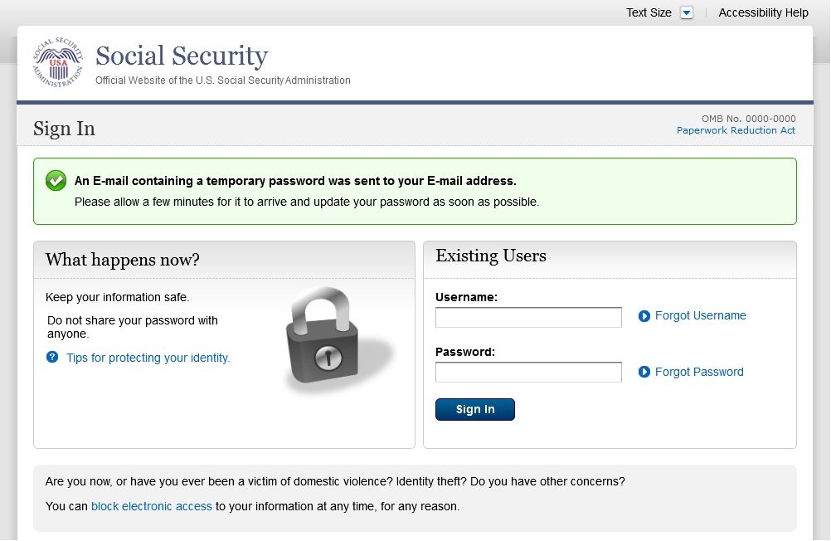

S7-P9 - Provide Cell Phone Number_ Grandfathered User_ Forgot Password
Modified font on Steps 1 and 2 on 1/8/2016.
Changed “Security Features FAQ” to “Security Feature FAQ” on 2/22/2016.
Added container
Changed wording
Added Step 3
Added warning notice. Revised on 11/19/2015. Removed “For your protection,” on 12/17/2015.
Changed wording
Changed “own” to “have”, “cannot” to “can’t” and reordered questions on 12/16/15.
Added text on 11/19/2015.
Removed Previous button on 12/02/2015.
Removed “Why?” link on 1/13/2016.

S7-P10 - Enter Texted Security Code_Grandfathered User_Forgot Password

Removed “SMS” from 2nd bullet on 12/17/2015.
Corrected steps on 12/02/2015. Changed capitalization of “your” on 12/17/2015.

S7-P11 - Update Password_Grandfathered User

Updated font on Steps 1, 2, and 3 on 1/8/2016.
Added Step 3
Removed Previous button on 12/02/2015.
Corrected capitalization on Step 2 on 12/17/2015.

S7-P12 - Confirmation of Password Change

Modified confirmation message

Scenario 8: Login Happy Path (All Users)

S8-P1 Sign In

Please see S1-P1 for description of changes.

S8-P2 Verify Cell Phone Number

Please see S2-P11 for changes.

S8-P3 Enter Texted Security Code

S8-P4 my Social Security Terms of Service

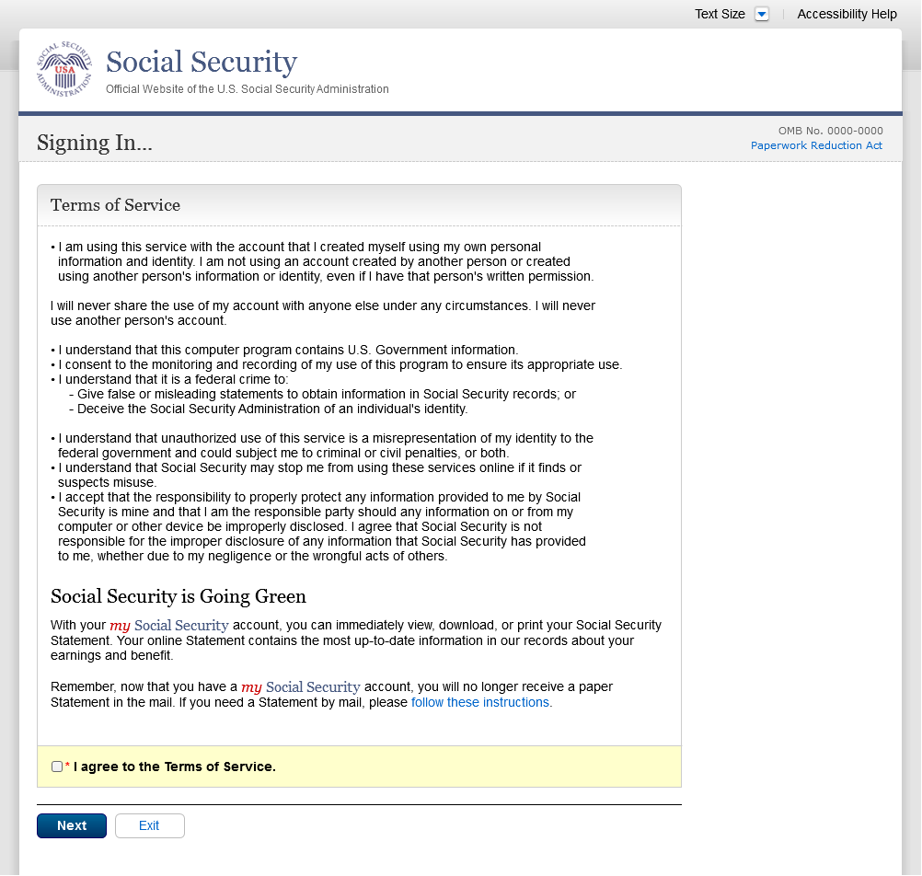

Security Feature FAQ

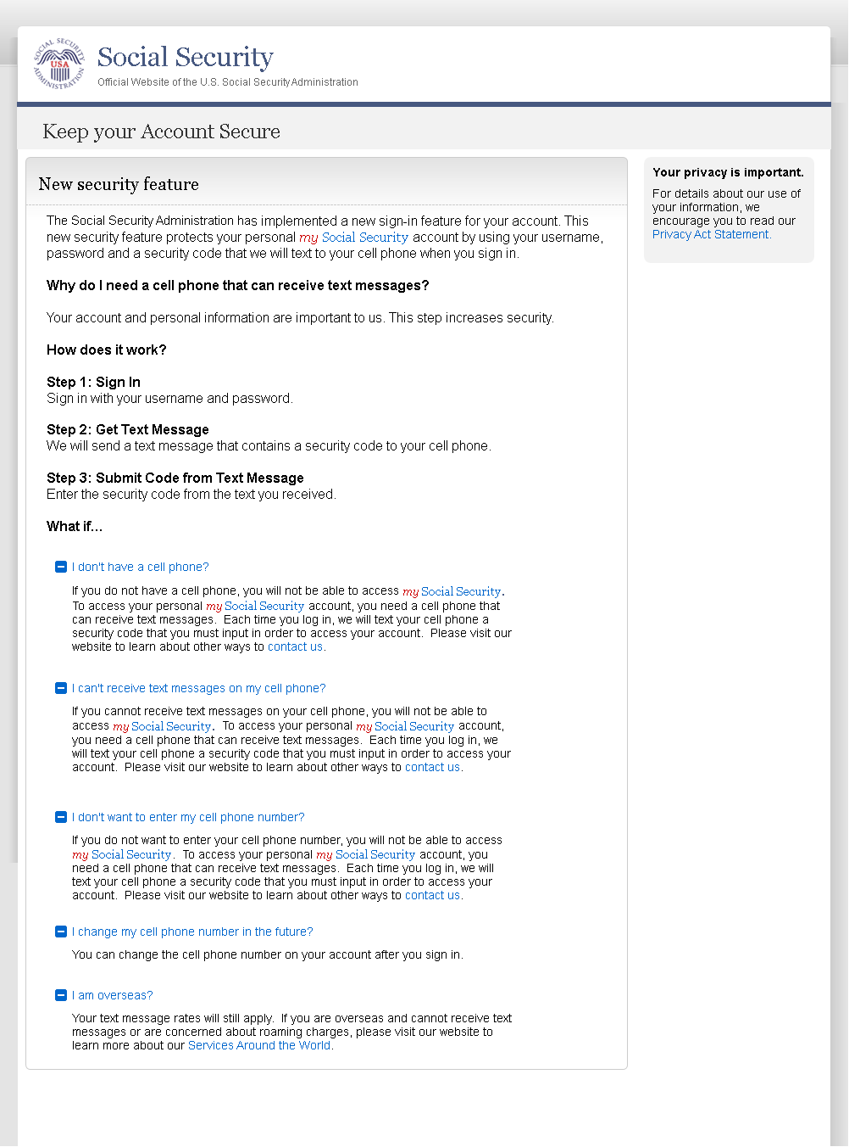
On 2/22/2016:
- Changed container title from “New Security Features” to “New Security Feature”.
- Changed first sentence from “my Social Security has…” to “The Social Security Administration has…”
- Changed second sentence from “This … my Social Security account…” to “This … personal my Social Security account…”

my Social Security - Security Settings

Standard Account

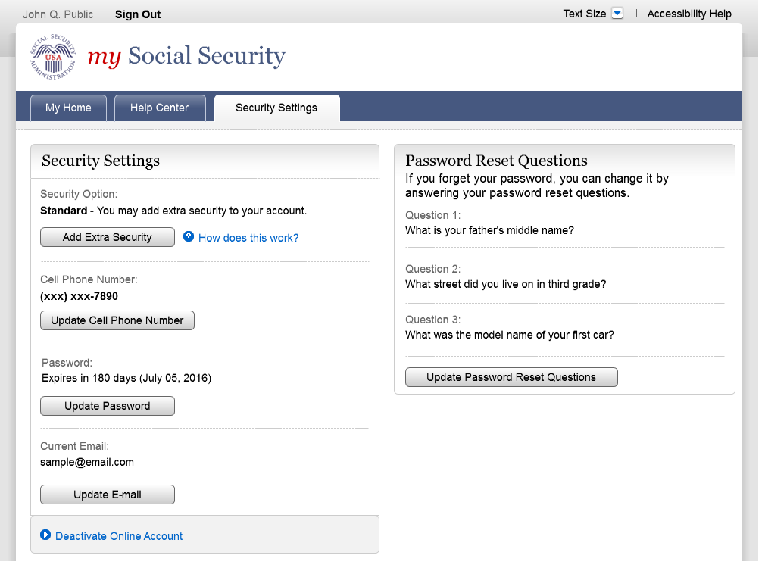

Enhanced (Pending) Account

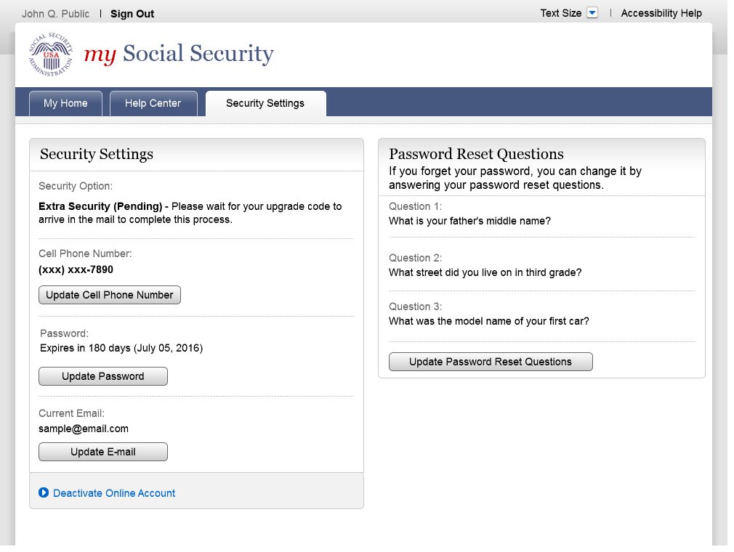

Enhanced Account

