Evaluation of the National Partnership for Action to End Health Disparities (NPA)
OMB No. 0990-0406
State Representative Survey Screenshots
Screen 1: Introduction
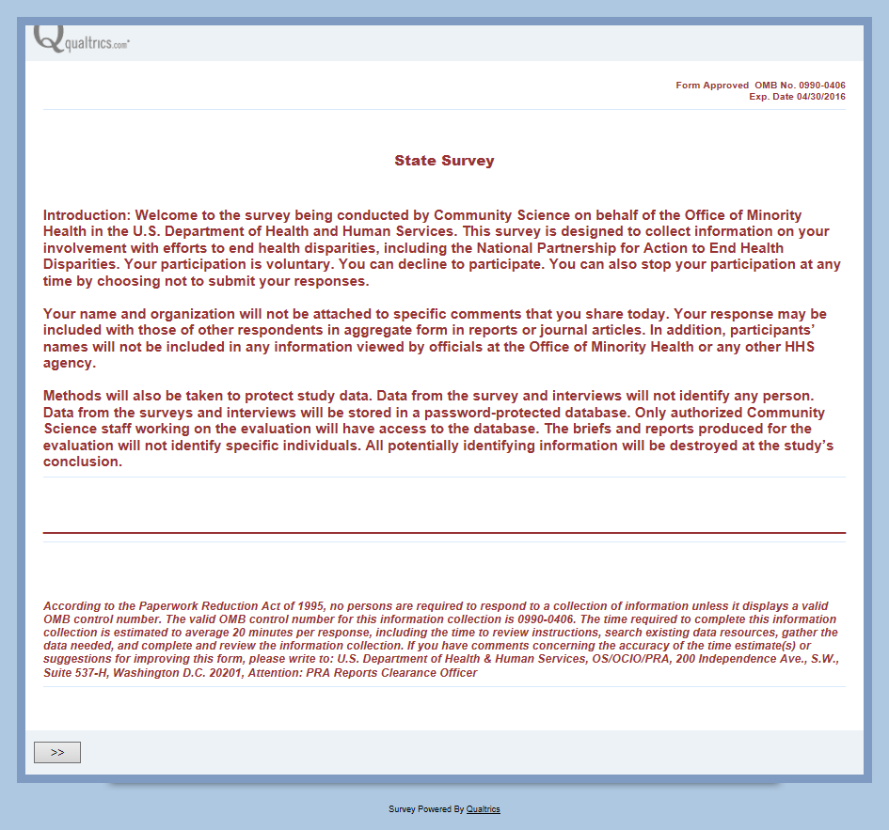

Screen 2: Location
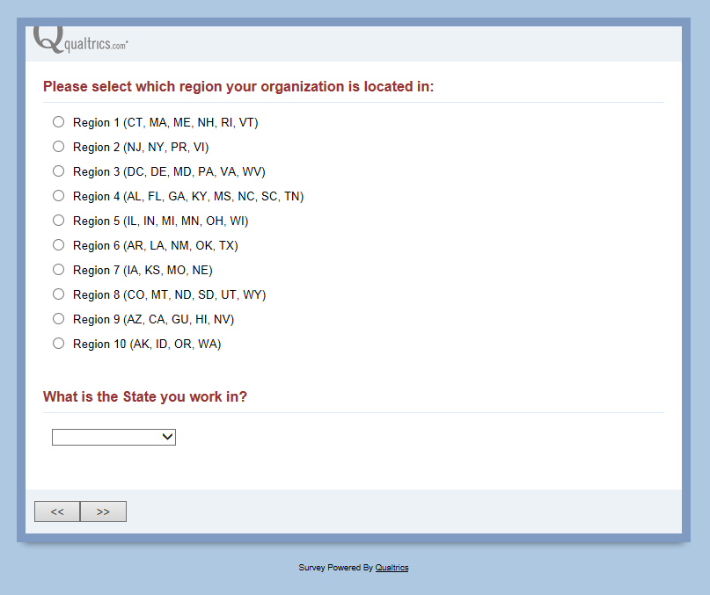

Screen 3: Goals and Partnerships
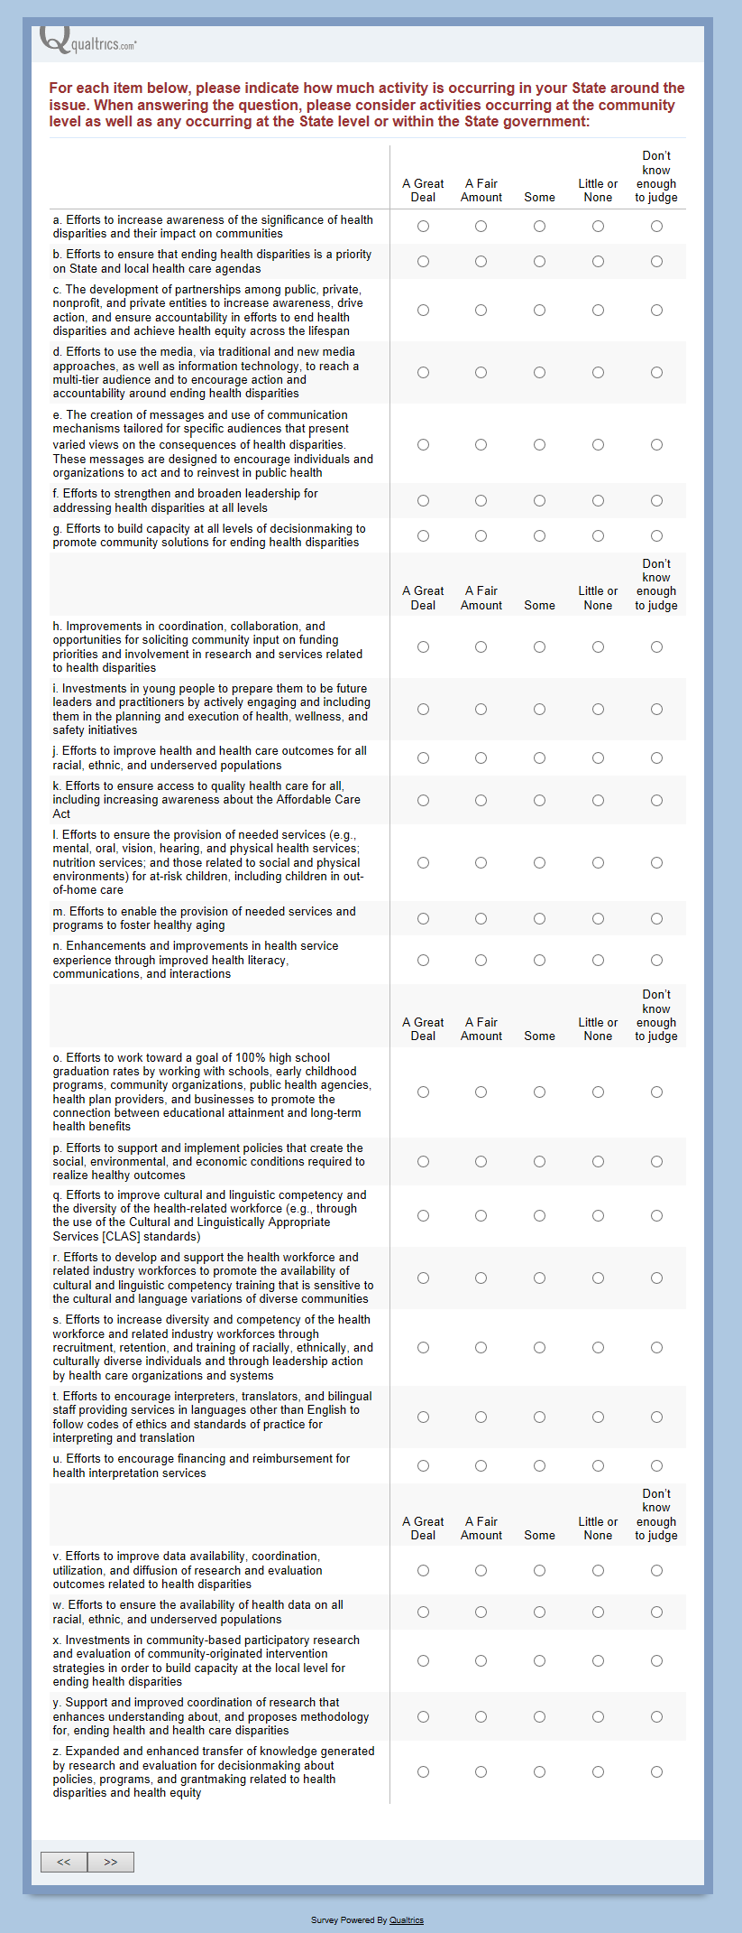
Screen 4: Knowledge Mobilization
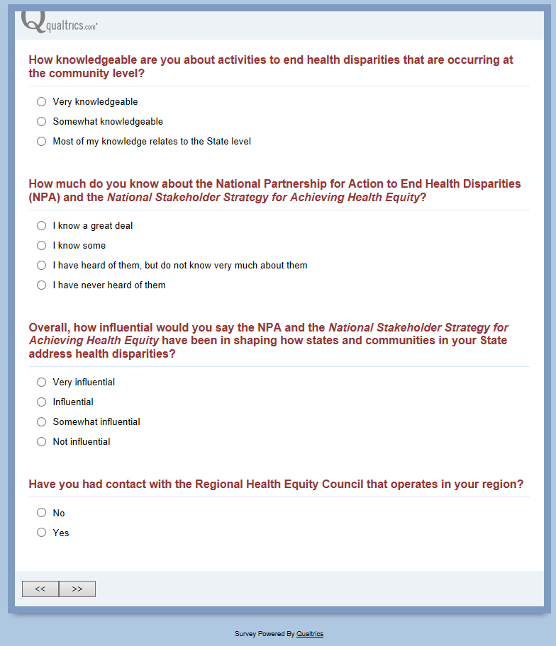
This question DOES NOT appear if the option “I have never heard of them” was selected for the above question.

Screen 5: Other Active Agencies
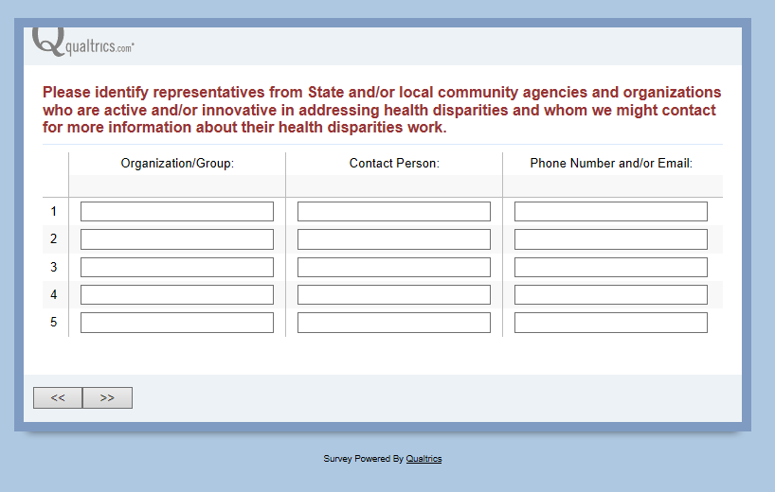

Screen 6: Conclusion
