Evaluation of the National Partnership for Action to End Health Disparities (NPA)
OMB No. 0990-0406
Regional Health Equity Council (RHEC) Survey Screenshots
Screen 1: Introduction & Location
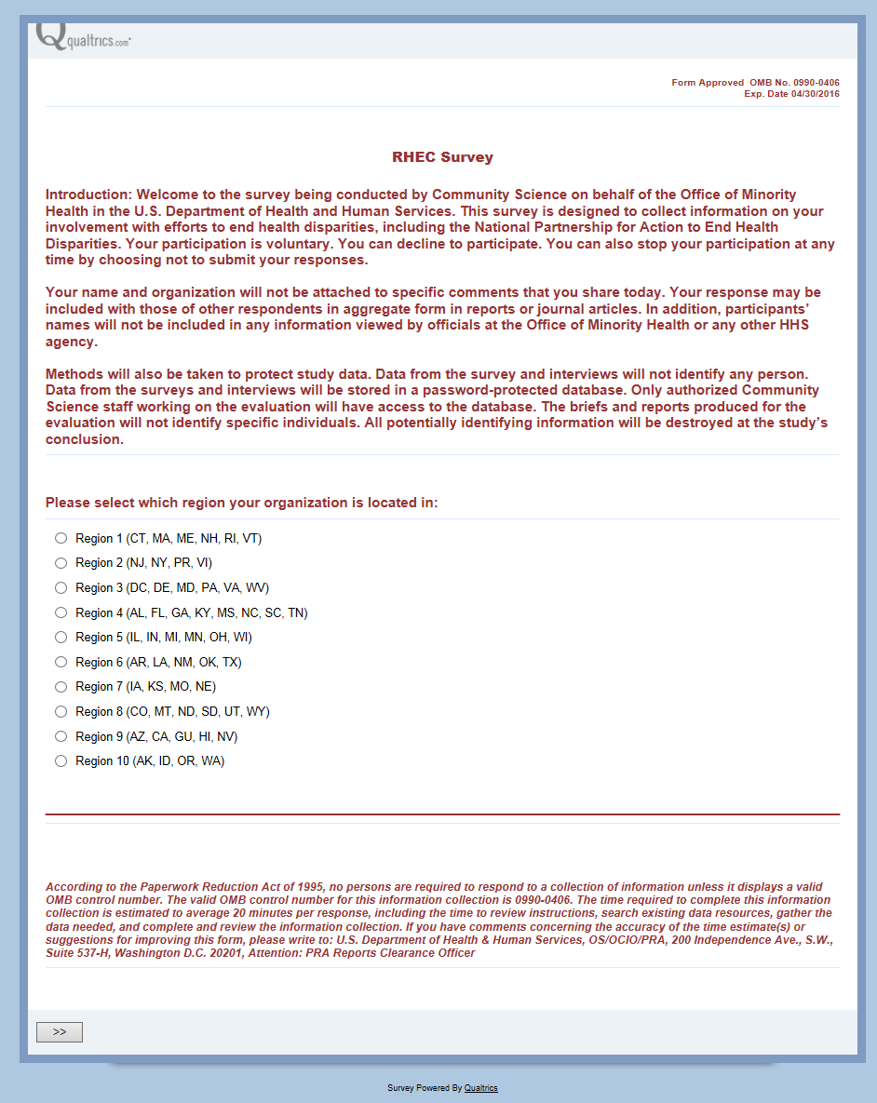
Screen 2: RHEC Membership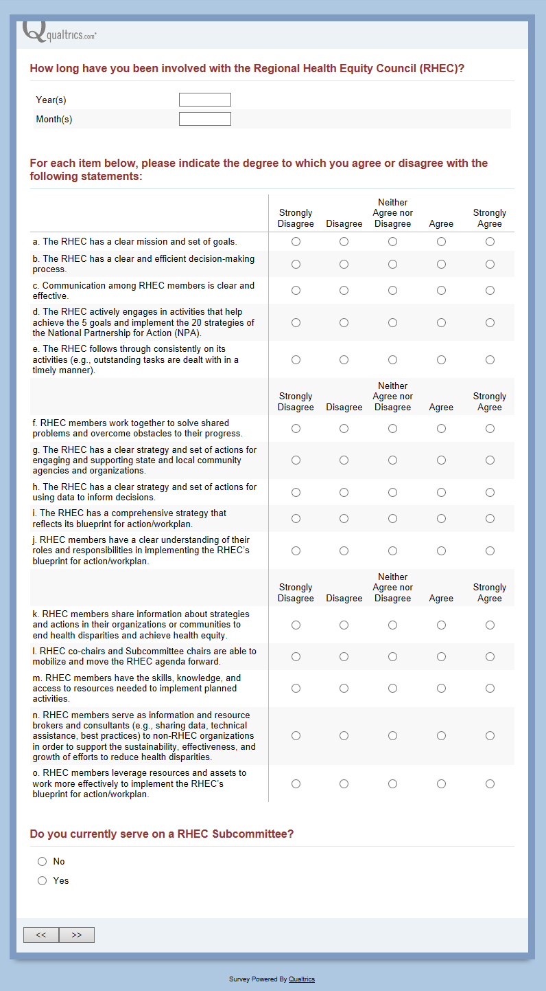

Screen 3a: RHEC Goals (appears if the respondent indicated they do NOT serve on a subcommittee)
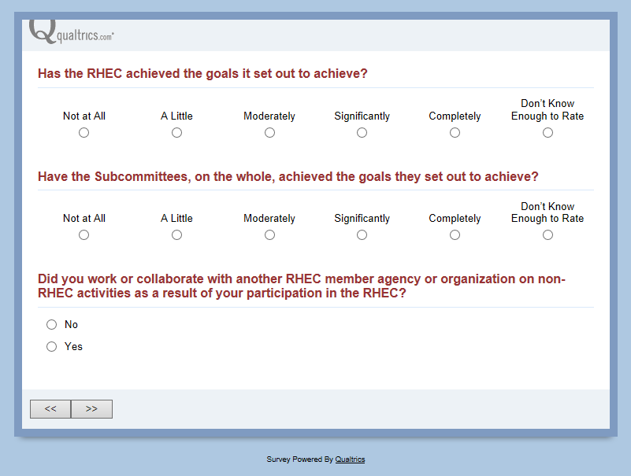

Screen 3b: Subcommittee and RHEC Goals (appears if the respondent indicated they serve on a subcommittee)
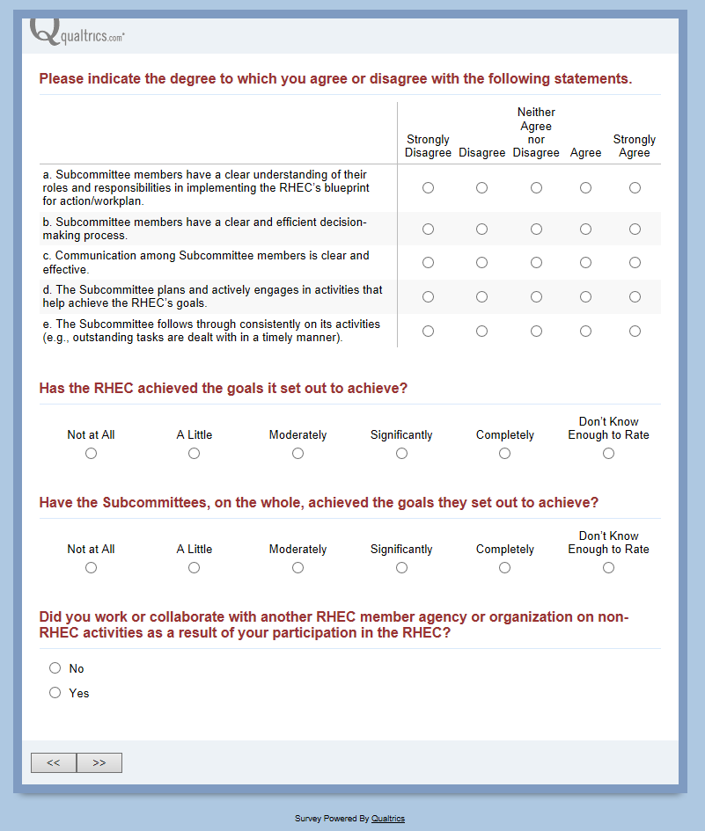

Screen 4: Collaboration with other RHEC agencies (appears only if respondent indicates they collaborate with another RHEC agency on Screen 3a or 3b)
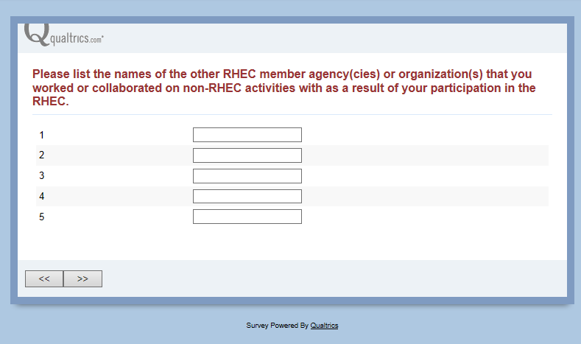
Screen 4a: Nature of collaboration (appears only if respondent indicates they collaborate with another RHEC agency on Screen 3a or 3b; appears for each agency listed on Screen 4 – the example shows the screen when “Test Agency 1” was entered)
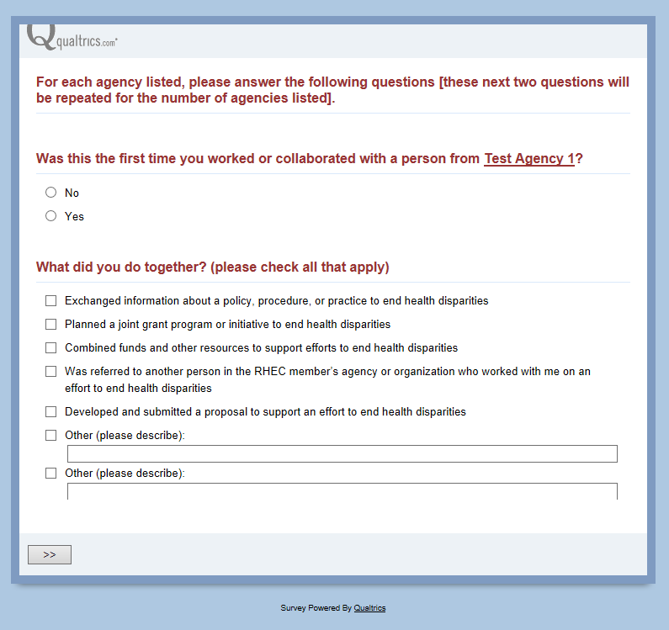

Screen 5: Influence & Relationships
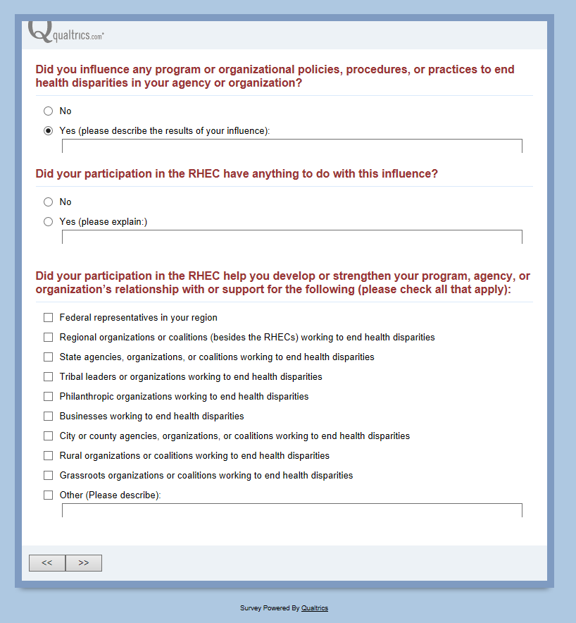
This question only appears if YES is selected in the above question

Screen 6: Support
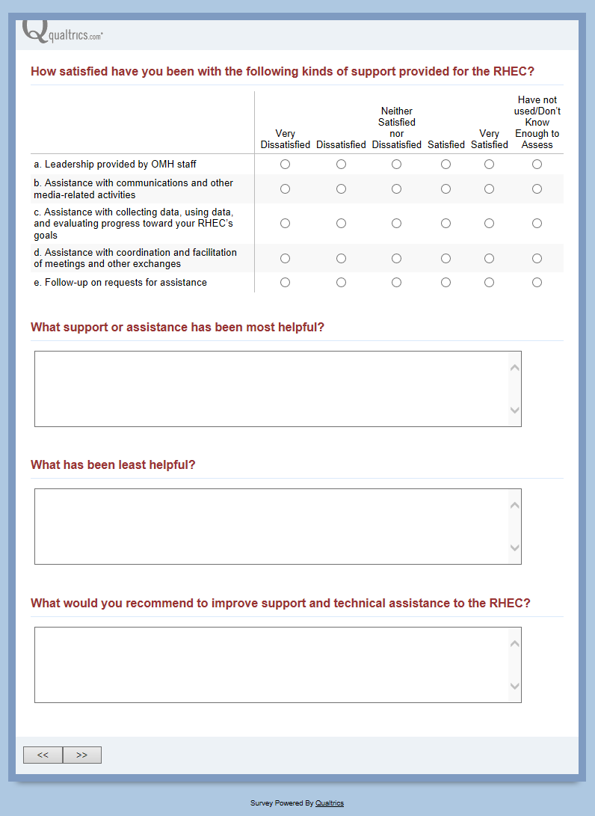
These questions DO NOT appear if the option “Have not used/don’t know enough to assess” was selected for statements b, c, d, and e above.
Screen 7: Other Agencies
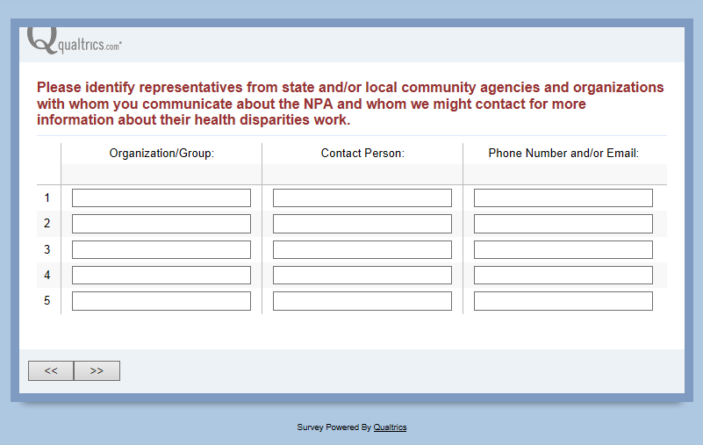

Screen 8: Conclusion
