Evaluation of the National Partnership for Action to End Health Disparities (NPA)
OMB No. 0990-0406

Partner Survey Screenshots

Screen 1: Introduction
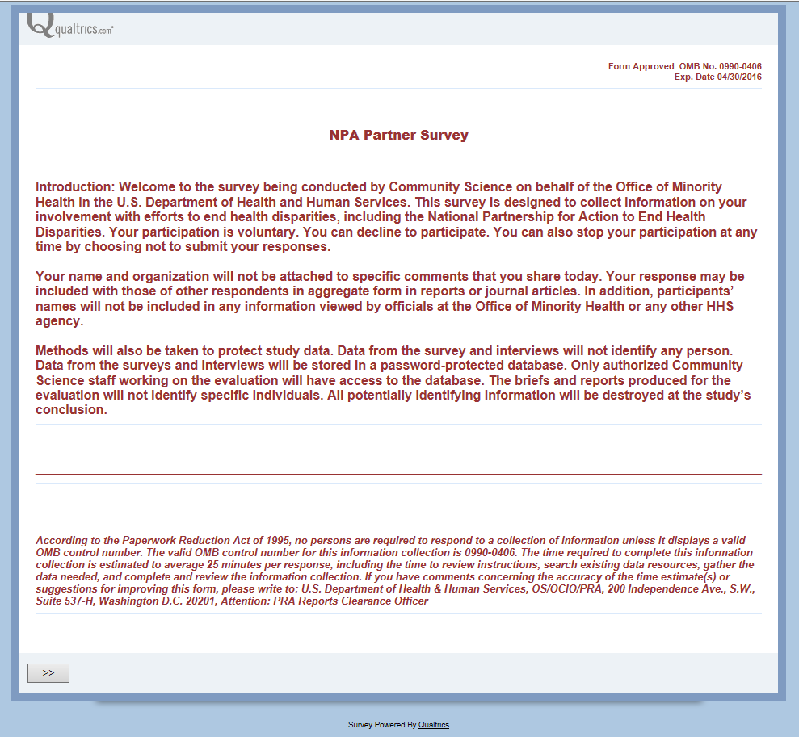

Screen 2: Location
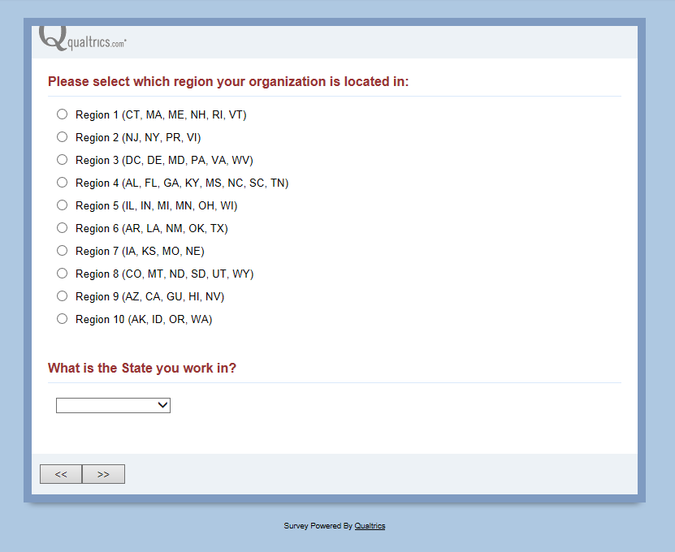

Screen 3: Goals and Partnerships
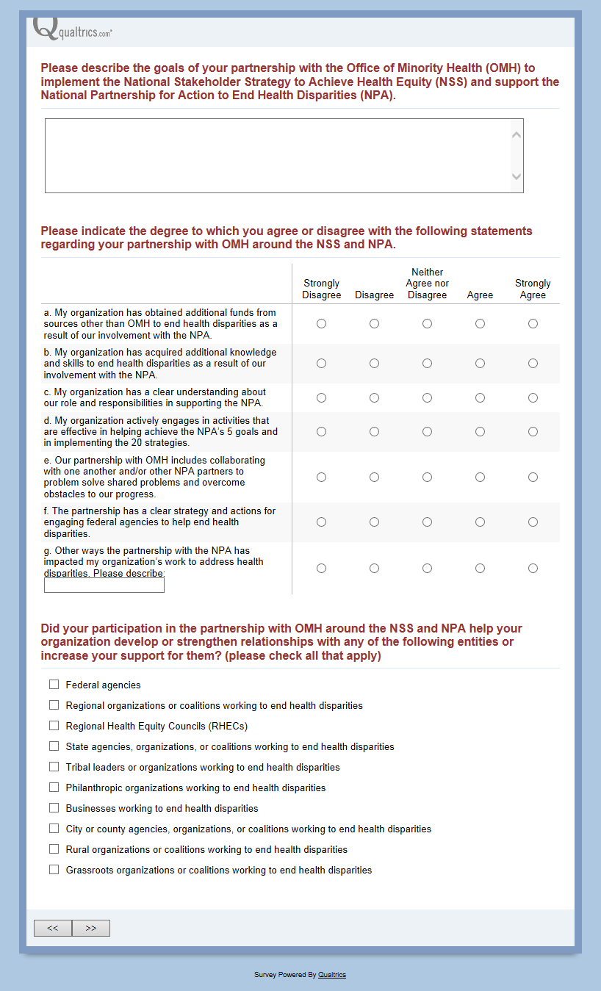
Screen 3a: Description of relationships with other entities (only those entities a respondent selects in Screen 3 will appear)
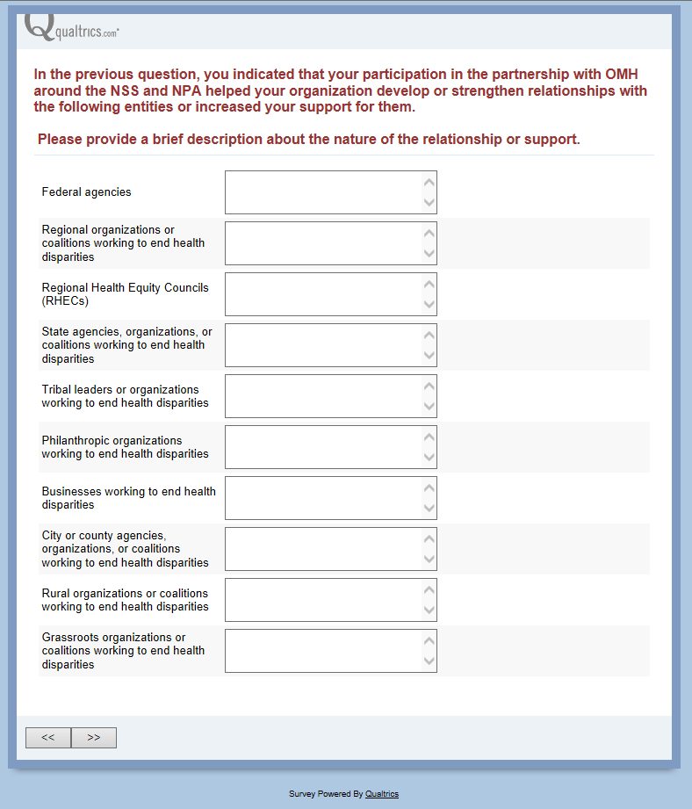

Screen 4: Knowledge Mobilization
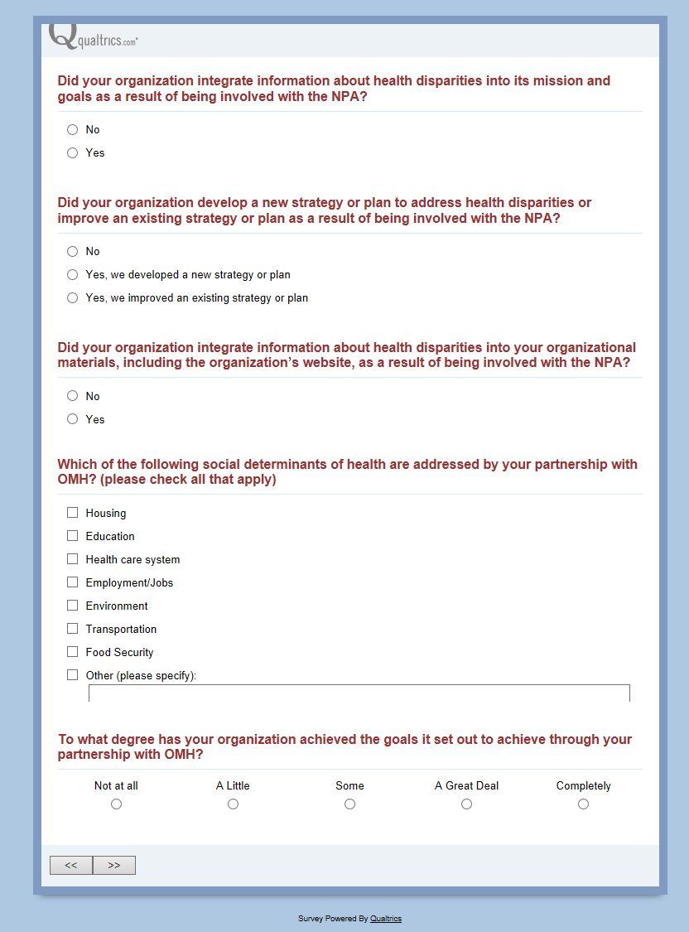
Screen 5: Support Provided
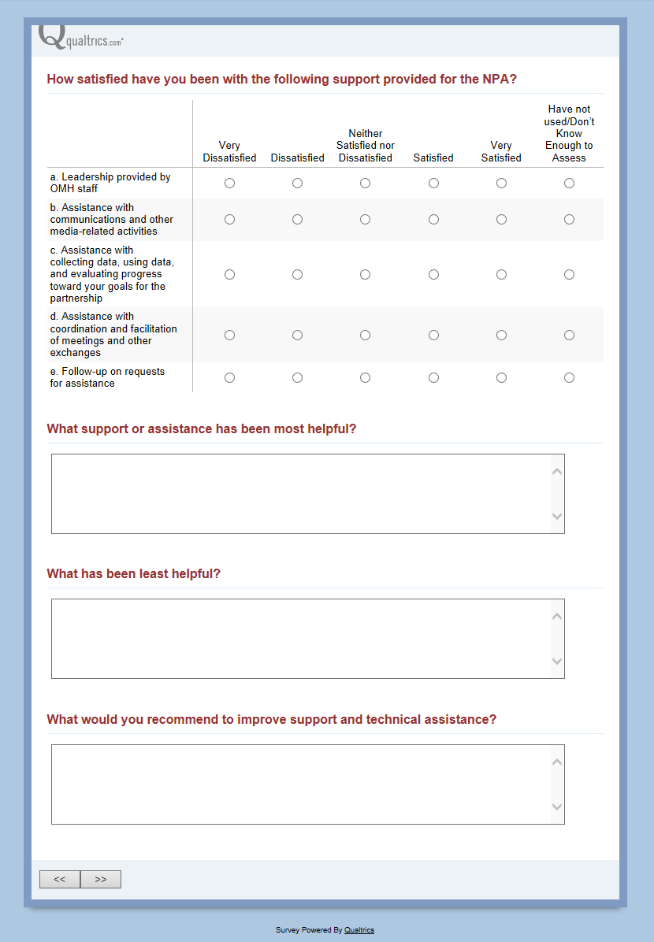
These questions DO NOT appear if the option “Have not used/don’t know enough to assess” was selected for statements b, c, d, and e above.
Screen 6: Conclusion
