FORMULAS ONLINE REFERENCE GUIDE
(Posted to the TTB Website at http://www.ttb.gov/foia/fonl.html

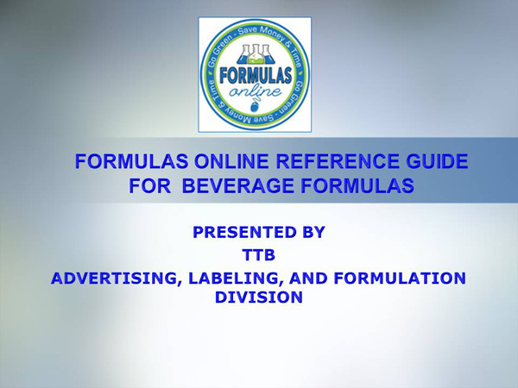
WELCOME!
ALFD FORMULATION TEAM
What is Formulas Online?
TOPICS
First Steps: TTBONline.gov Portal
Registration
Basics of Formula Submission
Common Errors
Formulas Online: System Features
Q&A*
Questions?

NOTE: Only the first slide is shown in this document. Go to the TTB Website at http://www.ttb.gov/foia/fonl.html to see the entire FONL Reference Guide.

