**Middle Grades Longitudinal Study of 2017–18 (MGLS:2017)**

**Recruitment Communication Materials for**

**2017 Operational Field Test (OFT)**

OMB# 1850-0911 v.10

**Appendices A through S**

September 2015

Revised March 2016

**Table of Contents**

Appendix A. Endorsement Request Letter 2

Appendix B. State Letter and Sample Endorsement Letter 3

Appendix C. District Notification and Recruitment Letter 5

Appendix D. School Recruitment Letters 6

Appendix E. Teacher Recruitment Letter 7

Appendix F. Parent Permission Letters 8

Appendix G. Parent Data Collection Letter 12

Appendix H. MGLS:2017 Brochure Text and Flyer, “How is MGLS:2017 Different from State and Local Assessment” 13

Appendix I. MGLS:2017 FAQs Text 15

Appendix J. MGLS:2017 Recruitment Website Text 17

Appendix K. MGLS:2017 Summary of Mathematics Assessment 25

Appendix L. MGLS:2017 Summary of Reading Assessment 26

Appendix M. MGLS:2017 Summary of Executive Function Assessments 27

Appendix N. MGLS:2017 Summary of Student Survey 28

Appendix O. MGLS:2017 Summary of the Parent Survey 29

Appendix P. MGLS:2017 Summary of the Math Teacher Survey 30

Appendix Q. MGLS:2017 Summary of the Special Education Teacher Survey 31

Appendix R. MGLS:2017 Summary of the School Administrator Survey 32

Appendix S. MGLS:2017 Student Rostering Materials for Operational Field Test 33

Appendix A. Endorsement Request Letter

Consortium/Network/Diocese Endorsement Request Letter

[NCES Letterhead]

[Date]

[Director’s name]

[Consortium/Network/Diocese name]

[Address]

[City, State Zip]

Dear [Name]:

I am writing to inform you about a vitally important new national study: the **Middle Grades Longitudinal Study of 2017-18 (MGLS:2017)**. The study is the first of its kind and will provide invaluable information on students’ mathematics and reading skills, executive function, socioemotional well-being, and on family and school factors that may encourage success during these important, yet generally understudied years of education.

The study will involve multiple phases, including two field tests and a main study, all of which are essential to learning about students in these grades. In order to encourage schools and parents to participate, we are asking esteemed organizations from around the nation to learn about and then endorse the study. We would like to speak with you or, if you prefer, someone else in your organization about the importance of the MGLS:2017 and the opportunity to endorse the study.

In the next few days, an individual from RTI International, which is administering MGLS:2017 on behalf of the National Center for Education Statistics (NCES), part of the U.S. Department of Education, will be following up with you about endorsing this historic study. Alternatively, you can sign up to endorse the study by visiting our website at <recruitment website URL>. Should you have any questions in the meantime, please call the MGLS:2017 information line at 855-500-1432, or send an email to MGLS@rti.org.

Enclosed you will find an MGLS:2017 brochure that further explains the study and a set of Frequently Asked Questions (FAQs).

Thank you in advance for your support of the MGLS:2017, and for working together to improve the quality of education for our country’s middle grade students.

Sincerely,

Peggy G. Carr, Ph.D.

Acting Commissioner, NCES

*NCES is authorized to conduct MGLS:2017 by the Education Sciences Reform Act of 2002 (ESRA 2002, 20 U.S.C., § 9543). The data are being collected for NCES by RTI International, a nonprofit research organization based in North Carolina. The collected data may be used only for statistical purposes and may not be disclosed or used, in identifiable form, for any other purpose except as required by law (ESRA 2002, 20 U.S.C., § 9573). The collected information will be combined across respondents to produce statistical reports.*

Enclosures:

MGLS:2017 Brochure

FAQs

Appendix B. State Letter and Sample Endorsement Letter

State Letter – [NCES/ED Letterhead]

[Title First Name Last Name] [Date]

[State Department of Education Official’s Title]

[State Department of Education]

[Address]

[City, State Zip]

Dear [Name]:

I am writing to inform your state education agency about a vitally important new national study: the **Middle Grades Longitudinal Study of 2017-18 (MGLS:2017)**. The study will involve multiple phases: a first field test in 2016, a second field test in 2017, and a main study in 2018. The main study will follow a cohort of sixth-grade students in spring of 2018 as they progress through the middle grade years, making the transition from elementary school and preparing for the transition into high school. One major goal of the study is to examine the factors that encourage success during these important yet generally understudied years of education. MGLS:2017 is described in more detail in the enclosed materials.

To encourage schools and parents to participate, we are asking state departments of education to learn about and then provide a letter of endorsement for the study. We would like to speak with you or, if you prefer, someone else in your organization about the importance of the MGLS:2017 and the opportunity to endorse the study.

The MGLS:2017 data collection will be administered by RTI International on behalf of the National Center for Education Statistics (NCES), part of the U.S. Department of Education. Schools in your state have been selected for one or more of the phases described below.

**~ 2016 item validation field test**- data collection will include a one-time student assessment and survey in grades 5, 6, 7 and 8. A school administrator, the math teachers and special education providers for each sampled student, and one parent of each sampled student, will be asked to complete brief questionnaires.

**~2017 operational field test**- data collection will include a student assessment and survey for sixth-grade students. A school administrator, the math teachers and special education providers for each sampled student, and one parent of each sampled student will be asked to complete brief questionnaires. Follow-up data collections will occur in the spring of 2018 and spring of 2019, when students are in the seventh and eighth grades, respectively, regardless of whether they have changed schools.

**~2018 main study**- data collection will include a student assessment and survey for sixth-grade students. A school administrator, the math teachers and special education providers for each sampled student, and one parent of each sampled student will be asked to complete brief questionnaires. Follow-up data collections will occur in the spring of 2019 and spring of 2020, when students are in the seventh and eighth grades, respectively, regardless of whether they have changed schools.

While participation in MGLS:2017 is voluntary, we ask for your support of the participation of sampled schools in your state. The MGLS:2017 field test samples are small, as only about 50 to 60 schools will be asked to participate in each. Each school’s participation is important, because these phases of the study need an inclusive and diverse group of American schools serving students in the middle grades. The results of this field test will significantly inform the main study, which will begin in early 2018 with sixth-graders from approximately 800 schools across the country.

In the next few days, an individual from RTI International, which is administering MGLS:2017 on behalf of the National Center for Education Statistics (NCES), part of the U.S. Department of Education, will be following up with you about endorsing this historic study. In the coming weeks, we will begin contacting the school districts and schools that have been selected to participate in the field test. Should you have any questions, please call the MGLS:2017 information number, 855-500-1432, or send an email to MGLS@rti.org. You may also contact Carolyn Fidelman at NCES at 202-245-7046 for more information.

We look forward to working with your schools to make MGLS:2017 a success. Thank you for your support.

Sincerely,

Peggy G. Carr Ph.D

Acting Commissioner, NCES>

Cc: <STATE> Testing Coordinator

Middle Grades Coordinator

*NCES is authorized to conduct MGLS:2017 by the Education Sciences Reform Act of 2002 (ESRA 2002, 20 U.S.C., § 9543). The data are being collected for NCES by RTI International, a nonprofit research organization based in North Carolina. The collected data may be used only for statistical purposes and may not be disclosed or used, in identifiable form, for any other purpose except as required by law (ESRA 2002, 20 U.S.C., § 9573). The collected information will be combined across respondents to produce statistical reports.*

Enclosures: MGLS:2017 Brochure and Frequently Asked Questions (FAQ) Sheet

**Sample Endorsement Letter**

[Date]

[Superintendent or Principal’s Name]

[Title]

[School]

[Address]

[City, State Zip]

Dear School District and School Administrators:

The [INSERT STATE EDUCATION AGENCY NAME] is pleased to support the **Middle Grades Longitudinal Study of 2017-18 (MGLS: 2017)**, conducted by the National Center for Education Statistics (NCES) within the U.S. Department of Education. The study will involve multiple phases: an item validation field test in 2016, an operational field test in 2017, and a main study in 2018. The main study will follow a cohort of sixth-grade students in spring of 2018 as they progress through the middle grade years, making the transition from elementary school and preparing for the transition into high school. The goal of the study is to examine the factors that encourage success during these important yet often understudied years of education. MGLS:2017 is described in more detail in the materials provided by RTI, which is collecting the data for NCES.

We strongly encourage your participation in any phase of MGLS: 2017 for which your district or school is selected. While participation in the study is voluntary, each school’s participation is important, because each phase of the study needs an inclusive and diverse group of American schools serving students in the middle grades. We are confident that schools in our state will understand the importance of this national study and will accept the invitation to participate.

Should you have any questions, please call the MGLS:2017 information number, 855-500-1432, or send an email to MGLS@rti.org. You may also contact Carolyn Fidelman at NCES at 202-245-7046 for more information.

Thank you for making MGLS:2017 a success.

Sincerely,

<Name>

Chief State School Officer

Appendix C. District Notification and Recruitment Letter

District Notification and Recruitment Letter – Operational Field Test

[MGLS Letterhead]

[Date]

[Superintendent’s Name]

Superintendent

[District]

[Address]

[City, State Zip]

Dear [Name]:

I am writing to inform you about a vitally important new national study: the **Middle Grades Longitudinal Study of 2017-18 (MGLS:2017)**. The study will involve multiple phases: an item validation field test, an operational field test, and a main study. The main study will follow a cohort of sixth-grade students in spring of 2018 as they progress through the middle grade years, making the transition from elementary school and preparing for the transition into high school. The goal of the study is to examine the factors that encourage success during these important yet generally understudied years of education.

The MGLS:2017 data collection will be administered by RTI International on behalf of the National Center for Education Statistics (NCES), part of the U.S. Department of Education. Some schools in your district have been sampled for the MGLS:2017 operational field test scheduled to begin in early 2017. Data collection in the majority of the sampled schools will include math, reading, and executive function assessments and surveys of a small sample of students in grade 6. A school administrator, the math teachers and special education providers for each sampled student, and one parent of each sampled student will be asked to complete brief questionnaires. Follow-up data collections will occur in the spring of 2018 and spring of 2019, when students are in the seventh and eighth grades, respectively, regardless of whether they have changed schools.

The student assessment will take about 70 minutes to complete and the student survey will require another 20 minutes. School administrators and parents will be asked to complete a 30-minute survey. The math teachers of students selected for the study will complete web-based questionnaires about their background and classroom characteristics (approximately 20 minutes), as well as answer questions about the skills and abilities of specific students in the study (about 10 minutes per student). The special education teacher for students with an Individualized Education Program (IEP) will be asked to complete web-based questionnaires about their background and the special education services they provide (about 10 minutes), as well as answer questions about the skills and abilities of specific students in the study (approximately 25 minutes per student). All data will be collected through a computer-based application or a telephone interview, and will significantly inform the main study, which will begin in early 2018 with sixth-graders from approximately 800 schools around the country.

We are asking you to encourage your school(s) to participate in this vital phase which will take place in early 2017. As a thank you for the school’s help with this phase of the study, each participating school in your district will receive **<$200, $400, or $400 in goods and/or services**>. We will also provide **$150** for a school coordinator to serve as the central point of contact and help with data collection at your school. Teachers completing surveys will receive **$20** for answering the surveys and an additional **$7 per student** form. One parent or guardian of each participating student may receive payment for completing a survey. The exact amount each parent receives will be randomly assigned ($0, $20, $40).

School and student participation is voluntary, but we hope your district and all selected schools will choose to contribute to the study. Enclosed you will find an MGLS:2017 brochure that further explains the study and a sheet of Frequently Asked Questions (FAQs). Should you have any questions, please call the MGLS:2017 information line at 855-500-1432, or send an email to MGLS@rti.org.

We look forward to working with your schools in this endeavor to advance the quality of education for our country’s middle grade students. Thank you for your support.

Sincerely,

Peggy G. Carr Ph.D.

Acting Commissioner, NCES

*NCES is authorized to conduct MGLS:2017 by the Education Sciences Reform Act of 2002 (ESRA 2002, 20 U.S.C., § 9543). The data are being collected for NCES by RTI International, a nonprofit research organization based in North Carolina. The collected data may be used only for statistical purposes and may not be disclosed or used, in identifiable form, for any other purpose except as required by law (ESRA 2002, 20 U.S.C., § 9573). The collected information will be combined across respondents to produce statistical reports.*

Enclosures:

MGLS:2017 brochure

List of selected schools in District

Frequently Asked Questions (FAQs) sheet

Appendix D. School Recruitment Letters

School Recruitment Letter – Operational Field Test

MGLS Letterhead

[Date]

[Principal’s Name]

[Title]

[School]

[Address]

[City, State Zip]

Dear [Name]:

I am writing to request your school’s participation in a vitally important new national study: the **Middle Grades Longitudinal Study of 2017-18 (MGLS:2017)**. The study will involve multiple phases: an item validation field test, an operational field test, and a main study. The study will focus on students’ mathematics, reading, and executive function skills and follow a cohort of sixth-graders as they progress through the middle grade years, making the transition from elementary school and preparing for the transition into high school. The goal of the study is to examine the factors that encourage success during these important yet generally understudied years of education.

The MGLS:2017 data collection will be administered by RTI International on behalf of the National Center for Education Statistics (NCES), part of the U.S. Department of Education.

Your school is one of only a limited number of schools around the country selected to participate in the MGLS:2017 operational field test to be conducted in early 2017. Student participation in MGLS:2017 will take about 90 minutes and will include a math, reading, and executive function assessment of students in grade 6, as well as a student survey on socioemotional well-being, peers, and schooling experiences. A school administrator, the math teachers and special education providers for each sampled student, and one parent of each sampled student will be asked to complete brief questionnaires. Each will require about 30 minutes. Math teachers and special education providers of participating students will also be asked to provide information on participating students. This will take approximately 25 minutes per student to complete. Follow-up data collections will occur in the spring of 2018 and spring of 2019, when students are in the seventh and eighth grades, respectively, regardless of whether they have changed schools. All data will be collected through a computer-based application or a telephone interview, and will significantly inform the main study, which will begin in early 2018 with about 20,000 sixth-graders from approximately 800 schools.

[IF PUBLIC AND GIVEN SUPPORT OF DISTRICT: The study has been given the support of Superintendent [INSERT NAME OF DISTRICT'S SUPERINTENDENT] and we encourage you to include MGLS:2017 on your 2017 calendar.] [IF PRIVATE AND ENDORSED: The study has been endorsed by [INSERT RELEVANT ENDORSING ORGANIZATION] and we encourage you to include MGLS:2017 on your 2016 calendar.] Your school will receive <**$200/$400/$400 in goods and/or services**> as a thank you for your help with this phase of the study. We will also provide **$150** for a school coordinator to serve as the central point of contact and help with data collection at your school. Teachers completing surveys will receive **$20** for answering the surveys and an additional **$7 per student** form. One parent or guardian of each participating student may receive payment for completing a survey. The exact amount each parent receives will be randomly assigned ($0, $20, $40).

Within the next few days, a representative from RTI International will contact you to answer any questions you may have and address any outstanding issues that may be required for your district and school(s) to participate in this unprecedented study. Enclosed please find an MGLS:2017 brochure that further explains the study and a sheet of Frequently Asked Questions (FAQs). Should you have any questions, please call the MGLS:2017 information number at 855-500-1432, or send an email to MGLS@rti.org. You can also learn more about the study and education research focused on students in the middle grades by visiting the MGLS:2017 website at <http://nces.ed.gov/surveys/mgls>.

We look forward to working with your school in this endeavor to advance the quality of education for our country’s middle grade students. Thank you for your support.

Sincerely,

Peggy G. Carr Ph.D

Acting Commissioner, NCES

*NCES is authorized to conduct MGLS:2017 by the Education Sciences Reform Act of 2002 (ESRA 2002, 20 U.S.C., § 9543). The data are being collected for NCES by RTI International, a nonprofit research organization based in North Carolina. The collected data may be used only for statistical purposes and may not be disclosed or used, in identifiable form, for any other purpose except as required by law (ESRA 2002, 20 U.S.C., § 9573). The collected information will be combined across respondents to produce statistical reports.*

Enclosures:

MGLS:2017 Brochure

Frequently Asked Questions (FAQs) sheet

Appendix E. Teacher Recruitment Letter

Teacher Recruitment Letter – Operational Field Test

MGLS Letterhead

[DATE]

[TEACHER NAME]

[SCHOOL NAME] Website:

[ADDR1] Study ID: [ID]

[ADDR2] Password: [password]

[CITY STATE ZIP]

Dear [TEACHER NAME],

[SCHOOL NAME] has graciously agreed to participate in the operational field test of the Middle Grades Longitudinal Study of 2017-18 (MGLS:2017), which is being administered by RTI International on behalf of the by the National Center for Education Statistics (NCES), part of the U.S. Department of Education. The study will focus on students’ mathematics, reading, and executive function skills and follow a cohort of sixth-graders as they progress through the middle grade years, making the transition from elementary school and preparing for the transition into high school. This MGLS:2017 field test includes a teacher survey of approximately 150 [MATH or SPECIAL EDUCATION] teachers in grade 6 around the county. You are one of the teachers selected to participate in the study.

As a [MATH or SPECIAL EDUCATION] teacher at [SCHOOL NAME], you can provide essential information about academic policies and programs, activities and curriculum in the classroom, and other school related experiences that impact student learning. [FOR MATH TEACHERS ONLY: The survey will include several general questions about your background and experiences at school and in the classroom, as well as questions about specific students that are part of the study. The questions on your background and classroom experiences will take approximately 20 minutes to complete, and the questions about specific students will take about 10 minutes per student to complete.] [FOR SPECIAL EDUCATION TEACHERS ONLY: The survey will include several general questions about your background and the special education services you provide at the school, as well as questions about specific students that are part of the study. The questions on your background and special education services provided will take about 10 minutes to complete, and the questions about specific students will take approximately 25 minutes per student to complete.]

To access the questionnaire online, please use the web address and unique study ID and password provided on this letter. As a token of our appreciation, you will receive **$20** for answering the questions about your background, and **$7** **per student** for answering questions about specific students.

Enclosed please find an MGLS:2017 brochure that further explains the study, a sheet of Frequently Asked Questions (FAQs), and a list of national organizations endorsing the study. Should you have any questions, please call the MGLS:2017 information number, 855-500-1432, or send an email to MGLS@rti.org. You can also learn more about the study and education research focused on students in the middle grades by visiting the MGLS:2017 website at <http://nces.ed.gov/surveys/mgls>.

We thank you in advance for your cooperation in making this important research study a success.

Sincerely,

Peggy G. Carr Ph.D.

Acting Commissioner, NCES

*NCES is authorized to conduct MGLS:2017 by the Education Sciences Reform Act of 2002 (ESRA 2002, 20 U.S.C., § 9543). The data are being collected for NCES by RTI International, a nonprofit research organization based in North Carolina. The collected data may be used only for statistical purposes and may not be disclosed or used, in identifiable form, for any other purpose except as required by law (ESRA 2002, 20 U.S.C., § 9573). The collected information will be combined across respondents to produce statistical reports.*

Enclosures:

MGLS:2017 brochure

Frequently Asked Questions (FAQ) sheet

Appendix F. Parent Permission Letters

**MGLS:2017 Child Permission Form- Implicit Permission- Operational Field Test**

Dear Parent or Guardian,

This letter is to inform you about a vitally important study of student learning being conducted in <our/your child’s> school this spring. The Middle Grades Longitudinal Study of 2017-18 (MGLS:2017) will follow a cohort of students as they progress through the middle grade years, making the transition from elementary school and preparing for the transition into high school. The goals of the study are to assess students’ mathematics and reading skills, their other (noncognitive) skills important to learning, their socioemotional well-being, and to collect data on family and school factors that may encourage success during these important years of education.

Your child’s school has accepted an invitation from the National Center for Education Statistics (NCES), part of the U.S. Department of Education, to participate in the operational field test of MGLS:2017. A sample of students from your child’s school will take part. Your child is one of only approximately 1,200 students selected from across the United States to participate. The enclosed summary sheet provides background information about MGLS:2017, explains what is involved for each student selected to participate in the study, and gives a contact phone number and email address where you can find answers to any questions you might have.

To have an accurate picture of what U.S. students in grade 6 can do in reading, math, and other (noncognitive) skills important to learning, it is important that each student selected take part in the study. In addition to answering reading and math questions, students will be asked to complete a brief questionnaire about themselves. I urge you to support this effort by encouraging your child to take part. One parent of each selected student will also be asked to complete a questionnaire for the study, and information about that will come separately.

Completing the survey is voluntary for you and your child and there are no penalties for not participating. Your child may also skip any question he or she does not want to answer. All of the information collected is protected, as required by law*.* NCES is authorized to conduct MGLS:2017 by the Education Sciences Reform Act of 2002 (ESRA 2002, 20 U.S.C., § 9543). The data are being collected for NCES by RTI International, a nonprofit research organization based in North Carolina. The collected data may be used only for statistical purposes and may not be disclosed or used, in identifiable form, for any other purpose except as required by law (ESRA 2002, 20 U.S.C., § 9573). The collected information will be combined across respondents to produce statistical reports.

If you do not want your child to participate in the MGLS activities, please let us know by completing the attached form and returning it to the school.

For more information, please visit the study website at <https://surveys.nces.ed.gov/mgls/>. You may also call the study hotline at (855) 500-1432 or send email to mgls@rti.org. Thank you for taking the time to learn about this important study.

Sincerely,

[Signature]

Enclosures:

Parent/Guardian Consent Form

Frequently Asked Questions Sheet

Brochure for MGLS:2017

**Parent/Guardian Implicit Permission Form – MGLS:2017**

Your child has been asked to participate in a study of student learning called the Middle Grades Longitudinal Study of 2017-18 (MGLS:2017). Student data will be collected in a 90-minute session during the school day. The student assessment will be administered by a team of researchers from RTI International, on behalf of the National Center for Education Statistics (NCES).

**If you give permission for your child to participate in MGLS:2017, you do not need to return this form. Please keep this copy for your records.**

**If you do not give permission for your child to participate in MGLS:2017, please check the box below, and sign and return this form to your child’s school as soon as possible.**

No, I do not give permission for my child to participate in MGLS:2017.

____________________________________________ Date of signature: _______/_______/____________

(Signature of parent or guardian)

**Please Print:**

Student Name: _________________________

Parent Name: __________________________

Parent telephone: _________________________________________

Parent email: ______________________________________________

FOR OFFICE USE ONLY:

Student ID: ________________________________________________

**MGLS:2017 Child Permission Form- Explicit Permission- Operational Field Test**

Dear Parent or Guardian,

This letter is to inform you about a vitally important study of student learning being conducted in <our/your child’s> school this spring. The Middle Grades Longitudinal Study of 2017-2018 (MGLS:2017) will follow a cohort of students as they progress through the middle grade years, making the transition from elementary school and preparing for the transition into high school. The goals of the study are to assess students’ mathematics and reading skills, their other (noncognitive) skills important to learning, their socioemotional well-being, and to collect data on family and school factors that may encourage success during these important years of education.

Your child’s school has accepted an invitation from the National Center for Education Statistics (NCES), part of the U.S. Department of Education, to participate in the operational field test of MGLS:2017. A sample of students from your child’s school will take part. Your child is one of only approximately 1,200 students selected from across the United States to participate. The enclosed summary sheet provides background information about MGLS:2017, explains what is involved for each student selected to participate in the study, and gives a contact phone number and email address where you can find answers to any questions you might have.

To have an accurate picture of what U.S. students in grade 6 can do in reading, math, and other (noncognitive) skills important to learning, it is important that each student selected take part in the study. In addition to answering reading and math questions, students will be asked to complete a brief questionnaire about themselves. I urge you to support this effort by encouraging your child to take part. One parent of each selected student will also be asked to complete a questionnaire for the study, and information about that will come separately.

Completing the survey is voluntary for you and your child and there are no penalties for not participating. Your child may also skip any question he or she does not want to answer. All of the information collected is protected, as required by law. NCES is authorized to conduct MGLS:2017 by the Education Sciences Reform Act of 2002 (ESRA 2002, 20 U.S.C., § 9543). The data are being collected for NCES by RTI International, a nonprofit research organization based in North Carolina. The collected data may be used only for statistical purposes and may not be disclosed or used, in identifiable form, for any other purpose except as required by law (ESRA 2002, 20 U.S.C., § 9573). The collected information will be combined across respondents to produce statistical reports.

**To allow your child to participate in the MGLS:2017 activities, we must have your written permission. Please complete the attached form and return it to the school.**

For more information, please visit the study website at <https://surveys.nces.ed.gov/mgls/>. You may also call the study hotline at (855) 500-1432 or send email to mgls@rti.org. Thank you for taking the time to learn about this important study.

Sincerely,

[Signature]

Enclosures:

Parent/Guardian Consent Form

Frequently Asked Questions Sheet

Brochure for MGLS:2017

**Parent/Guardian Explicit Permission Form – MGLS:2017**

Your child has been asked to participate in a study of student learning called the Middle Grades Longitudinal Study of 2017-18 (MGLS:2017). Student data will be collected in a 90-minute session during the school day. The student assessment will be administered by a team of researchers from RTI International, on behalf of the National Center for Education Statistics (NCES).

**PLEASE CHECK ONE:**

Yes, I give permission for my child to participate in MGLS:2017.

No, I do not give permission for my child to participate in MGLS:2017.

I have read this permission form and understand what my child and I are being asked to do.

**PLEASE SIGN YOUR NAME BELOW:**

___________________________________________ Date of signature: _______/_______/____________

(Signature of parent or guardian)

**PLEASE PRINT**:

Student name: _____________________________________________

School name: ______________________________________________

Parent name: ______________________________________________

Parent telephone: _________________________________________

Parent email: ______________________________________________

FOR OFFICE USE ONLY:

Student ID: ________________________________________________

Appendix G. Parent Data Collection Letter

Dear Parent or Guardian,

An important study of student learning is being conducted in your child’s school this spring. The Middle Grades Longitudinal Study of 2017-2018 (MGLS:2017) will follow a cohort of students as they progress through the middle grade years, making the transition from elementary school and preparing for the transition into high school. The goals of the study are to assess students’ mathematics and reading skills, their other (noncognitive) skills important to learning, their socioemotional well-being, and to collect data on family and school factors from the students, their family, and their school that may encourage success during these important years of education.

Data will be collected from students in grade 6 and from school administrators, teachers, and parents. Your child is one of only approximately 1,200 students sampled from across the United States to participate. You may have already received a letter inviting your child to participate in MGLS:2017, or that letter will be coming to you in the coming weeks.

You are the best person to tell us about your family. We would greatly appreciate it if the person most knowledgeable about <student_firstname>’s school and home life would complete a 30-minute online survey for the study. <IF INCENTIVE: As a token of our appreciation for being a part of the study, when you finish the survey either online or over the phone, you will receive a check for **[$20/$40**].>

**To access the parent survey, please log into:**

**surveys.nces.ed.gov/mgls**

**ID: xxxxxxxx**

**password: xxxxxxxx.**

The study is conducted by the National Center for Education Statistics (NCES), part of the U.S. Department of Education. The enclosed materials provide more information about MGLS:2017. All of the information collected is protected, as required by law. NCES is authorized to conduct MGLS:2017 by the Education Sciences Reform Act of 2002 (ESRA 2002, 20 U.S.C., § 9543). The data are being collected for NCES by RTI International, a nonprofit research organization based in North Carolina. Data collected may be used only for statistical purposes and may not be disclosed or used, in identifiable form, for any other purpose except as required by law (ESRA 2002, 20 U.S.C., § 9573). The collected information will be combined across respondents to produce statistical reports. Completing the survey is voluntary for you and your child and there are no penalties for not participating. You may also skip any question you do not want to answer if you choose to participate.

For more information, please visit the study website at <https://surveys.nces.ed.gov/mgls/>. You may also call the study hotline at (855) 500-1432 or send email to mgls@rti.org. Thank you for supporting education by participating in this important study.

Sincerely,

<Name>

<Title>

Enclosures:

Study brochure

Flyer

Appendix H. MGLS:2017 Brochure Text and Flyer, “How is MGLS:2017 Different from State and Local Assessment”

MGLS:2017 Brochure Text – Operational Field Test

**COVER**

Middle Grades Longitudinal Study of 2017-18 (MGLS:2017) – Operational Field Test

Education quote: “Education is not preparation for life; education is life itself." ~John Dewey

Study conducted by: National Center for Education Statistics of U.S. Department of Education

Data collection by: RTI International

**INTERIOR**

The Study

The Middle Grades Longitudinal Study of 2017-18 (MGLS:2017) will be the first study to follow a nationally-representative sample of students as they enter and move through the middle grades (grades 6, 7, and 8).

The Operational Field Test

Participants in the MGLS:2017 operational field test will provide invaluable feedback to improve the study. Information from this field test will be used to improve the data collection instruments and practices of the main study.

Your Participation

As part of the MGLS:2017operational field test, you are one of about 50 schools, about 1,200 students, or about 150 teachers selected to participate across the United States. This field test will be conducted in early 2017. Your participation is essential to the success of the study.

What Will Be Included?

* Mathematics and reading skills
* Executive function development
* Socioemotional wellbeing
* Peer experiences
* Classroom characteristics and students’ learning
* Services to students with disabilities
* Family characteristics and students’ success

**BACK**

For More Information

If you have questions about MGLS:2017 or would like more information, please contact the study. Its success depends on you!

Phone number: 855-500-1432

E-mail address: mgls@rti.org

Website: <http://nces.ed.gov/surveys/mgls>

MGLS:2017 Flyer Text – Operational Field Test

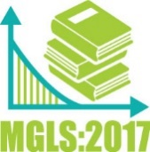**Quick Facts about the**

**Middle Grades Longitudinal Study of 2017-18**

**(MGLS:2017)**

* MGLS:2017 will help researchers and policymakers learn about growth in math and reading as well as family and school factors that encourage success during the important, yet generally understudied, middle grade years.
* The study is longitudinal and follows a cohort of students from grade six through eight to fully understand the student middle grade experience.
* The MGLS:2017 student sessions will involve approximately 25 randomly selected sixth-grade students at a given school and will take 90 minutes to complete.
* Students will provide data to the study through math, reading and executive function assessments along with some survey questions.
* Participation in the study is not required, but participation of each selected student is very important to the study.
* This is not a high stakes test! Students’ responses will not be reported to schools and do not affect student grades.

Appendix I. MGLS:2017 FAQs Text

MGLS:2017 FAQs – Operational Field Test

MGLS Letterhead

**Middle Grades Longitudinal Study of 2017-18 (MGLS:2017) – Operational Field Test – Frequently Asked Questions (FAQs)**

**What is MGLS:2017?**

The Middle Grades Longitudinal Study of 2017-18 (MGLS:2017) is a new, unprecedented study of middle grade students being conducted by the National Center for Education Statistics (NCES) within the U.S. Department of Education. RTI International is carrying out the MGLS:2017 data collection on behalf of NCES.

**What is the focus of MGLS:2017?**

The study will follow a cohort of sixth-grade students as they progress through the middle grade years, making the transition from elementary school and preparing for the transition into high school. The goals of the study are to assess students’ mathematics and reading skills, executive function, and socioemotional well-being, and to collect data on family and school factors that may encourage success during these important, yet generally understudied, years of education.

**When is the study being conducted?**

The operational field test will take place in early 2017. The main study will begin in early 2018.

**Why participate in the operational field test of MGLS:2017?**

The operational field test, or OFT, will inform protocols and materials for the MGLS:2017 main study, for which data collection will begin in January of 2018. Specifically, this field test will be used to obtain information on recruiting schools and students, particularly students in certain disability groups, the practices and procedures leading to successful study administration (e.g., protocols, timing, test accommodations), and the costs of tracking students across years as a result of respondents’ mobility. Surveys developed for school administrators, math teachers, special education teachers, parents, and students will also be tested. Participants in the OFT will provide essential feedback to improve data collection for the main study.

How will MGLS:2017 data be used?

MGLS:2017 data will allow researchers, educators, and policy makers to examine student development and achievement through this important stage of students’ educational career. More generally, MGLS:2017 data will allow researchers to examine family and schooling factors related to students’ achievement. The study will capture changes in young people’s lives and their connections with communities, schools, teachers, families, parents, and peers, including:

* Academic (especially in math and reading), social, and interpersonal growth;
* Transitions from elementary school and preparations for transitions into high school;
* School connectedness, belongingness, and engagement;
* Characteristics of schools serving students in the middle grades and their relationship to student outcomes; and
* School progress of and outcomes for students’ with disabilities.

How many schools and students will be involved in the field test?

A sample of approximately 1,200 students enrolled in grade 6, from about 50 schools, will participate in the OFT of the MGLS:2017. The main study will involve a nationally representative sample of about 20,000 students enrolled in grade 6 from about 800 public and private schools.

What is involved for students?

Students will complete a direct-assessment of their math, reading, and other skills important to learning that will take approximately 70 minutes. Each student will also be asked to complete a survey about his or her school, social, and home experiences that will take about 20 minutes. Follow-up data collections will occur in the spring of 2018 and spring of 2019, when students are in the seventh and eighth grades, respectively, regardless of whether they have changed schools.

**What is involved for school staff?**

A school administrator will be asked to complete an approximately 30 minute web-based questionnaire about the school and the school environment. The math teachers of students who participate in the study will complete web-based questionnaires about their background and classroom characteristics (approximately 20 minutes), as well as answer questions about the skills and abilities of specific students in the study (about 10 minutes per student). The special education teacher for students with an Individualized Education Program (IEP) will be asked to complete web-based questionnaires about their background and the special education services they provide (about 10 minutes), as well as answer questions about the skills and abilities of specific students in the study (approximately 25 minutes per student).

What is involved for parents?

One parent of each student who participates in the study will complete a questionnaire via a web survey or a telephone interview. The questionnaire will take about 30 minutes to complete.

Who will be responsible for data collection?

Trained MGLS:2017 staff will facilitate the completion of the student assessments and questionnaires and provide all required materials. Schools will only be asked to designate a school contact to assist MGLS:2017 staff with in-school assessment arrangements.

Do teachers need to help administer the assessments?

No, trained MGLS:2017 staff will visit the school, bringing all required materials for administering the assessments. Exceptions will be made for students with IEP accommodations that may require the assistance of school personnel (e.g., if a student works one-on-one with an aide).

Are there incentives for participating schools?

MGLS:2017 recognizes the demands placed on schools from many sources throughout the school year, and will give a modest incentive to schools that agree to help in the OFT. MGLS:2017 will also provide $150 for a school coordinator to serve as the central point of contact and manage the data collection at each school .

What happens if a student refuses to participate?

All participation is voluntary. There are no penalties for not participating in the study. When completing the questionnaires, respondents can skip any question they do not want to answer. If individuals or schools are hesitant to be a part of the study, please reach out to MGLS:2017 staff so we can address any concerns you may have.

Will the names of participants and their responses be kept confidential?

Under law, the information provided by schools, staff, students, and parents may be used only for statistical purposes and may not be disclosed or used in identifiable form for any other purpose except as required by law [Education Sciences Reform Act of 2002 (ESRA 2002), 20 U.S. Code, Section 9573]. All field staff and other staff working on the study have signed an affidavit of non-disclosure where they swear to abide by this law. Field staff have also undergone a criminal background check as a condition of employment.

Who do I contact for further information about MGLS:2017?

For additional information, call the MGLS:2017 information number, 855-500-1432, or send an email to mgls@rti.org. You may also learn more about the study and education research focused on students in the middle grades by visiting the MGLS:2017 website at <http://nces.ed.gov/surveys/mgls>.

Appendix J. MGLS:2017 Recruitment Website Text

The recruitment website is used to provide information to school staff and parents about the study. The website also serves as a portal to securely upload student list information and complete the parent and school staff questionnaires. A screenshot of the study homepage and several other pages in the website are provided here as examples. Additional content proposed for the OFT recruitment and data collection website is reflected in the text provided in this appendix.

**The study home page**

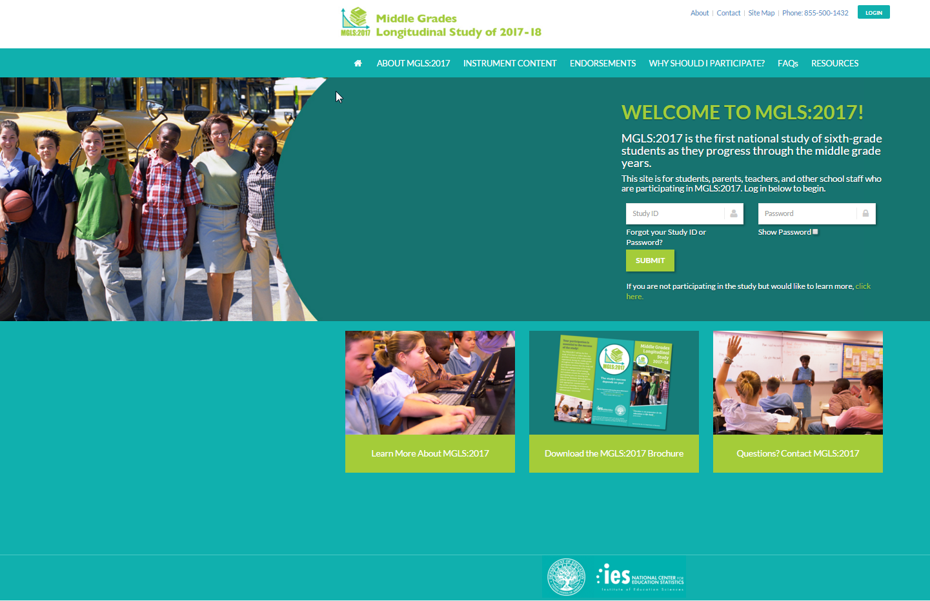

<MGLS:2017 study phone number will appear in header on every page>

<Login box will appear in header on every page><MGLS:2017 StudyID><Password>

Welcome to MGLS:2017! MGLS:2017 is the first national study of sixth-grade students as they progress through the middle grade years.

This site is designed to assist school staff, test administrators, parents, and students who are participating in MGLS:2017. Login to begin.

If you are not participating in the study but would like to learn more, click here

Login <study id><password>

< link to Home page>

<link to About MGLS:2017>

<link to Content>

<link to Endorsements>

<Link to Why Should I Participate?>

<link to FAQs>

<link to Resources>

<link to Learn More About MGLS:2017 in footer>

<link to MGLS:2017 Brochure>

Questions? Contact MGLS <Study phone number> <study email address>

**About MGLS:2017**

The Middle Grades Longitudinal Study of 2017-18 (MGLS:2017) is a new, unprecedented national study of middle grade students being conducted by the National Center for Education Statistics (NCES) within the U.S. Department of Education. RTI International is carrying out the MGLS:2017 data collection on behalf of NCES.

MGLS:2017 will gather information about the development and learning that occur during students’ middle-grade years, or grades 6 through 8. In particular, it will identify school, individual, social, and contextual factors that predict future student success.

**Sample and Data Collection Schedule:**

The Item Validation Field Test is taking place in early 2016 with a sample of approximately 5,000 students enrolled in grades 5 through 8.

The Operational Field Test will take place in early 2017 and a sample of about 1,200 students in sixth grade from about 50 schools will participate. Follow-up data collections will occur in the spring of 2018 and spring of 2019, when students are in the seventh and eighth grades, respectively, regardless of whether they have changed schools.

The main study will take place in the spring of 2018 and a sample of about 20,000 students in sixth grade from about 800 schools will participate. Planned follow-ups with students, parents, and school staff will occur in the spring of 2019 and 2020.

**What is involved for participants of MGLS:2017?**

What is involved for students? Students will complete a math and reading assessment and complete one or more computerized games to assess executive function skills, or skills that help to organize and act on information. Students will also complete a student survey. The student session will take approximately 90 minutes and will be completed in schools on tablet computers.

What is involved for school administrators? School administrators will be asked to complete the approximately 30-minute school administrator web-based survey about the school and the school environment.

What is involved for math teachers? Math teachers of students who participate in the study will complete the math teacher survey about their background and classroom characteristics (approximately 20 minutes), as well as answer questions about the skills and abilities of specific students in the study (about 10 minutes per student).

What is involved for special education teachers? Special education teacher for students selected to participate in the study with an Individualized Education Program (IEP) will be asked to complete the special education teacher survey about their background and special education services provided (about 10 minutes), as well as answer questions about the skills and abilities of specific students in the study (approximately 25 minutes per student).

What is involved for parents? Parents of each student who participates in the study will complete the parent survey or a telephone interview. The questionnaire will take about 30 minutes to complete

**What is the purpose of the field test:**

Results from the Item Validation Field Test of the study will significantly inform the creation and development of the assessments and survey instruments used in the main study. For example, the field test will be used to learn more about how students respond to the sixth-, seventh-, and eighth-grade mathematics and reading assessment items planned for the main study. Surveys developed for school administrators, math teachers, special education teachers, parents, and students will also be tested during the field test to inform the selection of items to include in the main study. Results from the Operational Field Test of the study will test the instrument developed based on the results of the Item Validation Field Test and will also test the study recruitment and data collection procedures. Participants in the field tests of the study will provide essential feedback to improve data collection for the main study, and provide the basis upon which the remainder of the Middle Grades Longitudinal Study will be built.

**How Will the Data be Used?**

MGLS:2017 data will allow researchers, educators, and policy makers to examine student development and achievement through this important stage of students’ educational career. More generally, MGLS:2017 data will allow researchers to examine family and schooling factors related to students’ achievement. The study will capture changes in young people’s lives and their connections with communities, schools, teachers, families, parents, and peers, including:

* Academic (especially in math and reading), social, and interpersonal growth;
* Transitions from elementary school and preparations for transitions into high school;
* School connectedness, belongingness, and engagement;
* Characteristics of schools serving students in the middle grades and their relationship to student outcomes; and
* School progress and outcomes of students’ with disabilities.

**Organizations Conducting and Collecting MGLS:2017 Data:**

MGLS:2017 is conducted by the National Center for Education Statistics (NCES), the primary federal statistical agency for collecting and analyzing data related to education in the United States. NCES is located within the Institute of Education Sciences of the U.S. Department of Education. NCES is authorized to conduct MGLS:2017 under the Education Sciences Reform Act of 2002 (ESRA 2002, 20 U.S.C. § 9543).

The data are collected by RTI International, a nonprofit research organization based in North Carolina under contract to the U.S. Department of Education’s National Center for Education Statistics.

**Confidentiality:**

MGLS:2017 data are being collected for NCES by RTI International, a nonprofit research organization based in North Carolina. The collected data may be used only for statistical purposes and may not be disclosed or used, in identifiable form, for any other purpose except as required by law (ESRA 2002, 20 U.S.C., § 9573). The collected information will be combined across respondents to produce statistical reports*.* Students, parents, and schools are never identified in any reports.

All RTI project staff have signed confidentiality agreements and affidavits of nondisclosure and are prohibited by law from using the obtained information for any purposes other than this research study.

You may review the [Confidentiality Agreements and Affidavit of Nondisclosure statements (pdf, 81KB)](https://surveys.nces.ed.gov/pirls/img/nondisc-confid-agmnt.pdf) that are signed by project staff.

You may also review the [procedures that govern NCES](http://nces.ed.gov/statprog/confproc.asp) and RTI International to maintain confidentiality.

**Instrument Content:**

A key goal of the study is to provide researchers and policymakers with the information they need to better understand the school and non-school influences associated with mathematics and reading success, socioemotional health, and positive life development during the middle-grade years and beyond.

Select an instrument to learn more about its content

< A graphic box will be displayed listing each instrument. Clicking on the box brings up the content page, which is found in appendices K – R.>

**Endorsements**

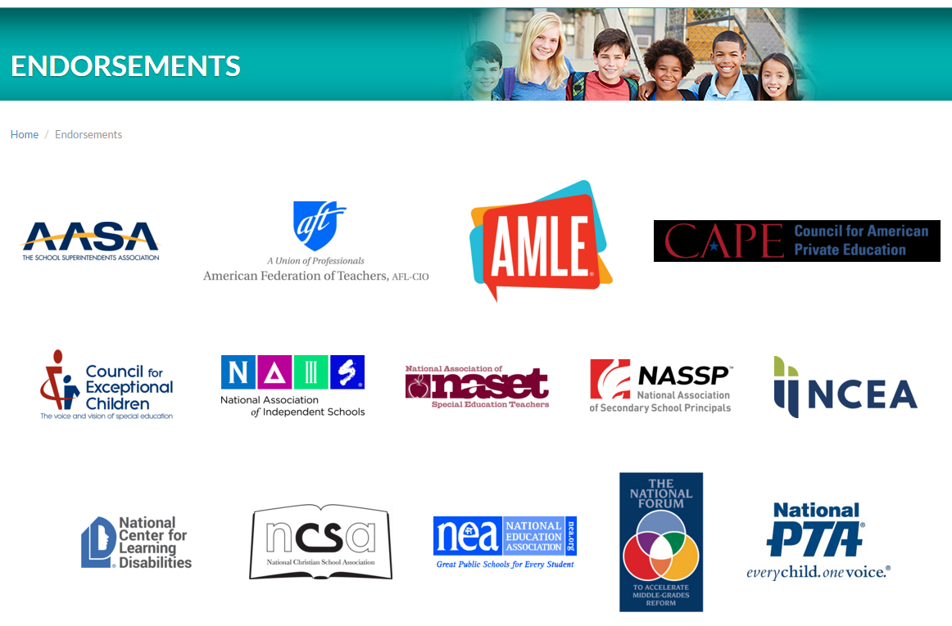

**Why Should I Participate?**

You are uniquely positioned to provide the much-needed information integral to the success of this comprehensive study of students as they enter and move through the middle grades. The study’s success hinges on being able to provide crucial national information on these students’ learning and contexts for development. Your participation will help ensure the study captures the diverse and unique experiences of students as they progress across the middle grade years.

**Schools** provide essential information on contexts for learning.

**Teachers** (mathematics teachers and special education teachers) have the opportunity to provide crucial information about instructional practices, planning, classroom characteristics, classroom climate, as well as individualized information about their students in the study in terms of social skills, classroom behaviors, and learning supports.

**Parents** contribute vital information on the home learning environment, students’ school experiences, their own involvement in their child’s learning, and characteristics about the household.

**Students** will have the opportunity to let us know about their school experiences, activities, and their educational aspirations. To contribute to the understanding of learning and development across the middle grade years, the study also collects invaluable information about students’ reading, math, and executive function, which includes skills that help them organize and act on information.

**Frequently Asked Questions**

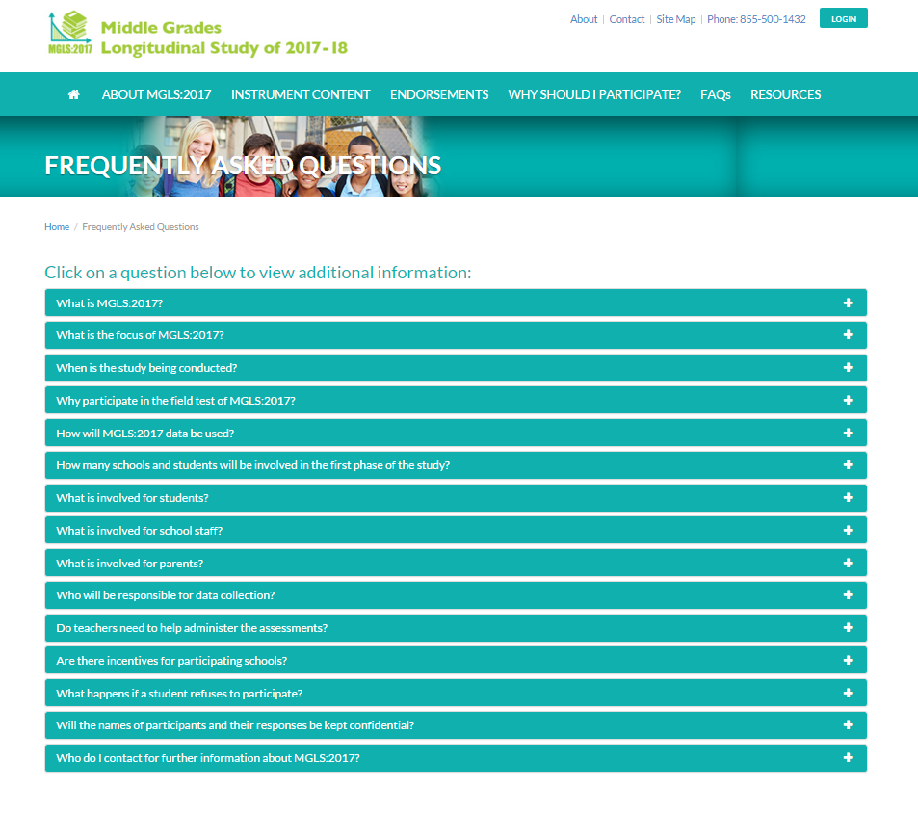

**<Frequently Asked Questions:** The FAQ text is provided in Appendix I>

**Resources**

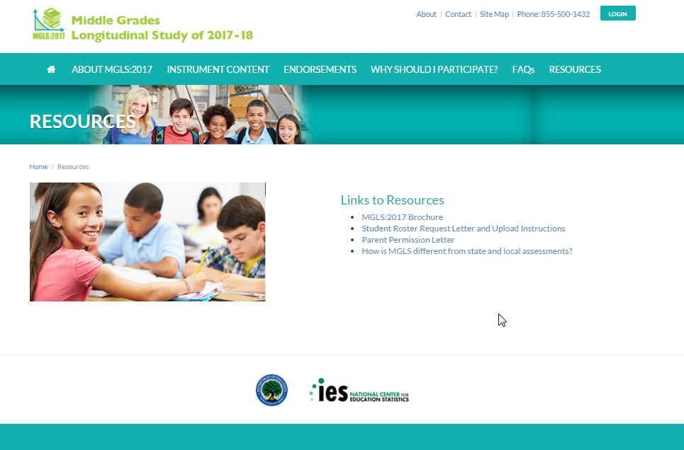

<The resources page provides links to files in Appendices H, S, F, and H, respectively>

**Contact**

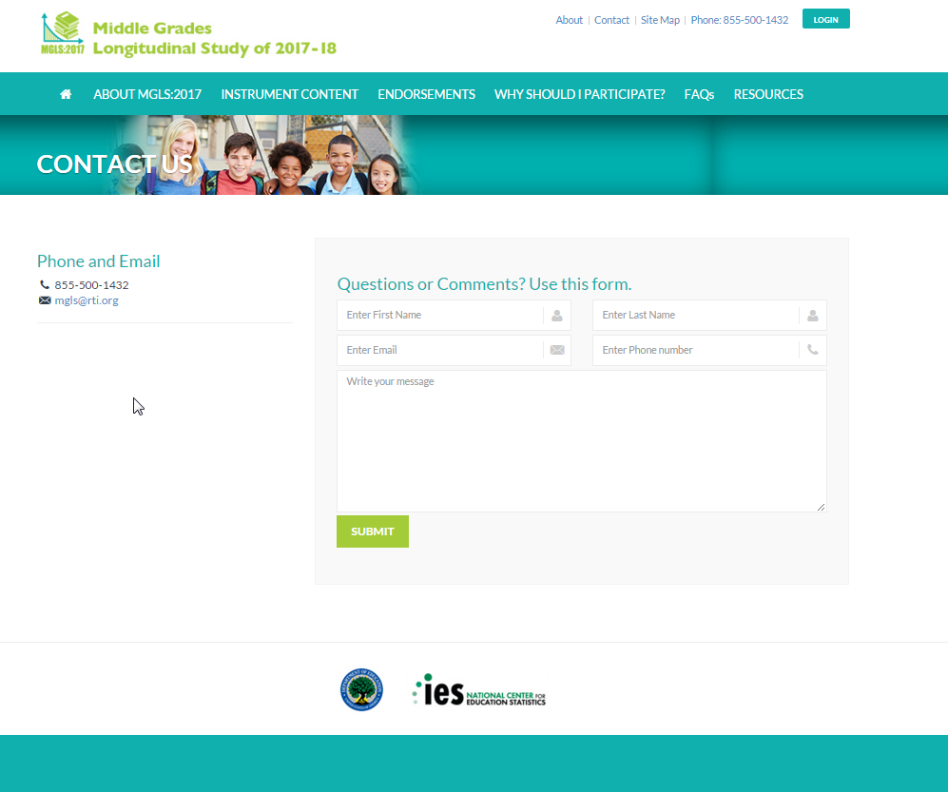

**OFT text**

Questions or Comments? Use this form.

**MGLS:2017- after login**

**Student Roster Upload**

Welcome!

Your participation in the Middle Grades Longitudinal Study of 2017-18 is very important.

MGLS:2017 data will allow researchers, educators, and policymakers to examine family and educational factors related to students’ achievement. Please complete the tasks in the list below with a green arrow next to them.

Request for Initial Roster – Step 1

Thank you for providing your school’s student roster. If you need assistance, please contact the Help Desk at 1-855-500-1432 or [mgls@rti.org](mailto:mgls@rti.org). Please complete the following steps:

1. Provide your contact information <name>, <e-mail address>, <telephone number> ,<school name>
2. Download the Student Roster Template
   1. Save the Student Roster Template on your computer
3. Prepare the Student Roster Template
   1. List all students in Grade 6
   2. For each student, please enter the following information:

Student information

* + 1. Student ID number
    2. Student’s name (First, Middle, Last, Suffix)
    3. Grade
    4. Date of birth (MM/DD/YY)
    5. Sex (M/F)
    6. Race/ethnicity
    7. IEP Status
    8. Disability code (if applicable)

Parent contact information (associated with each student)

1. Parent’s name (first and last name)

ii. Parent’s mailing address (street, city, state, zip)

iii. Parent’s email address

iv. Parent’s home phone number

v. Parent’s cell phone number

Math/Special Education Teacher Information (associated with each student)

1. Student’s math teacher (first and last name)

ii. Student’s math teacher’s email address

iii. Student’s math course name

iv. Student’s math course period/section

v. Student’s special education teacher (first and last name, if applicable)

vi. Student’s special education teacher’s email address (if applicable)

1. Upload the completed Student Roster Template
   1. Please use the corresponding “Upload” button to upload the completed Student Roster Template
2. Finalize Student Roster Template
   1. Once steps 1 through 4 above have been completed, please click the button below to finalize your school’s Student Roster Template.

Student Sample and Request for Additional Information – Step 2

Stage 1 – Review your school’s list of sampled students

Please review the sampled student list and, if any information is missing and/or in need of correction, proceed to “Stage 2” below.

Stage 2 – Update student information

If any information associated with your sampled students was noticed to be incomplete (such as missing parent contact information or teacher information) and/or in error in “stage 1”, please follow the steps below.

1. Download list of Sampled Students (Excel spreadsheet file)
   1. Save the template on your computer
2. Prepare Sampled Student File (downloaded in Step 1)
   1. Fort each sampled student, add any missing information (parent contacts, teacher information, etc.)
3. Upload the completed Sampled Student File
   1. Please use the corresponding “Upload” button to upload the completed template.
4. Finalize Sampled Student Template
   1. Once steps 1 through 3 above have been completed, please click the “Finalize” button below to finalize your school’s Sampled Student Template.

**Provide parent and teacher information [for sampled students; if unable to provide for entire enrollment list]**

Below are instructions for providing the parent contact information and student math and special education teacher information after the student sample has been selected if you are unable to provide this information for the entire student enrollment list. [Please note, this action can only be completed after the student enrollment list has been uploaded and you have been notified that the student sample has been selected at your school]

1. Click on the link “Parent and Teacher Contact Information” to download an Excel spreadsheet.
2. Save the Excel spreadsheet to your computer.
3. Student information will be pre-filled for all students selected to participate in MGLS:2017.
4. Prepare your document containing the requested information:
   1. Parent contact information
5. Parent’s name (first and last name)

ii. Parent’s mailing address (street, city, state, zip)

iii. Parent’s email address

iv. Parent’s home phone number

v. Parent’s cell phone number

b. Math/Special Education Teacher Information (associated with each student)

1. Student’s math teacher (first and last name)

ii. Student’s math teacher’s email address

iii. Student’s math course name

iv. Student’s math course period/section

v. Student’s special education teacher (first and last name, if applicable)

vi. Student’s special education teacher’s email address (if applicable)

1. When you have added all of the requested parent and teacher information to the Excel spreadsheet, go to the file menu in Excel and click save.
2. Go back to the MGLS:2017 website and click the corresponding BROWSE button.
3. Find the location where you saved the Excel spreadsheet containing the student information and click open. This will automatically start the upload process.
4. When a completed file has been uploaded, click the FINALIZE button at the bottom of the webpage.
5. Call 855-500-1432 if you need assistance.

Appendix K. MGLS:2017 Summary of Mathematics Assessment

MGLS Letterhead

|  |  |
| --- | --- |
|  | **Direct Mathematics Assessment** |
|  |  |
| Approximate length  Goal for main study | 30 minutes (part of 90 minute student assessment and survey) |
|  |  |
| Mode of administration | Computerized administration using touch screen, tablets, or computers that will be brought in to the school by the study |
|  |  |
| Key constructs (bullets represent learning progression) | **Number System**   * finding common factors and multiples * comparing fractions * applying basic operations with fractions and integers to word problems * using basic operations * representing and understanding rational numbers in multiple forms * understanding the relative size of irrational numbers   **Proportional Relationships**   * extending students’ understanding of the number system * multiplying and dividing fractions and multiplicative thinking * understanding basic concepts of ratio, rate and proportional relationships * using rational numbers to solve problems and understand slope and functions   **Expressions and Equations**   * understanding the use of expressions beginning with letter representations of a single number * applying knowledge of rational numbers and operations to solve equations * constructing equations and inequalities to solve real-world problems * recognizing different types of notation (such as square root) * reasoning with equalities and inequalities * solving and representing linear equations and inequalities   **Functions**   * understanding the definition of a function * comparing functions represented in different ways * distinguishing between linear and nonlinear functions * comparing and creating representations of different functions * understanding of functions to context |

Appendix L. MGLS:2017 Summary of Reading Assessment

MGLS Letterhead

|  |  |
| --- | --- |
|  | **Direct Reading Assessment** |
|  |  |
| Approximate length  Goal for main study | 30 minutes (part of 90 minute student assessment and survey) |
|  |  |
| Mode of administration | Two-stage, computerized assessment using touch screen, tablets, or computers that will be brought in to the school by the study |
|  |  |
| Key constructs | **Word Recognition & Decoding**  Students read words (e.g., elect), pronounceable nonwords (e.g., clort) and pseudohomophones (e.g., brane) and decide whether the stimulus is a word, not a real word, or sounds exactly like a real word.  **Vocabulary**  A single target word is presented and the student decides which of provided three words goes with the target word. Correct answers are either synonyms (e.g., data - information) or meaning associates (e.g., thermal - heat).  **Morphological Awareness**  The student completes a sentence by choosing from three words derived from the same root word (e.g., She is good at many sports, but her _______ is basketball: specialty, specialize, specialist). The target words vary in difficulty based on the frequency of the derived forms (i.e., lower frequency derivations are more difficult).  **Sentence Processing**  The student completes sentences of increasing length and syntactic complexity by choosing from three choices (e.g., Shouting in a voice louder than her friend Cindy's, Tonya asked Joe to unlock the door, but ______ didn’t respond: he, she, they). In this task, frequent words used in everyday language are used in the sentences to decrease the influence of vocabulary knowledge in this task. Consequently, the focus is on understanding of sentence syntax and meaning (rather than word meaning).  **Efficiency of Basic Reading Comprehension (MAZE task)**  Students read short passages containing sentences that are completed using a forced-choice cloze task (e.g., Agriculture meant that people stayed in one place to grow their baskets / crops / rings.). These passages are between 250-300 words in length and have Flesch-Kinkaid Grade Level estimates of grades 6 and 7. Students in this block will read approximately 3 paragraphs in this way. This task is timed such that students are given 3 minutes to complete a passage and its corresponding items, making it a measure of efficiency as well as basic comprehension.  **Reading Comprehension**  Students answer questions about the passage they read while doing the MAZE task. The passage presented in the MAZE task will be presented again with the correct completions for the items presented in the MAZE task. The passage will appear on the same screen as the questions. Easier questions will be selected for this skill-based block. |

Appendix M. MGLS:2017 Summary of Executive Function Assessments

MGLS Letterhead

|  |  |
| --- | --- |
|  | **Direct Executive Function Assessment** |
|  |  |
| Approximate length  Goal for main study | 10 minutes (part of 90 minute student assessment and survey) |
|  |  |
| Mode of administration | Computerized administration using touch screen, tablets, or computers that will be brought in to the school by the study |
|  |  |
| Key constructs | **Inhibitory control (Stop Signal task)**  Involves the ability to stop ongoing thoughts or actions, particularly prepotent responses. Development of inhibitory control occurs rapidly in early childhood and advances more slowly during adolescence. The Stop Signal task is a measure of inhibitory control that has been positively correlated with achievement among students in the middle grades. It distinguishes children with ADHD from both typically developing children and children with other clinical problems. The task revealed age effects for ages 10 through 14.  **Working memory (N-back tasks)**  Working memory is considered a strong measure of reasoning ability, and involves keeping information active in primary memory while acting on it in relation to other information, such as keeping a list of words in memory and then ordering the words alphabetically or by categories. The n-back tasks are measures of working memory often used in research, particularly in neuroscience studies that look at the regions of the brain activated by different types of working memory (that is memory for verbal, symbolic, and spatial information).  **Cognitive flexibility (Hearts and Flowers task)**  Shifting involves flexibility in thinking and moving between rules, tasks, or mental states. With shifting, each mental set may involve several task rules. Several regions of the brain (cortex and the prefrontal cortex) show increased activation when participants respond to measures of shifting. The Hearts and Flowers task (Dots task) includes a congruent condition, an incongruent condition, and a mixed condition. The task calls on working memory and inhibitory control as students remember the rule and decide whether to inhibit a prepotent response. The mixed condition measures shifting (or cognitive flexibility) as the task shifts between the congruent and incongruent condition. |

Appendix N. MGLS:2017 Summary of Student Survey

MGLS Letterhead

|  |  |
| --- | --- |
|  | **Student Survey** |
|  |  |
| Approximate length  Goal for main study | 20 minutes (part of 90 minute student assessment and survey) |
|  |  |
| Mode of administration | Computerized administration using touch screen, tablets, or computers that will be brought in to the school by the study |
|  |  |
| Key constructs | Demographics  School experiences   * Conversations with teachers about math courses, jobs or careers, and going to college * Student perspective of teacher support * Perceptions of school climate (e.g., safety and rule fairness) * Academic culture (e.g., high standards and expectations) * Problems at school (e.g., student misconduct and bullying)   Activities   * Time use-structured activities: student employment; participating in activities (sports, clubs, etc.) * Time use-unstructured or unsupervised activities (e.g., watching television, doing homework, or being with friends) * Technology activities   Health   * Physical well-being   Peers   * Perception of peer social support * Peer victimization * Perception of peer values (importance of education, engagement in risky behaviors, peer pressure) * Belongingness (a sense of belonging in school) * Risk-taking (students’ sensation seeking behaviors)   “Tell us about Yourself”   * Academic engagement (e.g., persistence) * Identity formation (interests of students (“sparks”); ethnic identity; perceived social status) * Socioemotional well-being   Home Life   * Conversations with parents about math courses, jobs or careers, and going to college * Parental support to help child achieve * Parent-child relationships (autonomy-granting, disclosure) * Community perspectives   Future   * Aspirations and expectations (educational, career/life goals) |

Appendix O. MGLS:2017 Summary of the Parent Survey

MGLS Letterhead

|  |  |
| --- | --- |
|  | **Parent Survey** |
|  |  |
| Approximate length  Goal for main study | 30 minutes |
|  |  |
| Mode of administration | Web-based administration accessible by individualized link, with a telephone-based interview option available. |
|  |  |
| Key constructs | Introduction   * Student demographics   Family Roster   * Family demographics * Household composition   Family and Parent Background   * Language (student uses most, family primary language) * Parent education   Home Life   * Parent-child relationship—monitoring/disclosure * Risk-taking and risky behaviors (i.e. students’ sensation seeking behaviors and parents’ report of students’ deviant behaviors) * Community perspectives (poverty, crime, victimization)   Child’s School Experiences   * Parent contact/communication with school * Disciplinary actions taken by school * Grade progression (retention, early promotion) * ESL participation * Student free- and reduced-price lunch eligibility   Child Health and Well-Being   * Health and physical well-being * IEP and Disability Details * IEP/Disability - Receipt of Special Education Services * IEP/Disability - Participation in IEP * IEP/Disability - School Services and Programs * IEP/Disability - Outside Services * IEP/Disability - Satisfaction with Services   Employment and Income   * Parent occupation * Family income * Family assets   Mobility   * Mobility (number of school changes)   Parent Involvement   * Conversation about math courses * Conversation about going to college * Conversation about jobs or careers * Academic expectations |

Appendix P. MGLS:2017 Summary of the Math Teacher Survey

MGLS Letterhead

|  |  |
| --- | --- |
|  | **Mathematics Teacher Survey** |
|  |  |
| Approximate length  Goal for main study | 30 minutes |
|  |  |
| Mode of administration | Web-based administration accessible by individualized link. |
|  |  |
| Key constructs | Teacher background and classroom characteristics  Student and Classroom Characteristics   * Class size (number of students) * Course type * Heterogeneity in math ability * Classroom climate (e.g., misbehavior)   Classroom Mathematics Instruction   * Curriculum/textbook used * Opportunities to learn (length of course) * Content covered in course (Common Core & practice standards) * Instructional practice/pedagogy * Availability and use of classroom resources   Views on Teaching and School Environment   * Instruction in self-contained classrooms or departmentalized * Factors for determining math course (take a test, prerequisite) * Teacher efficacy * Instructional leadership * Academic culture (high standards and expectations) * Teaching climate   Teacher Background   * Education and degree (courses in math and math education) * Years of experience * Certification * Demographic information   Teacher provided information on individual students  Mathematical Thinking   * Math class performance   Social Skills   * Approaches to learning * Externalizing behaviors * Social skills and positive behavior   Classroom Behaviors   * Academic engagement (behavioral and cognitive) * Attendance   Student and Classroom Information   * Math support services (tutoring, pull-out, instruction frequency) |

Appendix Q. MGLS:2017 Summary of the Special Education Teacher Survey

MGLS Letterhead

|  |  |
| --- | --- |
|  | **Special Education Teacher/Provider Survey** |
|  |  |
| Approximate length  Goal for main study | 35 minutes |
|  |  |
| Mode of administration | Web-based administration accessible by individualized link. |
|  |  |
| Key constructs | Teacher background  Teacher Assignment or Position   * Teaching Assignment or Position * Instruction and instructional environment   Teacher Background and Education   * Demographic information * Experiences and Training   Teacher Experience   * Years of experience   Teacher provided information on specific students  Student Grade and IEP Status   * Student Grade and IEP status   Student’s Disability and Services   * Primary disability * Special education and related services   Student’s Instruction and Instructional Environment   * Instruction and instructional environment   Communication About Student   * Communication with general education teacher   Student Goals, Performance, and Expectations   * IEP goals and evaluation * Teacher’s expectations for student * Academic & life skills |

Appendix R. MGLS:2017 Summary of the School Administrator Survey

MGLS Letterhead

|  |  |
| --- | --- |
|  | **School Administrator Survey** |
|  |  |
| Approximate length  Goal for main study | 20 minutes |
|  |  |
| Mode of administration | Web-based administration accessible by individualized link. |
|  |  |
| Key constructs | School Characteristics   * School characteristics (e.g., average daily attendance, tuition) * Student population (e.g., percent IEP, percent ELL/LEP) * Providing additional support for struggling students (tutoring, extra assistance, pull-out, homework assistance)   Services and Supports for Students with Disabilities   * IEP/Disability-School services and programs   School Programs and Practices   * Courses offered: for particular courses ask about the number of slots available * Subject-specific academic tracking practices (order/progression of courses) * School extended learning opportunities: additional instruction time, Gifted and Talented, International Baccalaureate * Assisting students with transitions from elementary to middle grades; from middle grades to high school * Health services (e.g., sex education classes)   School Environment   * Problems at school: absenteeism, student mobility, student misconduct, bullying * School-level security (police officer on site, security officer on site, metal detectors, teachers supervise hallways during transition) * Community perspectives (poverty, crime, victimization)   School’s Teachers   * School’s teachers: number, preparation   School Administrator Background   * Demographic information * Years of experience |

Appendix S. MGLS:2017 Student Rostering Materials for Operational Field Test

**Request for Student Roster Information from Schools**

**Operational Field Test**

[MGLS Letterhead]

[Date]

[Title] [Name First] [Name Last]

[Title/Department]

[State District]

[Address]

[City], [State] [Zip code]

Dear [School Contact Name]:

Thank you again for participating in the operational field test of the Middle Grades Longitudinal Study of 2017-18 (MGLS:2017). Your participation is critical to the success of the study.

Not all students in your school are needed for participation. We will be selecting a sample. In order to select the sample, we are requesting a complete roster of the students currently enrolled in sixth grade at your school. The roster should include key characteristics about each student for sampling purposes. The MGLS:2017 roster data request conforms fully to the requirements of the Family Educational Rights and Privacy Act of 1974 (FERPA) (20 U.S.C. § 1232g; 34 CFR Part 99). For the purposes of this collection of data, FERPA permits educational agencies and institutions to disclose personally identifiable information from students’ education records, without consent, to authorized representatives of the Secretary of Education in connection with an evaluation of federally supported education programs (34 CFR §§ 99.31(a)(3)(iii) and 99.35). Student data are subject to strict protections that are adhered to by NCES and its contractor organizations. Roster information will be securely destroyed when no longer needed for the purposes specified in 34 CFR § 99.35.

The key characteristics of interest include:

* Name
* Student identification number
* Date of birth
* Grade level
* Sex
* Race/ethnicity
* IEP status (Disability codes, if applicable)
* Students’ parent and/or guardians contact information
* Students’ math teacher(s)
* Students’ special education teacher (if applicable)
* Parent contact information
  + Name (last, first)
  + Parent Street address, City, State, Zip
  + Home phone number
  + Cell phone number
  + E-mail address
* Student’s Math Teacher Name (last, first)
* Student’s Math Teacher Email Address
* Student’s Math Course Name
* Student’s Math Course Period/Section
* Student’s Special Education Teacher(s) (list all if applicable)
* Student’s Special Education Teacher(s) email address

We have developed a form to provide guidance for preparing the student roster. You may access and submit the form via the study website. To access the form, please go to <https://surveys.nces.ed.gov/mgls> and enter user ID: xxxxxxxx and password: xxxxxxxx. To protect the students’ data, you will be asked to change your password after the initial login.

The sample of students will be selected in the next few weeks, but in order to select the sample we first need the student roster with key characteristics from you. In the next few days, a study representative from RTI International, which is administering MGLS:2017 on behalf of NCES, will contact you to discuss the best way of obtaining student roster information. Although we have provided a roster form for you, we are happy to collect this information in a different format if that is more convenient to you. This could be electronically or through a paper and pencil form. If at any time you should have questions about the study, please do not hesitate to contact me at 855-500-1432 or mgls@rti.org.

Thank you for your time and participation in this unprecedented study.

Sincerely,

Dan Pratt, Project Director

*NCES is authorized to conduct MGLS:2017 by the Education Sciences Reform Act of 2002 (ESRA 2002, 20 U.S.C., § 9543). The data are being collected for NCES by RTI International, a nonprofit research organization based in North Carolina. The collected data may be used only for statistical purposes and may not be disclosed or used, in identifiable form, for any other purpose except as required by law (ESRA 2002, 20 U.S.C., § 9573). The collected information will be combined across respondents to produce statistical reports.*