FAST Track 3090-0297-Instrument

(Req-4)

GSS AO Supplier Relationship Management Survey –Email

Date: [Date of distribution]

To:  [supplier email address]

From: feedback@gsa.gov

Subject:  Please take the 2016 General Services Administration’s Supplier Survey!

OMB No: 3090-0297  
Expires 07/31/2019

Paperwork Reduction Act Statement - This information collection meets the requirements of 44 U.S.C. § 3507, as amended by section 2 of the Paperwork Reduction Act of 1995. You do not need to answer these questions unless we display a valid Office of Management and Budget (OMB) control number. The OMB control number for this collection is 3090-0297. We estimate that it will take 6 minute/s to read the instructions, gather the facts, and answer the questions. Send only comments relating to our time estimate, including suggestions for reducing this burden, or any other aspects of this collection of information to: General Services Administration, Regulatory Secretariat Division (MVCB), ATTN: Ms. Flowers/IC 3090-0297, 1800 F Street, NW, Washington, DC 20405.

It’s here, GSA’s 2016 Supplier Survey – click here and take it today!

Each year, we request feedback from suppliers on how GSA is serving our industry partners by filling out this 6 minute survey.  Input from you helps us improve our acquisition processes, procedures, policies, and education.

|  |
| --- |
| **Begin the Supplier Survey Now** |

Don’t miss out on the opportunity to give us your feedback.  Don’t let your company go under represented.  If you have any questions about the survey or issues in completing it, please don’t hesitate to contact surveys@gsa.gov.

Thank you for your feedback,

Thomas Sharpe

Commissioner, GSA’s Federal Acquisition Service

**To take the survey:**

Click the following URL, or the button above, or paste the address into your web browser.

[http://www.weblink specific to the supplier]

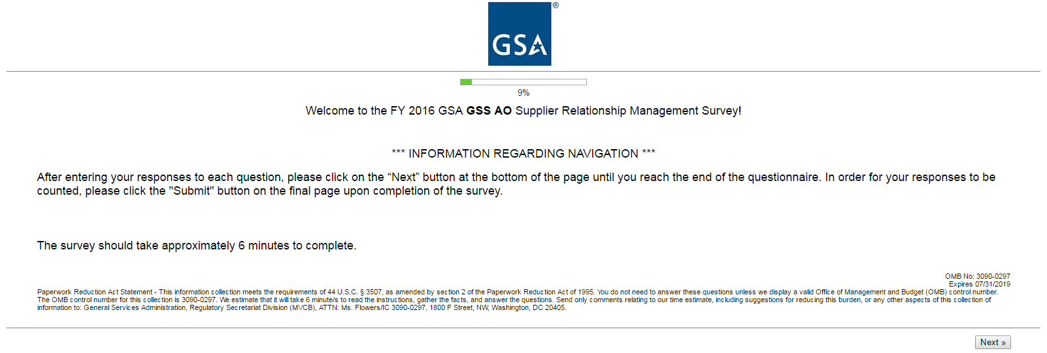GSS AO Supplier Relationship Management Survey

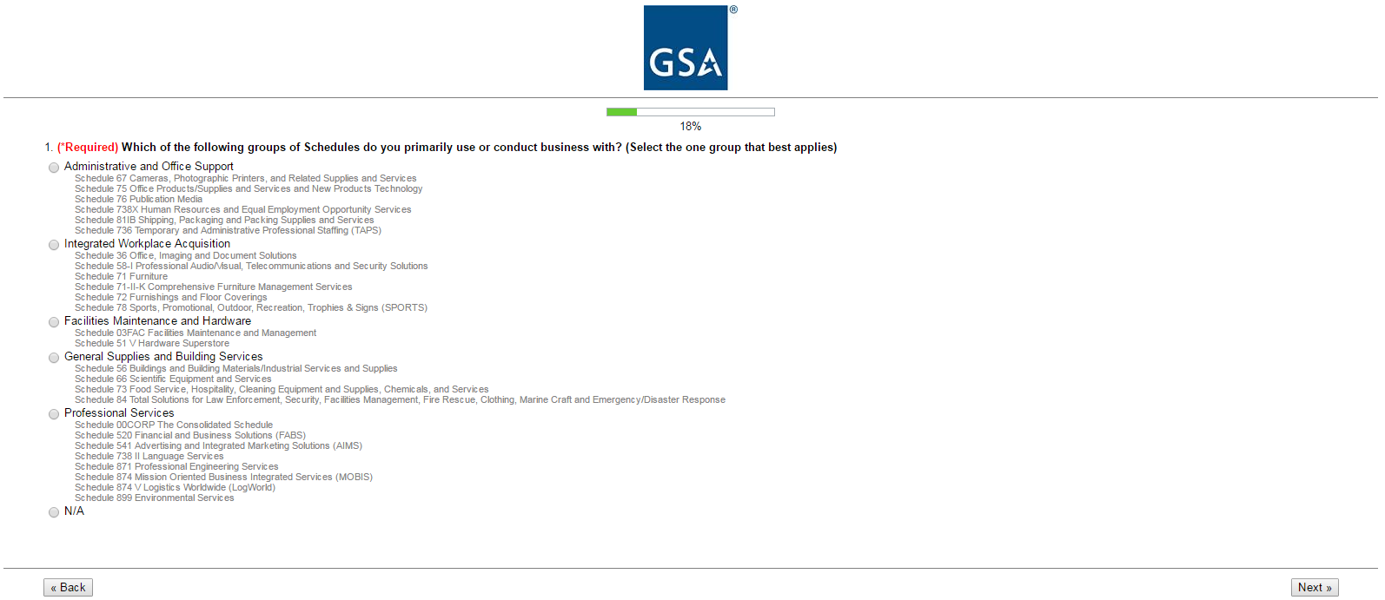

[Question 1 is a screener. Different responses will take respondents to different questions, as outlined below. Respondents will be shown only those questions that apply to their primary groups of schedules.]

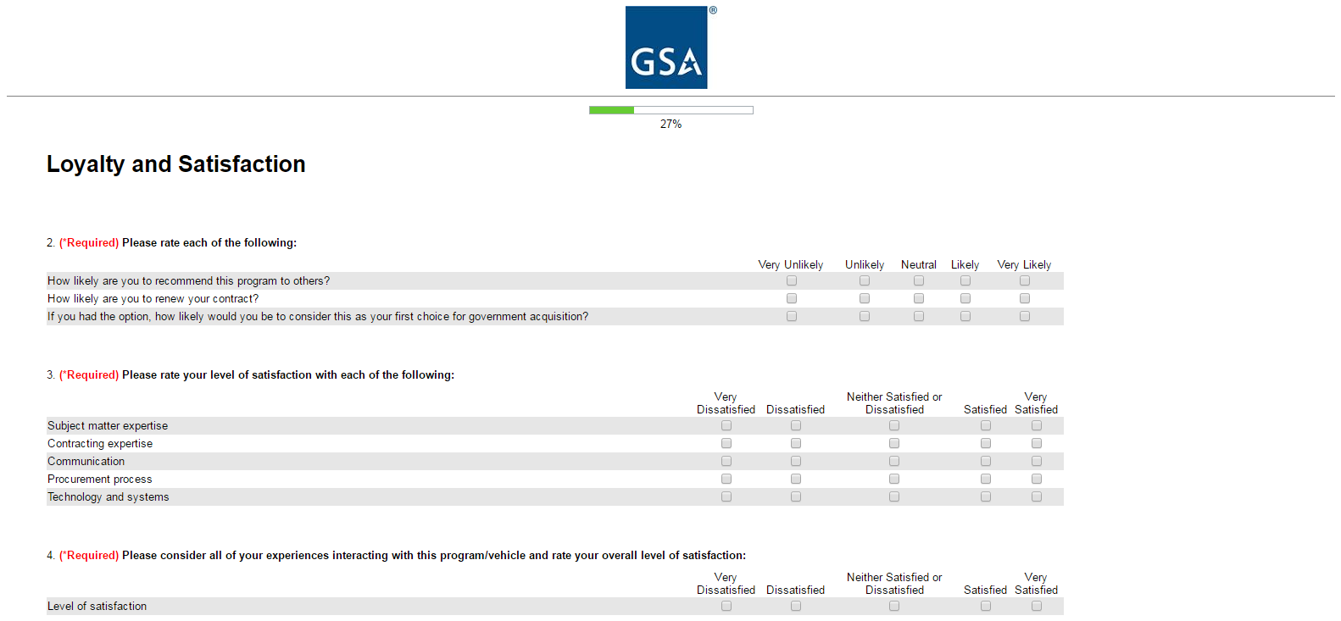**Option A** – Administrative and Office Support

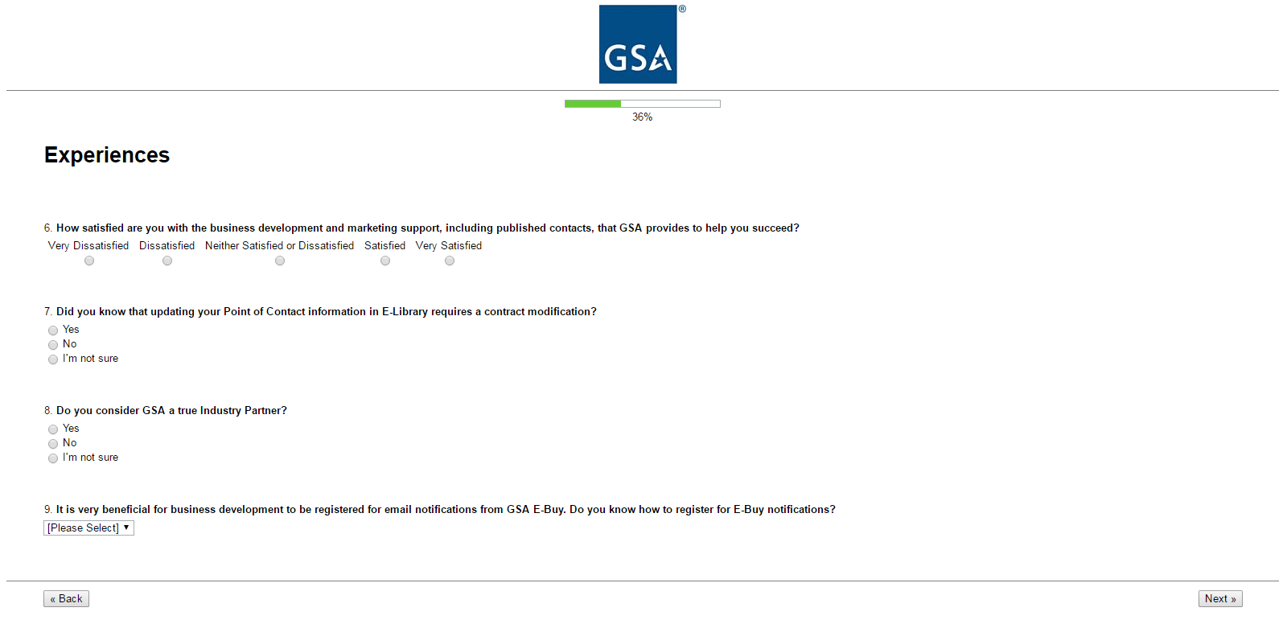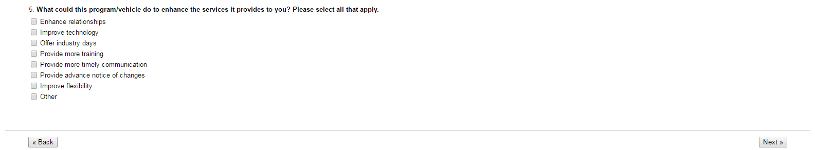

Options for Question 9:

* Yes
* No
* 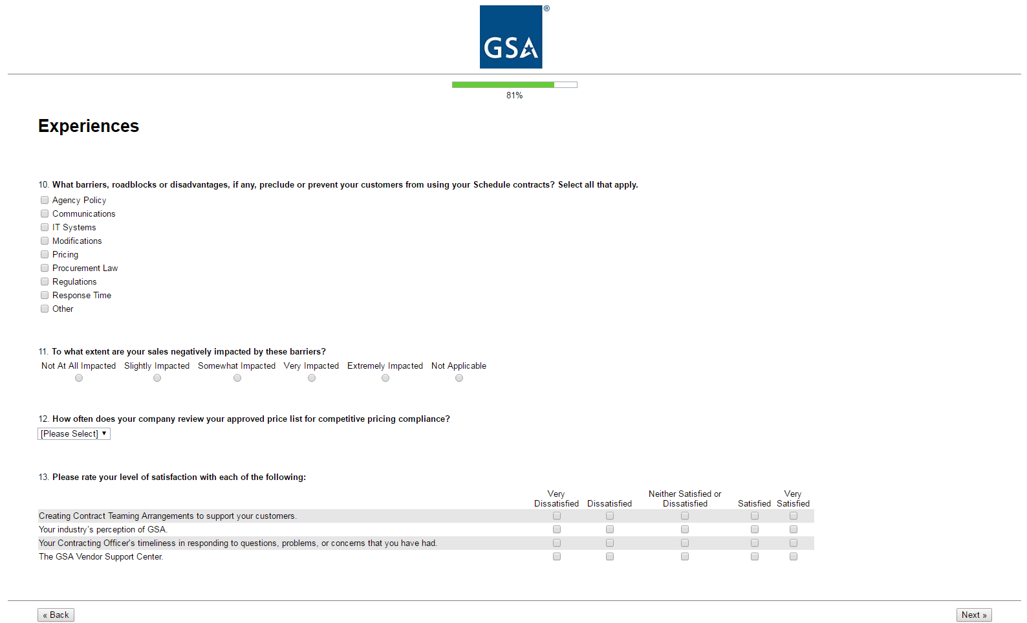I’m not sure

Options for Question 12:

* Weekly
* Monthly
* Quarterly
* Annually
* 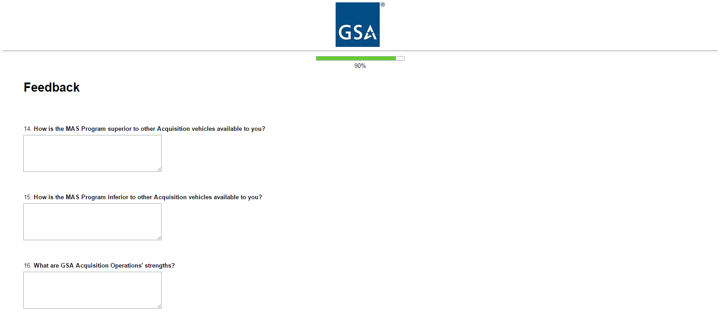Other

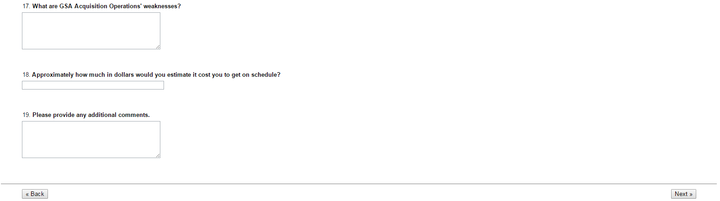

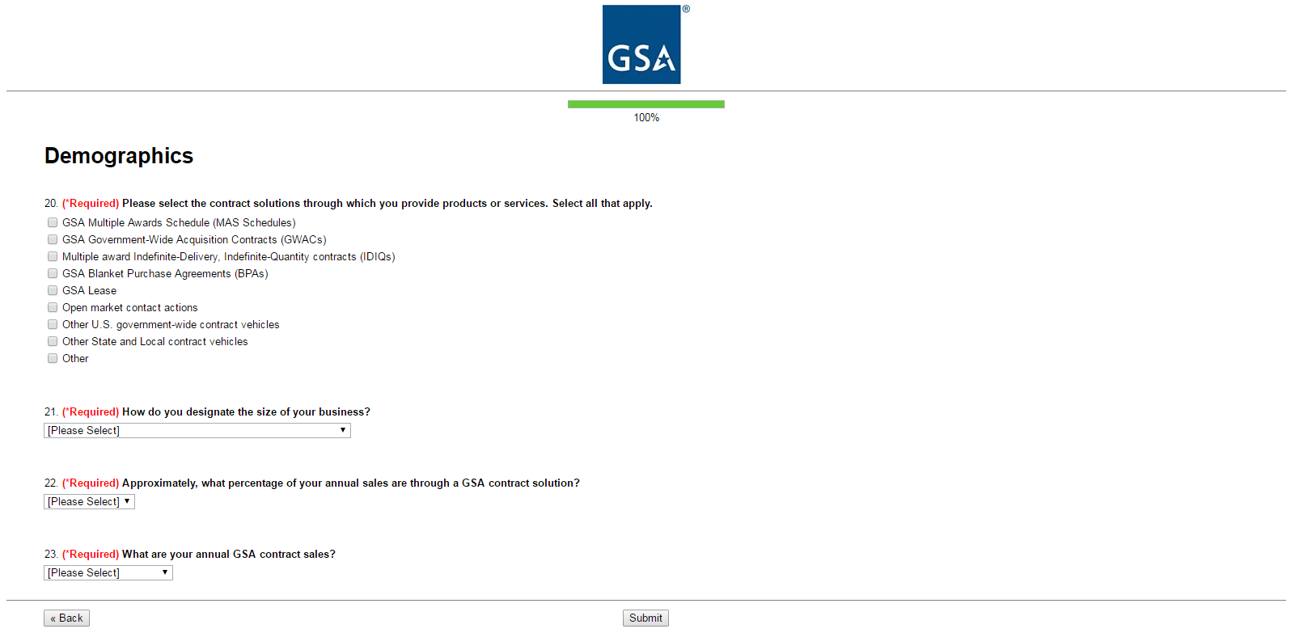Options for Question 21:

* Large
* Small
* Small Disadvantaged (8a)
* Woman-Owned Small Business (WOSB)
* Veteran-Owned Small Business (VOSB)
* Service-Disabled Veteran-Owned Small Business (SDVOSB)
* Qualified HubZone

Options for Question 22:

* < 5%
* 5% - 24%
* 25% - 49%
* 50% - 74%
* 75% - 100%
* I don’t know

Options for Question 23:

* $0 - $10,000
* $10,001 - $25,000
* $25,001 - $150,000
* $150,001 - $1,000,000
* More than $1,000,000
* I don’t know

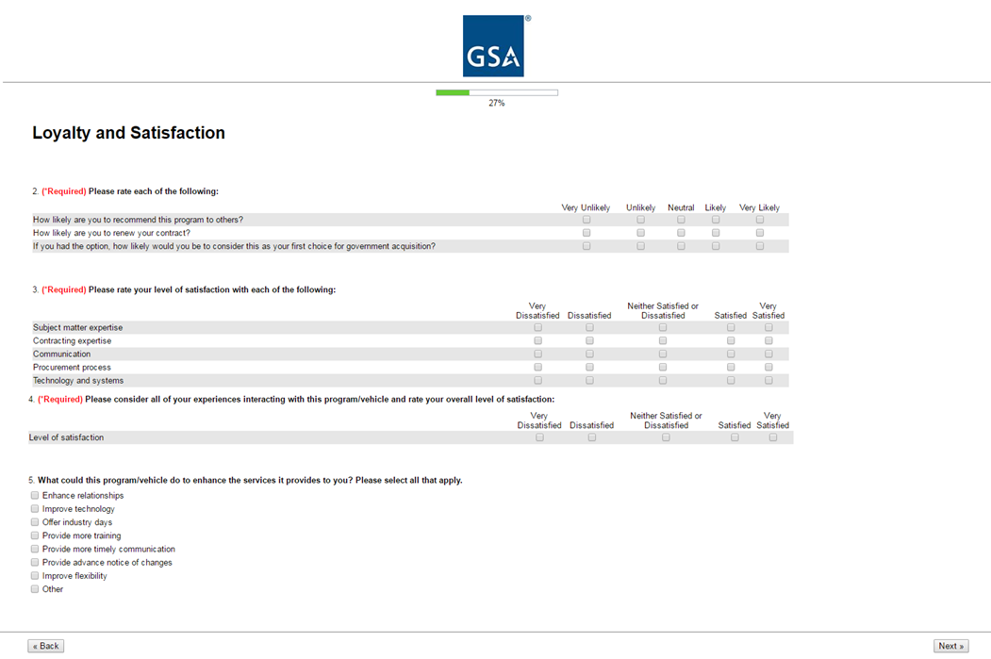**Option B** – Integrated Workplace Acquisition

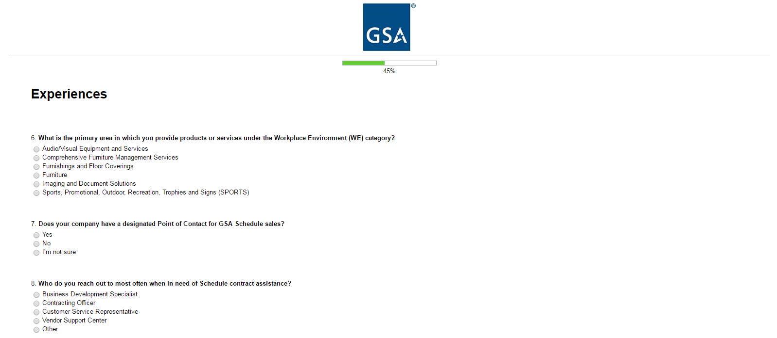

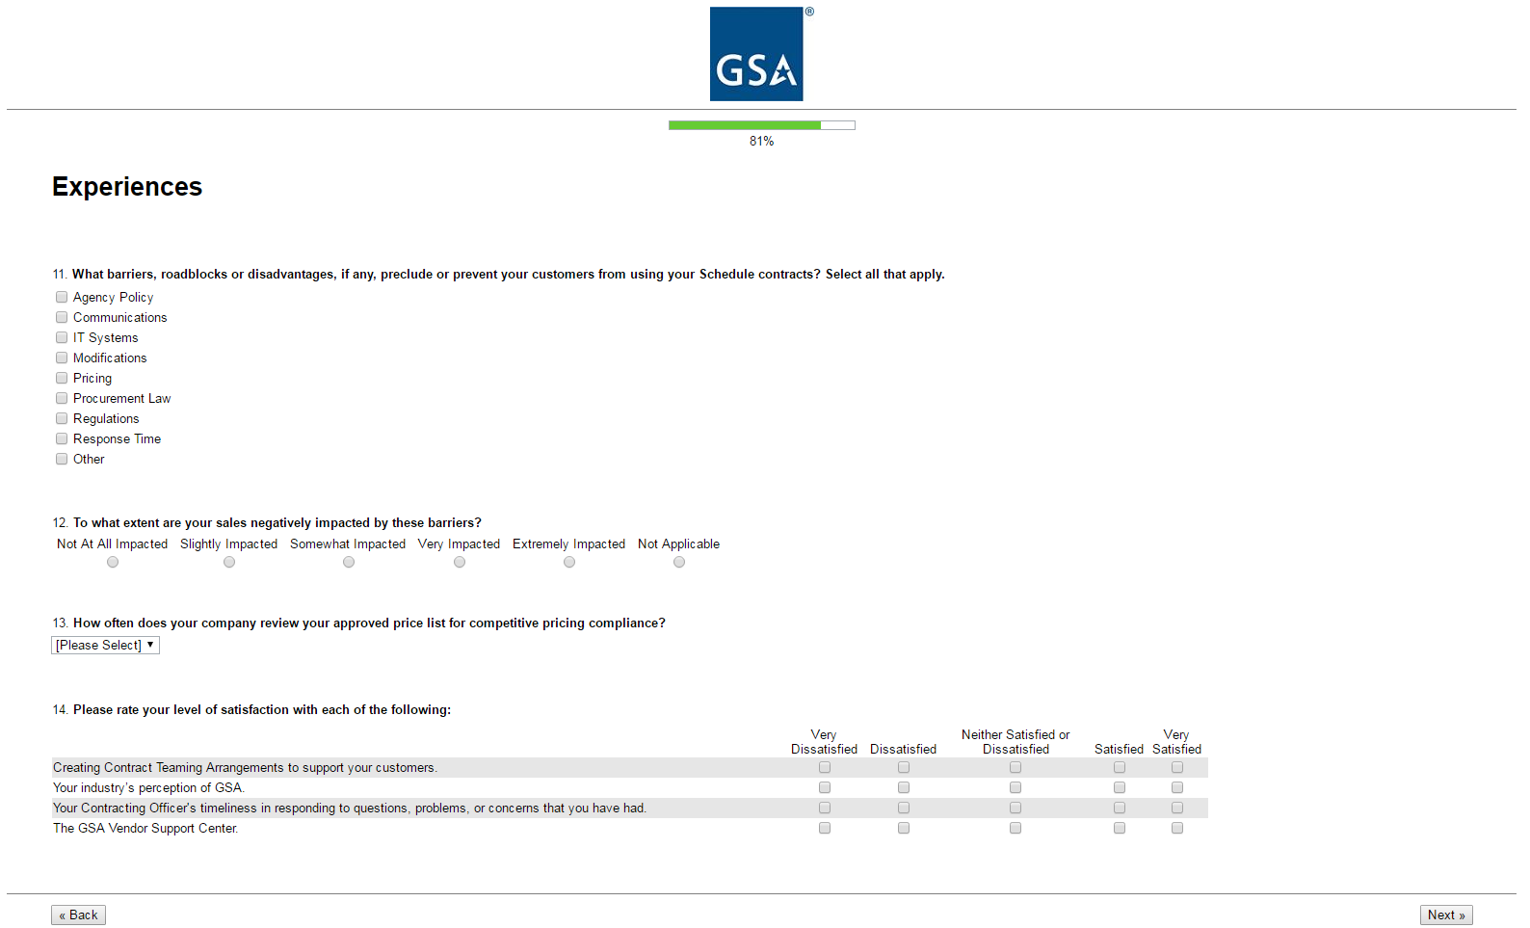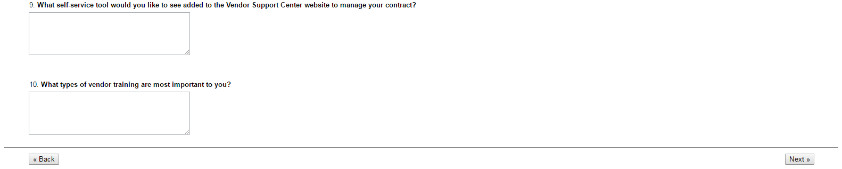Options for Question 13:

* Weekly
* Monthly
* Quarterly
* Annually
* Other

Options for Question 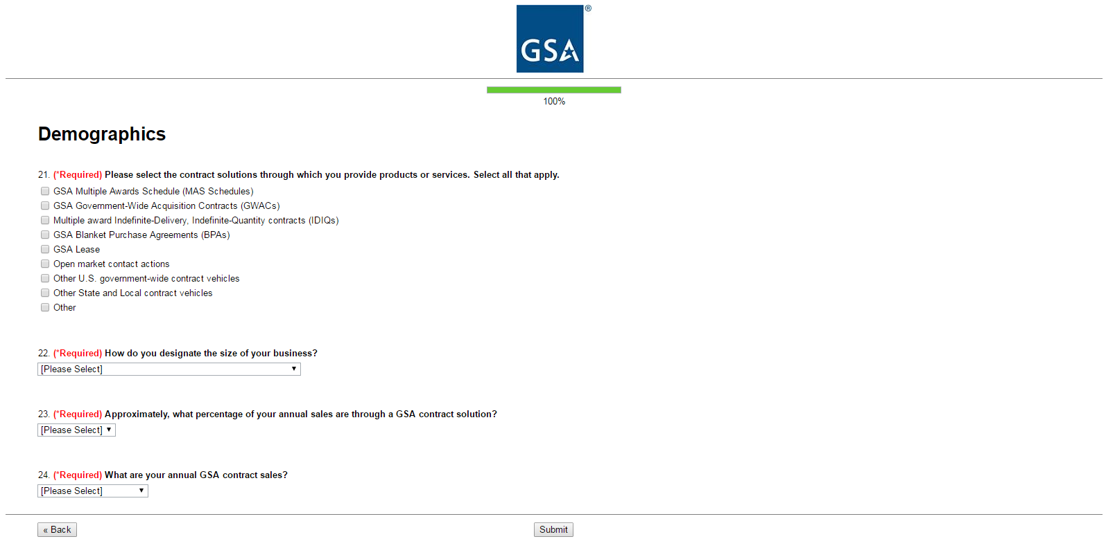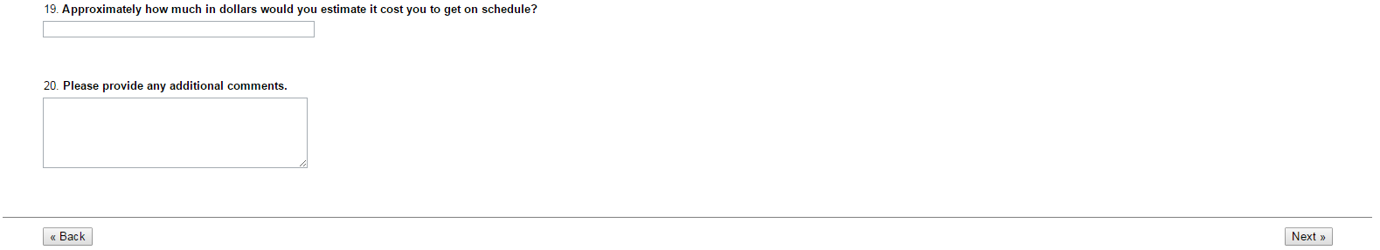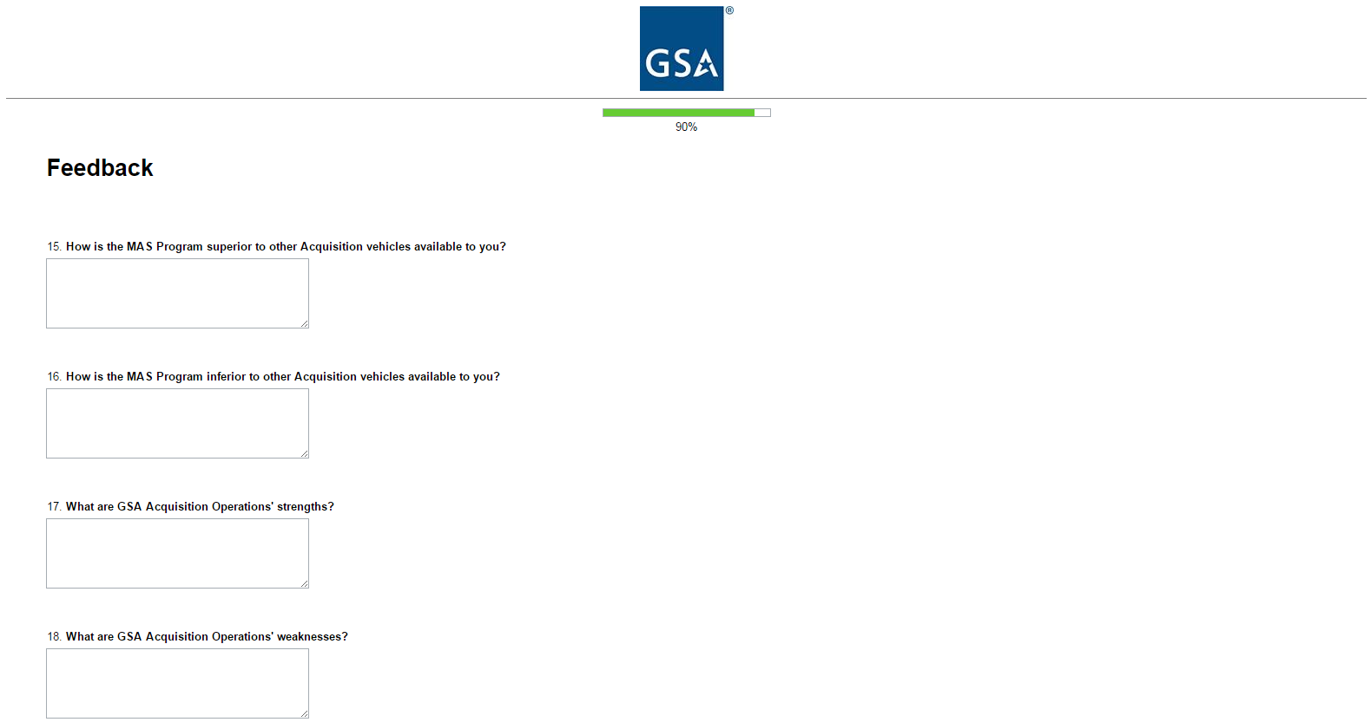22:

* Large
* Small
* Small Disadvantaged (8a)
* Woman-Owned Small Business (WOSB)
* Veteran-Owned Small Business (VOSB)
* Service-Disabled Veteran-Owned Small Business (SDVOSB)
* Qualified HubZone

Options for Question 23:

* < 5%
* 5% - 24%
* 25% - 49%
* 50% - 74%
* 75% - 100%
* I don’t know

Options for Question 24:

* $0 - $10,000
* $10,001 - $25,000
* $25,001 - $150,000
* $150,001 - $1,000,000
* More than $1,000,000
* I don’t know

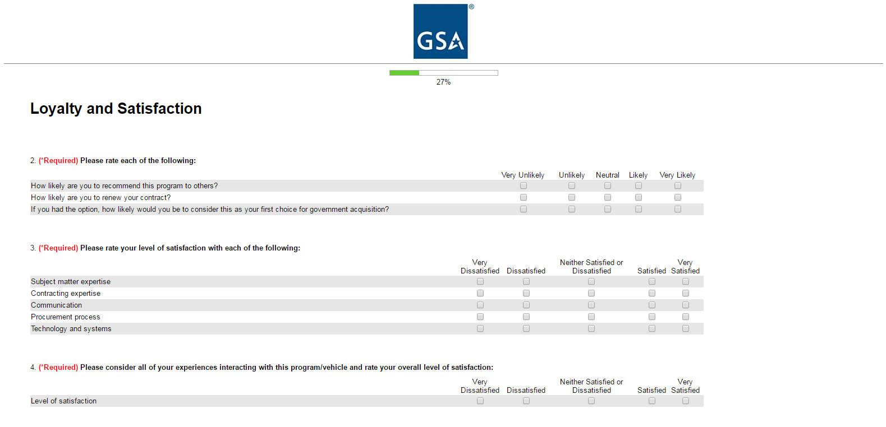**Option C** – Facilities Maintenance and Hardware

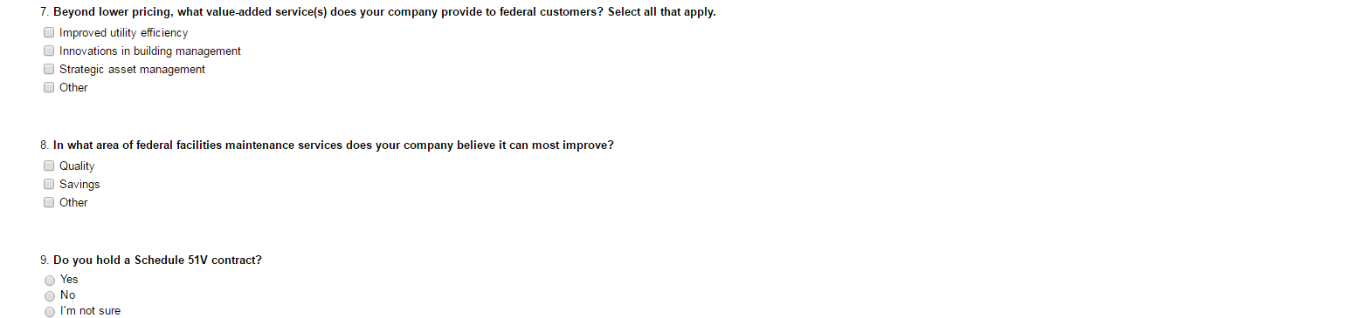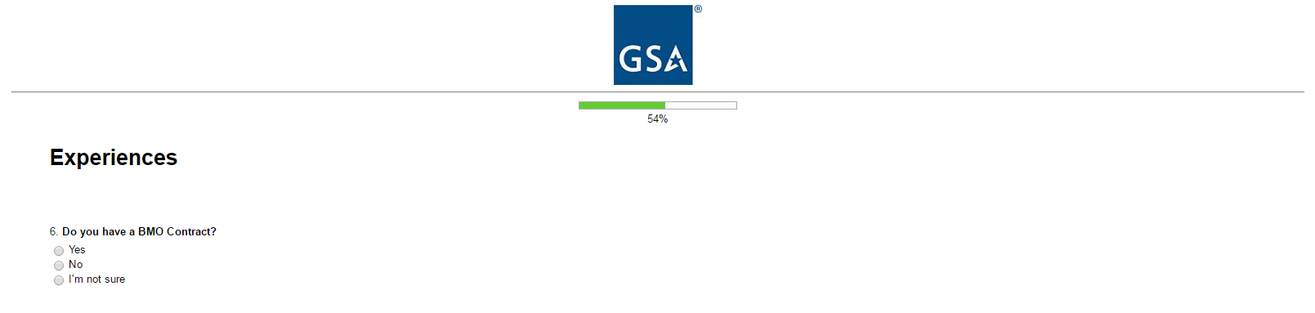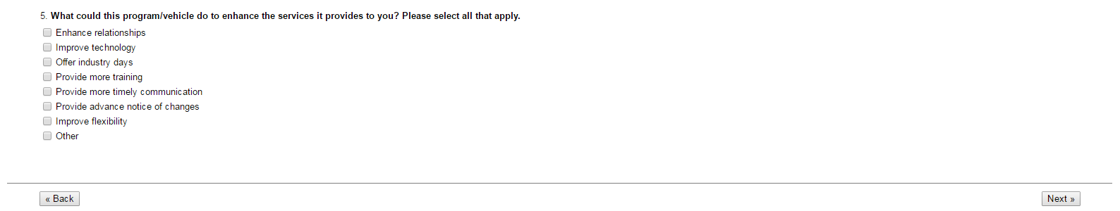

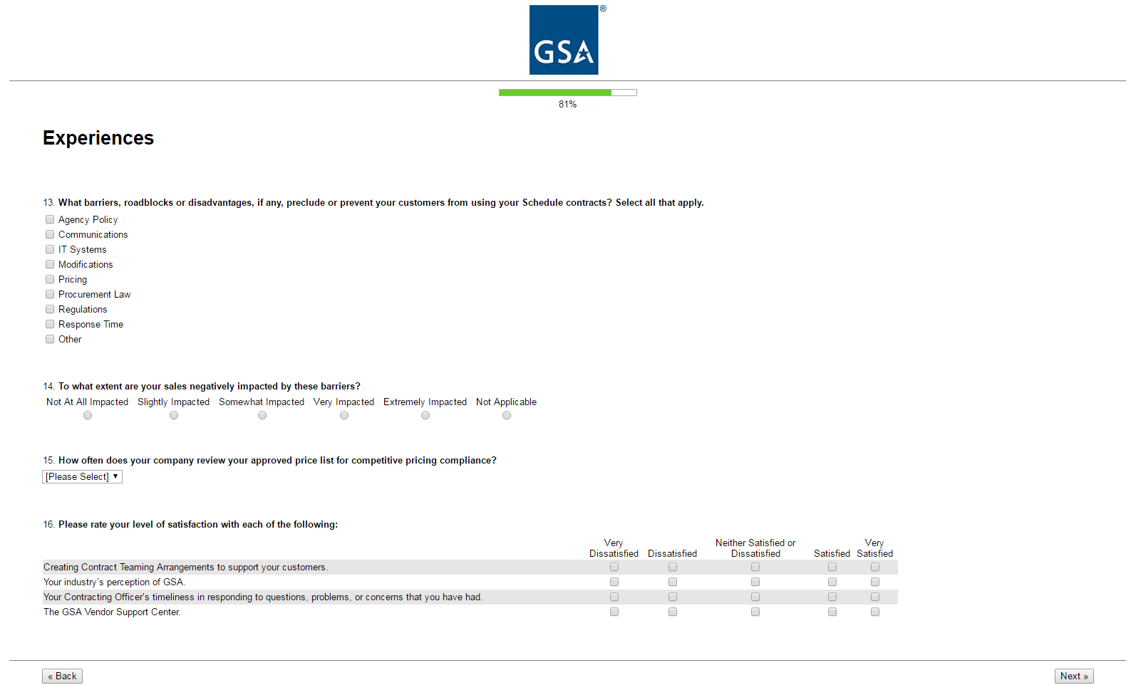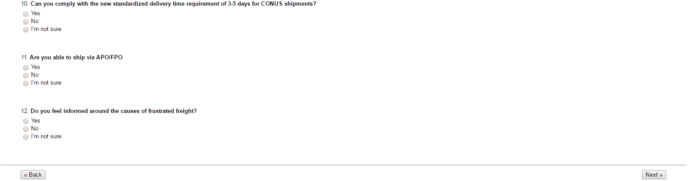Options for Question 15:

* Weekly
* Monthly
* Quarterly
* Annually
* Other

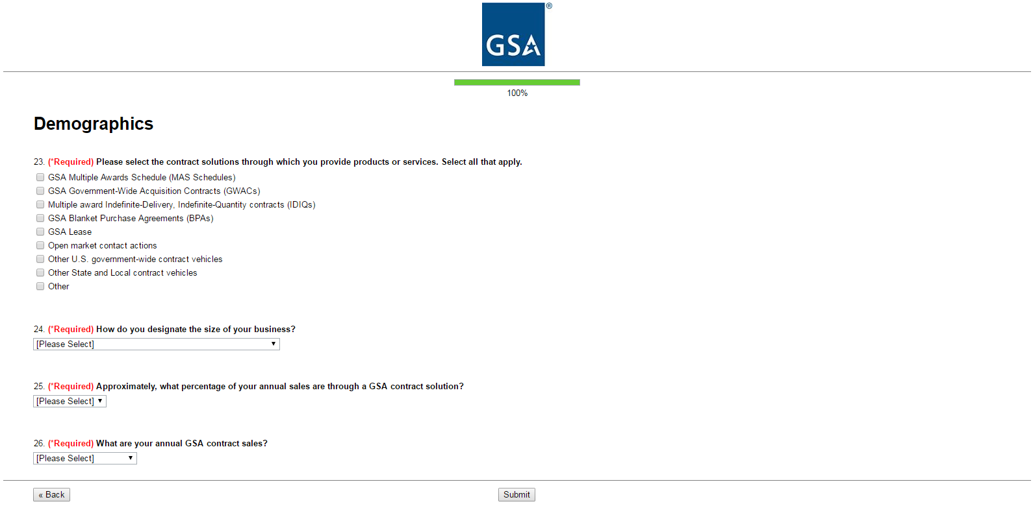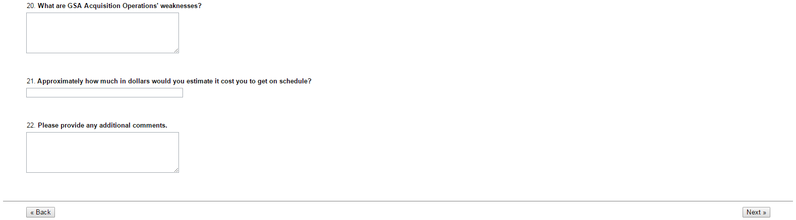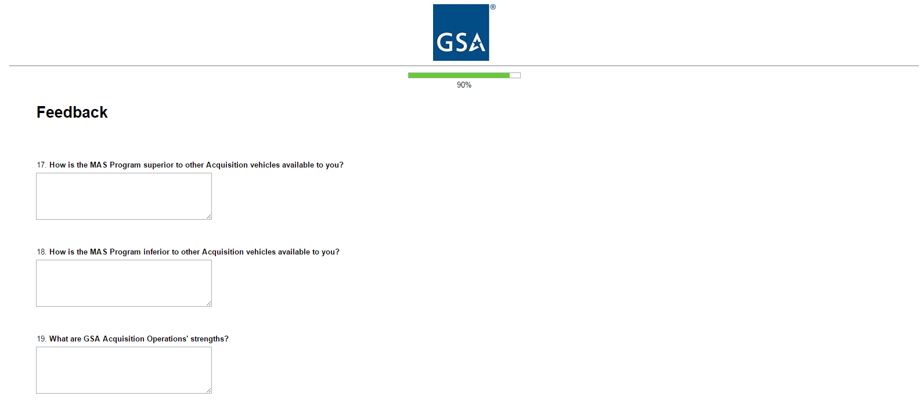Options for Question 24:

* Large
* Small
* Small Disadvantaged (8a)
* Woman-Owned Small Business (WOSB)
* Veteran-Owned Small Business (VOSB)
* Service-Disabled Veteran-Owned Small Business (SDVOSB)
* Qualified HubZone

Options for Question 25:

* < 5%
* 5% - 24%
* 25% - 49%
* 50% - 74%
* 75% - 100%
* I don’t know

Options for Question 26:

* $0 - $10,000
* $10,001 - $25,000
* $25,001 - $150,000
* $150,001 - $1,000,000
* More than $1,000,000
* I don’t know

**Option D** – General Supplies and Building Services 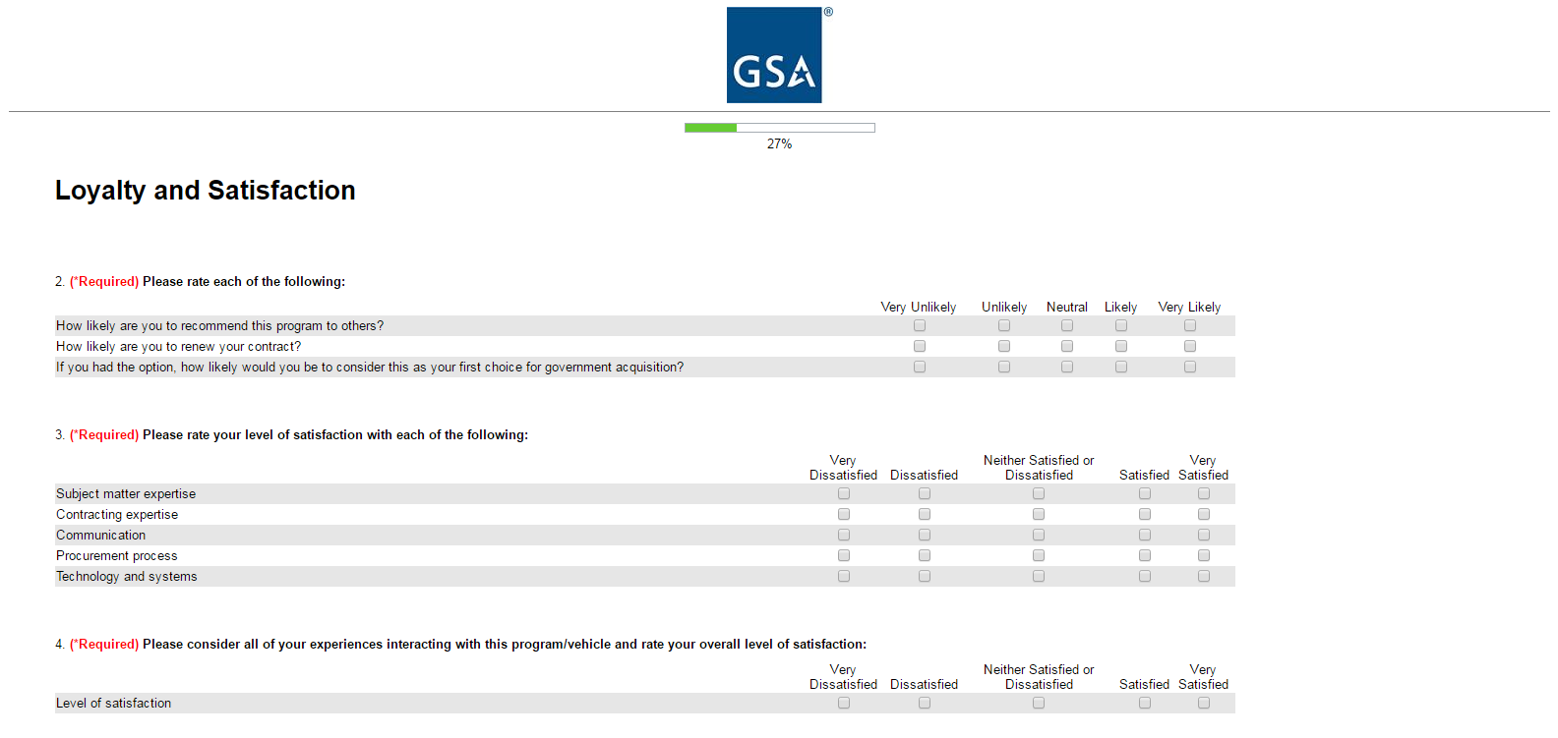

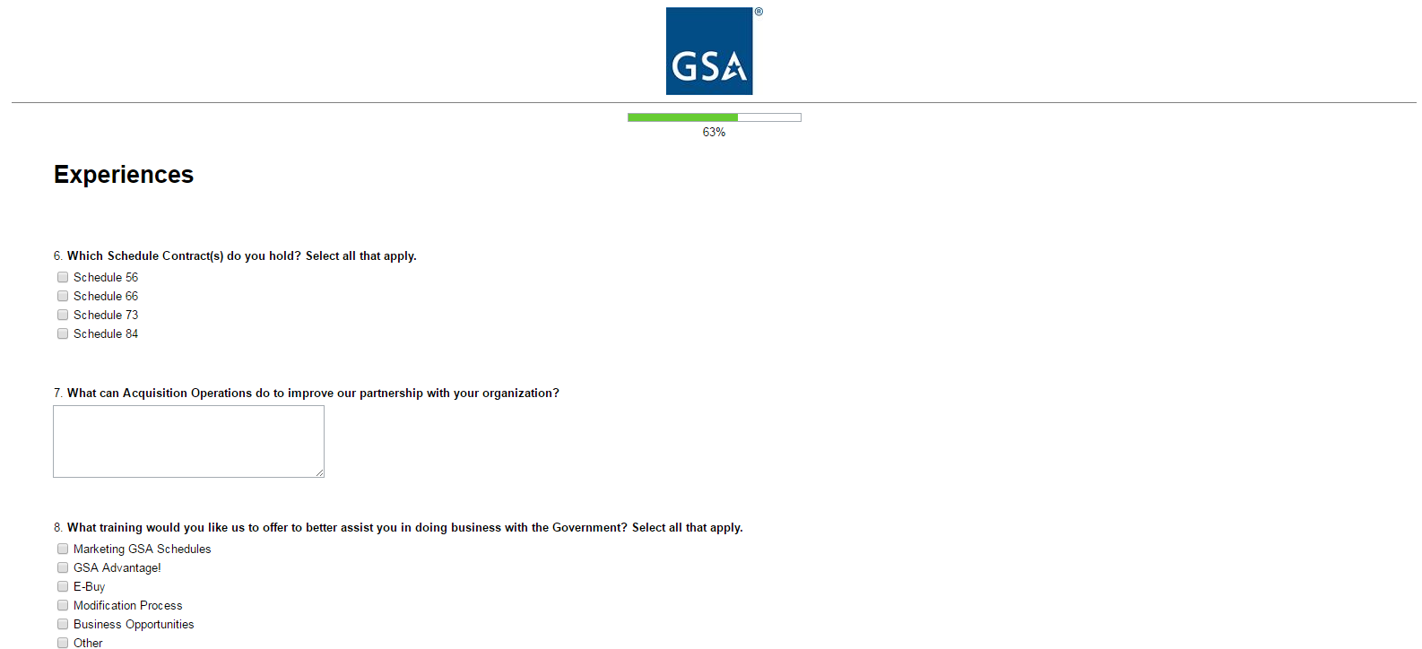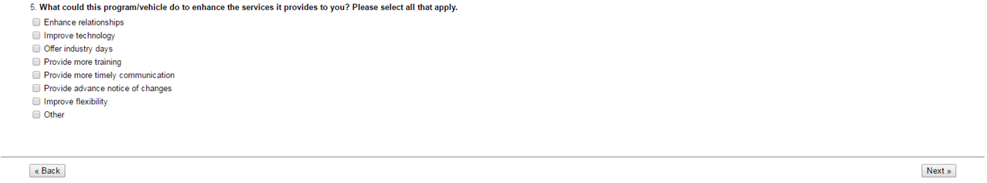

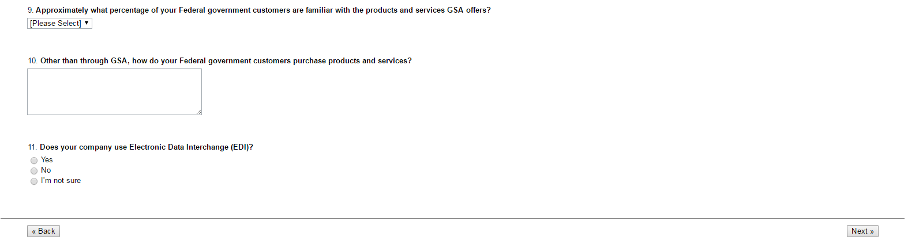Options for Question 9:

* < 5%
* 5-24%
* 25-49%
* 50-74%
* 75-100%
* I don’t know

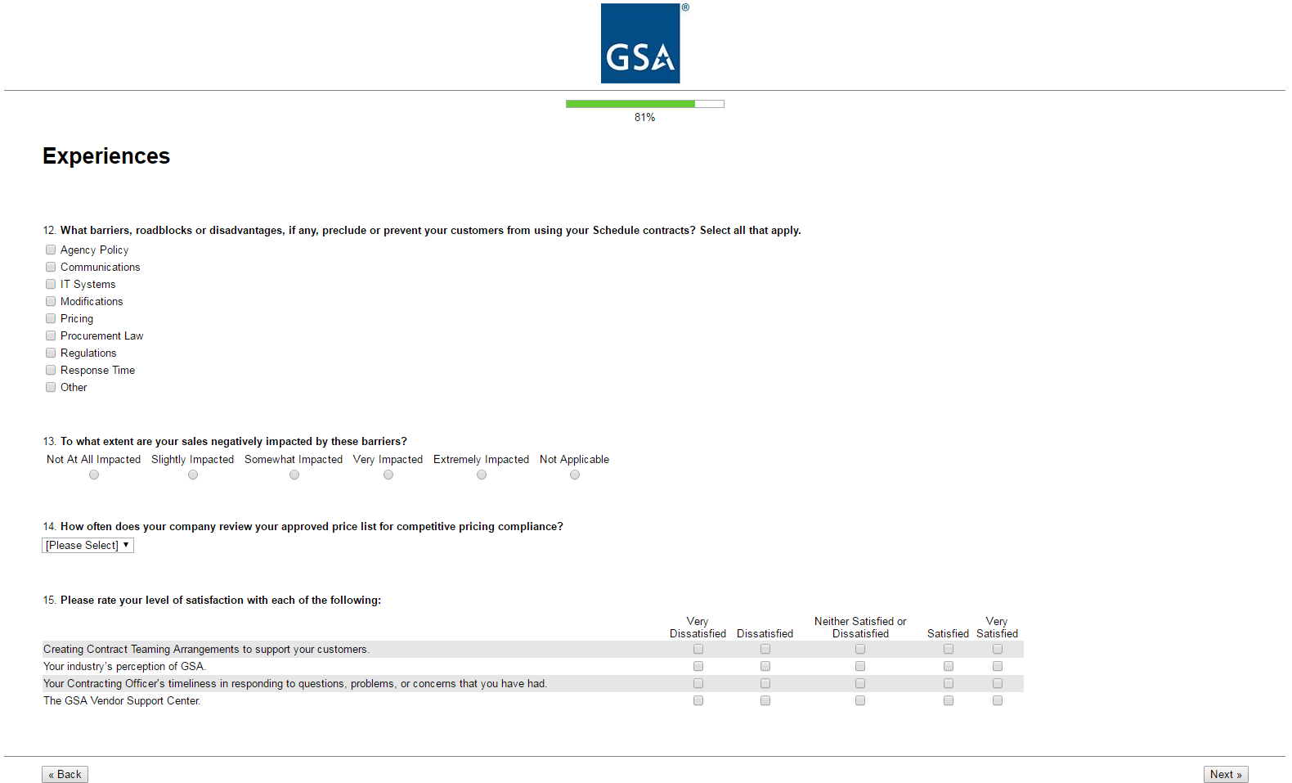Options for Question 14

* Weekly
* Monthly
* Quarterly
* Annually
* 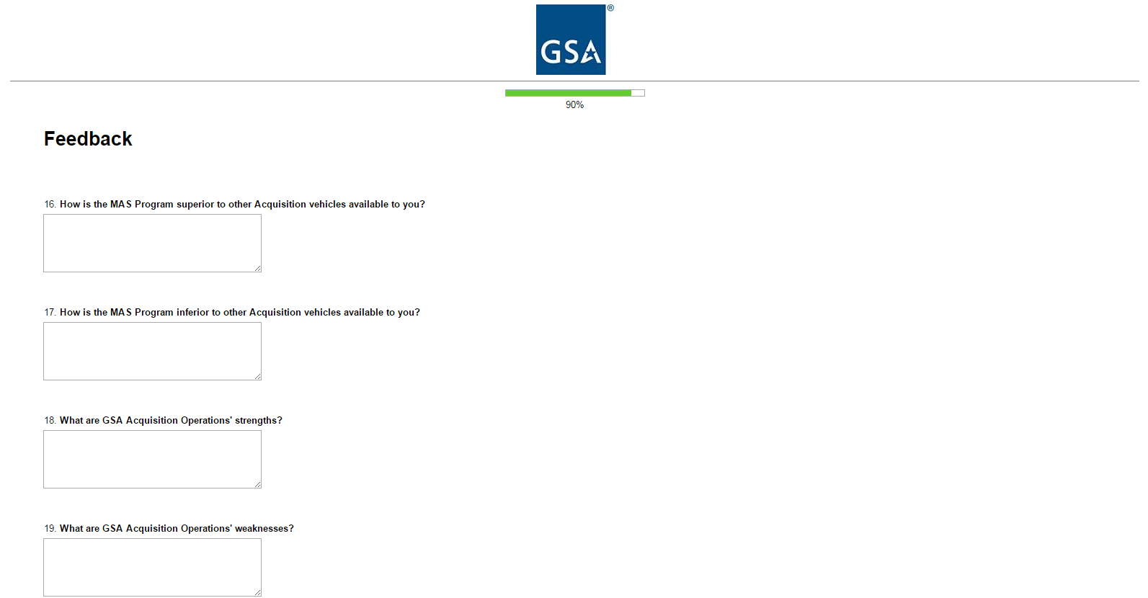Other

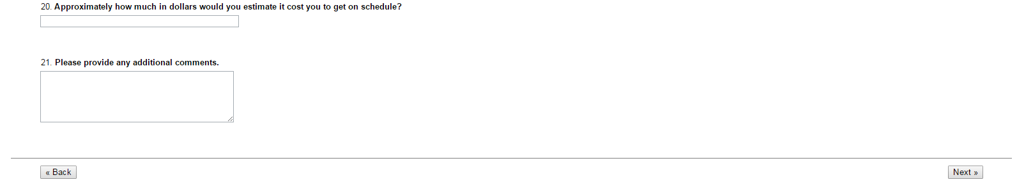

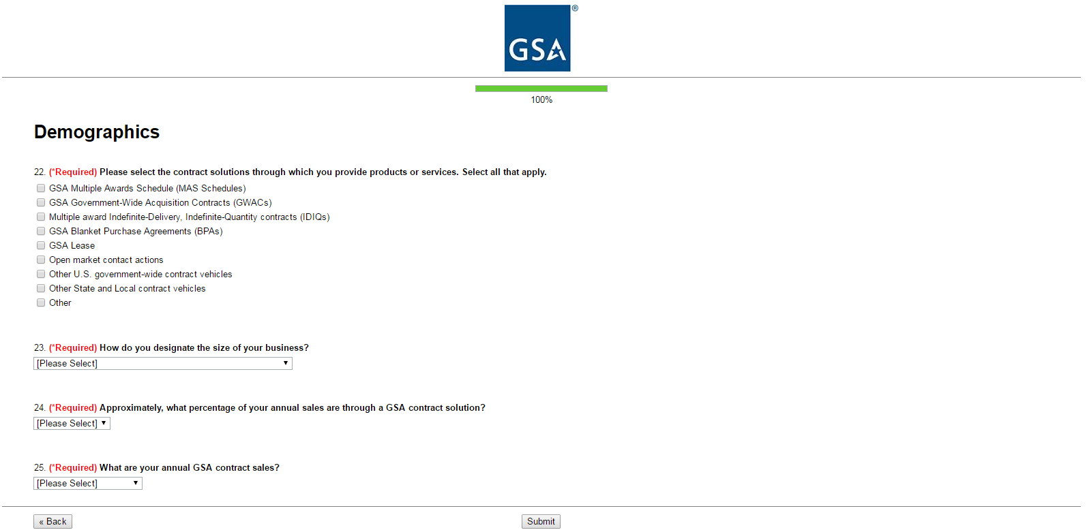Options for Question 23:

* Large
* Small
* Small Disadvantaged (8a)
* Woman-Owned Small Business (WOSB)
* Veteran-Owned Small Business (VOSB)
* Service-Disabled Veteran-Owned Small Business (SDVOSB)
* Qualified HubZone

Options for Question 24:

* < 5%
* 5% - 24%
* 25% - 49%
* 50% - 74%
* 75% - 100%
* I don’t know

Options for Question 25:

* $0 - $10,000
* $10,001 - $25,000
* $25,001 - $150,000
* $150,001 - $1,000,000
* More than $1,000,000
* I don’t know

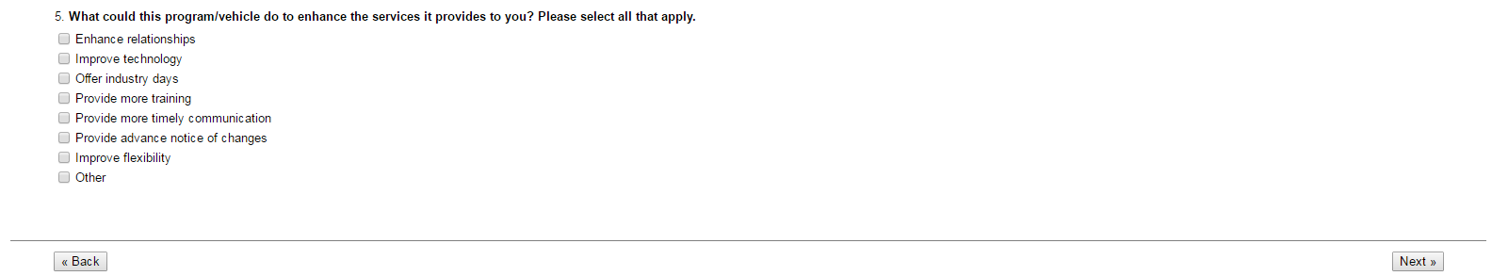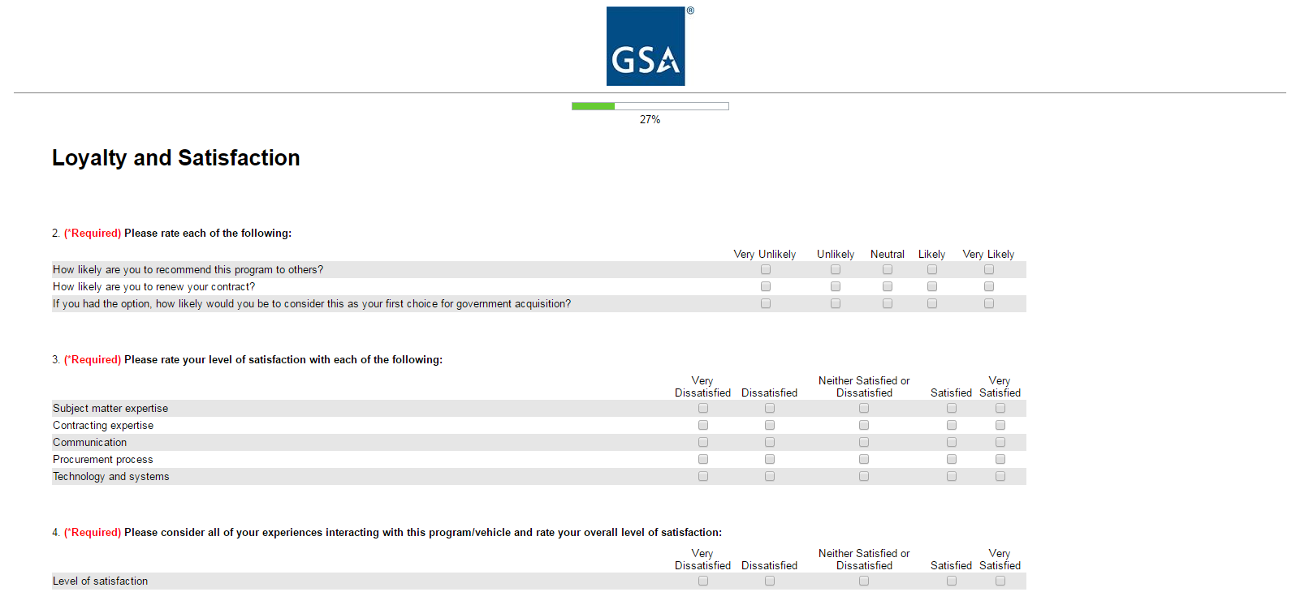**Option E** – Professional Services

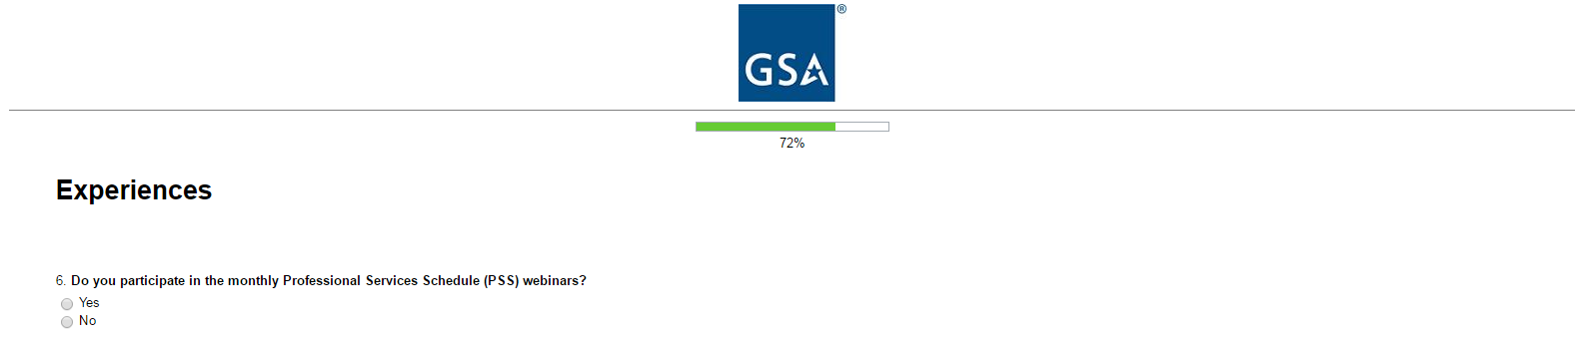

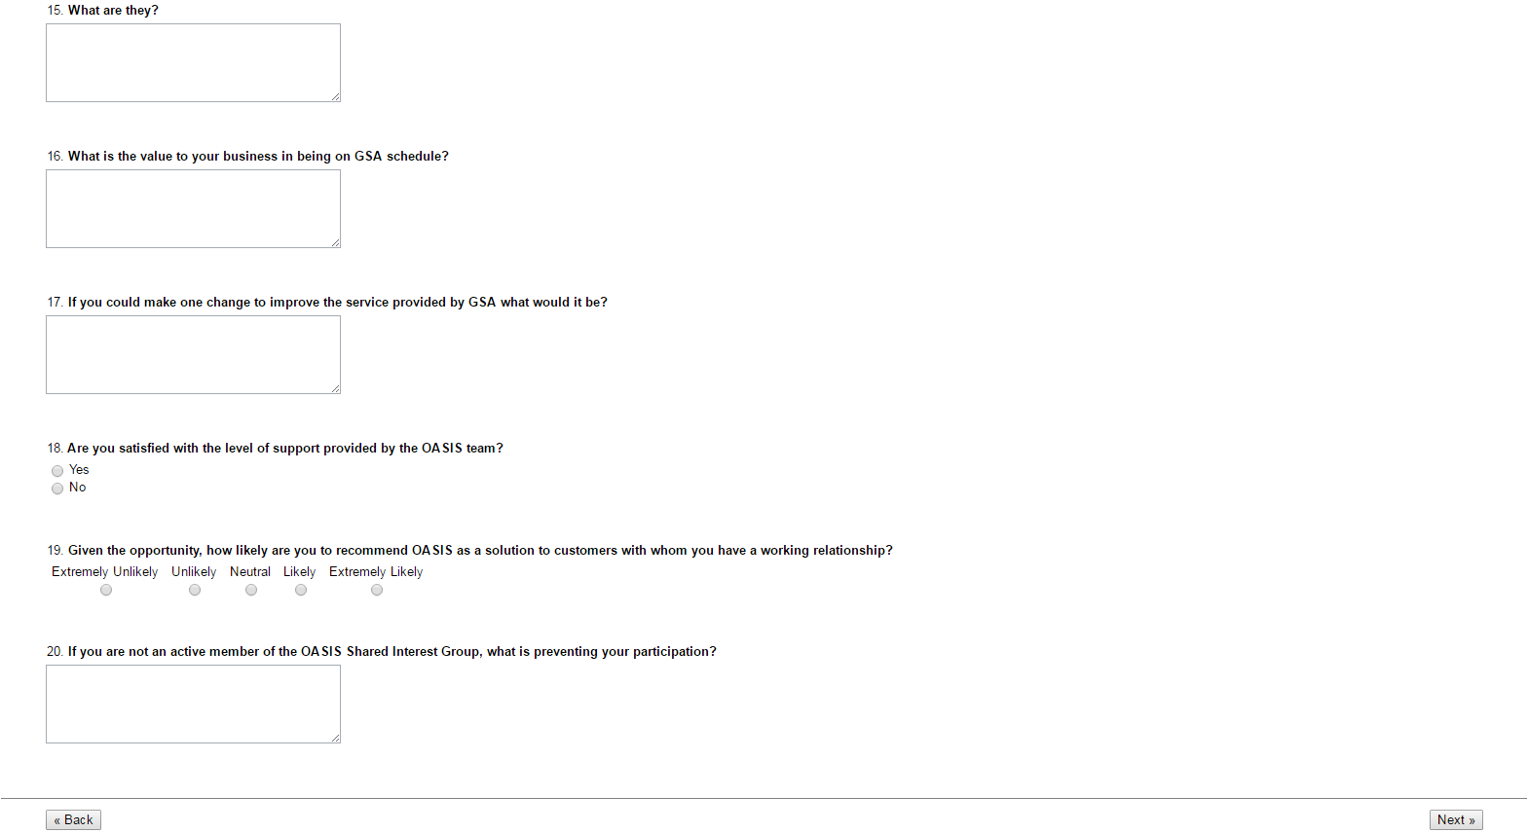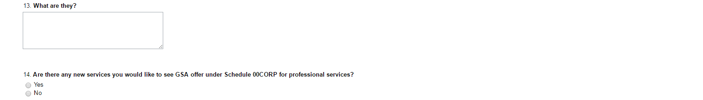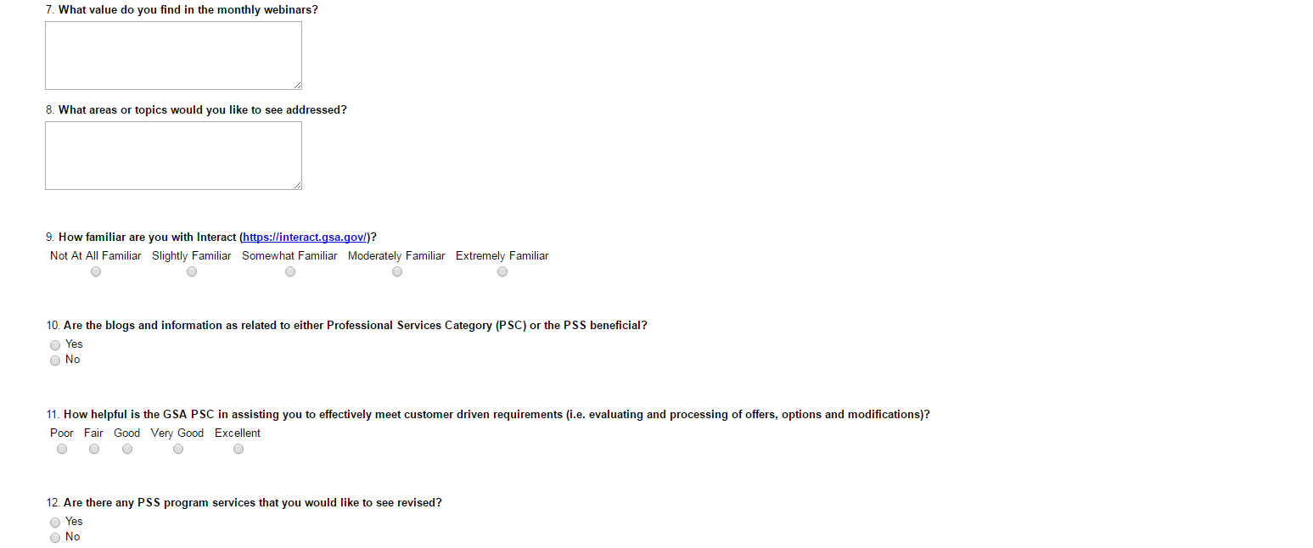

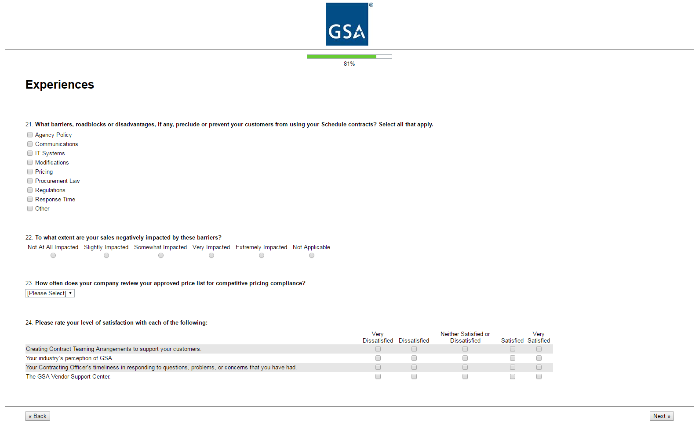

Options for Question 23:

* Weekly
* Monthly
* Quarterly
* Annually
* Other

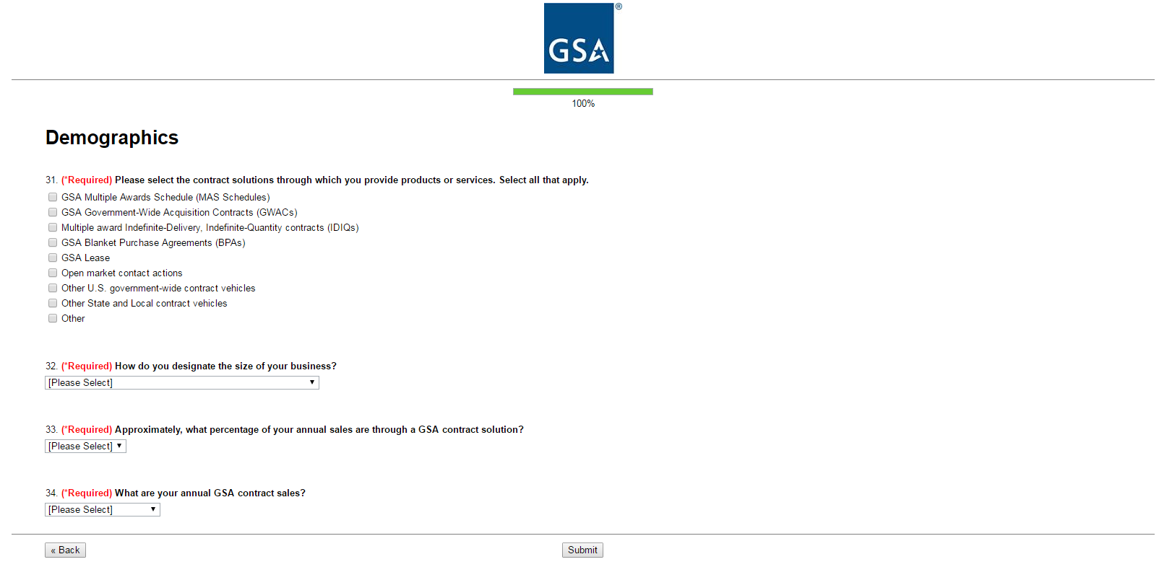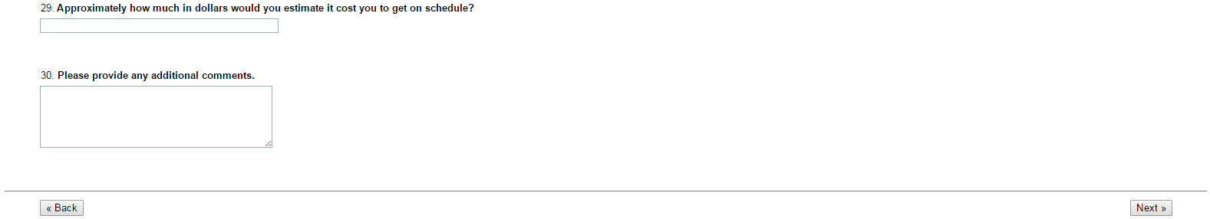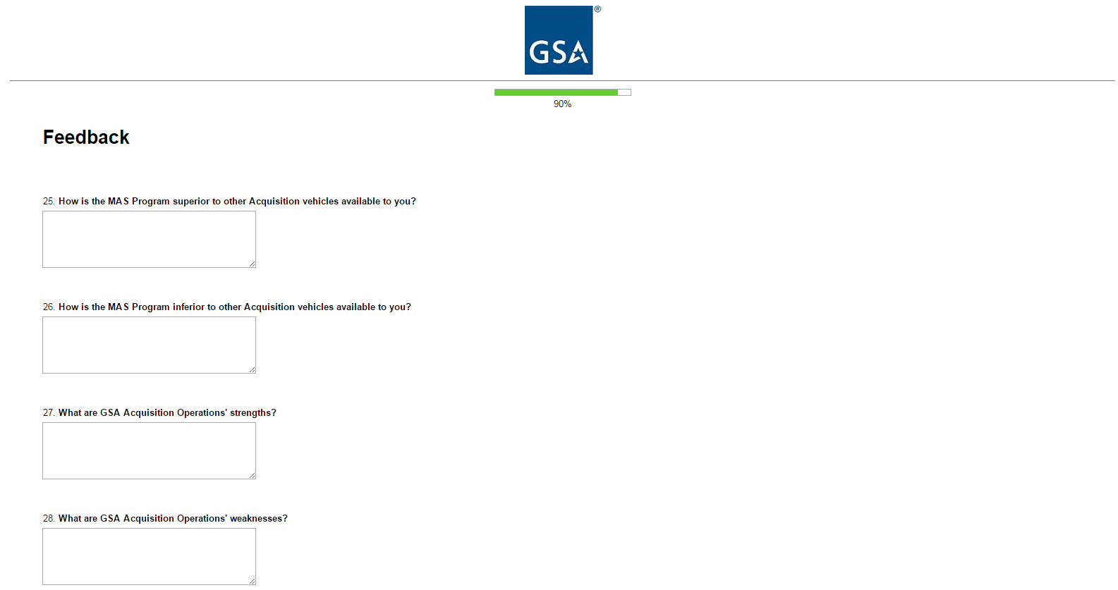Options for Question 32:

* Large
* Small
* Small Disadvantaged (8a)
* Woman-Owned Small Business (WOSB)
* Veteran-Owned Small Business (VOSB)
* Service-Disabled Veteran-Owned Small Business (SDVOSB)
* Qualified HubZone

Options for Question 33:

* < 5%
* 5% - 24%
* 25% - 49%
* 50% - 74%
* 75% - 100%
* I don’t know

Options for Question 34:

* $0 - $10,000
* $10,001 - $25,000
* $25,001 - $150,000
* $150,001 - $1,000,000
* More than $1,000,000
* I don’t know

**Option F** – N/A

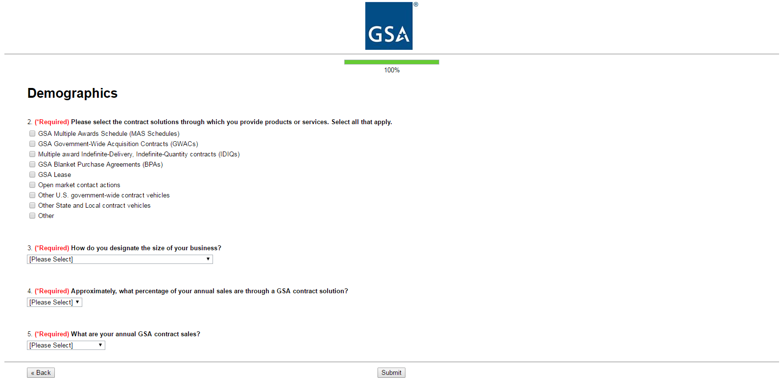Options for Question 3:

* Large
* Small
* Small Disadvantaged (8a)
* Woman-Owned Small Business (WOSB)
* Veteran-Owned Small Business (VOSB)
* Service-Disabled Veteran-Owned Small Business (SDVOSB)
* Qualified HubZone

Options for Question 4:

* < 5%
* 5% - 24%
* 25% - 49%
* 50% - 74%
* 75% - 100%
* I don’t know

Options for Question 5:

* $0 - $10,000
* $10,001 - $25,000
* $25,001 - $150,000
* $150,001 - $1,000,000
* More than $1,000,000
* I don’t know