FAST Track 3090-0297-Instrument

(Req-5)

2. **Survey Introduction Email**

**To accompany link to survey within an email**

1. The Acquisition Gateway, a GSA website geared toward federal acquisition professionals, understands that to improve federal acquisition outcomes, contracting officers and buying offices are only one piece of the puzzle.

As a vendor or industry professional, we’re interested in learning more about your pain points with the federal acquisition process so that future versions of the Acquisition Gateway can help meet your needs and improve federal acquisition outcomes.

1. Please click the link below to take a short survey. Thank you!
2. OMB No: 3090-0297 Expires 07/31/2019
3. Paperwork Reduction Act Statement - This information collection meets the requirements of 44 U.S.C. § 3507, as amended by section 2 of the Paperwork Reduction Act of 1995. You do not need to answer these questions unless we display a valid Office of Management and Budget (OMB) control number. The OMB control number for this collection is 3090-0297. We estimate that it will take 6 minute/s to read the instructions, gather the facts, and answer the questions. Send only comments relating to our time estimate, including suggestions for reducing this burden, or any other aspects of this collection of information to: General Services Administration, Regulatory Secretariat Division (MVCB), ATTN: Ms. Flowers/IC 3090-0297, 1800 F Street, NW, Washington, DC 20405.

Survey

Screen 1

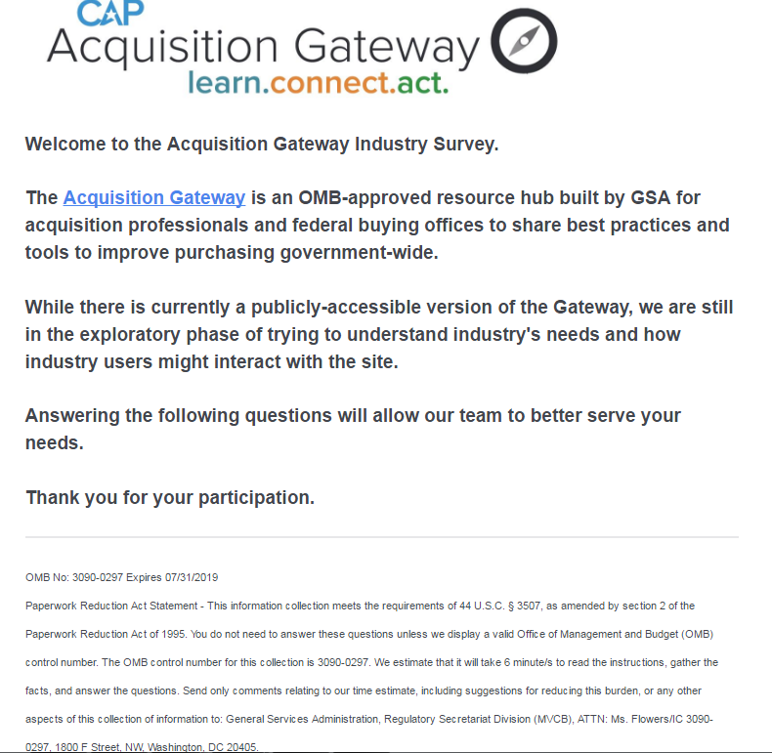

**Screen 2**

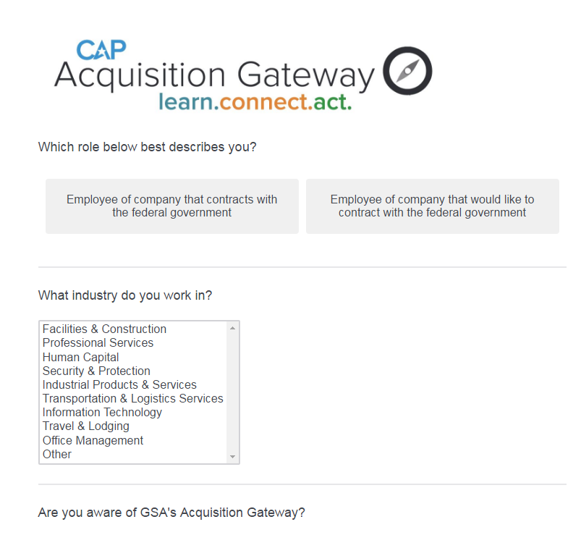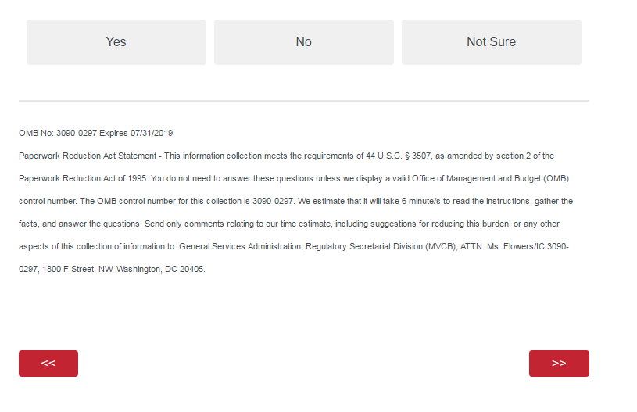

**Screen 3 - Full**

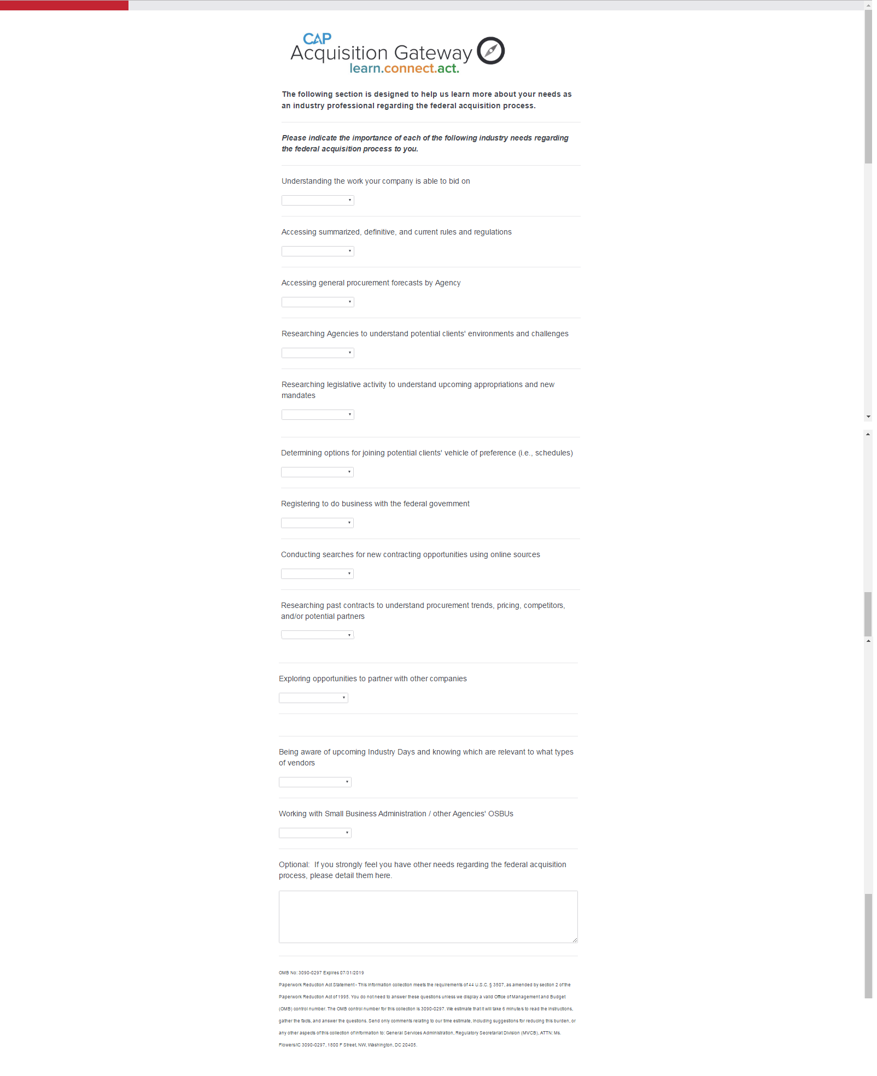

**Screen 3 - Dropdown Question Options (Consistent throughout this screen)**

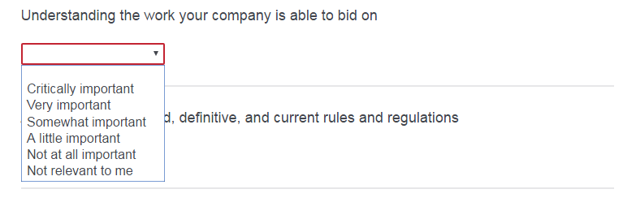

**Screen 3 – Close-up**

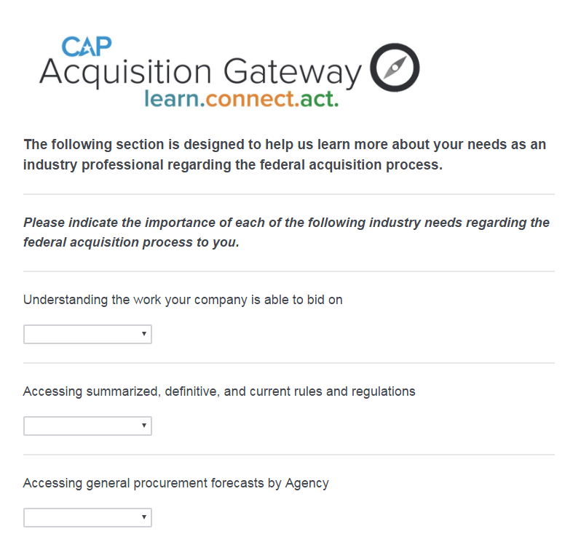

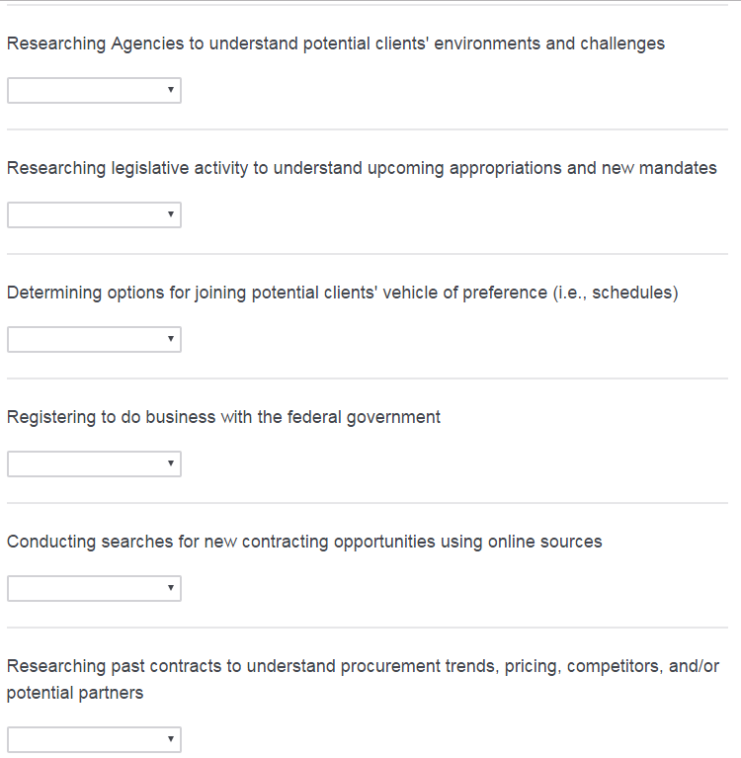

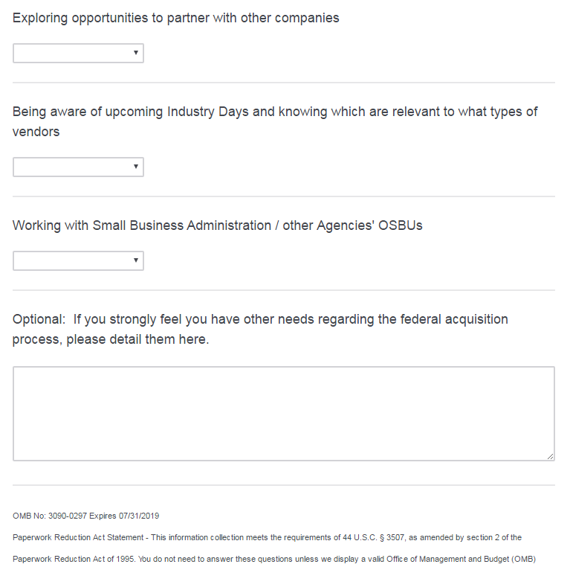

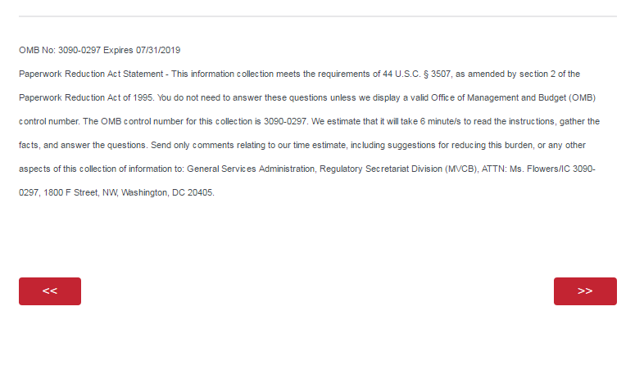

**Screen 4 – Full**

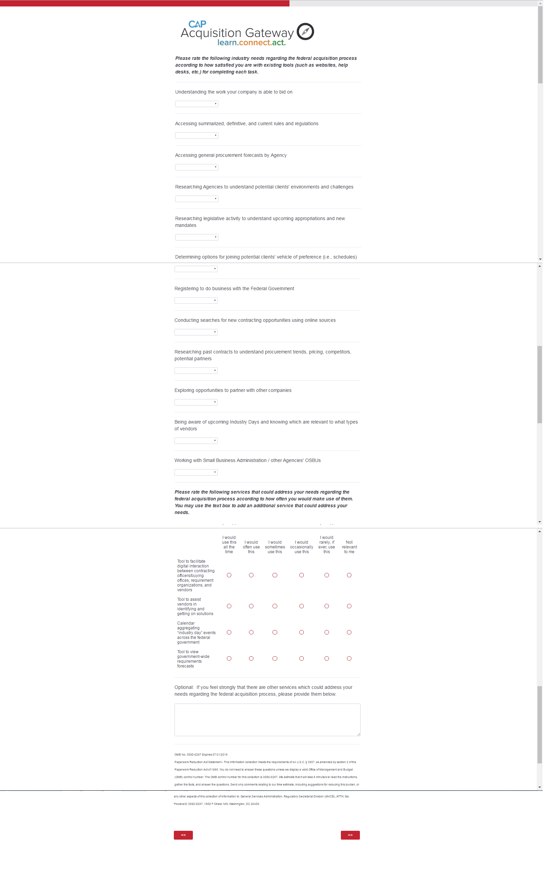

**Screen 4 – Dropdown Question Options (consistent throughout this screen)**

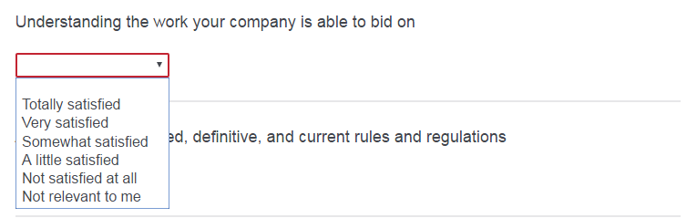

**Screen 4 – Close-up**

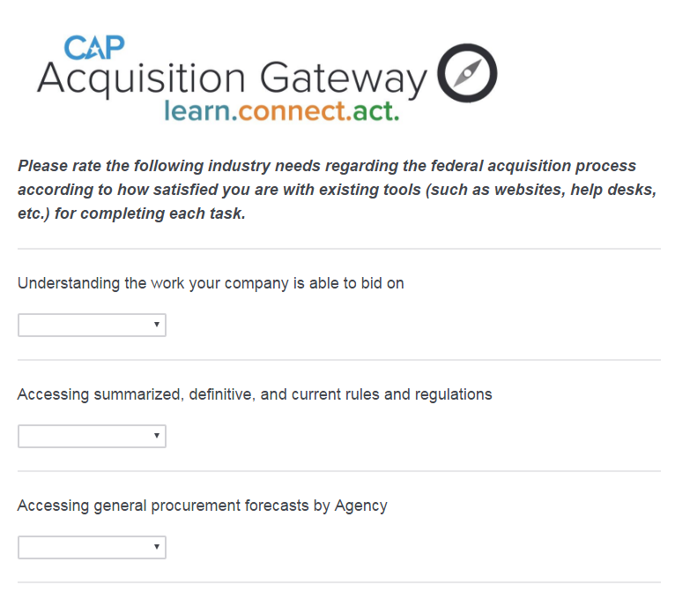

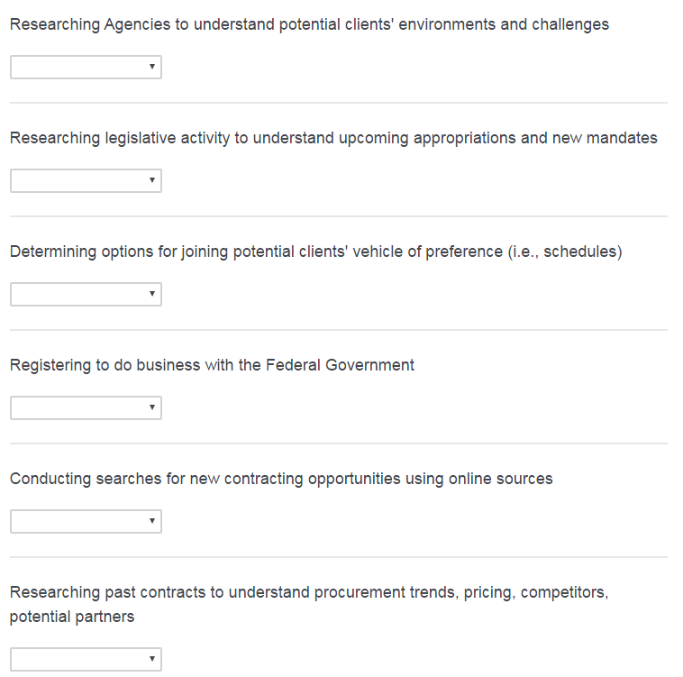

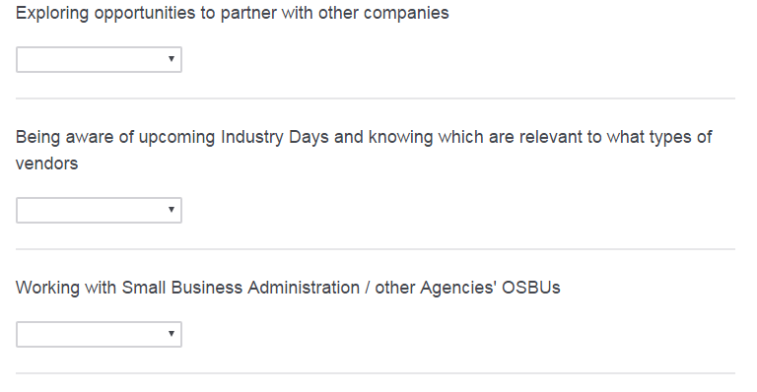

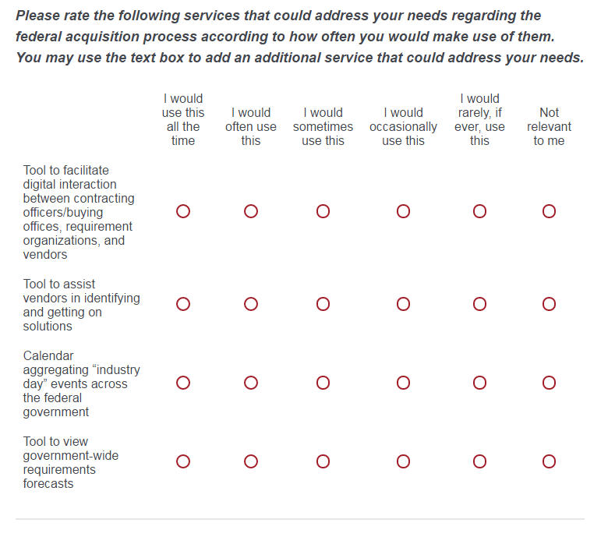

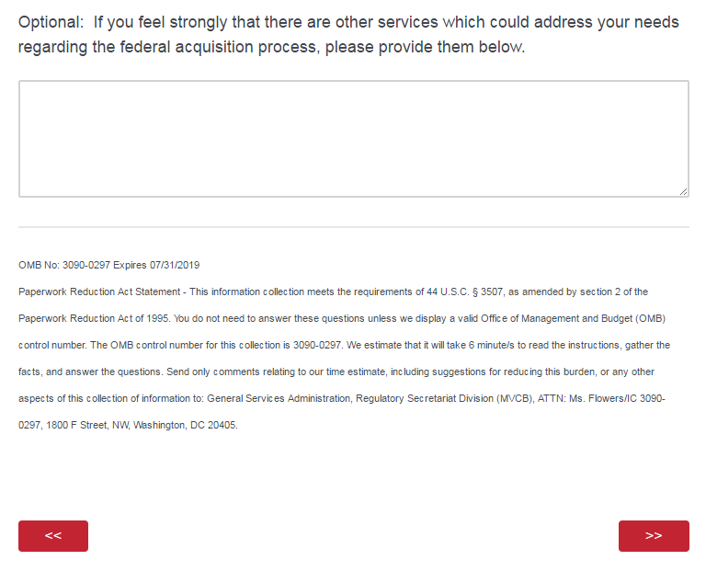

**Screen 5**

