**FAST Track 3090-0297 Instrument**

**Req-7**

Email Text Sent to Exhibitors Who Participated in the GSA Federal Acquisition Training Symposium

Thank you for attending the GSA Federal Acquisition Training Symposium.  We would like to hear from you about your experience during this education and training event.  Please take a few minutes to complete our short survey.  Your comments will be reviewed and will help us in planning and improving future events.

**Follow this link to the Survey:**  
[Take the survey](https://feedback.gsa.gov/jfe/preview/SV_2gc0m2oLJTKYf9X?Q_CHL=preview)

Or copy and paste the URL below into your internet browser:  
<https://feedback.gsa.gov/jfe/preview/SV_2gc0m2oLJTKYf9X?Q_CHL=preview>

Follow the link to opt out of future emails:  
[Click here to unsubscribe](https://feedback.gsa.gov/CP/Register.php?OptOut=true&RID&LID&BT=Z3NhY2Vt%250D%250A&_=1)  
  
Sincerely,  
GSA Federal Acquisition Training Symposium  
  
If you experience any technical difficulties, please send an email to [fasresearch@gsa.gov](mailto:fasresearch@gsa.gov)  
  
Paperwork Reduction Act Statement - This information collection meets the requirements of 44 U.S.C. § 3507, as amended by section 2 of the PaperworkReduction Act of 1995. You do not need to answer these questions unless we display a valid Office of Management and Budget (OMB) control number. The OMB control number for this collection is 3090-0297. We estimate that it will take 5 minutes to read the instructions, gather the facts, and answer the questions. Send only comments relating to our time estimate, including suggestions for reducing this burden, or any other aspects of this collection of information to: General Services Administration, Regulatory Secretariat Division (MVCB), ATTN: Joanne Sosa/IC 3090-0297, 1800 F Street, NW, Washington, DC 20405.

**Screen Shots of GSA Federal Acquisition Training Symposium**

**Exhibitor Survey**

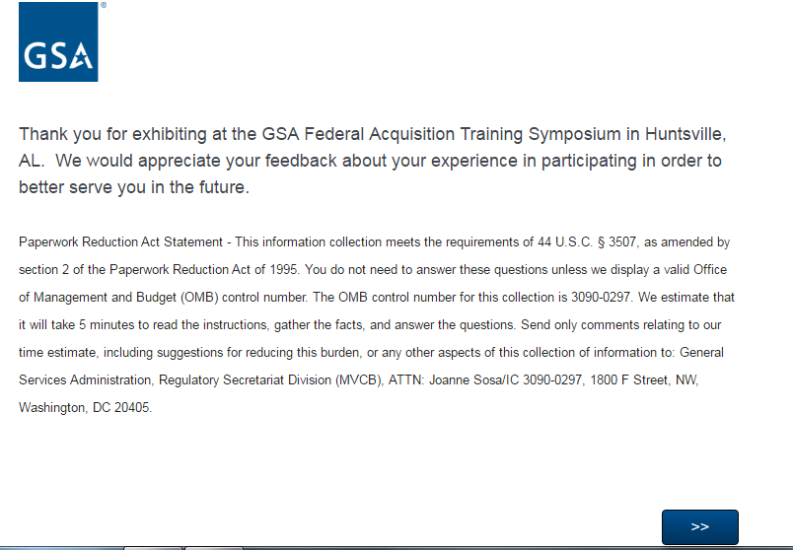

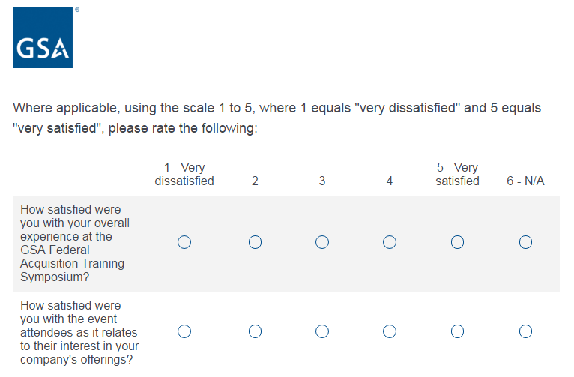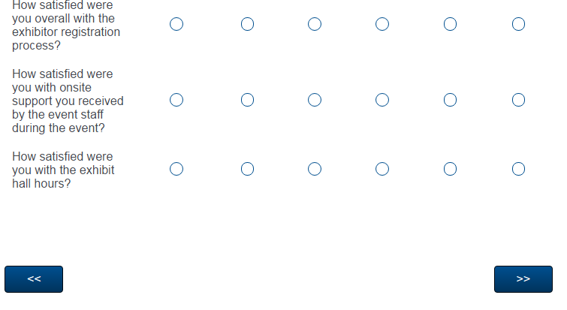

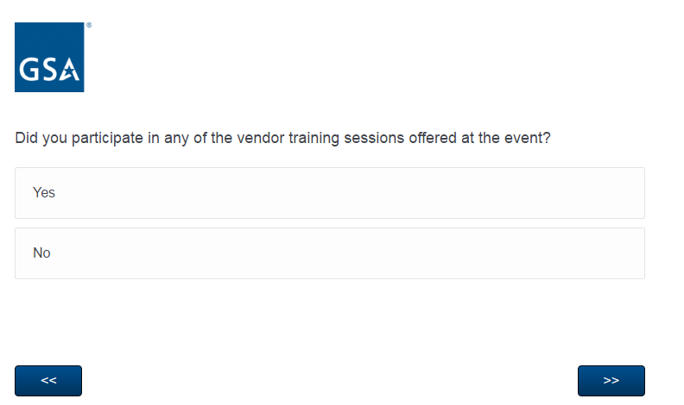

**If the respondent answers yes, they must respond to questions on the next 2 pages.**

**If the respondent answers no, they will automatically skip to the question that reads “Did you participate in any customer focused training sessions offered at the event?”**

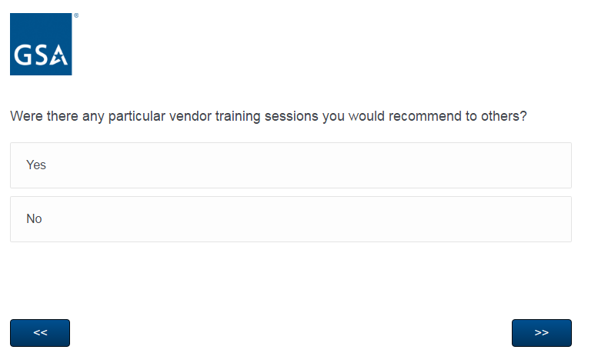

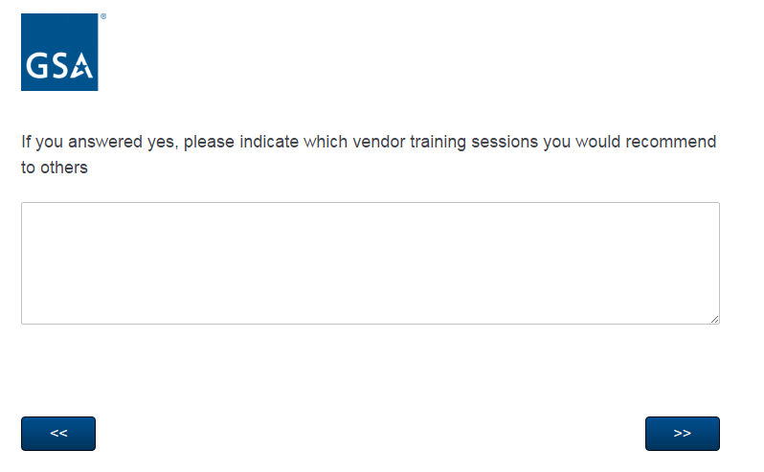

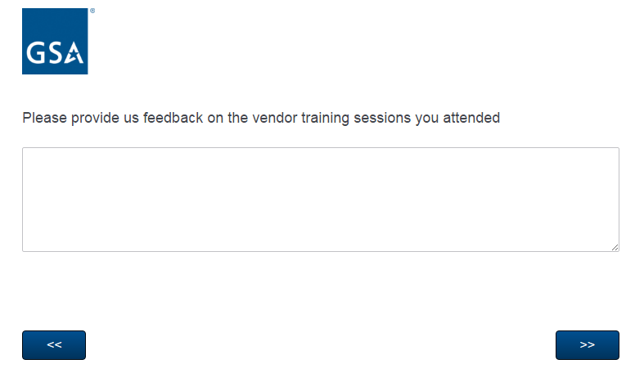

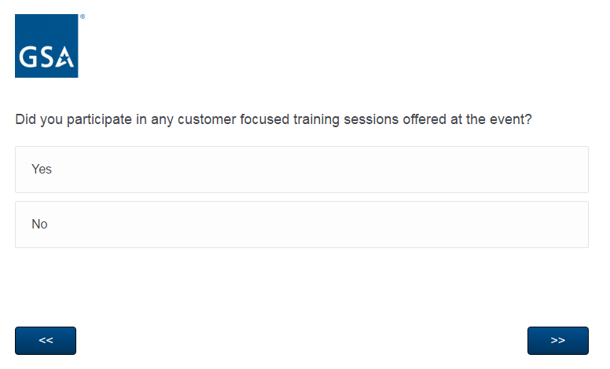**If the respondent answers yes, they must respond to questions on the next 2 pages.**

**If the respondent answers no, they will automatically skip to the question that reads “Did your company obtain any business leads during the event?”**

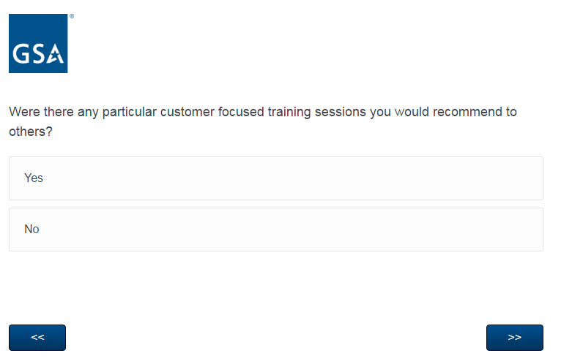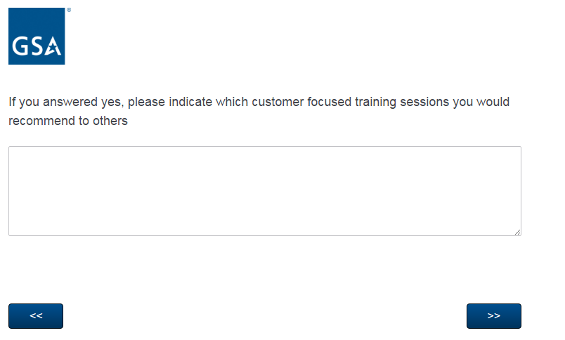

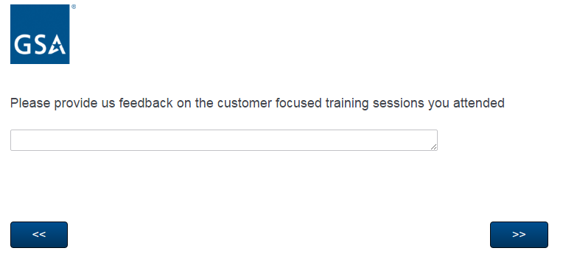

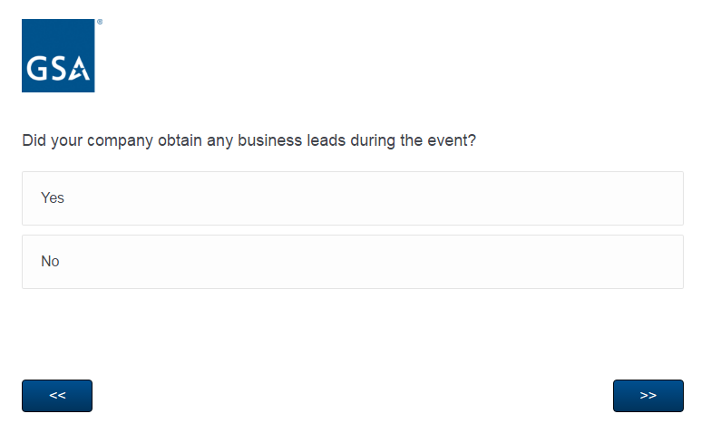

**If the respondent answered yes, they must select an amount (see next page)**

**If the respondent answered no, they will skip to the question that reads “How likely are you to recommend this symposium to a colleague?**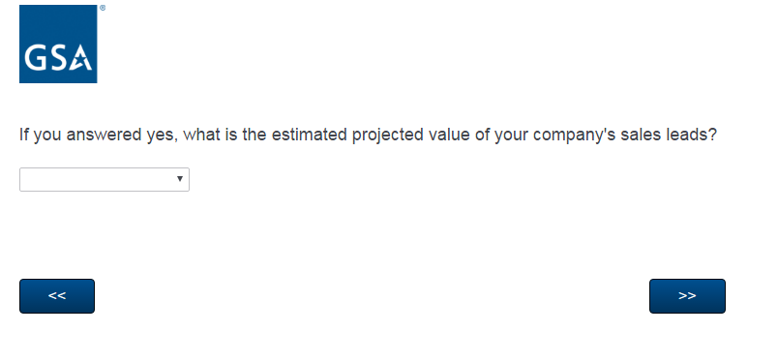

**If the respondent answered yes, they must select any amount from the list below:**

* **Under $10,000**
* **$10,001 - $99,999**
* **$100,000 - $500,000**
* **Over $500,000**

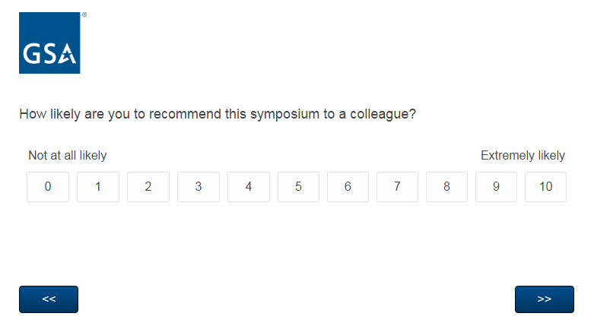

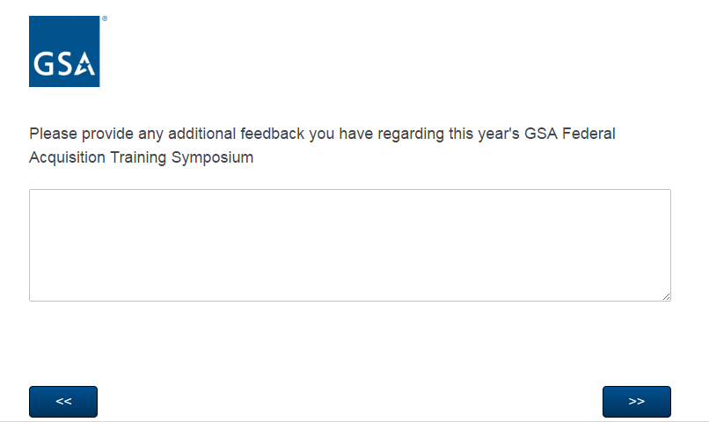

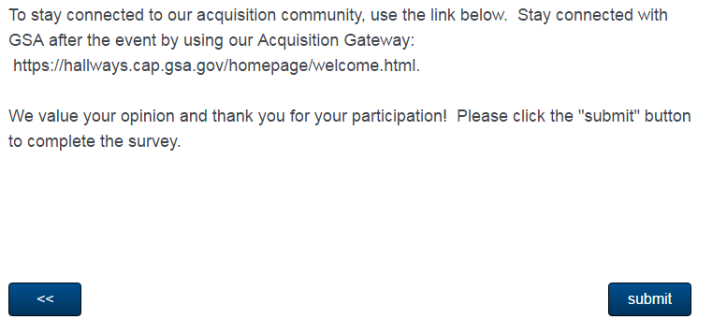

**After completion of the survey, respondents are routed to the Acquisition Gateway website** [**https://hallways.cap.gsa.gov/homepage/welcome.html**](https://hallways.cap.gsa.gov/homepage/welcome.html) **(see next page)**

