**3090-0297 Instrument**

**Email Text to Industry Attendees**

**GSA Professional Services and Human Capital Symposium**

**Req-9**

Thank you for attending the GSA Professional Services and Human Capital Symposium in Tacoma, WA.  We would like to hear from you about your experience while participating in order to better serve you in the future.  Please take a few minutes to complete our survey.  Your comments will be reviewed and will help us in planning and improving future events.

**Follow this link to the Survey:**   
[Take the survey](https://feedback.gsa.gov/jfe/preview/SV_bgB7TQcWONJKBKd?Q_CHL=preview)

Or copy and paste the URL below into your internet browser:  
<https://feedback.gsa.gov/jfe/preview/SV_bgB7TQcWONJKBKd?Q_CHL=preview>

Follow the link to opt out of future emails:  
[Click here to unsubscribe](https://feedback.gsa.gov/CP/Register.php?OptOut=true&RID&LID&BT=Z3NhY2Vt%250D%250A&_=1)  
  
Sincerely,  
GSA Professional Services and Human Capital Symposium  
  
If you experience any technical difficulties, please send an email to [fasresearch@gsa.gov](mailto:fasresearch@gsa.gov)  
  
Paperwork Reduction Act Statement - This information collection meets the requirements of 44 U.S.C. § 3507, as amended by section 2 of the Paperwork Reduction Act of 1995. You do not need to answer these questions unless we display a valid Office of Management and Budget (OMB) control number. The OMB control number for this collection is 3090-0297. We estimate that it will take 8 minutes to read the instructions, gather the facts, and answer the questions. Send only comments relating to our time estimate, including suggestions for reducing this burden, or any other aspects of this collection of information to: General Services Administration, Regulatory Secretariat Division (MVCB), ATTN: Joanne Sosa/IC 3090-0297, 1800 F Street, NW, Washington, DC 20405.

**INTRODUCTION AND SURVEY QUESTIONS**

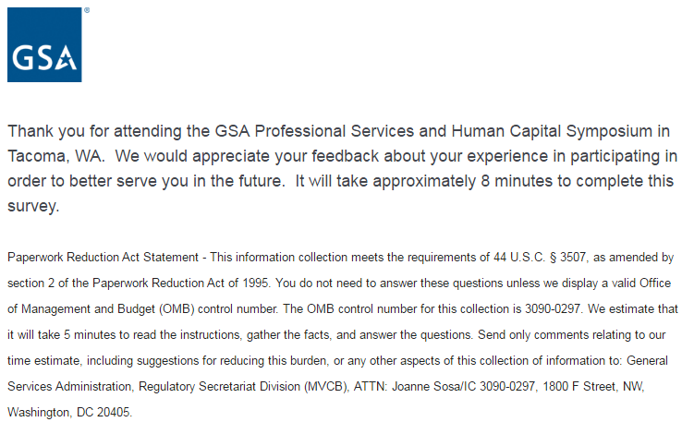



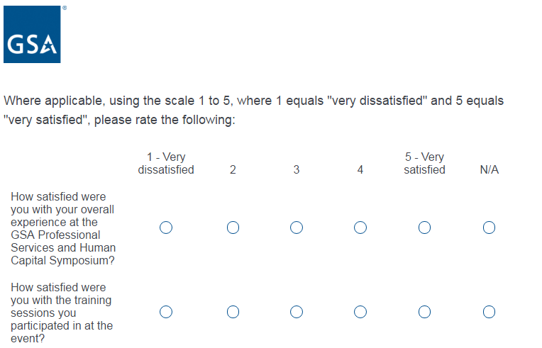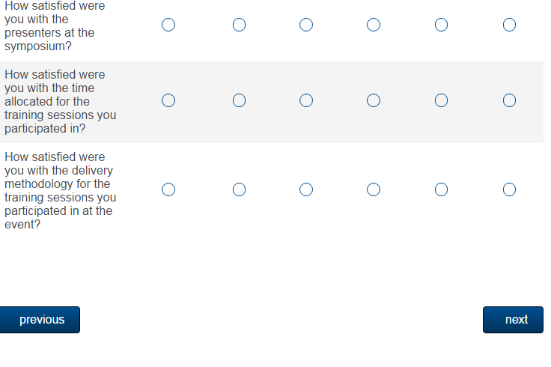

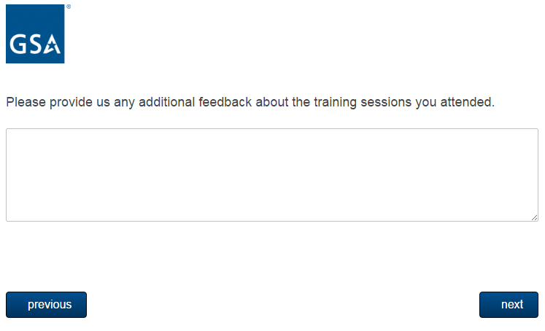

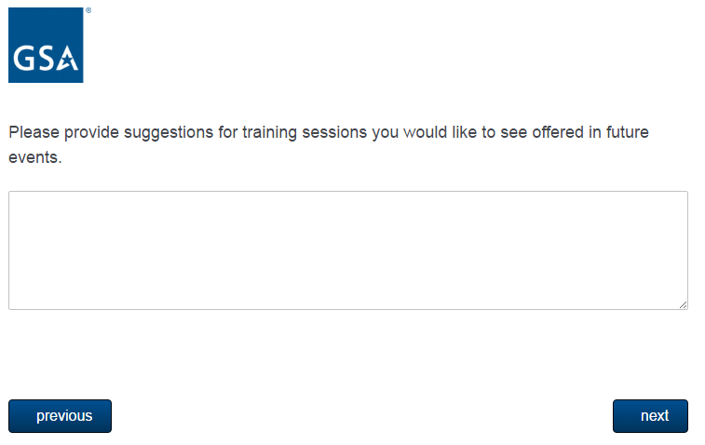

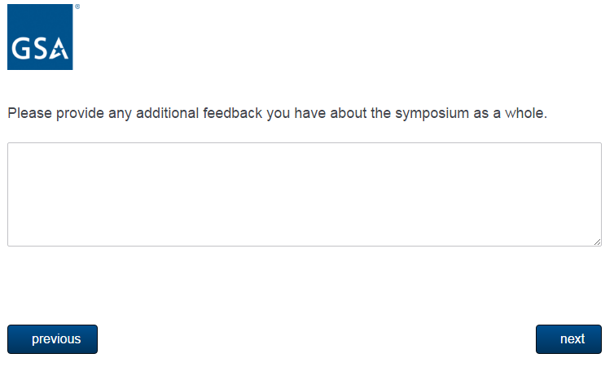

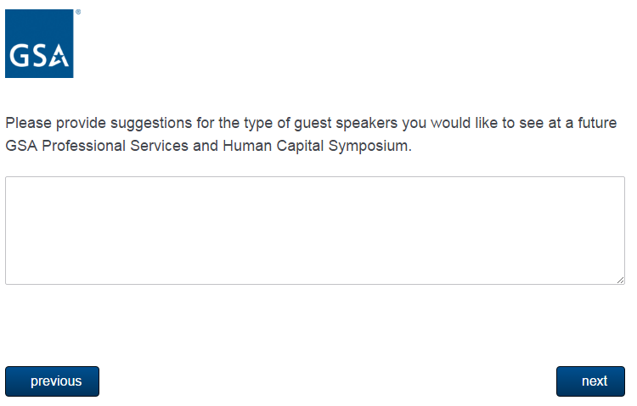

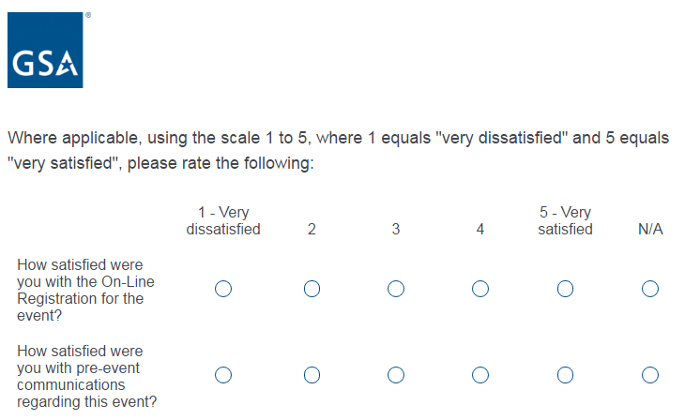

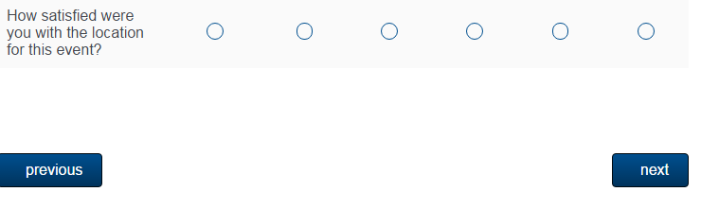

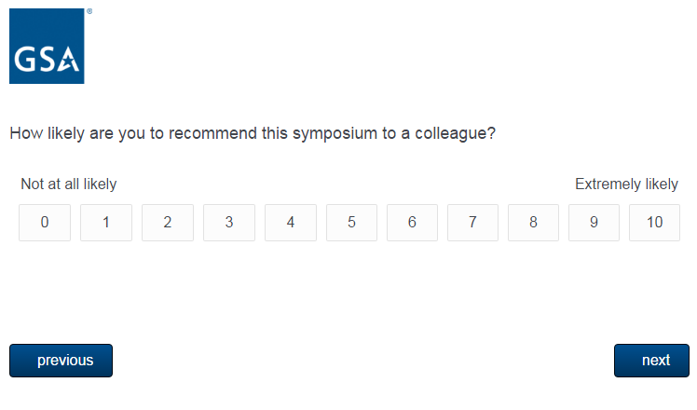

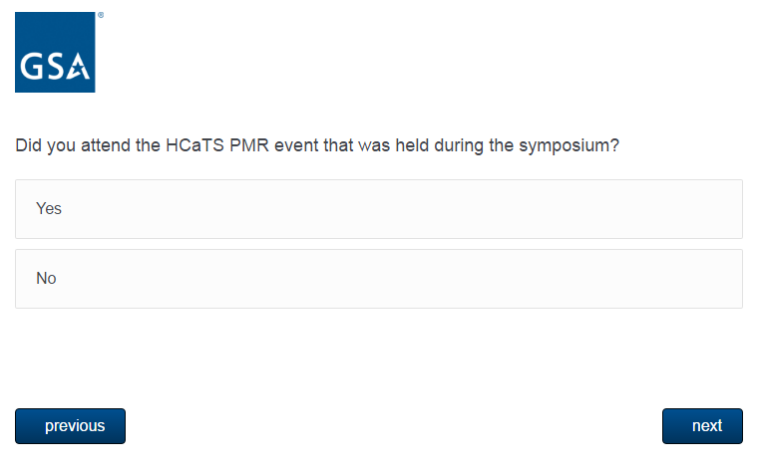

**IF RESPONDENT SAYS YES, THEY WILL BE ASKED THE FOLLOWING 3 QUESTIONS. IF RESPONDENT SAYS NO, THEY WILL SKIP TO OASIS PMR EVENT RELATED QUESTIONS**

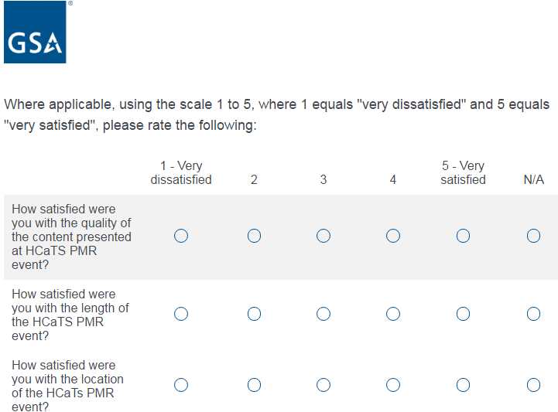



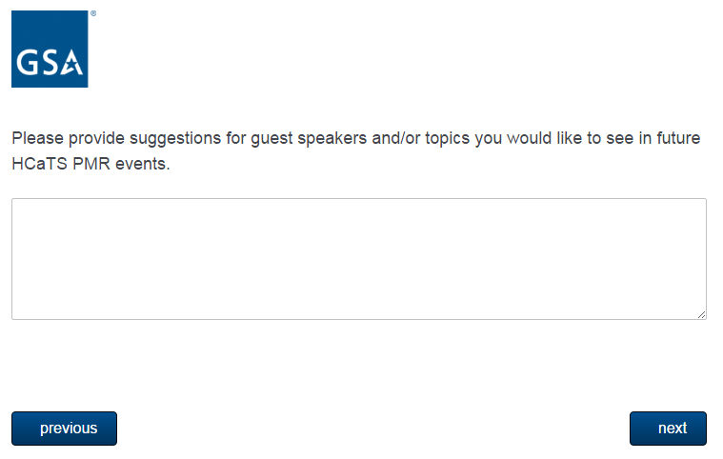

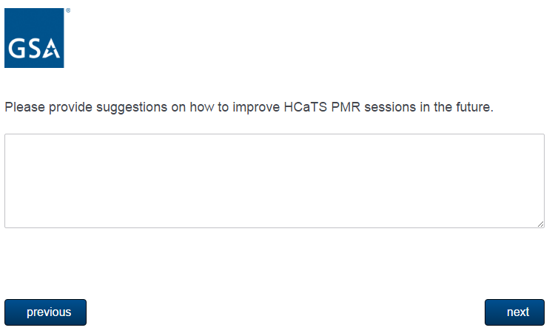

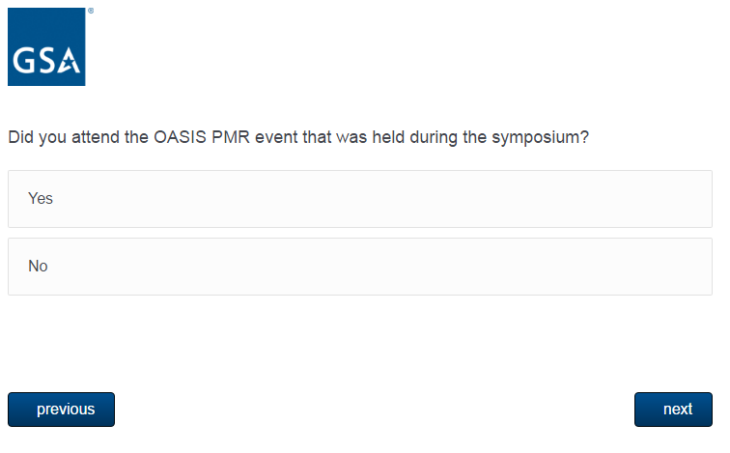

**IF RESPONDENT SAYS YES, THEY WILL BE ASKED THE FOLLOWING 3 QUESTIONS. IF THEY RESPOND SAYS NO, THEY WILL SKIP TO END OF SURVEY.**

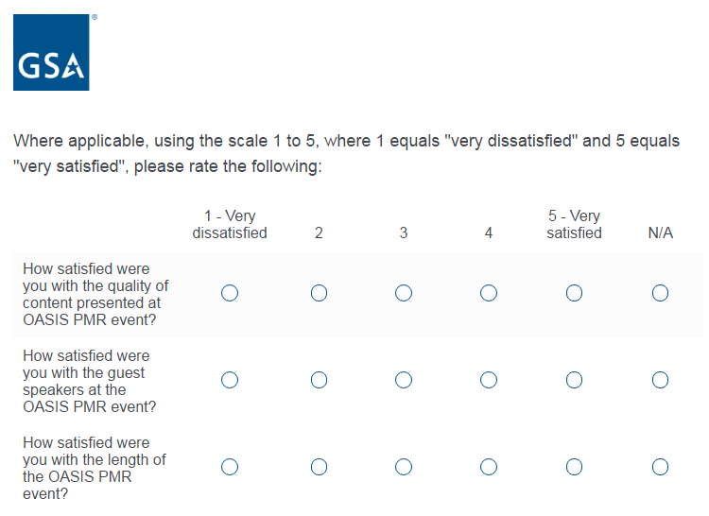

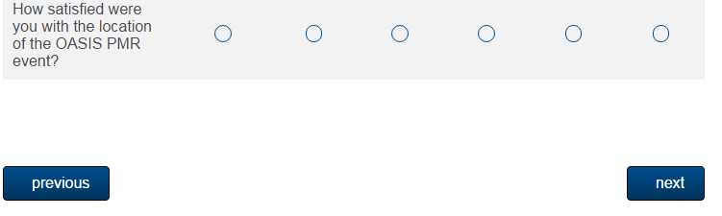

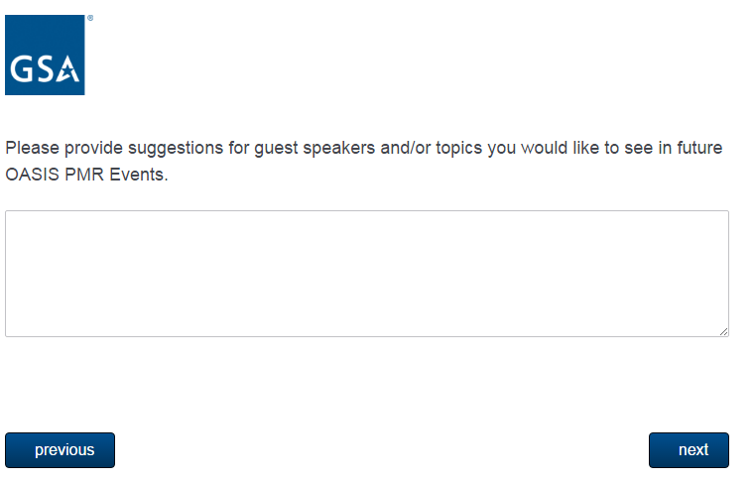

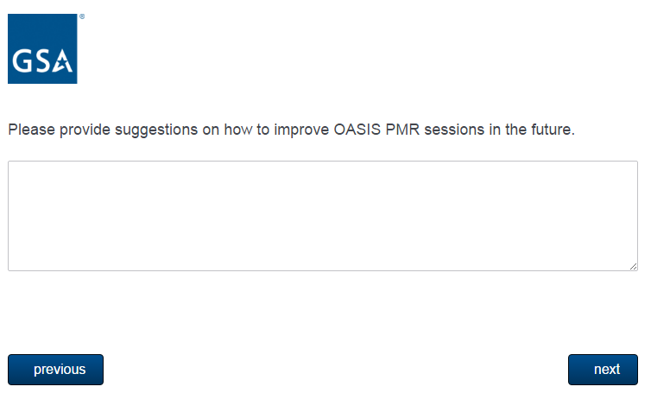

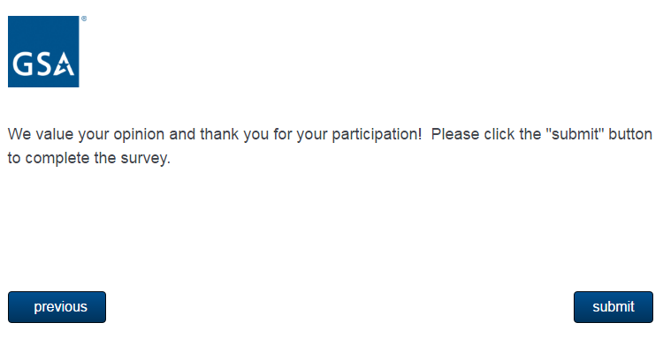

**EXIT PAGE ONCE RESPONDENT HITS “SUBMIT” BUTTON**

