## 3090-0297-Instrument for User Test of USA.gov Home Page English

## Req-8

## 

Desktop and Mobile resolutions.

Pre-Test PRA Statement

**Desktop Resolution**

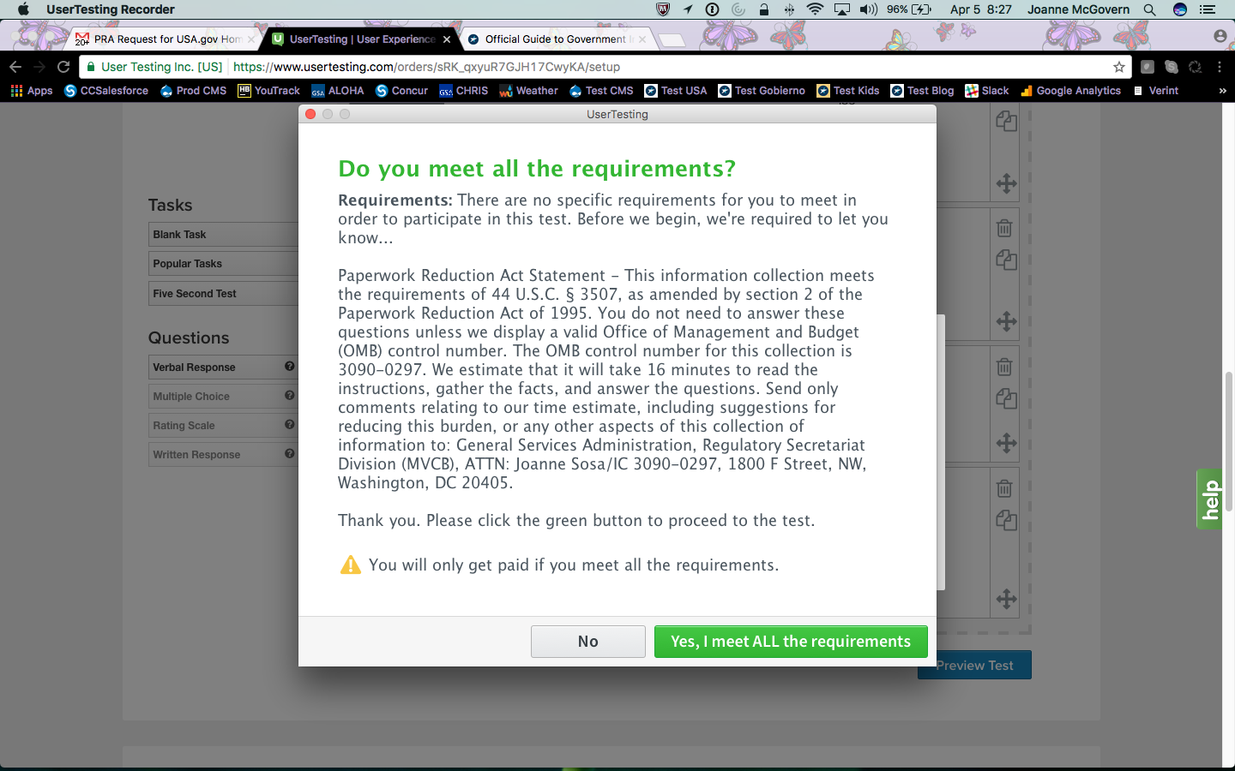

Pre-Test PRA Statement

**Mobile Resolution**

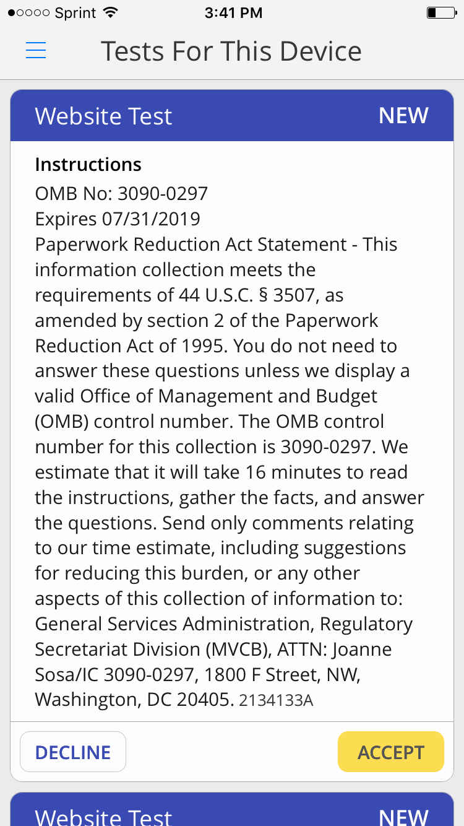

1. Browse around this web page for a moment. You can scroll, but don't click on anything. Please tell us who you think this site is for, and what you think you can do here.

**Desktop Resolution Scenario 1**

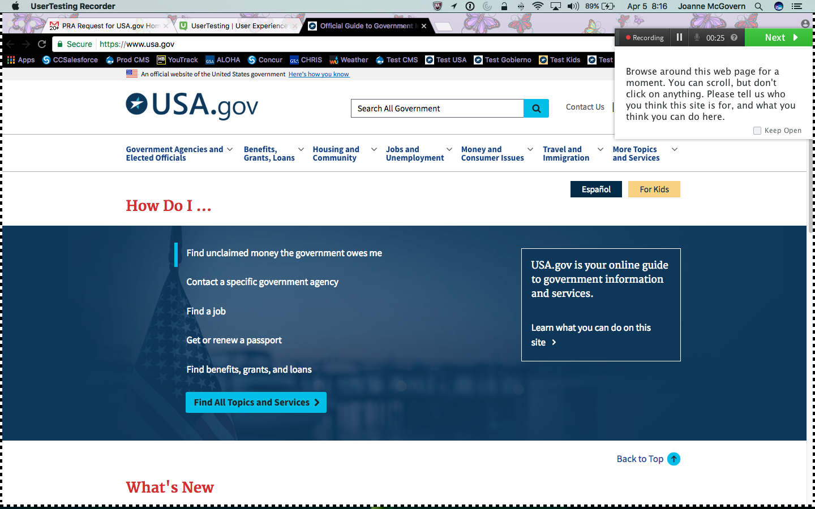

**Mobile Resolution Scenario 1**

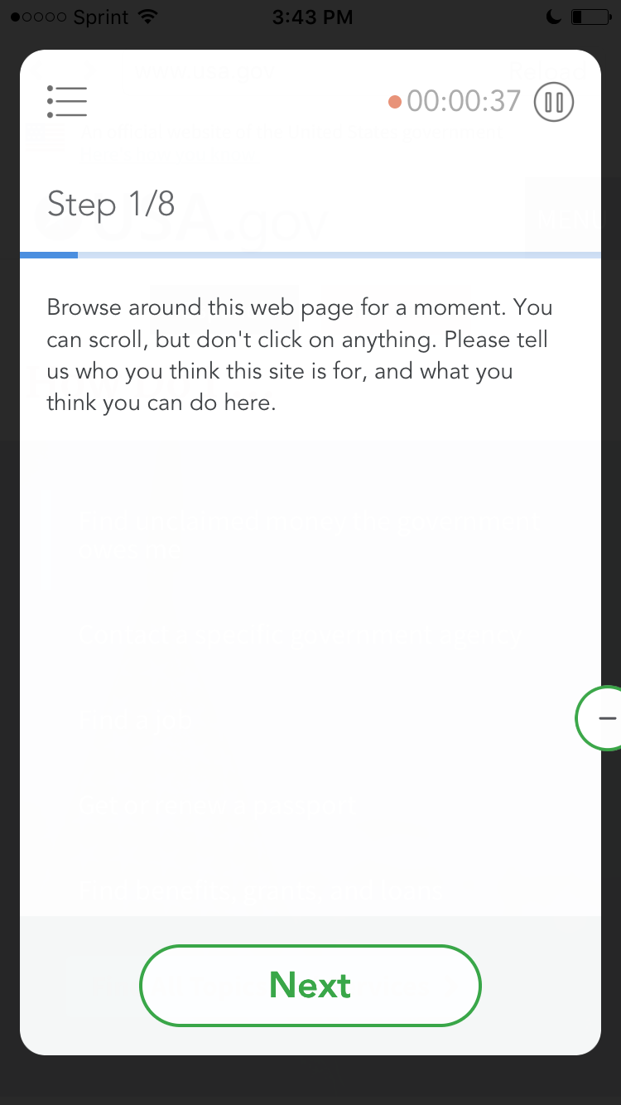

2. You’re really interested in politics and you can’t wait to register to vote when you turn 18 next month. Where would you look to find information about registering to vote?

**Desktop Resolution Scenario 2**

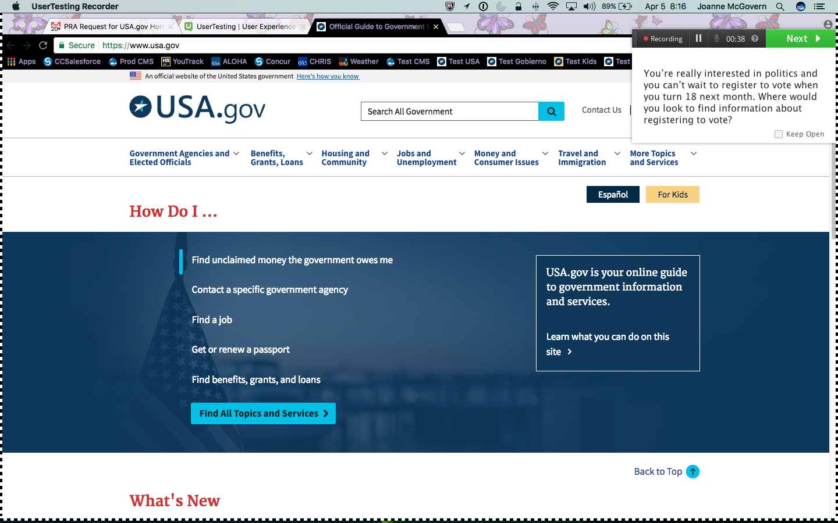

**Mobile Resolution Scenario 2**

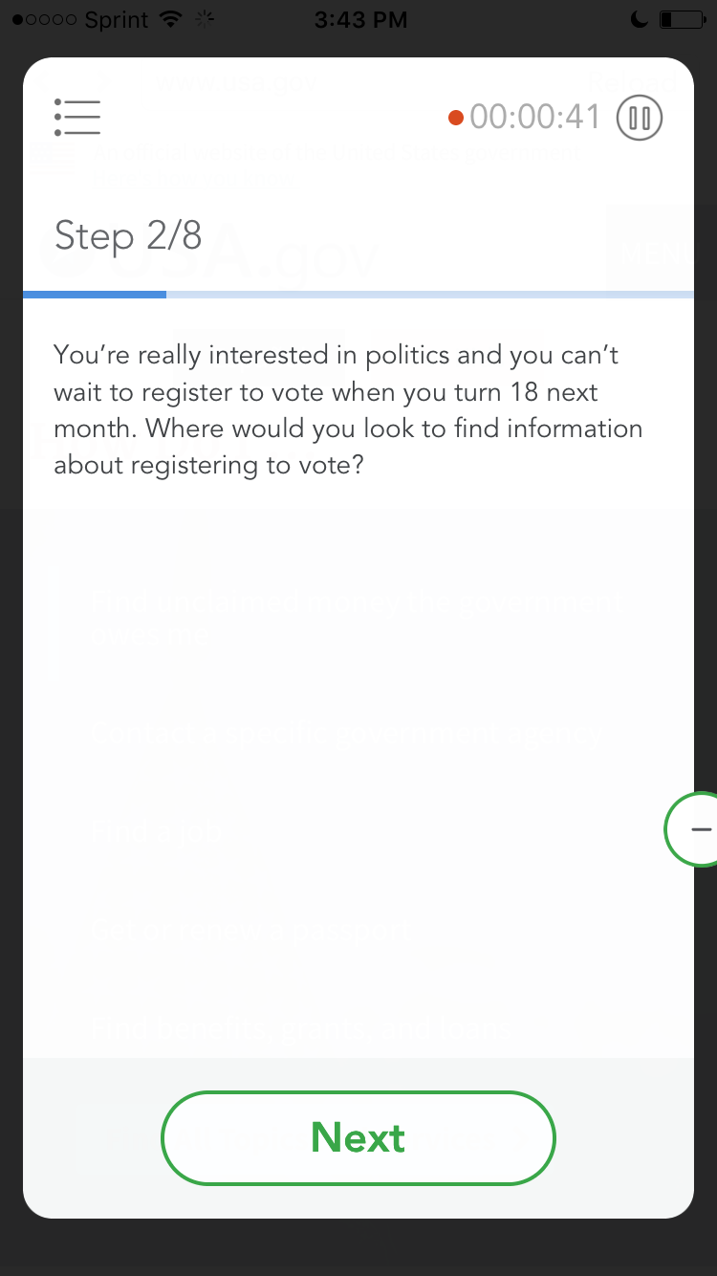

3. You want to read President Trump’s biography. You’re somebody who likes to search for information, and since you know exactly what you’re looking for, you want to use a search engine to find it. Where would you find a search function on this site?

**Desktop Resolution Scenario 3**

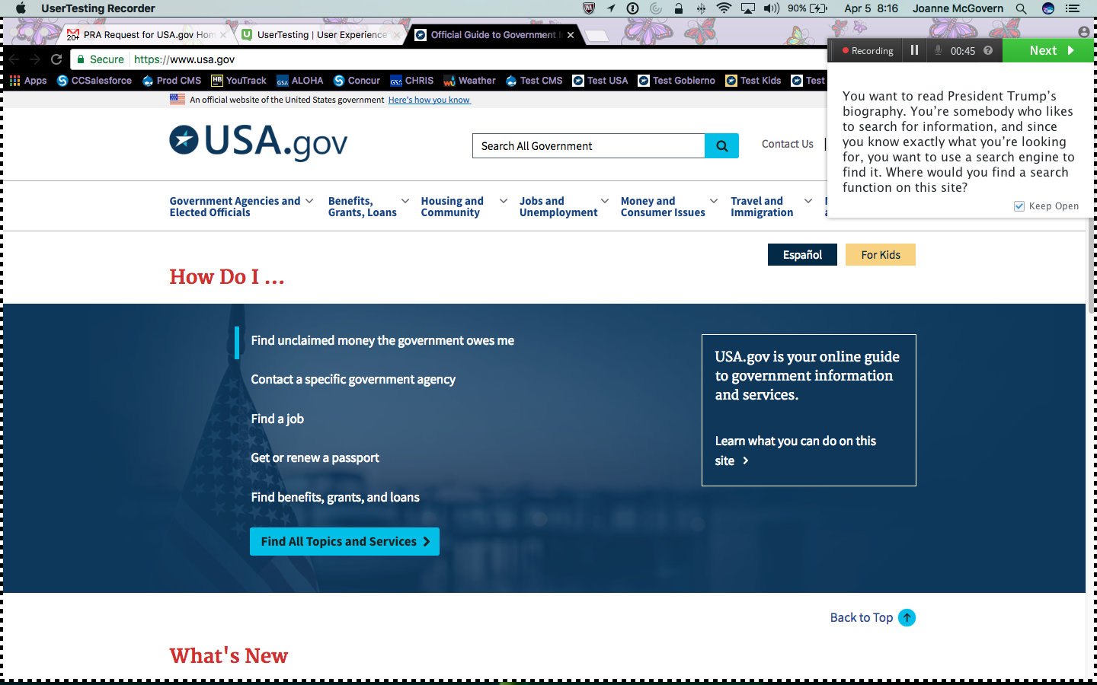

**Mobile Resolution Scenario 3**

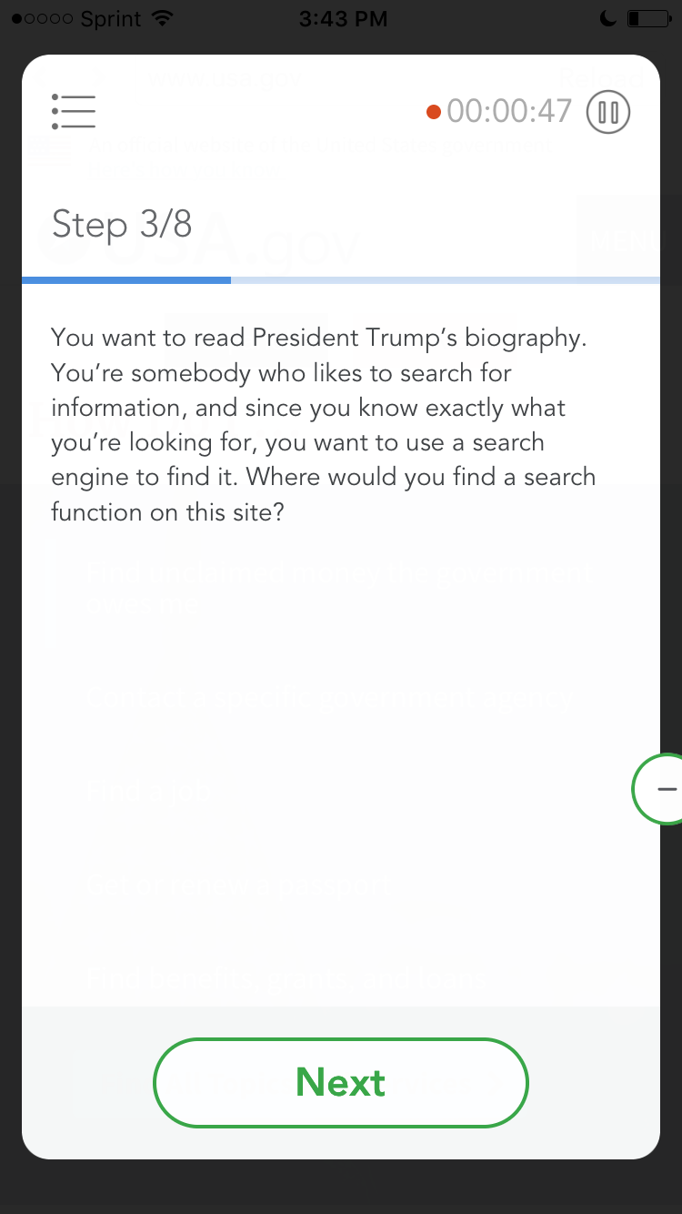

4. Today you heard something on the news about a ground beef recall. How can you find a phone number for the USDA (US Department of Agriculture) to see if the beef in your freezer is safe?

**Desktop Resolution Scenario 4**

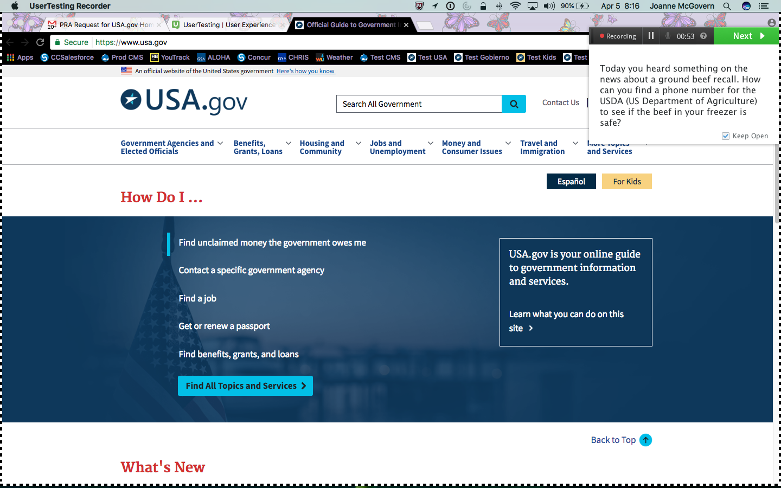

**Mobile Resolution Scenario 4**

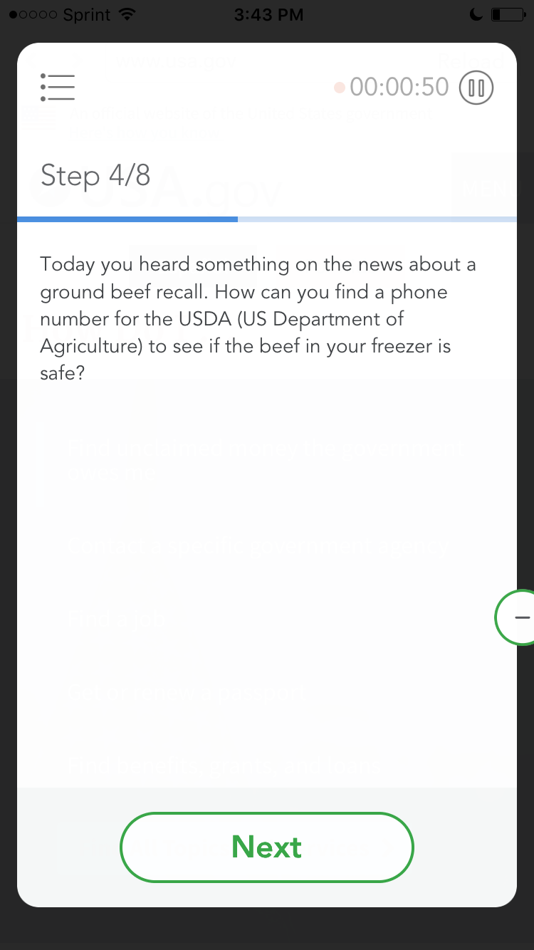

5. Someone broke into your car. They took your car insurance card with your personal information on it. Can you find a phone number for someone who can help you prevent identity theft before it’s too late?

**Desktop Resolution Scenario 5**

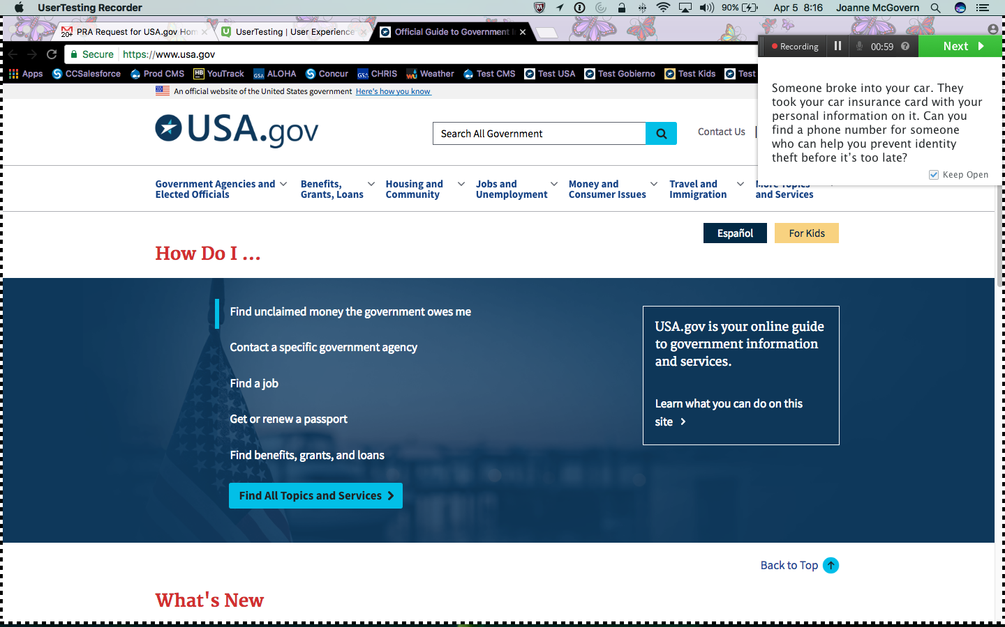

**Mobile Resolution Scenario 5**

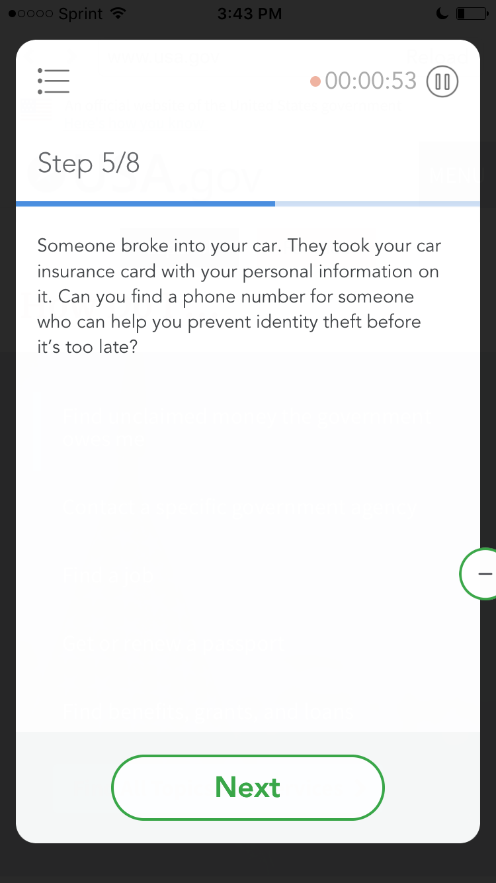

6. You noticed that your passport expires next month, and you want to renew it. Where would you find information on how to renew your passport?

**Desktop Resolution Scenario 6**

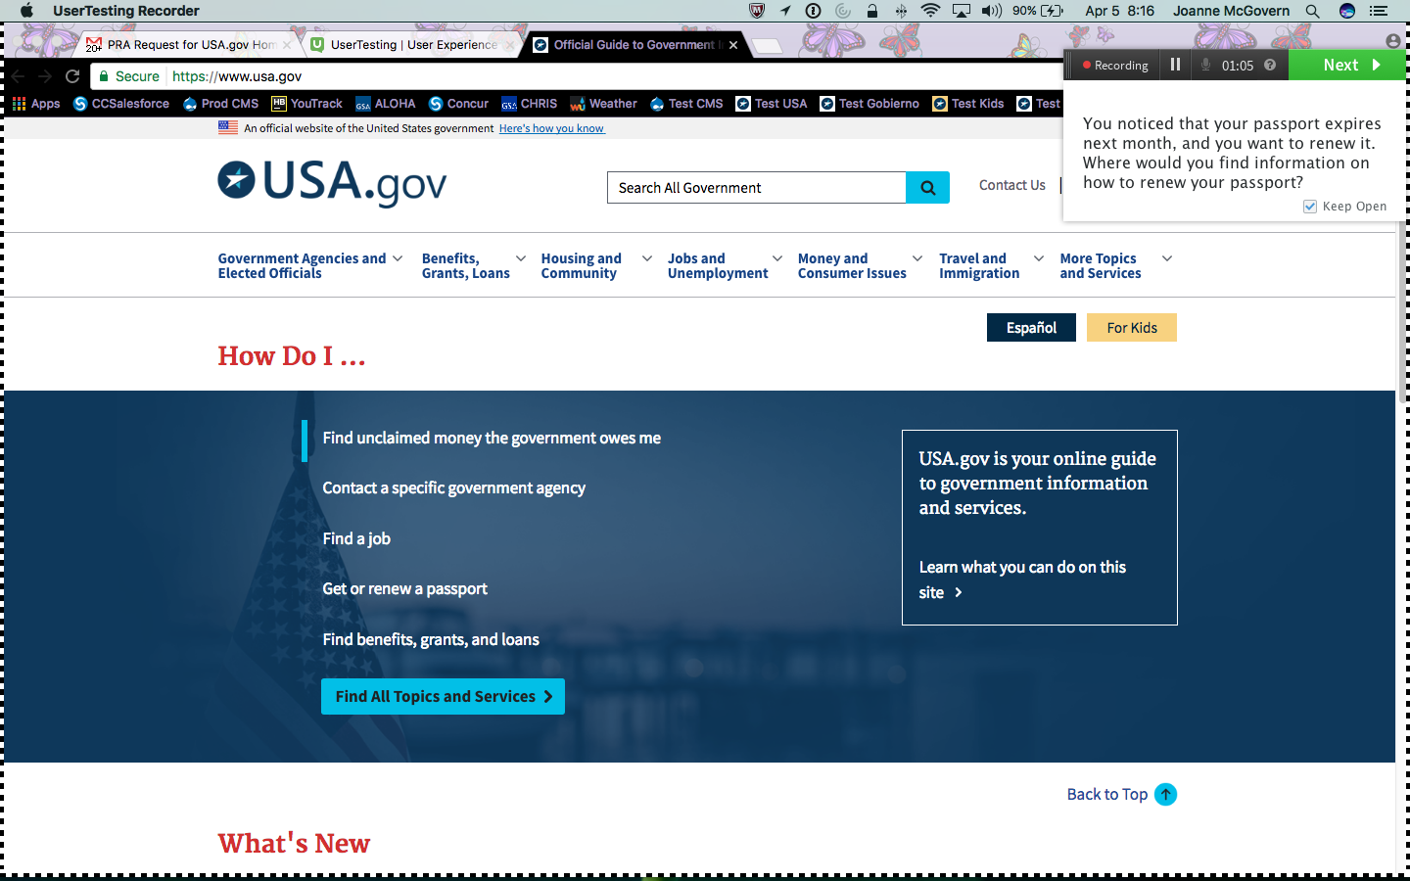

**Mobile Resolution Scenario 6**

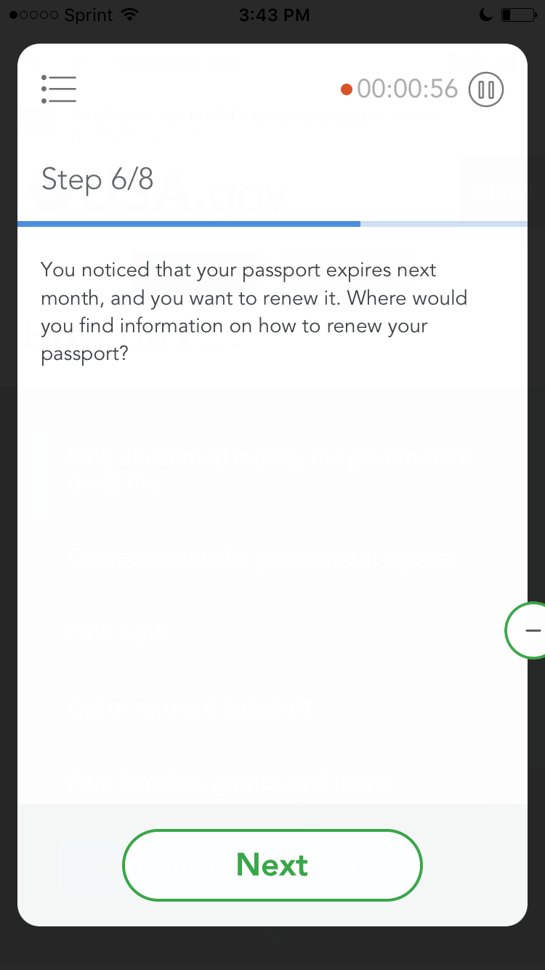

7. You were born and raised in the United States, but your parents are from Colombia and they don’t speak English very well. They need information about Social Security so they can plan for their upcoming retirement. Is there a place on this website where you can find information in Spanish?

**Desktop Resolution Scenario 7**

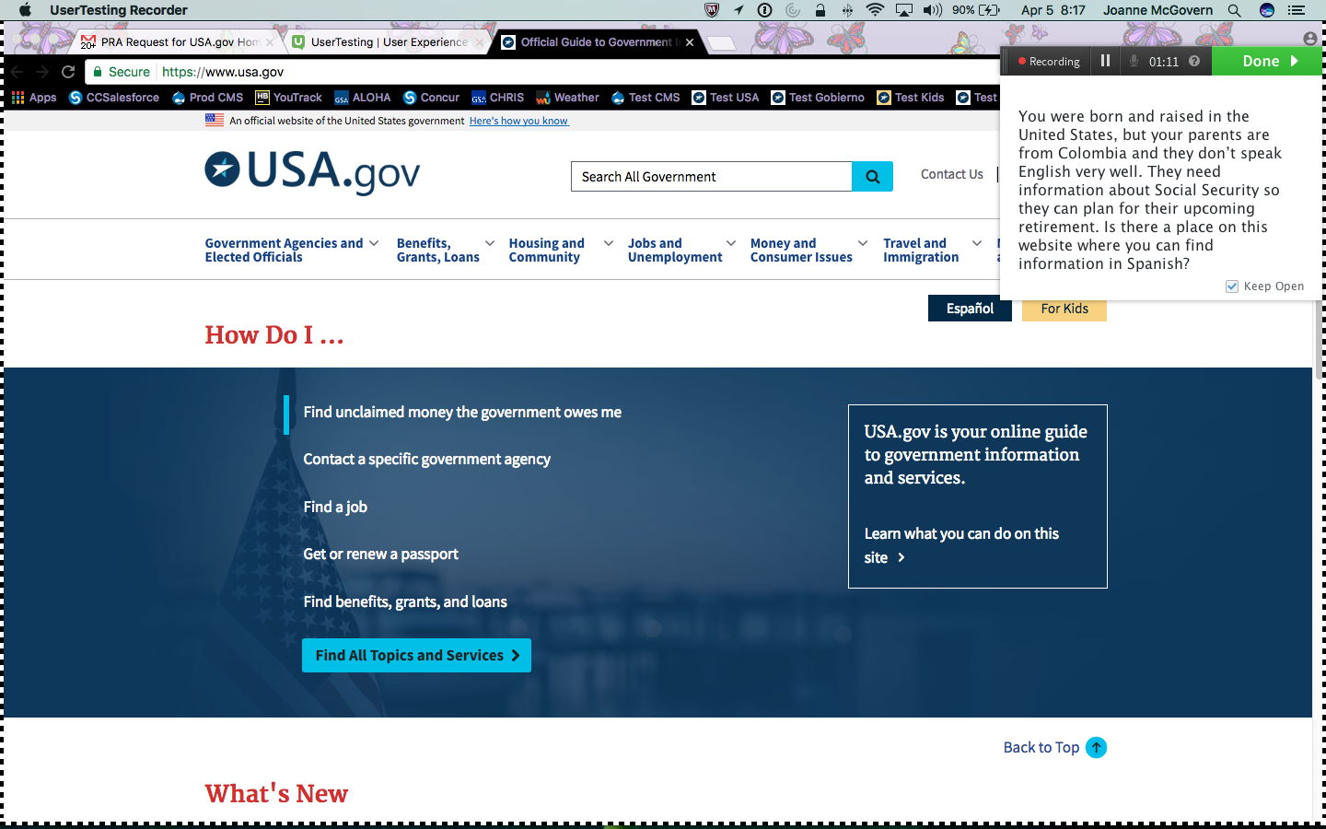

**Mobile Resolution Scenario 7**

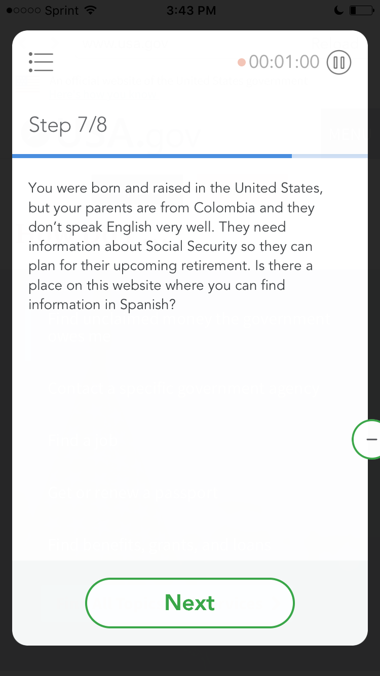

8. Scroll down, near the bottom of the page. You’ll see a link labeled “About USA.gov”. Don’t click it. Please tell us what you think you would see if you did click it.

**Scenario 8 is for mobile test participants only**

