**FAST Track 3090-0297**

**Req-10**

**Fleet Marshaling Transactional Survey**

**Screen 1**

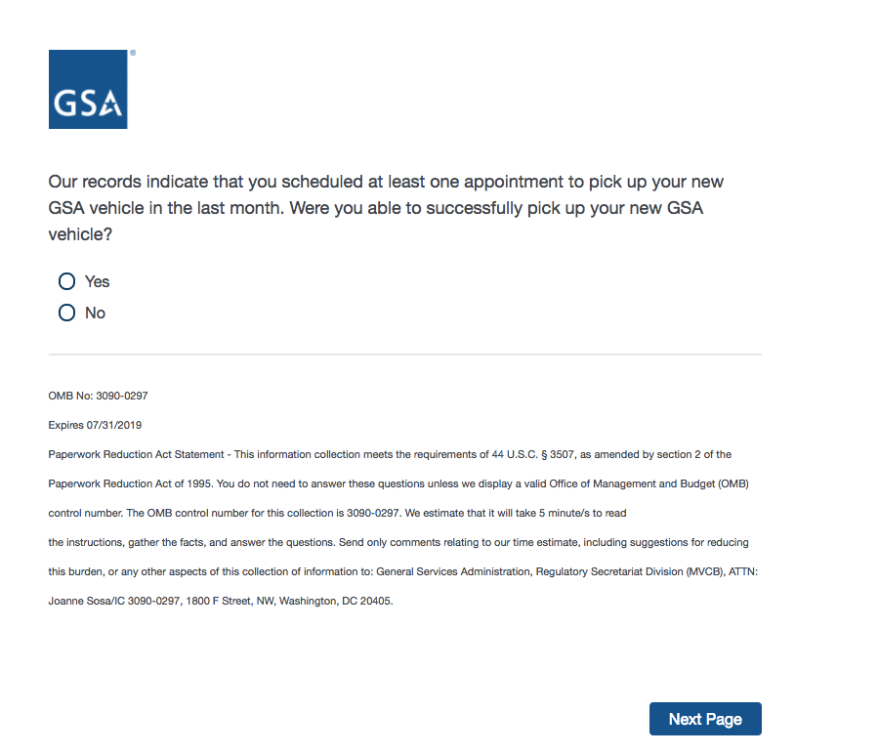

If Yes, then Display Screen 2.

If No, then skip to Screen 6

**Screen 2**

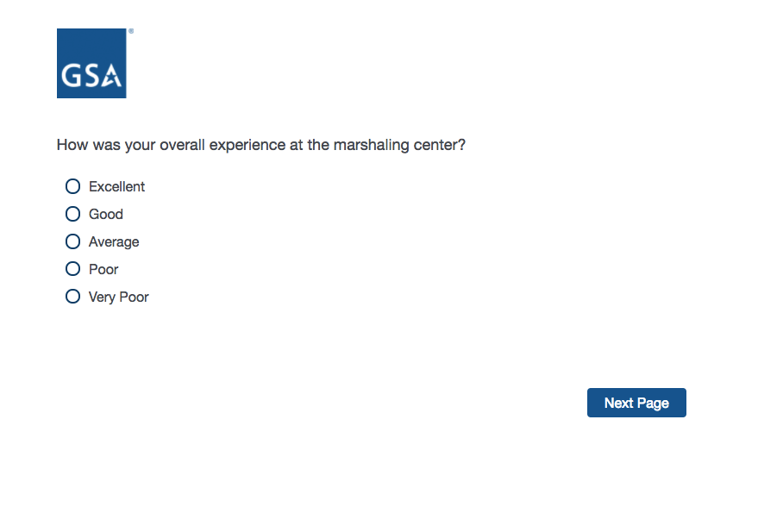

If Average, Poor, or Very Poor, then display Screen 3

If Excellent or Good, skip to Screen 4.

**Screen 3**

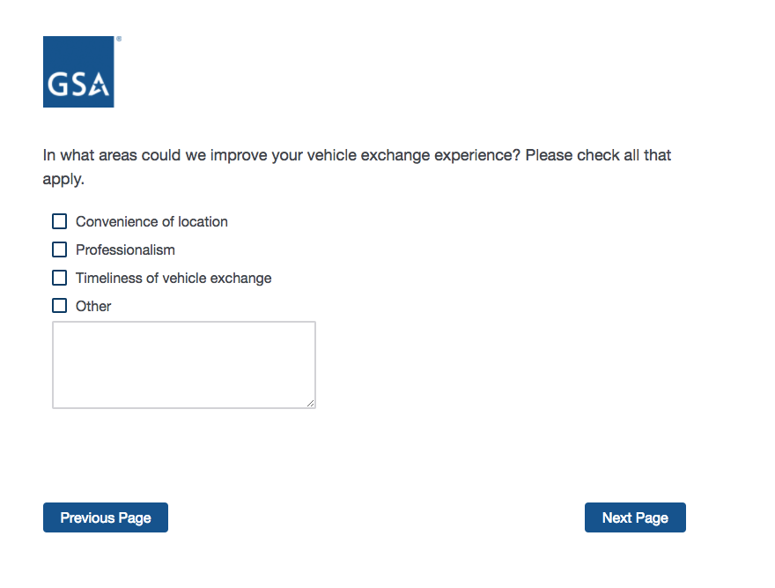

**Screen 4**

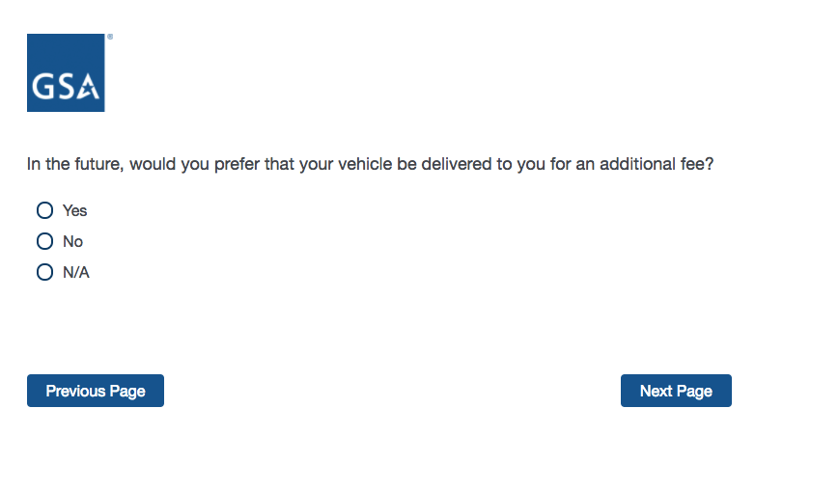

**Screen 5**

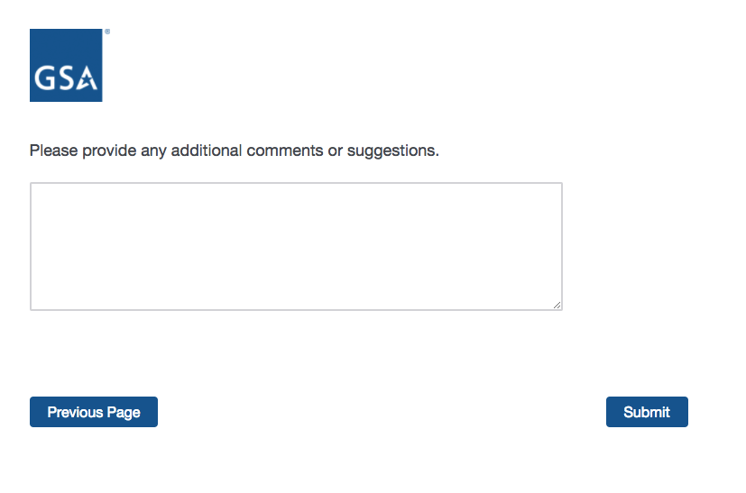

End of Survey:

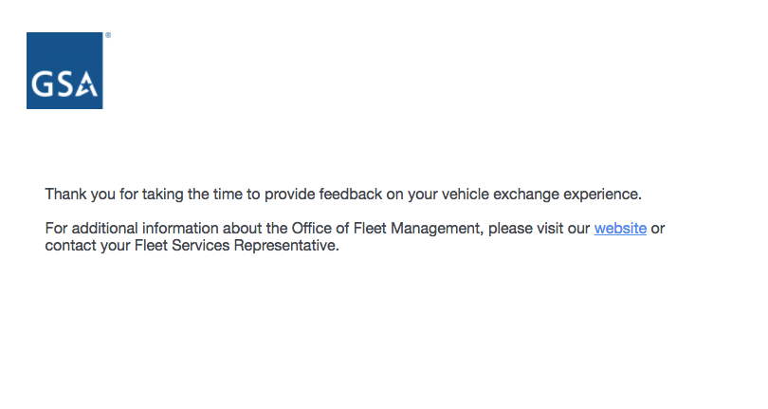

**Screen 6**

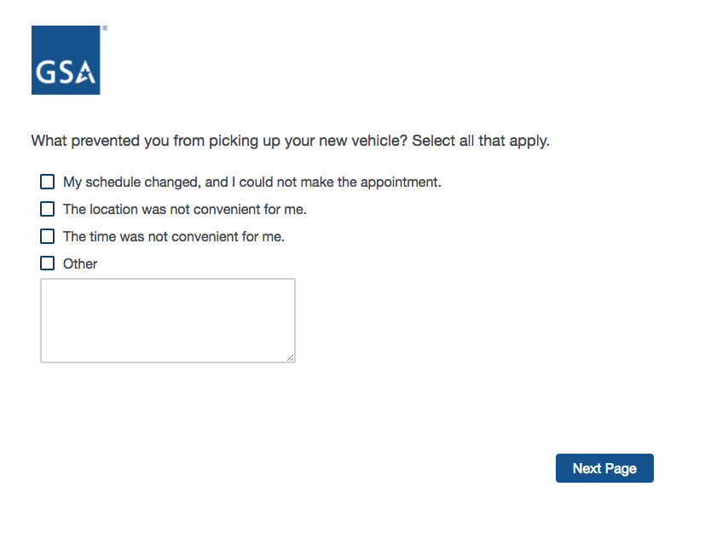

**Screen 7**

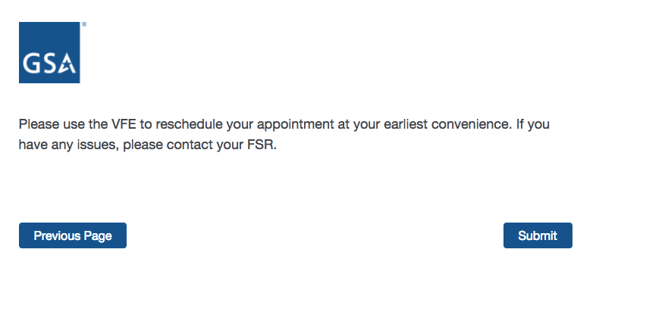

End of Survey:

