**2017 Supplier Relationship Management Survey**

For PRA Review only – Contents of this box will not be displayed to recipients.

Note that this survey depends on embedded data to determine which questions will be displayed to the recipient. Embedded data are commands built into the survey that draw information from the contact list. Survey responses remain confidential, and personally identifiable information is not solicited.

The embedded data fields that are used in this survey are:

* GSA Program Office (program being rated)
* Schedule (Primary GSA contract through which the supplier does business)

**Screen 1**



**Screen 2**

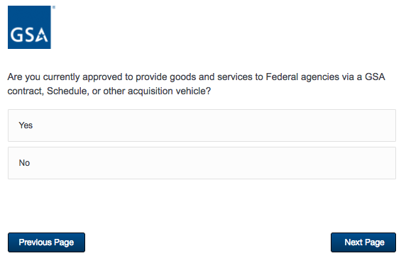

If No, then display Screen 3.

If Yes and GSA Program Office (embedded data) = GSA General Supplies and Services, GSA Fleet, GSA Information Technology Category, GSA Center for Travel Management, GSA Center for Transportation Management, or GSA Employee Relocation Resource Center (ERRC), then display Screen 4.

If Yes and GSA Program Office (embedded data) = GSA OASIS, GSA Professional Services Schedule, or GSA Professional Services as a whole, then skip to Screen 6.

**Screen 3**

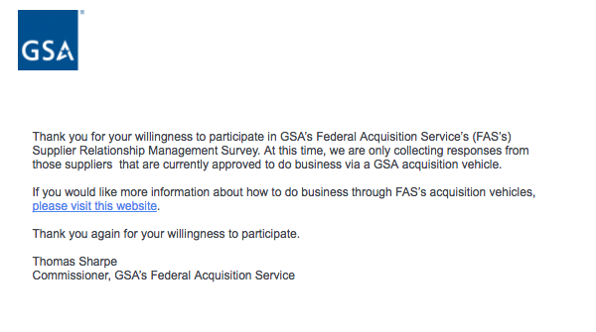

**Screen 4a**

Displayed if GSA Program Office (embedded data) = GSA General Supplies and Services.

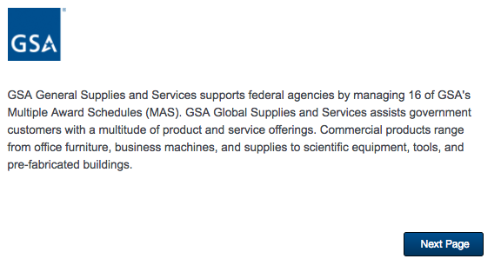

**Screen 4b**

Display if GSA Program Office (embedded data) = GSA Fleet:

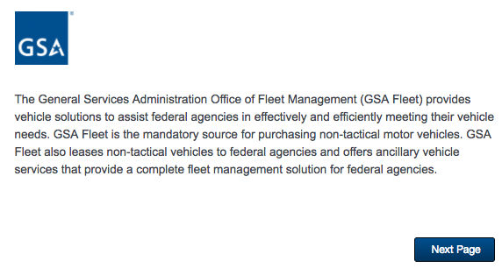

**Screen 4c**

Display if GSA Program Office (embedded data) = GSA Information Technology Category:

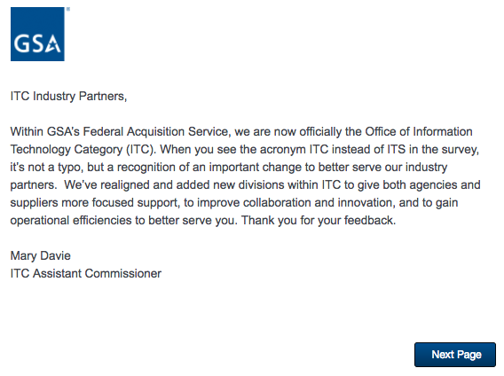

**Screen 4d**

Display if GSA Program Office (embedded data) = GSA Center for Travel Management:



**Screen 4e**

Display if GSA Program Office (embedded data) = GSA Center for Transportation Management:



**Screen 4f**

Display if GSA Program Office (embedded data) = GSA Employee Relocation Resource Center (ERRC):

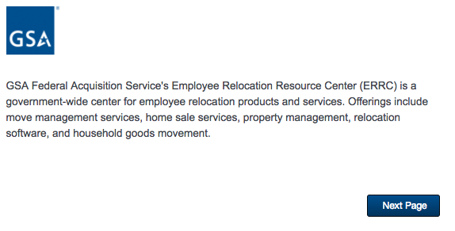

**Screen 5**

Display if GSA Program Office (embedded data) = GSA General Supplies and Services

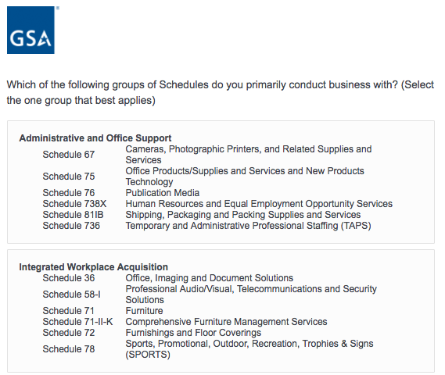

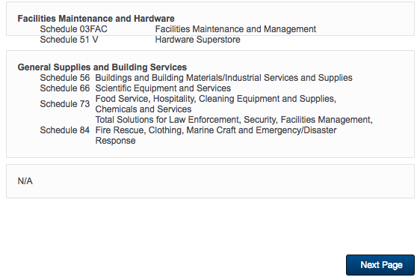

**Screen 6a**

Display if GSA Program Office (embedded data) = GSA General Supplies and Services

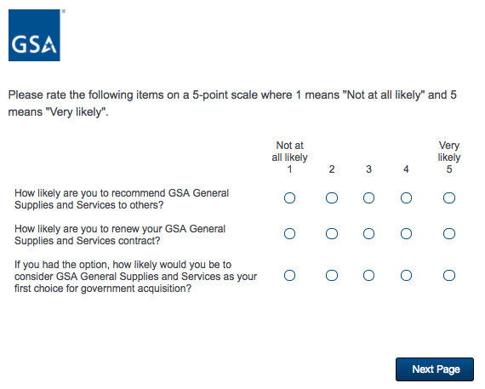

**Screen 6b**

Display if GSA Program Office (embedded data) = GSA Fleet

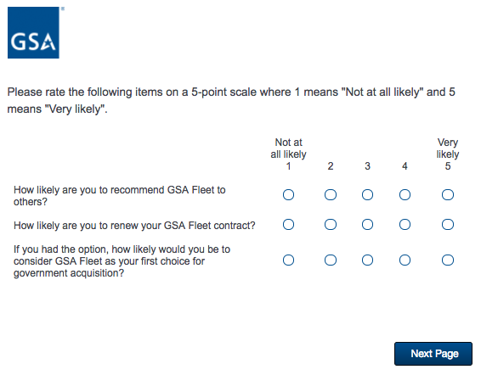

**Screen 6c**

Display if GSA Program Office (embedded data) = GSA Professional Services Schedule

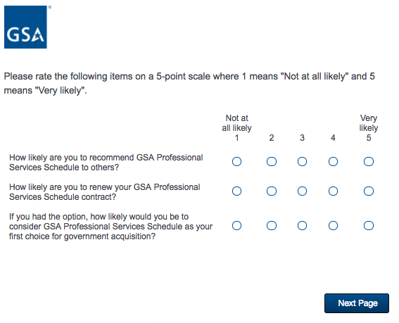

**Screen 6d**

Display if GSA Program Office (embedded data) = GSA OASIS

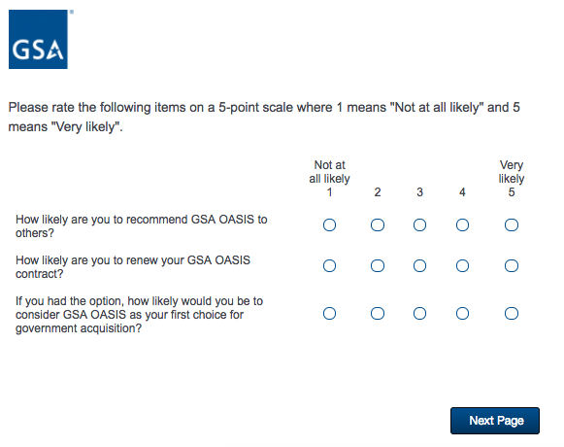

**Screen 6e**

Display if GSA Program Office (embedded data) = GSA Professional Services as a whole

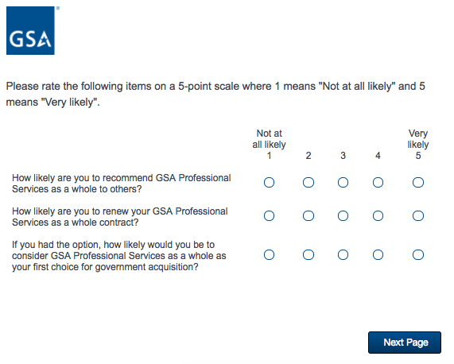

**Screen 6f**

Display if GSA Program Office (embedded data) = GSA Center for Travel Management

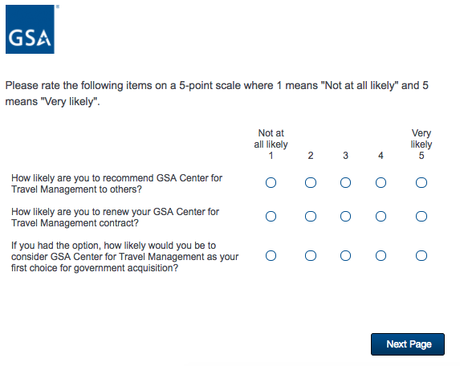

**Screen 6g**

Display if GSA Program Office (embedded data) = GSA Center for Transportation Management



**Screen 6h**

Display if GSA Program Office (embedded data) = GSA Employee Relocation Resource Center (ERRC)

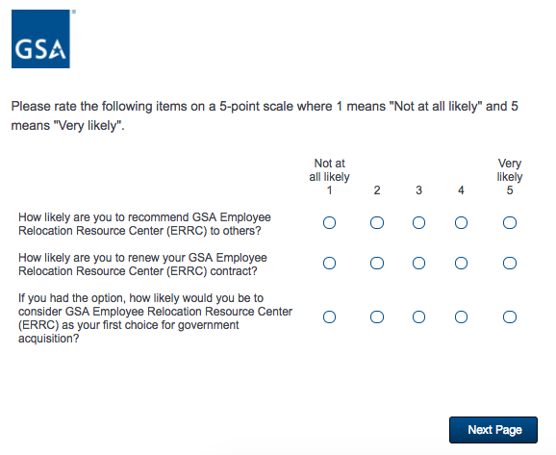

**Screen 7a**

Display if GSA Program Office (embedded data) = GSA General Supplies and Services

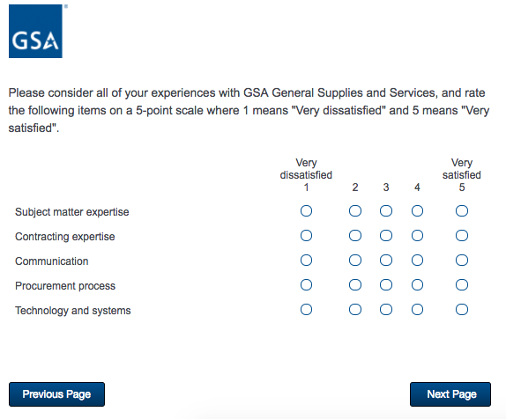

**Screen 7b**

Display if GSA Program Office (embedded data) = GSA Fleet

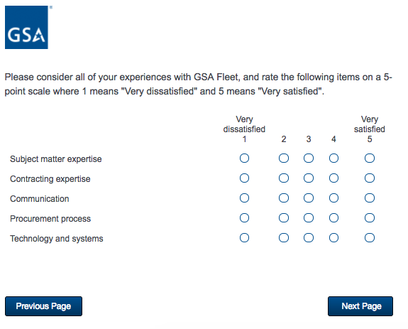

**Screen 7c**

Display if GSA Program Office (embedded data) = GSA Professional Services Schedule

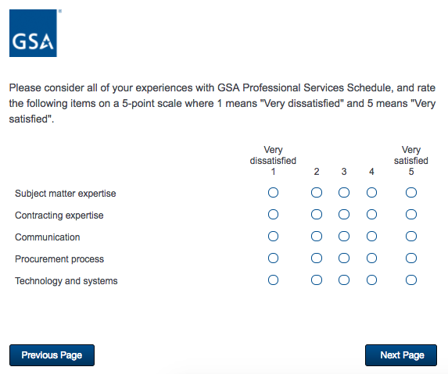

**Screen 7d**

Display if GSA Program Office (embedded data) = GSA OASIS

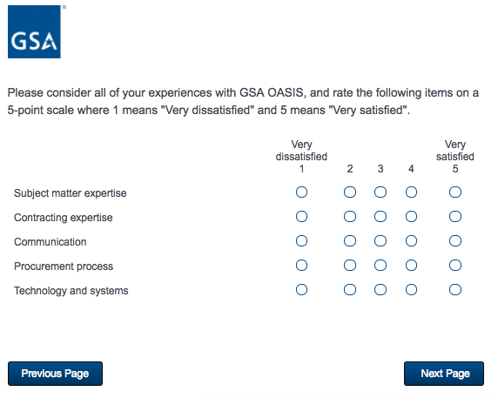

**Screen 7e**

Display if GSA Program Office (embedded data) = GSA Professional Services as a whole

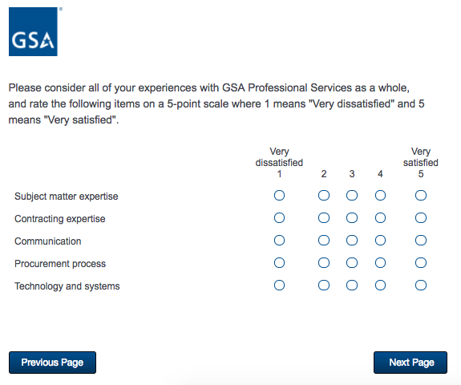

**Screen 7f**

Display if GSA Program Office (embedded data) = GSA Center for Travel Management

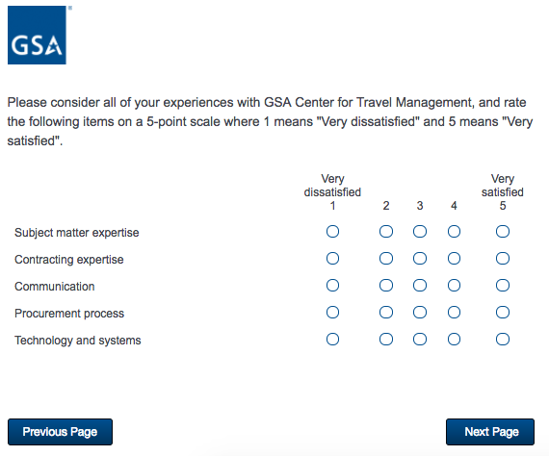

**Screen 7g**

Display if GSA Program Office (embedded data) = GSA Center for Transportation Management

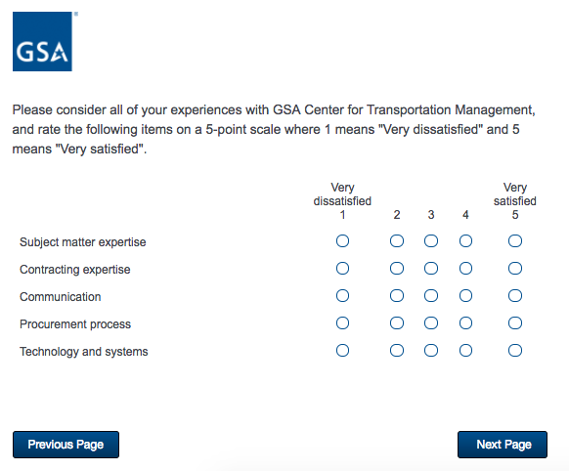

**Screen 7h**

Display if GSA Program Office (embedded data) = GSA Employee Relocation Resource Center (ERRC)

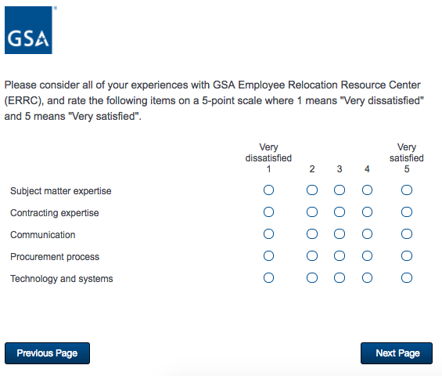

**Screen 8a**

Display if GSA Program Office (embedded data) = GSA General Supplies and Services

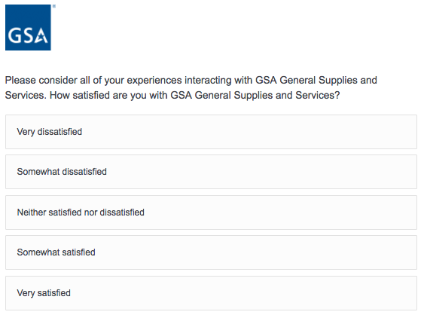

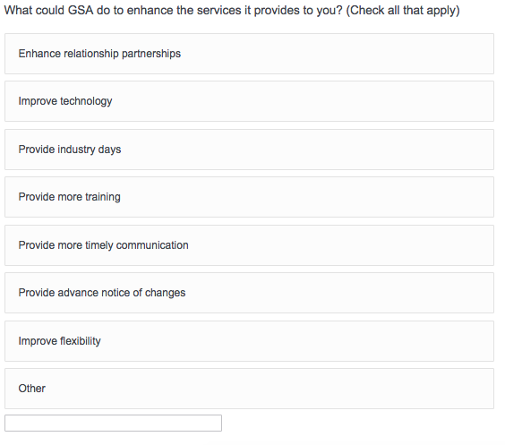

/Users/camilletucker/Desktop/Screen Shot 2017-05-29 at 8.39.09 PM.png

**Screen 8b**

Display if GSA Program Office (embedded data) = GSA Fleet

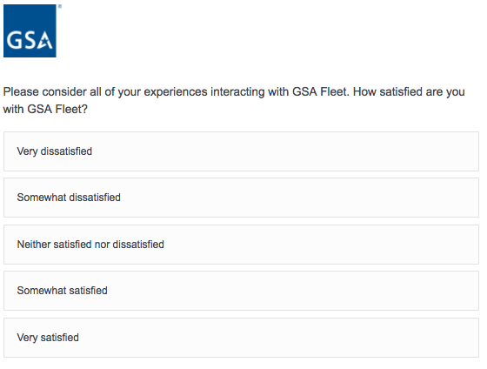



/Users/camilletucker/Desktop/Screen Shot 2017-05-29 at 8.39.09 PM.png

**Screen 8c**

Display if GSA Program Office (embedded data) = GSA Professional Services Schedule

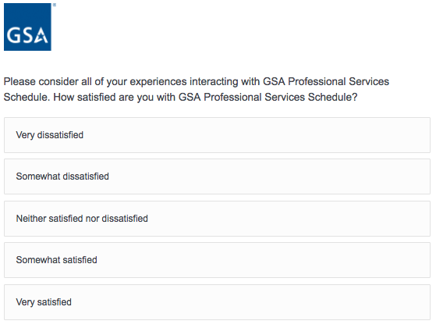



/Users/camilletucker/Desktop/Screen Shot 2017-05-29 at 8.39.09 PM.png

**Screen 8d**

Display if GSA Program Office (embedded data) = GSA OASIS

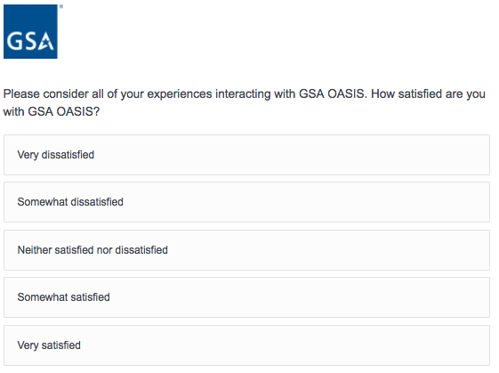



/Users/camilletucker/Desktop/Screen Shot 2017-05-29 at 8.39.09 PM.png

**Screen 8e**

Display if GSA Program Office (embedded data) = GSA Professional Services as a whole

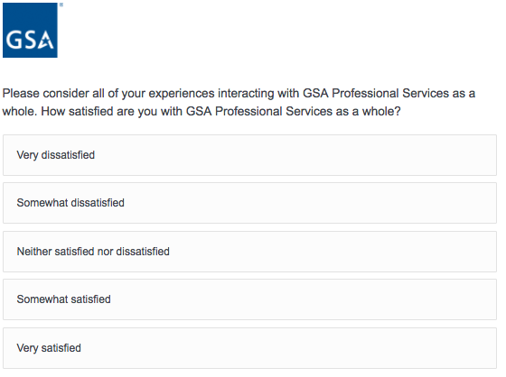



/Users/camilletucker/Desktop/Screen Shot 2017-05-29 at 8.39.09 PM.png

**Screen 8f**

Display if GSA Program Office (embedded data) = GSA Center for Travel Management

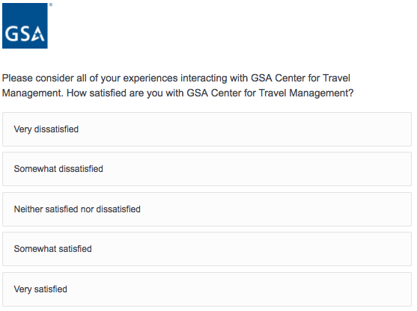



/Users/camilletucker/Desktop/Screen Shot 2017-05-29 at 8.39.09 PM.png

**Screen 8g**

Display if GSA Program Office (embedded data) = GSA Center for Transportation Management

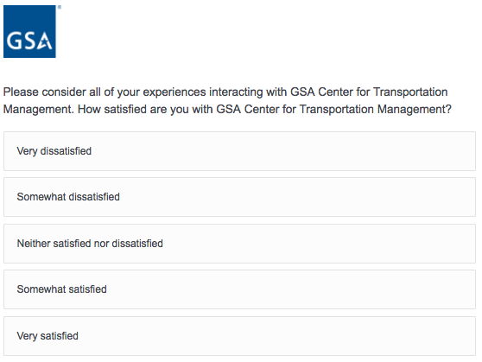



/Users/camilletucker/Desktop/Screen Shot 2017-05-29 at 8.39.09 PM.png

**Screen 8h**

Display if GSA Program Office (embedded data) = GSA Employee Relocation Resource Center (ERRC)

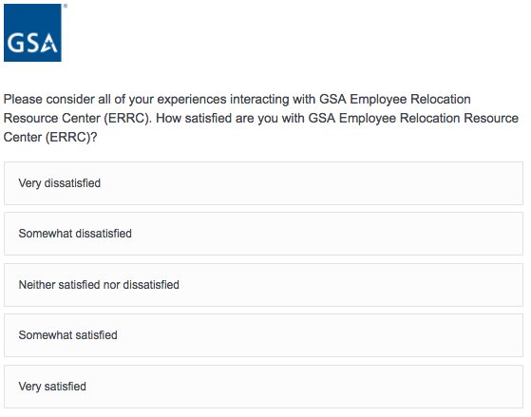



/Users/camilletucker/Desktop/Screen Shot 2017-05-29 at 8.39.09 PM.png

**Screen 9**

Display if GSA Program Office (embedded data) = GSA Information Technology Category

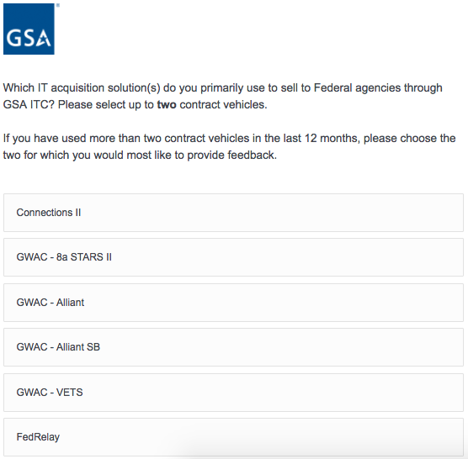

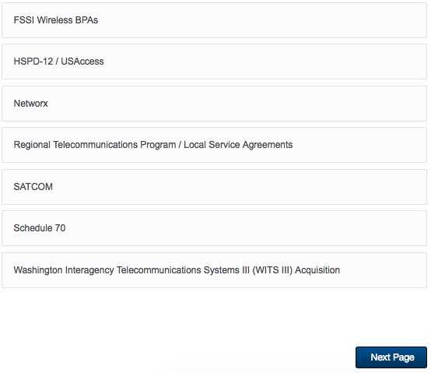

If Schedule 70 is selected, then display Screen 10.

**Screen 10**

Display if GSA Program Office (embedded data) = GSA Information Technology Category

AND if Schedule 70 is selected on Screen 9.

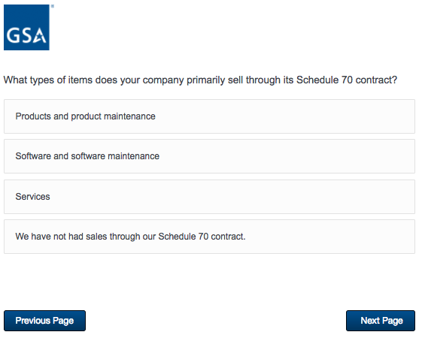

**Screen 11a**

Display if GSA Program Office (embedded data) = GSA Information Technology Category

AND if Connections II is selected on Screen 9.

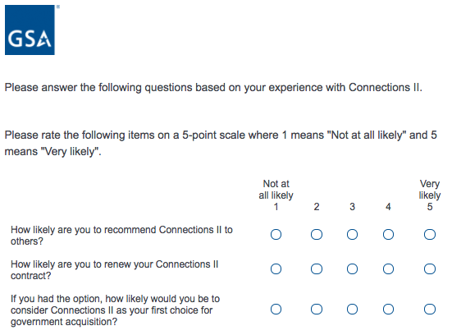

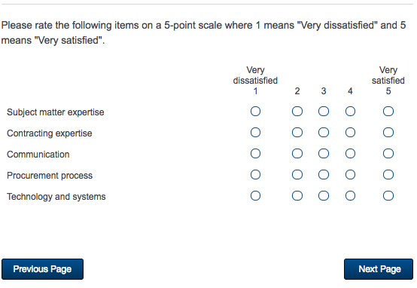

**Screen 11b**

Display if GSA Program Office (embedded data) = GSA Information Technology Category

AND if GWAC – 8a STARS is selected on Screen 9.

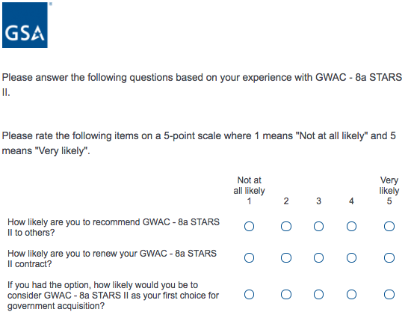



**Screen 11c**

Display if GSA Program Office (embedded data) = GSA Information Technology Category

AND if GWAC - Alliant is selected on Screen 9.

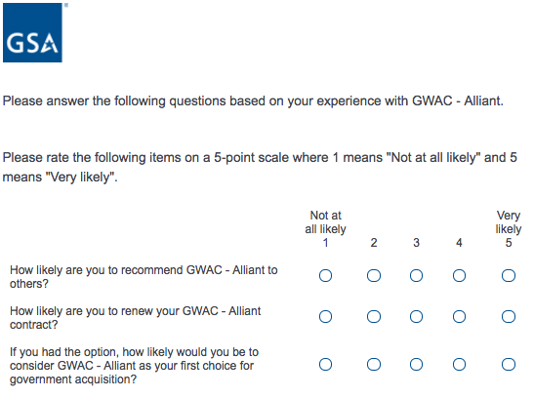



**Screen 11d**

Display if GSA Program Office (embedded data) = GSA Information Technology Category

AND if GWAC - Alliant SB is selected on Screen 9.

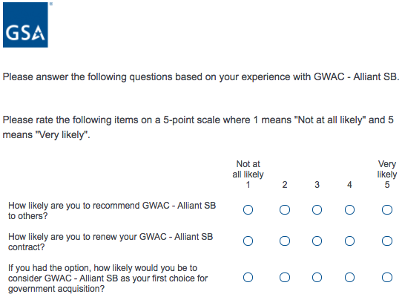



**Screen 11e**

Display if GSA Program Office (embedded data) = GSA Information Technology Category

AND if GWAC - VETS is selected on Screen 9.

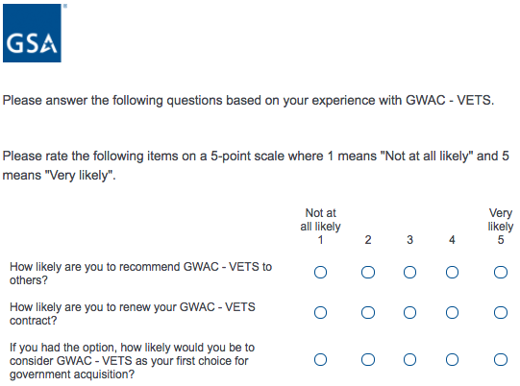



**Screen 11f**

Display if GSA Program Office (embedded data) = GSA Information Technology Category

AND if FedRelay is selected on Screen 9.

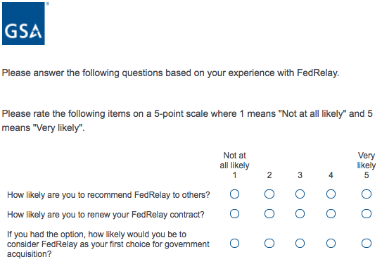



**Screen 11g**

Display if GSA Program Office (embedded data) = GSA Information Technology Category

AND if FSSI Wireless BPAs is selected on Screen 9.

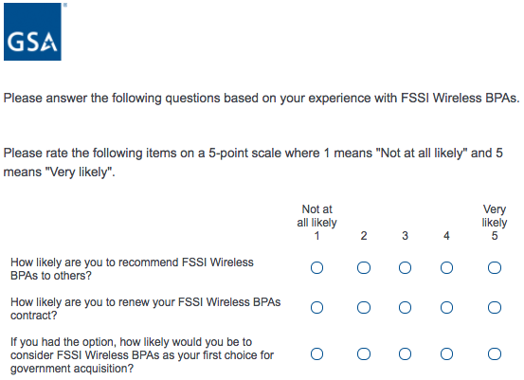



**Screen 11h**

Display if GSA Program Office (embedded data) = GSA Information Technology Category

AND if HSPD-12 / USAccess is selected on Screen 9.

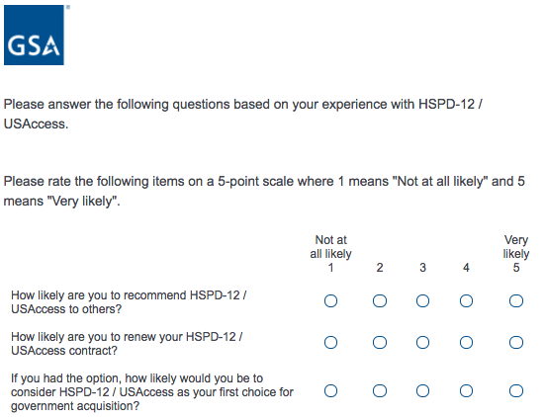



**Screen 11i**

Display if GSA Program Office (embedded data) = GSA Information Technology Category

AND if Networx is selected on Screen 9.

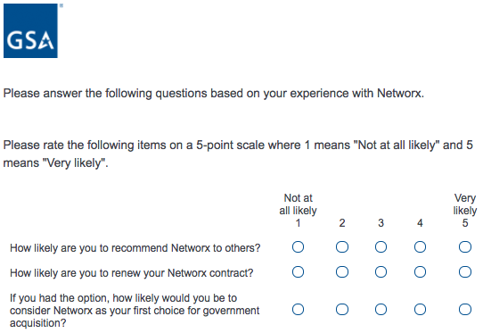



**Screen 11j**

Display if GSA Program Office (embedded data) = GSA Information Technology Category

AND if Regional Telecommunications Program / Local Service Agreements is selected on Screen 9.

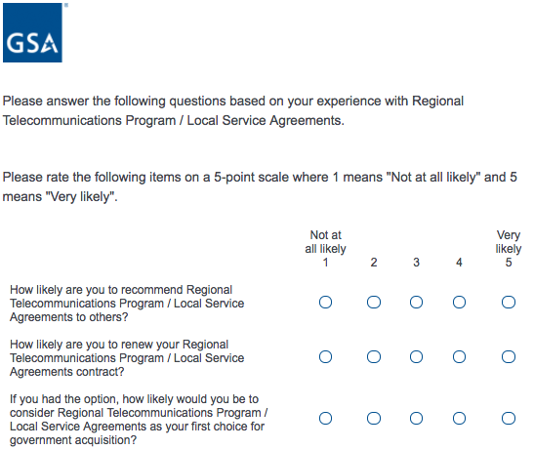



**Screen 11k**

Display if GSA Program Office (embedded data) = GSA Information Technology Category

AND if SATCOM is selected on Screen 9.

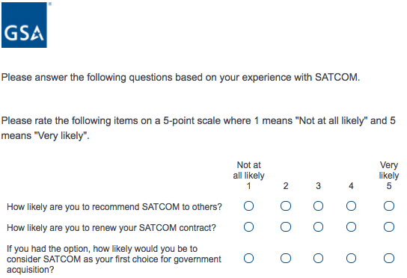



**Screen 11l**

Display if GSA Program Office (embedded data) = GSA Information Technology Category

AND if Schedule 70 is selected on Screen 9.

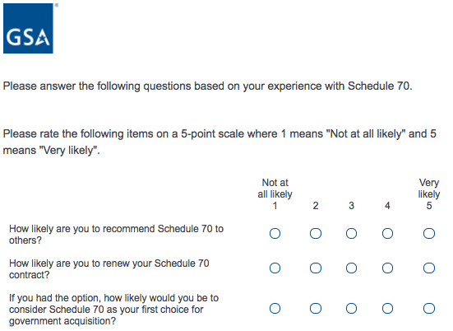



**Screen 11m**

Display if GSA Program Office (embedded data) = GSA Information Technology Category

AND if Washington Interagency Telecommunications Systems III (WITS III) Acquisition is selected on Screen 9.

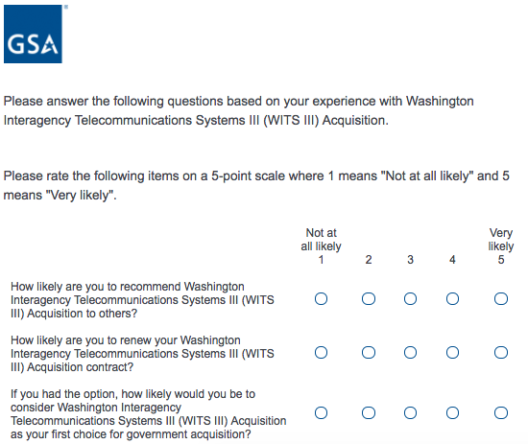



**Screen 12a**

Display if GSA Program Office (embedded data) = GSA Information Technology Category

AND if Connections II is selected on Screen 9.

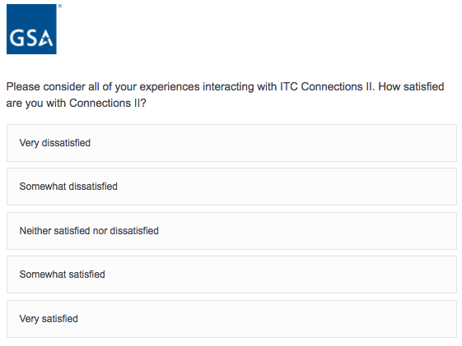

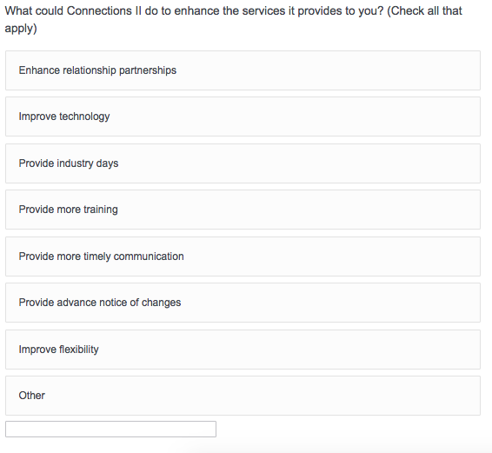

/Users/camilletucker/Desktop/Screen Shot 2017-05-29 at 8.58.36 PM.png

**Screen 12b**

Display if GSA Program Office (embedded data) = GSA Information Technology Category

AND if GWAC – 8a STARS is selected on Screen 9.

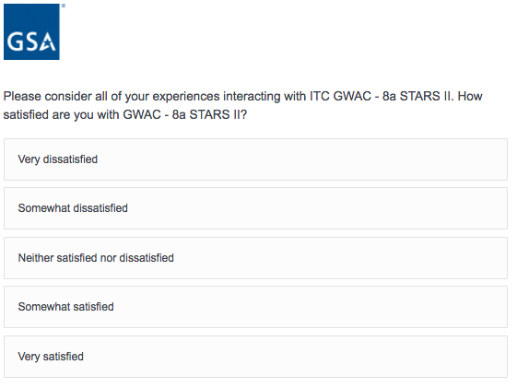

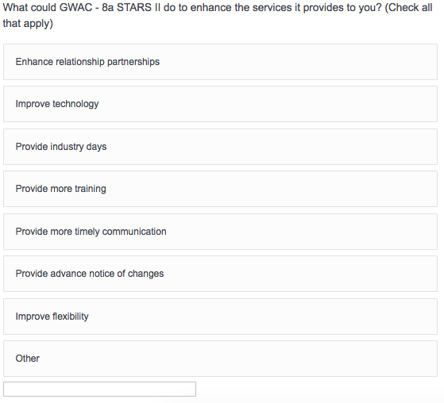

/Users/camilletucker/Desktop/Screen Shot 2017-05-29 at 8.58.36 PM.png

**Screen 12c**

Display if GSA Program Office (embedded data) = GSA Information Technology Category

AND if GWAC – Alliant is selected on Screen 9.

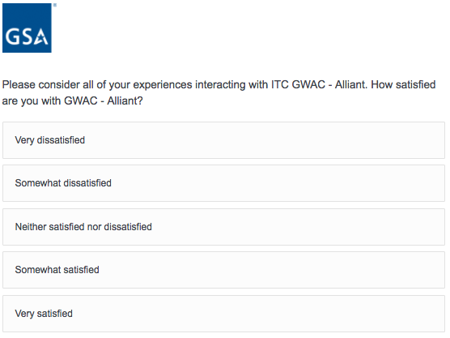

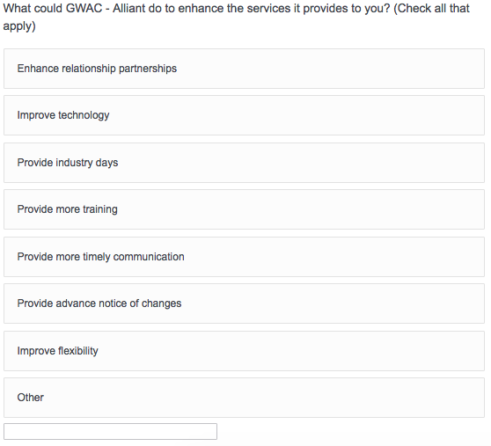

/Users/camilletucker/Desktop/Screen Shot 2017-05-29 at 8.58.36 PM.png

**Screen 12d**

Display if GSA Program Office (embedded data) = GSA Information Technology Category

AND if GWAC – Alliant SB is selected on Screen 9.

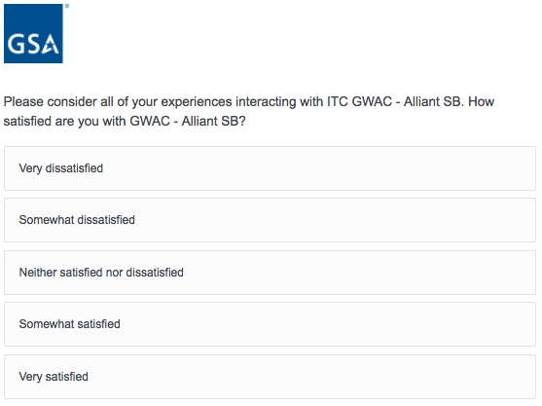

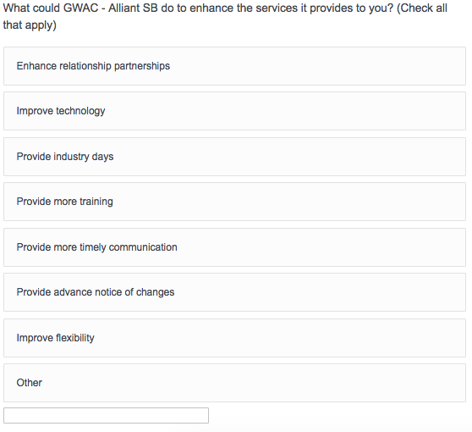

/Users/camilletucker/Desktop/Screen Shot 2017-05-29 at 8.58.36 PM.png

**Screen 12e**

Display if GSA Program Office (embedded data) = GSA Information Technology Category

AND if GWAC – VETS is selected on Screen 9.

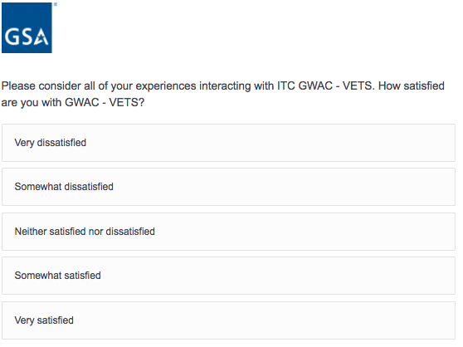

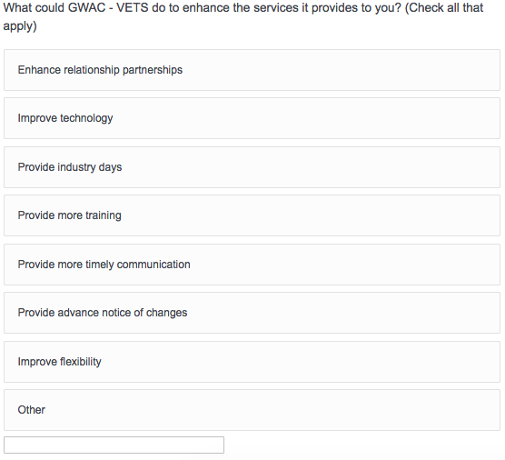

/Users/camilletucker/Desktop/Screen Shot 2017-05-29 at 8.58.36 PM.png

**Screen 12f**

Display if GSA Program Office (embedded data) = GSA Information Technology Category

AND if FedRelay is selected on Screen 9.

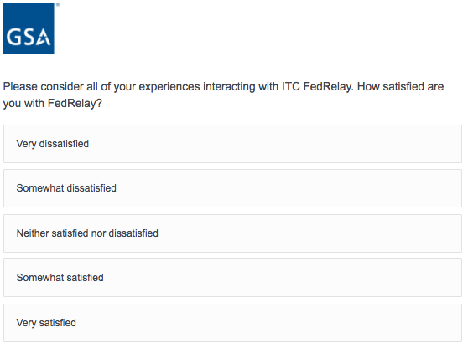

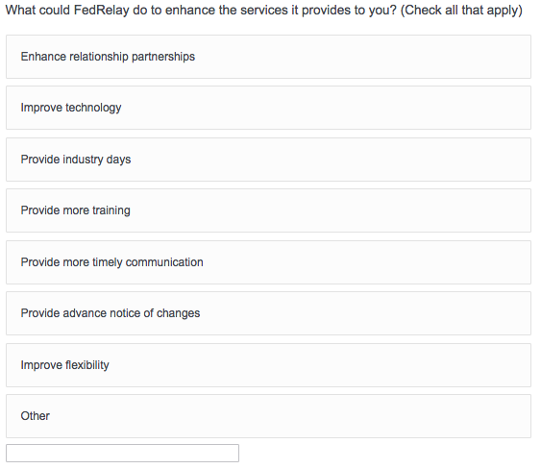

/Users/camilletucker/Desktop/Screen Shot 2017-05-29 at 8.58.36 PM.png

**Screen 12g**

Display if GSA Program Office (embedded data) = GSA Information Technology Category

AND if FSSI Wireless BPAs is selected on Screen 9.

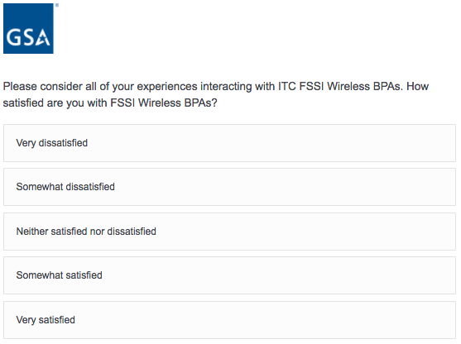

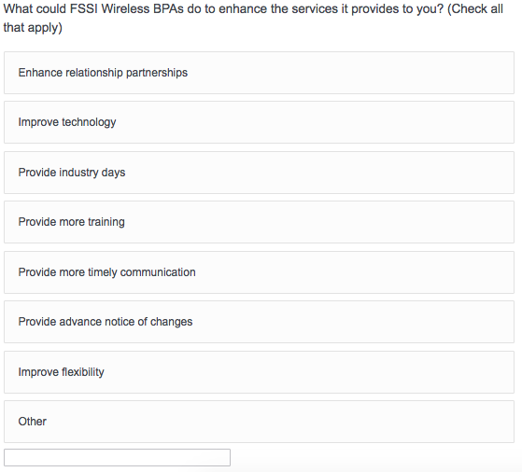

/Users/camilletucker/Desktop/Screen Shot 2017-05-29 at 8.58.36 PM.png

**Screen 12h**

Display if GSA Program Office (embedded data) = GSA Information Technology Category

AND if HSPD-12 / USAccess is selected on Screen 9.

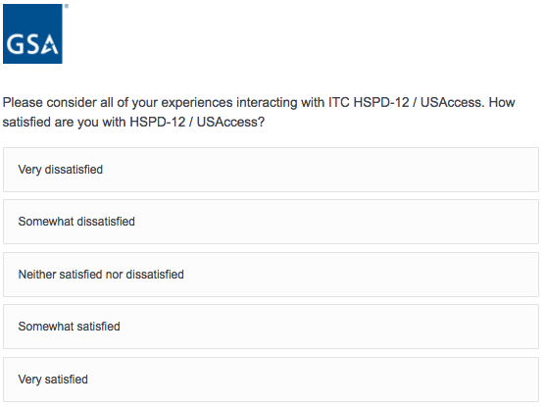

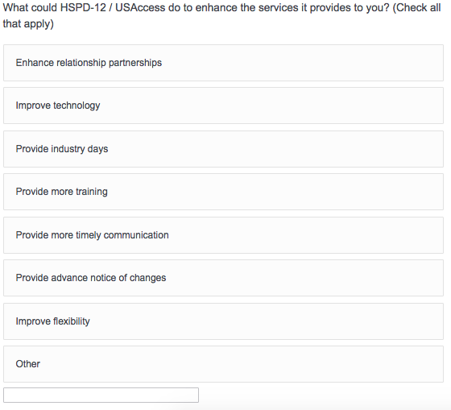

/Users/camilletucker/Desktop/Screen Shot 2017-05-29 at 8.58.36 PM.png

**Screen 12i**

Display if GSA Program Office (embedded data) = GSA Information Technology Category

AND if Networx is selected on Screen 9.

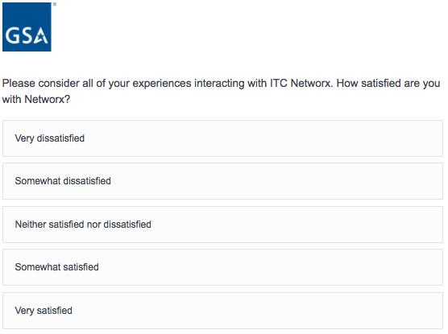

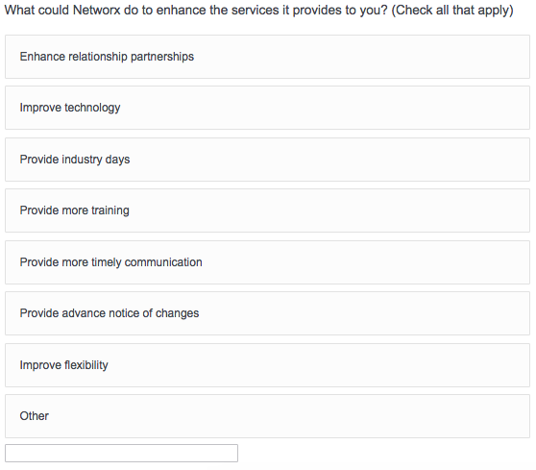

/Users/camilletucker/Desktop/Screen Shot 2017-05-29 at 8.58.36 PM.png

**Screen 12j**

Display if GSA Program Office (embedded data) = GSA Information Technology Category

AND if Regional Telecommunications Program / Local Service Agreements is selected on Screen 9.

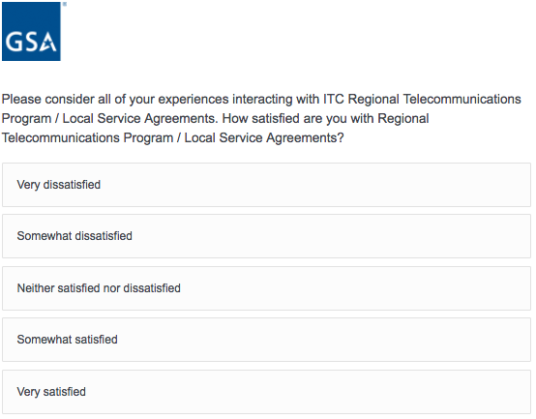

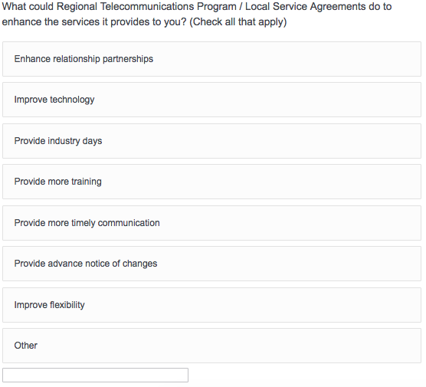

/Users/camilletucker/Desktop/Screen Shot 2017-05-29 at 8.58.36 PM.png

**Screen 12k**

Display if GSA Program Office (embedded data) = GSA Information Technology Category

AND if SATCOM is selected on Screen 9.

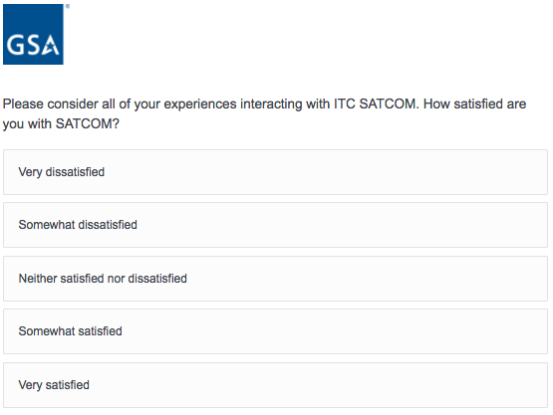

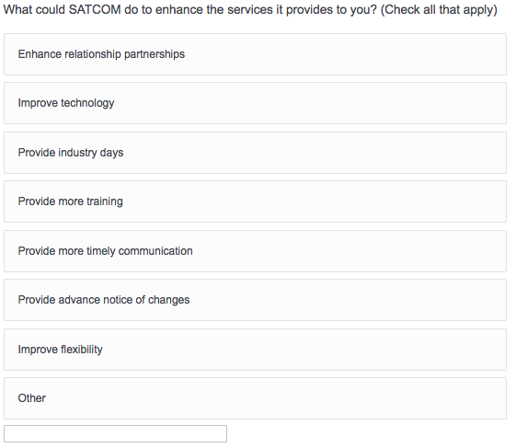

/Users/camilletucker/Desktop/Screen Shot 2017-05-29 at 8.58.36 PM.png

**Screen 12l**

Display if GSA Program Office (embedded data) = GSA Information Technology Category

AND if Schedule 70 is selected on Screen 9.

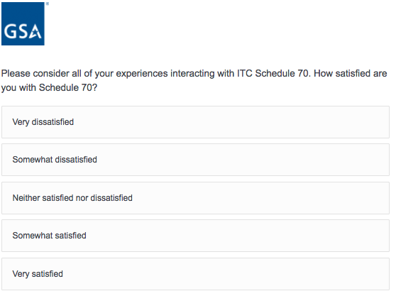

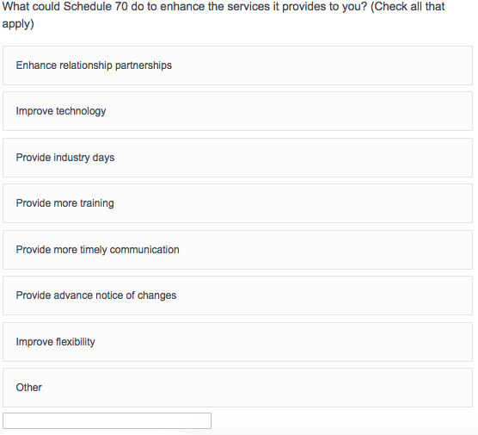

/Users/camilletucker/Desktop/Screen Shot 2017-05-29 at 8.58.36 PM.png

**Screen 12m**

Display if GSA Program Office (embedded data) = GSA Information Technology Category

AND if Washington Interagency Telecommunications Systems III (WITS III) Acquisition is selected on Screen 9.

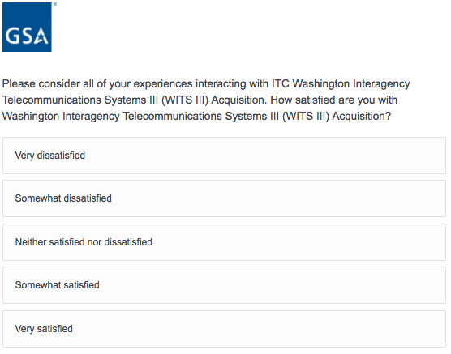

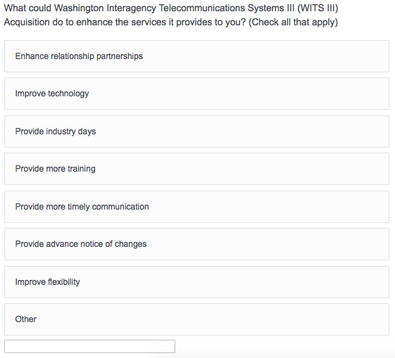

/Users/camilletucker/Desktop/Screen Shot 2017-05-29 at 8.58.36 PM.png

**Screen 13**

Display if GSA Program Office (embedded data) = GSA General Supplies and Services

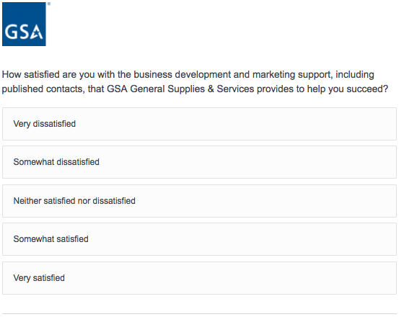

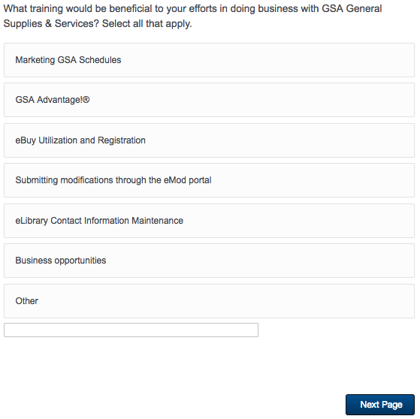

**Screen 14**

Display if GSA Program Office (embedded data) = GSA General Supplies and Services

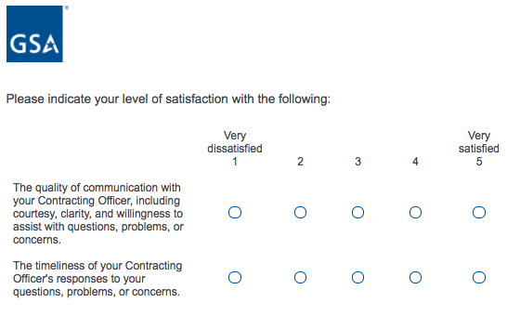

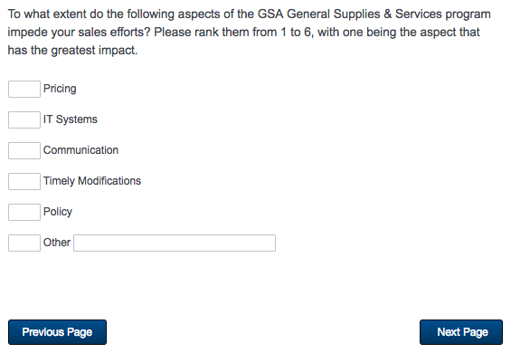

**Screen 15**

Display if GSA Program Office (embedded data) = GSA General Supplies and Services

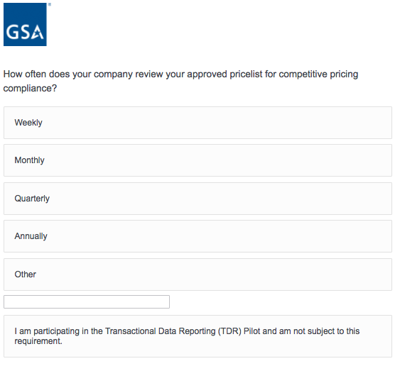

/Users/camilletucker/Desktop/Screen Shot 2017-05-29 at 9.40.24 PM.png

**Screen 16**

Display if GSA Program Office (embedded data) = GSA General Supplies and Services

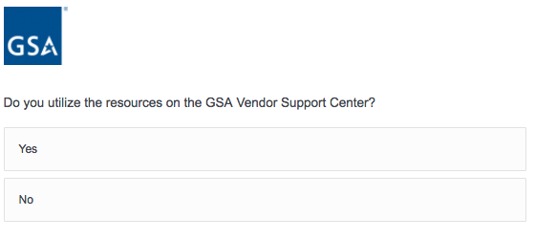

If Yes, then display the following question on the same page:

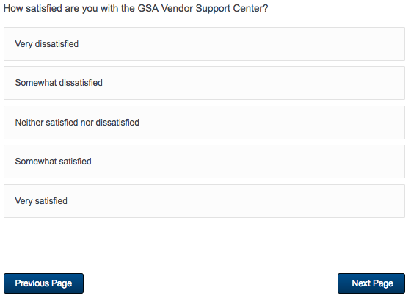

**Screen 17**

Display if GSA Program Office (embedded data) = GSA General Supplies and Services

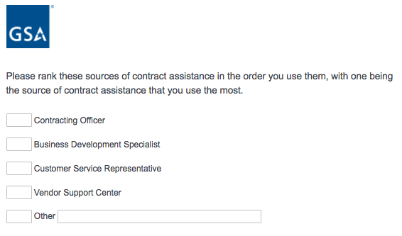

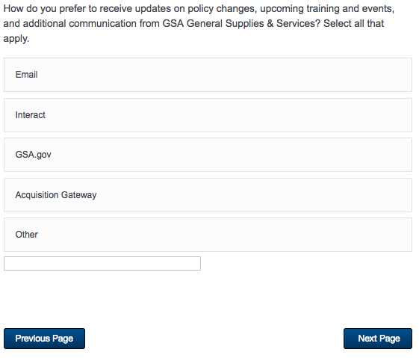

**Screen 18**

Display if GSA Program Office (embedded data) = GSA Fleet

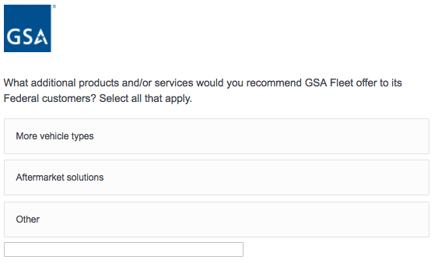

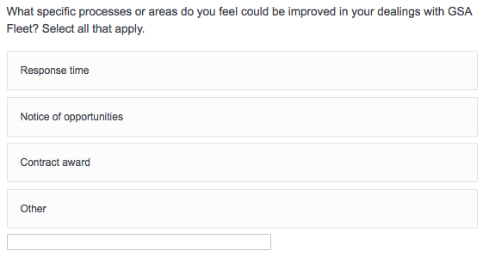

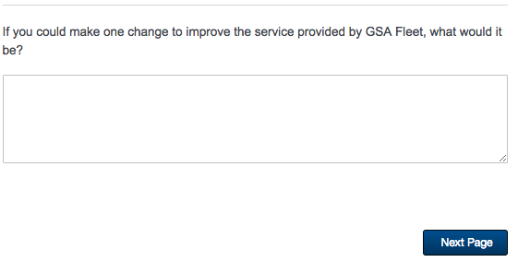

**Screen 19**

Display if GSA Program Office (embedded data) = GSA Professional Services Schedule

OR if GSA Program Office (embedded data) = GSA Professional Services as a whole

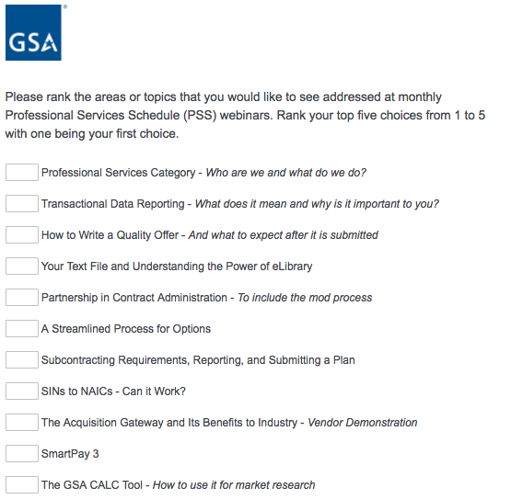

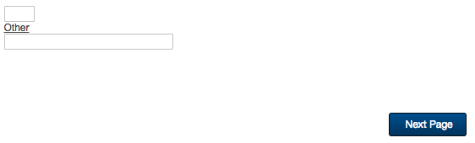

**Screen 20**

Display if GSA Program Office (embedded data) = GSA Professional Services Schedule

OR if GSA Program Office (embedded data) = GSA Professional Services as a whole

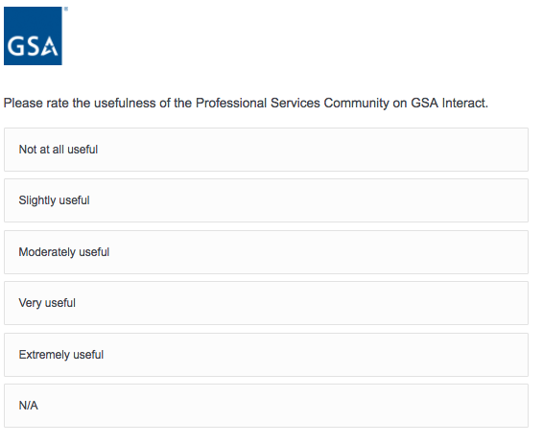

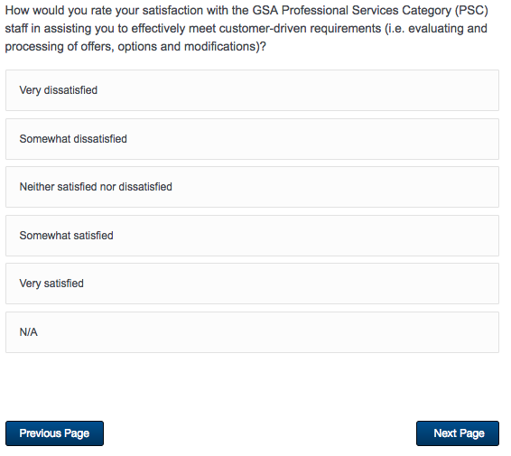

**Screen 21**

Display if GSA Program Office (embedded data) = GSA Professional Services Schedule

OR if GSA Program Office (embedded data) = GSA Professional Services as a whole

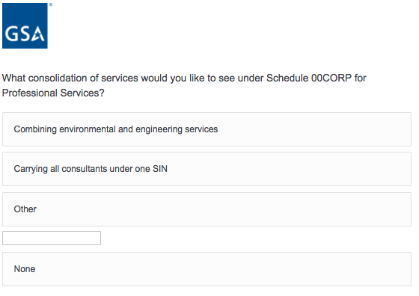

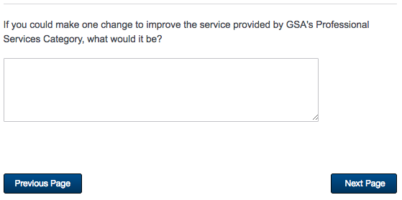

**Screen 22**

Display if GSA Program Office (embedded data) = GSA OASIS

OR if GSA Program Office (embedded data) = GSA Professional Services as a whole

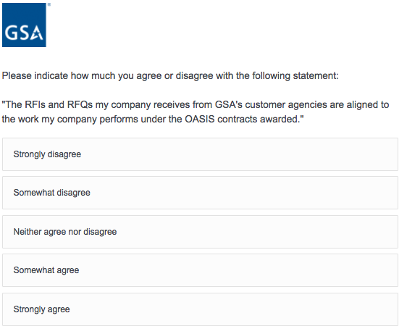

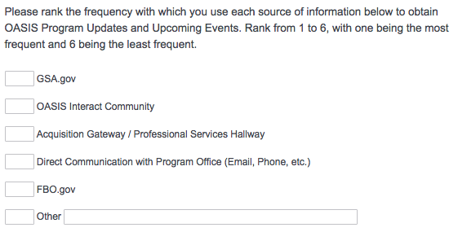

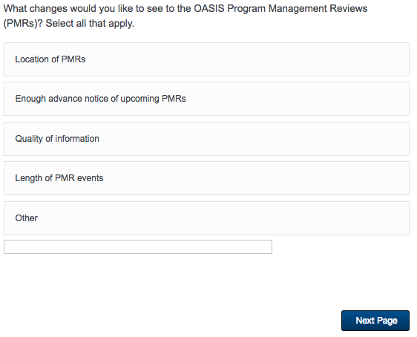

**Screen 23**

Display if GSA Program Office (embedded data) = GSA OASIS

OR if GSA Program Office (embedded data) = GSA Professional Services as a whole

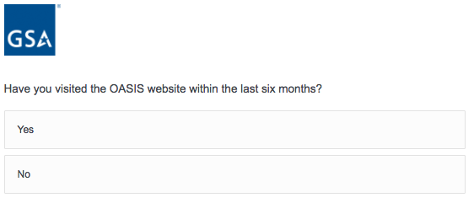

/Users/camilletucker/Desktop/Screen Shot 2017-05-29 at 9.54.21 PM.png

**Screen 24**

Display if GSA Program Office (embedded data) = GSA OASIS

OR if GSA Program Office (embedded data) = GSA Professional Services as a whole

AND if Yes was selected on Screen 23

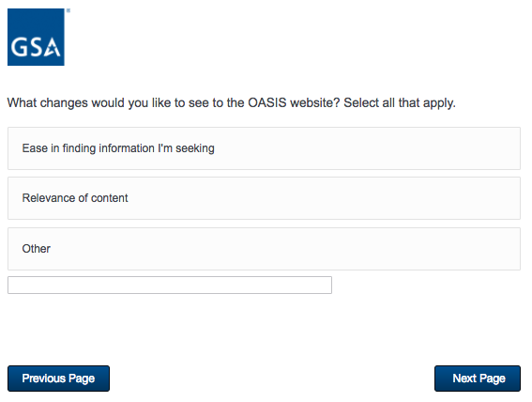

**Screen 25a**

Display if GSA Program Office = GSA Center for Travel Management

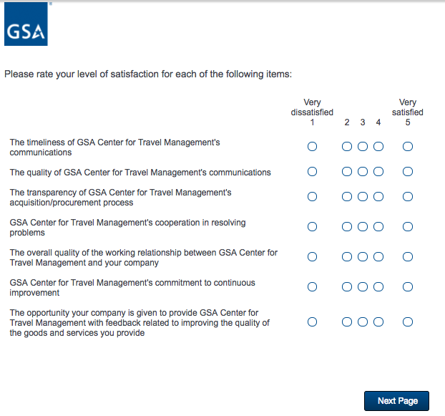

**Screen 25b**

Display if GSA Program Office = GSA Center for Transportation Management

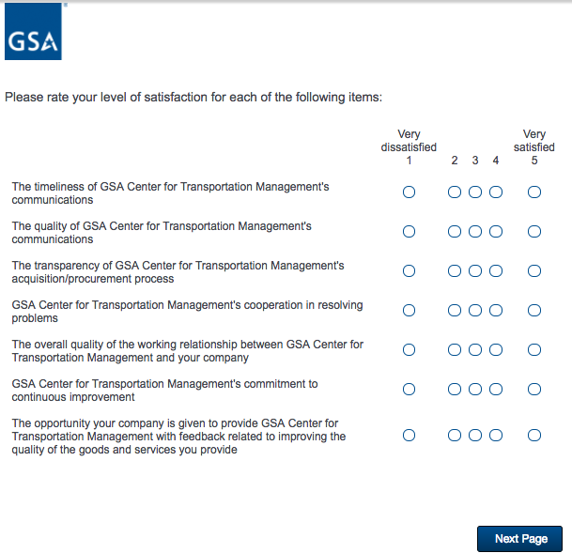

**Screen 25c**

Display if GSA Program Office = GSA Employee Relocation Resource Center (ERRC)

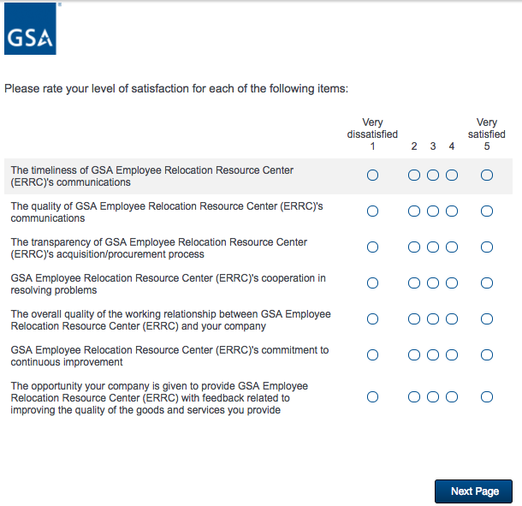

**Screen 26a**

Display if GSA Program Office = GSA Center for Travel Management

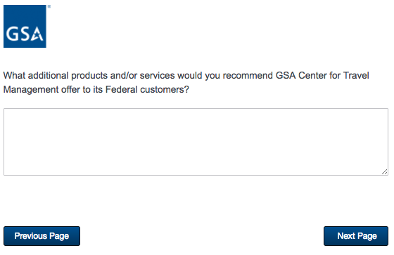

**Screen 26b**

Display if GSA Program Office = GSA Center for Transportation Management

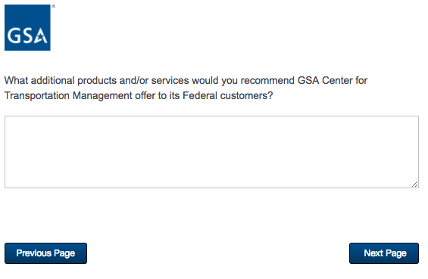

**Screen 26c**

Display if GSA Program Office = GSA Employee Relocation Resource Center (ERRC)

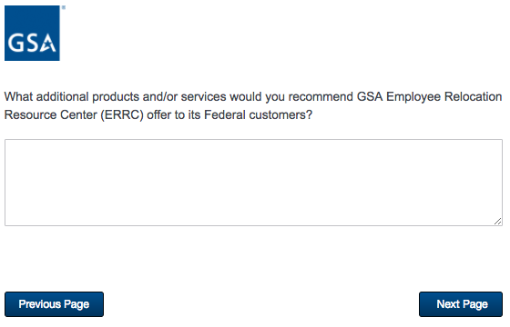

**Screen 27a**

Display if GSA Program Office = GSA Center for Travel Management

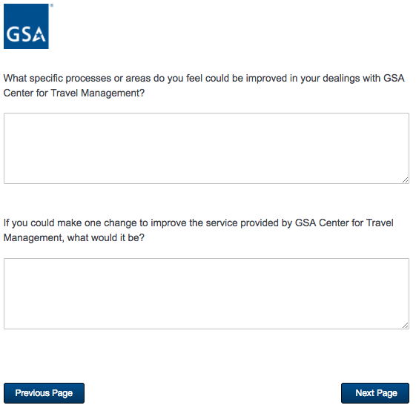

**Screen 27b**

Display if GSA Program Office = GSA Center for Transportation Management

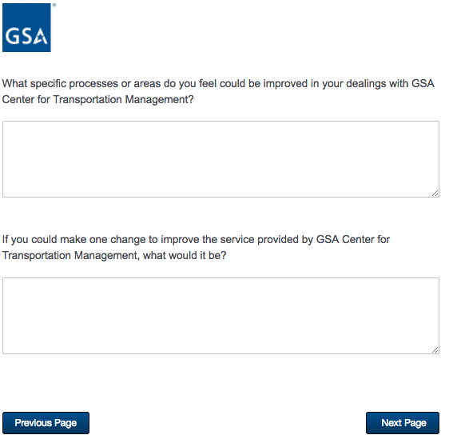

**Screen 27c**

Display if GSA Program Office = GSA Employee Relocation Resource Center (ERRC)

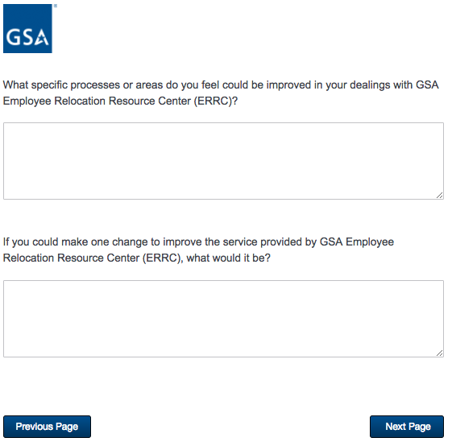

**Screen 28**

Display if Schedule = 51V, 58-I, 70, 72, 73, 75, 03FAC, or PSS

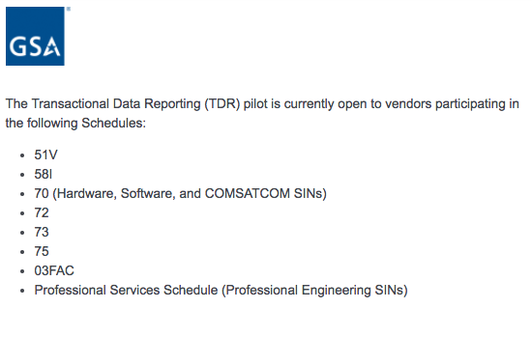

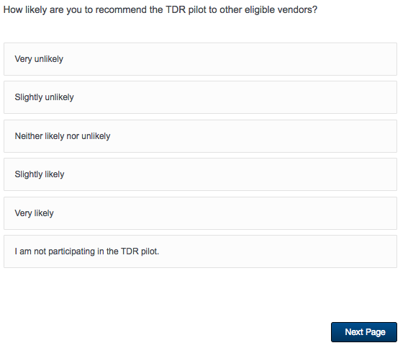

If “I am not participating in the TDR pilot” is selected, skip to Screen 31.

**Screen 29**

Display if Schedule = 51V, 58-I, 70, 72, 73, 75, 03FAC, or PSS

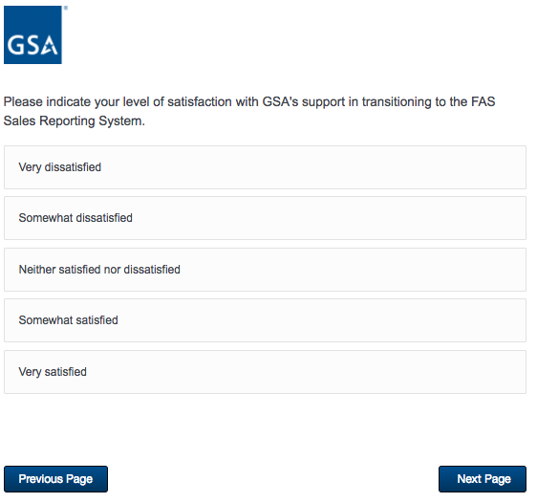

**Screen 30**

Display if Schedule = 51V, 58-I, 70, 72, 73, 75, 03FAC, or PSS

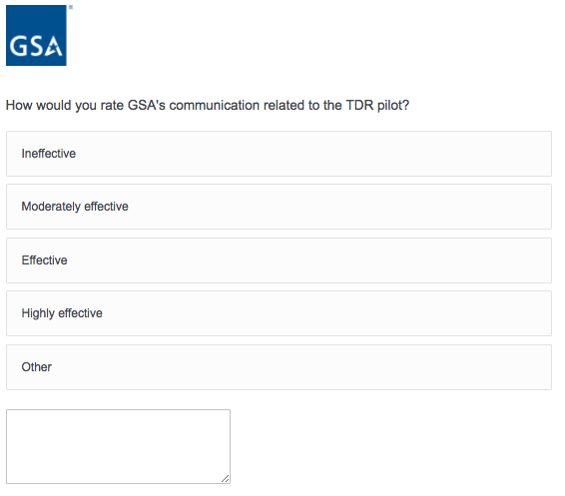

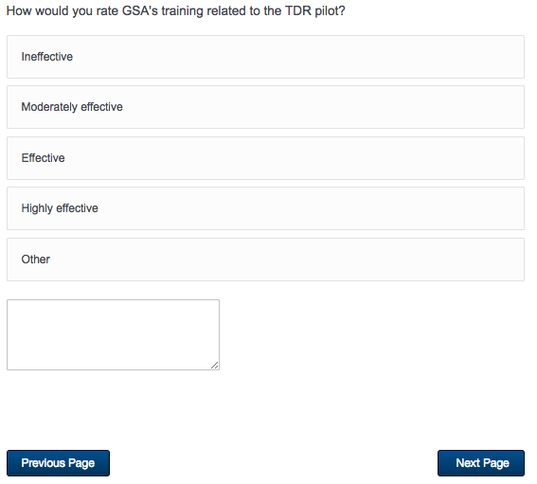

**Screen 31**

Displayed to all respondents.

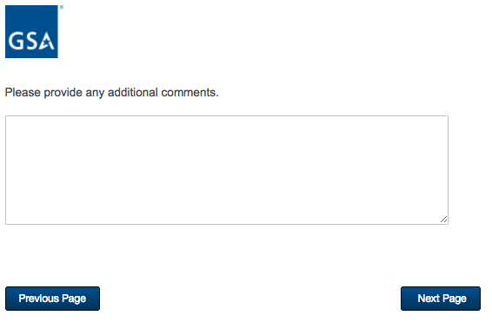

**Screen 32**

Displayed to all respondents.

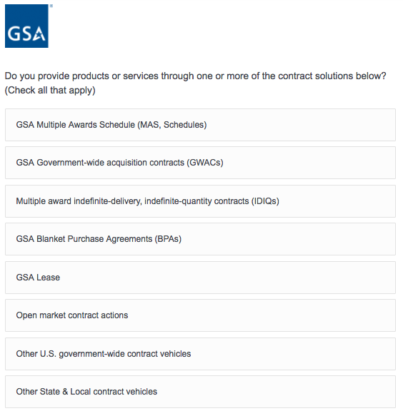



**Screen 32 - Continued**

Displayed to all respondents.

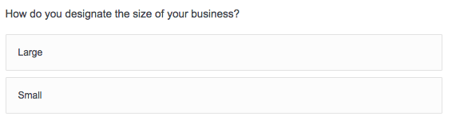

If “Small” is selected, then display the following question in the same page.

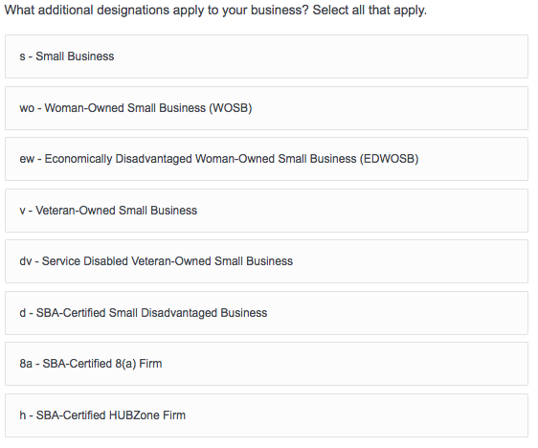

**Screen 32 - Continued**

Displayed to all respondents.

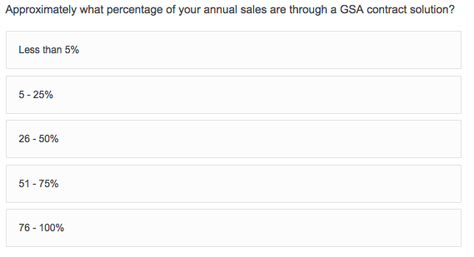

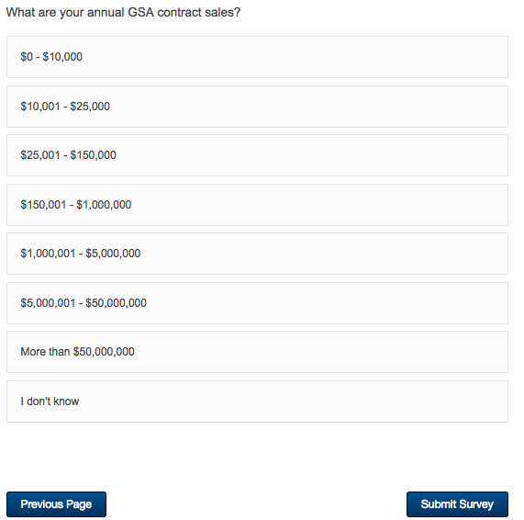

**Screen 33**

Displayed to all respondents.

