**FAST Track 3090-0297**

**GSA Auctions Survey**

**Screen 1**

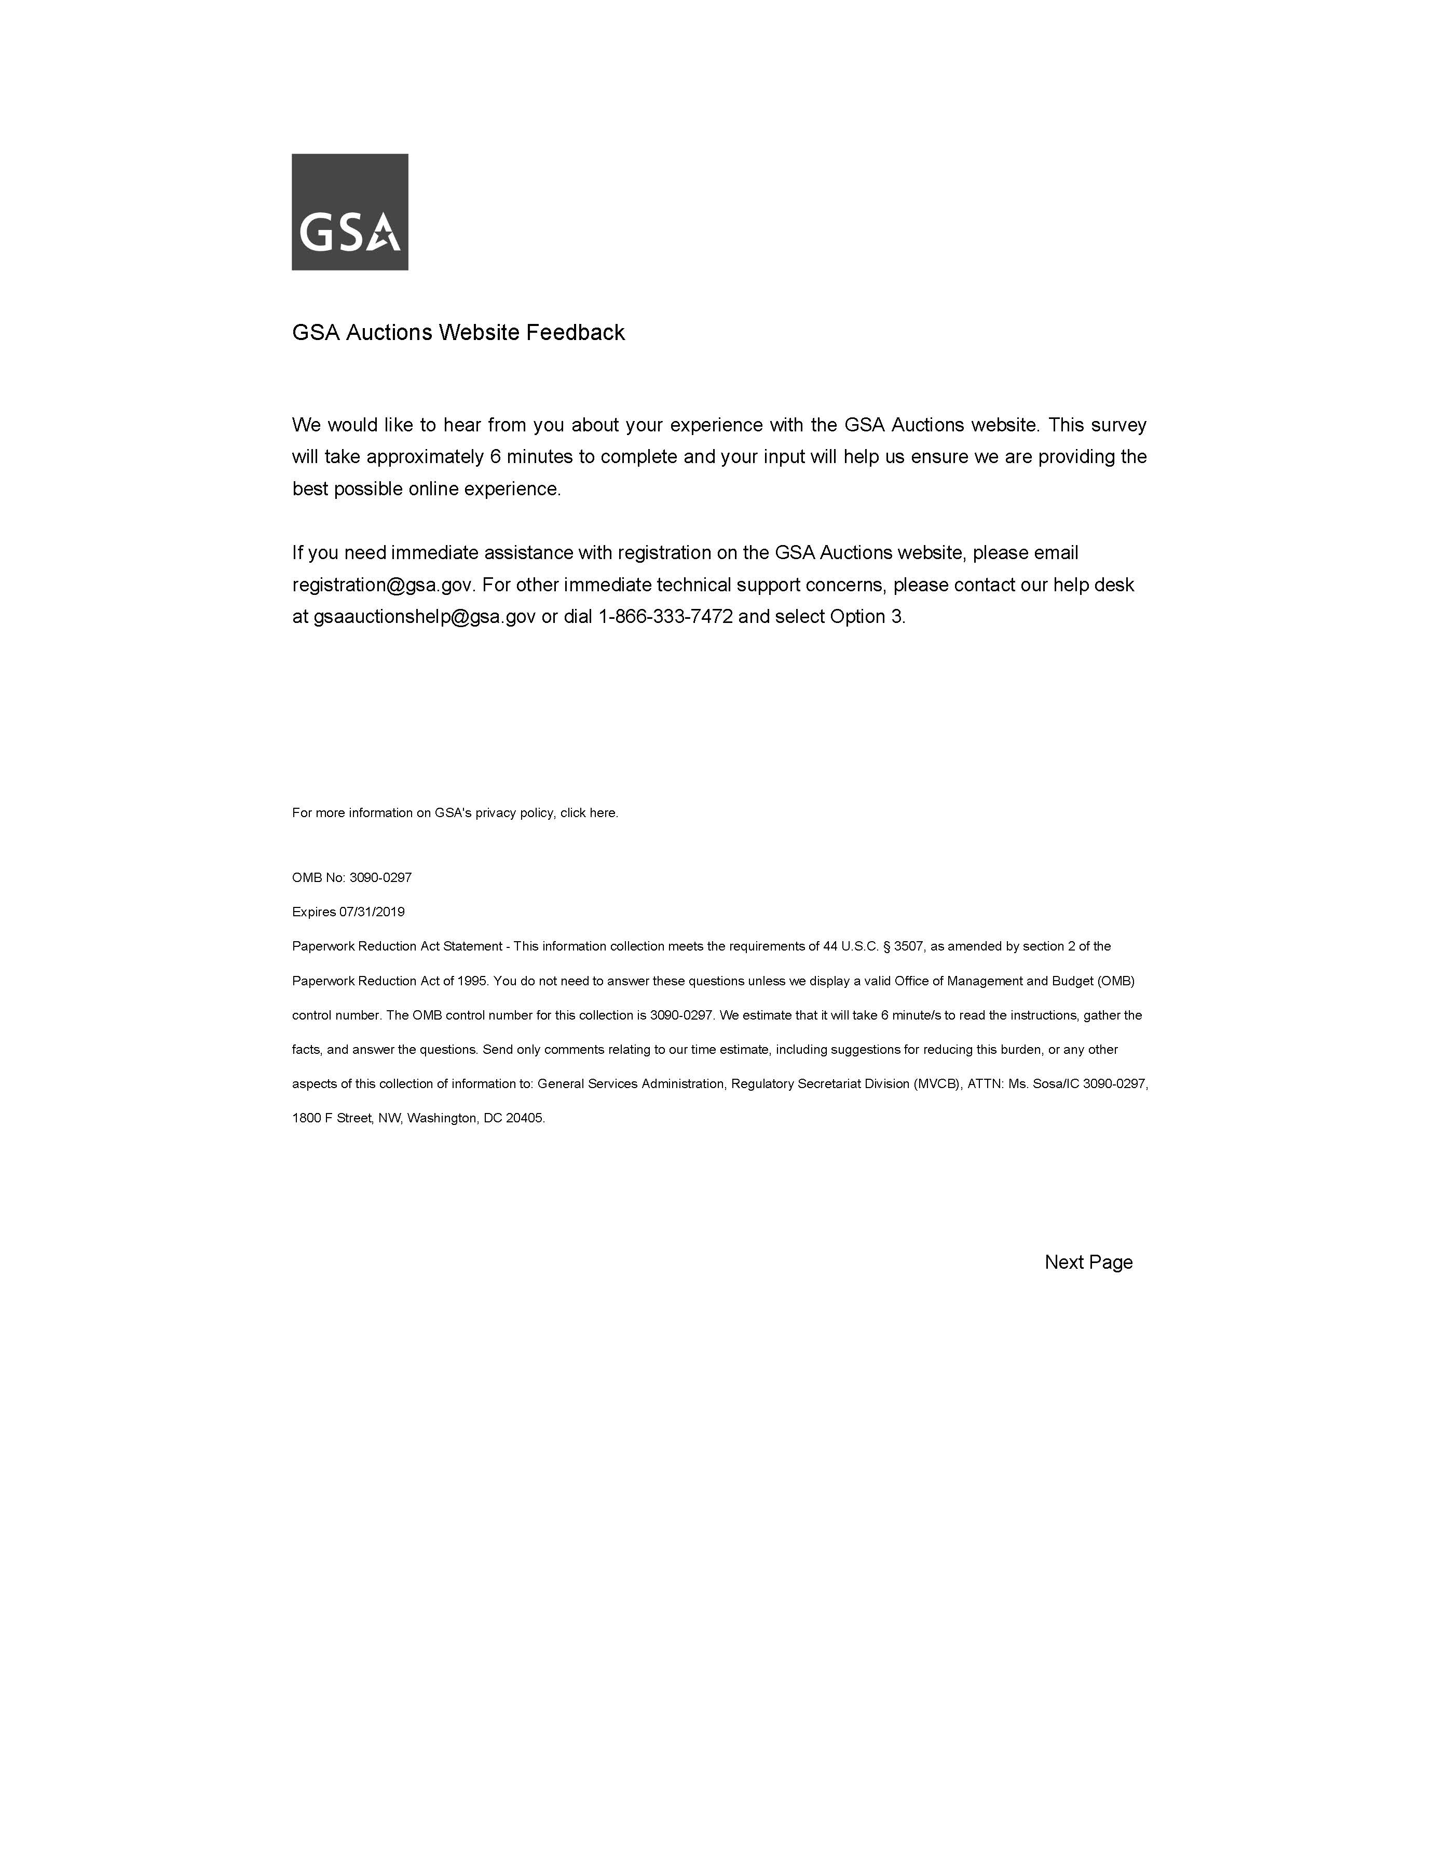

**Display Screen 2**

**Screen 2**

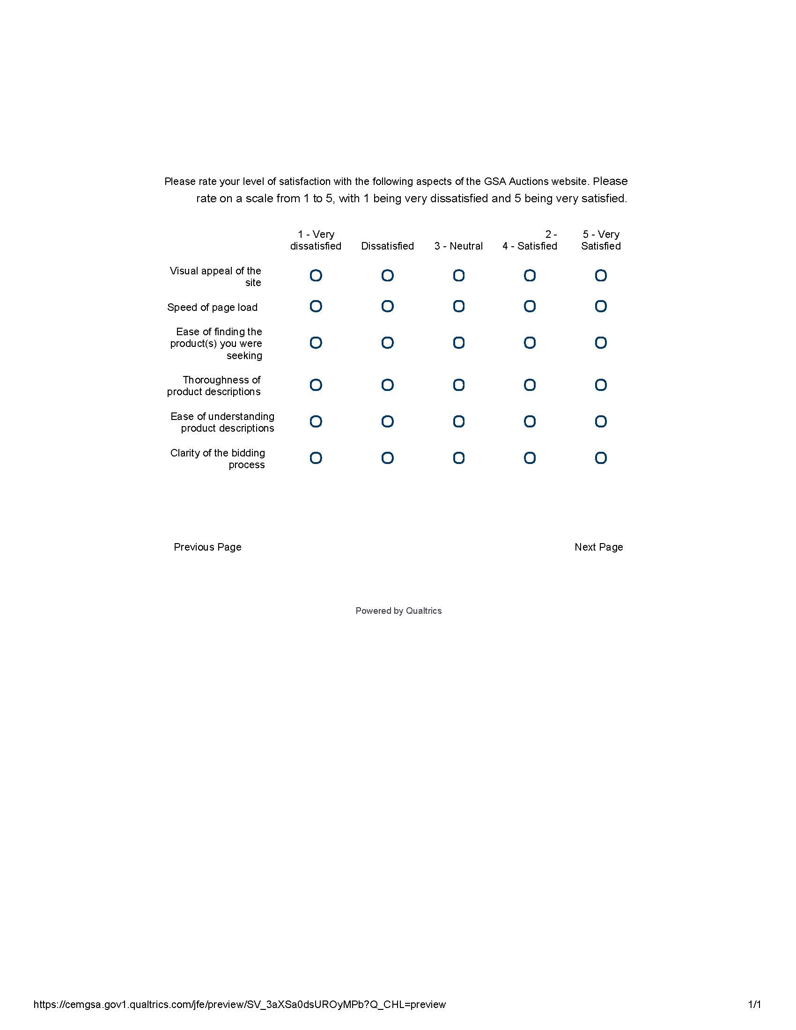

If Satisfaction Matrix Thoroughness of product descriptions - 4 - Satisfied Is Not Selected

And Satisfaction Matrix Thoroughness of product descriptions - 5 - Very Satisfied Is Not Selected

Or Satisfaction Matrix Ease of understanding product descriptions - 4 - Satisfied Is Not Selected

And Satisfaction Matrix Ease of understanding product descriptions - 5 - Very Satisfied Is Not Selected, display Screen 3

If Satisfaction Matrix Thoroughness of product descriptions - 4 - Satisfied Is Selected

And Satisfaction Matrix Thoroughness of product descriptions - 5 - Very Satisfied Is Selected

Or Satisfaction Matrix Ease of understanding product descriptions - 4 - Satisfied Is Selected

And Satisfaction Matrix Ease of understanding product descriptions - 5 - Very Satisfied Is Selected, display Screen 4

**Screen 3**

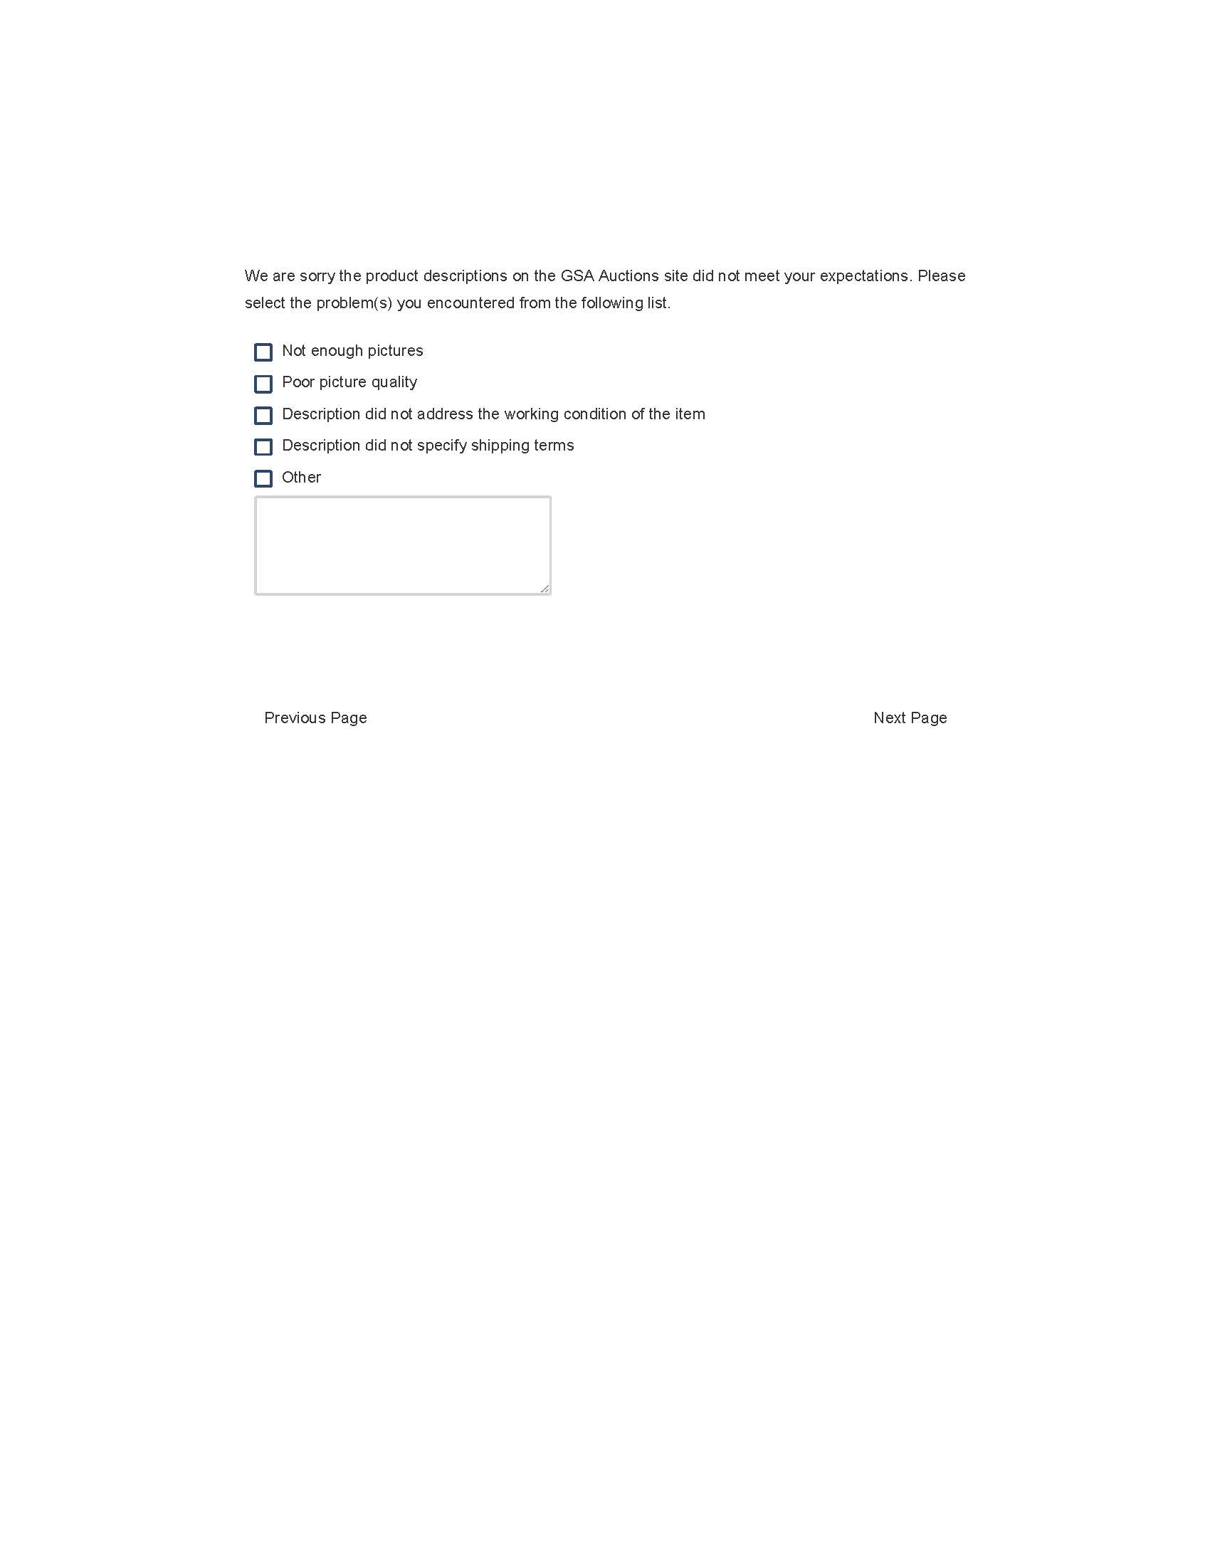

Display Screen 4

**Screen 4**



**If yes is selected display Screen 5**

**If no is selected display Screen 6**

**Screen 5**

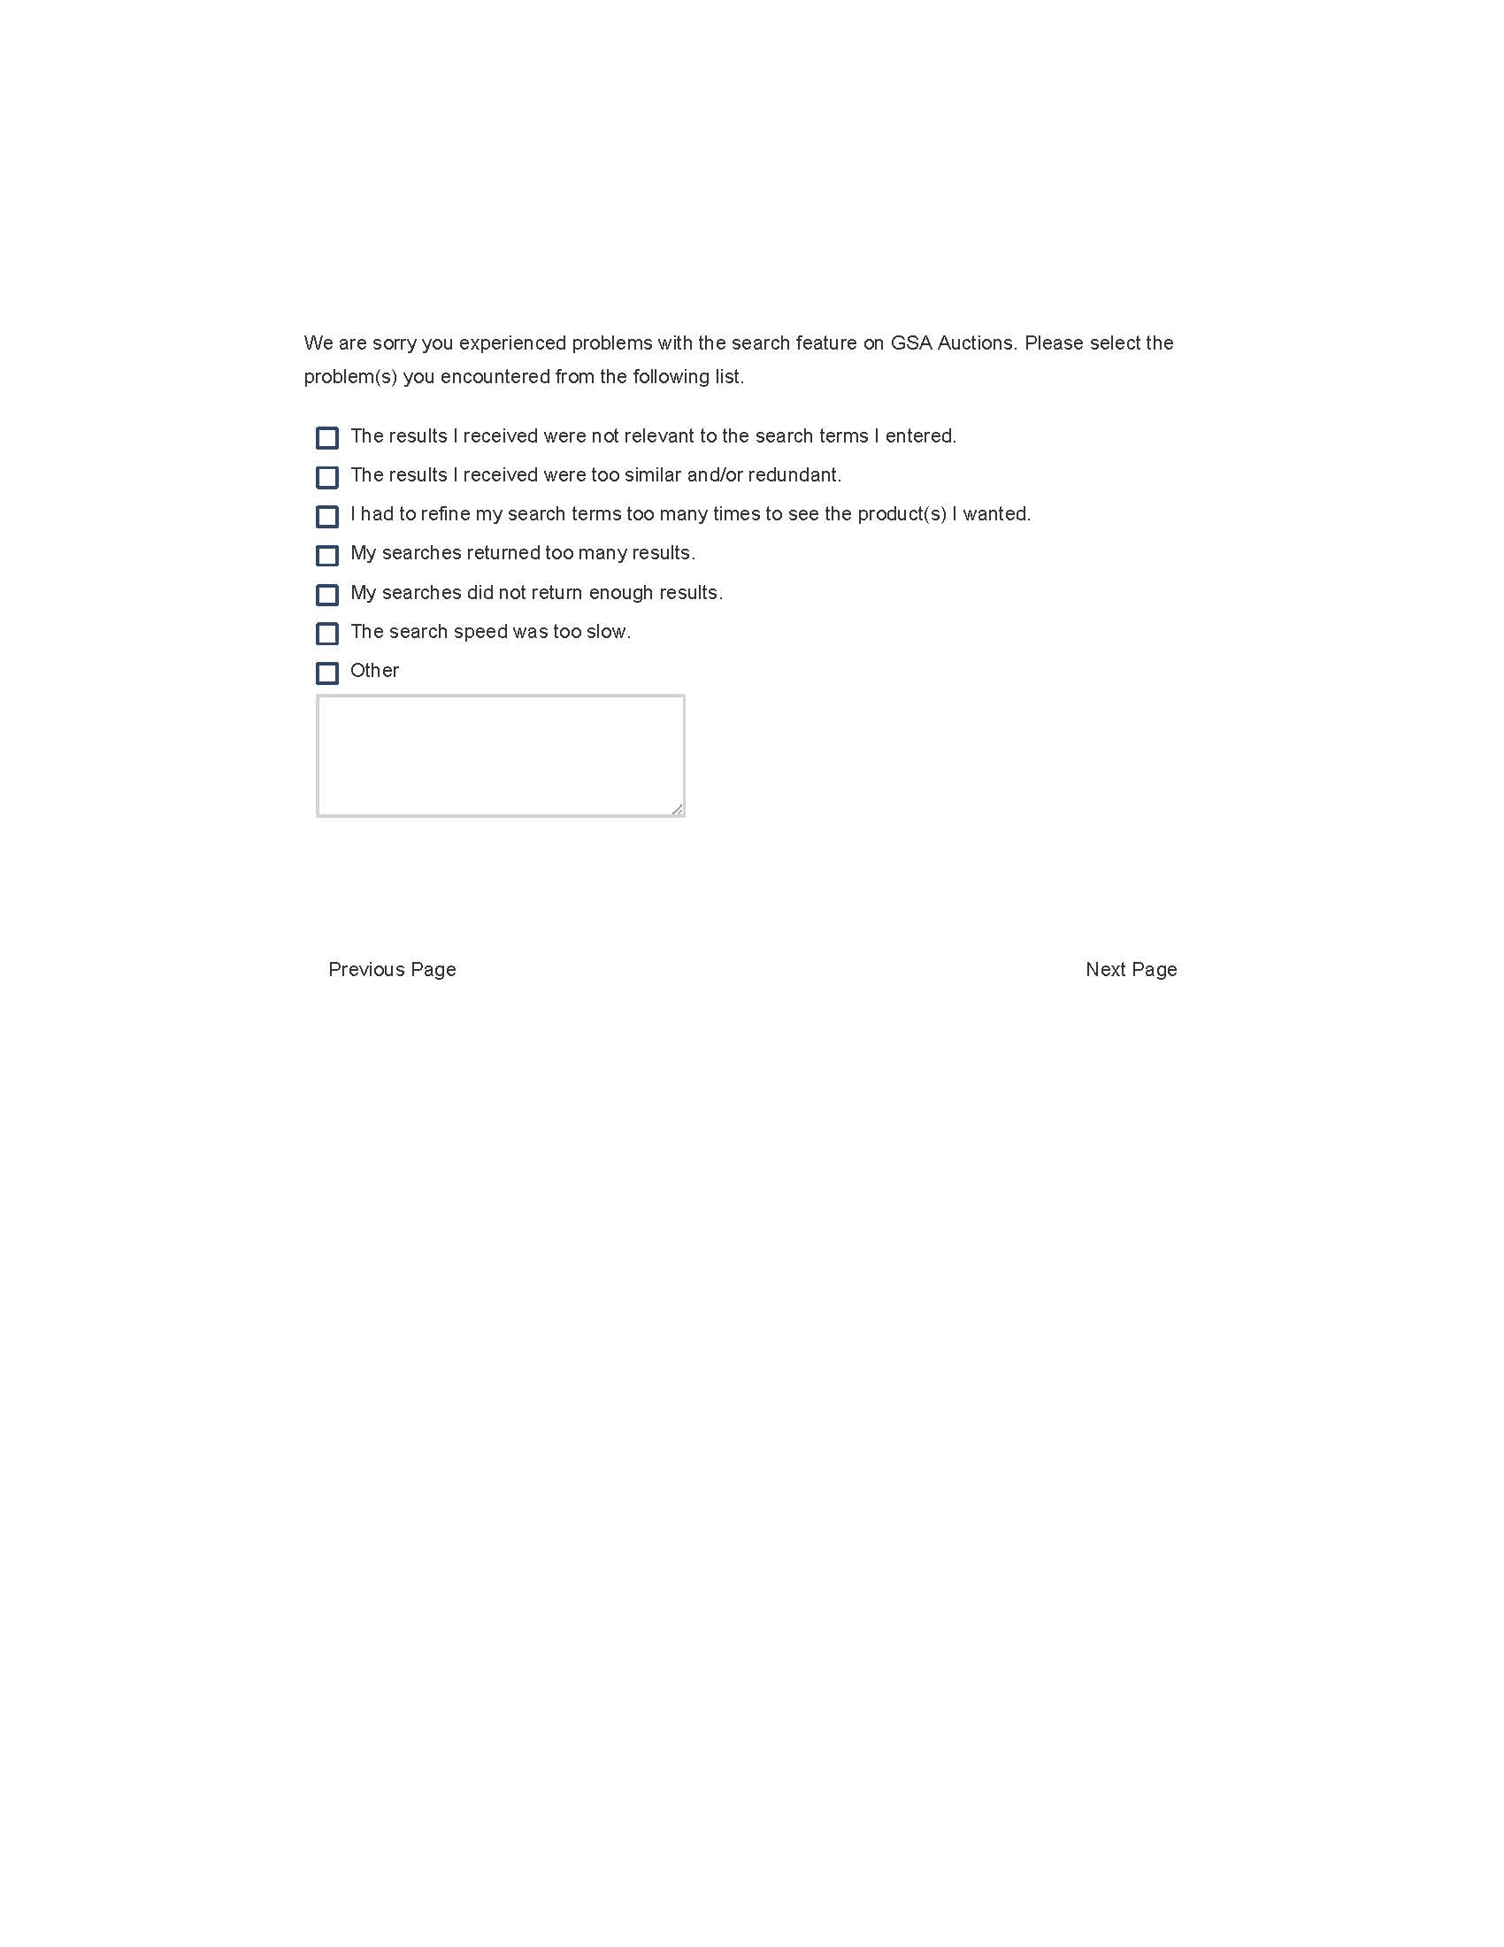

Display Screen 6

**Screen 6**

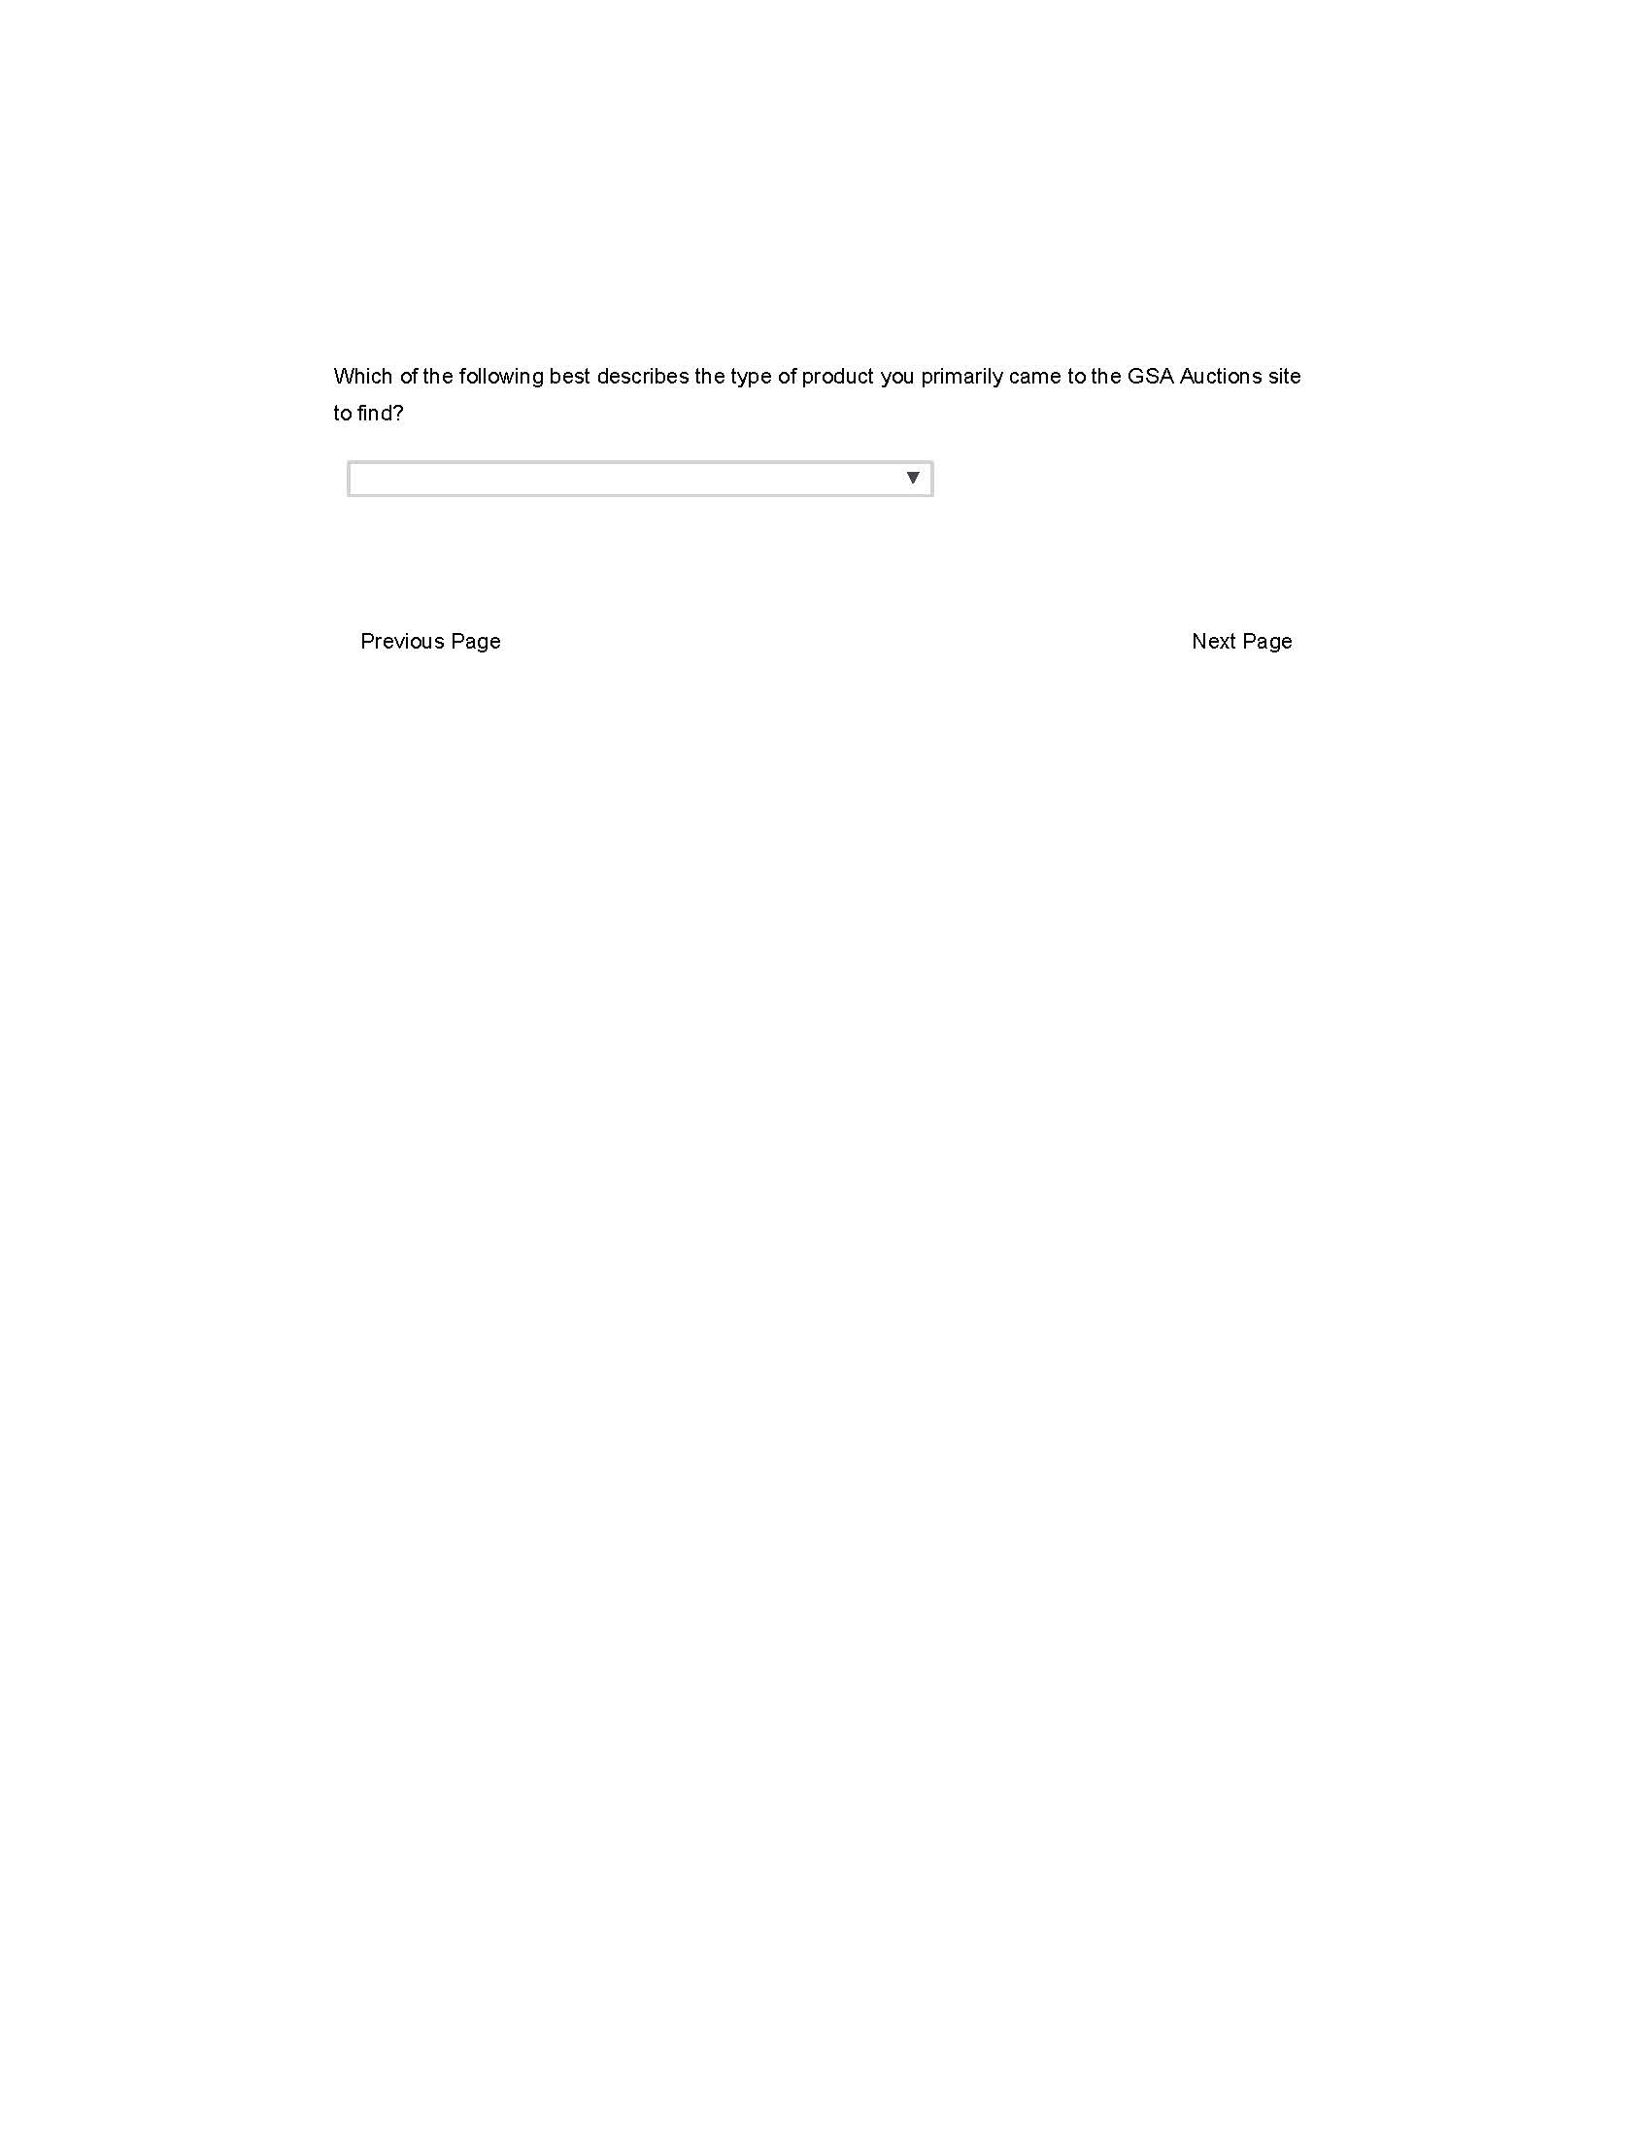

If Product I Was Not Looking for Anything Specific Is Not Selected, display Screen 7

If Product I Was Not Looking for Anything Specific Is Selected, display Screen 8

**Screen 7**



Display Screen 8

**Screen 8**



Display Screen 9

**Screen 9**

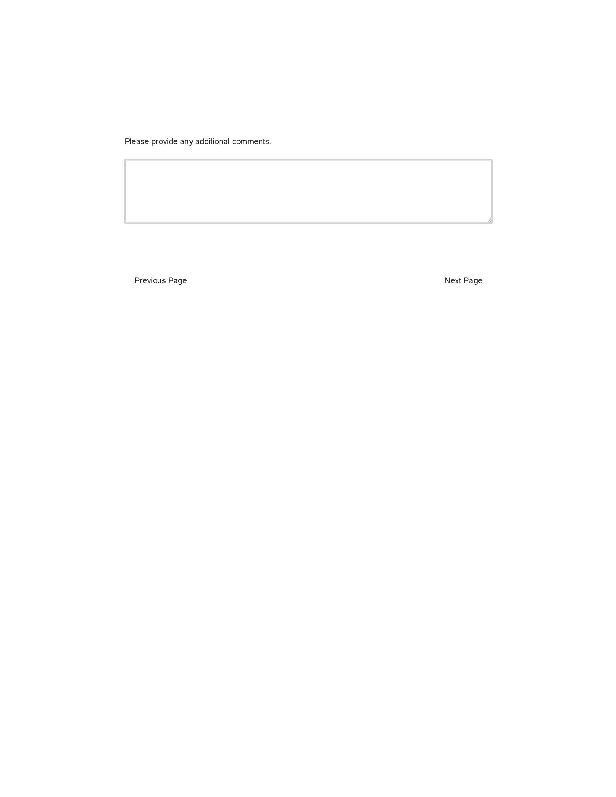

Display Screen 10

**Screen 10**

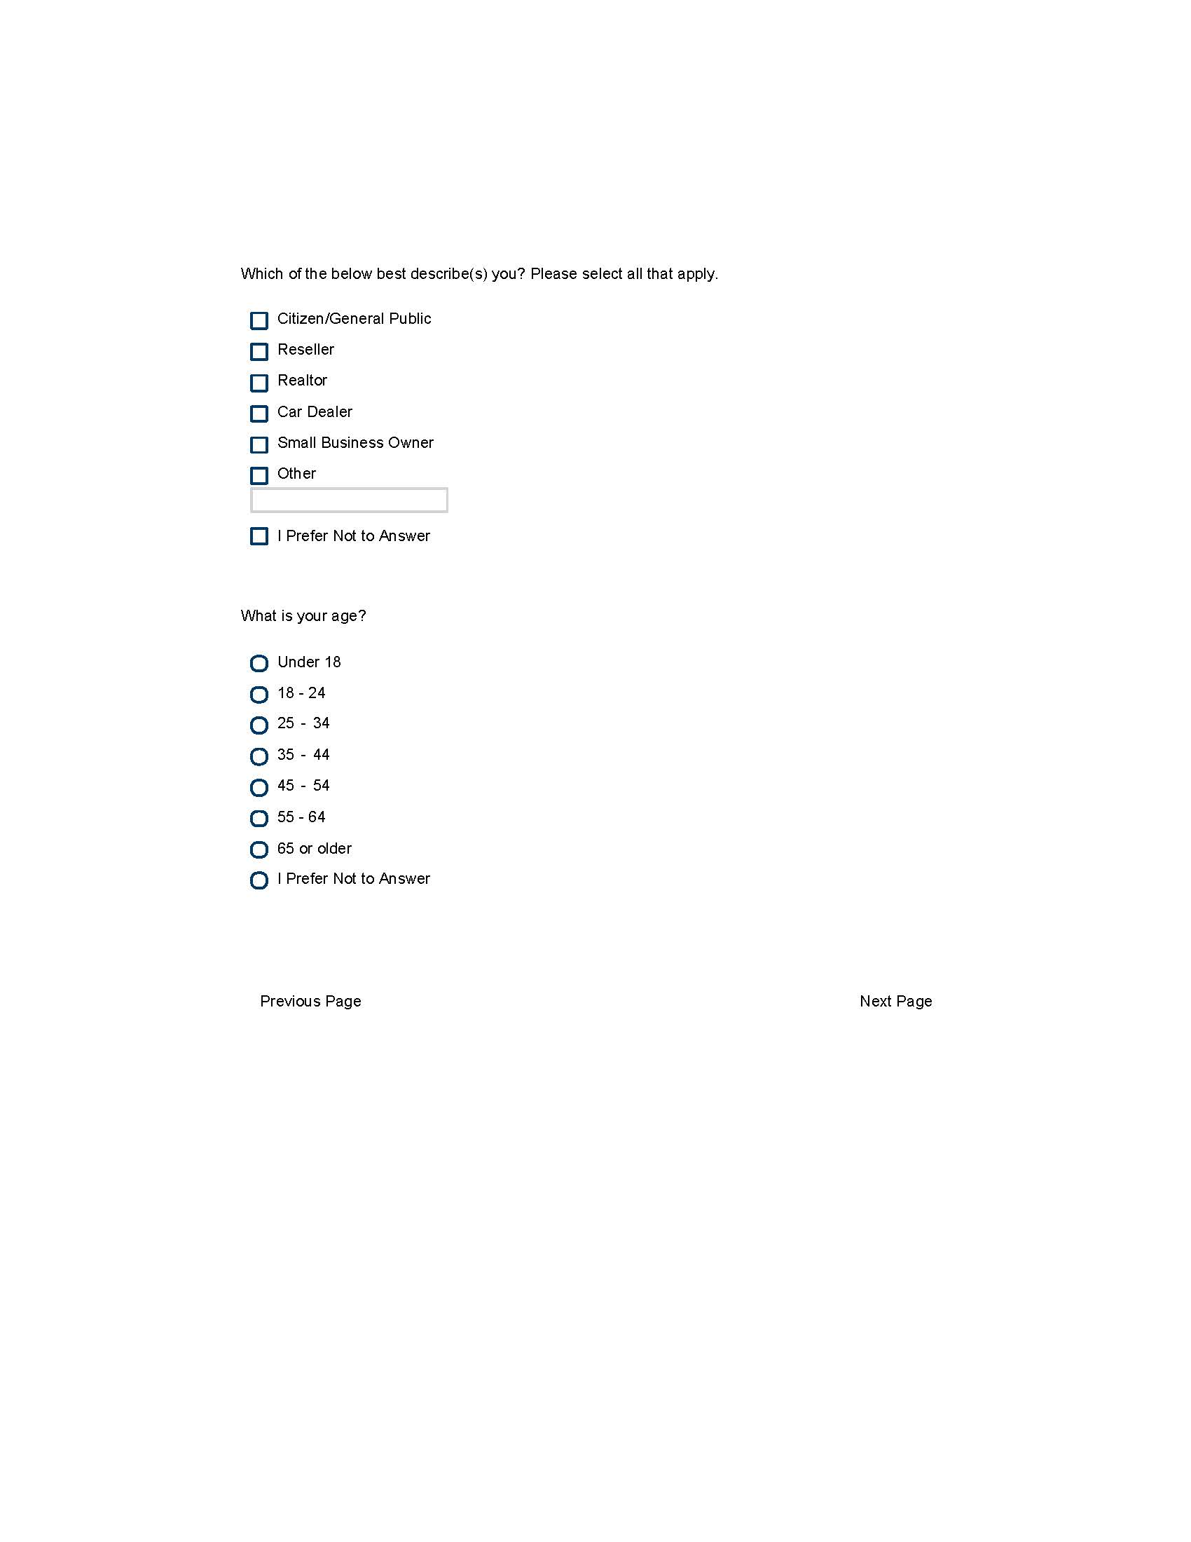

Display Screen 11

**Screen 11**

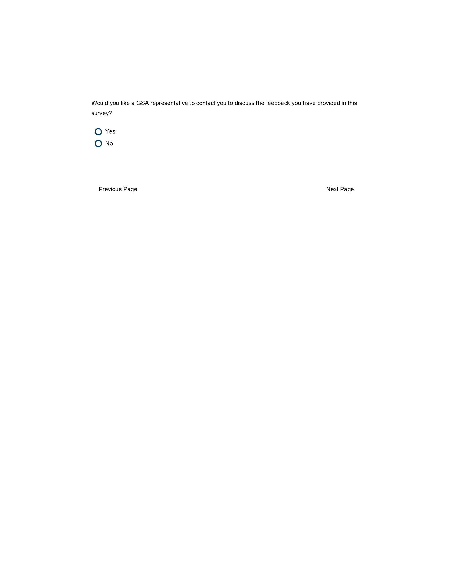

**yes is selected display Screen 12**

**If no is selected display Screen 13**

**Screen 12**

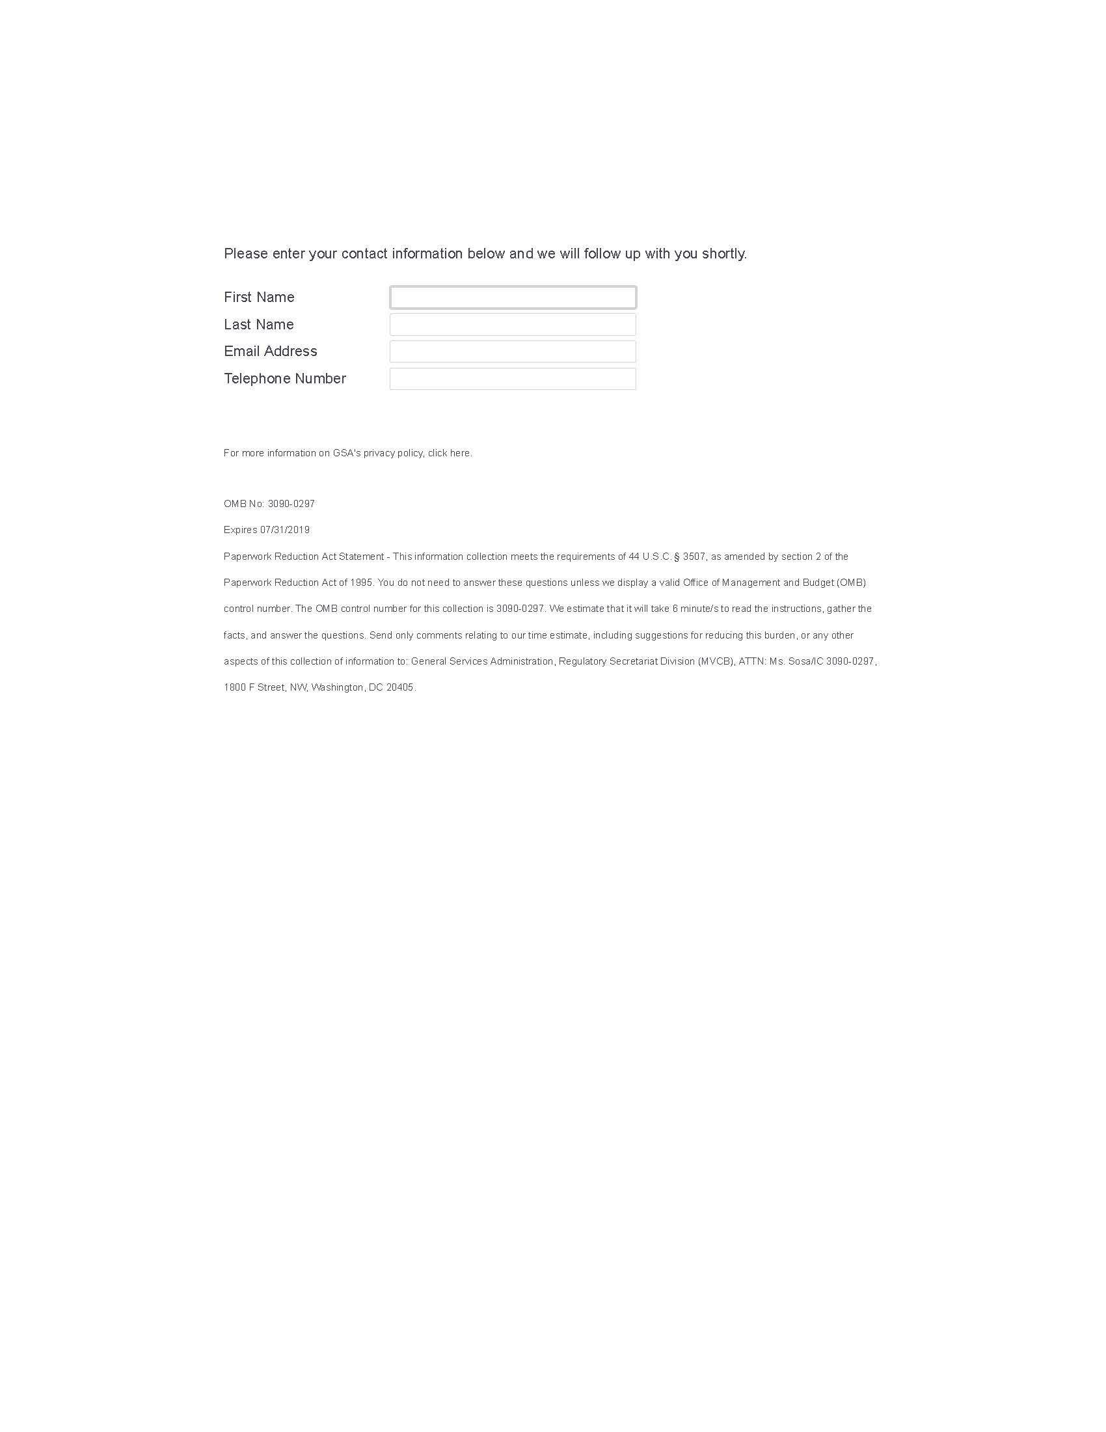

Display Screen 13

**Screen 13**

