**FAST-Track 3090-0297**

**Req-19**

**GSA.gov Website Feedback Survey**

**Screen 1**

This screen is a pop-up that appears when the user has not been invited to take the survey in the last 30 days **AND** fulfills one of the following criteria:

* Demonstrates intent to exit the website
* Visits three or more pages
* Spends at least 60 seconds on the website



The first link (“Click here to see the full Paperwork Reduction Act statement…”) will open the below pdf in a new tab.

The second link (“Click here to read more about…”) goes to GSA’s Website Privacy and Security Notice webpage.

**Screenshot of PRA statement pdf:**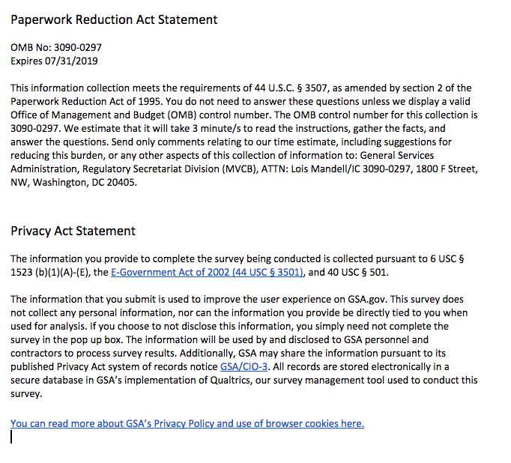

**Screen 2**

Displayed if survey was triggered because user demonstrated intent to exit webpage.

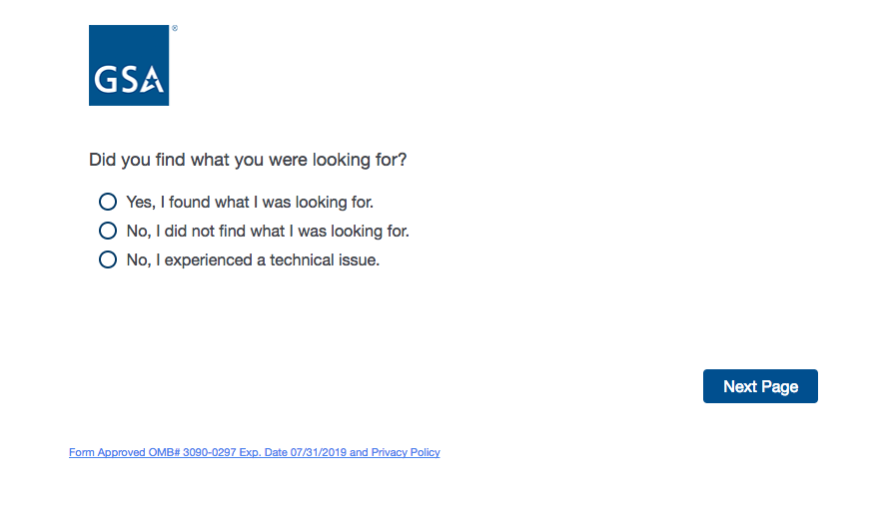

The link at the bottom of this and every page opens a pdf in a new tab. The pdf contains the PRA Statement and Privacy Act Statement for the survey. The text of the pdf is included in the appendix of this document.

If “Yes, I found what I was looking for”, display Screen 3.

If “No, I did not find what I was looking for”, display Screen 3

If “No, I experienced a technical issue”, skip to Screen 9.

**Screen 3**

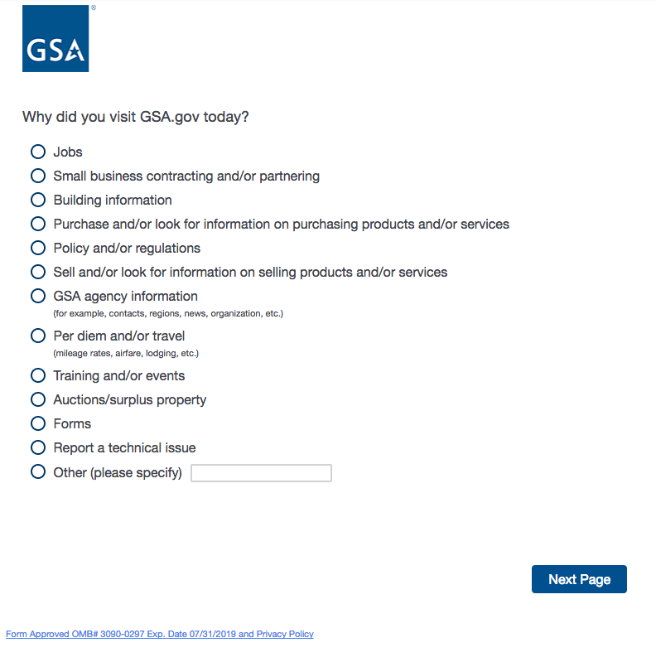

If “Report a technical issue”, then skip to Screen 9.

For all other responses, proceed to Screen 4.

**Screen 4**

There are three questions that could be displayed on Screen 4. The survey software will randomly display one of the three questions to the user.

**Screen 4a**

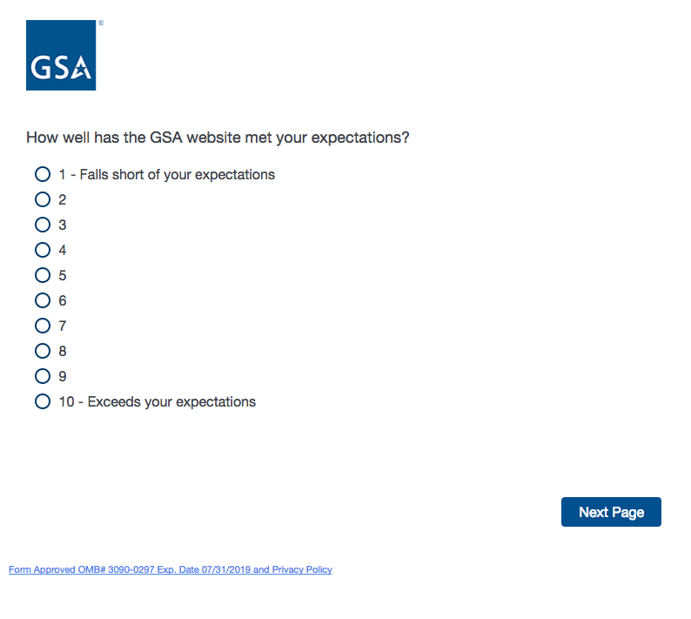

We recognize that 10-point scales are less preferable than smaller scales. This survey will replace an existing survey that is much longer and more confusing for the user. For the sake of metric continuity for our stakeholders, we have opted to keep the 10-point scale for these questions.

If the user selects 1, 2, 3, 4, or 5, then display Screen 5a.

If the user selects 6, 7, 8, 9, or 10, then skip to Screen 6.

**Screen 4b**

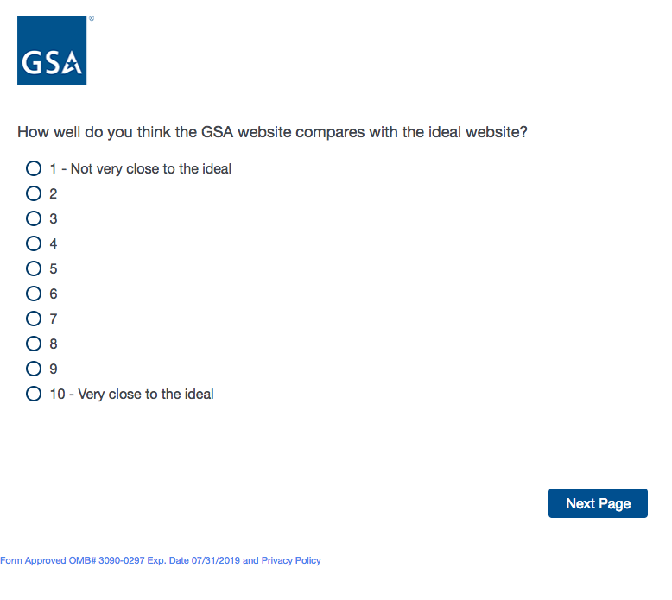

If the user selects 1, 2, 3, 4, or 5, then display Screen 5b.

If the user selects 6, 7, 8, 9, or 10, then skip to Screen 6.

**Screen 4c**

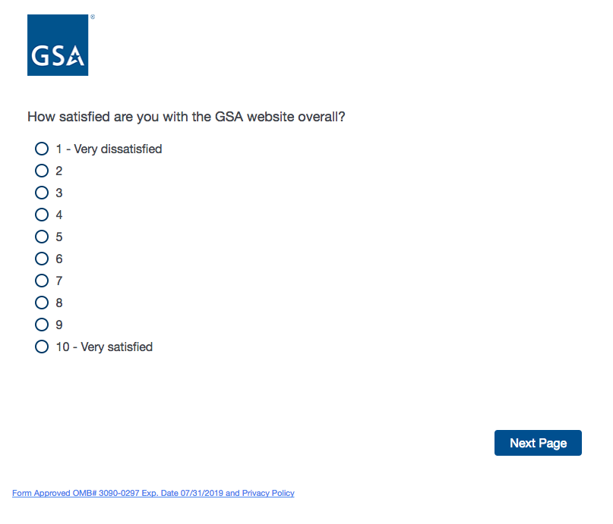

If the user selects 1, 2, 3, 4, or 5, then display Screen 5c.

If the user selects 6, 7, 8, 9, or 10, then skip to Screen 6.

**Screen 5a**

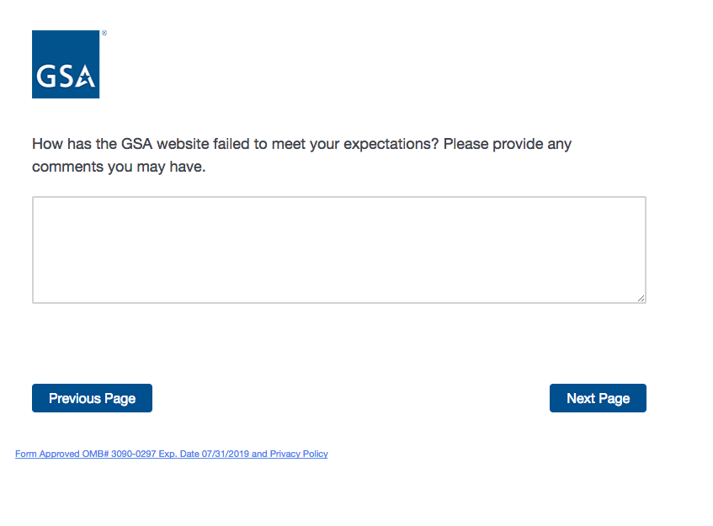

**Screen 5b**

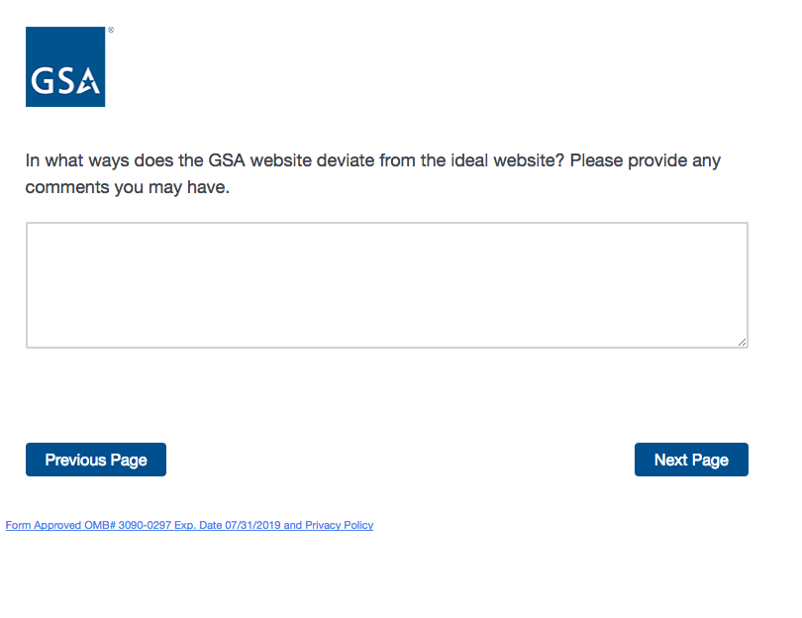

**Screen 5c**

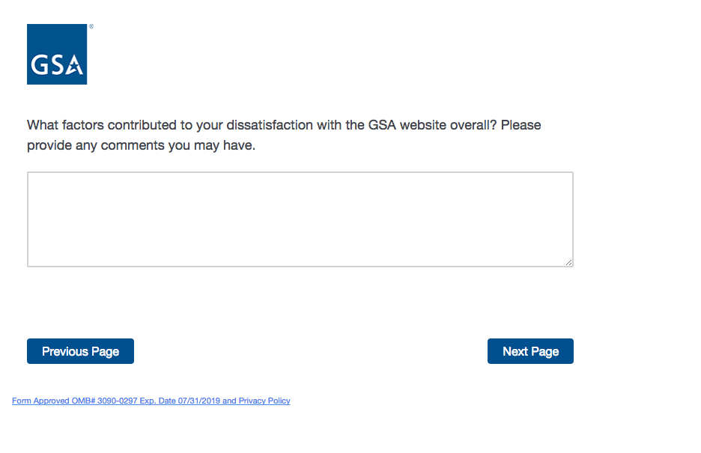

**Screen 6**

Display if user selected 6, 7, 8, 9, or 10 on Screen 4a, Screen 4b, or Screen 4c.

Else skip to Screen 7.

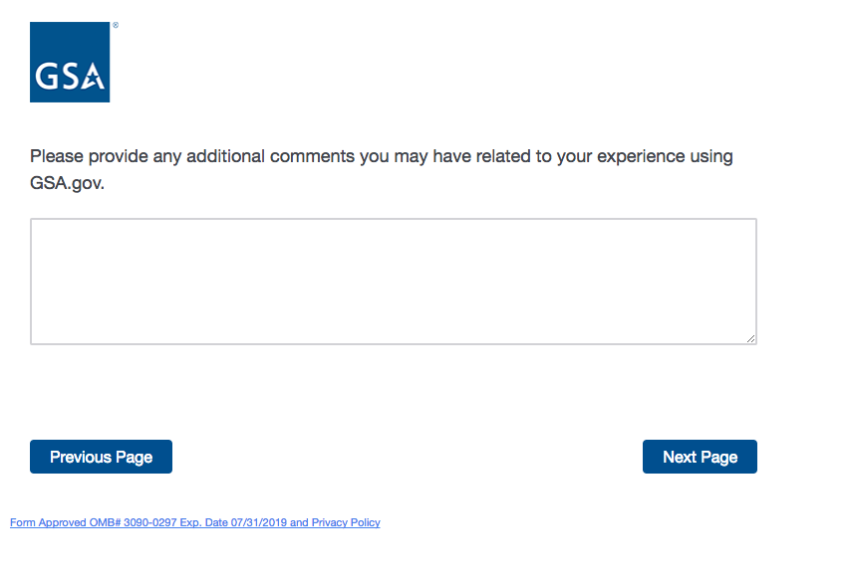

**Screen 7**

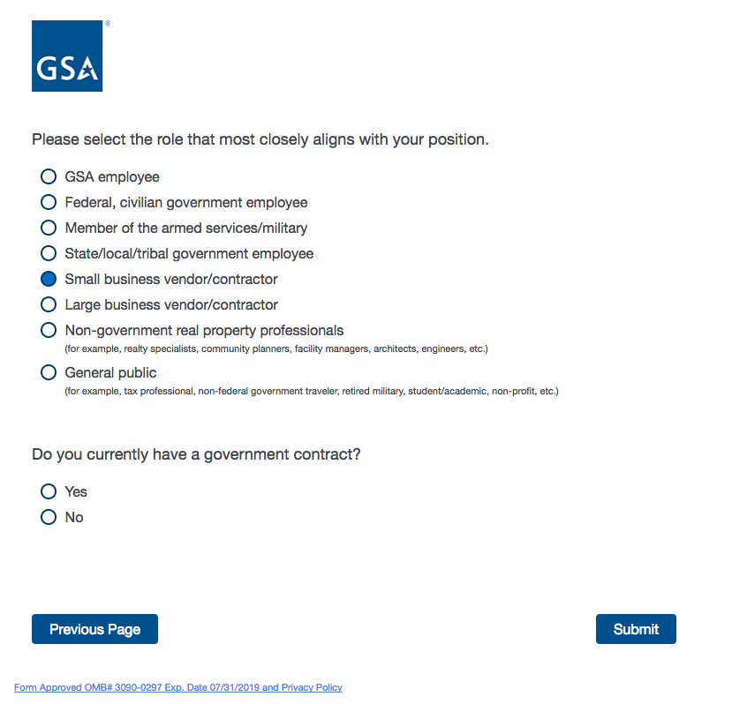

If the user selects “Small business vendor/contractor” or “Large business vendor/contractor”, then the question “Do you currently have a government contract?” will appear.

If the user selects any other option, then “Do you currently have a government contract?” will NOT appear.

If the user DID NOT indicate on Screen 2 or Screen 3 that they experienced a technical issue, then the survey ends and the message on Screen 8 is displayed.

If the user indicated on Screen 2 or Screen 3 that they experienced a technical issue, then the user was skipped from Screen 2 or Screen 3 to Screen 9.

**Screen 8**

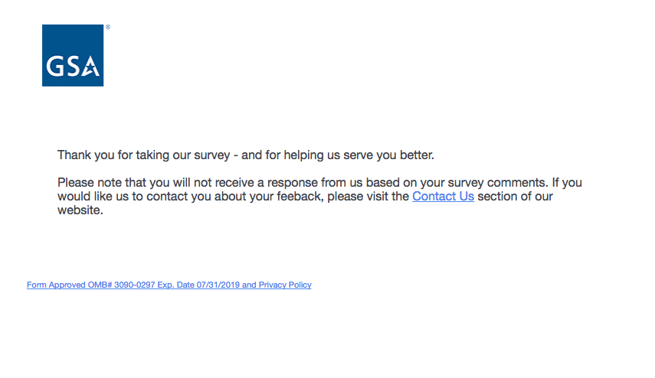

**Screen 9a**

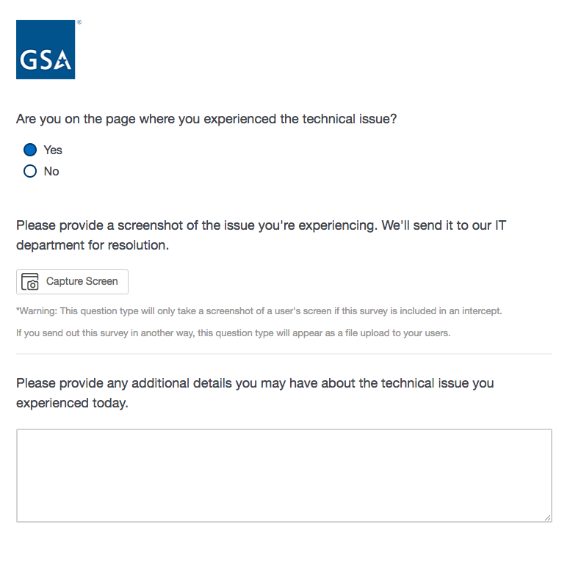

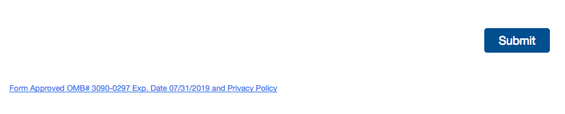

If the user selects “Yes” in response to the question “Are you on the page where you experienced the technical issue?”, then “Please provide a screenshot” will appear. The user will have the ability to black out any sensitive information captured in the screenshot.

If the user selects “No” to the question “Are you on the page where you experienced the technical issue?”, then “What is the URL of the page you experience the issue on?” will appear (Screen 9b).

**Screen 9b**

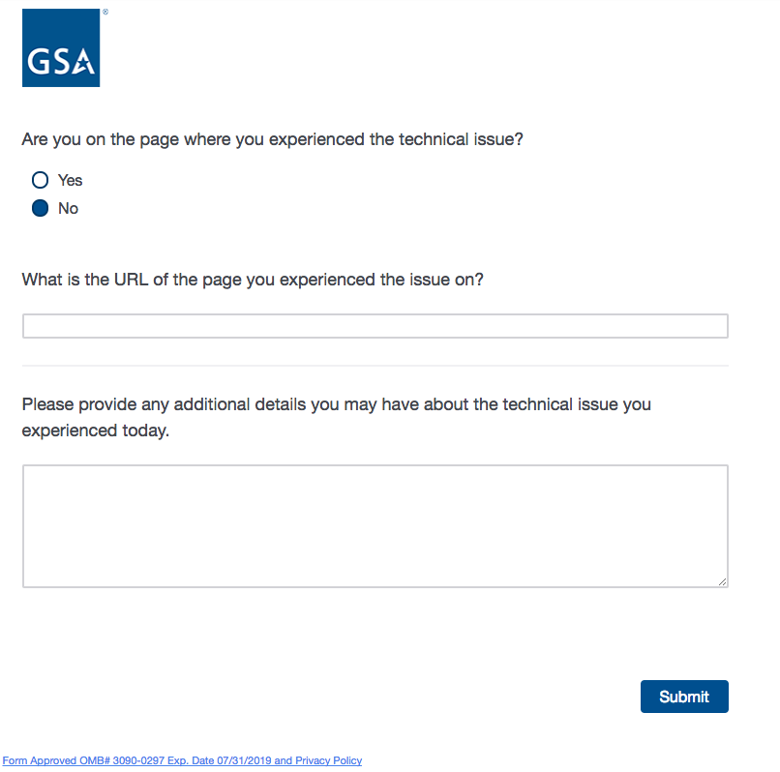

**Screen 11**

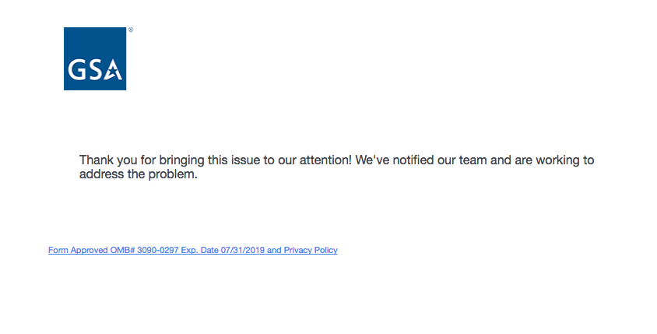

**Appendix:**

**Privacy Act and Paperwork Reduction Act Statements**

This is the pdf that will appear in a separate tab when the user clicks on the PRA link in the footer of every page.

