FAST-Track 3090-0297

Req. 21

NMCD Campaign Training Survey

Screen 1:

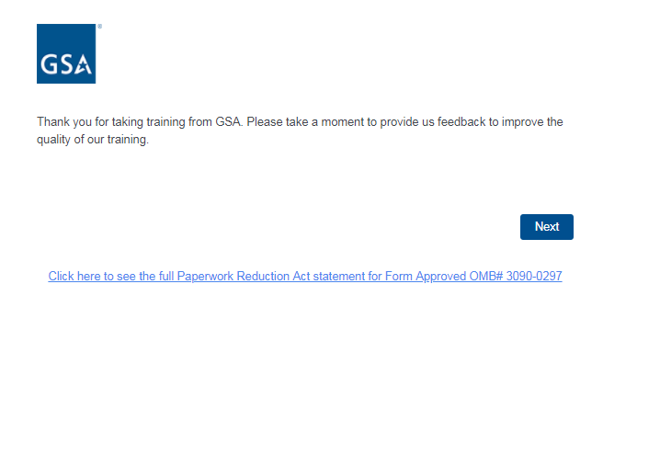

Screen 2:

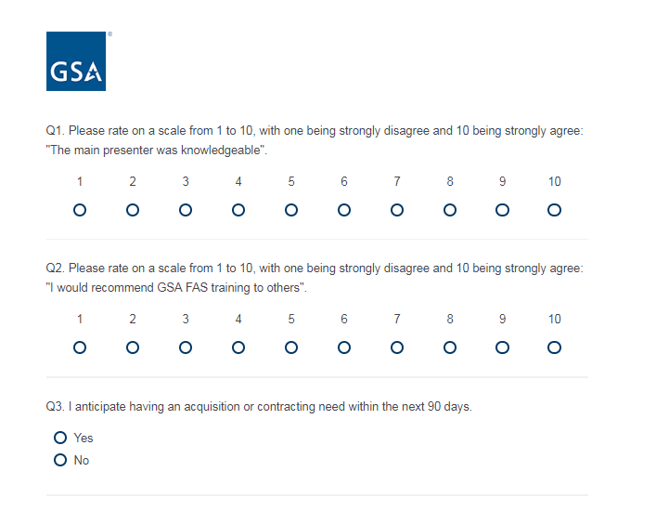

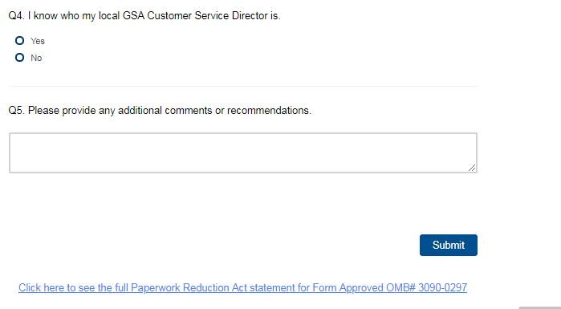

Screen 3:

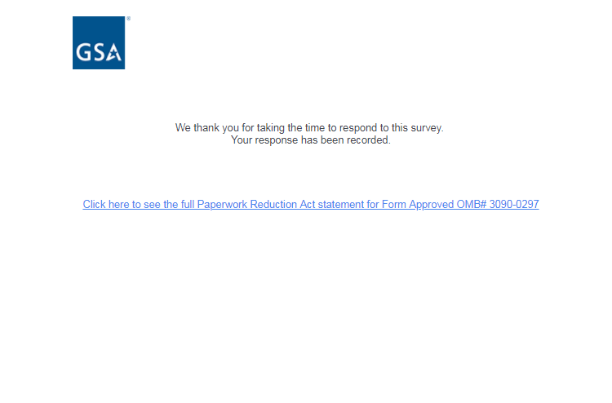

Link to PRA statement directs to PDF of the below statement:

