**FAST-Track 3090-0297**

**Instrument Req-24**

**NCSC Customer Satisfaction Survey**

Screen 1:

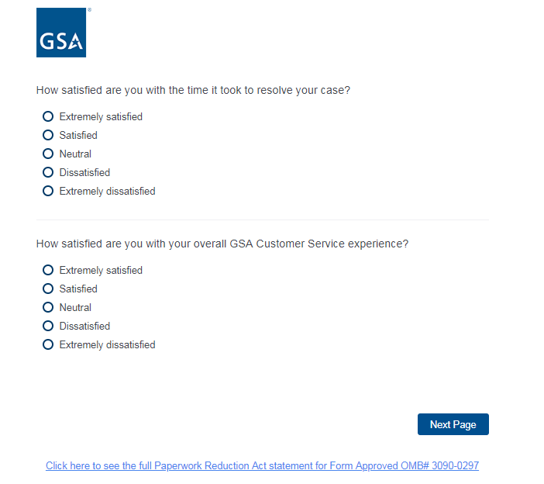

Screen 2:

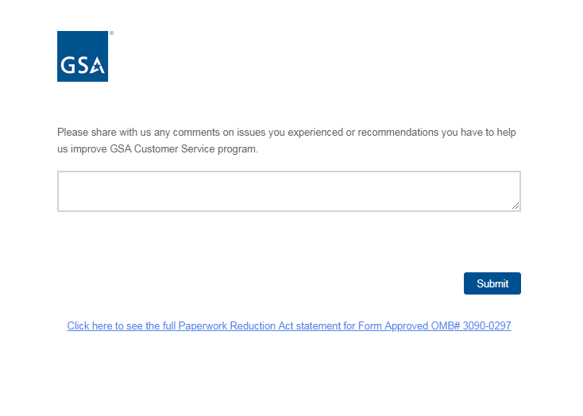

PRA statement as contained in link at bottom of page:

