**FAS Supplier Pulse Survey**

3090-0297

FAST-Track Req-26

**Screen 1**

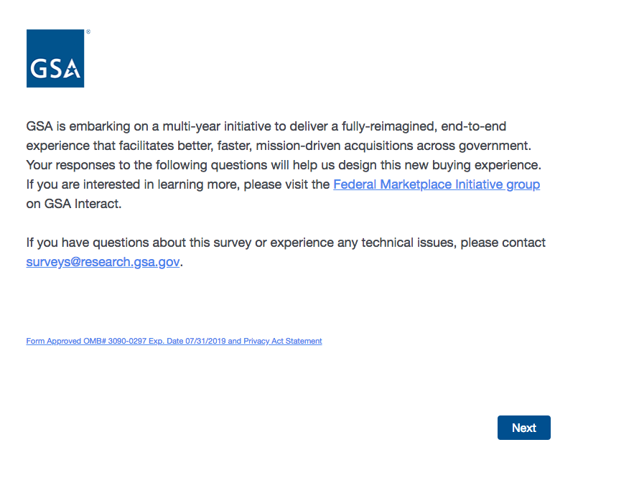

The first link (Federal Marketplace Initiative group) is an external link to GSA Interact.

The second link (Form Approved….) goes to a pdf with the PRA and Privacy Act Statements. See next page for a screenshot of the pdf.

**Screenshot of PRA and Privacy Act statement pdf:**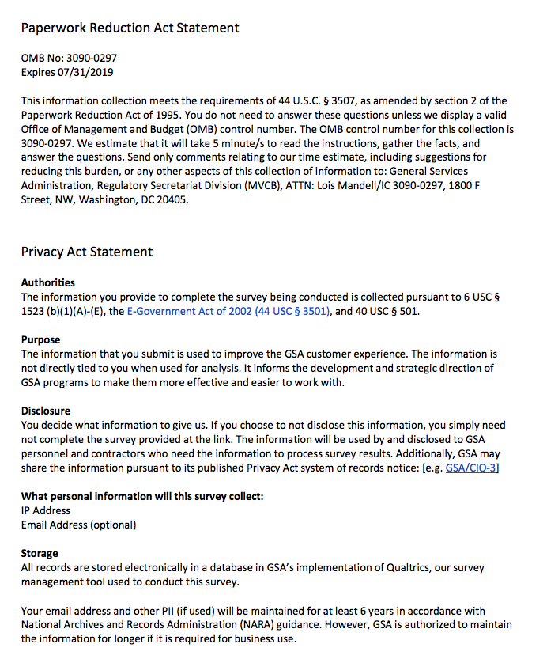

**Screen 2**

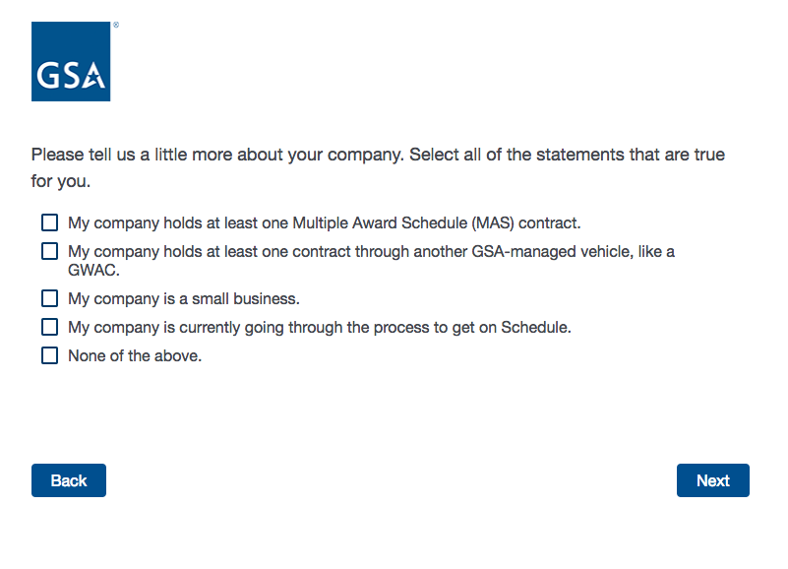

**Screen 3**

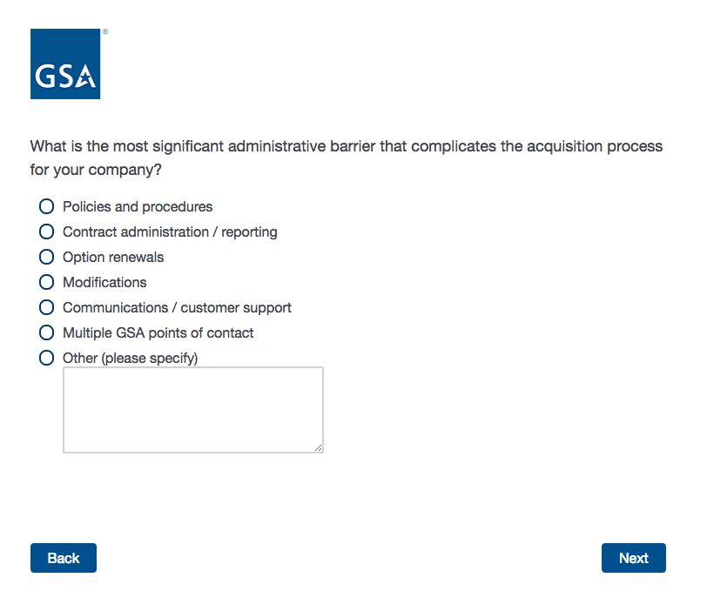

**Screen 4a**

Display if the user selects “My company holds at least one Multiple Award Schedule (MAS) contract” and/or “My company is currently going through the process to get on Schedule” on Screen 2.

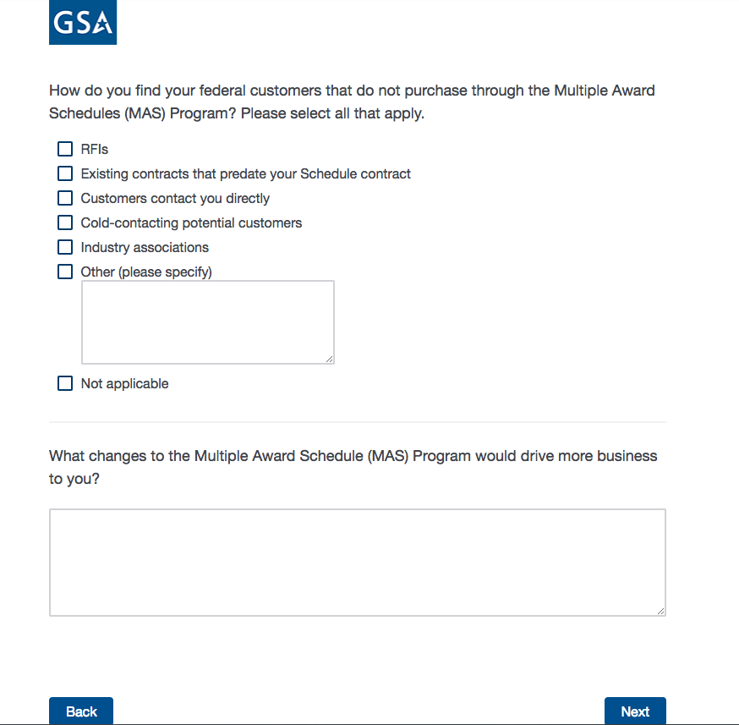

**Screen 4b**

Display if the user **does not** select “My company holds at least one Multiple Award Schedule (MAS) contract” and/or “My company is currently going through the process to get on Schedule” on Screen 2.

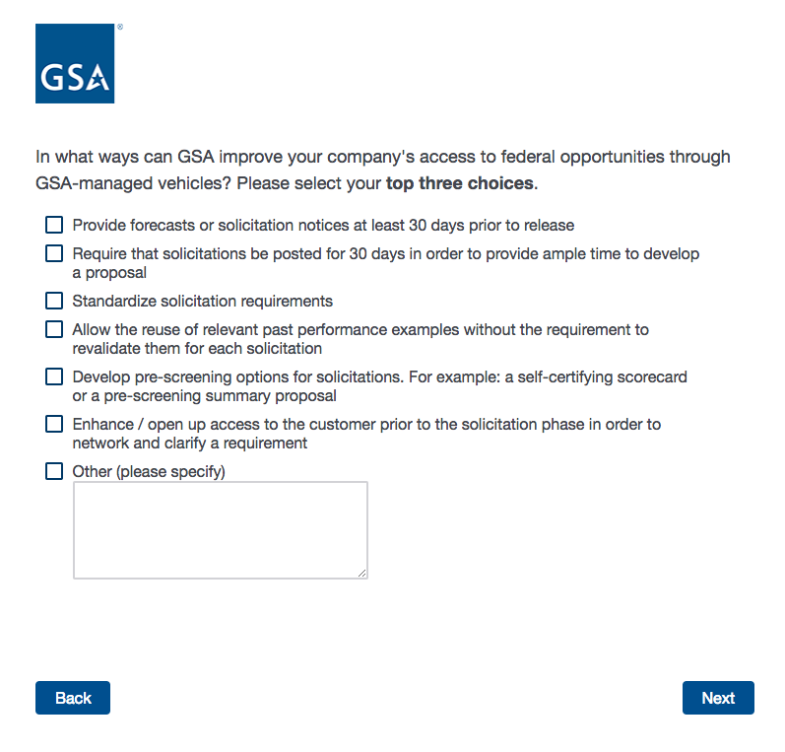

**Screen 5**

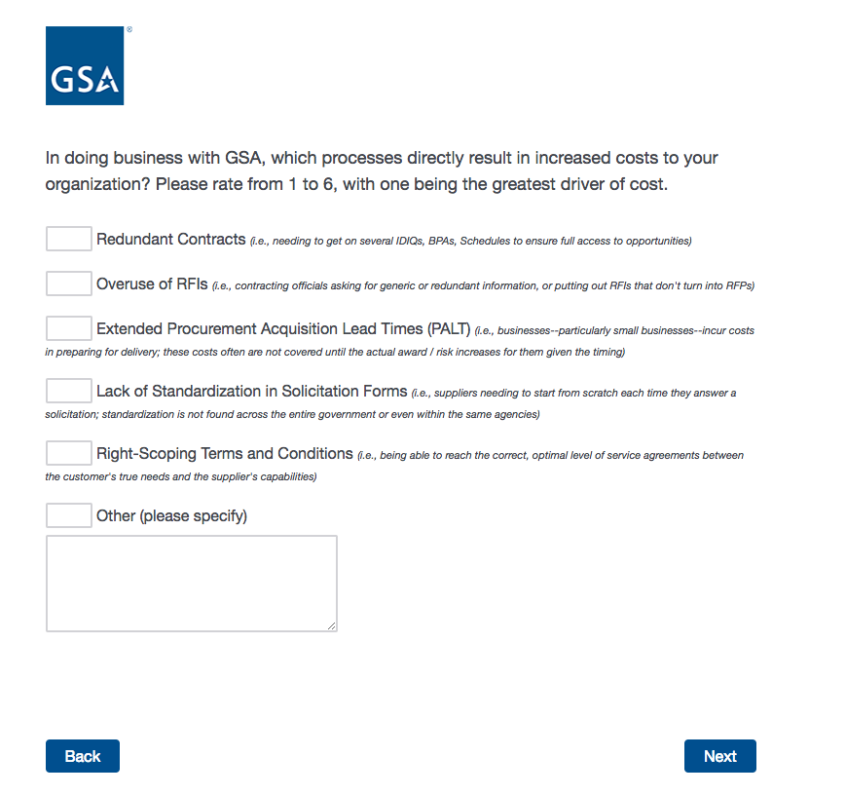

**Screen 6**

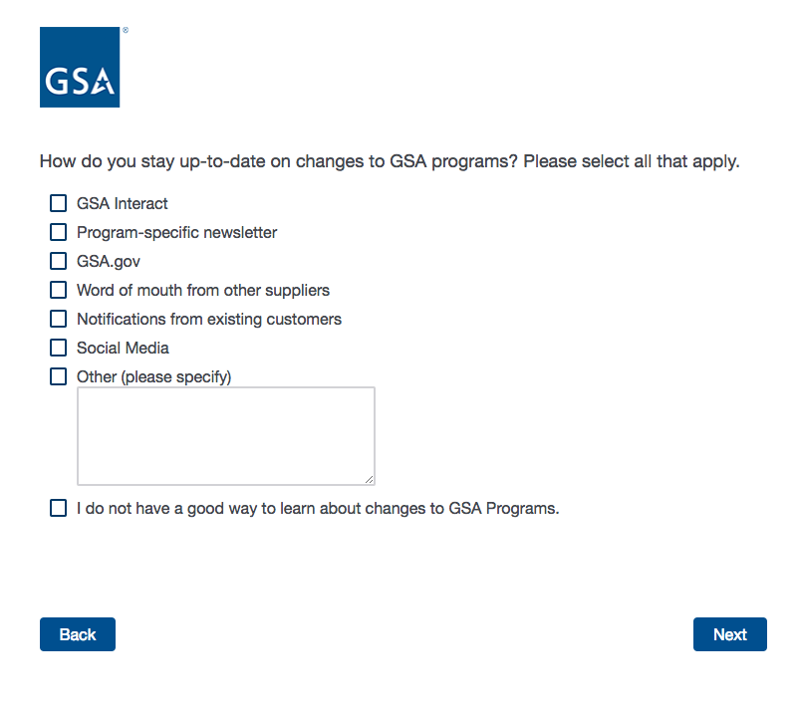

**Screen 7**

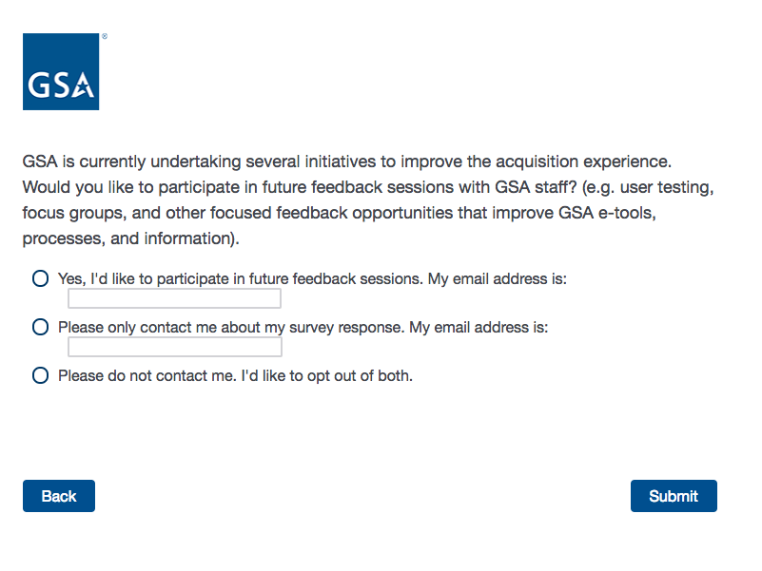

**Screen 8**

