FAST-Track 3090-0297

Req-32

OGP’s Website Feedback Survey

# **Screen 1**

This screen is a pop-up that appears when the user has not been asked to take the survey in the last 30 days **AND** fulfills one of the following criteria:

* Demonstrates intent to exit the website
* Visits 3 or more pages
* Spends at least 60 seconds on the website

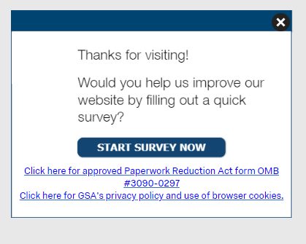

The first link (“Click here to see the full Paperwork Reduction Act statement…”) will open the below pdf in a new tab.

The second link (“Click here to read more about…”) goes to GSA’s Website Privacy and Security Notice webpage.  
  
**Screenshot of GSA’s PRA Statement pdf link**

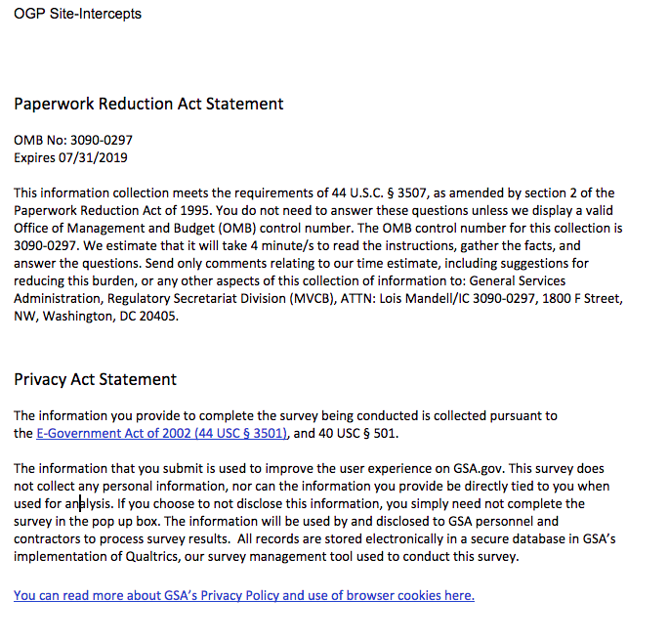

# **Screen 2 -** Displayed if survey was triggered

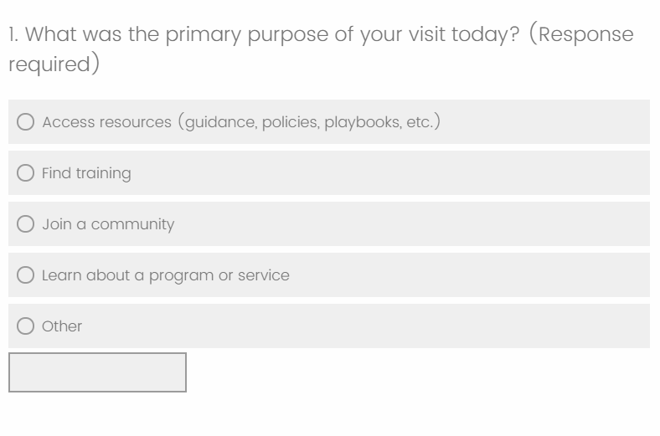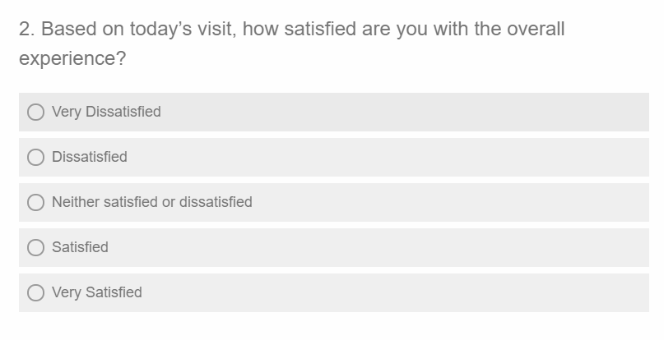

# 

# 

# Screen 3

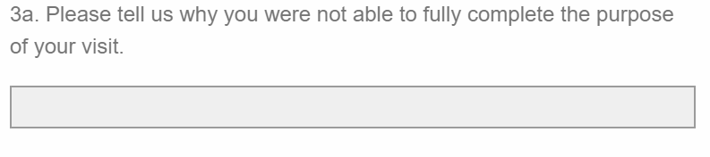

This question will only be displayed if the respondent answered “No” to the previous question

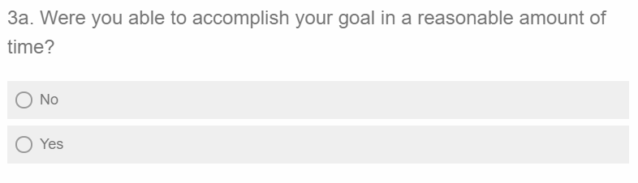

This question will only be displayed if the respondent answered “Yes” to the previous question

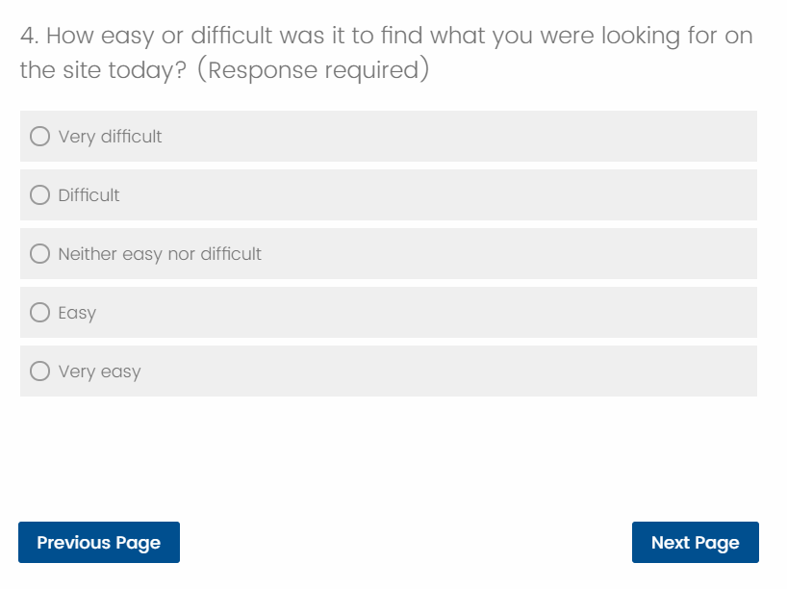

# 

# Screen 4

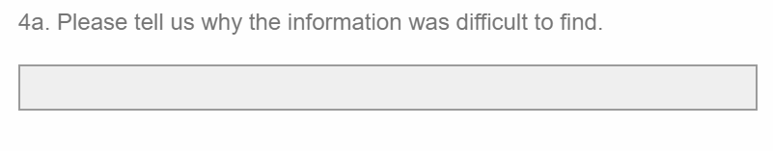

This question will only be displayed if the respondent answered “Difficult” or “Very Difficult” on the previous question

[WEBSITE] will be replaced with the actual website name for each survey.

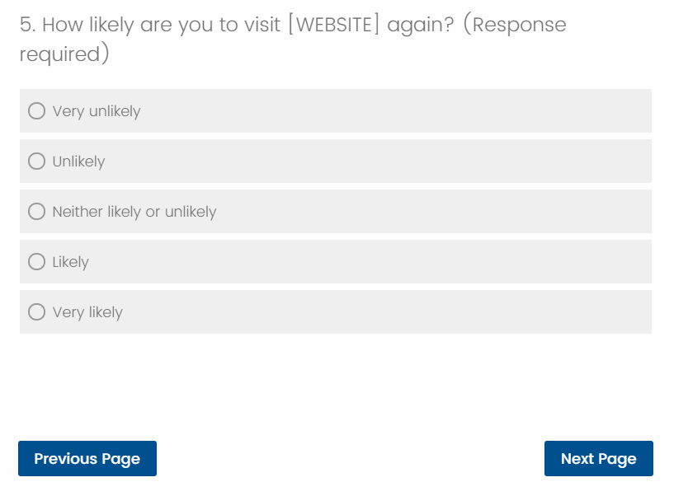

# Screen 5

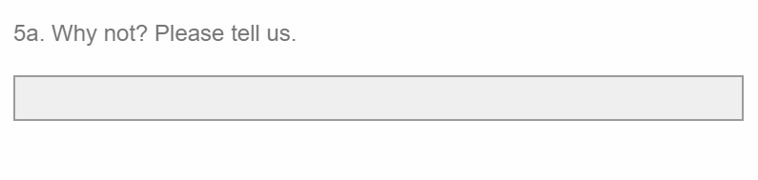

This question will only be displayed if the respondent answered “Unlikely” or “Very unlikely ”on the previous question

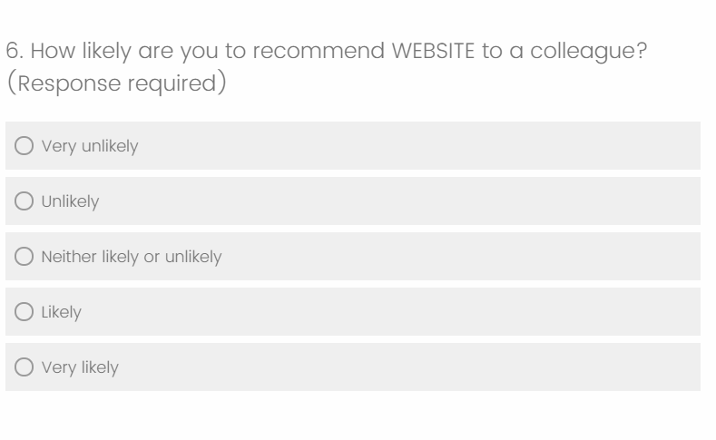

[WEBSITE] will be replaced with the actual website name for each survey.

[WEBSITE] will be replaced with the actual website name for each survey.

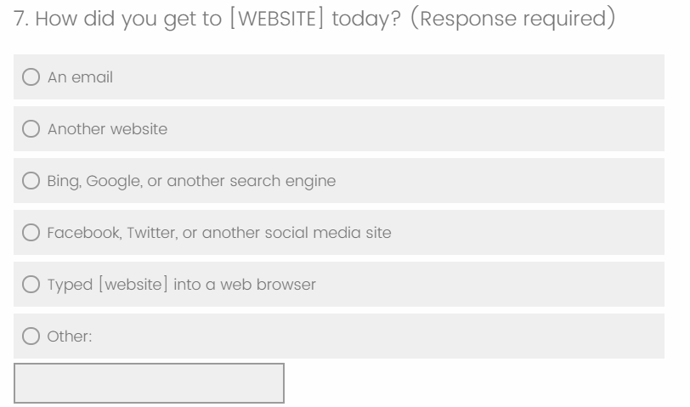

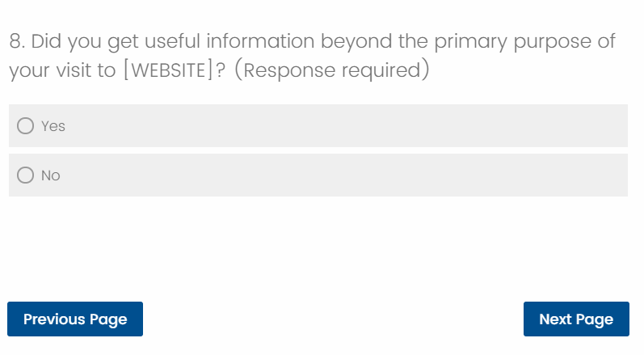

[WEBSITE] will be replaced with the actual website name for each survey.

# Screen 6

This question will only be displayed if the respondent answered “Yes” to the previous question

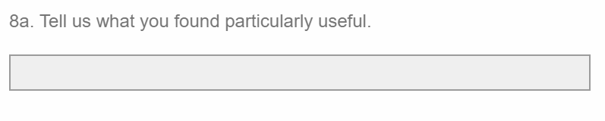

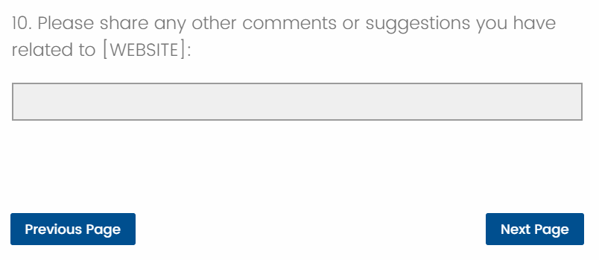

[WEBSITE] will be replaced with the actual website name for each survey.

# Screen 7

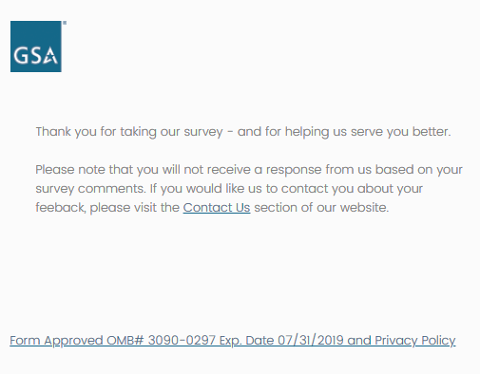

“Contact Us” link will link to individual website contact page / email address