FAST-Track 3090-0297

Request 34

Link to survey template:

<https://feedback.gsa.gov/jfe/preview/SV_412QIPpo3ajF50V?Q_SurveyVersionID=current&Q_CHL=preview>

The contract information is piped into the survey from contract information uploaded into Qualtrics. To show what is usually filled in, below is a screenshot of a mock contract. This is what the respondent will see:

Example survey link with embedded data:

|  |
| --- |
| [https://feedback.gsa.gov/jfe/form/SV_412QIPpo3ajF50V?OrderN=10311770&LineItem30822892&OrderD=February 26, 2018&Ven=W.W.GRAINGER, INC.&ContractN=GS06F0007J&MFR=ABILITY ONE&Prod=C-FOLD SHEETS BROWN SKILCRAFT&CO=donald.gray@gsa.gov&Flag=](https://feedback.gsa.gov/jfe/form/SV_412QIPpo3ajF50V?OrderN=10311770&LineItem30822892&OrderD=February) |

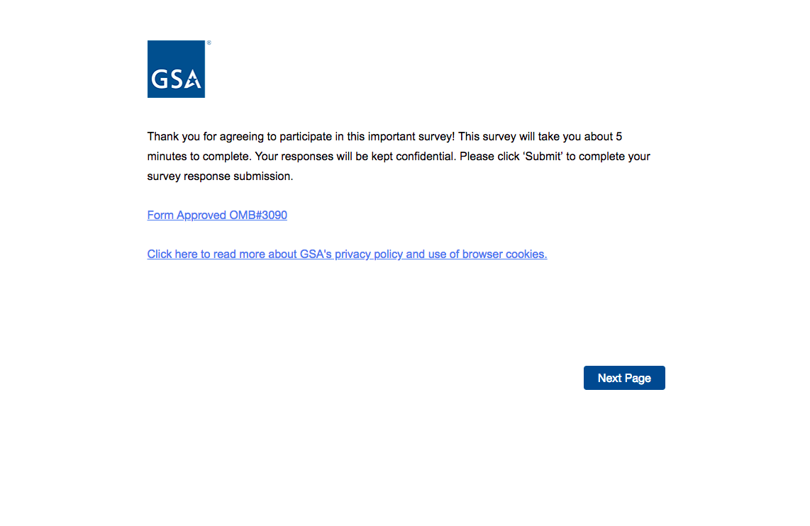

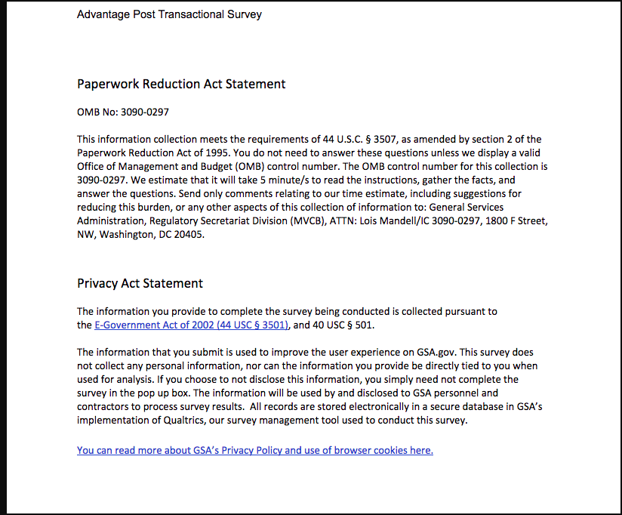

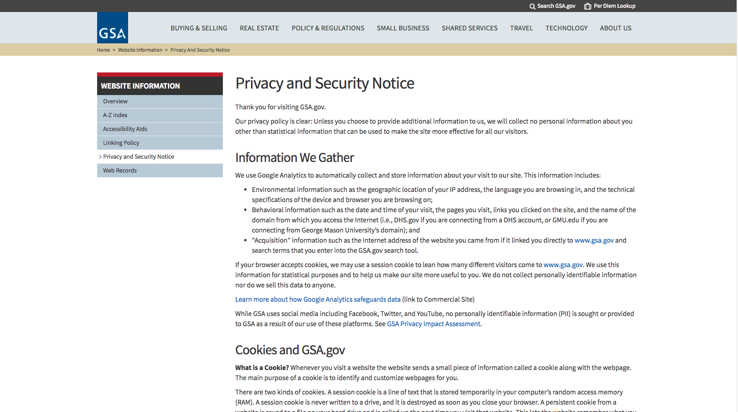

The respondent will then be asked to provide an email.

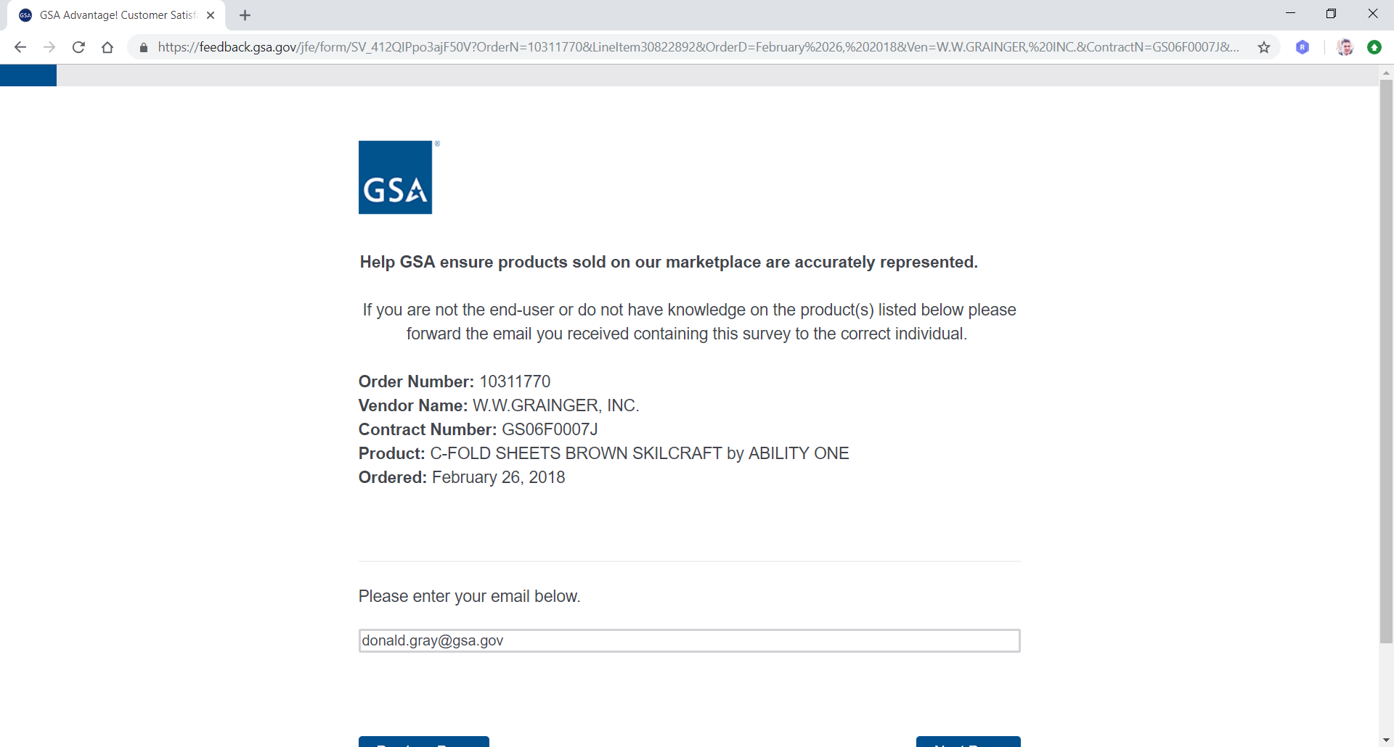

The respondent will then be asked a basic question on if the item has been received and if what arrived was exactly what was ordered. This question determines the what further questions will be asked of the respondent (Path 1 - 5, with Path 1 being “Yes”.)

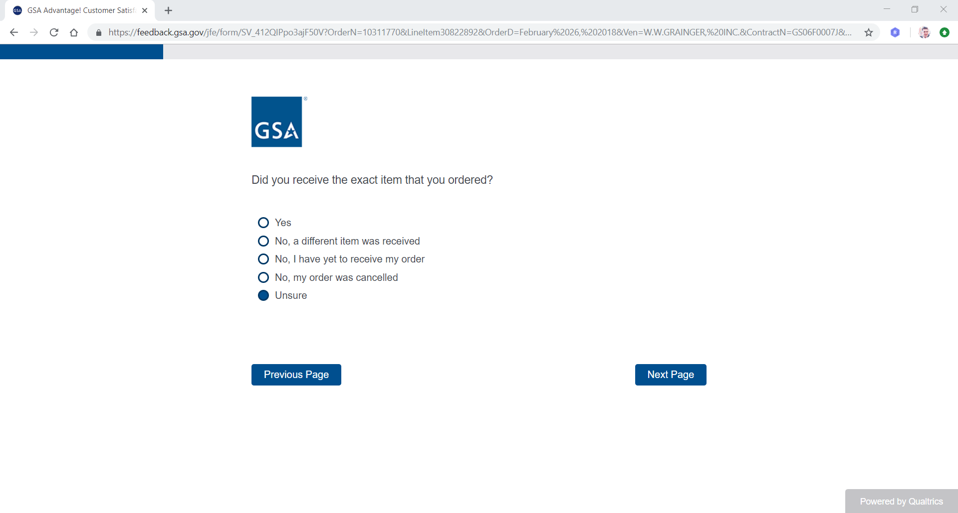

**Path 5**

If “Unsure” is selected the survey ends and asks that they forward to email they received to corrected individual.

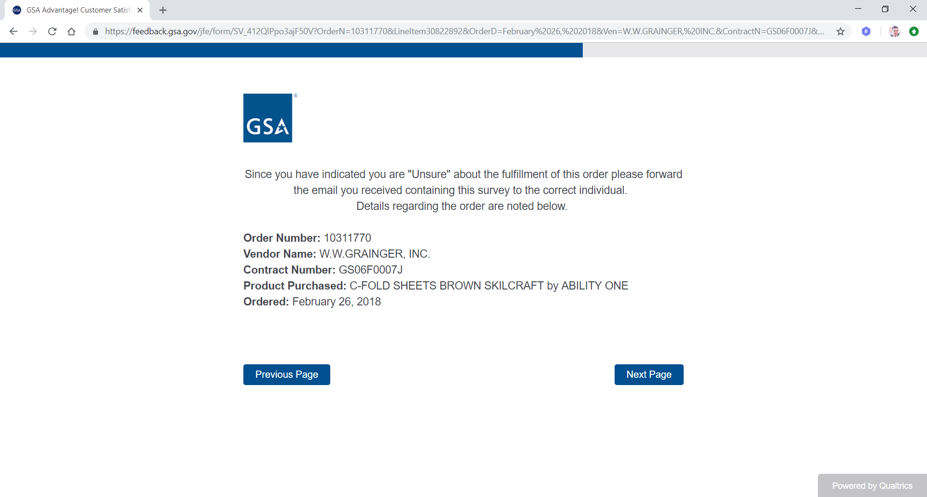

**Path 4**

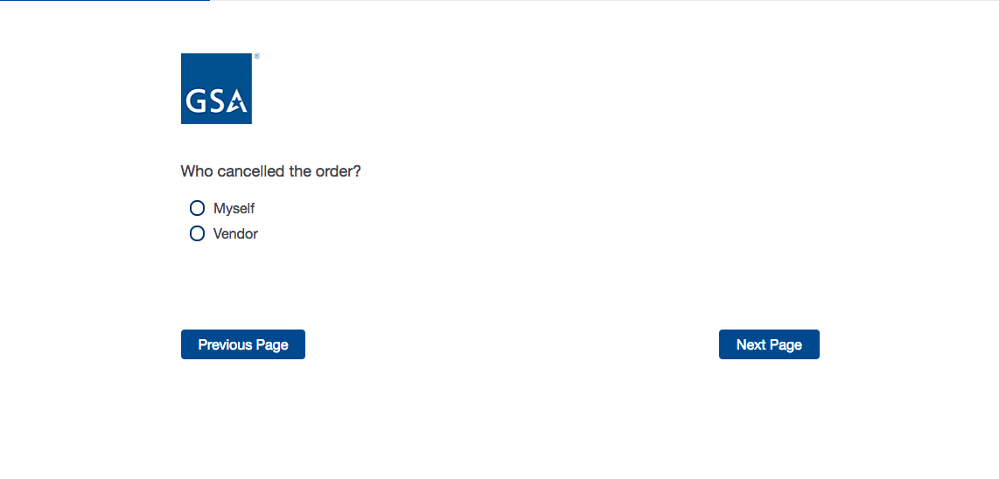

**Path 4a - If the respondent cancelled the order**

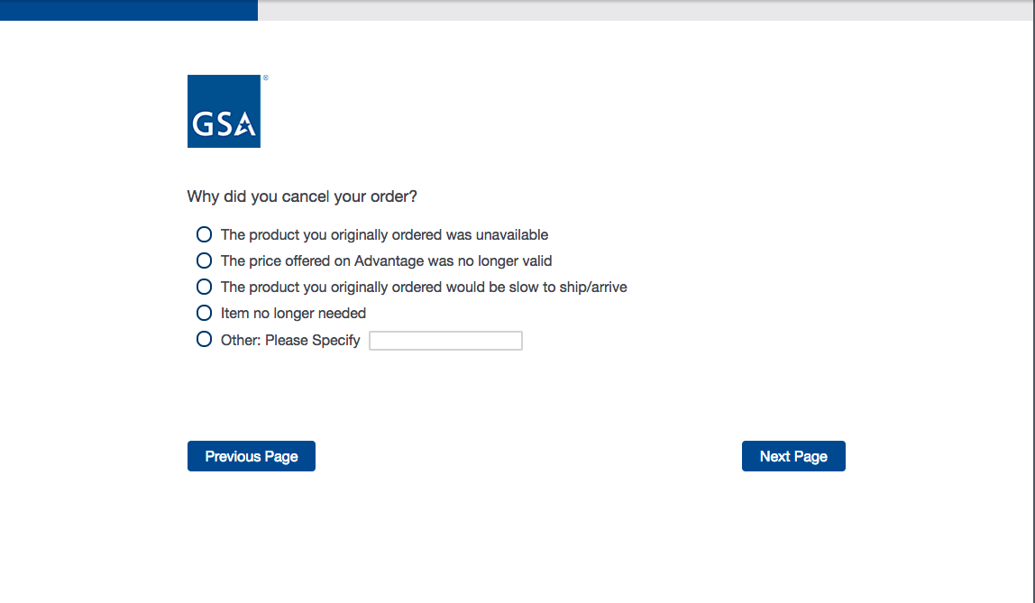

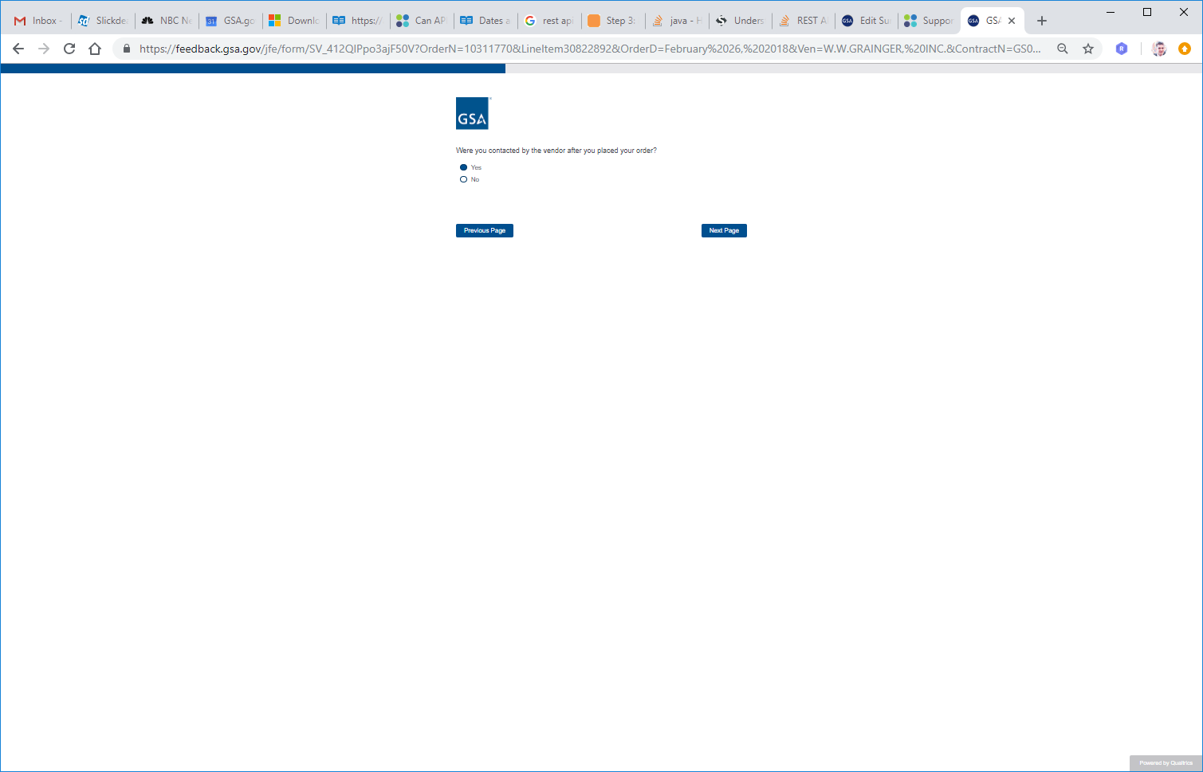

**Path 4aa - If the vendor cancelled the order and contacted the vendor**

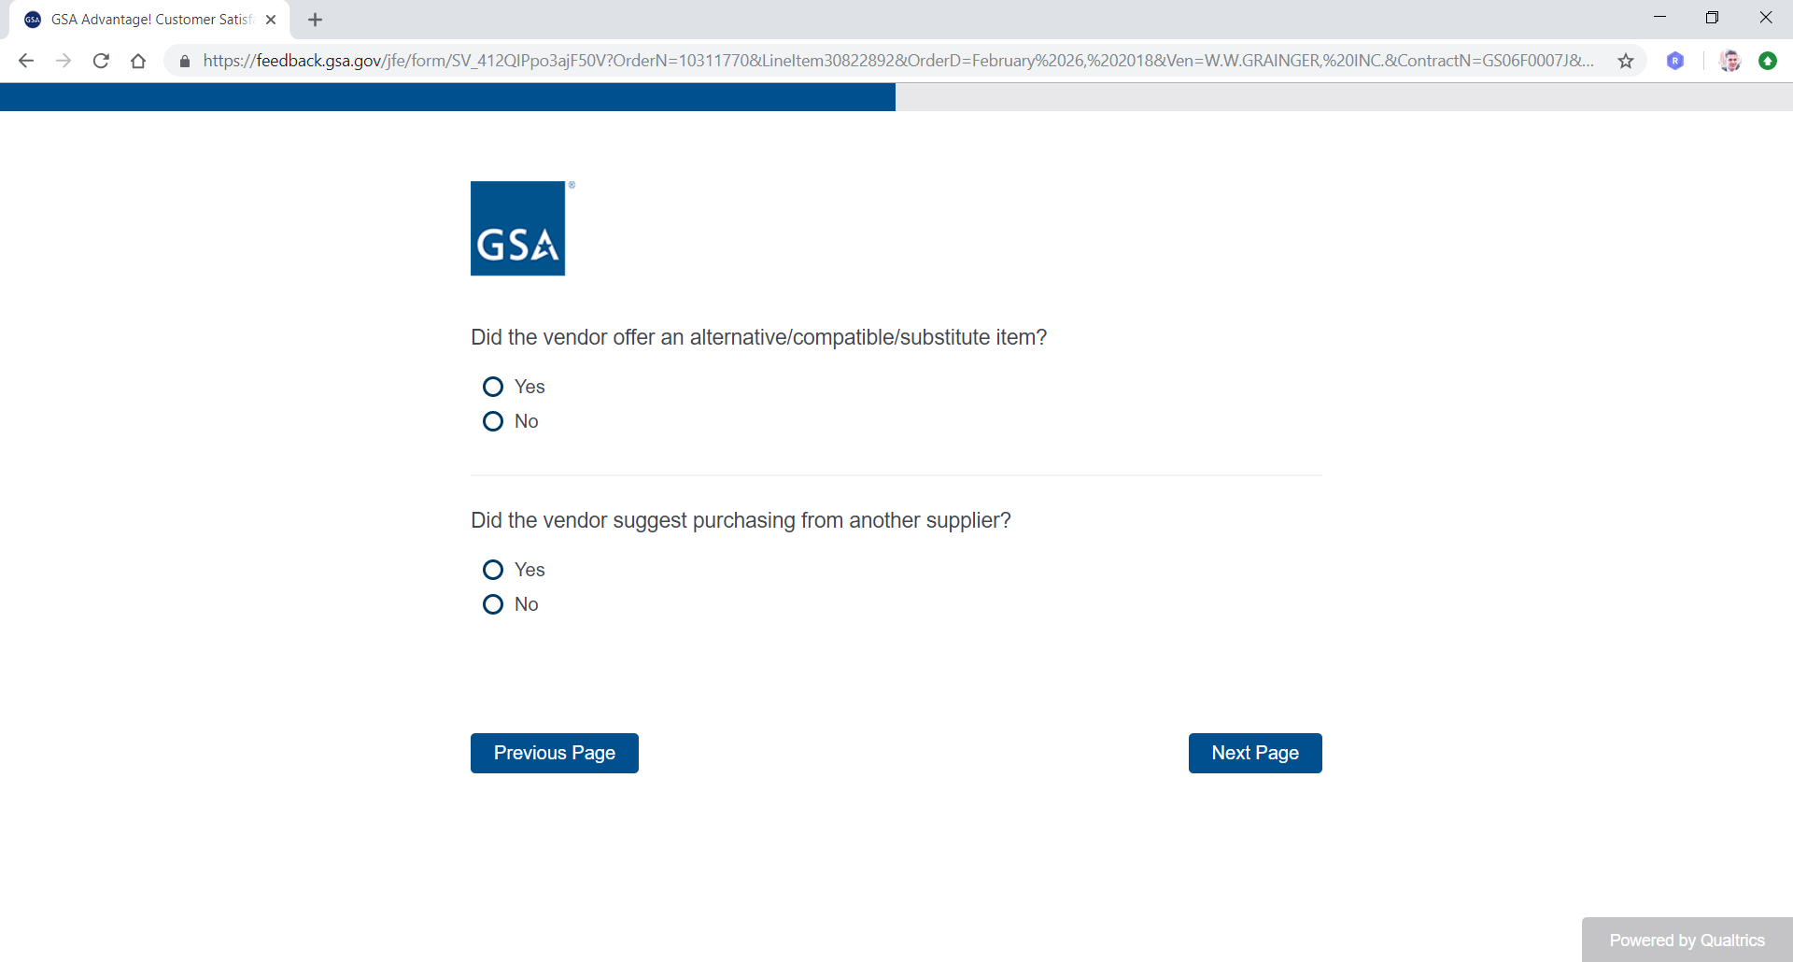

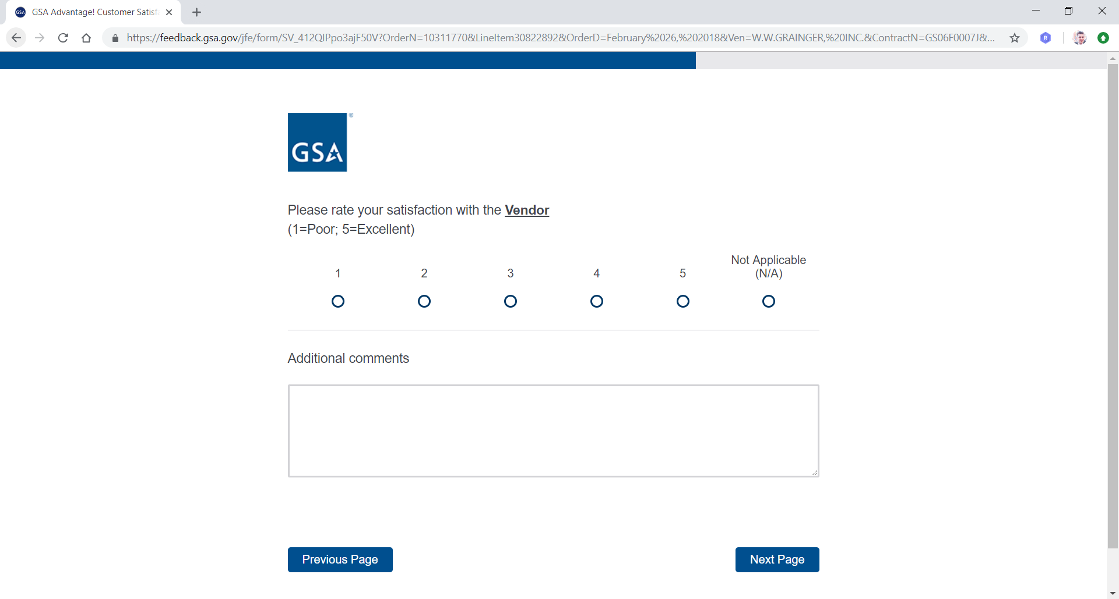

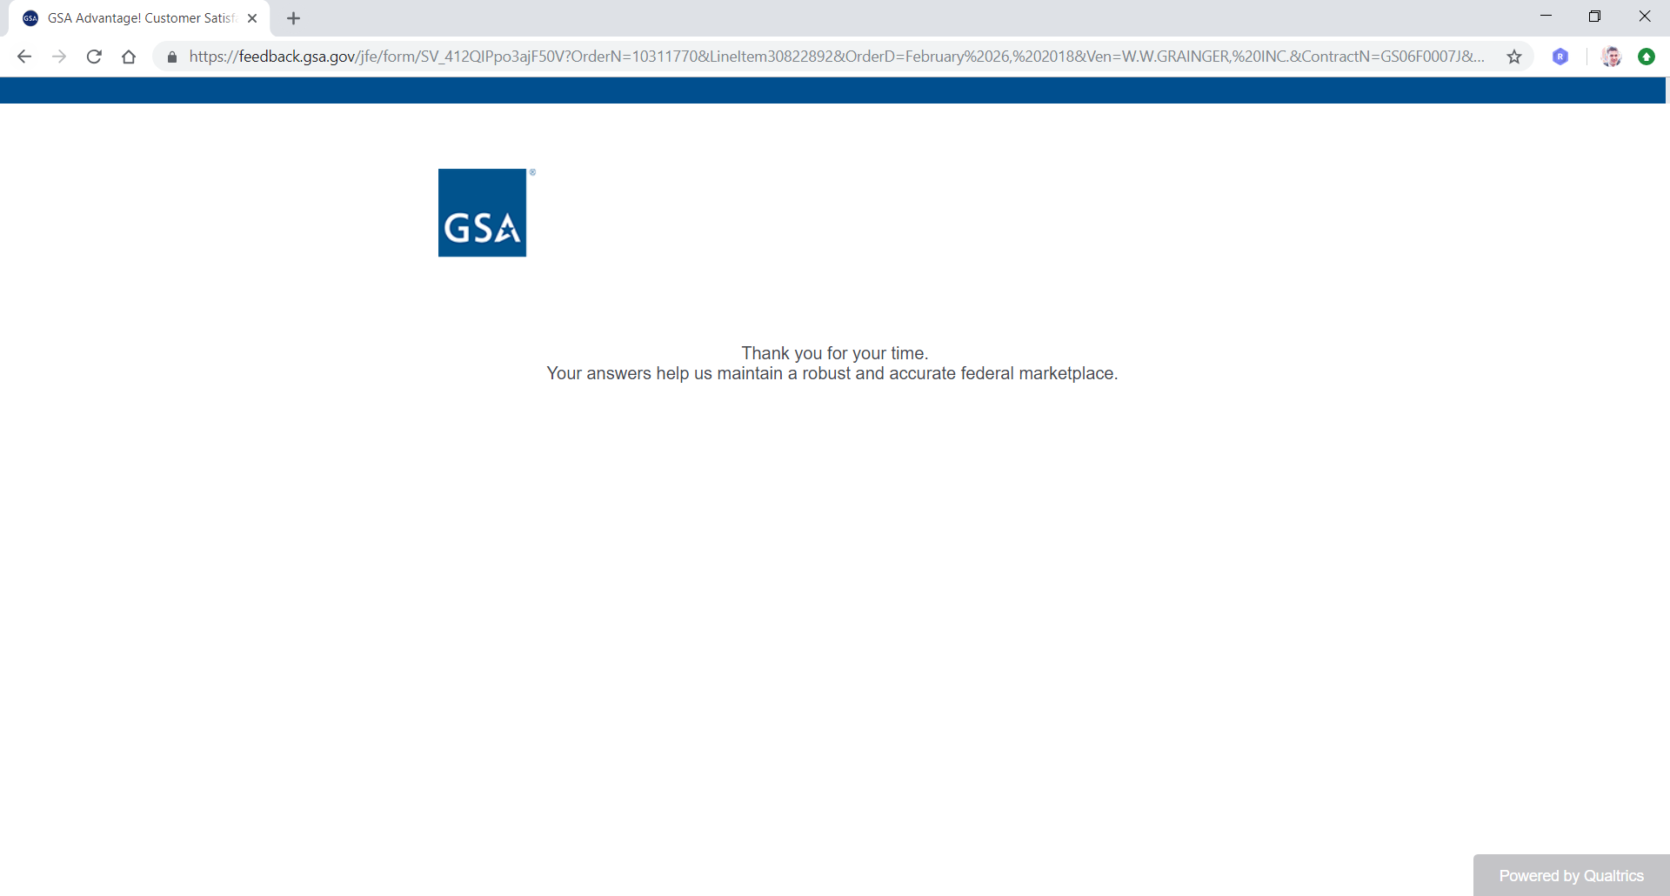

**Path 4ab - User cancelled the order and vendor did not contract them**

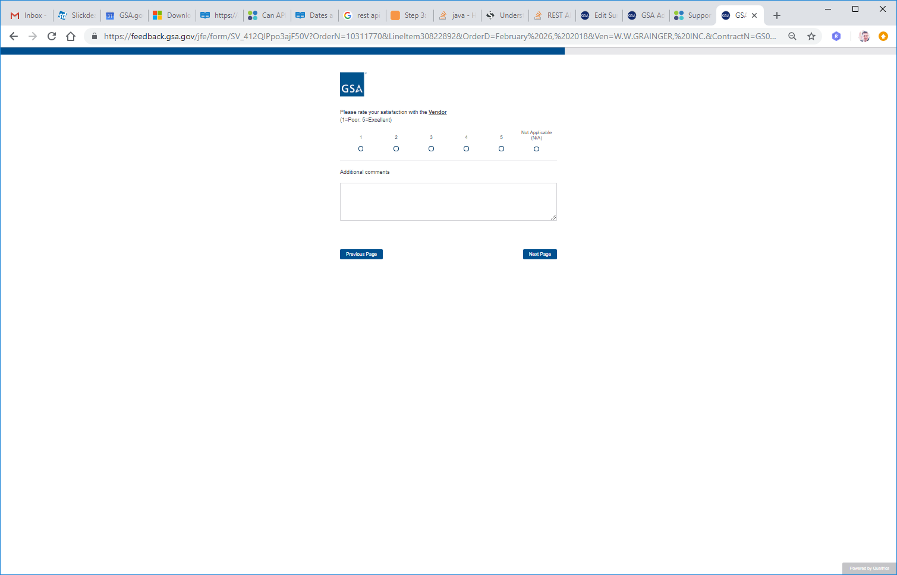

**Path 4b - If the vendor cancelled the order**



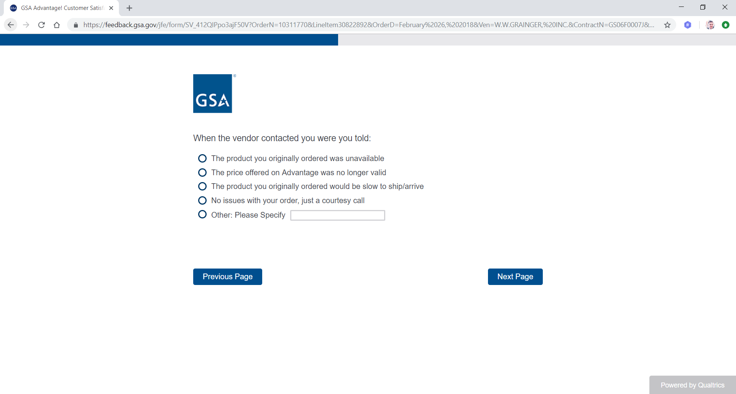



END

**Path 3**

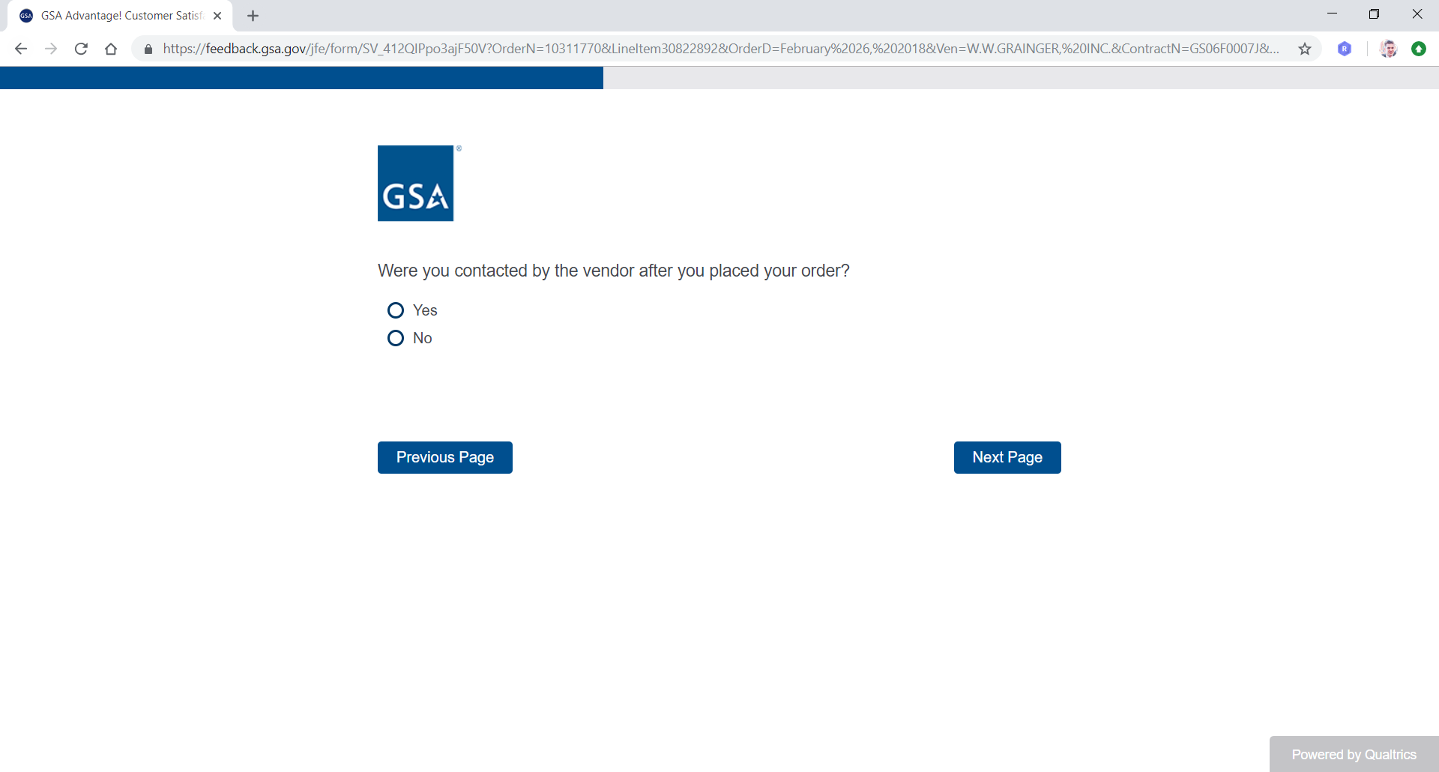

**Path 3a - The vendor did contact user**

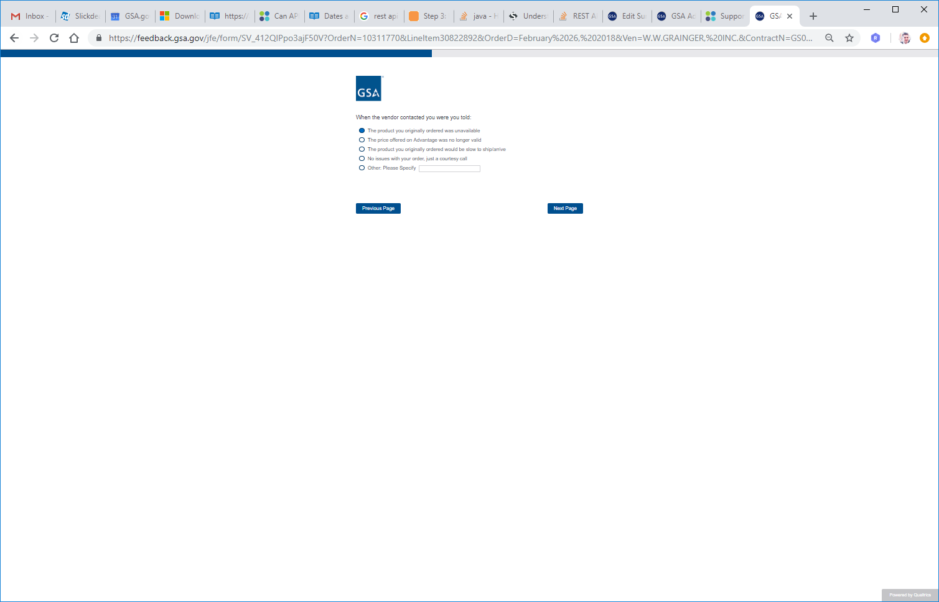

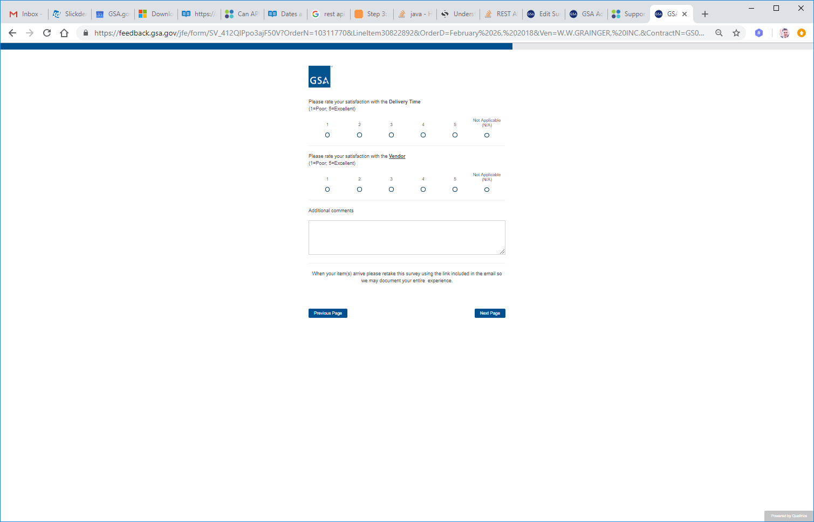

END

**Path 3b - The vendor did not contact user**

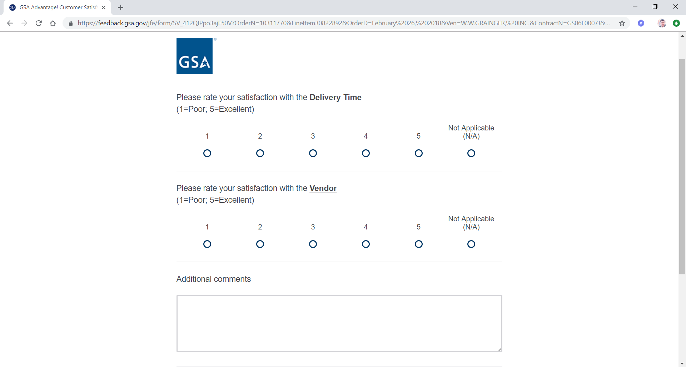

END

**Path 2**

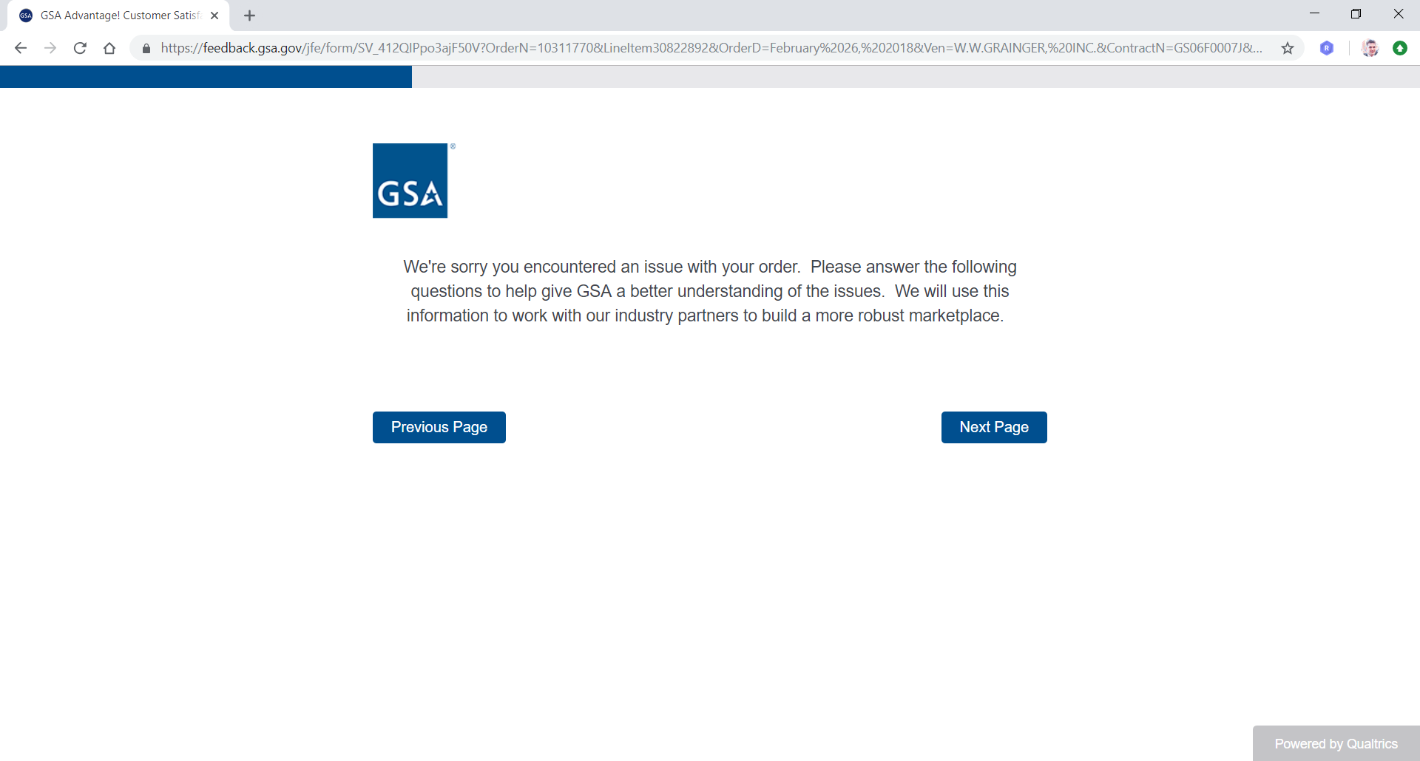

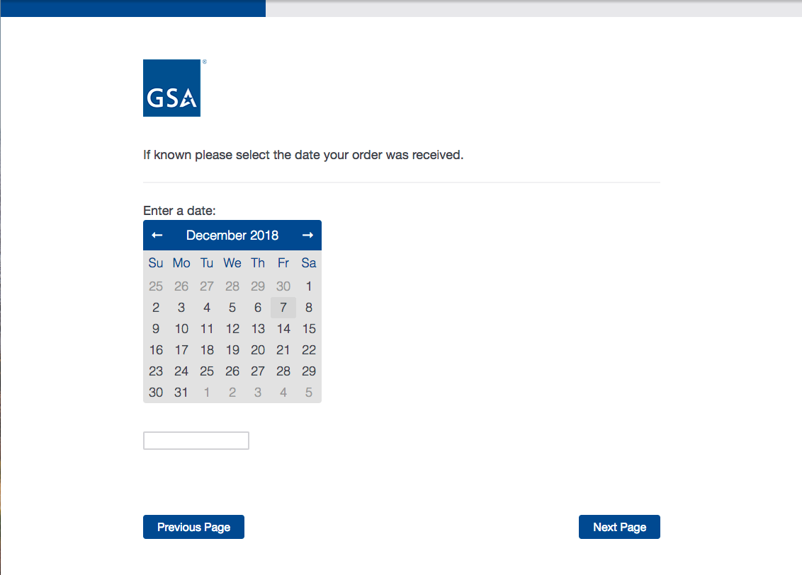

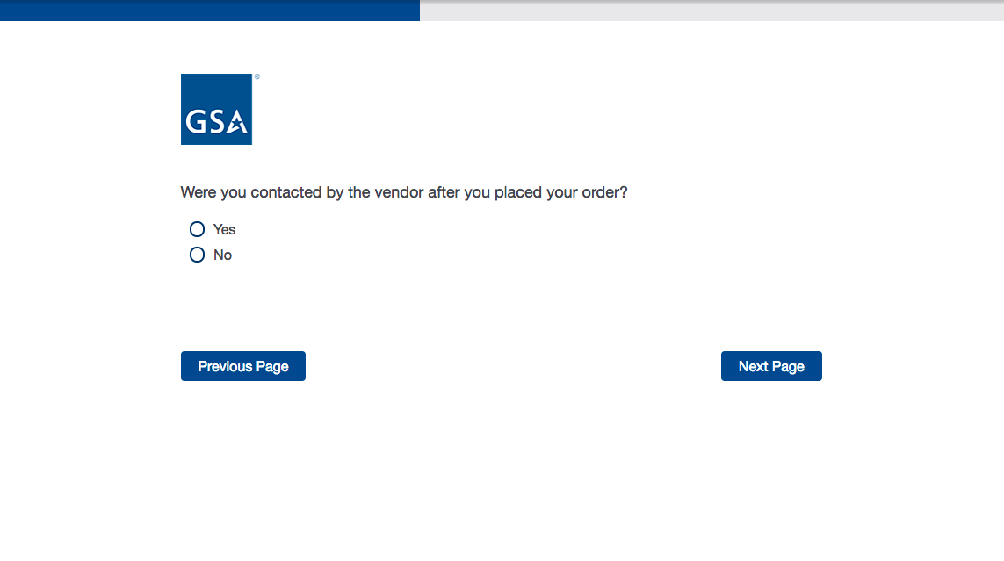

**Path 2a - Vendor contacted user**

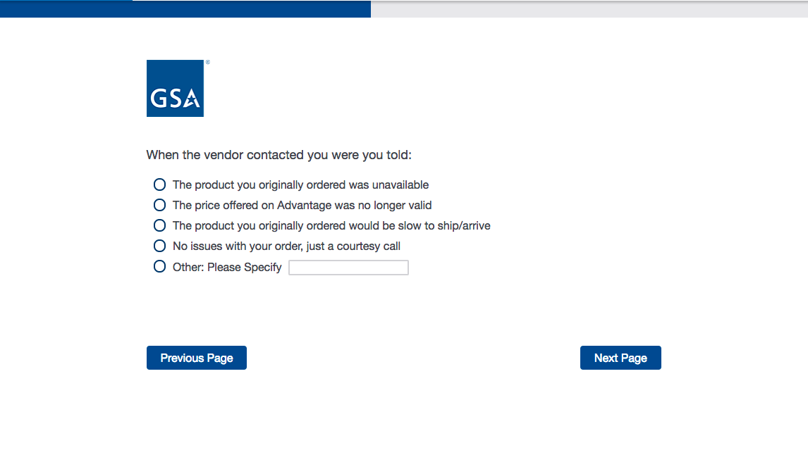



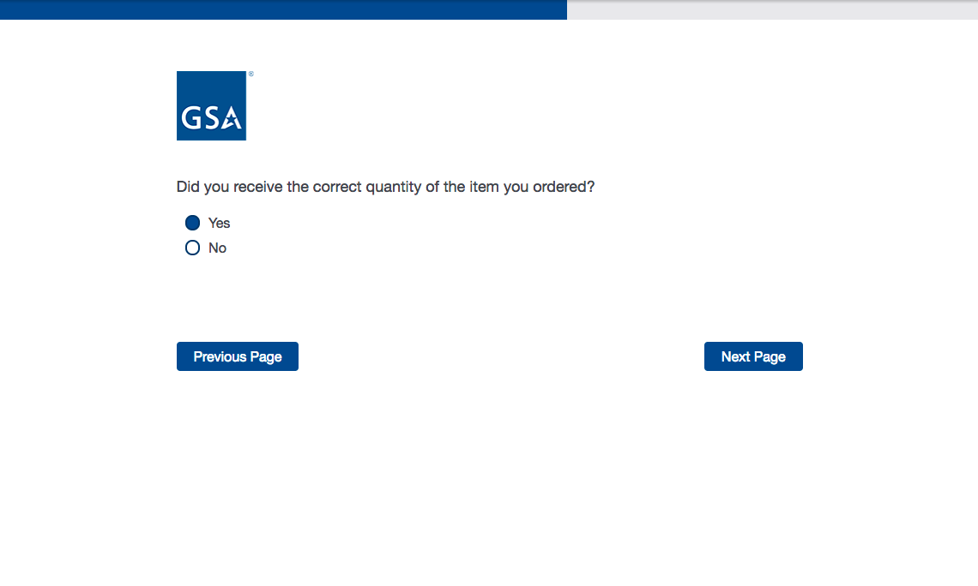

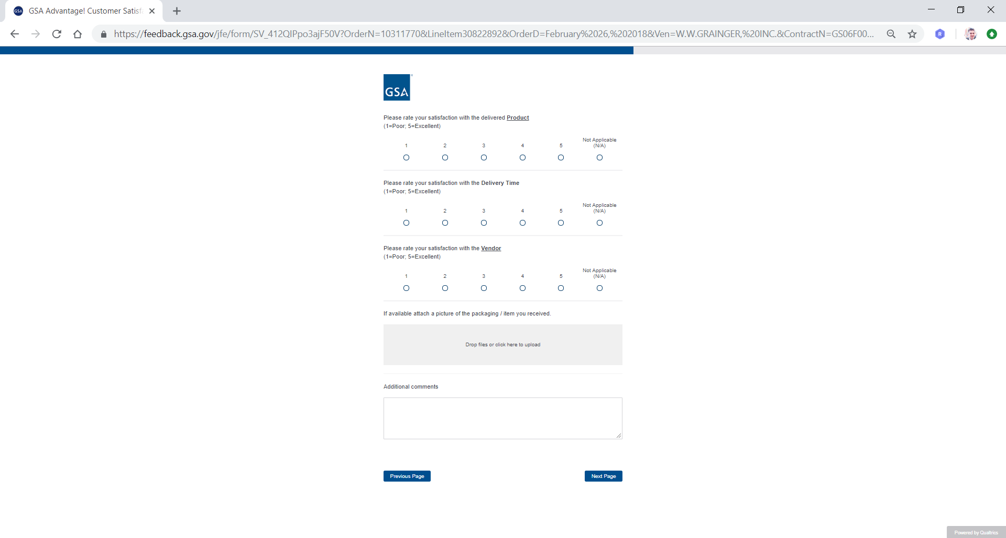

END

**Path 2b - Vendor did not contact user**





END

**Path 1**



**Path 1a - Vendor contacted user**





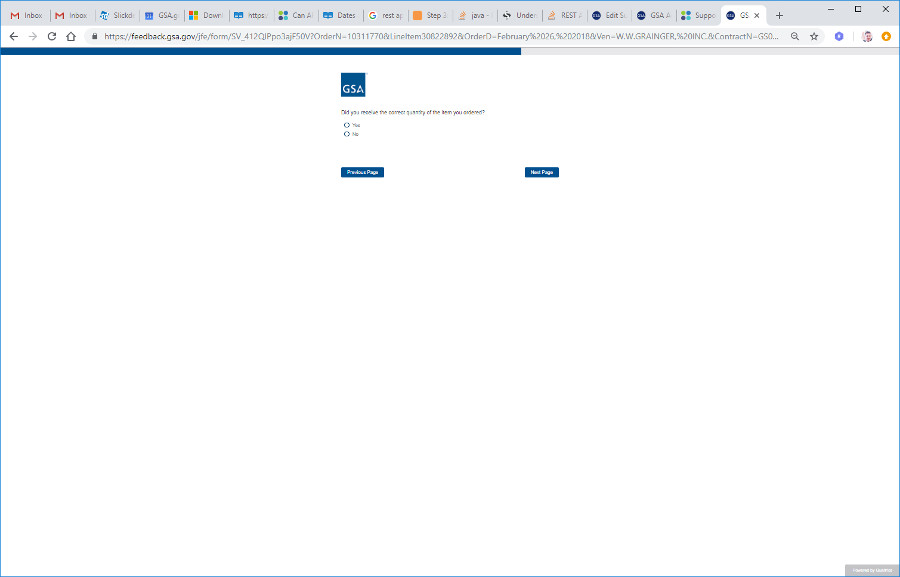

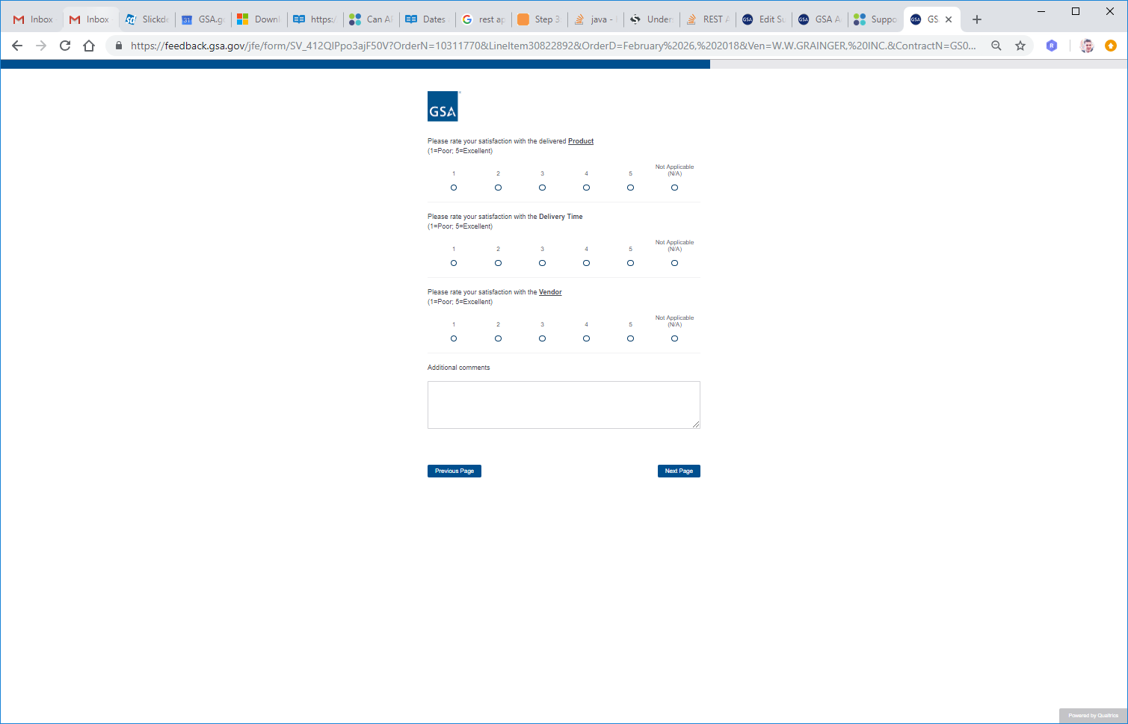

END

**Path 1b - Vendor did not contact user**





END

All users see this end screen

