**3090-0297**

**Req-37 Instrument**

**2019 Customer Loyalty Survey**

For PRA Review only – Contents of this box will not be displayed to recipients.

Note that this survey depends on embedded data to determine which questions will be displayed to each recipient. Embedded data are commands built into the survey that draw information from the contact list. Survey responses remain confidential.

The embedded data fields that are used in this survey are:

* Program Office (GSA program being rated)

**Screen 1**

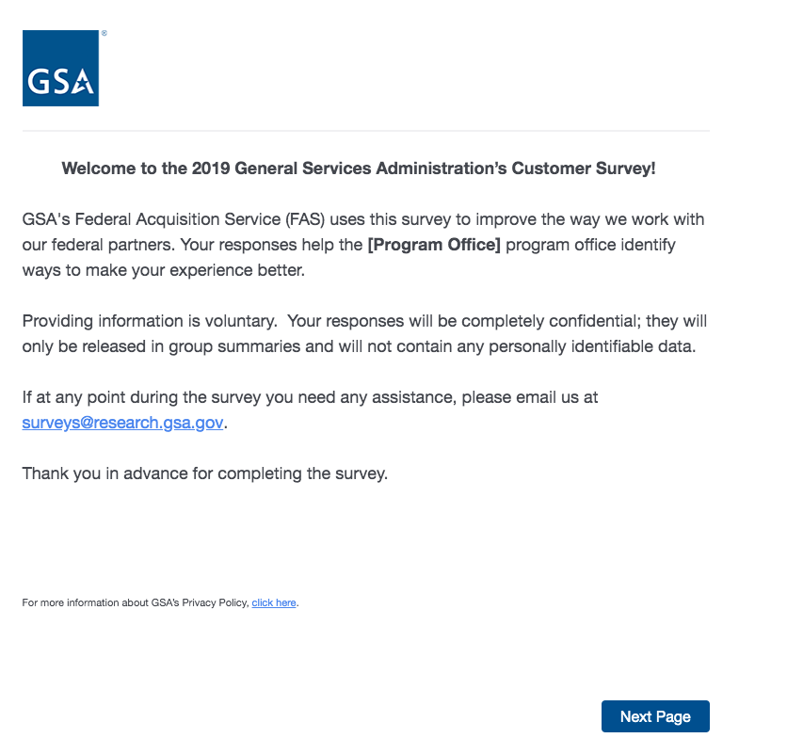

On Screens 1, 2, 3, 4, 5, 6, 7a, 7c, 39, and 40, [Program Office] will be replaced by one of the following:

* Login.gov
* GSA Information Technology Category
* GSA Personal Property Management
* GSA 4PL Retail Store (ServMart)
* GSA Global Supply
* GSA Fleet
* GSA SmartPay

Link at the bottom of above page goes to a pdf displaying the PRA statement and a GSA Privacy Act Statement. See next page for screenshot.

**Screen 1, continued**

Screenshot of pdf linked from bottom of first page:

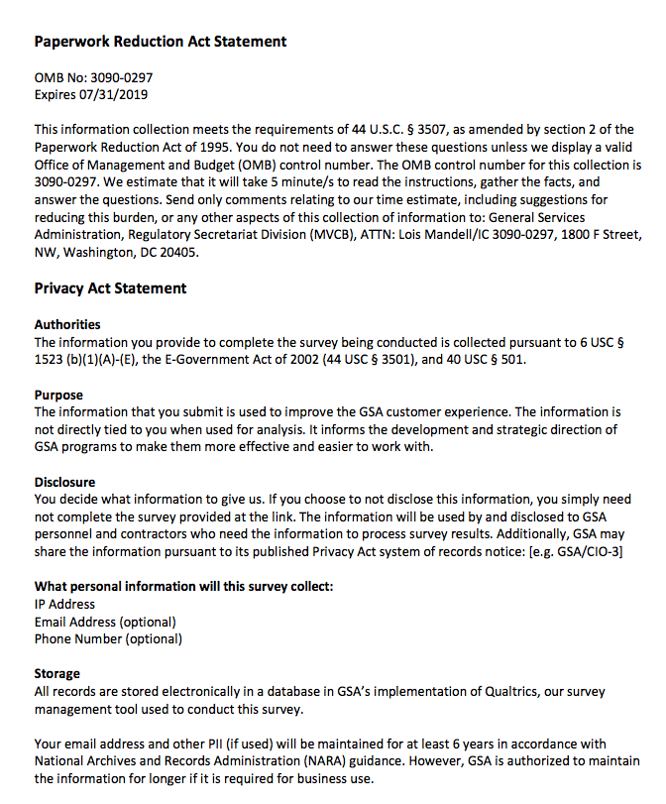

**Screen 2**

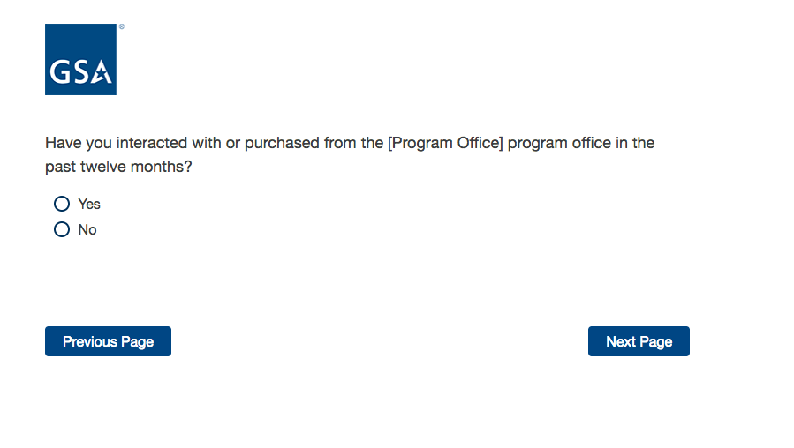

If No, then display Screen 3.

If Yes, skip to Screen 5.

**Screen 3**

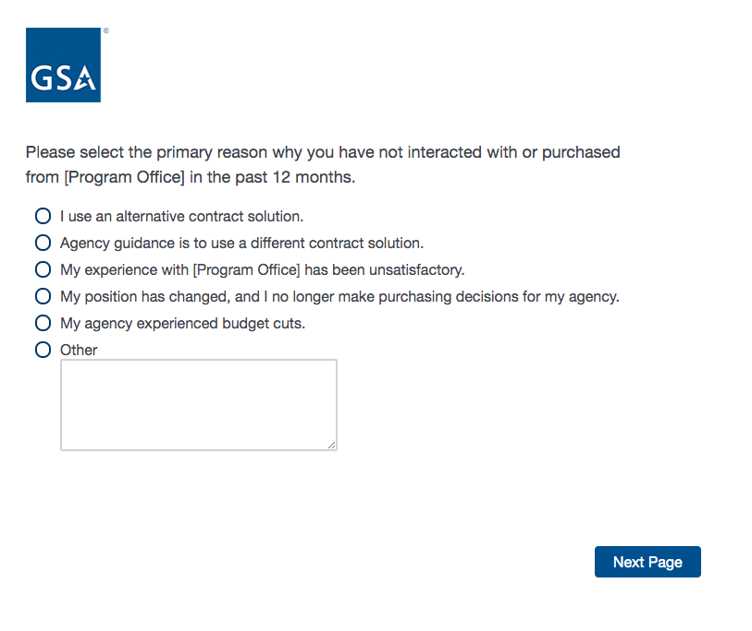

**Screen 4**

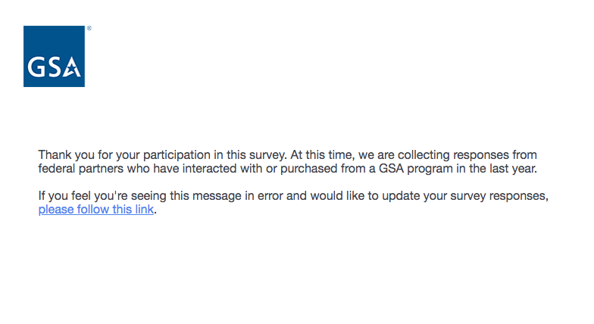

Exit survey (for respondents who select “No” on Screen 2).

**Screen 5**

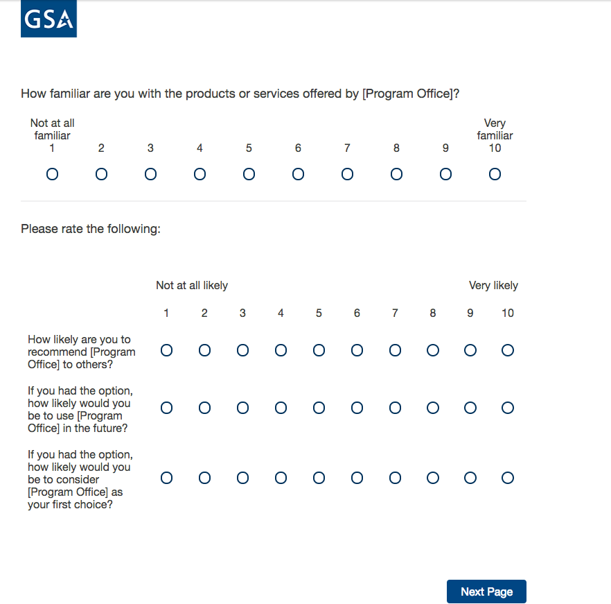

**Screen 6**

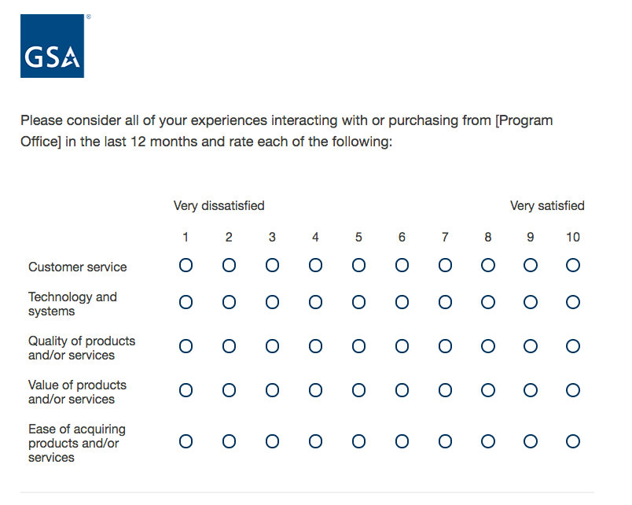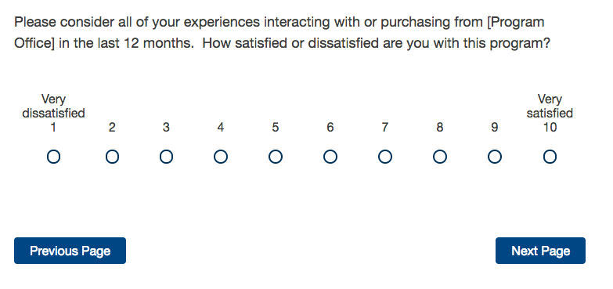

If “How satisfied or dissatisfied are you with this program?” = 1, 2, 3, 4, 5, or 6, move to Screen 7a.

If “How satisfied or dissatisfied are you with this program?” = 7 or 8, skip to Screen 7b.

If “How satisfied or dissatisfied are you with this program?” = 9 or 10, skip to Screen 7c.

**Screen 7a**

Display if “How satisfied or dissatisfied are you with this program?” = 1, 2, 3, 4, 5, or 6.

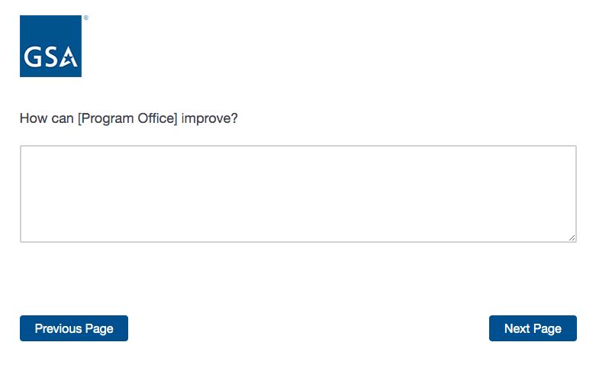

If Program Office = Login.gov, skip to Screen 8.

If Program Office = GSA Information Technology Category, skip to Screen 11.

If Program Office = GSA Personal Property Management, skip to Screen 12.

If Program Office = GSA 4PL Retail Store (ServMart), skip to Screen 16.

If Program Office = GSA Global Supply, skip to Screen 20.

If Program Office = GSA Fleet, skip to Screen 27.

If Program Office = GSA SmartPay, skip to Screen 35.

**Screen 7b**

Display if “How satisfied or dissatisfied are you with this program?” = 7 or 8.

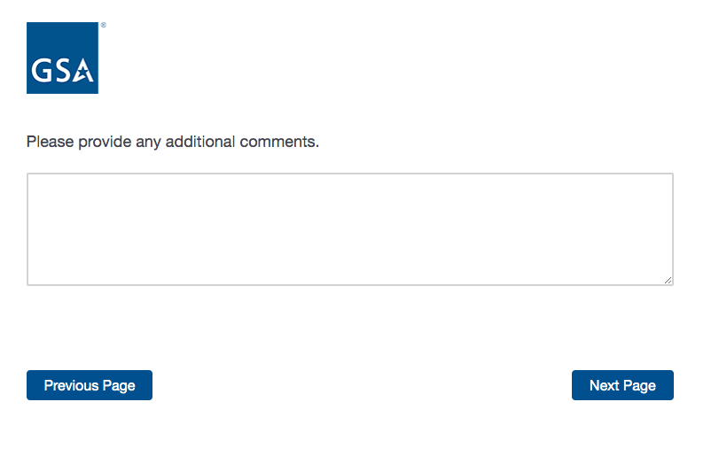

If Program Office = Login.gov, skip to Screen 8.

If Program Office = GSA Information Technology Category, skip to Screen 11.

If Program Office = GSA Personal Property Management, skip to Screen 12.

If Program Office = GSA 4PL Retail Store (ServMart), skip to Screen 16.

If Program Office = GSA Global Supply, skip to Screen 20.

If Program Office = GSA Fleet, skip to Screen 27.

If Program Office = GSA SmartPay, skip to Screen 35.

**Screen 7c**

Display if “How satisfied or dissatisfied are you with this program?” = 9 or 10.

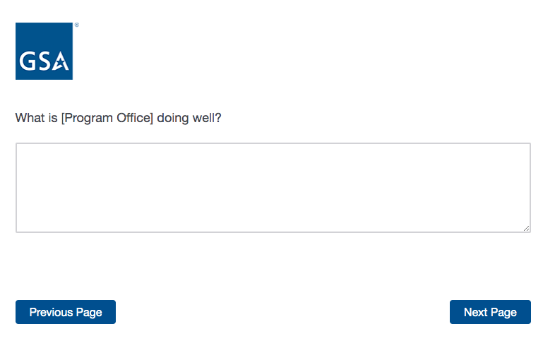

If Program Office = Login.gov, skip to Screen 8.

If Program Office = GSA Information Technology Category, skip to Screen 11.

If Program Office = GSA Personal Property Management, skip to Screen 12.

If Program Office = GSA 4PL Retail Store (ServMart), skip to Screen 16.

If Program Office = GSA Global Supply, skip to Screen 20.

If Program Office = GSA Fleet, skip to Screen 27.

If Program Office = GSA SmartPay, skip to Screen 35.

**Screen 8**

Display if Program = Login.gov

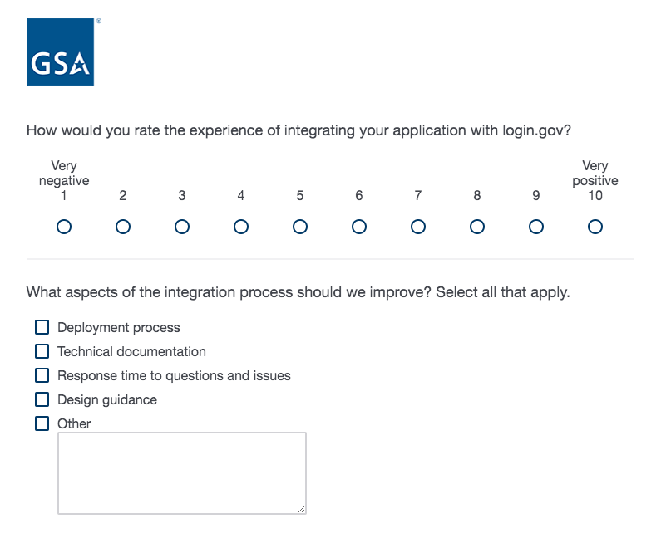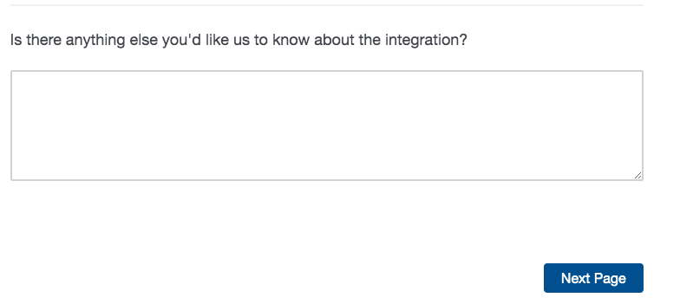

**Screen 9**

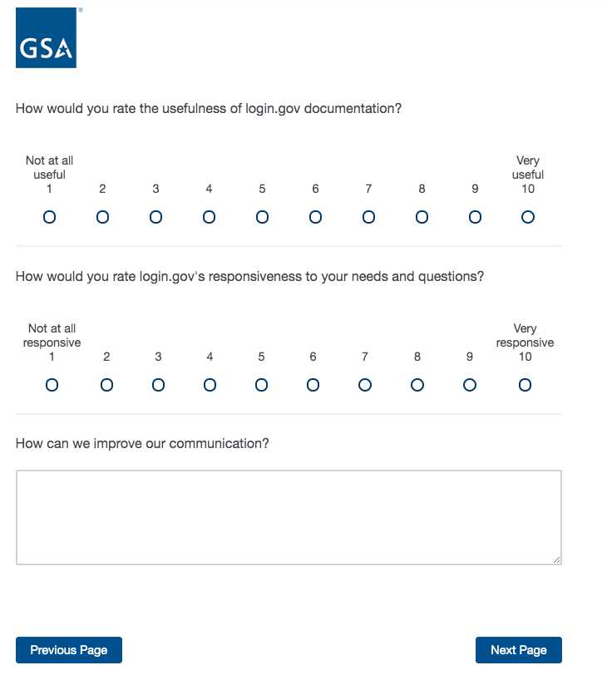

**Screen 10**

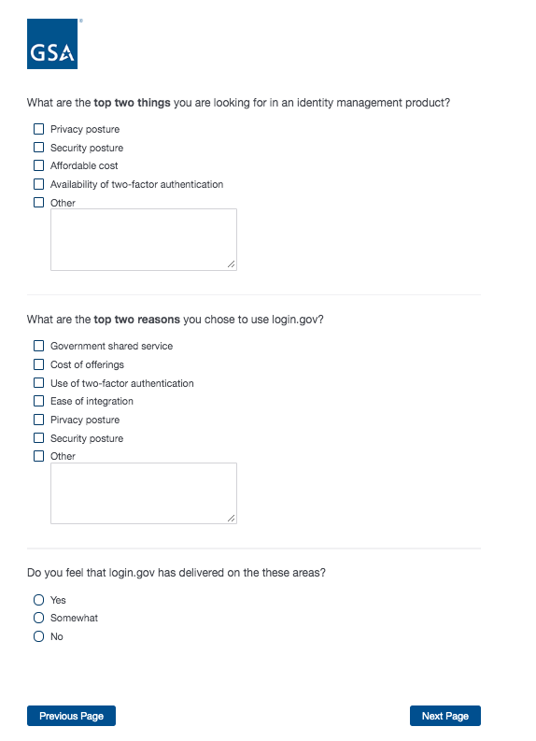

**Screen 10 (continued)**

If “Do you feel that login.gov has delivered on these areas?” = Somewhat or No, display additional question.

If “Do you feel that login.gov has delivered on these areas?” = Yes, skip to Screen .

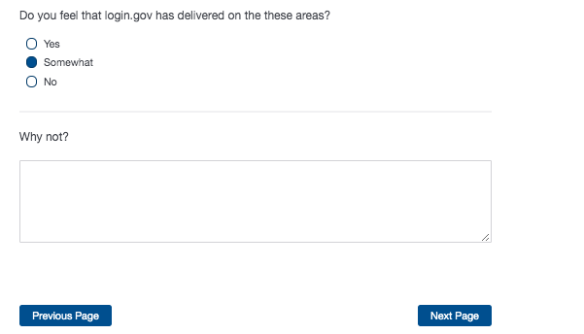

Proceed to Screen 39.

**Screen 11**

Display if Program Office = GSA Information Technology Category

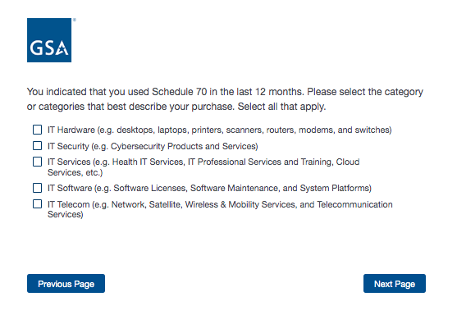

Proceed to Screen 39.

**Screen 12**

Display if Program Office = GSA Personal Property Management

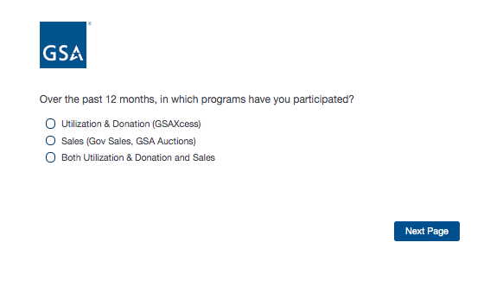

**Screen 13**

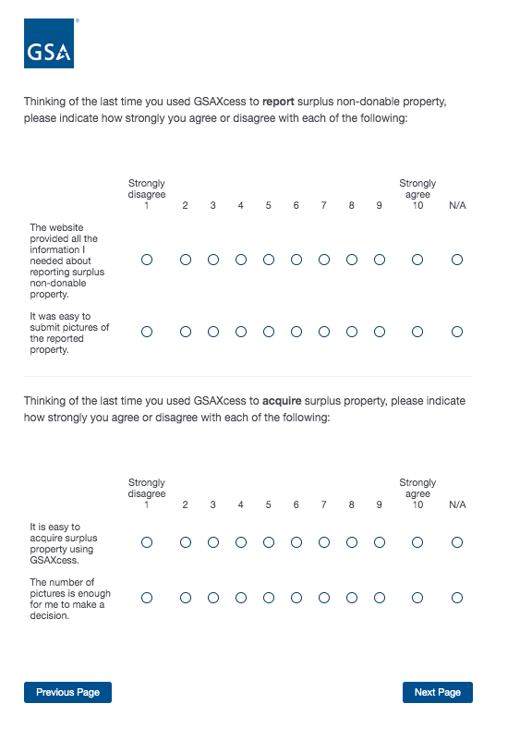

**Screen 14**

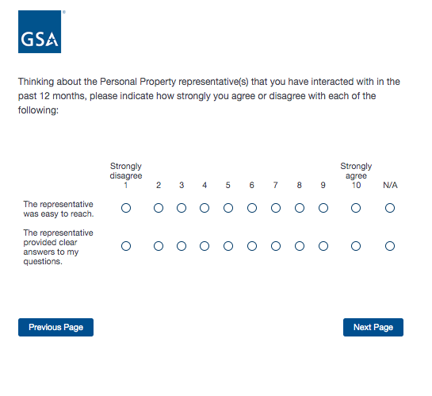

**Screen 15**

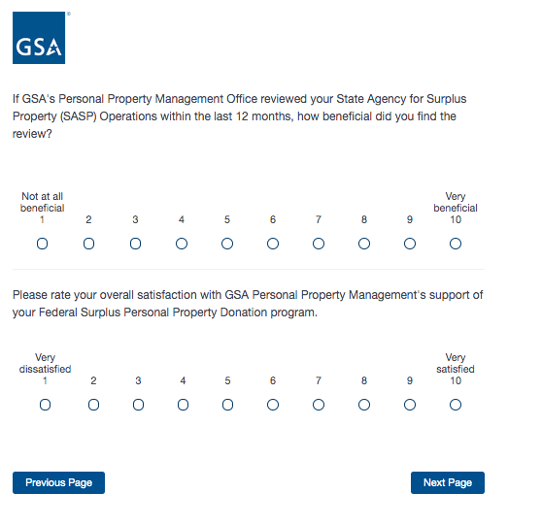

Proceed to Screen 39.

**Screen 16**

Display if Program = GSA 4PL Retail Store (ServMart)

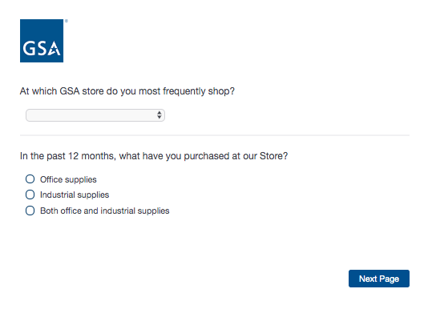

If “In the past 12 months, what have you purchased at our Store” = Office supplies, move to Screen 17a.

If “In the past 12 months, what have you purchased at our Store” = Industrial supplies, skip to Screen 17b.

If “In the past 12 months, what have you purchased at our Store” = Both office and industrial supplies, skip to Screen 17c.

**Screen 17a**

Display if “In the past 12 months, what have you purchased at our Store” = Office supplies.

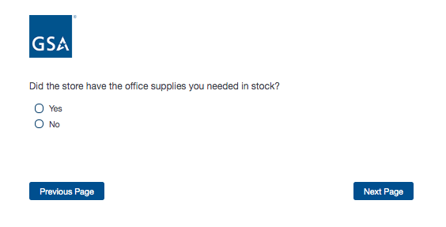

Proceed to Screen 18.

**Screen 17b**

Display if “In the past 12 months, what have you purchased at our Store” = Industrial supplies.

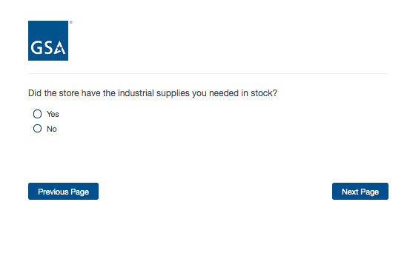

Proceed to Screen 18.

**Screen 17c**

Display if “In the past 12 months, what have you purchased at our Store” = Both office and industrial supplies.

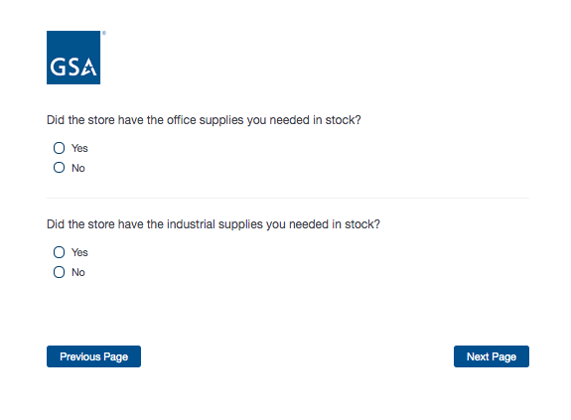

Proceed to Screen 18.

**Screen 18**

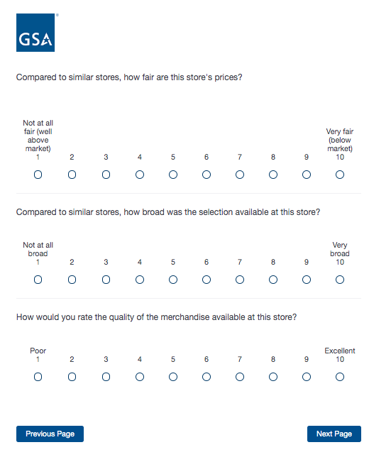

**Screen 19**

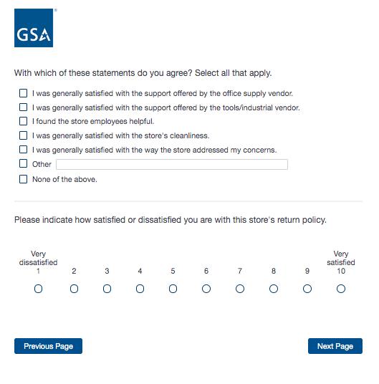

Proceed to Screen 39.

**Screen 20**

Display if Program Office = GSA Global Supply

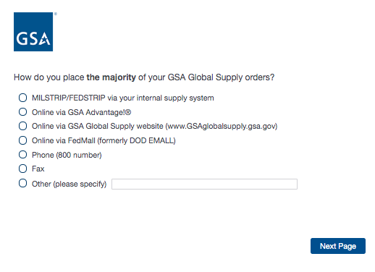

If “How do you place the majority of your GSA Global Supply orders?” = MILSTRIP/FEDSTRIP, display additional question 20a.

If “How do you place the majority of your GSA Global Supply orders?” = Online via GSA Advantage or Online via GSA Global Supply website, display additional question 20b.

If “How do you place the majority of your GSA Global Supply orders?” = Online via FedMall, display additional question 20c.

If “How do you place the majority of your GSA Global Supply orders?” = Phone (800 number), display additional question 20d.

**Screen 20a**

Display if “How do you place the majority of your GSA Global Supply orders?” = MILSTRIP/FEDSTRIP

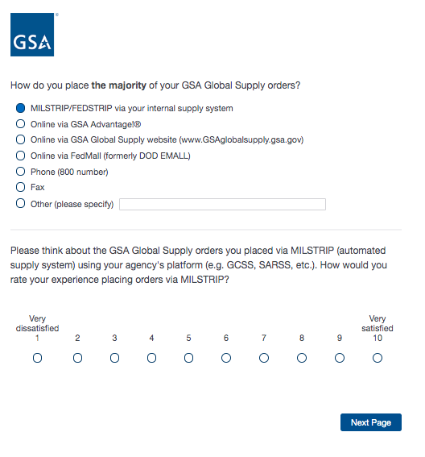

Proceed to Screen 21.

**Screen 20b**

Display if “How do you place the majority of your GSA Global Supply orders?” = Online via GSA Advantage or Online via GSA Global Supply website

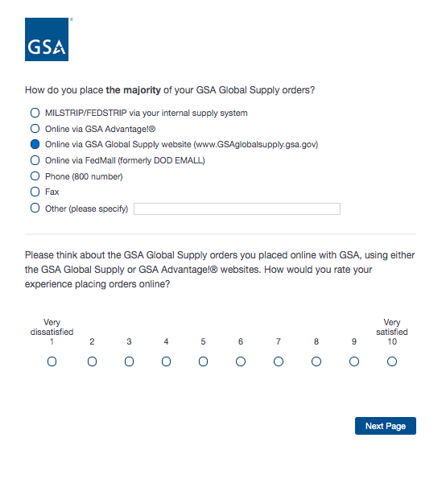

Proceed to Screen 21.

**Screen 20c**

Display if “How do you place the majority of your GSA Global Supply orders?” = Online via FedMall

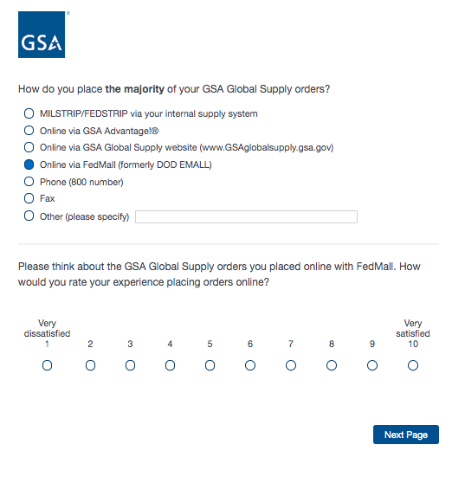

Proceed to Screen 21.

**Screen 20d**

Display if “How do you place the majority of your GSA Global Supply orders?” = Phone (800 number)

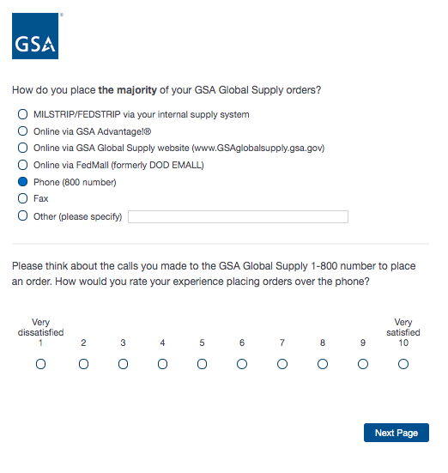

Proceed to Screen 21.

**Screen 21**

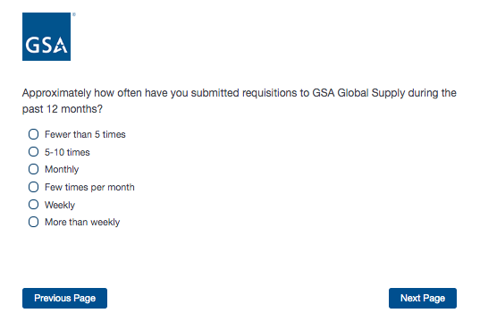

**Screen 22**

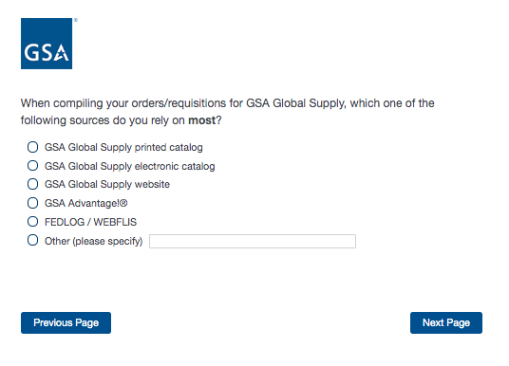

If “When compiling your orders, which of the following sources do you rely on most?” = GSA Global Supply printed catalog, display additional question on Screen 22a.

If “When compiling your orders, which of the following sources do you rely on most?” = GSA Global Supply electronic catalog, display additional question on Screen 22b.

**Screen 22a**

Display if “When compiling your orders, which of the following sources do you rely on most?” = GSA Global Supply printed catalog

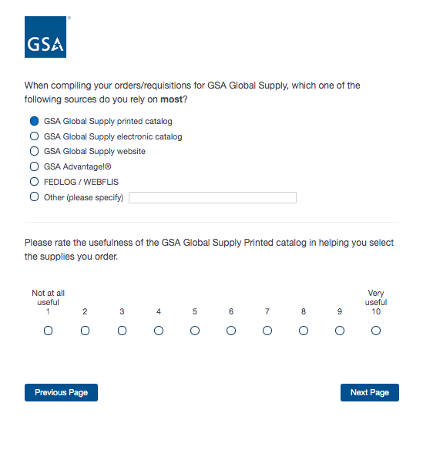

Proceed to Screen 23.

**Screen 22b**

Display if “When compiling your orders, which of the following sources do you rely on most?” = GSA Global Supply electronic catalog

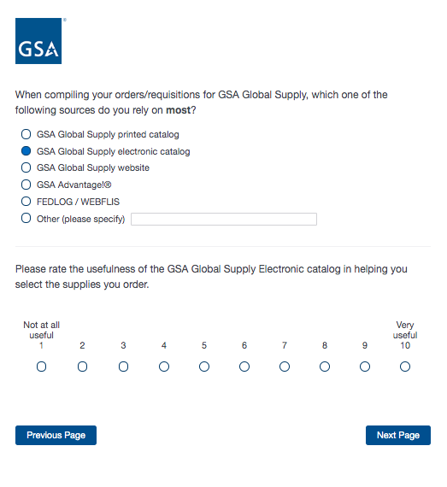

Proceed to Screen 23.

**Screen 23**

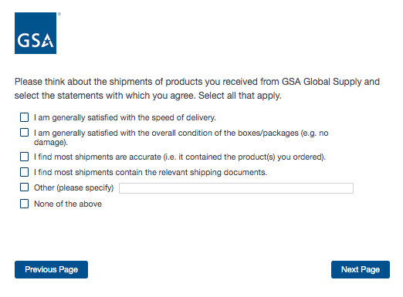

**Screen 24**

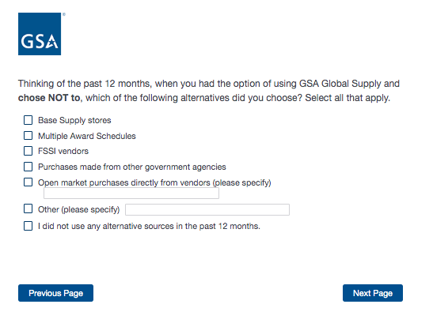

If “I did not use any alternative sources in the past 12 months” is selected, skip to Screen 26.

For all other response options, move to Screen 25.

**Screen 25**

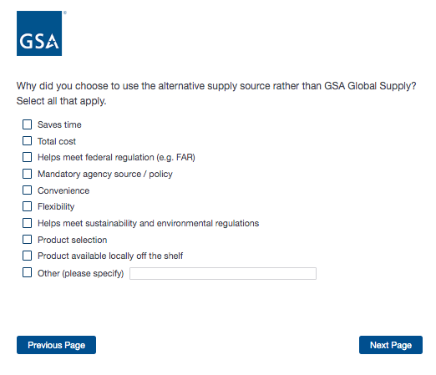

**Screen 26**

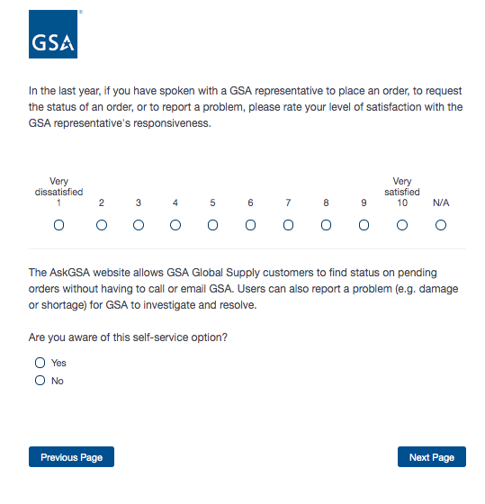

Proceed to Screen 39.

**Screen 27**

Display if Program Office = GSA Fleet

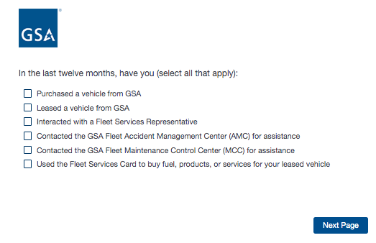

If “Purchased a vehicle” is selected, display Screen 28.

If “Leased a vehicle” is selected, display Screen 29.

If “Interacted with a Fleet Services Representative” is selected, display Screen 30.

If “Contacted the GSA Fleet Accident Management Center” is selected, display Screen 31.

If “Contacted the GSA Fleet Maintenance Control Center” is selected, display Screen 32.

If “Used the Fleet Services Card” is selected, display Screen 33.

**Screen 28**

Display if “Purchased a vehicle” is selected on Screen 27.

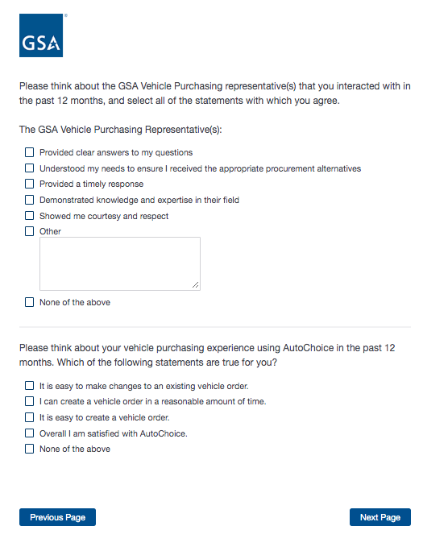

**Screen 29**

Display if “Leased a vehicle” is selected on Screen 27,

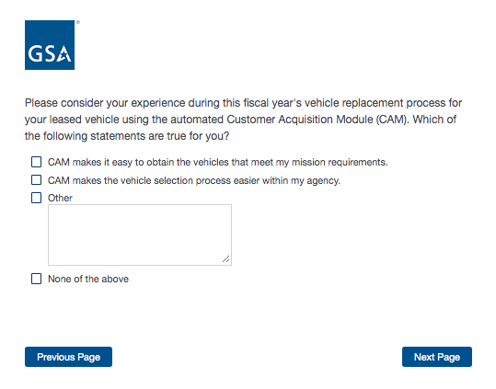

**Screen 30**

If “Interacted with a Fleet Services Representative” is selectedon Screen 27.

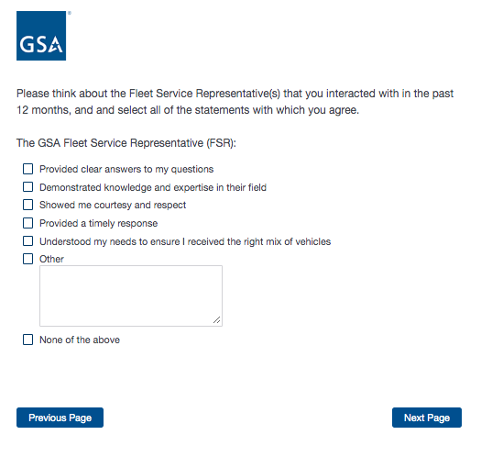

**Screen 31**

Display if “Contacted the GSA Fleet Accident Management Center” is selected on Screen 27.

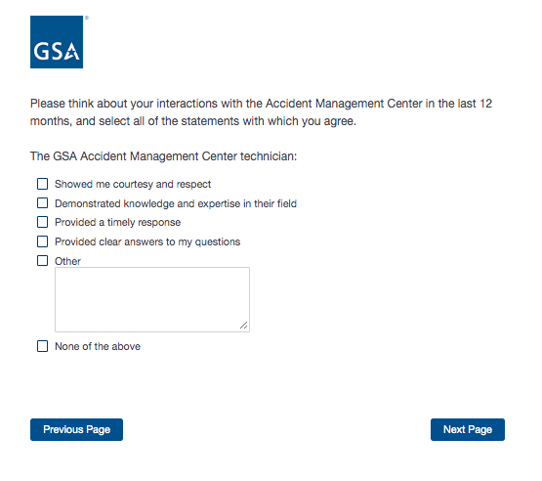

**Screen 32**

Display if “Contacted the GSA Fleet Maintenance Control Center” is selected on Screen 27.

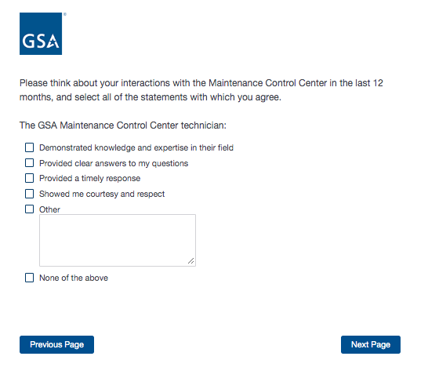

**Screen 33**

Display if “Used the Fleet Services Card” is selected on Screen 27.

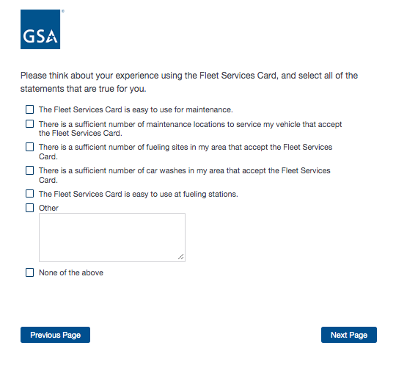

**Screen 34**

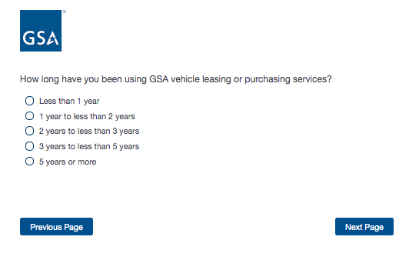

Proceed to Screen 39.

**Screen 35**

Display if Program Office = GSA SmartPay

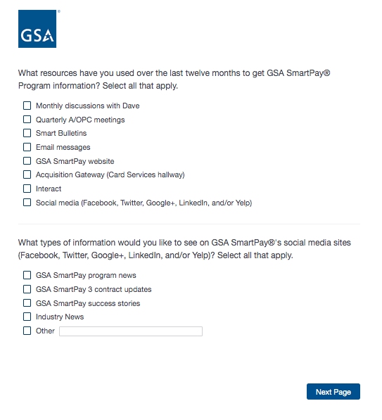

**Screen 36**

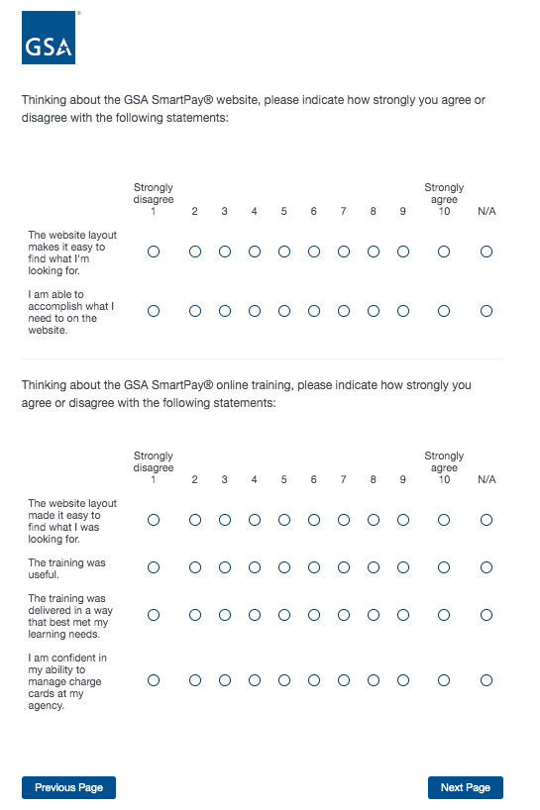

**Screen 37**

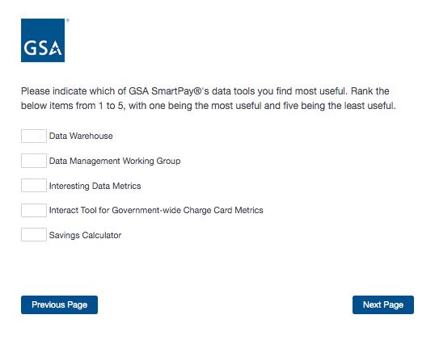

**Screen 38**

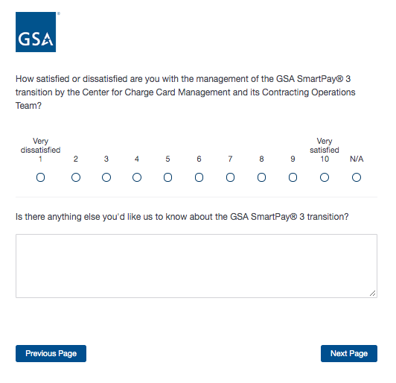

Proceed to Screen 39.

**Screen 39**

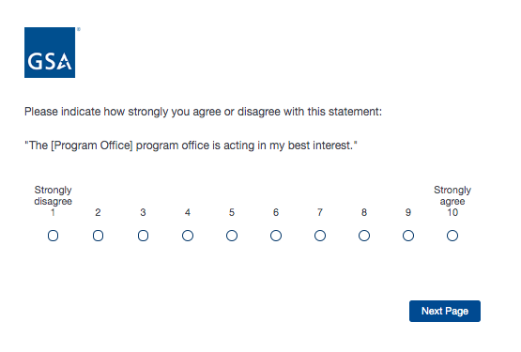

**Screen 40**

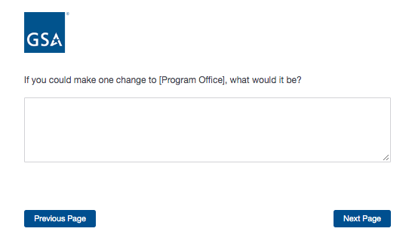

**Screen 41**

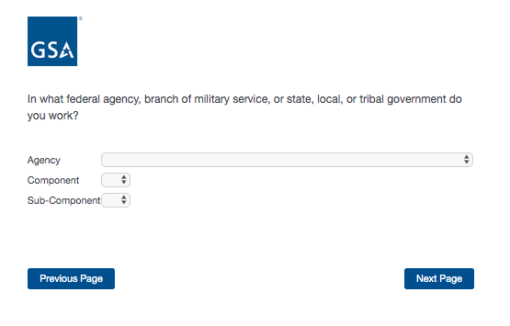

**Screen 42**

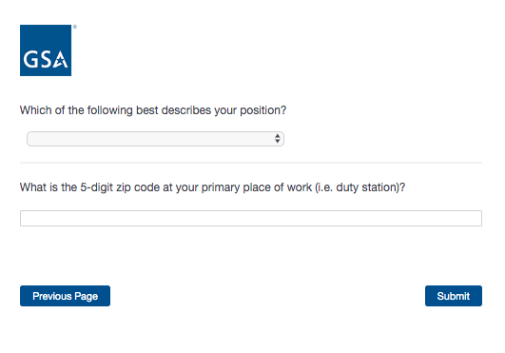

**Screen 42**

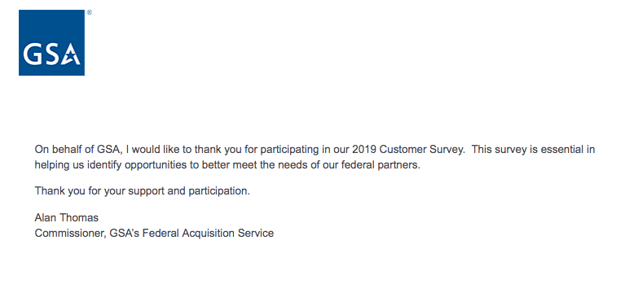

End of survey