3090-0297 FAST Track Req-39
2019 Supplier Relationship Management Survey

For PRA Review only – Contents of this box will not be displayed to recipients.

Note that this survey depends on embedded data to determine which questions will be displayed to each recipient. Embedded data are commands built into the survey that draw information from the contact list. Survey responses remain confidential, and personally identifiable information is not collected by the system.

The embedded data fields that are used in this survey are:
- GSA Program Office (program being rated)
- Schedule (Primary GSA contract through which the supplier does business)

Screen 1
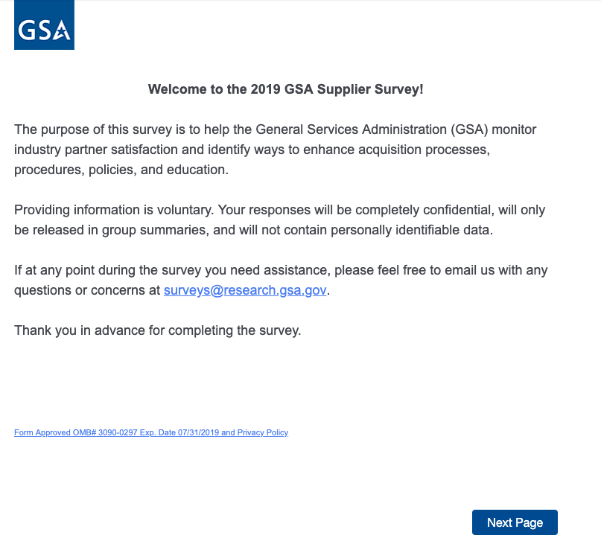
Link at the bottom of above page goes to a pdf displaying the PRA statement and a GSA Privacy Act Statement. See next page for screenshot.

Screen 1, continued

Screenshot of pdf linked from bottom of first page:

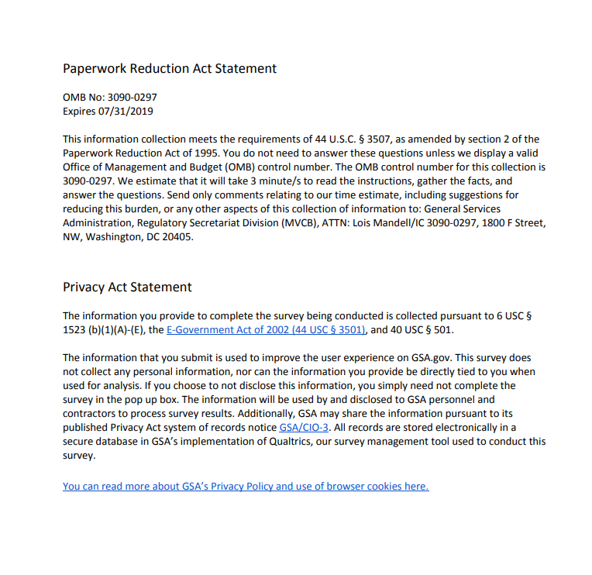
Screen 2

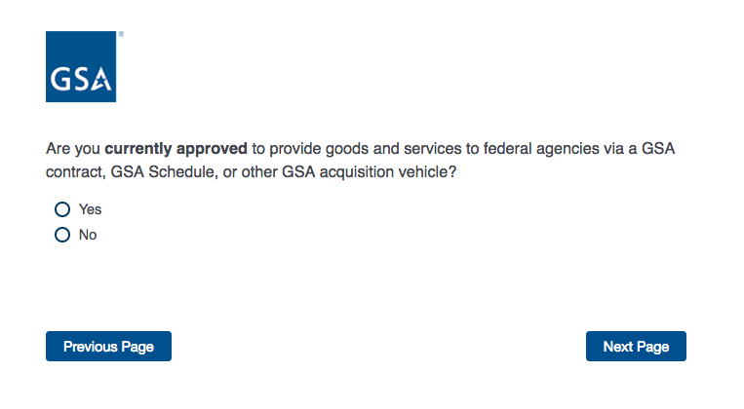

If No, then display Screen 3 and exit survey.

If Yes and GSA Program Office (embedded data) = GSA General Supplies and Services, the display Screen 4a.

If Yes and GSA Program Office (embedded data) = GSA Fleet, the display Screen 4b.

If Yes and GSA Program Office (embedded data) = GSA Information Technology Category, then display Screen 4c.

If Yes and GSA Program Office (embedded data) = GSA Center for Travel Management, then display Screen 4d.

If Yes and GSA Program Office (embedded data) = GSA Center for Transportation Management, then display Screen 4e.

If Yes and GSA Program Office (embedded data) = GSA Employee Relocation Resource Center (ERRC), then display Screen 4f.

If Yes and GSA Program Office (embedded data) = GSA Professional Services and Human Capital (PSHC) Categories, then display Screen 4g.

Screen 3

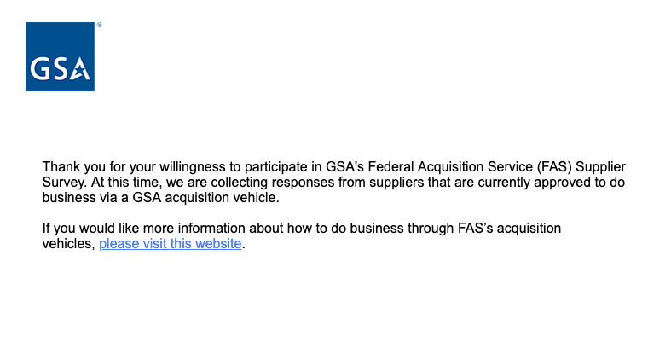Exit survey (for respondents who select “No” on Screen 2). The above link goes to a page on GSA.gov that provides information on how to do business with GSA.
Screen 4a

Displayed if GSA Program Office (embedded data) = GSA General Supplies and Services.
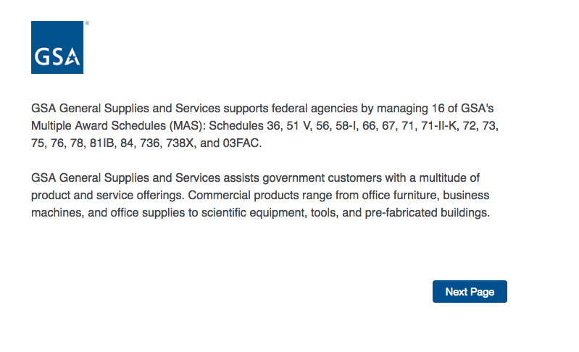
Then proceed to Screen 5.
Screen 4b

Display if GSA Program Office (embedded data) = GSA Fleet:

Then skip to Screen 6a.

Screen 4c

Display if GSA Program Office (embedded data) = GSA Information Technology Category:


Then skip to Screen 9.
Screen 4d

Display if GSA Program Office (embedded data) = the GSA Center for Travel Management:

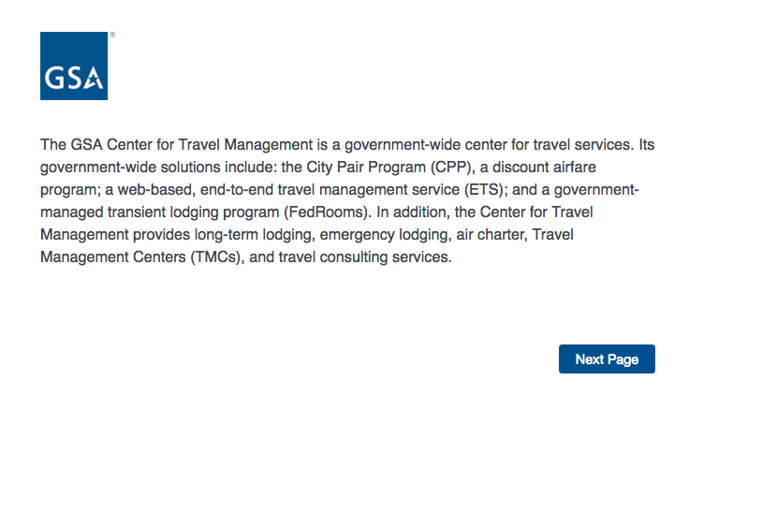
Then skip to Screen 6b.
Screen 4e

Display if GSA Program Office (embedded data) = the GSA Center for Transportation Management:


Then skip to Screen 6c.
Screen 4f

Display if GSA Program Office (embedded data) = the GSA Employee Relocation Resource Center (ERRC):
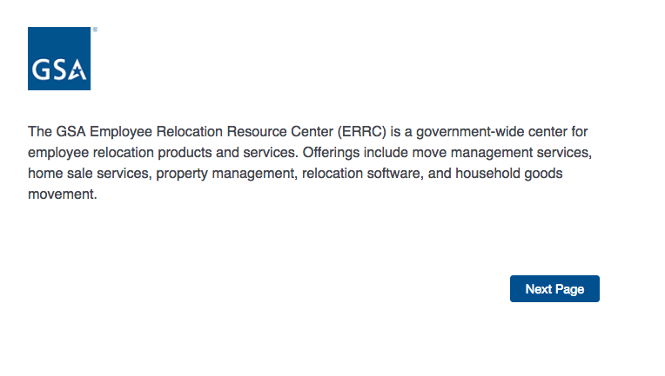
Then skip to Screen 6d.
Screen 4g

Display if GSA Program Office (embedded data) = GSA Professional Services and Human Capital (PSHC) Categories:

Then skip to Screen 13.

Screen 5

Display if GSA Program Office (embedded data) = GSA General Supplies and Services
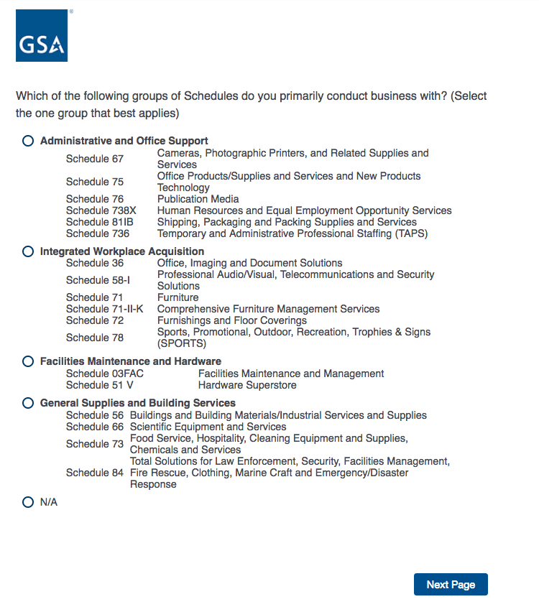

Then skip to Screen 6e.

Screen 6a

Display if GSA Program Office (embedded data) = GSA Fleet

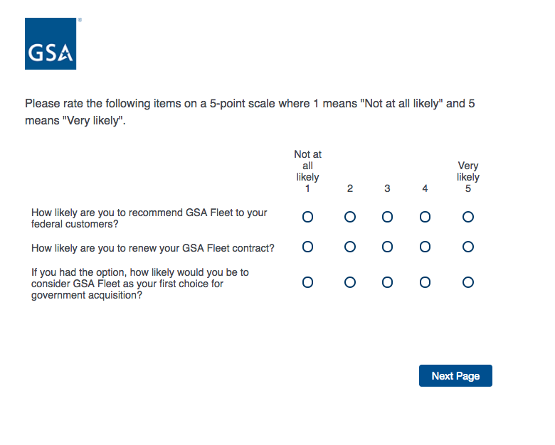
Then skip to Screen 7a.
Screen 6b

Display if GSA Program Office (embedded data) = the GSA Center for Travel Management

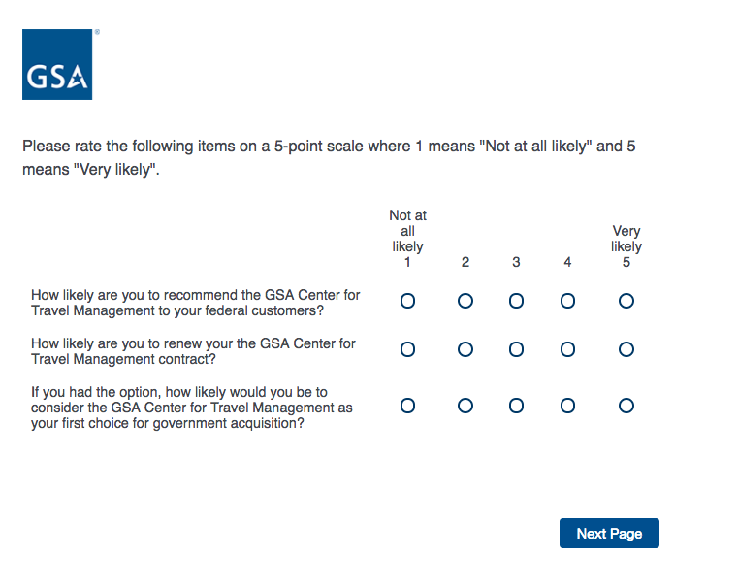
Then skip to Screen 7b.
Screen 6c

Display if GSA Program Office (embedded data) = the GSA Center for Transportation Management
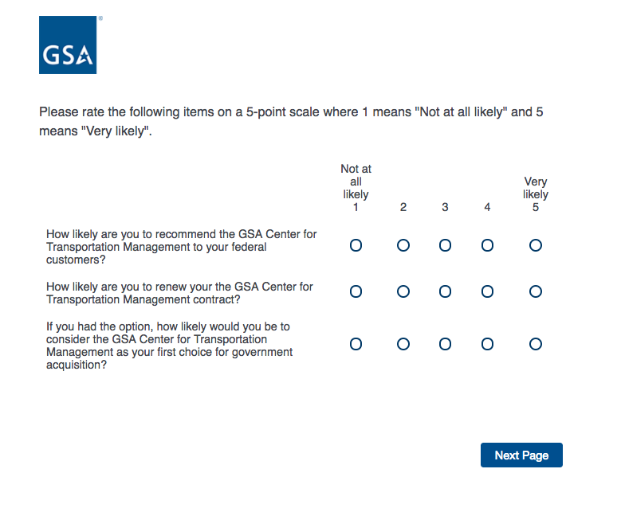
Then skip to Screen 7c.

Screen 6d

Display if GSA Program Office (embedded data) = the GSA Employee Relocation Resource Center (ERRC)

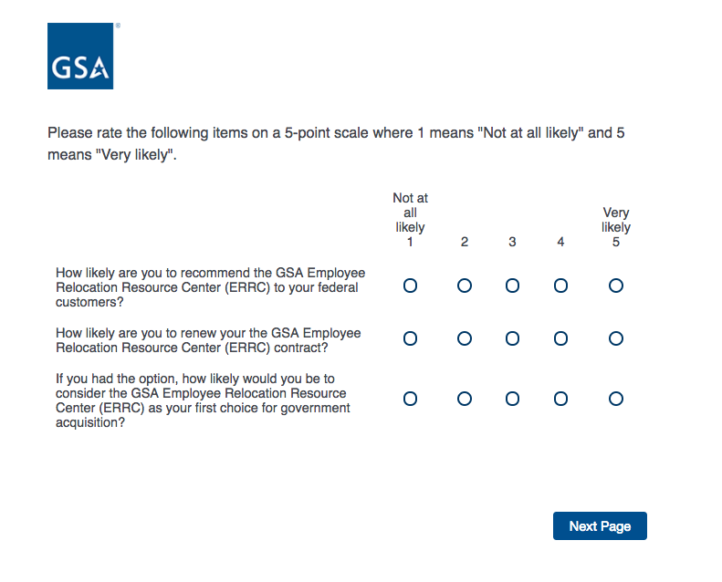
Then skip to Screen 7d.
Screen 6e

Display if GSA Program Office (embedded data) = GSA General Supplies and Services

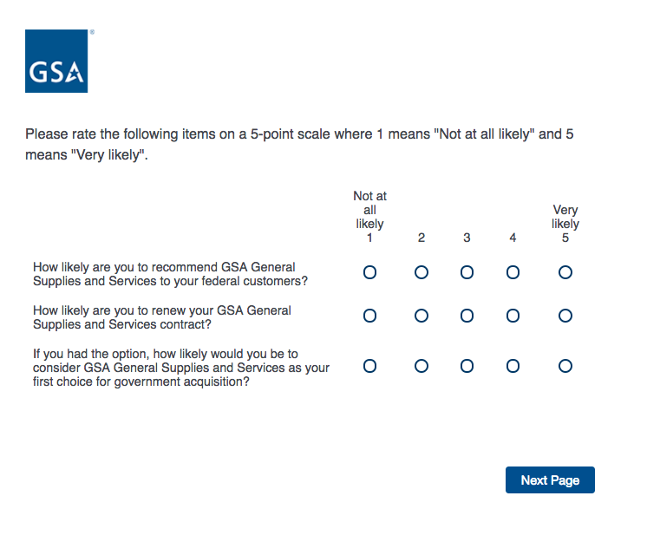
Then skip to Screen 7e.

Screen 7a

Display if GSA Program Office (embedded data) = GSA Fleet

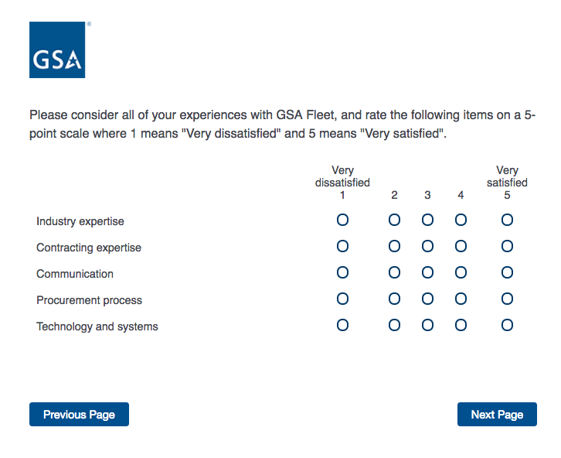
Then skip to Screen 8a.
Screen 7b

Display if GSA Program Office (embedded data) = the GSA Center for Travel Management
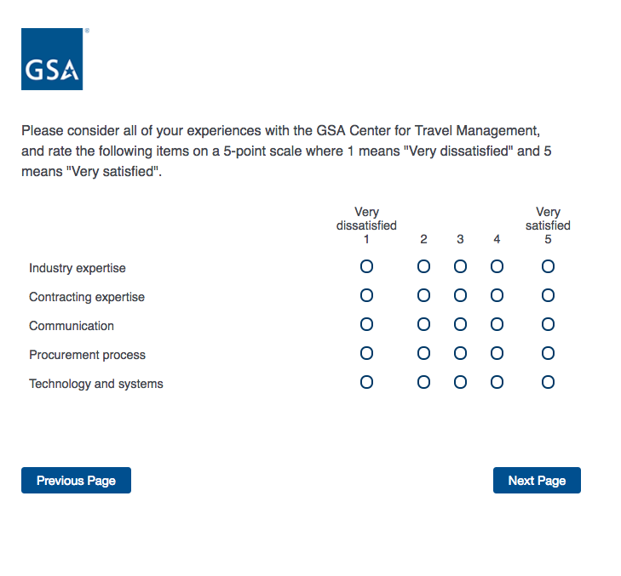
Then skip to Screen 8b.

Screen 7c

Display if GSA Program Office (embedded data) = the GSA Center for Transportation Management
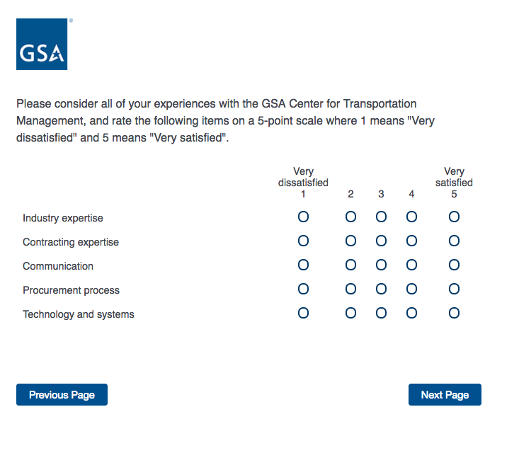
Then skip to Screen 8c.

Screen 7d

Display if GSA Program Office (embedded data) = the GSA Employee Relocation Resource Center (ERRC)
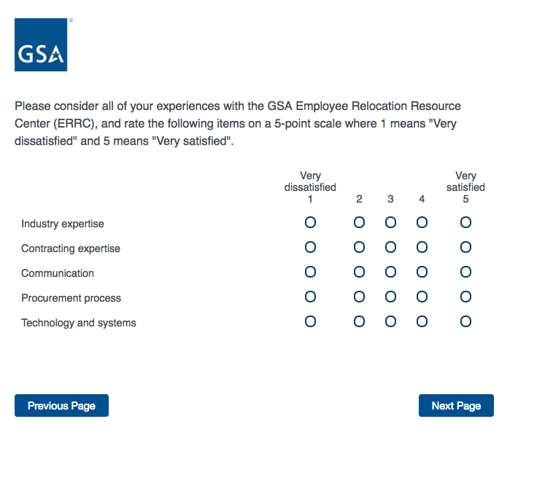

Then skip to Screen 8d.

Screen 7e

Display if GSA Program Office (embedded data) = GSA General Supplies and Services

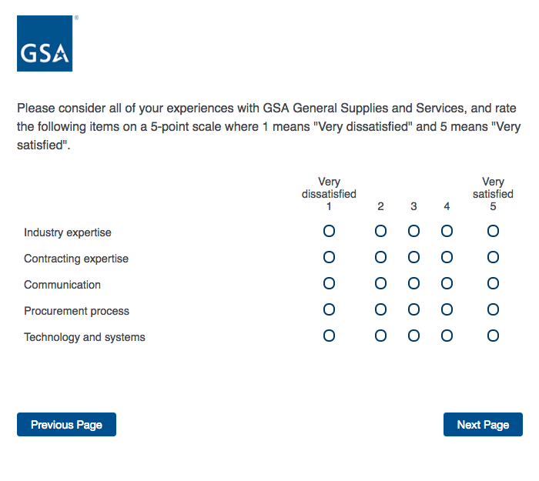

Then skip to Screen 8e.

Screen 8a

Display if GSA Program Office (embedded data) = GSA Fleet
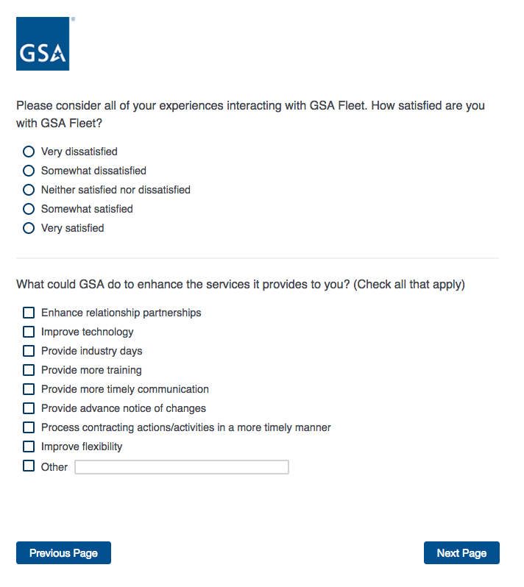

Then skip to Screen 16.
Screen 8b

Display if GSA Program Office (embedded data) = the Center for Travel Management

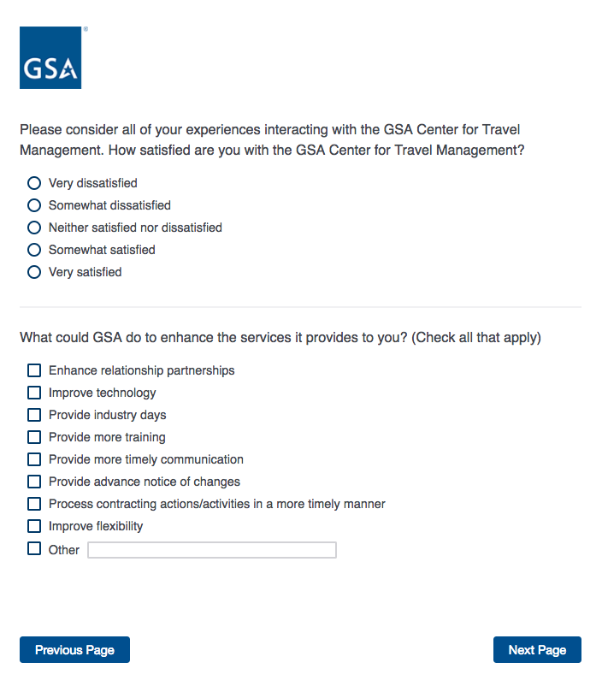

Then skip to Screen 17.
Screen 8c

Display if GSA Program Office (embedded data) = the GSA Center for Transportation Management

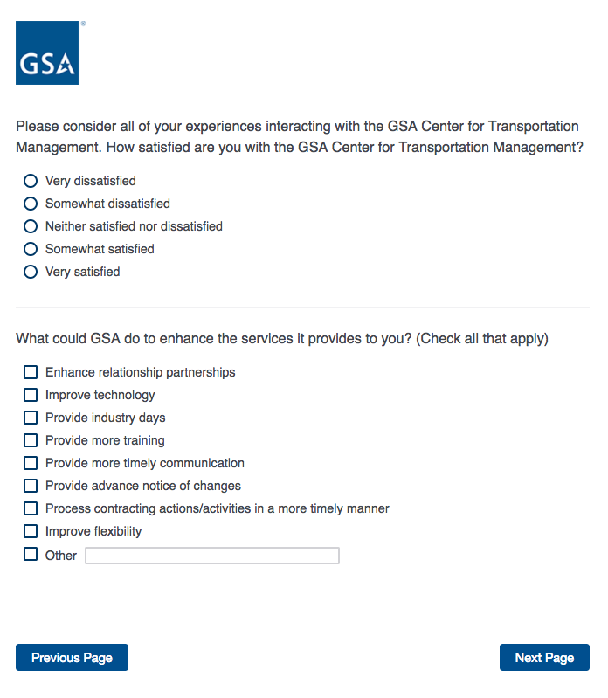
Then skip to Screen 20.
Screen 8d

Display if GSA Program Office (embedded data) = the GSA Employee Relocation Resource Center (ERRC)
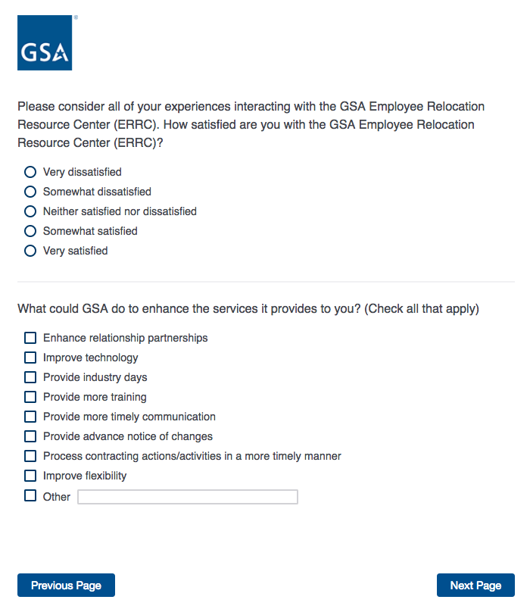

Then skip to Screen 23.
Screen 8e

Display if GSA Program Office (embedded data) = GSA General Supplies and Services
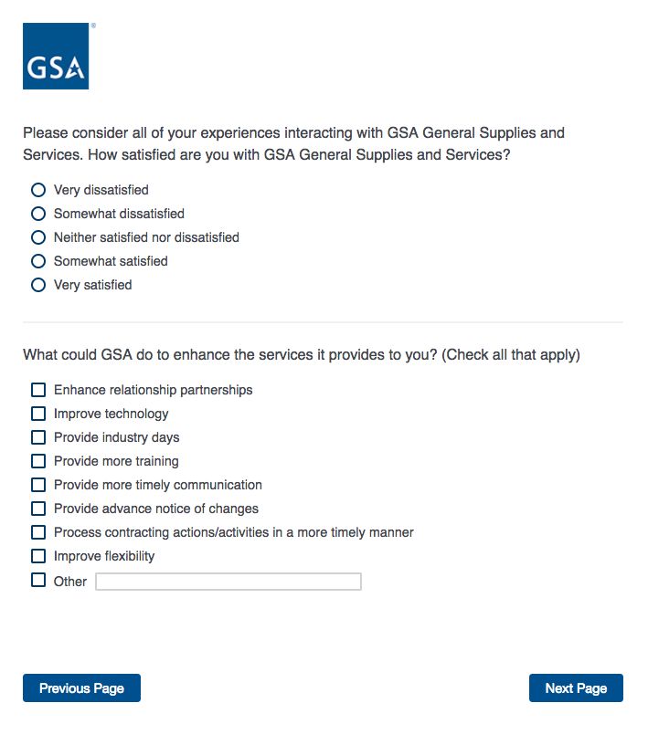
Then skip to Screen 26.

Screen 9

Display if GSA Program Office (embedded data) = GSA Information Technology Category

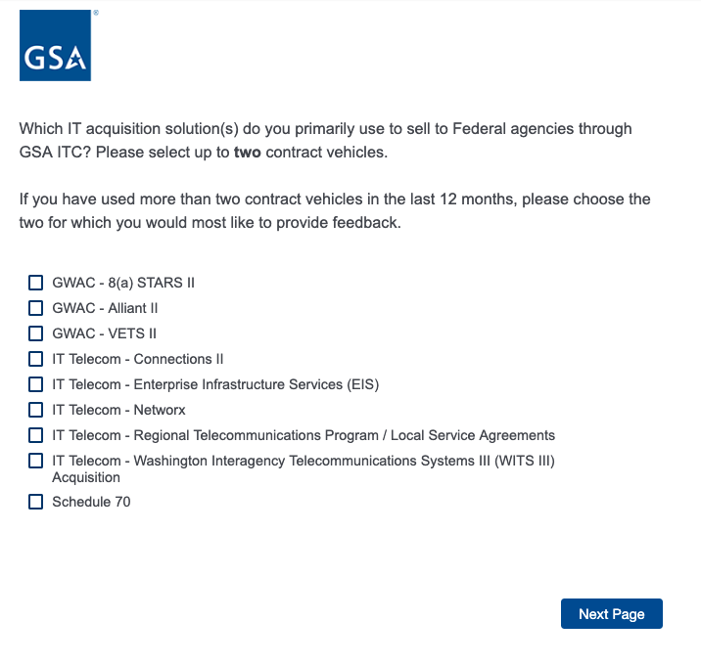
If GWAC – 8(a) STARS II is selected, skip to Screen 10a.
If GWAC – Alliant II is selected, skip to Screen 10b.
If GWAC – VETS II is selected, skip to Screen 10c.
If IT Telecom – Connections II is selected, skip to Screen 10d.
If IT Telecom – Enterprise Infrastructure Services (EIS) is selected, skip to Screen 10e.
If IT Telecom – Networx is selected, skip to Screen 10f.
If IT Telecom – Regional Telecommunications Program is selected, skip to Screen 10g.
If IT Telecom – Washington Interagency Telecommunications III (WITS III) is selected, Skip to Screen 10h.
If Schedule 70 is selected, then skip to Screen 10i.

Screen 10a

Display if GSA Program Office (embedded data) = GSA Information Technology Category
AND if GWAC – 8(a) STARS II is selected on Screen 9.
Then skip to Screen 11a.

Screen 10b

Display if GSA Program Office (embedded data) = GSA Information Technology Category
AND if GWAC – Alliant II is selected on Screen 9.
Then skip to Screen 11b.

Screen 10c

Display if GSA Program Office (embedded data) = GSA Information Technology Category
AND if GWAC – VETS II is selected on Screen 9.
Then skip to Screen 11c.
Screen 10d

Display if GSA Program Office (embedded data) = GSA Information Technology Category
AND if IT Telecom – Connections II is selected on Screen 9.
Then skip to Screen 11d.
Screen 10e

Display if GSA Program Office (embedded data) = GSA Information Technology Category
AND if IT Telecom – Enterprise Infrastructure Services (EIS) is selected on Screen 9.
Then skip to Screen 11e.
Screen 10f

Display if GSA Program Office (embedded data) = GSA Information Technology Category
AND if IT Telecom – Networx is selected on Screen 9.
Then skip to Screen 11f.
Screen 10g

Display if GSA Program Office (embedded data) = GSA Information Technology Category
AND if IT Telecom – Regional Telecommunications Program is selected on Screen 9.
Then skip to Screen 11g.
Screen 10h

Display if GSA Program Office (embedded data) = GSA Information Technology Category
AND if IT Telecom – Washington Interagency Telecommunications III (WITS III) is selected on Screen 9.
Then skip to Screen 11h.
Screen 10i

Display if GSA Program Office (embedded data) = GSA Information Technology Category
AND if Schedule 70 is selected on Screen 9.
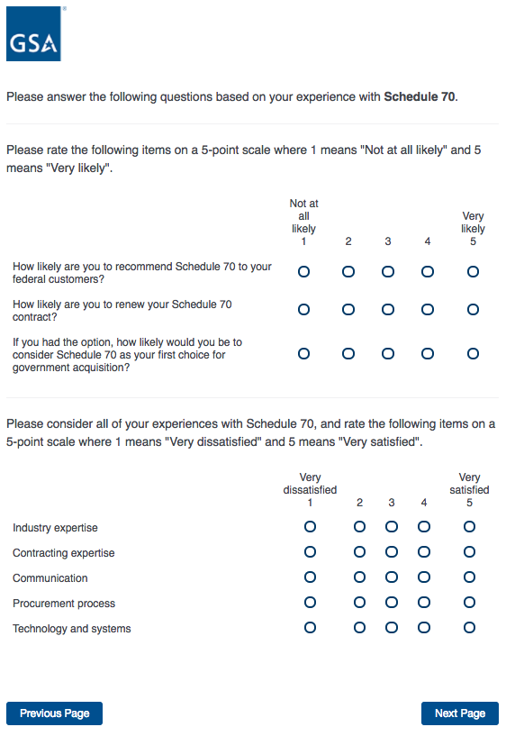
Then skip to Screen 11i.
Screen 11a

Display if GSA Program Office (embedded data) = GSA Information Technology Category
AND if GWAC – 8(a) STARS II is selected on Screen 9.

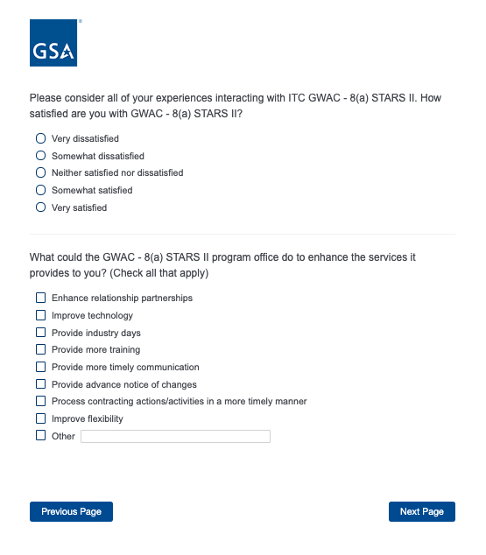
Then skip to Screen 32.
Screen 11b

Display if GSA Program Office (embedded data) = GSA Information Technology Category
AND if GWAC – Alliant II is selected on Screen 9.
Then skip to Screen 32.
Screen 11c

Display if GSA Program Office (embedded data) = GSA Information Technology Category
AND if GWAC – VETS II is selected on Screen 9.

Then skip to Screen 32.
Screen 11d

Display if GSA Program Office (embedded data) = GSA Information Technology Category
AND if IT Telecom – Connections II is selected on Screen 9.
Then skip to Screen 32.
Screen 11e

Display if GSA Program Office (embedded data) = GSA Information Technology Category
AND if IT Telecom – Enterprise Infrastructure Services (EIS) is selected on Screen 9.
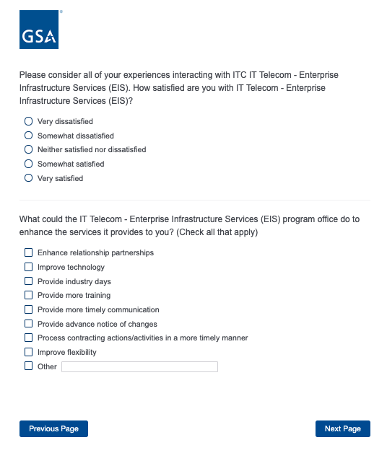
Then skip to Screen 32.
Screen 11f

Display if GSA Program Office (embedded data) = GSA Information Technology Category
AND if IT Telecom – Networx is selected on Screen 9.
Then skip to Screen 32.
Screen 11g

Display if GSA Program Office (embedded data) = GSA Information Technology Category
AND if IT Telecom – Regional Telecommunications Program is selected on Screen 9.
Then skip to Screen 32.
Screen 11h

Display if GSA Program Office (embedded data) = GSA Information Technology Category
AND if IT Telecom – Washington Interagency Telecommunications III (WITS III) is selected on Screen 9.
Then skip to Screen 32.
Screen 11i

Display if GSA Program Office (embedded data) = GSA Information Technology Category
AND if Schedule 70 is selected on Screen 9.
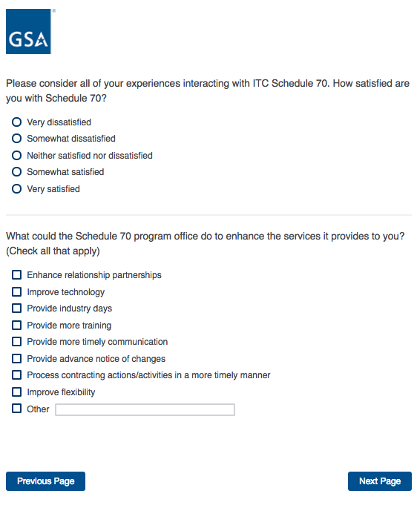
Then skip to Screen 30.

Screen 13

Display if GSA Program Office (embedded data) = GSA Professional Services and Human Capital (PSHC) Categories

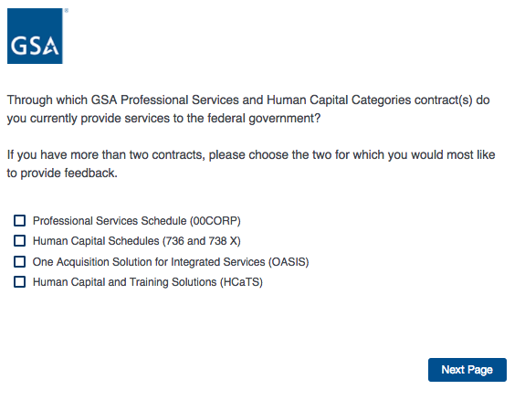
If Professional Services Schedule (00CORP) is selected, skip to 14a.
If Human Capital Schedules (736 and 738X) is selected, skip to 14b.
If One Acquisition Solution for Integrated Services (OASIS) is selected, skip to 14c.
If Human Capital and Training Solutions (HCaTS) is selected, skip to 14d.
Screen 14a

Display if GSA Program Office (embedded data) = GSA Professional Services and Human Capital (PSHC) Categories
AND if Professional Services Schedule is selected on Screen 13.
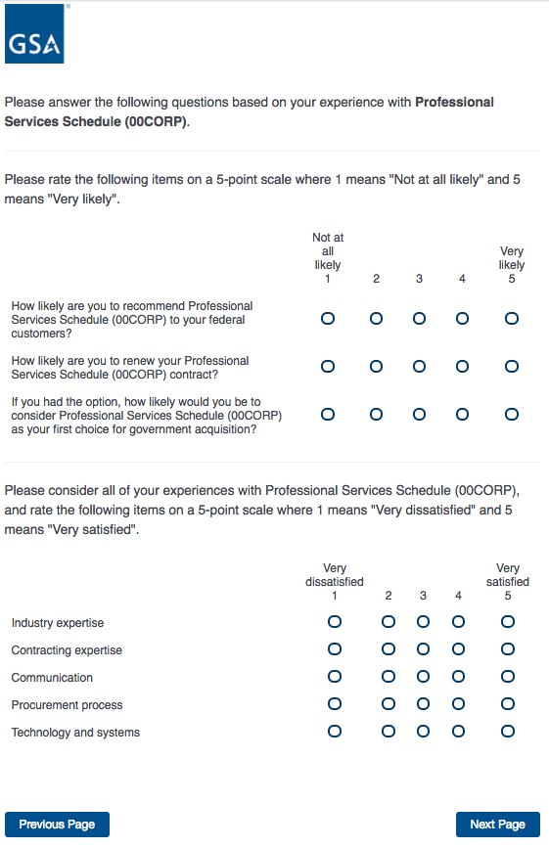
Then skip to 15a.

Screen 14b

Display if GSA Program Office (embedded data) = GSA Professional Services and Human Capital (PSHC) Categories
AND if Human Capital Schedules is selected on Screen 13.
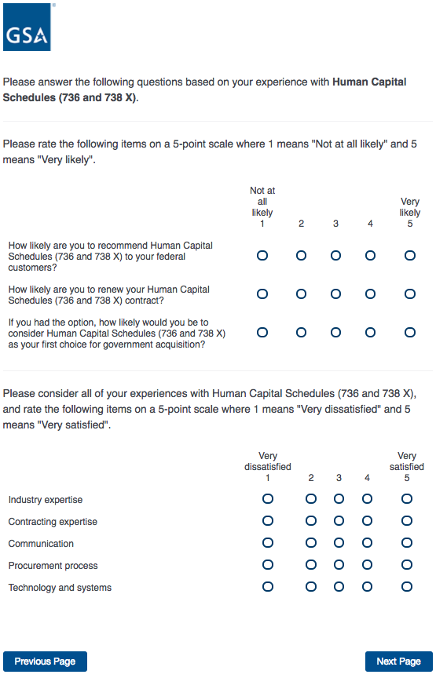
Then skip to 15b.
Screen 14c

Display if GSA Program Office (embedded data) = GSA Professional Services and Human Capital (PSHC) Categories
AND if One Acquisition Solution for Integrated Services is selected on Screen 13.
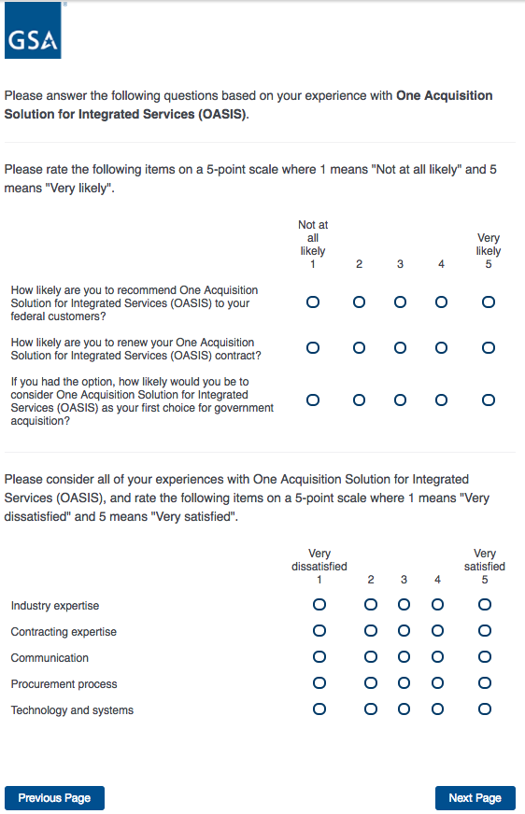
Then skip to Screen 15c.
Screen 14d

Display if GSA Program Office (embedded data) = GSA Professional Services and Human Capital (PSHC) Categories
AND if Human Capital and Training Solutions is selected on Screen 13.
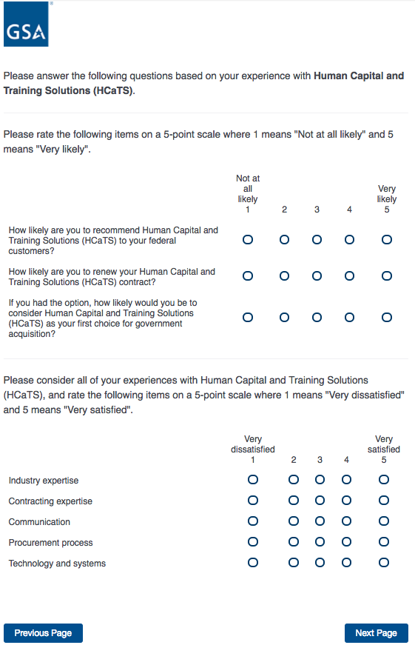
Then skip to Screen 15d.
Screen 15a

Display if GSA Program Office (embedded data) = GSA Professional Services and Human Capital (PSHC) Categories
AND if Professional Services Schedule is selected on Screen 13.
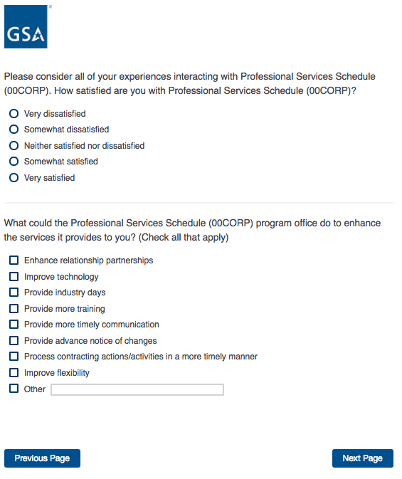
Then skip to Screen 30.
Screen 15b

Display if GSA Program Office (embedded data) = GSA Professional Services and Human Capital (PSHC) Categories
AND if Human Capital Schedules is selected on Screen 13.
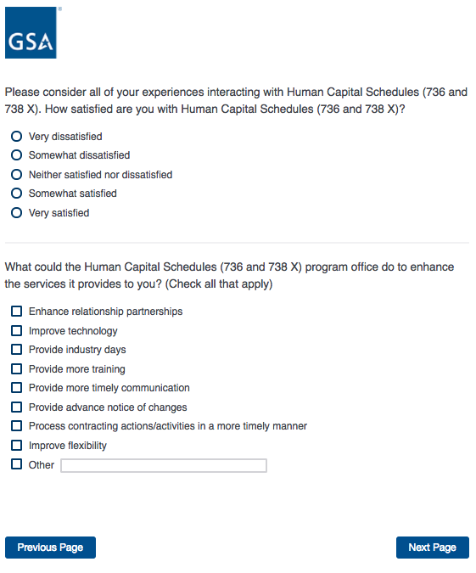
Then skip to Screen 31.
Screen 15c

Display if GSA Program Office (embedded data) = GSA Professional Services and Human Capital (PSHC) Categories
AND if One Acquisition Solution for Integrated Services is selected on Screen 13.
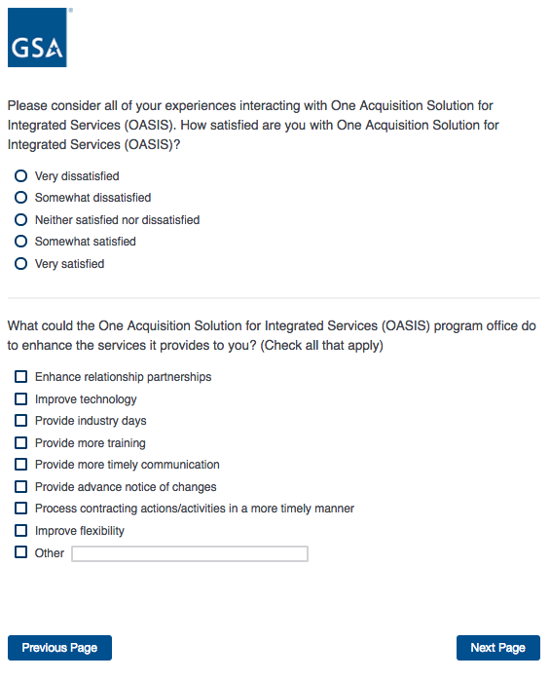
Then skip to Screen 31.
Screen 15d

Display if GSA Program Office (embedded data) = GSA Professional Services and Human Capital (PSHC) Categories
AND if Human Capital and Training Solutions is selected on Screen 13.
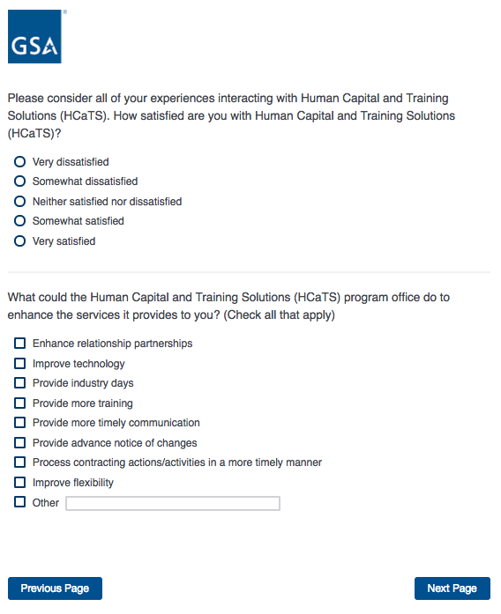
Then skip to Screen 31.
Screen 16

Display if GSA Program Office (embedded data) = GSA Fleet

If Schedule (embedded data) = 23V, then skip to Screen 31.
ELSE skip to Screen 32.
Screen 17

Display if GSA Program Office (embedded data) = the GSA Center for Travel Management

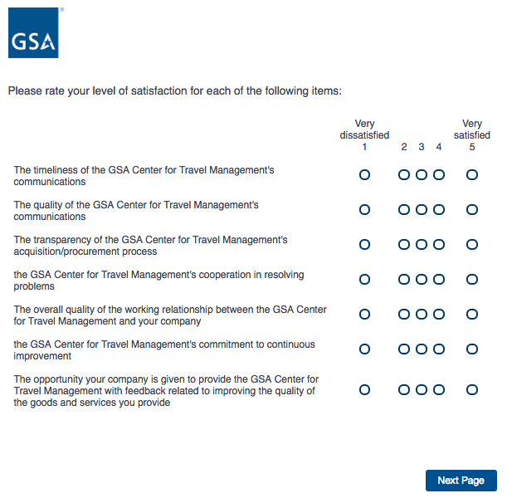
Then proceed to Screen 18.
Screen 18

Display if GSA Program Office (embedded data) = the GSA Center for Travel Management
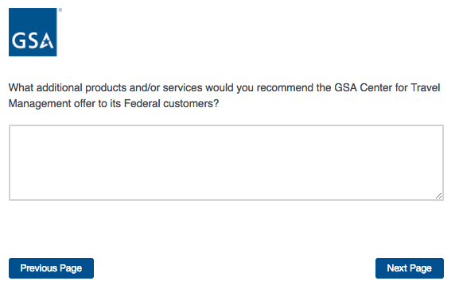

Then proceed to Screen 19.
Screen 19

Display if GSA Program Office (embedded data) = the GSA Center for Travel Management

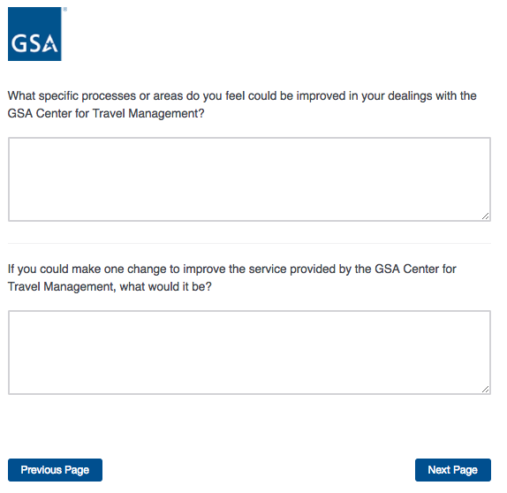
If Schedule = 599, skip to Screen 31.
ELSE skip to Screen 32.
Screen 20

Display if GSA Program Office (embedded data) = the GSA Center for Transportation Management

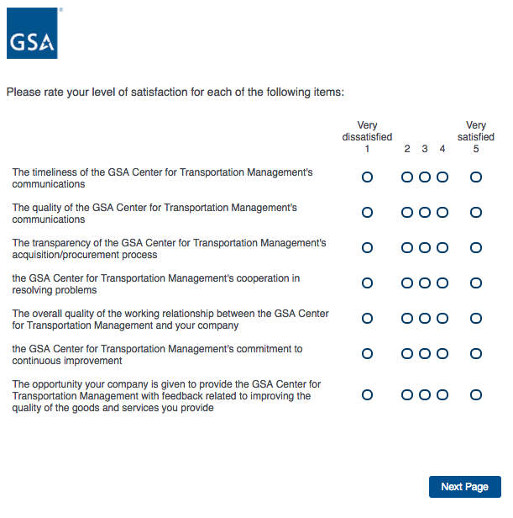
Then proceed to Screen 21.
Screen 21

Display if GSA Program Office (embedded data) = the GSA Center for Transportation Management

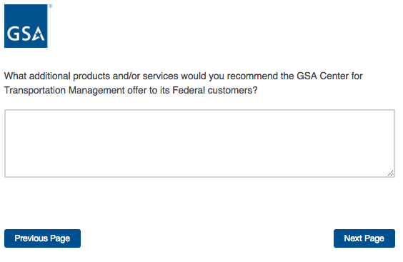
Then proceed to Screen 22.
Screen 22

Display if GSA Program Office (embedded data) = the GSA Center for Transportation Management

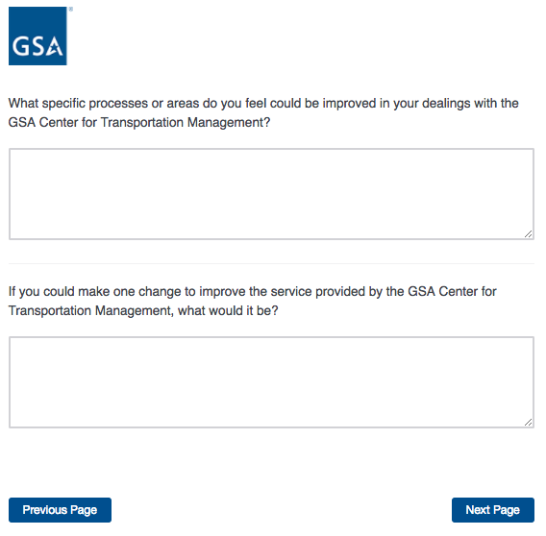
Then skip to Screen 32.
Screen 23

Display if GSA Program Office (embedded data) = the GSA Employee Relocation Resource Center (ERRC)
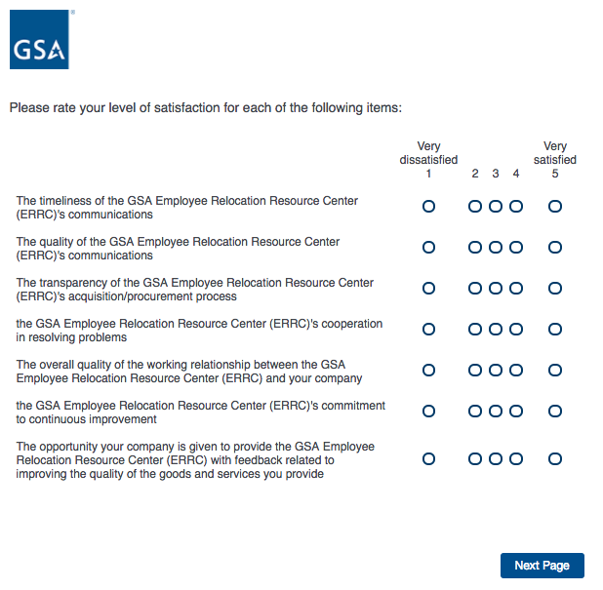
Then proceed to Screen 24.

Screen 24

Display if GSA Program Office (embedded data) = the GSA Employee Relocation Resource Center (ERRC)
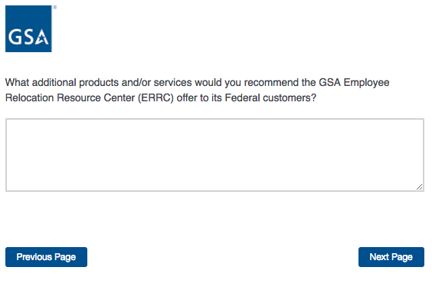
Then proceed to Screen 25.

Screen 25

Display if GSA Program Office (embedded data) = the GSA Employee Relocation Resource Center (ERRC)
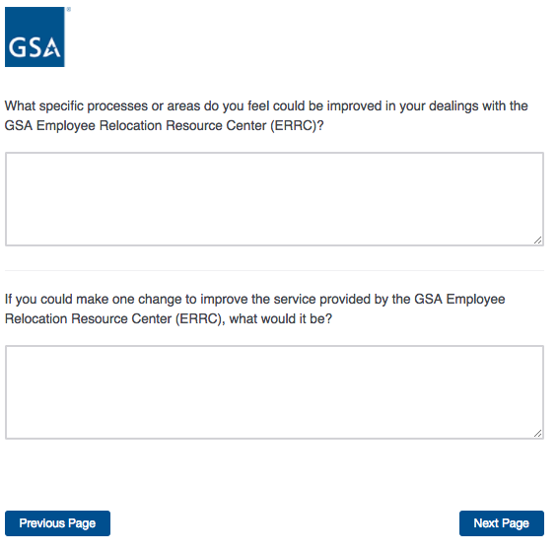
If Schedule = 48, skip to Screen 31.
ELSE skip to Screen 32.

Screen 26

Display if GSA Program Office (embedded data) = GSA General Supplies and Services
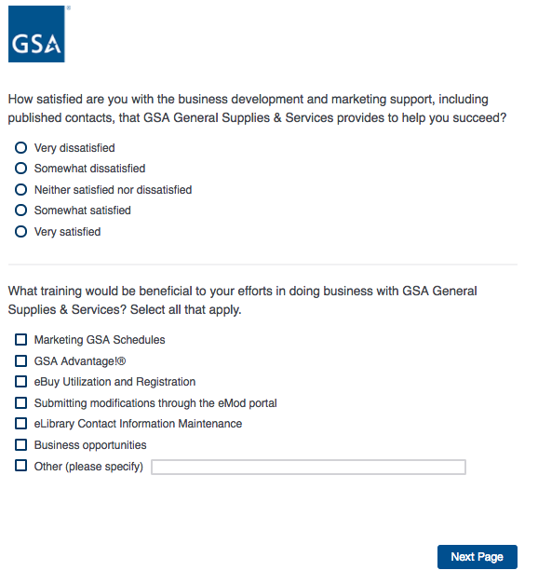
Then proceed to Screen 27.

Screen 27

Display if GSA Program Office (embedded data) = GSA General Supplies and Services

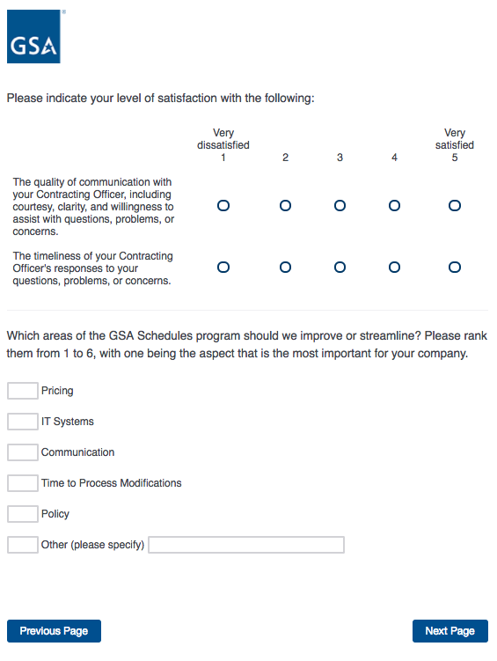
Then proceed to Screen 28.
Screen 28

Display if GSA Program Office (embedded data) = GSA General Supplies and Services
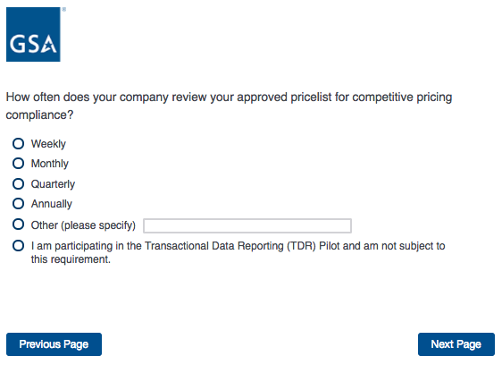
Then proceed to Screen 29.

Screen 29

Display if GSA Program Office = GSA General Supplies and Services
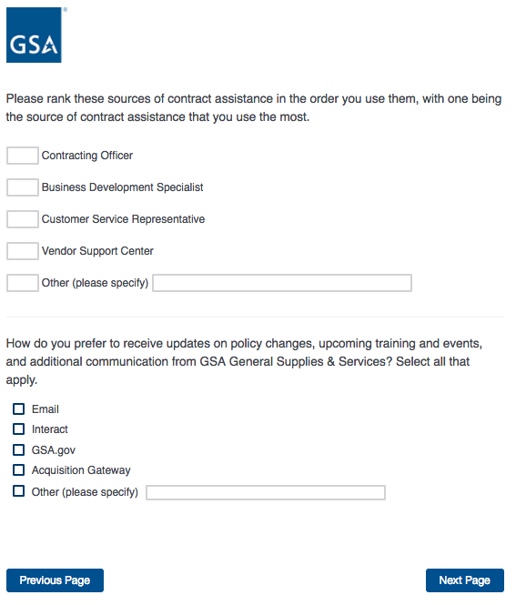
If Schedule = 51V, 58-I, 72, 73, 75, OR 03FAC, proceed to Screen 30.
ELSE skip to Screen 31.

Screen 30

Display if Schedule = 51V, 58-I, 70, 72, 73, 75, 03FAC, OR PSS.

If “I am not participating in the TDR pilot” is selected, skip to Screen 32.

Screen 31

Display if Schedule = 51V, 58-I, 70, 72, 73, 75, 03FAC, OR PSS.
If Program Office = GSA General Supplies and Services,
OR if Schedule 70 is selected on page 9,
OR if Professional Services Schedule is selected on page 13,
OR if Human Capital Schedules is selected on page 13,
OR if Schedule = 48,
OR if Schedule = 599,
OR if Schedule = 23V, proceed to Screen 31.
ELSE skip to Screen 32.
Screen 32

Display if Program Office = GSA General Supplies and Services,
OR if Schedule 70 is selected on page 9,
OR if Professional Services Schedule is selected on page 13,
OR if Human Capital Schedules is selected on page 13,
OR if Schedule = 48,
OR if Schedule = 599,
OR if Schedule = 23V.
Then proceed to Screen 33.
Screen 33

Display if Program Office = GSA General Supplies and Services,
OR if Schedule 70 is selected on page 9,
OR if Professional Services Schedule is selected on page 13,
OR if Human Capital Schedules is selected on page 13,
OR if Schedule = 48,
OR if Schedule = 599,
OR if Schedule = 23V.
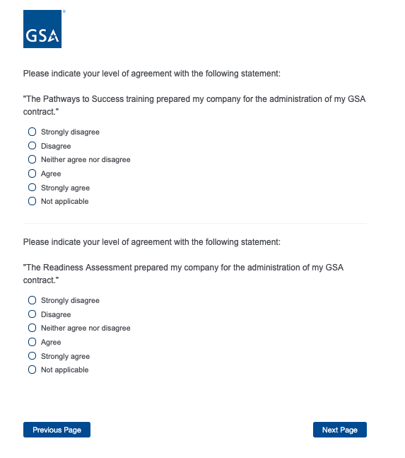
Then proceed to Screen 34.

Screen 34

Display to all respondents
Then proceed to Screen 35.
Screen 35

Display to all respondents.
Then proceed to Screen 36.
Screen 34

Display to all respondents

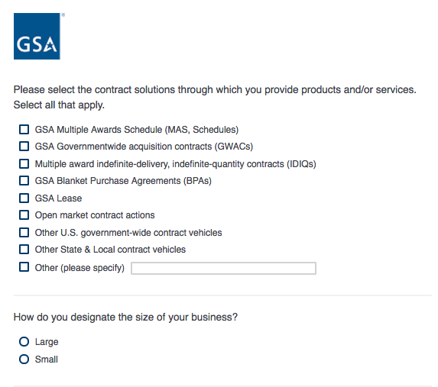

If “Small” is selected, then display the following question in the same page.

Screen 34, continued

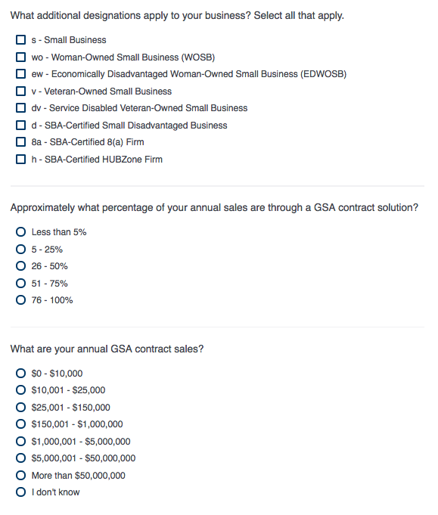
If “$0 - $10,000” or “$10,001 - $25,000” is selected, then display the following question in the same page:

Screen 34, continued

Screen 35

Display to all respondents.

