**Instrument 3090-0297**

**Req 40**

**Email Text for**

**2019 Professional Services & Human Capital (PSHC)**

**Industry Days and Program Management Reviews**

Thank you for attending the 2019 Professional Services & Human Capital (PSHC) Industry Days and Program Management Reviews.  We would like to hear from you about your experience while participating in order to better serve you in the future.  Please take a few minutes to complete our survey.  Your comments will be reviewed and will help us in planning and improving future events.

Click this link to proceed to survey:  [Take the Survey](https://feedback.gsa.gov/jfe/form/SV_abjVdBBZh0eucfz?Q_DL=eKjRBbjKC8k6xeZ_abjVdBBZh0eucfz_MLRP_5vdlz1TENJq6zBj&Q_CHL=email)  
  
Follow the link to opt out of future emails:  
[Click here to unsubscribe](https://feedback.gsa.gov/CP/Register.php?OptOut=true&RID=MLRP_5vdlz1TENJq6zBj&LID=GR_3Ozbu3Msks9flUp&BT=Y2VtZ3Nh&_=1)  
  
Sincerely,  
GSA  Federal Acquisition Service  
  
If you experience any technical difficulties, please send an email to [fasresearch@gsa.gov](mailto:fasresearch@gsa.gov)

**INTRODUCTION/DESCRIPTIVE TEXT (Q1)**

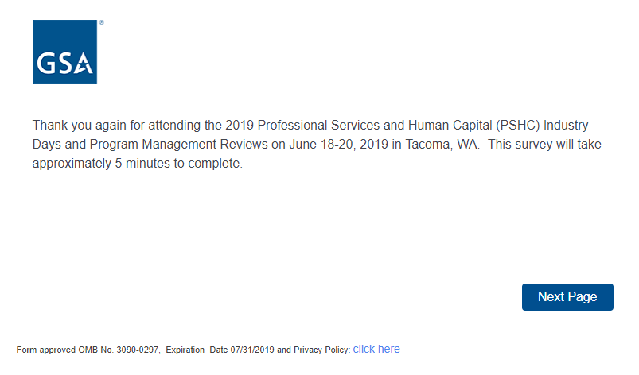

**PRA Statement and Privacy Policy Statement**

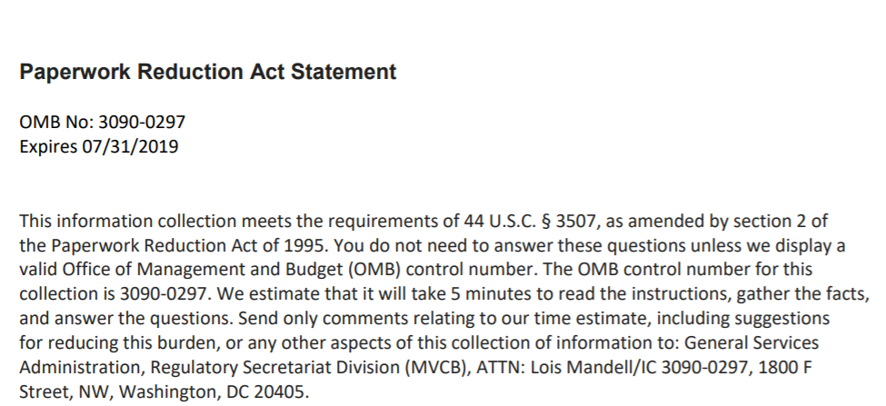

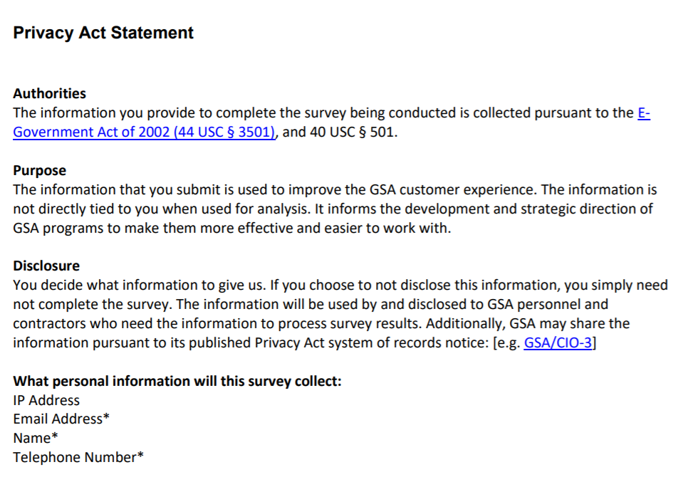

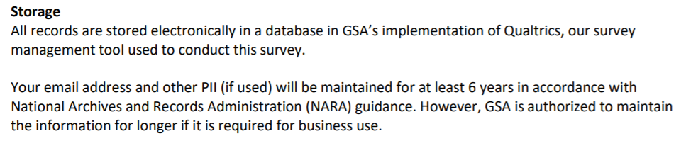

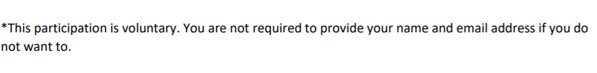

**Survey Questions**

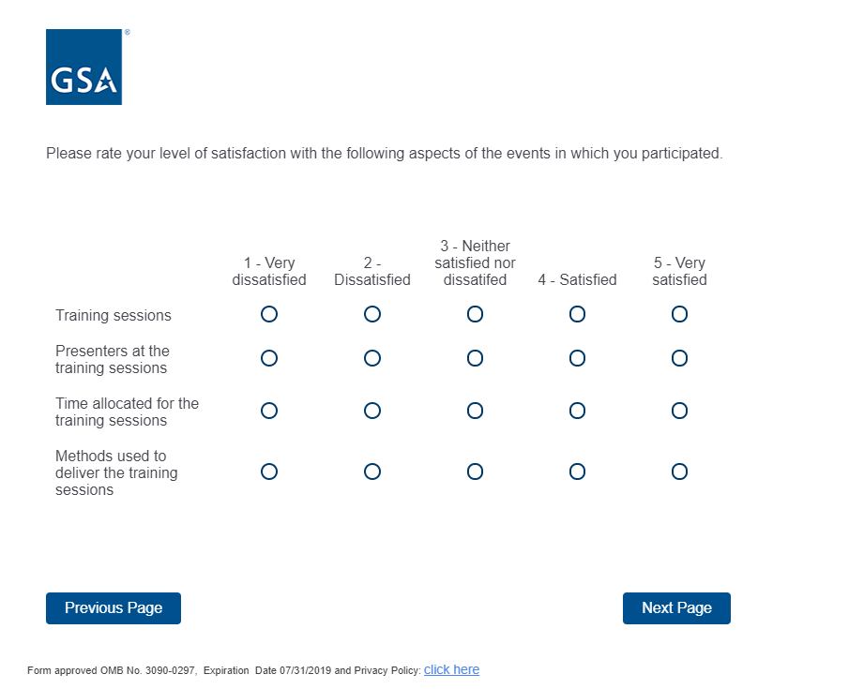

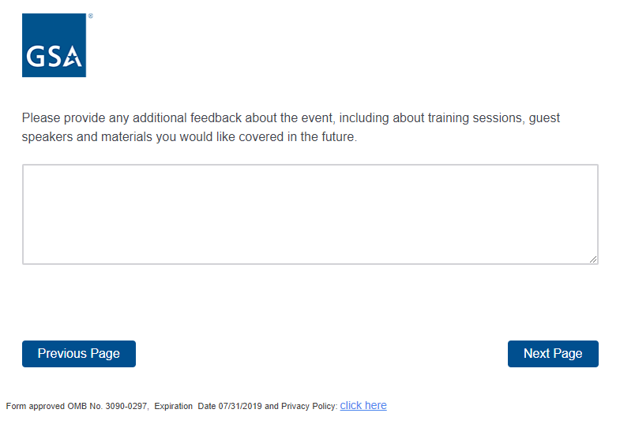

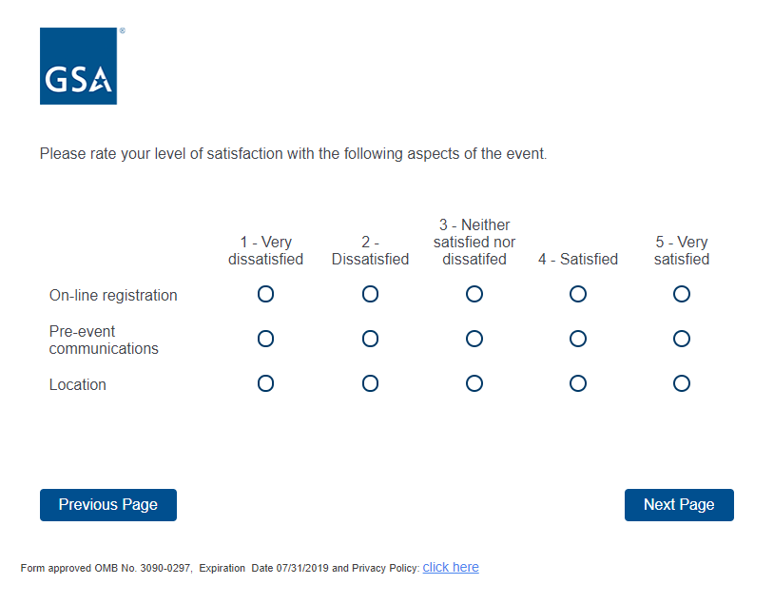

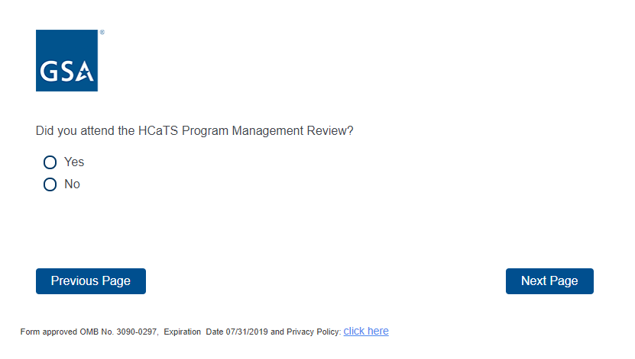

If the respondent answers yes, it takes them to the next 2 screenshots regarding HCaTS Program Management Review. If the respondent answers no, it takes them to the OASIS Program Review screenshot.

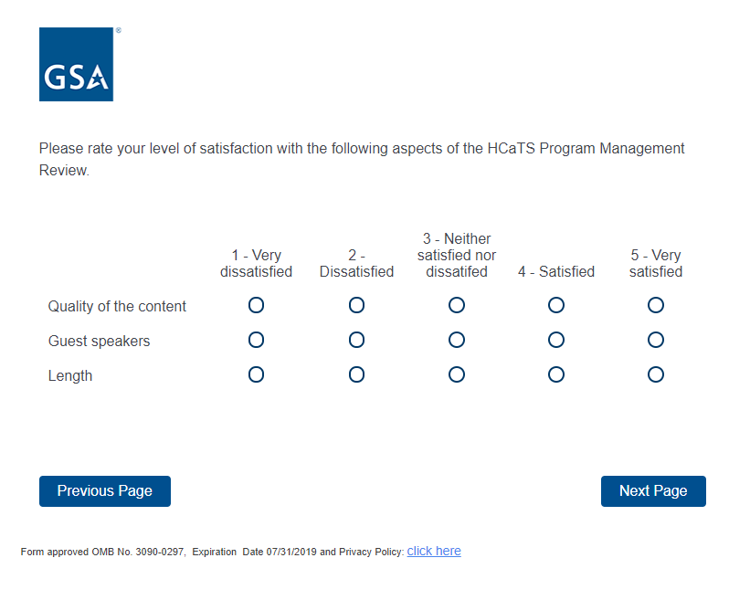

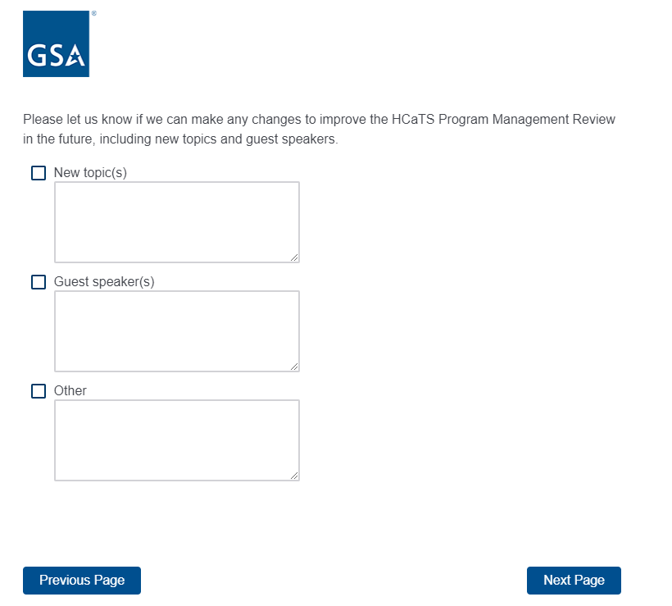

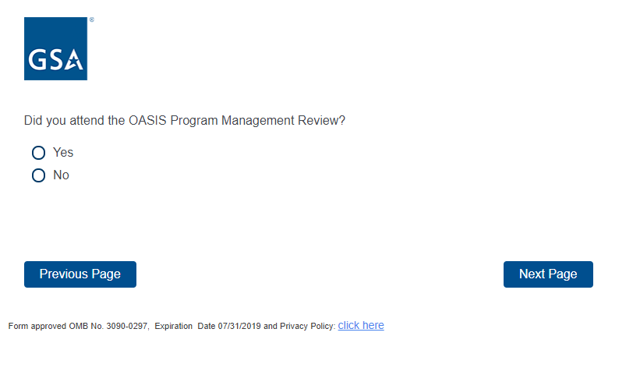

If the respondent answers yes, it takes them to the next 2 screenshots regarding OASIS Program Management Review. If the respondent answers no, it takes them to the screeshot that reads, “Overall, how likely are you to recommend the PSHC Industry Days and Program Management Reviews to a friend or colleague?”

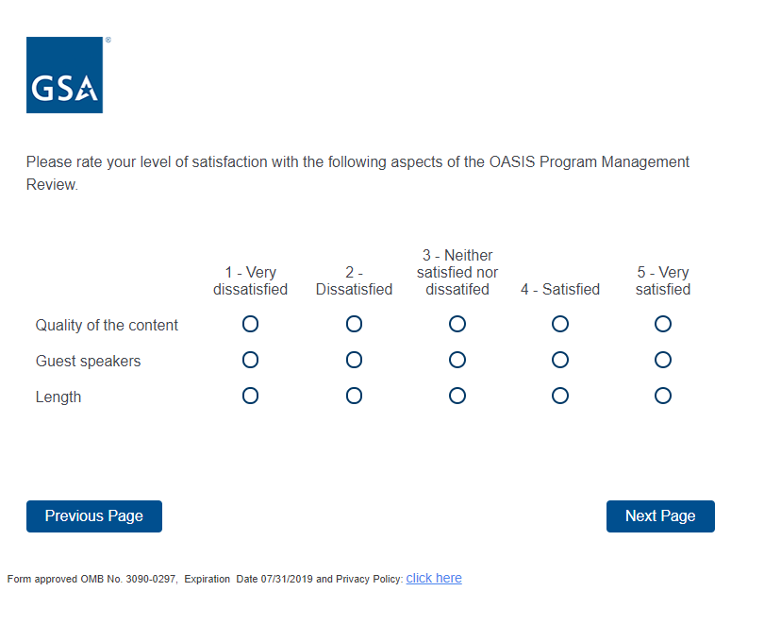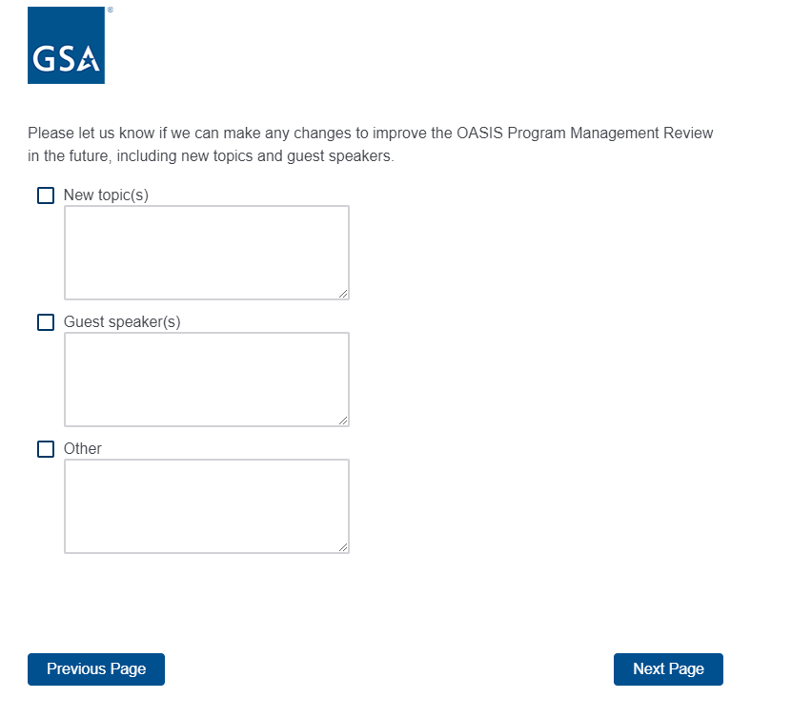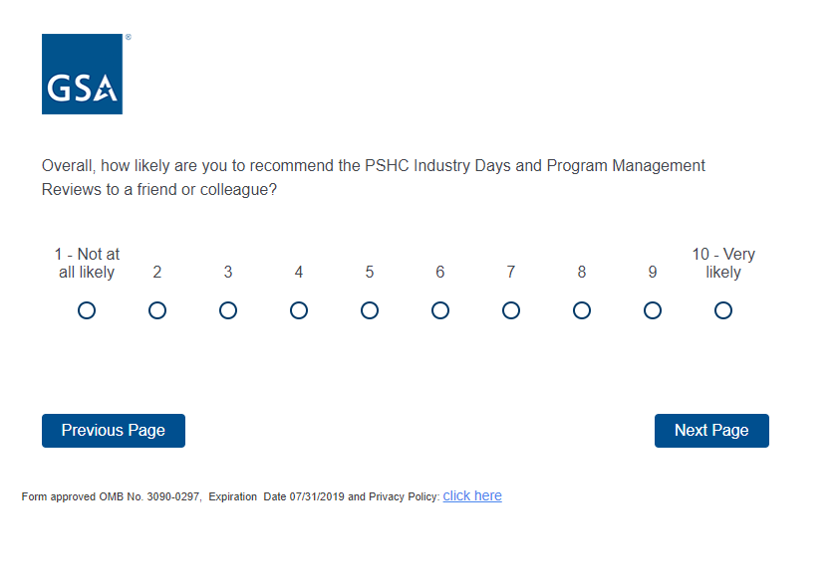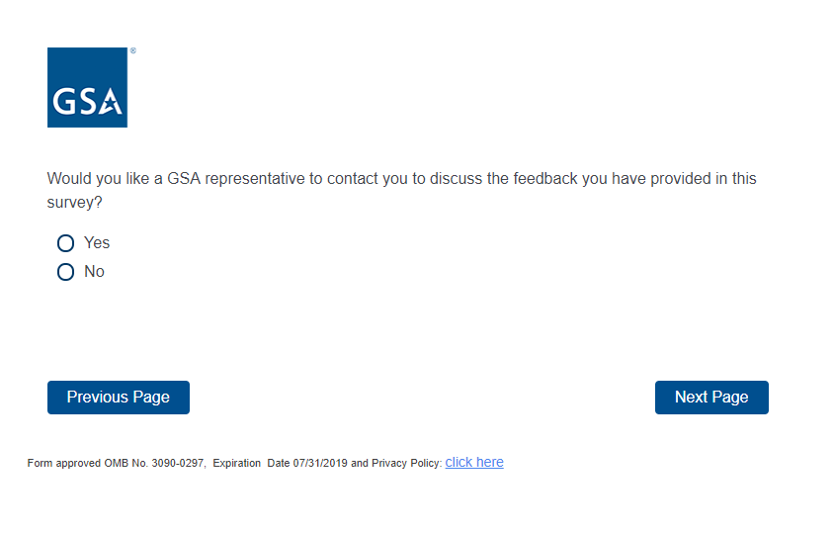

If the respondent select yes, it will take them to the next screenshot to enter name, email and phone number. If the respondent selects no, it will take them to the end of the survey that reads “We value your feedback”.

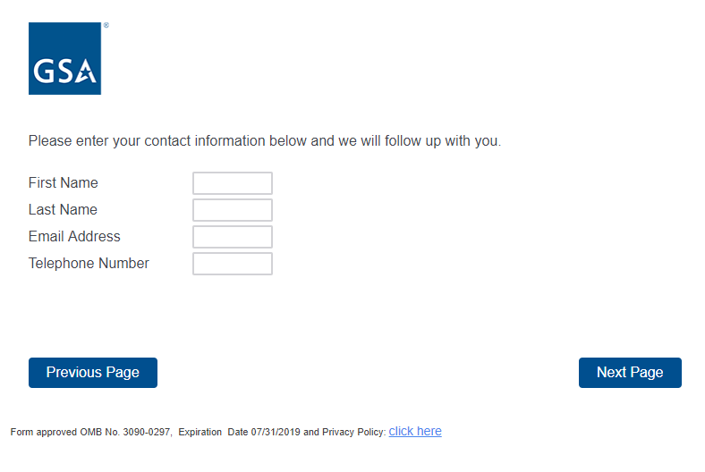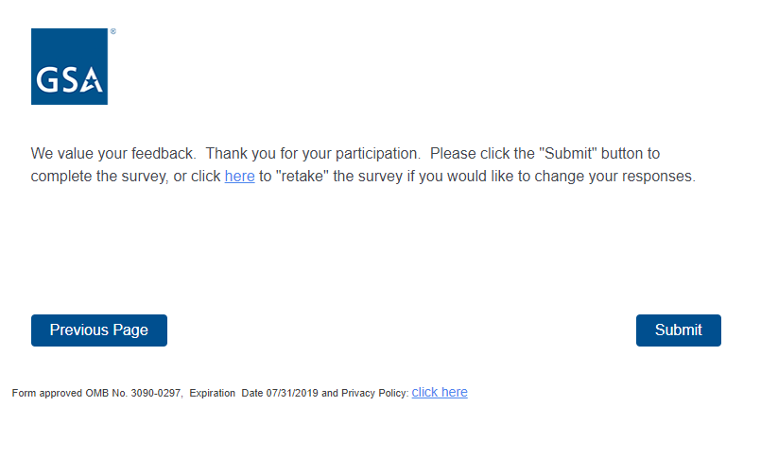

**Exit Page Once Respondent Click Submit Button**



