**FAST Track 3090-0297**

**Re-41**

**NCSC Customer Satisfaction Survey**

Screen 1:

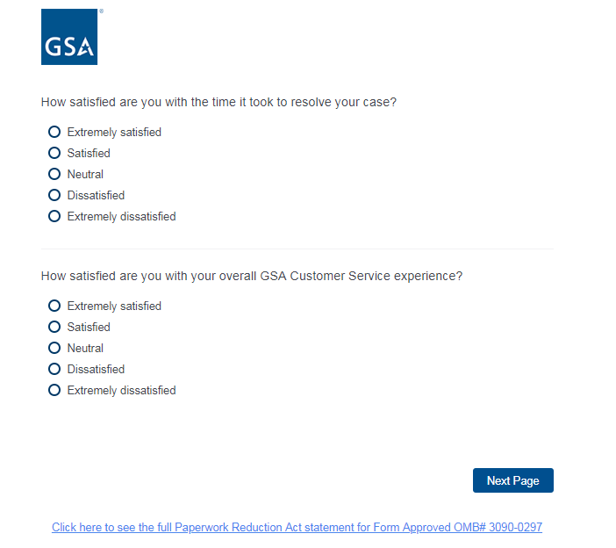

Screen 2:

