**Customer Experience Hackathon Post-Event Survey Instrument**

**FAST Track 3090-0297**

**Req-44**

For PRA Review only – Contents of this box will not be displayed to recipients.

Note that this survey depends on embedded data to determine which questions will be displayed to each recipient. Embedded data are commands built into the survey that draw information from the contact list. Survey responses remain confidential.

The embedded data fields that are used in this survey are:

* Attended

On each page, there is a link in the footer. The link takes the user to the PRA statement and a Privacy Act statement. A screenshot of what appears is below.

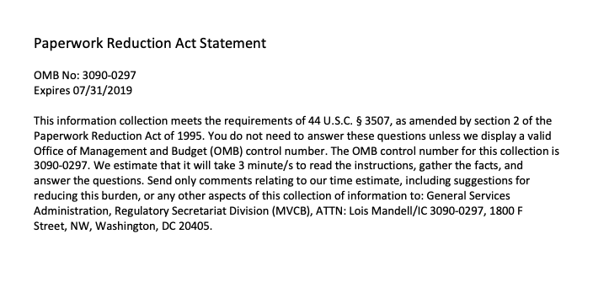

**Screen 1**

Display if Attended = Yes

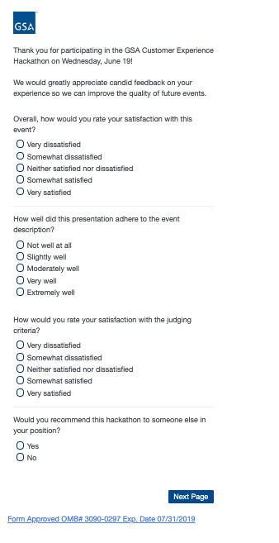

Continue to Screen 2

**Screen 2**

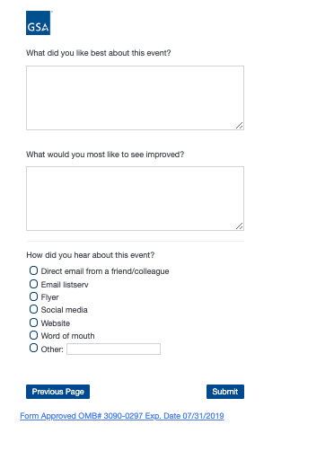

**Screen 3**

Display if Attended = No

