**eBuy Pilot - Survey to Awarded Vendors**

**FAST Track 3090-0297**

**Req-45**

This survey will be delivered via email approximately 14 days after the initial award notice is posted on FedBizOpps (FBO). A draft of the email is shown below:

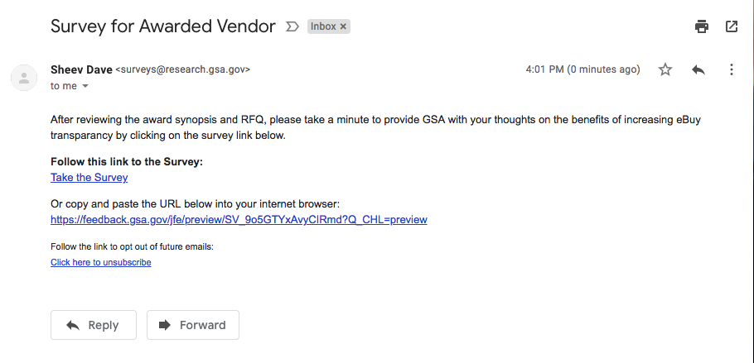

**\*The entire survey will be on 1-page, but screenshot of every question are shown individually below.\***

**A Link to the survey can be accessed below:**

[https://feedback.gsa.gov/jfe/preview/SV_9o5GTYxAvyCIRmd?Q_SurveyVersionID=current&Q_CHL=preview\](https://feedback.gsa.gov/jfe/preview/SV_9o5GTYxAvyCIRmd?Q_SurveyVersionID=current&Q_CHL=preview%5C)

**Question 1**

The first part of the survey thanks the participant for participating in the survey. It also says the estimated amount of time to complete, and a brief background on the survey’s purpose. The last two hyperlinks are to the PRA Statements and GSA’s Website Privacy and Security Notice webpage.

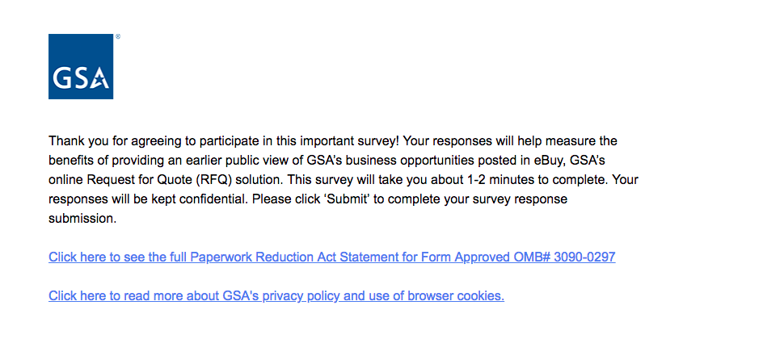

**Screenshot of PRA statement pdf:**

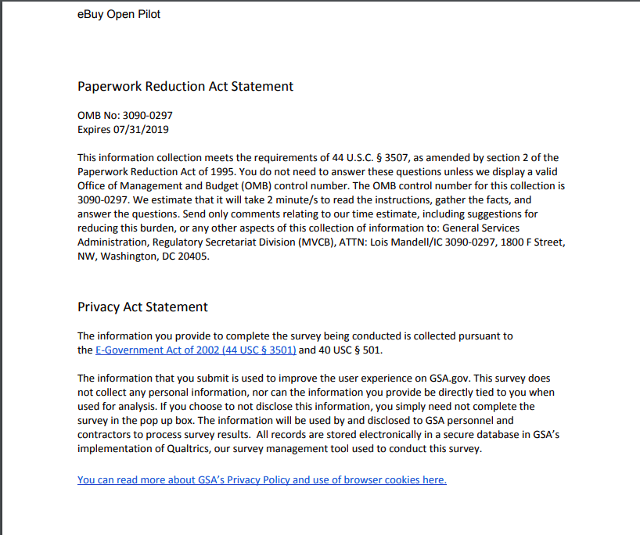

**Screenshot of the gsa.gov Privacy and Security Notice Page:**

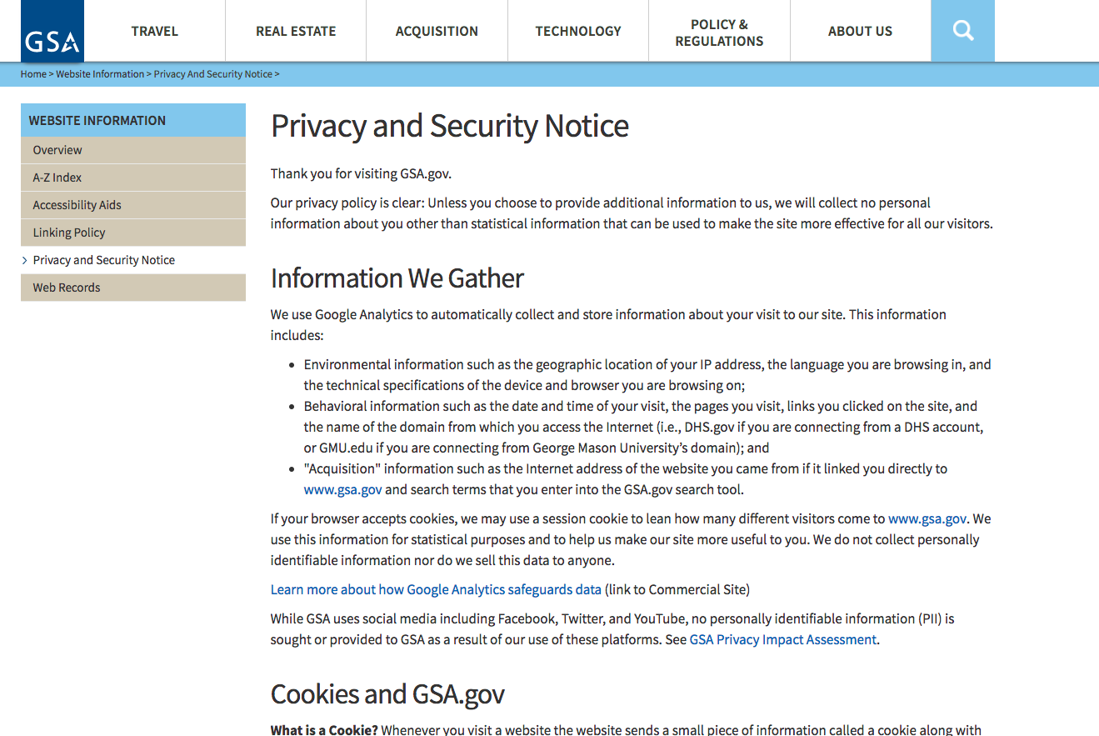

**Question 2**

This question asks the participant on their satisfaction with the pilot’s award process. The answers are arranged in accordance to a likert scale.

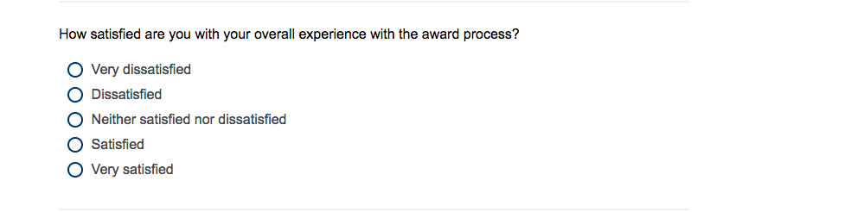

**Question 3**

This question asks if the new process was helpful for partnerships in subcontracting. The answers are arranged in accordance to a likert scale.

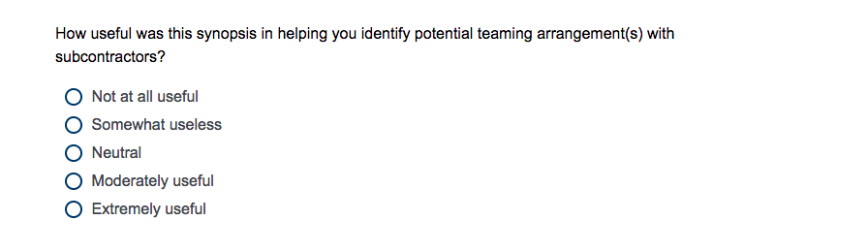

**Last Question**

The last question asks participants to provide any more feedback.

