**eBuy Pilot - Survey to General Public**

**3090-0297**

**Req-46**

**\*The entire survey will be on 1-page, but screenshots of every question are shown individually below.\***

**You may view the survey using the following link:**

<https://feedback.gsa.gov/jfe/preview/SV_8BN7MMha0Agi8rr?Q_SurveyVersionID=current&Q_CHL=preview>

**Introductory Text**

The first part of the survey thanks the participant for participating in the survey. It also gives the estimated amount of time to complete, and a brief background on the survey’s purpose. The last two hyperlinks are to the PRA Statements and GSA’s Website Privacy and Security Notice webpage.

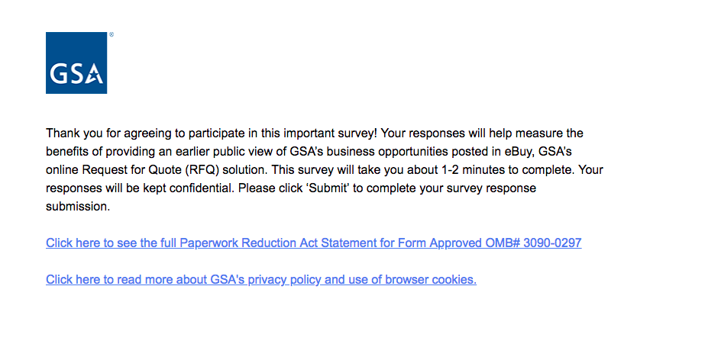

**Screenshot of PRA statement pdf:**

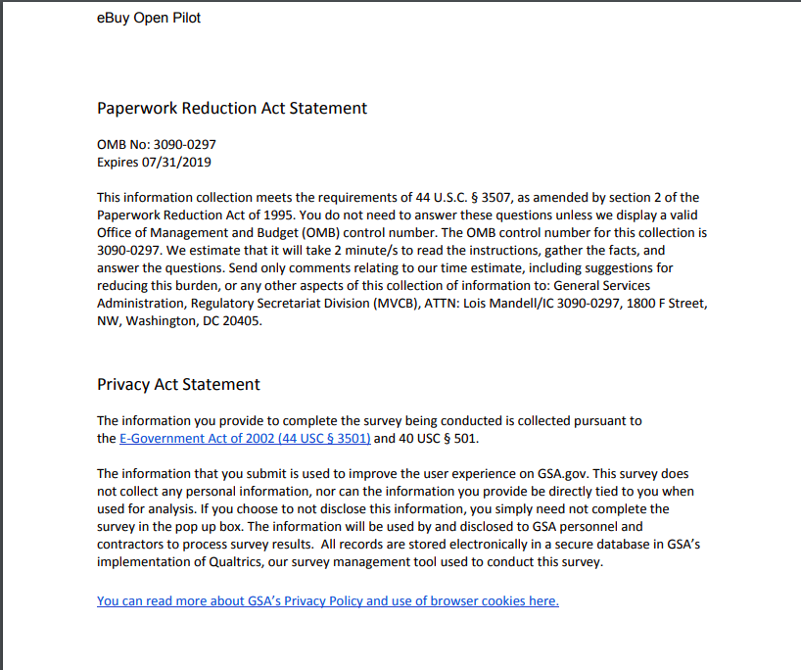

**Screenshot of the gsa.gov Privacy and Security Notice Page:**

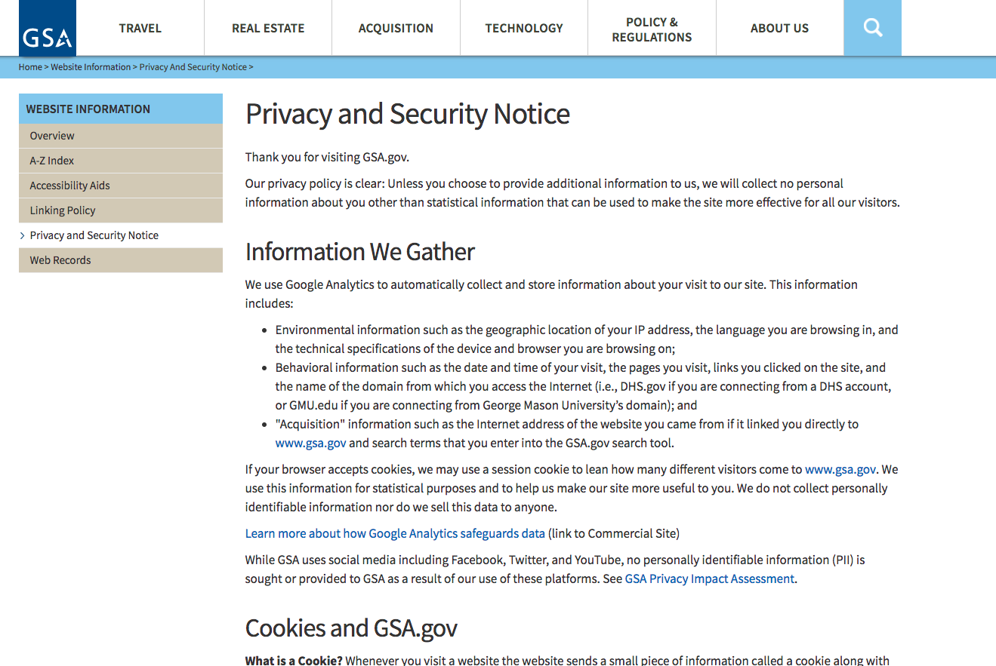

**Question 1**

Question 1 (Q1) asks if the new process was helpful for partnerships in subcontracting. The answers are arranged in accordance to a likert scale.

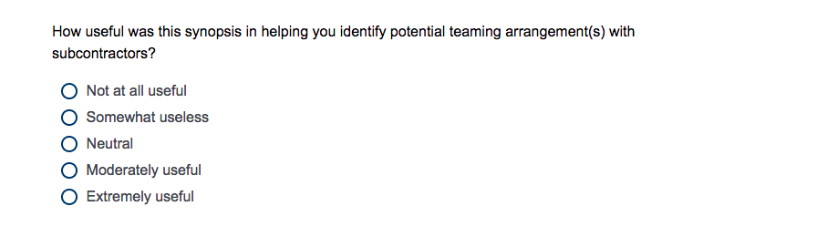

**Question 2**

Question 2 (Q2) asking participants if they have a GSA Schedule Contract. The hyperlink provided is connected to the “GSA Schedules” page on gsa.gov

<https://www.gsa.gov/acquisition/purchasing-programs/gsa-schedules>

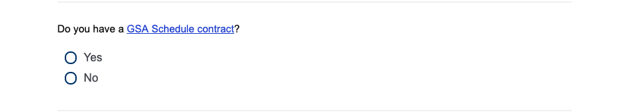

**Question 3**

Question 3 (Q3) will only appear if “Yes” is selected in Question 2 (Q2). If “Yes” is selected in Q2 then a display logic will run for Question 3 asking participants if they are interested in expanding the scope of their existing GSA offerings after viewing the synopsis.

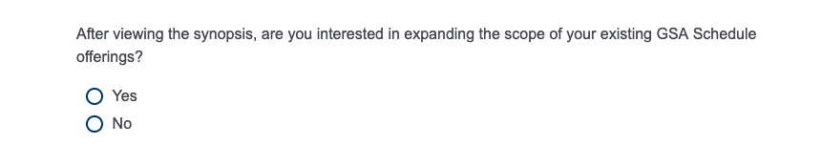

**Question 4**

Question 4 (Q4) will only appear if “No” is selected in Question 2 (Q2). If “No” is selected in Q2 then a display logic will run for Question 4

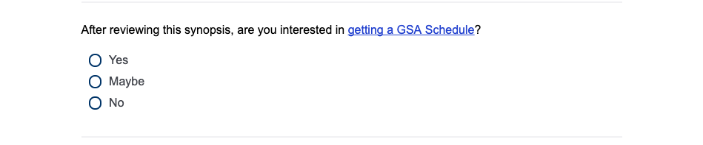

**GSA.gov GSA Schedules Page** if GSA Schedule hyperlink is clicked on

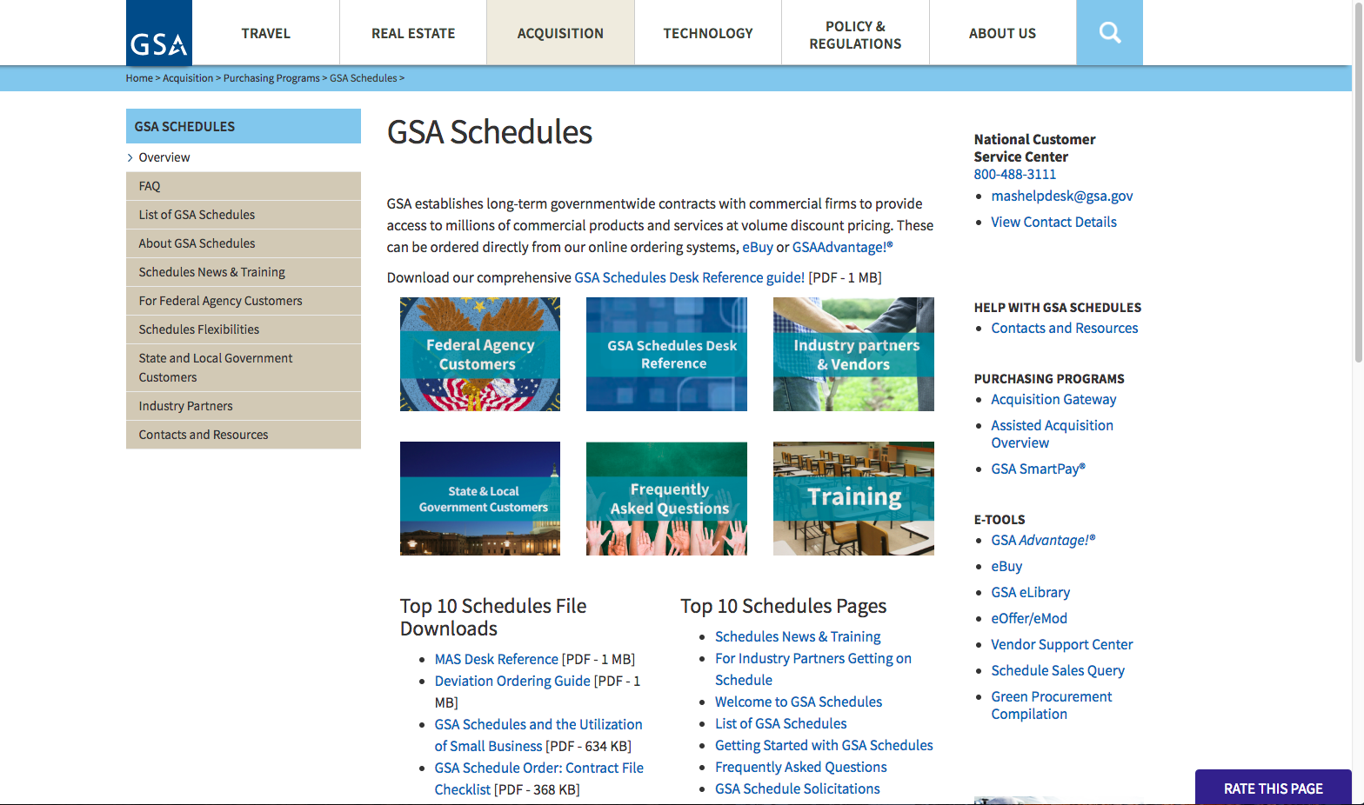

**Last Question**

We ask the participant to provide comments should they have any.

