3090-0297 Instrument
(Req-1)
GWACs Supplier Relationship Management Survey

Invitation Email
Date: July 16, 2016
To: [supplier email address]
From: feedback@gsa.gov

Subject: Please take the 2016 General Services Administration’s Supplier Survey!

OMB No: 3090-0297
Expires 07/31/2019
Paperwork Reduction Act Statement - This information collection meets the requirements of 44 U.S.C. § 3507, as amended by section 2 of the Paperwork Reduction Act of 1995. You do not need to answer these questions unless we display a valid Office of Management and Budget (OMB) control number. The OMB control number for this collection is 3090-0297. We estimate that it will take 6 minute/s to read the instructions, gather the facts, and answer the questions. Send only comments relating to our time estimate, including suggestions for reducing this burden, or any other aspects of this collection of information to: General Services Administration, Regulatory Secretariat Division (MVCB), ATTN: Ms. Flowers/IC 3090-0297, 1800 F Street, NW, Washington, DC 20405.

It’s here, GSA’s 2016 Supplier Survey – click here and take it today!
Each year, we request feedback from suppliers on how GSA is serving our industry partners by filling out this 6 minute survey. Input from you helps us improve our acquisition processes, procedures, policies, and education.

Begin the Supplier Survey Now

Don’t miss out on the opportunity to give us your feedback. Don’t let your company go under represented. If you have any questions about the survey or issues in completing it, please don’t hesitate to contact surveys@gsa.gov.

Thank you for your feedback,

Thomas Sharpe
Commissioner, GSA’s Federal Acquisition Service

To take the survey:
Click the following URL, or the button above, or paste the address into your web browser.
[http://www.weblink specific to the supplier]

Survey
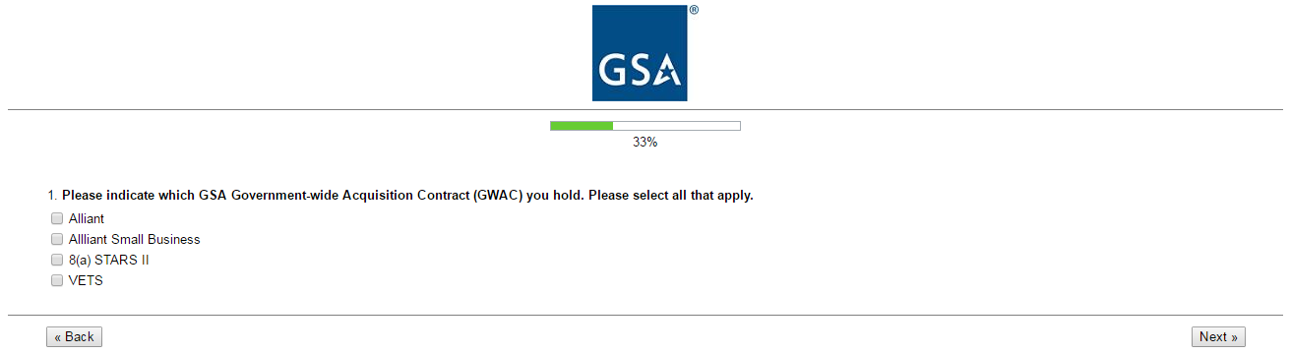
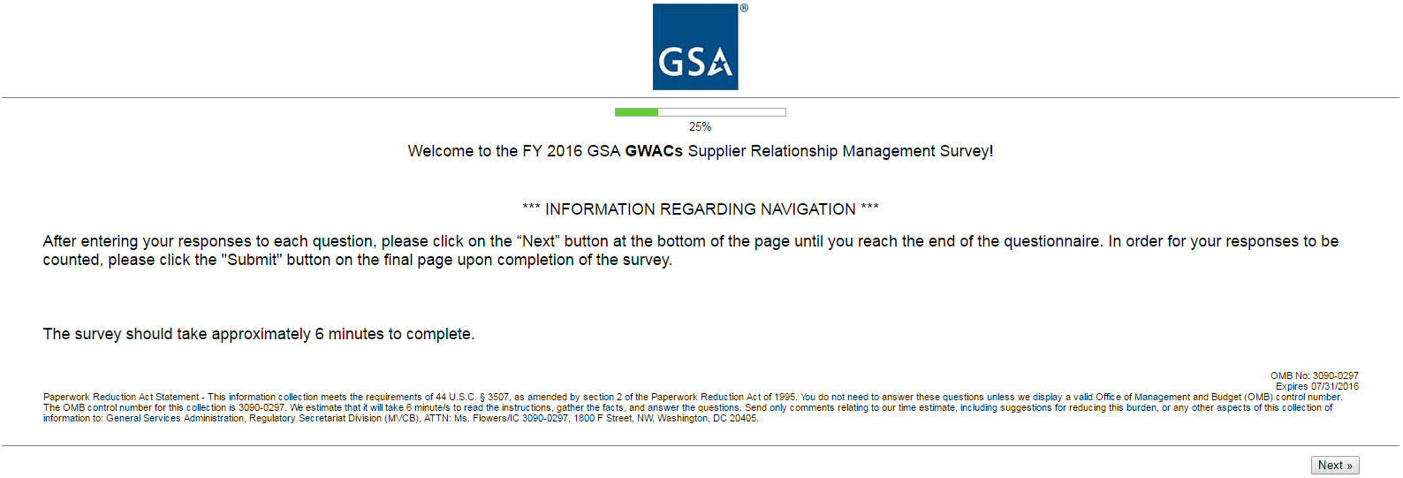

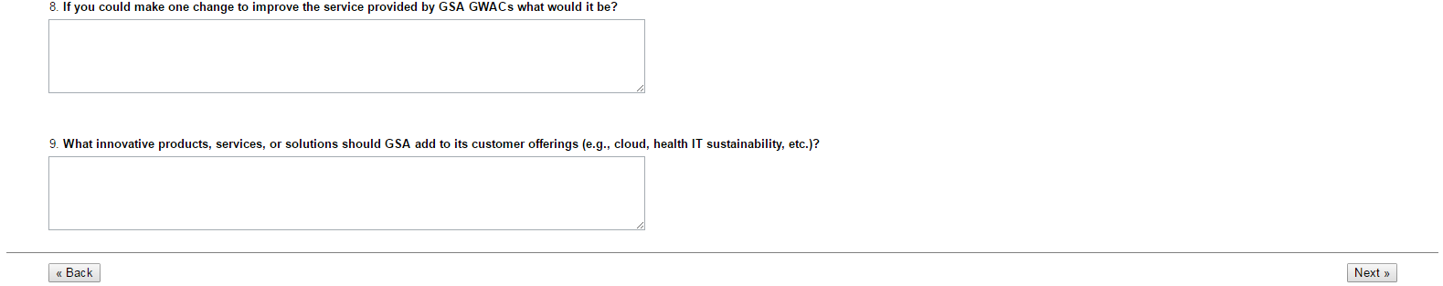
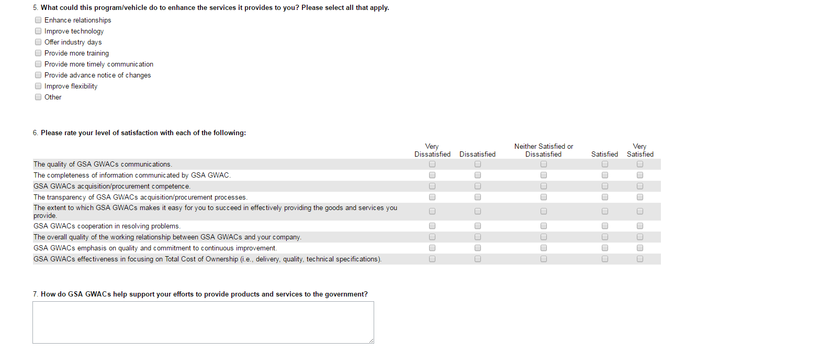
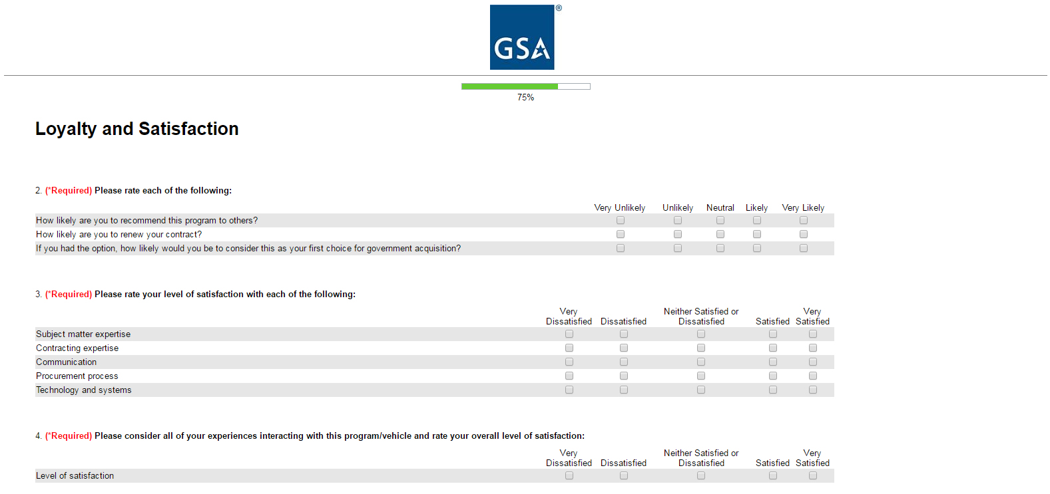

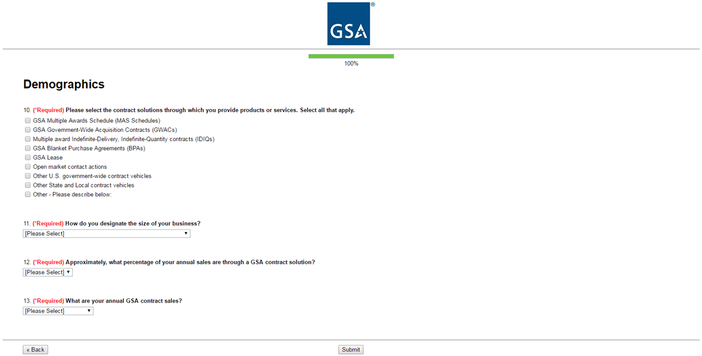
Options for Question 11:
- Large
- Small
- Small Disadvantaged (8a)
- Woman-Owned Small Business (WOSB)
- Veteran-Owned Small Business (VOSB)
- Service-Disabled Veteran-Owned Small Business (SDVOSB)
- Qualified HubZone
Options for Question 12:
- < 5%
- 5 - 24%
- 25 -49%
- 50 -74%
- 75-100%
- I don’t know
Options for Question 13:
- $0 - $10,000
- $10,001 - $25,000
- $25,001 - $150,000
- $150,001 - $1,000,000
- More than $1,000,000
- I don’t know

