FAST Track 3090-0297
GSA Auctions Survey

Screen 1
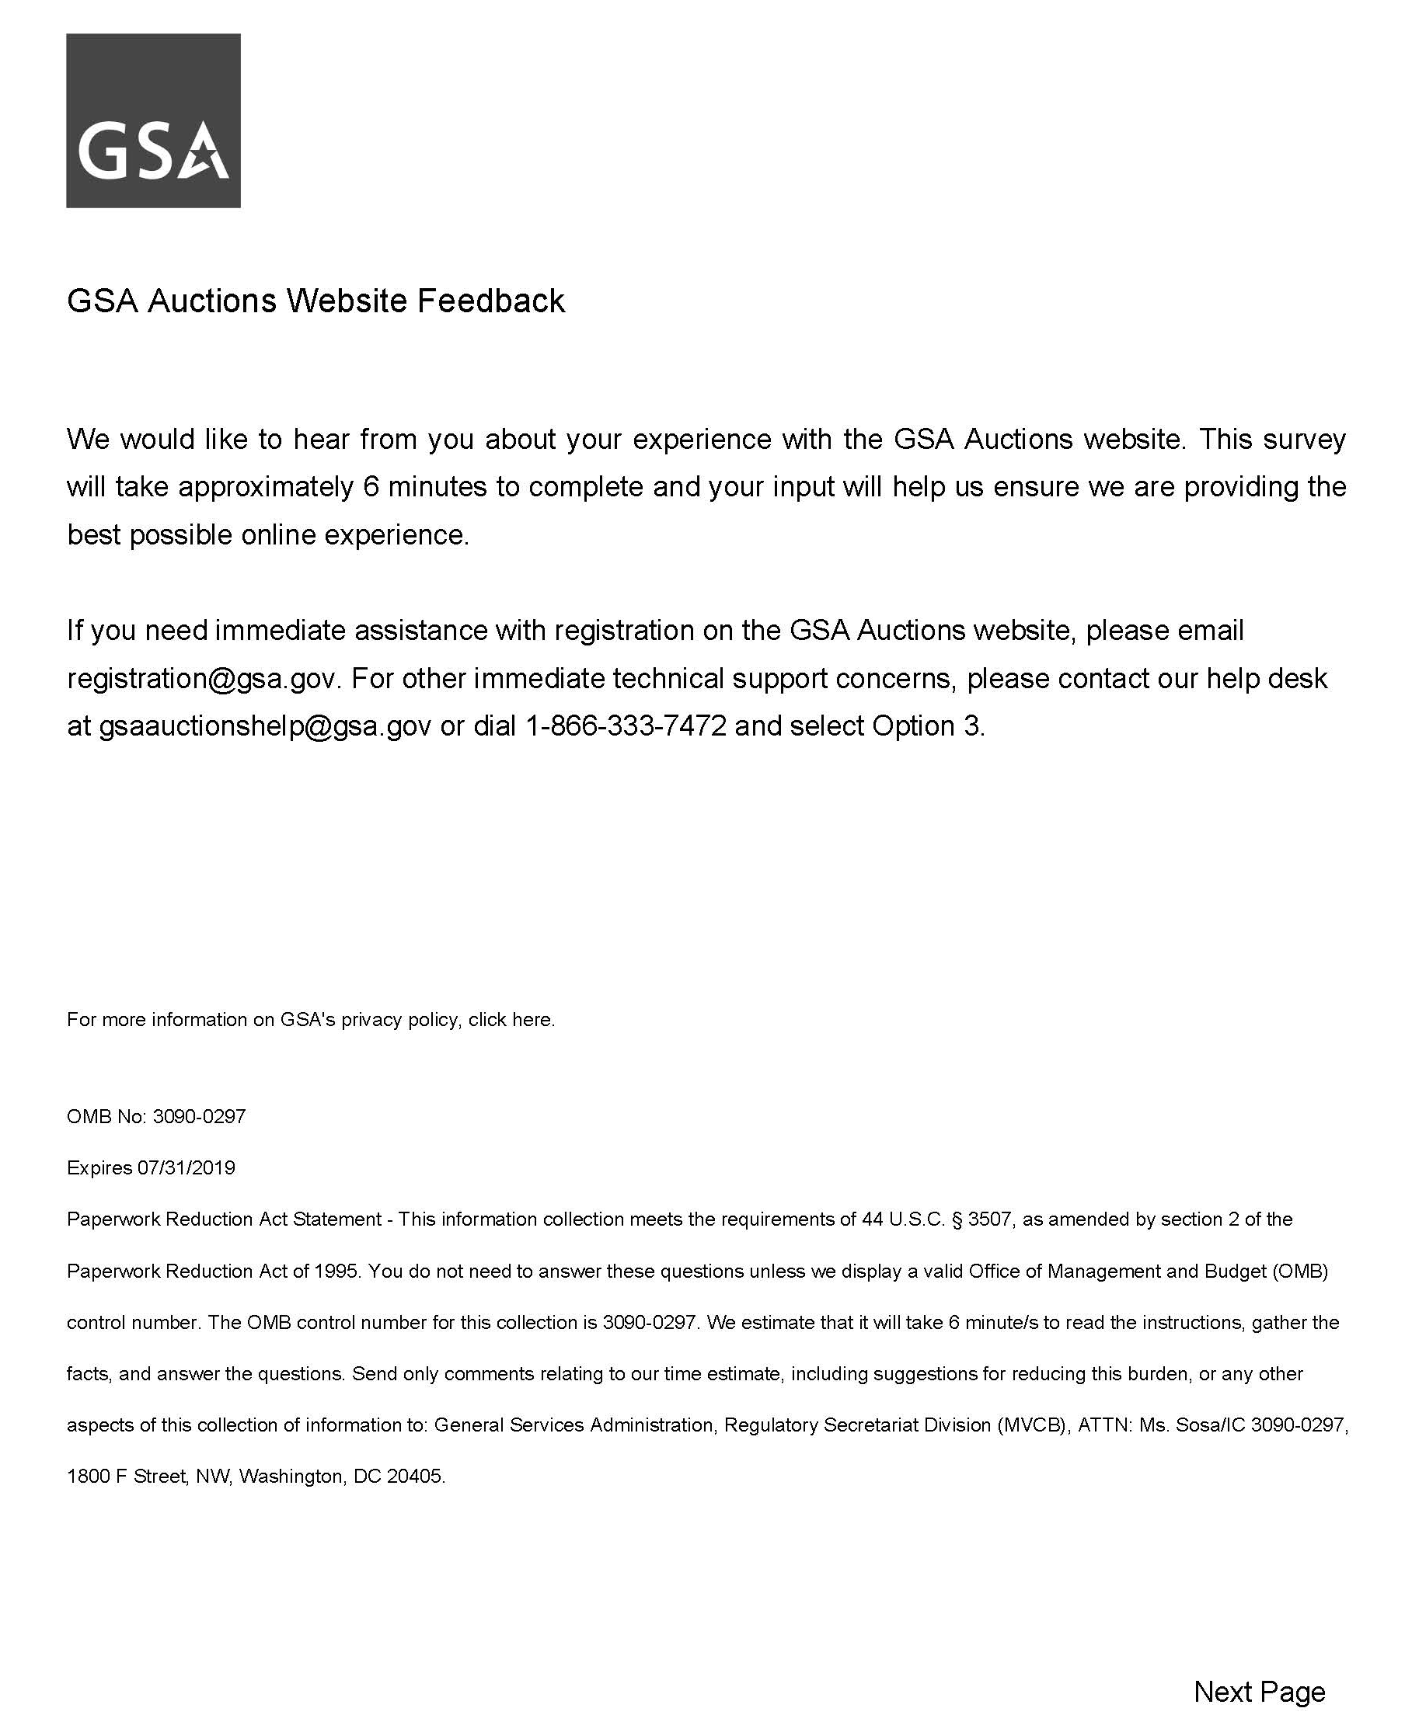

Display Screen 2

Screen 2
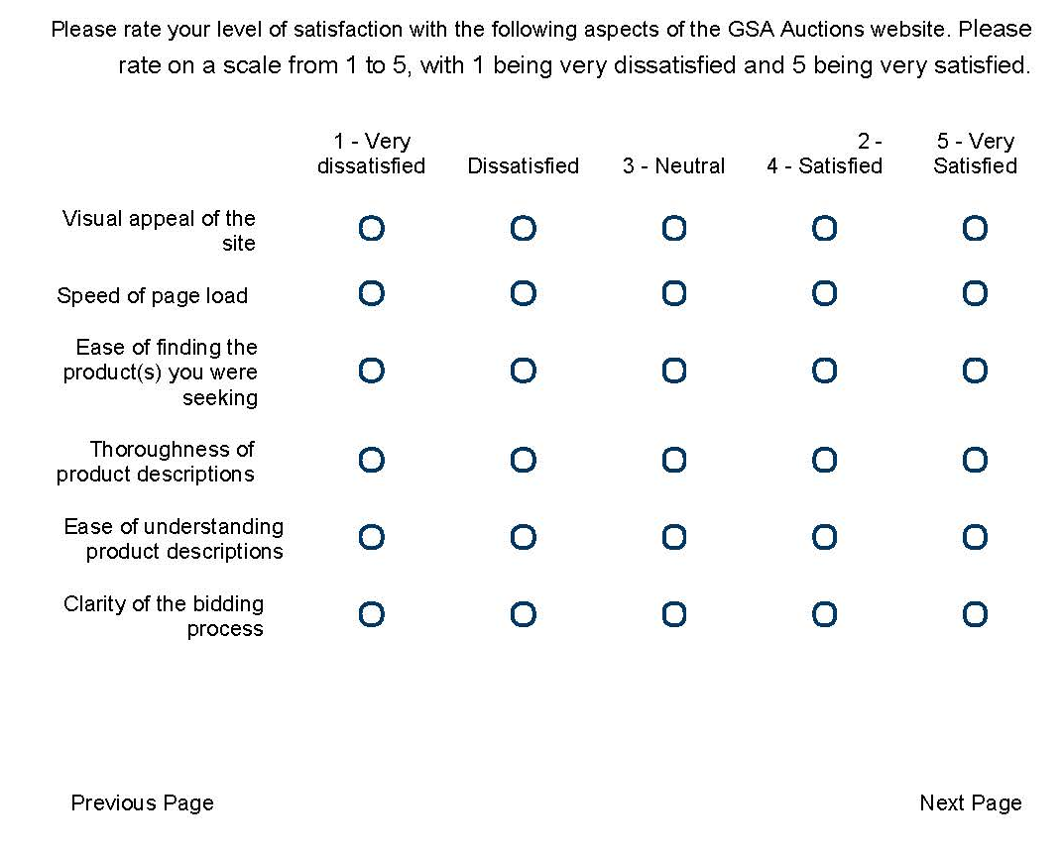

If Satisfaction Matrix Thoroughness of product descriptions - 4 - Satisfied Is Not Selected
And Satisfaction Matrix Thoroughness of product descriptions - 5 - Very Satisfied Is Not Selected
Or Satisfaction Matrix Ease of understanding product descriptions - 4 - Satisfied Is Not Selected
And Satisfaction Matrix Ease of understanding product descriptions - 5 - Very Satisfied Is Not Selected, display Screen 3

If Satisfaction Matrix Thoroughness of product descriptions - 4 - Satisfied Is Selected
And Satisfaction Matrix Thoroughness of product descriptions - 5 - Very Satisfied Is Selected
Or Satisfaction Matrix Ease of understanding product descriptions - 4 - Satisfied Is Selected
And Satisfaction Matrix Ease of understanding product descriptions - 5 - Very Satisfied Is Selected, display Screen 4

Screen 3
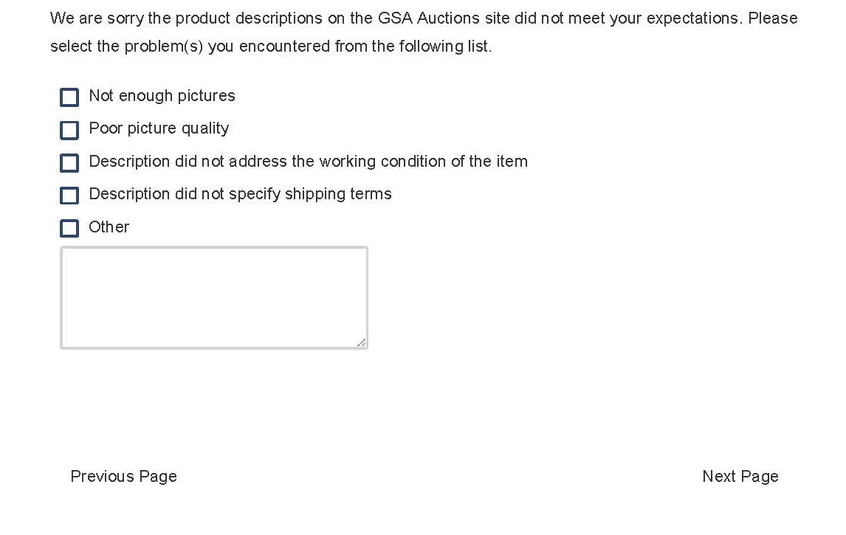

Display Screen 4
Screen 4


If yes is selected display Screen 5
If no is selected display Screen 6

Screen 5
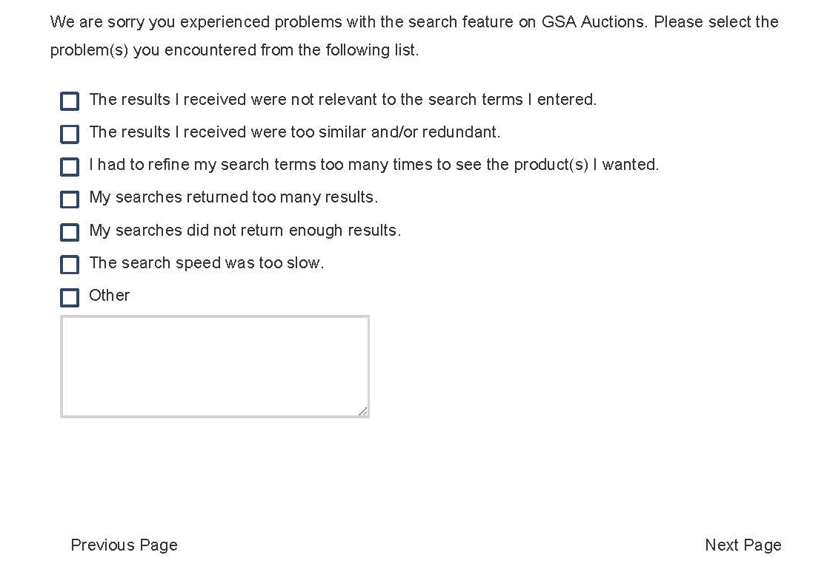

Display Screen 6

Screen 6
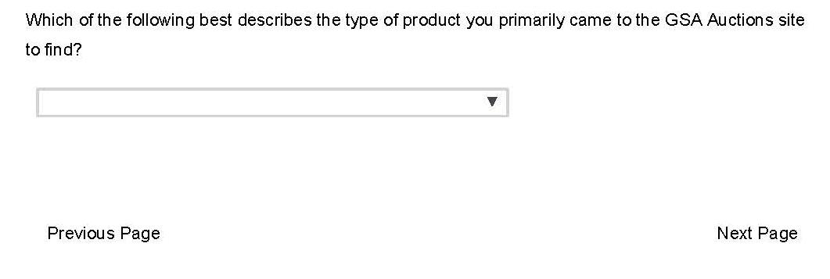

If Product I Was Not Looking for Anything Specific Is Not Selected, display Screen 7
If Product I Was Not Looking for Anything Specific Is Selected, display Screen 8

Screen 7


Display Screen 8

Screen 8


Display Screen 9

Screen 9

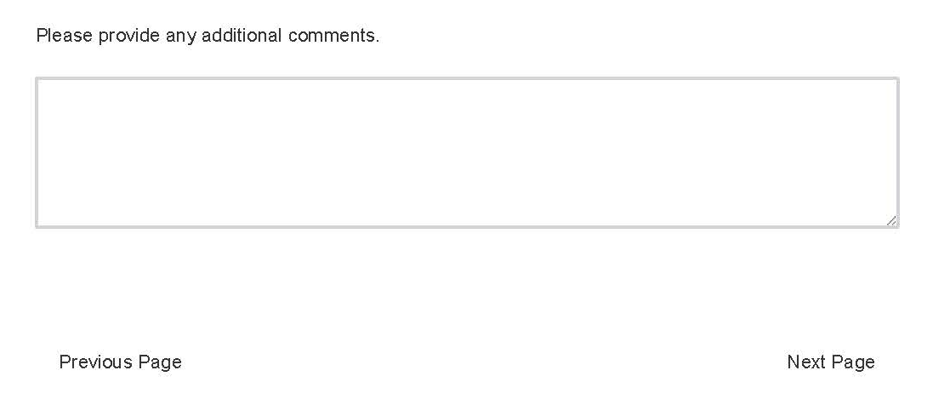

Display Screen 10

Screen 10
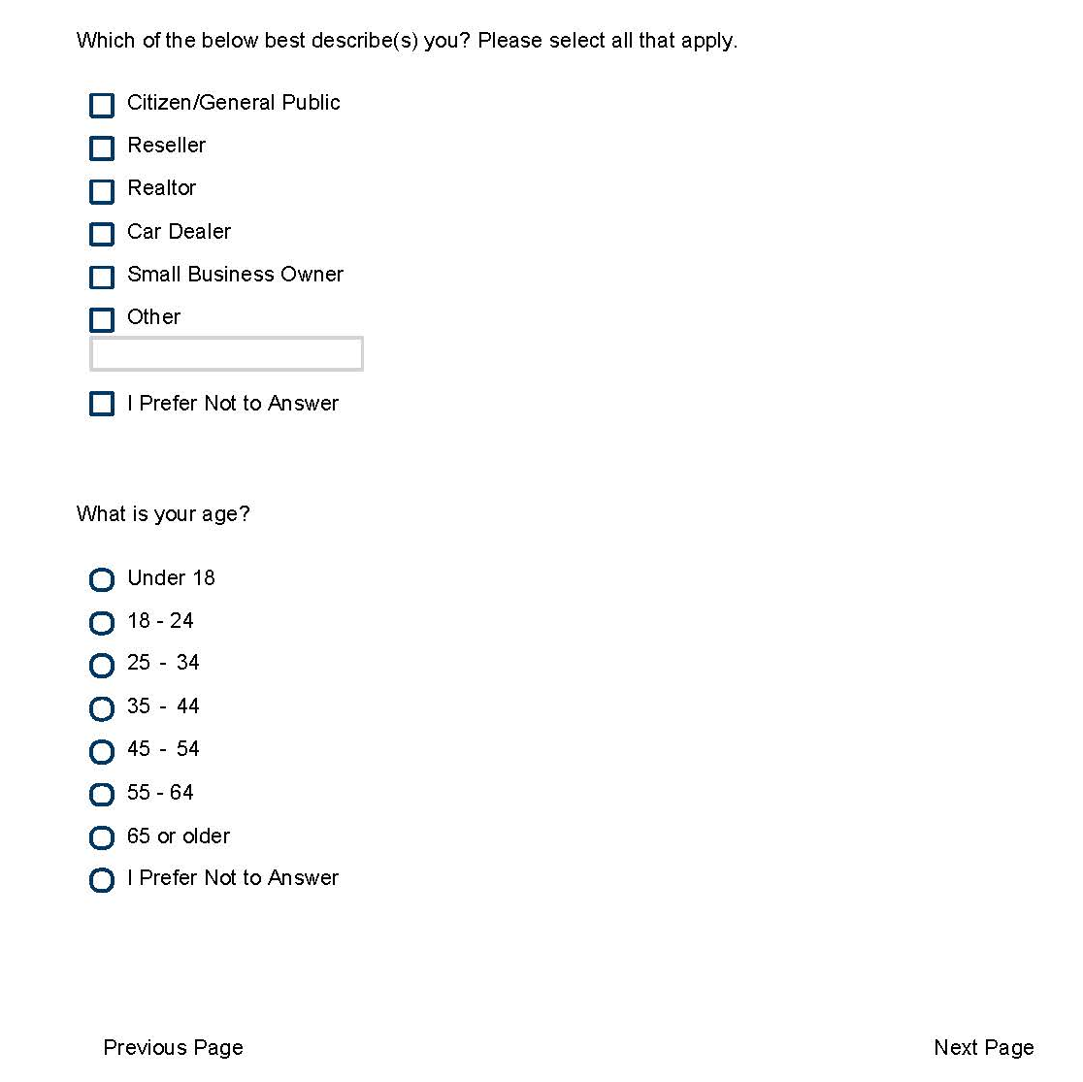

Display Screen 11

Screen 11


yes is selected display Screen 12
If no is selected display Screen 13

Screen 12
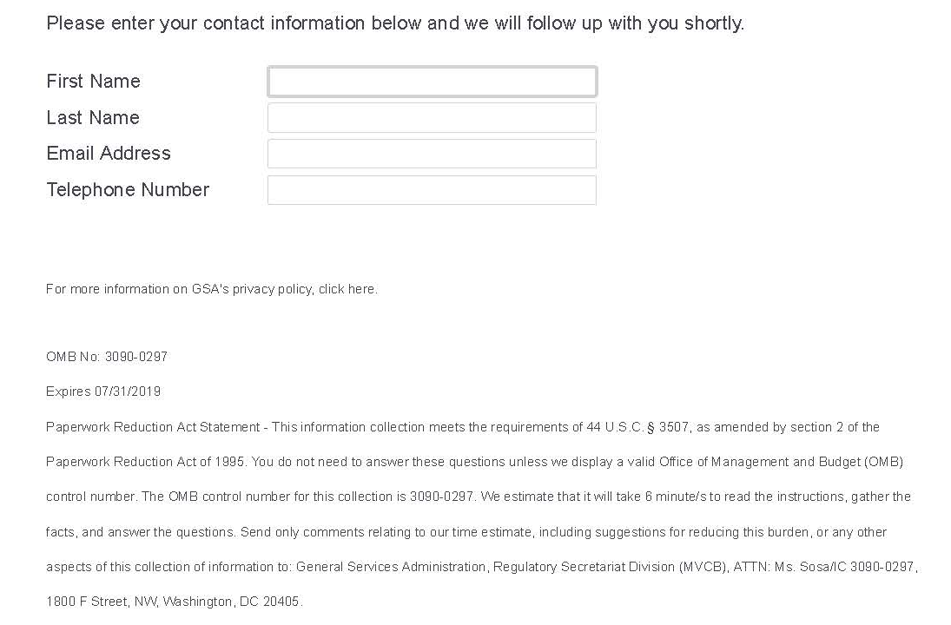

Display Screen 13

Screen 13


