FAST-Track 3090-0297
Instrument Req-24
NCSC Customer Satisfaction Survey

Screen 1:

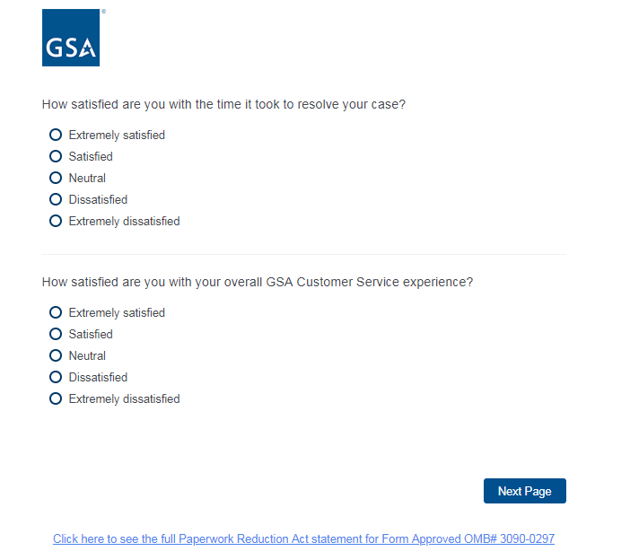

Screen 2:

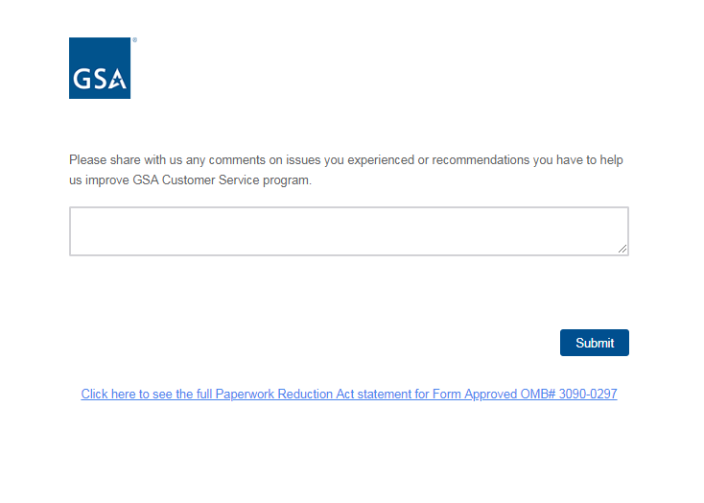

PRA statement as contained in link at bottom of page:
