FAST Track 3090-0297
Re-41
NCSC Customer Satisfaction Survey

Screen 1:

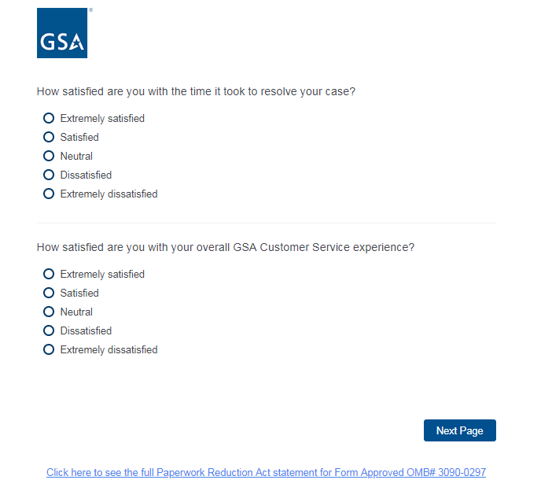

Screen 2:

