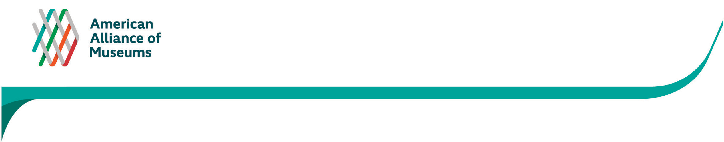
APPENDIX D
Pre-survey notice emailed to MAP Participants (sample)

Dear _______________,

I am writing to alert you to an important forthcoming survey about how the Museum Assessment Program (MAP) has informed practices and influenced operations at your museum—from its overall professionalization and capacity development to specific initiatives, and plans and policies. You are receiving this email because your institution previously participated in MAP.

Why take part in this survey? As part of its agreement with Institute of Museum and Library Services (IMLS)*, AAM conducts periodic summative evaluations to collect long-term and longitudinal data about the results and value of MAP on individual museums.. This data, in turn, helps IMLS document the importance of MAP to legislators to ensure its continued funding and operation. The survey also helps inform changes to improve the program overall.

If you were not at the museum during its last MAP assessment, but are familiar with your institution’s MAP experience or have since been involved with implementing efforts that resulted from MAP, we highly encourage you to take the survey. Your participation, while voluntary, is greatly valued. After reading this email, if you are not the right person at your institution to take the survey, please let me know the correct name and email.

Watch your in-box this fall for the survey.

Sincerely,

Julie Hart
Senior Director, Museum Standards & Excellence Programs
jhart@aam-us.org

P.S. Now is a good time to pull out your last MAP report and take stock of how the findings have been implemented. If you would like a copy of the report, please let me know. And if you’d like to participate in MAP again but do a different assessment, the next deadlines are December 1, 2015 and July 1, 2016. Get more information here. [H/L to: http://www.aam-us.org/resources/assessment-programs/MAP]

*The Institute of Museum and Library Services (IMLS) funds the Museum Assessment Program (MAP) through a Cooperative Agreement with the American Alliance of Museums (AAM).

