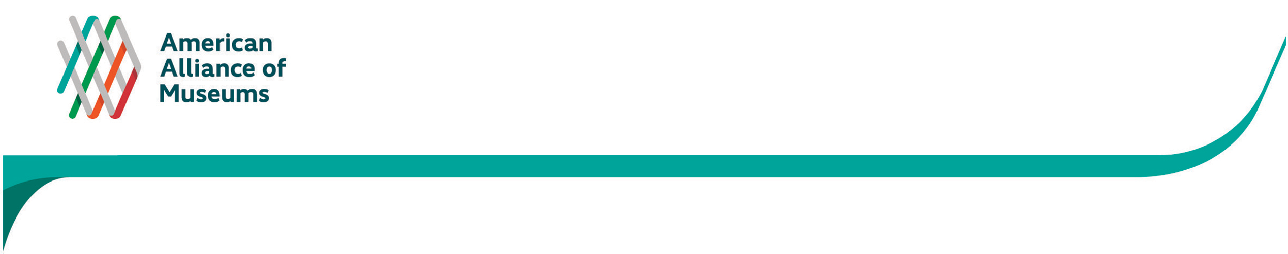
APPENDIX C
Museum Assessment Program: Participant Interview Guide
Interviewee Name and Job Title
Institution Name:
Date of interview (day/time):
Thank you for taking the time to talk with me today. As you know, AAM is conducting a nationwide study to explore how MAP has informed practices and influenced operations of the institutions that undertook the assessment process. Our conversation today may expand on some of the thought you’ve already shared with us in the online survey. I’m interested in learning a few more details about your responses.

Our conversation should take about 45 minutes. There are no right or wrong answers. I will be typing your responses as we talk so that I can keep track of our conversation and ensure I’m accurately recording your thoughts. For the most part, your feedback will be aggregated with others from different sites so it remains confidential and anonymous. Any direct quotations used in reporting will be connected only with your institution name, and not attributed to you or your job title.

IMPORTANT: However, we are developing case studies for AAM as a way for them to share success stories with the museum field and encourage other institutions to participate in MAP. If your institution were selected for a case study, would you be willing to be properly identified? ☐ Yes ☐ No

Do you have any questions before we begin?

BACKGROUND:
Just to confirm, your institution completed MAP in: <insert month/year>
And you participated in: <insert assessment type>
- Describe the role did you play in the assessment process?

INSTITUTIONAL CHANGE:
I’d like to talk more about the kinds of changes your institution experienced during or after its participation in MAP, and when they occurred or were implemented. I’m going to read a few excerpts from your online survey responses to jog your memory before we dig deeper… [Read the participant’s responses to: Nature of change in their organization / How MAP strengthened their organization] Does that sound familiar?
- I’d like to learn more about these changes to your institution? Specifically,
  - What was the process for identifying what you wanted to change, and then making them happen?
- Tell me about how you planned out the timeline for these initiatives.
  - How long did it take for these changes to take place? Are you still working on them?
  - Did you work to a particular schedule? Did you have an end-date in mind?
I want to understand the factors that most contributed to these institutional changes. And I want to talk about them in two parts:
  - Those inherent in your institution, and
  - Those brought about through the MAP process.

- ORGANIZATIONAL READINESS:
- Prior to your involvement in MAP, how aware were you/your institution that change needed to (or should) occur at your institution? What was the organizational situation?
  - Had you planned for a change?
  - To what extent was your museum prepared for change to occur?
  - Were there elements present in your museum that made change inevitable?
- Do you think these changes would have taken place without your participation in MAP?

- MAP’s CONTRIBUTION TO ORGANIZATIONAL CHANGE:
- How instrumental was MAP to identifying the changes or need for change?
- To what extent did MAP make you feel that change was feasible/realistic?
- Were there certain components or parts of the MAP process that were particularly useful in helping you identify and implement these changes?
- Do you think the type of assessment you participated in contributed to your institutional change? Why or why not?
Probe: if museum undertook more than one initiative and/or if they did more than one assessment, how did that affect their process/timeline
- What additional resources provided by AAM/IMLS did you use, if any, to help you identify and implement these changes?

MAP CHALLENGES:
- What were the greatest challenges in completing the MAP process for your institution?
- Are there ways in which MAP could have been even more helpful/useful in enabling you to achieve your goals?
  - Probe about each MAP component
  - Probe about MAP process (e.g. AAM communication, peer communication, application process, etc.)
- What do you think may prevent other museums from participating in MAP? Ideas of how these challenges can be mitigated?
- Do you have any advice for institutions who are thinking about undertaking MAP?

FUTURE INITIATIVES:
- Do you feel that the initiatives your museum has undertaken as a result of MAP are sustainable? Why or why not?
- Looking into the future, are there initiatives your institution may be considering that could make use of your MAP experience?
- Do you have any other comments about MAP that we haven’t covered?

Thank you for your time today. We really appreciate your feedback. Have a great day.

