Draft Regulatory Analysis for Proposed Rule: Approval of American Society of Mechanical Engineers Code Cases
(NRC-2012-0059); RIN 3150-AJ13

U.S. Nuclear Regulatory Commission
Office of Nuclear Reactor Regulation

January 5, 2016



  - Nuclear Regulatory Commission Office of Nuclear Reactor Regulation ADAMS Accession No. ML15041A816

Table of Contents
List of Figures iv
List of Tables v
Abbreviations and Acronyms vi
Abstract viii
Executive Summary ix
- Introduction 11
- Statement of the Problem and Objective 11
  - Background 11
  - Objective 13
  - Statement of the Problem 13
- Identification and Analysis of the Alternative Approaches 14
  - Alternative 1 – No-action alternative 14
  - Alternative 2 – Incorporate by Reference NRC-Approved ASME BPV and OM Code Cases 15
- Evaluation of Benefits and Costs 16
  - Identification of Affected Attributes 16
  - Analytical Methodology 19
    - Regulatory Baseline 19
    - Discount Rates 19
    - Cost/Benefit Inflators 20
    - Labor Rates 21
    - Affected Entities 21
    - Sign Conventions 22
    - Code Case Horizon 23
    - Dollar per Person-Rem Conversion Factor 23
    - Replacement Power Cost 23
    - Base Year 24
    - Cost Estimation 24
    - Conditioned Code Cases 26
- Presentation of Results 30
  - Public Health (Accident) 30
  - Occupational Health (Accident) 31
  - Occupational Health (Routine) 31
  - Onsite Property — Power Replacement 32
  - Industry Implementation 33
  - Industry Operation 33
    - Averted Costs from Code Case Alternative Request Submittals 34
    - Conditioned Code Cases Costs 36
    - Total Industry Operations Costs 39
  - NRC Implementation 39
  - NRC Operation 40
    - NRC Operation Averted Cost Sensitivity 41
  - Improvements in Knowledge 41
  - Regulatory Efficiency 41
  - Disaggregation 42
  - Uncertainty Analysis 42

    - Uncertainty Analysis Results 43
    - Summary of Uncertainty Analysis. 49
  - Independent Cost Estimate 50
  - Summary 51
    - Quantified Net Benefit 51
    - Nonquantified Benefits 52
    - Nonquantified Costs 53
  - Safety Goal Evaluation 53
- Decision Rationale 53
- Implementation Schedule 55
- Regulatory Guides 55
- References 56
Appendix A: Industry Labor Rates 59
Appendix B: Uncertainty Analysis Variables 61

List of Figures
Figure 1 Industry Implementation Costs 44
Figure 2 NRC Implementation Costs 44
Figure 3 Industry Operations Costs (7% Discount Rate) 45
Figure 4 Industry Operations Averted Costs (3% Discount Rate) 45
Figure 5 NRC Operations Averted Costs (7% Discount Rate) 46
Figure 6 NRC Operations Costs Averted (3% Discount Rate) 46
Figure 7 Total (7% Discount Rate) 47
Figure 8 Total (3% Discount Rate) 47
Figure 9 Net Benefit (Cost) Tornado Diagram based on 7-percent Discount Rate – Inputs Ranked by Effect on Output Mean 49
Figure 10 Net Benefit (Cost) Tornado Diagram based on 3-percent Discount Rate – Inputs Ranked by Effect on Output Mean 49

List of Tables
Table 1 Consumer Price Index—All Urban Consumers, U.S. City Average 20
Table 2 Dollar per Person-Rem Conversion Factor 23
Table 3 Average Wholesale Electricity Price with a Nuclear Power Plant Outage 24
Table 4 Estimated Replacement Power Hourly Costs for a Typical BWR 24
Table 5 List of Conditioned Code Cases 26
Table 6 Occupational Health Impacts 31
Table 7 Code Case 795-1 Short-Term Replacement Power Costs 32
Table 8 Industry Implementation Costs 33
Table 9 Averted Industry Operation Costs 35
Table 10 Averted Industry Operation Costs for Hypothetical Reactor Code Case Alternative Request Submittal 35
Table 11 Incremental Industry Operations Costs for Conditioned Code Case N-638-6 (Operating Reactors only) 36
Table 12 Incremental Industry Operations Costs for Conditioned Code Case N-789
(Operating Reactors only) 37
Table 13 Incremental Operations Costs for Conditioned Code Case N-795
(Operating BWRs) 37
Table 14 Incremental Operations Costs for Conditioned Code Case N-799 for a Hypothetical New Reactor 37
Table 15 Incremental Industry Costs for Conditioned Code Case OMN-19 for New Reactors 38 Table 16 Industry Cost Summary 39
Table 17 NRC Implementation Costs 40
Table 18 NRC Operation Costs 40
Table 19 Averted NRC Operation Costs for New Reactor ASME Code Case Alternative Request Submittal 41
Table 20 Disaggregation 42
Table 21 Uncertainty Results Descriptive Statistics 48
Table 22 Regulatory Analysis Estimate Changes 51
Table 23 Total Net Benefits and Costs 52
Table 24 Summary of Totals 53

Abbreviations and Acronyms

ADAMS agencywide documents access and management system APA Administrative Procedures Act
ASME American Society of Mechanical Engineers

BLS U.S. Department of Labor Bureau of Labor Statistics
BPV Boiler and Pressure Vessel
BWR boiling-water reactor

CC concrete containment
CFR Code of Federal Regulations
CNWRA Center for Nuclear Waste Regulatory Analyses COL combined license
CP construction permit
CPI-U Consumer Price Index for all urban consumers

DG draft regulatory guide

FR Federal Register

GAO General Accountability Office

IAEA International Atomic Energy Agency
ICE independent cost estimate
ISI inservice inspection
IST inservice testing

LOE level of effort

MC metal containment

NDT nil ductility temperature
NPV net present value
NRC U.S. Nuclear Regulatory Commission
NTTAA National Technology Transfer and Advancement Act

OFR Office of the Federal Register
OL operating license
OM operation and maintenance
OM Code Code for Operation and Maintenance of Nuclear Power Plants OMB U.S. Office of Management and Budget

PERT program evaluation and review technique

PPA power purchase agreements
PWR pressurized-water reactor

Rev. revision
RG final regulatory guide

SI international system of units

    - United States Code

Abstract

This proposed rule would incorporate by reference into the U.S. Nuclear Regulatory Commission’s (NRC’s) regulations at 10 CFR 50.55a the latest revisions of the NRC Regulatory Guides (RGs) listing American Society of Mechanical Engineers (ASME) Boiler and Pressure Vessel (BPV) and Operations and Maintenance (OM) Code Cases that the NRC find to be acceptable, or acceptable with NRC-specified conditions (“conditionally acceptable”). The NRC is revising RGs to identify the Code Cases that are newly approved by the NRC. Regulatory Guide 1.84, Revision 37 (Draft Regulatory Guide (DG)-1295), would supersede the incorporation by reference of Revision 36; RG 1.147, Revision 18 (DG-1296), would supersede the incorporation by reference of Revision 17; and RG 1.192, Revision 2 (DG-1297), would supersede the incorporation by reference of Revision 1.

The ASME Code Cases that are the subject of this rulemaking are the new and revised Section III and Section XI Code Cases listed in Supplement 11 to the 2007 BPV Code through Supplement 10 to the 2010 BPV Code, and the OM Code Cases published with the
2009 Edition through the 2012 Edition. This document presents a draft regulatory analysis of the proposed incorporation by reference rule for the three RGs listing the Code Cases newly approved by the NRC.

To improve the credibility of the NRC staff cost estimates for this regulatory action, the NRC staff cross-checked its results with an independent cost estimate and conducted sensitivity analysis to identify variables most affecting cost estimates (i.e. cost drivers).

Executive Summary

The U.S. Nuclear Regulatory Commission (NRC) is proposing to amend its regulations to incorporate by reference the latest revisions of three NRC Regulatory Guides (RGs) approving new and revised Code Cases published by the American Society for Mechanical Engineers (ASME). The NRC is revising RGs to identify the Code Cases that are newly approved by the NRC. The three regulatory guides that would be incorporated by reference are RG 1.84, “Design, Fabrication, and Materials Code Case Acceptability, ASME Section III,” Revision 37 (DG-1295 for this proposed rule); RG 1.147, “Inservice Inspection Code Case Acceptability, ASME Section XI, Division 1,” Revision 18 (DG-1296); and RG 1.192, “Operation and Maintenance [OM] Code Case Acceptability, ASME OM Code,” Revision 2 (DG-1297).

The proposed action would allow nuclear power plant licensees and applicants for construction permits (CPs), operating licenses (OLs), combined licenses (COLs), standard design certifications, standard design approvals, and manufacturing licenses, to use the Code Cases newly listed in these RGs as alternatives to engineering standards for the construction, inservice inspection (ISI), and inservice testing (IST) of nuclear power plant components.

The analysis presented in this document examines the benefits and costs of the proposed rulemaking and implementing guidance relative to the baseline case (i.e., the no action alternative).

The key findings are as follows:

      - Proposed Rule Analysis. The NRC staff-recommended proposed rule and implementation guidance would result in a cost-justified change based on the net averted cost to the industry that ranges from $3.35 million using a 7-percent discount rate to $3.98 million using a 3-percent discount rate. Relative to the regulatory baseline, the NRC would realize a net averted cost of $2.15 million using a 7-percent discount rate or $2.54 million using a 3-percent discount rate.

According to Executive Order 12866, Regulatory Planning and Overview, (58 FR 190), an economically significant regulatory action is one that would have an annual effect on the economy of $100 million or more. From a cost perspective, this proposed rulemaking does not reach this threshold.

      - Non-quantified Benefits. Other beneficial factors include meeting the NRC goal of ensuring the protection of public health and safety and the environment through the NRC’s approval of new ASME Code Cases, which allow the use of the most current methods and technology. In addition, the staff-recommended alternative would help ensure that the NRC’s actions are effective, efficient, realistic, and timely by eliminating the need for unnecessary NRC review of plant-specific alternative requests. This alternative also would support the NRC’s goal of maintaining an open regulatory process because approving ASME Code Cases demonstrates the NRC’s commitment to

participate in the National Consensus Standards process per the National Technology Transfer and Advancement Act (NTTAA) of 1995. Other important characteristics the NRC staff analyzed are the industry’s familiarity with the well-established process of approving Code Cases through NRC regulatory guides, the value of a Code Case approval process is that the Code Cases are consistently applied across the industry, and the value of continuing to support the use of the most updated and technically sound techniques developed by the ASME. Considering both the quantitative information and the non-quantitative information, the rulemaking is justified.

      - Decision Rationale. Relative to the no action baseline, the NRC staff concludes that the quantitative benefits justify the quantitative costs of this proposed rule.

Introduction

This document presents the draft regulatory analysis for the ASME Code Cases proposed rule (the NRC’s Agencywide Documents Access and Management System (ADAMS) Accession No. ML15041A813) and the three associated NRC draft regulatory guides:

      - DG-1295, “Design, Fabrication, and Materials Code Case Acceptability, ASME Section III,” (ADAMS Accession No. ML15027A002);

      - DG-1296, “Inservice Inspection Code Case Acceptability, ASME Section XI, Division 1,” (ADAMS Accession No. ML15027A202); and

      - DG-1297, “Operation and Maintenance Code Acceptability, ASME OM Code,” (ADAMS Accession No. ML15027A330).

The recommended regulatory action incorporates by reference the latest revisions of the three regulatory guides listed above so that the NRC approves as alternatives for use to the ASME Code Editions and Addenda, the newly-identified ASME Code Cases.

Statement of the Problem and Objective

Background

General Design Criterion 1, “Quality Standards and Records,” of Appendix A, “General Design Criteria for Nuclear Power Plants,” to 10 CFR Part 50 requires, in part, states that:

Structures, systems, and components important to safety shall be designed, fabricated, erected, and tested to quality standards commensurate with the importance of the safety function to be performed. Where generally recognized codes and standards are used, they shall be identified and evaluated to determine their applicability, adequacy, and sufficiency and shall be supplemented or modified as necessary to ensure a quality product in keeping with the required safety function.

The National Technology Transfer and Advancement Act of 1995, Pub. L. 104-113 mandates that, where the Federal agency determines that government regulation is required, that the NRC use an available voluntary consensus standard to carry out the Federal agency’s objective, unless it is inconsistent with law or otherwise impractical. In carrying out this legislation, Federal agencies are to consult with voluntary consensus standards bodies and participate with such bodies in the development of technical standards when such participation is in the public interest and compatible with the agency mission, priorities, and budget resources.

Provisions of the ASME BPV Code have been used since 1971 as one part of the regulatory framework to establish the necessary design, fabrication, construction, testing, and performance requirements for structures, systems, and components important to safety. Various technical interests (e.g., utility, manufacturing, insurance, regulatory) are represented on the ASME standards committees that develop, among other things, improved methods for the construction and inservice inspection of ASME Class 1, 2, 3, metal containment (MC), and concrete containment (CC) nuclear power plant components. This broad spectrum of stakeholder participation helps to ensure that various interests are considered.

In 1990, the ASME published the initial edition of the OM Code that provides rules IST of pumps and valves. The ASME Committee on Operation and Maintenance of Nuclear Power Plants developed and maintains the OM Code. The ASME Board on Nuclear Codes and Standards directive transferred responsibility for development and maintenance of rules for the IST of pumps and valves from the ASME Section XI Subcommittee on Nuclear Inservice Inspection to the ASME OM Code Committee and lead for the development of the OM Code.

Section 50.55a of the NRC regulations requires that nuclear power plant owners construct Class 1, Class 2, and Class 3 components in accordance with Section III, Division 1, of the ASME BPV Code. Section 50.55a also requires that owners perform ISI of Class 1, Class 2, Class 3, Class MC, and Class CC components in accordance with Section XI, Division 1, of the BPV Code, and that they perform IST of Class 1, Class 2, and Class 3 safety-related pumps and valves in accordance with the OM Code. The ASME also publishes Code Cases on a quarterly basis (Sections III and XI) or every two years (OM Code) to provide alternatives to existing Code requirements developed and approved by ASME. The ASME Code Cases are developed to gain experience with new technology before incorporation into the ASME Code, permit licensees to use advancements in ISI and IST; provide alternative examinations for older plants, provide an expeditious response to user needs, and provide a limited, clearly focused alternative to specific ASME Code provisions.

The NRC prepared DG-1295, “Design and Fabrication Code Case Acceptability, ASME Section III” (draft RG 1.84), DG-1296, “Inservice Inspection Code Case Acceptability, ASME Section XI, Division 1” (draft RG 1.147), and DG-1297, “Operation and Maintenance Code Acceptability, ASME OM Code” (draft RG 1.192). In these draft regulatory guides, the NRC identifies those ASME Code Cases that were determined to be acceptable alternatives to
applicable parts of Section III, Section XI, and the OM Code. The ASME Code Cases that were revised are listed in Supplement 11 to the 2007 BPV Code through Supplement 10 to the
2010 BPV Code, and the OM Code Cases published with the 2009 Edition through the 2012 Edition.

The NRC’s practice is to review ASME BPV and OM Code Cases, determine their acceptability, and specify the NRC’s findings in the above stated regulatory guides. The NRC has permitted nuclear power plant licensees to adopt the NRC-approved Code Cases listed in these RGs as alternatives to the requirements in the ASME BPV Code and the OM Code, which the NRC has incorporated by reference into the NRC’s regulations at 10 CFR 50.55a and either mandated or

approved for use. Because the practice of generally referencing the RGs may not fully satisfy the notice and comment provisions of the Administrative Procedure Act of 1946 (APA)
(5 U.S.C. 551 et seq.), as amended, the NRC determined that it is necessary to include these Code Cases in the NRC’s regulations through the incorporation by reference process.
Incorporating by reference into the NRC’s regulations the latest revisions of the three regulatory guides identifying NRC-approved Code Cases provides these Code Cases the same legal status and the same notice and comment provisions as the ASME BPV Code and the OM Code requirements that are incorporated by reference in 10 CFR 50.55a.

Objective

The objective of this regulatory action is to incorporate by reference the latest revisions of three draft regulatory guides that list Code Cases, published by the ASME and approved by the NRC. These are RG 1.84, “Design, Fabrication, and Materials Code Case Acceptability, ASME Section III,” Revision 37; RG 1.147, “Inservice Inspection Code Case Acceptability, ASME Section XI, Division 1,” Revision 18; and RG 1.192, “Operation and Maintenance Code Case Acceptability, ASME OM Code,” Revision 2. These revisions supersede the incorporation by reference of RG 1.84, Revision 36; RG 1.147, Revision 17; and RG 1.192, Revision 1. This regulatory action improves the effectiveness of future licensing actions, is consistent with the provisions of the NTTAA, which encourages Federal regulatory agencies to consider adopting voluntary consensus standards as an alternative to de novo agency development of standards affecting an industry, and is consistent with the NRC policy of evaluating the latest versions of consensus standards already approved by the NRC in terms of their suitability for endorsement by regulation or regulatory guide.

Statement of the Problem

The endorsement of a Code Case in these regulatory guides constitutes acceptance of their technical positions for applications not precluded by regulatory or other requirements or by the recommendations in this or other regulatory guides. With regard to the use of any Code Case, it is the responsibility of the licensee to make certain that use of the Code Case does not conflict with regulatory requirements (e.g., plant technical specifications) or licensee commitments. The Code Cases listed in the regulatory guides are acceptable for use within the limits specified in the Code Case, if they are used with any identified limitations or modifications.

The ASME may revise Code Cases for many reasons, such as incorporating operational examination and testing experience or to update material requirements based on research results. On occasion, an inaccuracy in an equation is discovered or an examination as practiced is found not to be adequate to detect a newly discovered degradation mechanism. Therefore, it follows that when a licensee initially implements a Code Case, 10 CFR 50.55a requires that the licensee implement the most recent version of that Code Case as listed in the approved or conditionally approved tables in 10 CFR 50.55a. An alternative could be submitted and approved through alternative requests, under 10 CFR 50.55a(z), where a licensee could apply to use a previous Code Case and the NRC would evaluate on a case-by-case basis.

Section III applies only to new construction (i.e., the edition and addenda to be used in the construction of a plant are selected based upon the date of the construction permit and are not changed thereafter, except voluntarily by the licensee). Hence, if an ASME Section III Code Case is implemented by a licensee, and a later version of the Code Case is incorporated by reference into 10 CFR 50.55a and listed in the RG tables, that licensee may use either version of the Code Case.

Section XI ISI and OM IST programs are updated every ten years to the latest edition and addenda of Section XI that were incorporated by reference into 10 CFR 50.55a and in effect twelve months before the start of the next inspection interval. Licensees who were using a Code Case prior to the effective date of its revision may continue to use the previous version for the remainder of the 120-month ISI or IST interval. This relieves licensees of the burden of having to update their ISI or IST program each time ASME revises a Code Case. Because Code Cases are applicable to specific editions and addenda, and because ASME may revise Code Cases that are no longer accurate or adequate; licensees choosing to continue to use a Code Case during the subsequent ISI interval must implement the latest version incorporation by reference in 10 CFR 50.55a and listed in the RGs or apply for an alternative request under 10 CFR 50.55a(z).

Identification and Analysis of the Alternative Approaches

Given the existing data and information, the NRC considers a rule change to be the most effective way to implement the NRC-approved ASME Code Cases. Two alternatives are identified by the NRC: Alternative 1 – the no-action alternative (i.e., status quo, regulatory baseline) and Alternative 2 - incorporate by reference NRC-approved ASME BPV Code Cases in RG 1.84, Revision 37; RG 1.147, Revision 18; and OM Code Cases in RG 1.192, Revision 2 into 10 CFR 50.55a through rulemaking.

Alternative 1 – No-action alternative

The no-action alternative (status quo, regulatory baseline) is a non-rulemaking alternative. The no-action alternative would not revise the NRC’s regulations to incorporate by reference the latest revisions of these three regulatory guides and 2) would not make conforming changes to 10 CFR 50.55a to comply with the Office of the Federal Register (OFR) guidance for incorporating by reference multiple standards into regulations. The no-action alternative would cause licensees and applicants that desire to use these ASME Code Cases to request and receive approval from the NRC for the use of alternatives under 10 CFR 50.55a(z). The NRC does not recommend this alternative for the following reasons:

      - Licensees and applicants would need to submit requests for alternatives to apply Code Cases under 10 CFR 50.55a(z) since those Code Cases are not being approved in the RGs and are not being incorporated by reference in 10 CFR 50.55a. This process would result in increased regulatory burden to licensees, applicants, and the NRC.

      - Public confidence in the NRC as an effective regulator may be reduced because the ASME periodically publishes, revises, and annuls its Code Cases. Under Alternative 1, outdated material and possibly inaccurate information would remain incorporated by reference in the Code of Federal Regulations.

      - This alternative does not meet the intent of NTTAA, which encourages Federal regulatory agencies to consider adopting voluntary consensus standards as an alternative to de novo agency development of standards affecting an industry.

Alternative 2 – Incorporate by Reference NRC-Approved ASME BPV and OM Code Cases

Alternative 2 would incorporate by reference the latest revisions of the regulatory guides listing Code Cases newly approved by the NRC. This alternative would allow licensees and applicants to implement these ASME Code Cases and their conditions and modifications, if any, without seeking prior NRC approval. This alternative continues NRC’s process of periodic rulemakings to incorporate by reference in 10 CFR 50.55a the latest regulatory guides that list
NRC-approved alternatives to the provisions of the ASME BPV and OM Codes. The NRC recommends the rulemaking alternative for the following reasons:
      - This alternative reduces regulatory burden on applicants for holders of licenses for nuclear power plants by eliminating the need for licensees to submit plant specific requests for alternatives in accordance with 10 CFR 50.55a(z) and reduces the need for the NRC to review those submittals.

      - This alternative meets the NRC goal of ensuring the protection of public health and safety and the environment by continuing to provide NRC approval of new ASME Code Cases that allow the use of the most current methods and technology.

      - This alternative supports the NRC’s goal of maintaining an open regulatory process by informing the public about and by having the opportunity for the public to participate in the regulatory process.

      - This alternative supports the NRC’s commitment to participate in the national consensus standard process through the approval of these ASME Code Cases and it conforms to NTTAA requirements.

      - The initial burden on the NRC to update the regulations by incorporation by reference the editions and addenda of the ASME BPV and OM Codes is more than offset by the reduction in the number of plant-specific alternative requests that the NRC would evaluate. Section 4 of this analysis provides a discussion of the costs and benefits of this alternative relative to the regulatory baseline (Alternative 1).

Evaluation of Benefits and Costs

This section examines the benefits and costs expected to result from Alternative 2 relative to the regulatory baseline (Alternative 1). All costs and benefits are monetized, when possible. The total costs and benefits are then summed to determine whether the difference between the costs and benefits results in a positive benefit. In some cases, benefits and costs are not monetized because meaningful quantification is not possible.

Identification of Affected Attributes

This section identifies the components of the public and private sectors, commonly referred to as attributes that are expected to be affected by the alternatives identified in section 3. The alternatives would apply to licensees and applicants of nuclear power plants and holders of nuclear power plant design certifications. The NRC believes that nuclear power plant licensees would be the primary beneficiaries. An inventory of the impacted attributes was developed using the list provided in Chapter 5 of the NRC’s “Regulatory Analysis Technical Evaluation Handbook” (Ref. 10).

The affected attributes are the following:

      - Public Health (Accident). This attribute accounts for expected changes in radiation exposure to the public caused by changes in accident frequencies or accident consequences associated with the alternative (i.e., delta risk). Alternative 2 relative to the regulatory baseline (Alternative 1) meets the NRC goal of ensuring the protection of public health and safety and the environment by continuing to provide NRC approval of new ASME Code Cases that allow the use of the most current methods and technology and may decrease the likelihood for an accident and, thus decreases the overall risk to the public health.

      - Occupational Health (Accident). This attribute measures health effects, immediate and long-term, associated with site workers because of changes in accident frequency or accident consequences associated with the alternative (i.e., delta risk). A decrease in worker radiological exposure is a decrease in risk (i.e., benefit); an increase in worker exposures is an increase in risk (i.e., negative benefit). The use of ASME Code Cases may decrease the incremental risk to occupational health following an accident, but this effect is not easily quantifiable. For example, advancements in inservice inspection (ISI) and inservice testing (IST) may result in an incremental decrease in the frequency of an accident resulting in averted worker post-accident radiological exposure when compared to the regulatory baseline.

      - Occupational Health (Routine). This attribute accounts for radiological exposures to workers during normal facility operations (i.e., non-accident situations). For many types of proposed actions, there would be an increase in worker exposures; sometimes this would be a one-time effect (e.g., installation or modification of equipment in a radiation

area), and sometimes it would be an ongoing effect (e.g., routine surveillance or maintenance of contaminated equipment or equipment in a radiation area). The use of ASME Code Cases may affect occupational health due to radiological exposure. This is a result of the addition time required to perform the additional weld examinations and pressure testing that are called for in the Code Case conditions that would result in increased occupational radiation exposure when compared to the regulatory baseline.

      - Industry Implementation. This attribute accounts for the projected net economic effect on the affected licensees to implement the mandated changes. Costs include procedural and administrative activities to maintenance, inspection, or testing procedures.

      - Industry Operation. This attribute accounts for the projected net economic effect caused by routine and recurring activities required by the proposed alternative on all affected licensees. Under Alternative 2, a licensee of a nuclear power plant would no longer be required to submit a Code Case alternative request under the 10 CFR 50.55a(z), which would provide a net benefit (i.e., averted cost) to the licensee.

Section 50.55a of the NRC regulations requires that nuclear power plant owners construct Class 1, Class 2, and Class 3 components in accordance with Section III, Division 1, of the ASME BPV Code. Section 50.55a also requires that owners perform ISI of Class 1, Class 2, Class 3, Class MC, and Class CC components in accordance with Section XI, Division 1, of the BPV Code, and that they perform IST of Class 1, Class 2, and Class 3 safety-related pumps and valves in accordance with the OM Code. Until 2012, the ASME issued new editions of the ASME BPV Code every 3 years and addenda to the editions annually, except in years when a new edition was issued.
Similarly, the ASME published new editions and addenda of the ASME OM Code. Starting in 2012, the ASME decided to issue editions of its BPV and OM Codes (no addenda) every 2 years with the BPV Code to be issued on the odd years
(e.g., 2013, 2015) and the OM Code to be issued on the even years (e.g., 2012, 2014). The ASME also publishes Code Cases on a quarterly basis (Sections III and XI) or every two years (OM Code) to provide alternatives to existing Code requirements developed and approved by ASME. Code Cases are developed to gain experience with new technology prior to incorporation into the ASME Code, permit licensees to use advancements in ISI and IST; provide alternative examinations for older plants, provide an expeditious response to user needs, and provide a limited, clearly focused alternative to specific ASME Code provisions.

Under Alternative 2, licensees and applicants are allowed to implement endorsed ASME Code Cases and their conditions and modifications without seeking prior NRC approval. This alternative continues NRC’s process of periodic rulemakings to incorporate by reference in 10 CFR 50.55a the latest regulatory guides that list NRC-approved alternatives to the provisions of the ASME BPV and OM Codes.

The Code Case requests and subsequent costs are considered sunk (i.e., already incurred) for issued design certifications, submitted design certifications under review, and submitted reactor applications to the NRC.

      - NRC Implementation. This attribute accounts for the projected net economic effect on the NRC to place the proposed alternative into operation. To implement Alternative 2, the NRC incurs a cost in relation to Alternative 1 (i.e., regulatory baseline) for developing the proposed and final rule and updating corresponding guidance in RG 1.84, RG 1.147, and RG 1.192.

      - NRC Operation. This attribute accounts for the projected net economic effect on the NRC after the proposed action is implemented. If the NRC does not approve a Code Case that a licensee or applicant wants to use, the licensee or applicant typically would request, under 10 CFR 50.55a(z), permission to use the ASME Code Cases through a submittal. This submittal requires additional NRC staff time to evaluate the Code Case to determine its acceptability and whether any limitations or modifications should apply. Under Alternative 2, these Code Case alternative requests would not be required, which results in a net benefit (i.e., averted cost) for the NRC.

The NRC review costs for Code Case alternative requests submitted to the NRC before the effective date of the final rule are sunk costs and are not considered further in this regulatory analysis.

      - Improvements in Knowledge. This attribute accounts for improvements in knowledge by industry and NRC staff gaining experience with new technology prior to incorporation into the ASME Code, and permitting licensees to use advancements in ISI and IST. Improvements in ISI and IST may also result in the earlier identification of material degradation that if undetected could result in further degradation that eventually results in a plant transient.

      - Regulatory Efficiency. This attribute accounts for regulatory and compliance improvements resulting from the implementation of Alternative 2 relative to the regulatory baseline. Alternative 2 would increase regulatory efficiency as licensees and applicants that wish to use NRC-approved ASME Code Cases would not require 10 CFR 50.55a(z) alternative requests. Further, Alternative 2 is consistent with the provisions of the NTTAA that encourages Federal agencies to consider adopting voluntary consensus standards as an alternative to de novo agency development of standards affecting an industry. Alternative 2 is consistent with NRC policy of evaluating the latest versions of consensus standards in terms of their suitability for endorsement by regulations and regulatory guides. In addition, Alternative 2 is consistent with NRC’s goal to harmonize with international standards to improve regulatory efficiency for both the NRC and international standards groups.

      - Attributes with No Effects. Attributes not expected to be affected under any of the alternatives include the following: public health (routine), offsite property, onsite property, other government, general public, antitrust considerations, safeguards and security considerations, environmental considerations addressing Section 102(2) of the National Environmental Policy Act of 1979, and other considerations.

Analytical Methodology

This section describes the process used to evaluate costs and benefits associated with the proposed alternatives, consistent with the guidance provided in NUREG/BR-0058, “Regulatory Analysis Guidelines of the U.S. Nuclear Regulatory Commission” (Ref. 11). The benefits include desirable changes in affected attributes (e.g., monetary savings, improved safety, reduced burden on licensees, streamlined process), while the costs include any undesirable changes in affected attributes (e.g., monetary costs).

The analysis evaluates four attributes on a quantitative basis: occupational health (routine), industry implementation, industry operation, NRC implementation, and NRC operation.
Quantitative analysis requires a baseline characterization of the affected universe, including characterization of factors such as the number of affected entities, the type and complexity of the NRC conditioned Code Case tasks, and the administrative processes and procedures that licensees or applicants would implement, or no longer implement, because of the proposed alternative. The remaining four attributes are evaluated using non-quantitative techniques because the benefits and costs relating to consistent policy application and improvements in ISI and IST techniques are not possible or practical (i.e., due to lack of methodologies or data).
Sections 4.2.1 through 4.2.9 describe the analytical method and assumptions used in the quantitative and non-quantitative analysis of these attributes.

    - Regulatory Baseline

This draft regulatory analysis measures the incremental effects of the proposed rule relative to a baseline that reflects anticipated behavior in the event the NRC undertakes no other regulatory (Alternative 1, the no-action alternative). As part of the regulatory baseline used in this analysis, the NRC staff assumes full licensee compliance with existing NRC regulations. Section 5 presents the estimated incremental costs and benefits of incorporation by reference
NRC-approved ASME BPV and OM Code Cases (Alternative 2) relative to this baseline.

    - Discount Rates

In accordance with guidance from the Office of Management and Budget (OMB) Circular No. A-4 (Ref. 22) and NUREG/BR-0058, Rev. 4, net present worth calculations are used to determine how much society would need to invest today to ensure that the designated dollar amount is available in a given year in the future. By using present worth values, costs and benefits, regardless of when the cost or benefit is incurred in time, are valued to a reference
year for comparison. Based on OMB Circular No. A-4 and consistent with NRC past practice and guidance, present worth calculations are presented using three-percent and seven-percent

real discount rates.1 A three-percent discount rate approximates the real rate of return on long-term government debt, which serves as a proxy for the real rate of return on savings to reflect reliance on a social rate of time preference discounting concept. A seven-percent discount rate approximates the marginal pretax real rate of return on an average investment in
the private sector, and is the appropriate discount rate whenever the main effect of a regulation is to displace or alter the use of capital in the private sector. A seven-percent rate is consistent with an opportunity cost of capital2 concept to reflect the time value of resources directed to meet regulatory requirements.

    - Cost/Benefit Inflators

To evaluate the costs and benefits consistently, the analysis inputs are inflated into
2016 dollars. The most common inflator is the Consumer Price Index for all urban consumers (CPI-U), developed by the U.S. Department of Labor, Bureau of Labor Statistics (BLS). The formula to determine the amount in 2016 dollars is

CPIU2016
CPIUValue Year
∗ ValueValue Year
= Value2016

Values of CPI-U used in this cost-benefit analysis are summarized in Table 1.

Table 1 Consumer Price Index—All Urban Consumers, U.S. City Average

Base Year | CPI-U Annual Averagea | Forecast percent change from previous yearb
2000 | 172.2
2011 | 224.939
2012 | 229.594
2013 | 232.957
2014 | 236.736
2015 | 239.340 | 1.10%
2016 | 244.606 | 2.20%

a United States Bureau of Labor Statistics, CPI Detailed Report, December 2014. “Table 24. Historical Consumer Price Index for All Urban Consumers (CPI-U): U.S. City Average, All-Items,” December, 2014. Web. 16 Apr. 2015. http://www.bls.gov/cpi/tables.htm.)
b United States Congressional Budget Office, The Budget and Economic Outlook: 2015 to 2025. “Table 2-1.
CBO’s Economic Projections for Calendar Years 2015 to 2025,” January 2015. Web. Sept. 2015. http://www.cbo.gov/sites/default/files/cbofiles/attachments/49892-Outlook2015.pdf.

1 The NRC did not use the discount rates presented in Appendix C to OMB Circular No. A-94 (Ref. 23). The OMB discount rates are used for lease-purchase and cost-effectiveness analysis, as specified in the Circular, and do not apply to regulatory analysis or benefit-cost analysis of public investment.

2 Opportunity cost is the value of the next best alternative to a particular activity or resource. An analyst does not need to assess opportunity cost in monetary terms. Opportunity cost can be assessed in terms of anything that is of value.

    - Labor Rates

For regulatory analysis purposes, labor rates are developed wherein only variable costs that are directly related to the implementation and operation and maintenance of the proposed requirement are included. This approach is consistent with guidance set forth in
NUREG/CR-4627, “Generic Cost Estimates,” (Ref. 8) and general cost-benefit methodology. The NRC incremental labor rate is $124 per hour.3

The estimated mean industry incremental labor rate is $105 per hour. The NRC staff derived these labor rates according to data provided by the BLS. The NRC staff used the 2014 Occupational Employment and Wages data, which provided labor categories and the mean hourly wage rate by job type and used the inflator discussed in Section 4.2.3 to inflate these labor rate data to 2016 dollars. The labor rates used in the analysis reflect total compensation, which includes health and retirement benefits (using a burden factor of 2.0). The NRC staff used the BLS data tables to select appropriate hourly labor rates for performing the estimated procedural, licensing, and utility related work necessary during and following implementation of the proposed alternative. In establishing this labor rate, wages paid for the individuals performing the work plus the associated fringe benefit component of labor cost (i.e., the time for plant management over and above those directly expensed) are considered incremental expenses and are included. The NRC staff also verified that these labor rates are consistent with wage rates submitted by industry in recent severe accident mitigation alternatives cost estimates. Appendix A of this regulatory analysis provides a breakdown of the labor categories considered that may be required to implement this proposed rule. The NRC staff performed an uncertainty analysis, which is discussed in Section 5.12.

    - Affected Entities

- Operating reactor units – The NRC staff models 61 U.S. light-water nuclear power reactors sites in this analysis.4 One conditioned Code Case, N-795, is specific to boiling-water reactor (BWR) designs for which there are 23 BWR sites. Watts Bar Nuclear Power Plant, Unit 2 received its operating license in October 2015 and is expected to begin operation by year end. Note that during calendar year 2019, the Oyster Creek and Pilgrim units, both BWR sites, plan to prematurely shutdown resulting in 21 BWR sites.5

3 The NRC labor rates presented here differ from those developed under the NRC’s license fee recovery program (10 CFR Part 170). The NRC labor rates for fee recovery purposes are set for cost recovery of the services rendered and as such include nonincremental costs (e.g., overhead, administrative, and logistical support costs).

4 Based on information obtained from NRC, 2015-2016 Information Digest (NUREG-1350, Volume 27), “Appendix H: U.S. Commercial Nuclear Power Reactor Operating Licenses - Expiration by Year, 2013–2049,” June 2015. Available at: http://www.nrc.gov/reading-rm/doc-collections/nuregs/staff/sr1350/, last accessed on November 19, 2015 (Ref. 13).

5 On November 18, 2015, Entergy Nuclear Operations, Inc. certified to the NRC that it has decided to permanently cease power operations at the James A. FitzPatrick Power Plant at the end of the current fuel cycle, which is

- Future operating reactor units – The NRC staff assumes that there are four future operating light-water nuclear power reactors that would be affected by the proposed final rule and are considered in this analysis. The future nuclear power reactor units are Vogtle Electric Generating Plant, Units 3 and 4 (Vogtle 3 and 4), assumed to begin operations in 2019 and 2020, respectively; and Virgil C. Summer Nuclear Station, Units 2 and 3 (Summer 2 and 3), assumed to begin operations in 2019 and 2020, respectively.6

To account for new nuclear power reactors under construction that are anticipated to begin operation beginning in 2019, the NRC modeled a hypothetical nuclear power reactor to analyze the costs and benefits. The NRC assumes that there would be no significant differences between the future operating reactor units listed above and the modelled hypothetical nuclear power reactor. The NRC staff assumes these new reactor units would be a pressurized-water reactor (PWR) design.

Assumptions Related to Affected Entities

Other potential new reactors licensed under 10 CFR Part 52 and small modular reactors, are not included in this analysis. In the case that additional Part 52 applicants are issued licenses and are under construction, the regulatory analysis for the final rule would reflect that change.7

    - Sign Conventions

The sign conventions used in this analysis are all favorable consequences for the alternative are positive and all adverse consequences for the alternative are negative. For example, additional costs above the regulatory baseline are shown as negative values and cost savings and averted costs are shown as positive values. Negative values are shown using parentheses
(e.g., negative $500 is displayed as ($500)).

expected to occur in late 2016 or early 2017 (Ref. 29). This announcement was made after the regulatory analysis was completed and will be incorporated as part of the final rule. The impact of this announcement would reduce the number of BWR sites to 20, which is the BWR site low estimate value used in the uncertainty analysis (see Appendix B).

6 The timing and certainty for operation of the Bellefonte Nuclear Station, Units 1 and 2, as well as other new operating licenses are too speculative to be included in this regulatory analysis.

7 The Bellefonte Nuclear Power Station is not included in this analysis because the site does not have any operating units and new construction is indefinitely delayed. Bellefonte Units 1 and 2 are under the Commission Policy Statement on Deferred Plants (52 FR 38077; October 14, 1987). Fermi, Unit 3 is not included in this draft analysis because as of May 1, 2015, the NRC issued a combined license to DTE Electric Company but DTE Electric Company has no immediate plans to begin construction. If the construction plans change for these units during the final rule phase, the regulatory analysis will be updated accordingly to reflect the costs and benefits of the rule on these additional units.

    - Code Case Horizon

The NRC staff assumes that incorporation of ASME Code Cases would occur within two cycles of issuing a new edition of the Code or within six years, whichever occurs first. A six-year period for the effective use of Code Case, a relatively short period, was used for two reasons. First, because ASME updates the edition of the Code every two years, it is likely that those Code Cases used by industry would be incorporated into the Code. Second, as the alternatives within this regulatory analysis have up-front costs with benefits that accrue in later years through averted costs (e.g., licensees and applicants no longer need to submit a Code Case alternative request), shorter time horizons place heavier emphasis on the implementation costs than on its benefits. In this analysis, a six-year horizon is selected to provide an estimate of the
Alternative 2 impact.

    - Dollar per Person-Rem Conversion Factor

The NRC is currently proposing to revise the dollar per person-rem averted conversion factor of
$2,000 per person-rem based on recent information regarding the value of a statistical life and cancer risk factors. The NRC staff included the proposed updated dollar per person rem values provided in Table 2 in this analysis.8

Table 2 Dollar per Person-Rem Conversion Factor

Low estimate | Base case | High estimate
$2,000 | $3,550 | $5,100

    - Replacement Power Cost

Replacement power costs are the costs for “replacing” the energy generated by the plant when the NRC requirements on a Code Case specify or result in extended power plant downtime, during which the plant is not generating electricity. The NRC assumes that licensees engage in power purchase agreements (PPA) to economically replace power.9 Although not all licensees may have PPAs, the licensee would still need to replace the lost power any time the nuclear power plant is not operating in order to meet its electrical supply obligations.

The NRC is currently updating its estimates for replacement energy costs based on a
U.S. competitive electricity market area model. The updated model provides the replacement energy costs by day, week, and year, based on the market area for each year between
years 2010 and 2020. For each U.S. power market area, a lowest and highest cost

8 The dollar per person-rem conversion factor values range from the current approved value of $2,000 to the draft proposed value of $5,100 contained in NUREG-1530, Rev. 1 (draft) released for public comment (Ref. 25).

9 The NRC assumes that the power plant licensee is contractually required to provide power generated by the plant, and, therefore, the licensee purchases “replacement power” in order to fulfill its contractual requirements.

replacement energy cost estimate was calculated, normalizing for reactor megawatt rating differences. The estimated replacement energy costs per megawatt-hour for all seven
U.S. power market areas are provided in Table 3.

Table 3 Average Wholesale Electricity Price with a Nuclear Power Plant Outage

U.S. power market area | Low range  $/MWe-hr (2016 dollars) | High range  $/MWe-hr (2016 dollars)
NYISO | $43.10 | $47.83
PJM | $42.17 | $42.53
MISO | $37.69 | $40.74
SPP | $37.51 | $37.69
SERC | $40.41 | $40.97
ERCOT | $40.97 | $40.97
WECC | $39.07 | $40.30

The estimated replacement power cost ranges from a low estimate of $37.51 per MW-hour to a high estimate of $47.83 per MW-hour with an average value of $40.85 per MW-hr. The average BWR rated electrical output is 1,049 MWe.10

Based on these estimates, the average estimated replacement energy hourly cost for a typical BWR reactor is provided in Table 4.

Table 4 Estimated Replacement Power Hourly Costs for a Typical BWR

Low estimate (2016 dollars) | Base case estimate (2016 dollars) | High estimate (2016 dollars)
$39,400 | $42,900 | $50,200

    - Base Year

The assumed date of implementation of the final rule is year 2016 so the monetized benefits and costs in this analysis are expressed in year 2016 dollars. One-time implementation costs are assumed to be incurred in year 2016. Ongoing and annual costs of operation related to the alternatives are assumed to begin in year 2017 unless otherwise stated and are then discounted into year 2016 dollars.

    - Cost Estimation

In order to estimate the costs associated with the evaluated alternatives, the NRC staff used a work breakdown approach to deconstruct the requirements according to the required activities

10 The NRC staff calculated the average BWR rated electrical output value from IAEA Power Reactor Information System data (Ref. 26).

for each requirement. For each required activity, the NRC further subdivided the work across labor categories (i.e., executives, managers, technical staff, administrative staff, and licensing staff). The NRC staff estimated the required level of effort (LOE) for each required activity and used a blended labor rate to develop bottoms-up cost estimates.

The NRC staff gathered data from several sources and consulted ASME Code working group members to develop levels of effort and unit cost estimates. The NRC staff applied several cost estimation methods in this analysis. The professional knowledge and judgment of the NRC staff were used to estimate many of the costs and benefits. Additionally, a build-up method, solicitation of licensee input, and extrapolation techniques were used to estimate costs and benefits. Finally, an independent cost estimate was performed to compare to NRC staff’s cost estimates to be responsive to the General Accountability Office (GAO) concerns and recommendations (Ref. 27).

The NRC staff began by estimating some activities using the engineering build-up method of cost estimation, which combined incremental costs of an activity from the bottom up to estimate a total cost. For this step, the NRC reviewed previous license submittals and extracted the length of each section, in page numbers, and the NRC used these data to develop preliminary levels of effort.

The NRC staff consulted subject matter experts within and outside of the agency to develop most of the LOE estimates used in the analysis. For example, for both cost savings and the costs of the proposed rule, the NRC staff consulted licensees when estimating the level of effort required for ASME Code Case impacts. Additionally, the NRC staff contributed to the estimation of levels of effort for review-related activities.

The NRC staff extrapolated to estimate some cost activities, which relies on actual past or current costs to estimate the future cost of similar activities. For instance, to calculate the estimated averted costs of alternative requests and the preparation of the final rule and accompanying regulatory guidance, it was necessary for the NRC staff to extrapolate the labor categories responsible for the work based on past data. For steps in the current and proposed alternative with no data, however, the NRC staff estimated the level of effort based on similar steps in the process for which data are available.

To evaluate the effect of uncertainty in the model, the NRC staff employed Monte Carlo simulation, which is an approach to uncertainty analysis where input variables are expressed as distributions. The simulation was run 10,000 times and values were chosen at random from the distributions of the input variables provided in Appendix B. The result was a distribution of values for the output variable of interest. With Monte Carlo simulation, it is also possible to determine the input variables that have the greatest effect on the value of the output variable.
See Section 5.12 for a detailed description of the Monte Carlo simulation methods and a presentation of the results.

    - Conditioned Code Cases

The NRC staff analyzes ASME Code Cases to determine whether the Code Cases are
a) acceptable without conditions, b) generally acceptable with conditions, or c) not approved. When the NRC generally approves Code Cases with conditions, there may be additional regulatory burden on licensees to meet the conditioned Code Cases. The conditions would specify, for each applicable Code Case, the additional activities that must be performed, the limits on the activities specified in the Code Case, and/or the supplemental information needed to provide clarity. These ASME Code Cases are included in Table 2 of DG-1295, DG-1296, and DG-1297. The NRC’s evaluation of the Code Cases and the reasons for the NRC’s proposed conditions are discussed in the proposed rule and in the draft guides. The conditioned Code Cases would have additional resource burden on licensees under the Industry Operation affected attribute. A list of conditioned Code Cases is provided in Table 5.

Table 5 List of Conditioned Code Cases

DG  Listing | Conditioned Code Case Number | New Condition Description11 | Incremental Resources Required12
DG-1296 | N-593-2 | - Essentially 100 percent (not less than 90 percent) of the examination volume A-B-C-D-E-F-G-H must be inspected. (Note: the above condition is identical to condition on the use of Code Case N-593, RG 1.147, Rev. 16.)  - The examination volume specified in Section XI, Table IWB-2500-1, Examination Category B-D, must be used for the examination of steam generator nozzle-to-vessel welds at least once prior to using the reduced examination volume allowed by Code  Case N-593-2. | No additional hours for condition (1) because it is part of the regulatory baseline. Condition (2) is related to scheduling and requires no additional hours compared to unconditionally approving the Code Case.
DG-1296 | N-638-6 | - Demonstration for ultrasonic examination of the repaired volume is required using representative samples, which contain construction type flaws.  - Section 1(b)(1) for through-wall circumferential welds is unacceptable. | These two conditions require minimal additional effort for the following reasons. Condition (1), would require 4-6 weld examinations per refueling outage. The NRC staff estimates that each weld examination would require 8 hours.  This would result in an incremental cost impact to industry for every refueling outage.
DG-1296 | N-666-1 | (1) A surface examination (magnetic particle or liquid penetrant) must be performed after installation of the weld overlay and seal weld on Class 1 and 2 piping socket welds. Fabrication defects, if detected, must be dispositioned using the surface examination | With respect to Condition (1), the NRC estimates that 2 additional hours would be necessary to prepare and perform the

11 This information is copied directly from the respective draft guide.

12 These incremental hours are the additional time necessary to conform to the NRC conditioned Code Case when using the same Code Case with no NRC conditions as the baseline.

DG  Listing | Conditioned Code Case Number | New Condition Description11 | Incremental Resources Required12
 |  | acceptance criteria of the Construction Code identified in the Repair/Replacement Plan.  (2) A VT-1 visual examination is required to be performed after completion of the weld overlay and seal weld for Class 3 piping. (Note: Code Case N-666 was unconditionally approved in Rev. 17 of RG 1.147.) | surface examination and to disposition any fabrication defects detected per weld.  Condition (2) would require an extra hour to perform the visual examination. This would result in a one-time cost impact to industry.
DG-1296 | N-749 | In lieu of the upper shelf transition temperature, Tc, as defined in the Code Case, the following shall be used:  Tc = 170.4 °F + 0.814 x RTNDT (in U.S. Customary Units), and  Tc = 73.6 °C + 0.814 x RTNDT (in SI Units).  Alternatively, the licensee may use a different Tc value if it can be justified by plant-specific Charpy Curves. | These conditioned Code Cases are for calculation purposes and, therefore, require no-to-minimal incremental effort.
DG-1296 | N-754 | - The conditions imposed on the optimized weld overlay design in the NRC safety evaluation for MRP-169, Revision 1-A (ADAMS Accession  No. ML101620010 and ML101660468) must be  satisfied.  - The preservice and inservice inspections of the overlaid weld must satisfy 10 CFR 50.55a(g)(6)(ii)(F).  - The first layer of weld metal deposited shall not be credited toward the required optimized weld overlay thickness unless the chromium content of the first layer is at least 24 per cent. The presence of the first layer shall be considered in the design analysis requirements of paragraph 2(b) of Code Case N-754 regardless of the chromium content. | None of these conditions requires additional effort because licensees must meet either currently acceptable NRC approvals (for Condition  (1) or the criteria for Conditions (2) and (3)).
DG-1296 | N-778 | Licensees must submit the following reports to the regulatory authority:  - The preservice inspection summary report must be submitted prior to the date of placement of the unit into commercial service.  - The inservice inspection summary report must be submitted within 90 calendar days of the completion of each refueling outage. | The ASME approved Code Case requires the licensees to submit these reports, but gives no requirements related to when the reports should be submitted. The conditions provide submittal requirements and therefore require no additional effort if the Code Case was approved without conditions.
DG-1296 | N-789 | - Areas containing pressure pads shall be visually observed at least once per month to monitor for evidence of leakage. If the areas containing pressure pads are not accessible for direct observation, then monitoring would be accomplished by visual assessment of surrounding areas or ground surface areas above pressure pads on buried piping, or monitoring of leakage collection systems, if available.  - For the pressure pad design, the higher of the 2 times the actual measured corrosion rate and  4 times the estimated maximum corrosion rate for the system must be used. If the actual measured | Condition (1) requires additional inspections of the pressure pads. The NRC staff estimates that there would most likely be 3 pad inspections performed. The NRC staff estimates that the incremental time required to perform a visual inspection of an additional three pads would require

DG  Listing | Conditioned Code Case Number | New Condition Description11 | Incremental Resources Required12
 |  | corrosion rate in the degraded location is unavailable, the estimated maximum corrosion rate for the system assumed in the design must be calculated based on the same degradation mechanism as the degraded location. | between one and ten labor hours with a best estimate of 1.5 hours. These visual inspections would be performed at least once a month.  Condition (2) is used for calculation purposes and therefore, requires no additional effort beyond approval of the Code Case without conditions.
DG-1296 | N-795 | - The use of nuclear heat to conduct the  boiling-water reactor (BWR) Class 1 system leakage test is prohibited (i.e., the reactor must be in a non- critical state).  - This condition also applies to pressure testing of reactor coolant pressure boundary components repaired or replaced in accordance with Section XI, IWA-4000.  - The test condition holding times, after pressurization to test conditions, and before the visual examinations commence, shall be 1 hour for non-insulated components. | Condition (1) requires no additional effort compared to unconditional approval of the Code Case. The NRC staff estimates that Condition (2)(a) would require an incremental effort of 45 minutes to perform the examination. The NRC staff estimates that the repair and replacement would occur twice per ten-year period per reactor. This Code Case is applicable only to BWR designs.
DG-1296 | N-799 | - The gap between the ultrasonic probe and component surface shall not exceed 1/32 in. If the gap exceeds 1/32 in., the weld shall be considered to be unexamined unless the examination technique is successfully demonstrated on representative mockups.  - The following requirements must be implemented when applying this Code Case to ensure that welds are adequately inspected:  - Examination requirements of Section XI, Mandatory Appendix I, paragraph I-3200(c) must be applied.  - The examination of the dissimilar metal welds joining vessel nozzles to components must be full volume, including the cast austenitic stainless steel component of the weld.  - Ultrasonic depth and sizing qualifications for cast austenitic stainless steel components must follow Appendix VIII, Supplement 10, using representative cast austenitic stainless steel mockups containing representative cracks and be independent of other Supplement 10 qualifications.  - For components with wall thicknesses beyond the crack detection and sizing capabilities of a through-wall ultrasonic performance-based qualification, the examination’s acceptability shall be based on an ultrasonic examination of the qualified examination volume and a flaw evaluation of the largest hypothetical crack | Condition (1) requires no additional effort compared to unconditional approval of the Code Case.  Condition (2) is a stipulation for use. The NRC staff estimates that each weld inspection would require 5 additional labor hours. The NRC staff’s best estimate is that 2 welds would be inspected. The NRC staff’s low estimate is 1 weld and its high estimate is 5 welds. The NRC staff notes that there could be significant costs from this conditioned Code Case if flaws in the components are detected.  This Code Case is applicable only to new reactor designs.

DG  Listing | Conditioned Code Case Number | New Condition Description11 | Incremental Resources Required12
that could exist in the volume and not be qualified for ultrasonic examination.
e. Cracks detected and not depth sized to Appendix VIII type performance-based procedures, equipment, and personnel qualifications shall be repaired or removed.
DG-1297 | OMN-16 | Figure 1 was inadvertently omitted from OMN-16, Revision 1, in the 2012 Edition of the OM Code. This Code Case is approved for use provided it is supplemented with Figure 1 of OMN-16 that is in the 2006 Addendum of the OM Code.  (Note: OMN-16, 2006 Addenda, was unconditionally approved in Rev. 1 of RG 1.192.) | The NRC staff expects no incremental change in resource requirements between the unconditioned and the conditioned Code Case.
DG-1297 | OMN-18 | The upper end values of the Group A Test Acceptable Ranges for flow and differential pressure (or, discharge pressure) must be 1.06Qr and 1.06∆Pr (or 1.06Pr), respectively, as applicable to the pump type. The high values of the Required Action Ranges for flow and differential pressure (or discharge pressure) must be >1.06Qr and >1.06∆Pr (or 1.06Pr), respectively, as applicable to the pump type. | The NRC staff expects that this condition requires no additional effort compared to the Code Case without conditions.
DG-1297 | OMN-19 | Applicants or licensees who use this Code Case must implement a pump periodic verification test program. A pump periodic verification test is defined as a test that verifies a pump can meet the required (differential or discharge) pressure as applicable, at its highest design basis accident flow rate.  The applicant or licensee must:  - Identify those certain applicable pumps with specific design basis accident flow rates in the applicant’s or licensee’s credited safety analysis (e.g., technical specifications, technical requirements program, or updated safety analysis report) for inclusion in this program.  - Perform the pump periodic verification test at least once every two years.  - Determine whether the pump periodic verification test is required before declaring the pump operable following replacement, repair, or maintenance on the pump.  - Declare the pump inoperable if the pump periodic verification test flow rate and associated differential pressure (or discharge pressure for positive displacement pumps) cannot be achieved.  - Maintain the necessary records for the pump periodic verification tests, including the applicable test parameters (e.g., flow rate and associated differential pressure, or flow rate and associated discharge pressure, and speed for variable speed pumps) and their basis.  - Account for the pump periodic verification test instrument accuracies in the test acceptance criteria.  - The applicant or licensee need not perform a pump periodic verification test if the design basis accident flow rate in the applicant’s or | This alternative provides for an alternative upper limit level for a comprehensive pump test. For this code case, work packages for periodic pump verification tests would have to be written. The NRC staff estimates that each work package would require 40 labor hours.  Additionally 16 labor hours would be required to update test procedures and 16 labor hours would be required to determine test points and inspection requirements to perform the initial test. The NRC staff estimates that one- half labor hour is required to test each pump. The NRC staff estimates that this periodic pump verification would apply to 21 pumps per unit. The periodic pump tests are performed every two years. The NRC staff estimates that 0.5 hours are required to prepare each subsequent periodic test work package.

DG  Listing | Conditioned Code Case Number | New Condition Description11 | Incremental Resources Required12
 |  | licensee’s safety analysis is bounded by the comprehensive pump test or Group A test.

Presentation of Results

This section presents the quantitative and non-quantitative results by attribute relative to the regulatory baseline. As described in the previous sections, costs and benefits are quantified where possible and can have either a positive or a negative algebraic signs, depending on whether the proposed alternative has a favorable or adverse effect relative to the regulatory baseline (Alternative 1). A discussion is provided for those attributes not easily represented in monetary values. This ex ante cost-benefit analyses13 provides useful information that can be used when deciding whether to select an alternative, even if the analysis is based on estimates of the future costs and benefits.

The NRC Regulatory Analysis Guidelines state that the NRC’s periodic review and endorsement of consensus standards such as new versions of the ASME Codes and associated Code Cases is a special case. This is because consensus standards have already undergone extensive external review and have been endorsed by industry. In addition, endorsement of the ASME Codes and Code Cases has been longstanding NRC policy. Licensees and applicants participate in the development of the ASME Codes and Code Cases and are aware that periodic updating of the ASME Code is part of the regulatory process. Code Cases are
ASME-developed alternatives to the ASME BPV and OM Codes that licensees and applicants may voluntarily choose to adopt without an alternative request if approved through incorporation by reference in the NRC’s regulations. Finally, endorsement of the ASME Codes and Code Cases is consistent with the NTTAA, inasmuch as the NRC has determined that there are sound regulatory reasons for establishing regulatory requirements for design, maintenance, ISI, and IST and examination by rulemaking.

In a typical incorporation of Code Cases, the NRC endorsements can involve hundreds, if not thousands, of individual provisions. Evaluating the benefit vis-à-vis the cost of each individual provision in this regulatory analysis would be prohibitive, and the value gained by performing such an exercise would be limited. Thus, this regulatory analysis does not evaluate individual requirements of the consensus standards.

Public Health (Accident)

Industry practice to adopt ASME BPV and OM Code Cases that incorporation by reference into the regulations may incrementally reduce the likelihood of a radiological accident in a positive, but not easily quantifiable, manner. Pursuing Alternative 2 would continue to meet the NRC’s goal of maintaining safety by continuing to provide NRC approval of new ASME Code Cases to

13 An ex ante cost-benefit analysis is prepared before a policy, program, or alternative is in place and can assist in the decision about whether resources should be allocated to that alternative.

gain experience with new technology prior to incorporation into the ASME Code, permit licensees to use advancements in ISI and IST; provide alternative examinations for older plants, provide an expeditious response to user needs, and provide a limited, clearly focused alternative to specific ASME Code provisions. Improvements in ISI and IST may also result in the earlier identification of material degradation that if undetected could result in further degradation that eventually results in a plant transient. As such, Alternative 2 maintains the same level or may provide an incremental improvement in safety when compared to the regulatory baseline.

Occupational Health (Accident)

The NRC’s practice to review ASME BPV and OM Code Cases, determine their acceptability, and specify its finding in regulatory guides that are incorporated by reference into the regulations assures that the mandated ASME Code requirement and approved Code alternatives result in an acceptable level of quality and safety. Pursuing Alternative 2 would continue to meet the NRC’s goal of maintaining safety by continuing to provide NRC approval of new ASME Code Cases to gain experience with new technology prior to incorporation into the ASME Code, permit licensees to use advancements in ISI and IST; provide alternative examinations for older plants, provide an expeditious response to user needs, and provide a limited, clearly focused alternative to specific ASME Code provisions. The NRC expects that licensee and applicant voluntary use of NRC-approved Code Cases would reduce occupational radiation exposure in a positive, but not easily quantifiable, manner. For example, the NRC staff expects that the use of the approved Code Cases would result in an incremental decrease in the likelihood of an accident and would reduce worker radiological exposures during routine inspections or testing when compared to the regulatory baseline.

The proposed rule alternative (Alternative 2) would allow licensees and applicants to apply voluntarily NRC-approved Code Cases, sometimes with NRC-specified conditions. The approved Code Cases are listed in three regulatory guides that are proposed to be incorporated by reference into 10 CFR 50.55a.

Occupational Health (Routine)

The NRC staff estimates that the use of ASME Code Cases would affect occupational health due to radiological exposure. The following Code Cases would result in an incremental increase in worker radiological exposure during routine inspections when compared to the regulatory baseline.

Table 6 Occupational Health Impacts

Code Case | No. of workers | Incremental Dose per worker (mrem) | Annual Incremental Dose (mrem)
N-638 | 2 | 25 | 50
N-789 | 2 | 25 | 50
N-799 | 2 | 25 | 50

This is a result of the ISI that relates to the additional weld examinations and inspection of the pressure pads, due to the imposed conditions of the Code Cases. Consequently, industry would incur a total cost that ranges from ($227,000) (7-percent NPV) to ($254,000) (3-percent NPV). The cost incurred is calculated based on the mean estimate of the dollar per person-rem value of $3,550.

Onsite Property — Power Replacement

For Code Case 795-1, the NRC requires that the hold times after reaching the test conditions must be held for one hour for non-insulated components, which is 45 minutes longer than that required by the current Code Case. The pressure test is an outage critical path item; therefore, extending the pressure test time would extend the outage to perform the test of the repaired or replaced components. The NRC staff estimates that this requirement would add 45 minutes to a plant outage for the repair or replacement activities. The staff assumed that this test would be performed twice per 10-year inservice inspection for each BWR unit with the first occurrences in 2017 and evenly distributed throughout the 10-year interval. The cost estimated is the cost to replace the power that is not generated during the additional 45 minutes. Industry labor to perform the test is addressed in Section 5.6.2.

Using the estimated short-term replacement power hourly costs for a typical U.S. BWR provided in Table 4 and the incremental 45 minute increase in outage time to perform the conditioned Code Case 795-1 test, for which the frequency of the repair and replacement would occur twice per ten-year period per BWR unit. The estimated short-term replacement power costs are shown in Table 7.

Table 7 Code Case 795-1 Short-Term Replacement Power Costs

Year | Mean Incremental Test Duration (Hr) | No. of BWR outages with Code Case 795-1 inspections | Mean Short- Term Replacement Power Cost (S/Hr) | Mean Short-Term Replacement Power Cost (2016 $)
 |  |  |  | Undiscounted | 7% NPV | 3% NPV
2017 | 0.75 | 7 | $43,533 | ($228,550) | ($213,598) | ($221,893)
2018 | 0.75 | 7 | $43,533 | ($228,550) | ($199,624) | ($215,430)
2019 | 0.75 | 6 | $43,533 | ($195,900) | ($159,913) | ($179,276)
2020 | 0.75 | 6 | $43,533 | ($195,900) | ($149,451) | ($174,055)
2021 | 0.75 | 6 | $43,533 | ($195,900) | ($139,674) | ($168,985)
Total Cost |  |  |  | ($1,044,800) | ($862,260) | ($959,639)

Table 7 shows that industry would incur a total cost, due to short-term replacement power, that ranges from ($862,000) using a 7-percent discount rate to ($960,000) using a 3-percent discount rate.

Industry Implementation

The NRC staff estimates that updating 10 CFR 50.55a to conform to OFR’s guidance on incorporation by reference required by Alternative 2 would result in administrative revisions to update technical material and references for an estimated 50 plant procedures for each nuclear reactor unit. The NRC staff estimates that this one-time cost to revise, review, approve, and issue these procedures would occur in year 2016 and would require five hours per procedure. The best estimate for the total industry implementation cost of this change is provided in Table
8. The estimates below also include the resources required to implement the procedure changes affected by the conditioned Code Cases. The NRC staff estimates the industry implementation cost for 61 operating nuclear power plant sites would incur a cost of ($1.93 million).

For Code Case N-666-1, the acceptance of the weld overlay as part of the pre-service exam results in a one-time industry implementation cost of ($25,000) shown in Table 8.

The total industry implementation costs are ($1,96 million). Table 8 Industry Implementation Costs
Year | Activities | No. of Reactor Sites | No. of Procedures per Reactor Site | No. of Hours | Labor Rate | One-Time Implementation Cost
2016 | Revise plant procedure to incorporate revised references | 61 | 50 | 5 | $127 | ($1,933,000)
2016 | Perform Code Case N-666-1 test | 61 | -- | 3.3 | $127 | ($25,000)
Total |  |  |  |  |  | ($1,958,000)

* There may be discrepancies in calculations due to rounding.
** All values are in 2016 dollars

A hypothetical new reactor that begins commercial operation after year 2016 would issue its initial ISI and IST procedures with the updated references and would incur no incremental costs.

Industry Operation

The use of ASME BPV and OM Code Cases is beneficial to NRC nuclear power plant licensees and applicants for several reasons. Licensees and applicants may use Code Cases immediately following NRC approval. In addition, Code Cases are stand-alone alternatives to specific provisions contained in the ASME Code, which makes their implementation straightforward. Hence, a Code Case is a good tool for introducing the use of advanced

techniques, procedures, and measures on a trial basis to gain experience prior to the incorporation of the alternatives into the ASME Code and the NRC approval of the later editions and addenda. This experience is used to either refine or reject the new provisions. Code Cases are also suited for use in areas where the application of risk-informed principles indicates that there are too many examinations or tests or that occupational exposure can be reduced.
Alternative 2 has the advantage that, on implementation of the final rule, licensees and applicants would be able to use the Code Cases that the NRC approved through the revised regulatory guides compared to Alternative 1. Therefore under Alternative 2, licensees and applicants would be permitted to apply the Code Cases listed in the subject regulatory guides without the need to seek NRC approval through a request for use of alternatives under
10 CFR 50.55a(z).

    - Averted Costs from Code Case Alternative Request Submittals

Submission of an alternative request to the NRC can be expensive. Once ASME issues a Code Case, the licensee or applicant must make a determination as to the applicability of the Code Case to its facility and the benefit derived therein. If the licensee or applicants determine that use of the Code Case would be beneficial and it has not been approved by the NRC, a request for the use of the Code Case alternative must be prepared, and appropriate levels of licensee or applicant management must review and approve the request prior to submission to the NRC. A review of Code Case alternate requests submitted to the NRC over the last five years identified that these submittals ranged from a few pages to several hundred pages with an average length of approximately 32 pages with average technical complexity. Therefore, the NRC staff estimates that a Code Case alternative request submittal requires an average of 300 hours of effort to develop the technical justification and an additional 80 hours to perform research, review, approve, process, and submit the document to the NRC for use of alternatives under
10 CFR 50.55a(z). The NRC assumes that licensees or applicants would decide whether an alternative request should be sought by weighing the cost against the benefit to be derived. In some cases, licensees may decide to forfeit the benefits of using a Code Case, whether in terms of radiological considerations or burden reduction.

A review of past Code Case alternative request submittal has determined that plant owners submit a Code Case alternative request that covers multiple units and multiple plant sites. The NRC staff currently receives approximately 30 Code Case alternative request submittals each year for the last five years. If Alternative 2 is not adopted to incorporate by reference the allowable Code Cases, the NRC estimates that, on average, the number of Code Case alternative request submittals may increase until the Code Case is incorporated by ASME into a new edition of the BPV Code and the OM Code. The NRC staff estimates that incorporation of Code Cases would occur within two cycles of issuing a new edition of the Code or within
six years. Under Alternative 2, a licensee of a nuclear power plant would no longer be required to submit a Code Case alternative request under the new 10 CFR 50.55a(z) which would provide a net benefit (i.e., averted cost) to the licensee. As shown in Table 9, the implementation of Alternative 2 would result in 30 additional Code Case alternative request submittals for Code Cases N-666-1 and N-789 and 12 Code Case alternative request submittals

for N-795 for a total of 42 alternative requests that would not need to be prepared annually under 10 CFR 50.55a(z). The NRC estimates the averted costs from preparing the Code Case alternative request submittals would range from $8.36 million using a 7-percent discount rate to
$9.34 million using a 3-percent discount rate. Table 9 Averted Industry Operation Costs
Year | Alternative Request Submittals | Hours per Submittal | Labor Rate | Averted Industry Operation Costs (2016 dollars)
 |  |  |  | Undiscounted | 7% NPV | 3% NPV
2017 | 42 | 380 | $127 | $2,038,968 | $1,905,578 | $1,979,581
2018 | 42 | 380 | $127 | $2,038,968 | $1,780,914 | $1,921,923
2019 | 42 | 380 | $127 | $2,038,968 | $1,664,406 | $1,865,945
2020 | 42 | 380 | $127 | $2,038,968 | $1,555,519 | $1,811,597
2021 | 42 | 380 | $127 | $2,038,968 | $1,453,756 | $1,758,832
Total |  |  |  | $10,190,000 | $8,360,000 | $9,340,000

* There may be discrepancies in calculations due to rounding.
** All values are in 2016 dollars

As shown in Table 10, new reactors submitting a Code Case alternative request in the first few year after commencing commercial operation beginning in year 2020 would incur a cost that ranges from $74,200 using a 7-percent discount rate to $85,700 using a 3-percent discount rate, yielding a net positive savings.

Table 10 Averted Industry Operation Costs for Hypothetical Reactor Code Case Alternative Request Submittal

Year | Activities | Alternative Request Submittals | Hours per Submittal | Labor Rate | Averted Cost Per Year (2016 dollars)
 |  |  |  |  | Undiscounte d | 7% NPV | 3% NPV
2022 | Average Annual Code Case alternative request preparation, submission, and conforming changes | 1 | 380 | $127 | $48,165 | $32,094 | $40,337
2024 |  | 1 | 380 | $127 | $48,165 | $42,069 | $45,400
Total |  |  |  |  | $96,300 | $74,200 | $85,700
* There may be discrepancies in calculations due to rounding.
** All values are in 2016 dollars

Although incorporating the most recent regulatory guides listing NRC-approved Code Cases by reference into the Code of Federal Regulations is expected to decrease industry operation costs, the NRC has not received data from licensees or applicants stating the number of planned ASME Code Case alternative request submittals that would no longer be necessary.

Because of such uncertainty in these quantifiable industry operation costs, the NRC made conservative estimates on the number of alternative request submittals averted and the amount of industry resources that would have been otherwise required to prepare these submittals. As a result, if the NRC-approved Code Cases considered in this analysis are not useful to the affected licensees and applicants, then the averted operation costs presented in Table 9 and Table 10 are overstated.

    - Conditioned Code Cases Costs

Code Cases with conditions may have additional incremental costs compared to the NRC approval of Code Cases without conditions. Section 4.2.12 of this regulatory analysis provides an overview of the conditioned Code Cases and the incremental increase in estimated labor requirements for meeting those conditioned Code Cases compared to approved Code Cases without conditions. Code Cases N-666-1, N-638-6, N-789 and OMN-19 would require resources from all NRC licensees, while Code Case N-795 is applicable only to BWRs, and
N-799 is applicable only to new reactors. Table 11 through Table 15 show the incremental industry implementation costs of the conditioned Code Cases.

Table 11 Incremental Industry Operations Costs for Conditioned Code Case N-638-6 (Operating Reactors only)

Year | Conditioned Code Case N-638-6 Costs (2016 dollars)
Year | Undiscounted | 7% discount | 3% discount
2017 | ($309,267) | ($289,035) | ($300,260)
2018 | ($314,337) | ($274,554) | ($296,293)
2019 | ($309,267) | ($252,454) | ($283,024)
2020 | ($314,337) | ($239,807) | ($279,285)
2021 | ($309,267) | ($220,503) | ($266,777)
Total | ($1,556,000) | ($1,276,000) | ($1,426,000)
* There may be discrepancies in calculations due to rounding.
** All values are in 2016 dollars

Table 12 Incremental Industry Operations Costs for Conditioned Code Case N-789 (Operating Reactors only)

Year | Conditioned Code Case N-789 Costs (2016 dollars)
Year | Undiscounted | 7% discount | 3% discount
2017 | ($152,716) | ($142,725) | ($148,268)
2018 | ($152,716) | ($133,388) | ($143,949)
2019 | ($152,716) | ($124,661) | ($139,756)
2020 | ($149,760) | ($114,251) | ($133,060)
2021 | ($149,760) | ($106,777) | ($129,184)
Total | ($758,000) | ($622,000) | ($694,000)
* There may be discrepancies in calculations due to rounding.
** All values are in 2016 dollars

Industry would incur an operating cost to implement Code Case N-795 for the testing and inspection of noninsulated components. This Code Case condition requires a hold time of one hour, which is 45 minutes longer than required by the current Code Case. The NRC staff estimates that this requirement adds 45 minutes to repair and replacement activities. The incremental labor cost is provided in Table 13.

Table 13 Incremental Operations Costs for Conditioned Code Case N-795 (Operating BWRs)

 |  | Conditioned Code Case N-795 (2016 dollars)
Year | No. of Code Case 795-1 inspections | Undiscounted | 7% discount | 3% discount
2017 | 7 | ($665) | ($622) | ($646)
2018 | 7 | ($665) | ($581) | ($627)
2019 | 6 | ($570) | ($466) | ($522)
2020 | 6 | ($570) | ($435) | ($507)
2021 | 6 | ($570) | ($407) | ($492)
Total |  | ($3,000) | ($2,500) | ($2,800)
* There may be discrepancies in calculations due to rounding.
** Short-term replacement power costs are addressed in Section 5.4.
*** All values are in 2016 dollars

Table 14 Incremental Operations Costs for Conditioned Code Case N-799 for a Hypothetical New Reactor

Year | Conditioned Code Case N-799 (2016 dollars)
Year | Undiscounted | 7% discount | 3% discount
2019 | ($2,957) | ($2,414) | ($2,707)
2020 | ($2,957) | ($2,256) | ($2,628)
2021 | ($2,957) | ($2,109) | ($2,551)
2022 | ($2,957) | ($1,971) | ($2,477)

Year | Conditioned Code Case N-799 (2016 dollars)
Year | Undiscounted | 7% discount | 3% discount
2023 | ($2,957) | ($1,842) | ($2,405)
Total | ($14,800) | ($10,600) | ($12,800)
* There may be discrepancies in calculations due to rounding.
** All values are in 2016 dollars

Code Case OMN-19 provides for an alternative upper limit level for a comprehensive pump test. For this Code Case, work packages for periodic pump verification tests would need to be written. The NRC staff estimates that each work package would require a plant engineer
40 labor hours to prepare and issue. Additionally, 16 engineering hours would be required to update plant test procedures and an additional 16 engineering hours would be required to determine test points and inspection requirements to perform the initial test. The NRC staff estimates that one-half labor hour is required to test each pump. The NRC staff estimates that this periodic pump verification would apply to 21 pumps per unit. The NRC staff assumes that the work packages and test procedures would be prepared in 2019 and initial comprehensive pump testing would be completed by half of the units in year 2019 with the remaining tests completed in year 2020. The periodic pump tests are performed every two years. The NRC staff estimates that four hours are required to prepare each subsequent periodic test work package and 0.5 hours are required to test each pump. Table 15 provides the estimates of the industry costs for conditioned Code Case OMN-19. The estimated industry implementation and operation costs range from ($37,000) using a 7-percent discount rate to ($42,000) using a
- percent discount rate.

Table 15 Incremental Industry Costs for Conditioned Code Case OMN-19 for New Reactors

 |  |  |  |  |  | Industry Cost (2016 dollars)
Year | Activity | No. of items | No. of hours | Labor Rate | No. of units | Undiscounted | 7%  discount | 3%  discount
2019 | Prepare work package and test procedures | 1 | 72 | $127 | 4 | ($36,504) | ($29,798) | ($33,406)
2019 | Initial pump test | 21 | 0.5 | $127 | 2 | ($2,662) | ($2,173) | ($2,436)
2020 | Initial pump test | 21 | 0.5 | $127 | 2 | ($2,662) | ($2,031) | ($2,365)
2021 | Prepare subsequent work package | 1 | 4 | $127 | 2 | ($1,014) | ($723) | ($875)
2021 | Recurring pump test | 21 | 0.5 | $127 | 2 | ($2,662) | ($1,898) | ($2,296)
2022 | Prepare subsequent work package | 1 | 4 | $127 | 2 | ($1,014) | ($676) | ($849)
2022 | Recurring pump test | 21 | 0.5 | $127 | 2 | ($2,662) | ($1,774) | ($2,229)
2023 | Prepare subsequent work package | 1 | 4 | $127 | 2 | ($1,014) | ($631) | ($824)

 |  |  |  |  |  | Industry Cost (2016 dollars)
Year | Activity | No. of items | No. of hours | Labor Rate | No. of units | Undiscounted | 7%  discount | 3%  discount
2023 | Recurring pump test | 2 | 4 | $127 | 2 | ($2,028) | ($1,263) | ($1,649)
2024 | Prepare subsequent work package | 1 | 4 | $127 | 2 | ($1,014) | ($590) | ($800)
2024 | Recurring pump test | 21 | 0.5 | $127 | 2 | ($2,662) | ($1,549) | ($2,101)
Total |  |  |  |  |  | ($47,000) | ($37,000) | ($42,000)
* There may be discrepancies in calculations due to rounding.
** All values are in 2016 dollars
*** Tests for OMN-19 are performed every 2 years

    - Total Industry Operations Costs

As shown in Table 16, industry would have averted costs of between $3.53 million using a 7-percent discount rate to $3.98 million using a 3-percent discount rate. The average unit averted cost is approximately $38,000.

Table 16 Industry Cost Summary

Cost attribute | Labor | Occupational Health (Routine) | Replacement Power | Undiscounted | 7% NPV | 3% NPV
One-time implementation | ($1,932,922) |  |  | ($1,932,922) | ($1,932,922) | ($1,932,922)
Averted Alternative requests | $10,190,000 |  |  | $10,190,000 | $8,360,000 | $9,340,000
Code Case N-638-6 | ($1,556,477) | ($93,189) |  | ($1,649,666) | ($1,352,832) | ($1,511,018)
Code Case N-666-1 | ($25,491) |  |  | ($25,491) | ($25,491) | ($25,491)
Code Case N-789 | ($757,666) | ($183,417) |  | ($941,083) | ($772,211) | ($862,216)
Code Case N-795 | ($3,042) |  | ($1,044,800) | ($1,047,842) | ($864,771) | ($962,433)
Code Case N-799 | ($29,600) | ($355) |  | ($29,955) | ($21,491) | ($25,825)
Code Case OMN-19 | ($46,517) |  |  | ($46,517) | ($37,298) | ($42,227)
Total |  |  |  | $4,516,524 | $3,352,986 | $3,977,869
* There may be discrepancies in calculations due to rounding.
** All values are in 2016 dollars

NRC Implementation

To implement Alternative 2, the NRC incurs a cost in relation to Alternative 1 for developing the final rule and the associated regulatory guides. The NRC staff estimates that the development of the final rule would require 1,110 hours and the update of the three supporting regulatory

guides would require 1,180 hours in year 2016. Table 17 shows the estimated cost for developing and issuing the final rule and associated regulatory guides is $294,000 (2016 dollars).

Table 17 NRC Implementation Costs

Year | Activities | Hours per action | Labor rate | NRC Implementation Cost (2016 dollars)
2016 | Develop and issue final Rule and RGs 1.84, 1.147, and 1.193 | 2360 | $124 | ($293,615)
Total |  |  |  | ($294,000)
* There may be discrepancies in calculations due to rounding.
** All values are in 2016 dollars

NRC Operation

When the NRC receives a Code Case alternative request, the NRC requires additional NRC staff time to evaluate the acceptability of the request relative to the criteria currently NRC approved. Under Alternative 2, the NRC would not receive any averted Code Case alternative request submittals. As shown in Table 18, the NRC estimates that each Code Case alternative request submittal requires 90 hours to perform the technical review including resolving technical issues and 30 hours to document the evaluation and respond to the licensee on their request.
The cost, results in an NRC averted cost of approximately $2.42 million using a 7-percent discount rate to $2.81 million using a 3-percent discount rate.

Table 18 NRC Operation Costs

Year | Averted Alternative Request Submittals | Hours per Submittal | Labor Rate | Averted Industry Operation Costs (2016 dollars)
 |  |  |  | Undiscounted | 7% NPV | 3% NPV
2018 | 42 | 120 | $124 | $632,020 | $552,031 | $595,739
2019 | 42 | 120 | $124 | $632,020 | $515,916 | $578,388
2020 | 42 | 120 | $124 | $632,020 | $482,165 | $561,541
2021 | 42 | 120 | $124 | $632,020 | $450,621 | $545,186
2022 | 42 | 120 | $124 | $632,020 | $421,141 | $529,307
Total |  |  |  | $3,160,000 | $2,422,000 | $2,810,000
* There may be discrepancies in calculations due to rounding.
** All values are in 2016 dollars

As shown in Table 19, industry submitting Code Case alternative requests for new reactors after commencing commercial operation in year 2020 would incur an NRC review cost in the following year. Consistent with the assumptions made in Section 5.6.1, the NRC staff estimates an averted operating costs for new reactors that range from $22,300 using a 7-percent discount

rate to $26,200 using a 3-percent discount rate, yielding a net savings for each Code Case alternative request submittal review.

Table 19 Averted NRC Operation Costs for New Reactor ASME Code Case Alternative Request Submittal

Year | Averted Alternative Request Submittals | Hours per Submittal | Labor Rate | Averted NRC Operation Costs (2016 dollars)
 |  |  |  | Undiscounted | 7% discount | 3% discount
2023 | 1 | 120 | $124 | $14,930 | $9,297 | $12,139
2025 | 1 | 120 | $124 | $14,930 | $13,040 | $14,073
Total |  |  |  |  | $22,300 | $26,200
* There may be discrepancies in calculations due to rounding.
** All values are in 2016 dollars

5.8.1. NRC Operation Averted Cost Sensitivity

Although incorporating the most recent regulatory guides listing NRC-approved Code Cases by reference into the Code of Federal Regulations could decrease NRC operation costs, the NRC has not received data from licensees stating the number of planned ASME Code Case alternative request submittals that would no longer be necessary. Because of such uncertainty in the reduced number of planned ASME Code Case alternative request submittals, the NRC made what we consider to be conservative estimates on the number of Code Case alternative request submittals avoided and the amount of NRC resources that would have been otherwise required to review these submittals. The NRC estimates are just that-estimates. Only industry feedback or empirical testing can prove these estimates to be sound. As a result, if the
NRC-approved Code Cases considered in this analysis are not useful to the affected licensees and are not used, than the potential averted NRC operation costs presented in Table 18 and Table 19 are overstated.

Improvements in Knowledge

Alternative 2 relative to the regulatory baseline (Alternative 1) would improve knowledge by industry and NRC staff by gaining experience with new technology prior to incorporation into the ASME Code, and permitting licensees to use advancements in ISI and IST. Developing greater knowledge and common understanding of the Code plus eliminating unnecessary work better enables industry and NRC staff to produce desired on-the-job results, which leads to pride in performance and increased job satisfaction.

Regulatory Efficiency

Alternative 2 relative to the regulatory baseline (Alternative 1) would increase regulatory efficiency, as licensees that wish to use NRC-approved ASME Code Cases would not require alternative requests from NRC regulations. This would provide licensees with flexibility and

would decrease licensee’s uncertainty when making modifications or preparing to perform ISI or IST. Further, Alternative 2 is consistent with the provisions of the NTTAA, which encourages Federal regulatory agencies to consider adopting voluntary consensus standards as an alternative to de novo agency development of standards affecting an industry. Alternative 2 is also consistent with NRC’s policy of evaluating the latest versions of consensus standards in terms of their suitability for endorsement by regulations and regulatory guides. Finally, Alternative 2 is consistent with NRC’s goal to harmonize with international standards to improve regulatory efficiency for both the NRC and international standards groups.

Disaggregation

In order to comply with the guidance in Section 4.3.2, “Criteria for the Treatment of Individual Requirements,” of the Regulatory Analysis Guidelines (Ref. 11), the NRC performed a screening review to determine if any of the individual requirements (or set of integrated requirements) of the final rule would be unnecessary to achieve the objectives of the rulemaking. The NRC determined that the objectives of the rulemaking are to incorporate by reference regulatory guides and make conforming changes. Furthermore, the NRC concludes that each of the proposed rule’s requirements would be necessary to achieve one or more objectives of the rulemaking. The results of this determination are set forth in Table 20.
Therefore, the NRC did not disaggregate and evaluate individual requirements in this rulemaking.

Table 20 Disaggregation Evaluation for the Proposed Rule

Regulatory Goals for Final Rule | 1) Approve for use the new Code Cases in each of the regulatory guides | 2) Make incorporation by reference conforming changes
10 CFR 50.55a(a)(3)(i) NRC Regulatory Guide 1.84, Revision 37 | X | X
10 CFR 50.55a(a)(3)(ii) NRC Regulatory Guide 1.147, Revision 18 | X | X
10 CFR 50.55a(a)(3)(iii) NRC Regulatory Guide 1.192, Revision 2 | X | X

Uncertainty Analysis

To determine the robustness of the net benefit estimates, the NRC staff examined how the values estimated for benefits and costs change due to uncertainties associated with the staff’s analytical assumptions and input data. The NRC used Monte Carlo simulation to examine the impact of uncertainty on the estimated net benefits. The NRC staff performed Monte Carlo simulations using the @Risk software package by Palisade Corporation.14

14 Information about this software is available online at www.palisade.com.

Monte Carlo simulations involve introducing uncertainty into the analysis by replacing the point estimates of the variables used to estimate costs and benefits with probability distributions. By defining input variables as probability distributions as opposed to point estimates, the effect of uncertainty on the results of the analysis (i.e., the net benefits) can be modeled.

The probability distributions chosen to represent the different variables in the analysis were bounded by the range of estimates collected and the NRC staff’s professional judgment. These distributions have mean values calculated from the low, medium and high estimates. These estimates, mean values, and assigned distributions are provided in Appendix B.

When defining the probability distributions for use in the Monte Carlo simulation, other summary statistics besides the mean value are needed to characterize the distributions. These other summary statistics include the standard deviation of a distribution with a normal shape, or the minimum and maximum of a PERT15 distribution. For these distributions, the NRC staff used collected input to set the minimum and maximum values of the PERT distributions.

Lastly, the NRC selected the output variables for the Monte Carlo simulations, which were the estimated net benefits.

    - Uncertainty Analysis Results

Ten thousand simulations were run. Figures 1 through 7 display the histograms of the realized benefits and costs. The analysis showed that industry would realize averted costs (savings) operation costs. By allowing uncertain assumptions and inputs to range across a distribution, the results are no longer static and instead spread across a range with varying degrees of certainty. In Figure 1, the analysis indicates that 90 percent of the time the simulation model was run (out of 10,000 times) the industry implementation costs ranged from ($2.552 million) to ($1.456 million). In some iterations, the model did result in an estimated industry implementation cost as low as ($3.32 million) and as high as ($1.09 million), with a mean value of ($1.96 million).

15 A Program Evaluation and Review Technique (PERT) distribution is a special form of the beta distribution with a minimum and maximum value specified. The shape parameter is calculated from the defined most likely value. The PERT distribution is similar to a Triangular distribution, in that it has the same set of three parameters. Technically, it is a special case of a scaled Beta (or Beta General) distribution. It can generally be considered as superior to the Triangular distribution when the parameters result in a skewed distribution, as the smooth shape of the curve places less emphasis in the direction of skew. Similar to the triangular distribution, the PERT distribution is bounded on both sides, and therefore may not be adequate for some modelling purposes where it is desired to capture tail or extreme events.

Figure 1 Industry Implementation Costs

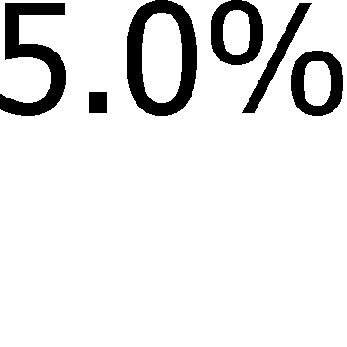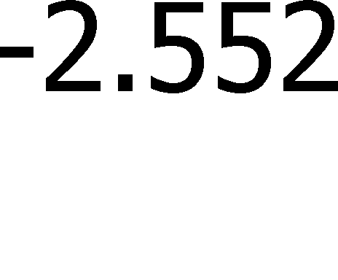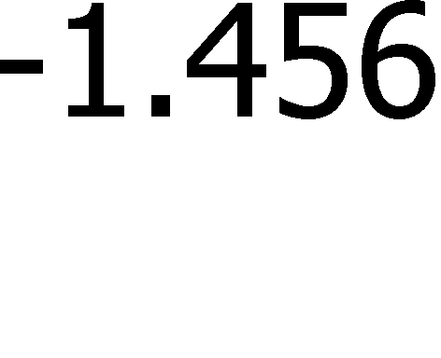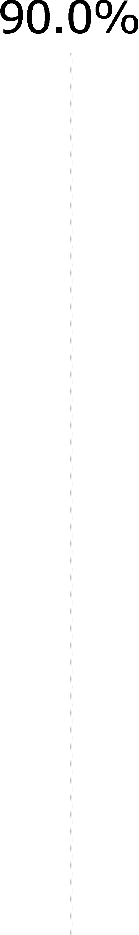

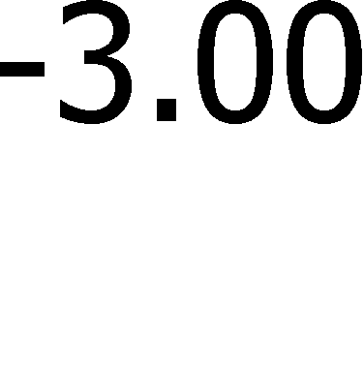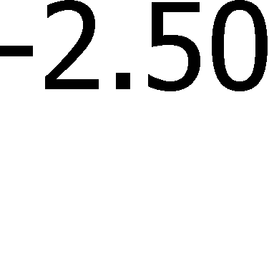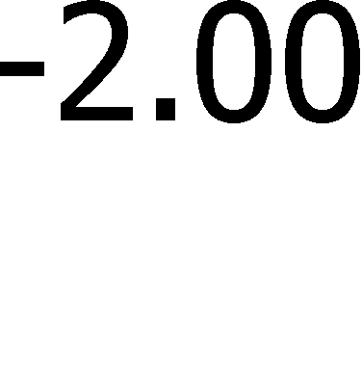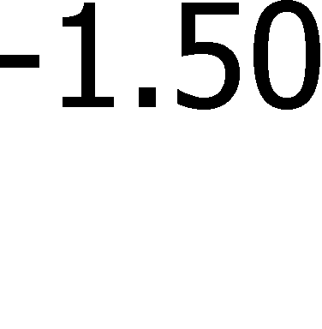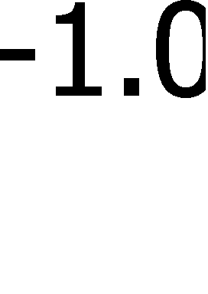

Figure 2 NRC Implementation Costs

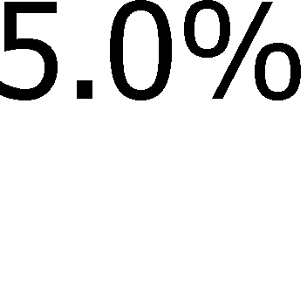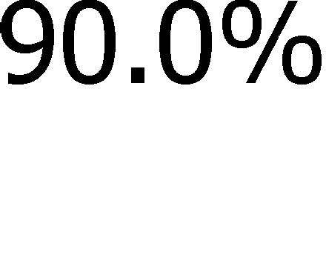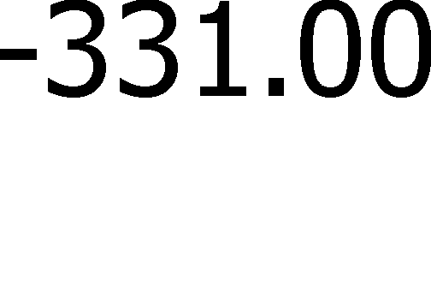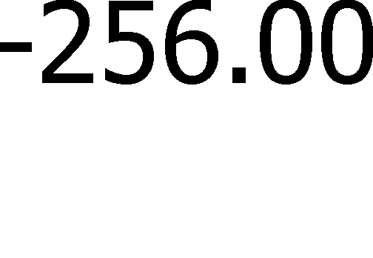

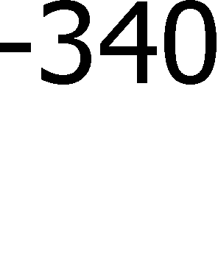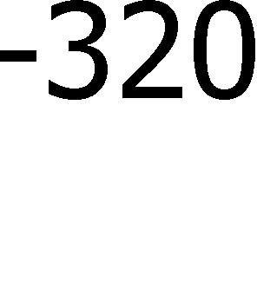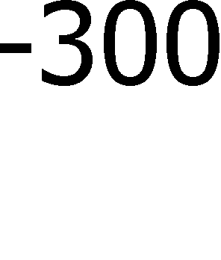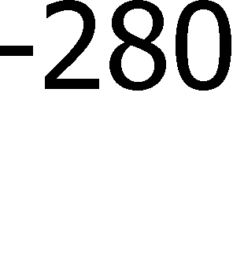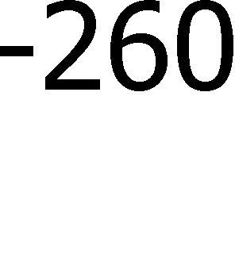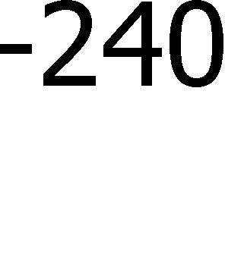

Figure 3 Industry Operations Costs (7% Discount Rate)

4.63 8.40

5.0%
90.0%
5.0%
3 4 5 6 7 8 9 10 11 12
Values in Millions ($)
Figure 4 Industry Operations Averted Costs (3% Discount Rate)

5.17 9.38

5.0%
90.0%
5.0%
3 4 5 6 7 8 9 10 11 12 13
Values in Millions ($)

Figure 5 NRC Operations Averted Costs (7% Discount Rate)

2.059 2.811

5.0%
90.0%
5.0%
.60 1.80 2.00 2.20 2.40 2.60 2.80 3.00 3.20 3.4
Values in Millions ($)
Figure 6 NRC Operations Costs Averted (3% Discount Rate)

2.412 3.290

5.0%
90.0%
5.0%
.00 2.20 2.40 2.60 2.80 3.00 3.20 3.40 3.60 3.80 4.0
Values in Millions ($)

Figure 7 Total (7% Discount Rate)

3.82 7.35

5.0%
90.0%
5.0%
2 3 4 5 6 7 8 9 10 11
Values in Millions ($)
Figure 8 Total (3% Discount Rate)

4.63 8.65

5.0%
90.0%
5.0%
2 3 4 5 6 7 8 9 10 11 12
Values in Millions ($)

Table 21 Uncertainty Results Descriptive Statistics

Uncertainty Result | Min | Mean | Mode | Median | Max | 5% | 95%
Industry Implementation (One-Time) | ($3.32) | ($1.96) | ($1.74) | ($1.93) | ($1.09) | ($2.55) | ($1.46)
NRC  Implementation (One-Time) | ($0.36) | ($0.29) | ($0.29) | ($0.29) | ($0.23) | ($0.33) | ($0.27)
Industry Operation (7% Discount Rate) | $3.48 | $6.37 | $5.88 | $6.29 | $11.18 | $4.63 | $8.40
Industry Operation (3% Discount Rate) | $3.89 | $7.02 | $6.60 | $7.02 | $12.49 | $5.17 | $9.38
NRC Operation (7% Discount Rate) | $1.79 | $2.42 | $2.39 | $2.41 | $3.25 | $2.06 | $2.81
NRC Operation (3% Discount Rate) | $2.09 | $2.84 | $2.79 | $2.82 | $3.80 | $2.41 | $3.29
Net Benefit (Cost) (7% Discount Rate) | $2.30 | $5.48 | $5.56 | $5.42 | $10.06 | $3.82 | $7.35
Net Benefit (Cost) (3% Discount Rate) | $2.93 | $6.52 | $5.82 | $6.44 | $11.71 | $4.63 | $8.65
* There may be discrepancies in calculations due to rounding.
** All values are in 2016 million dollars).

Figures 9 and 10 show a Tornado Diagram, which identifies the factors whose uncertainty drives the largest impact on total costs (and averted costs) for this rulemaking. The uncertainty regarding the number of hours required to prepare and disposition an alternative request, the range in industry labor rates, and the number of alternative requests averted drive the largest amount of uncertainty in the costs (and averted costs) of the rulemaking. The rest of the variables in Figures 9 and 10 show diminishing variation with respect to the net benefit mean value for this proposed regulatory action.

Figure 9 Net Benefit (Cost) Tornado Diagram based on 7-percent Discount Rate – Inputs Ranked by Effect on Output Mean

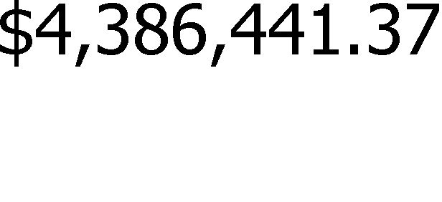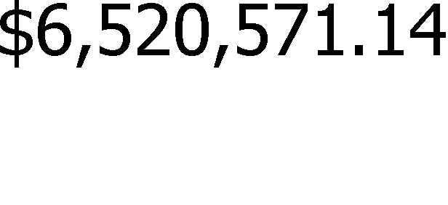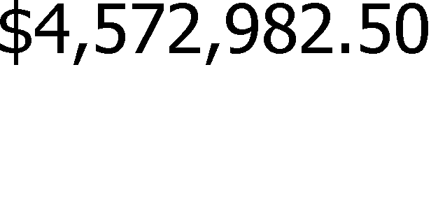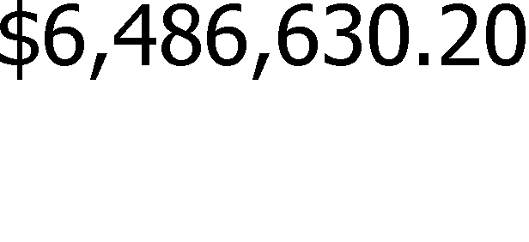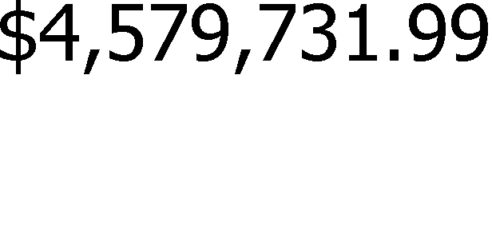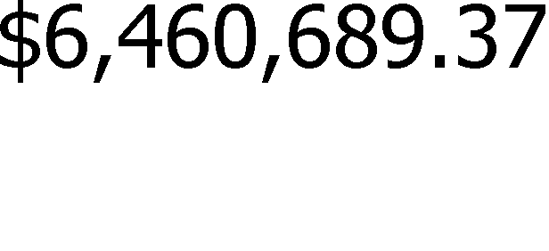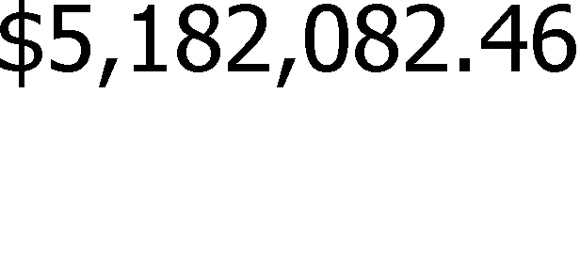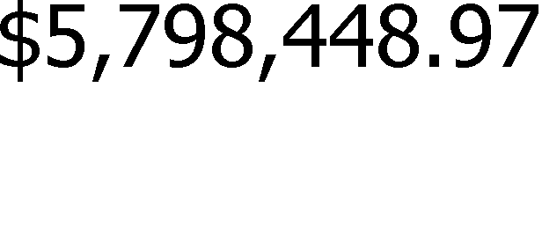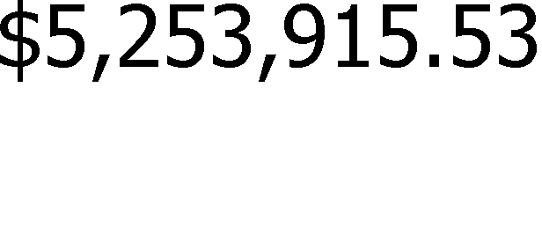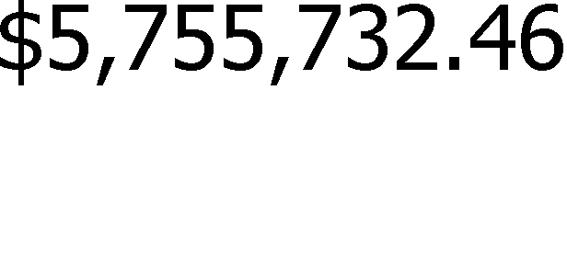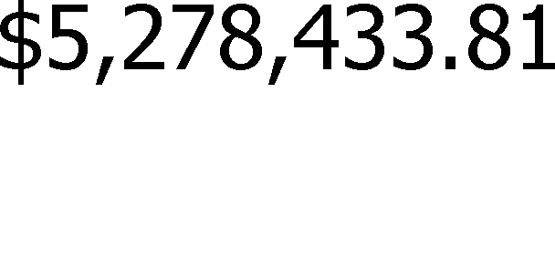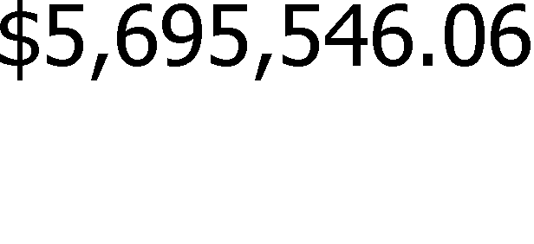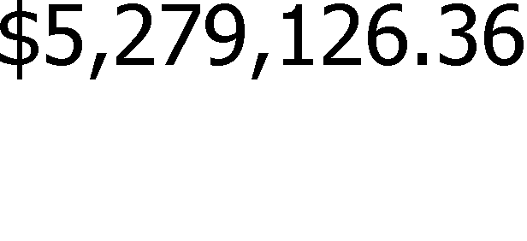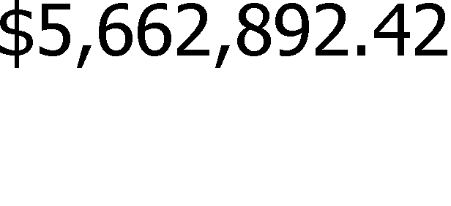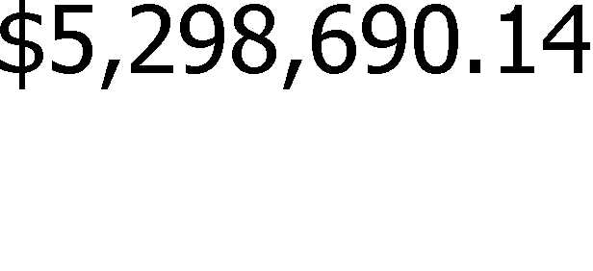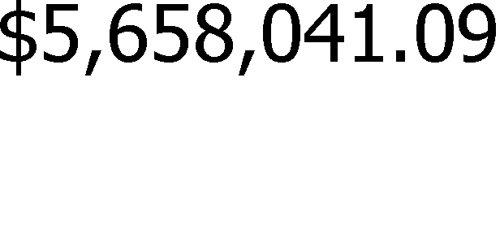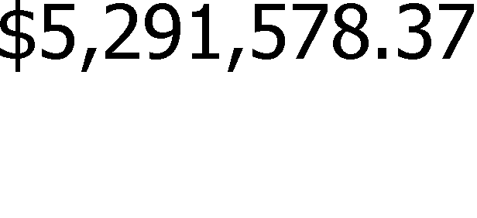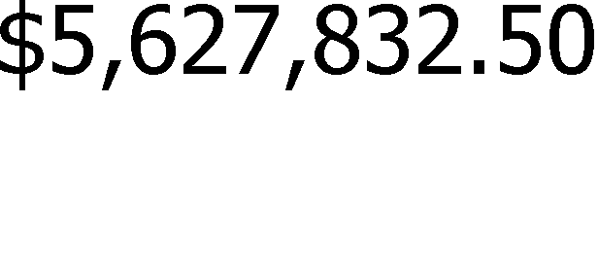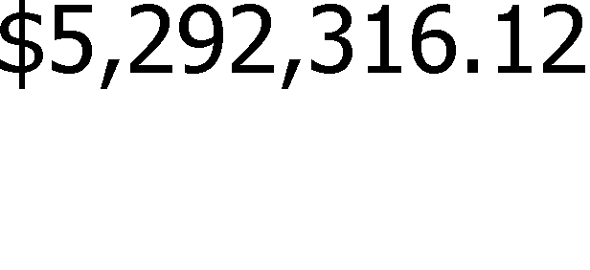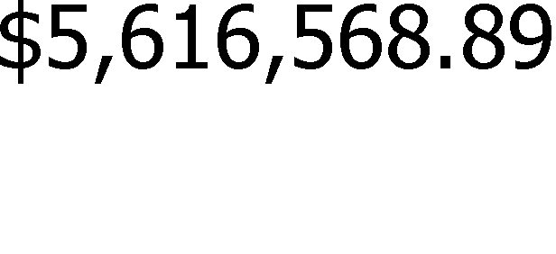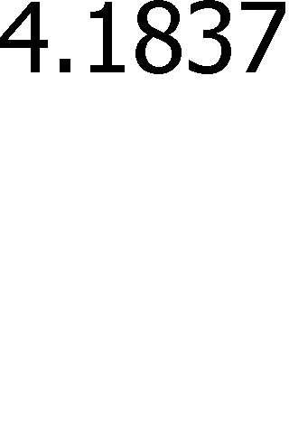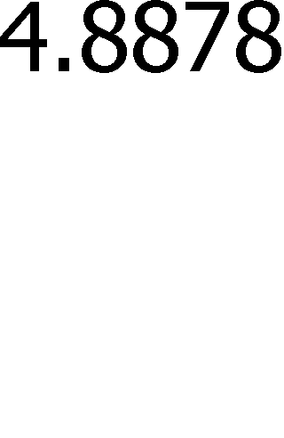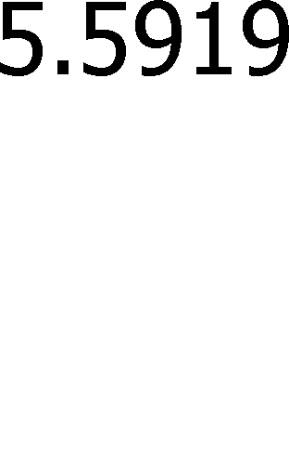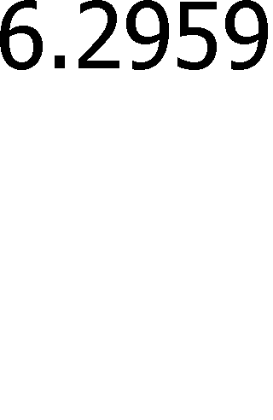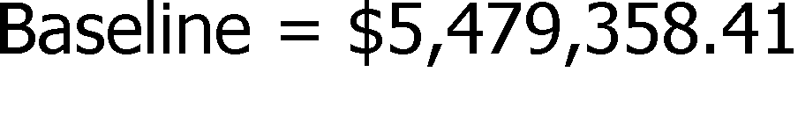
Figure 10 Net Benefit (Cost) Tornado Diagram based on 3-percent Discount Rate – Inputs Ranked by Effect on Output Mean

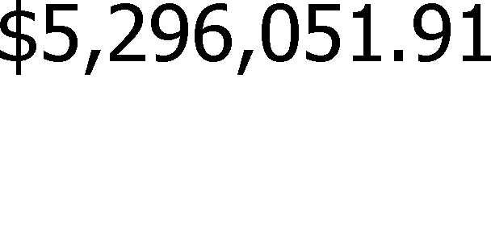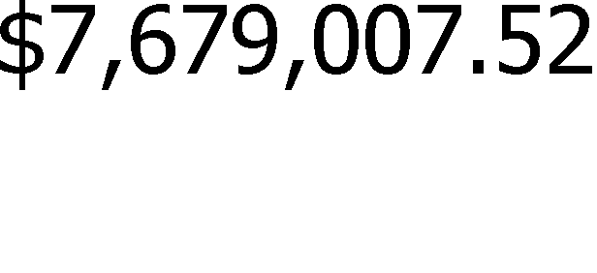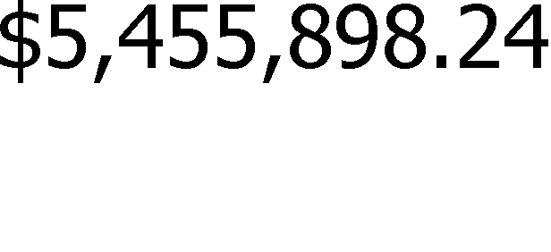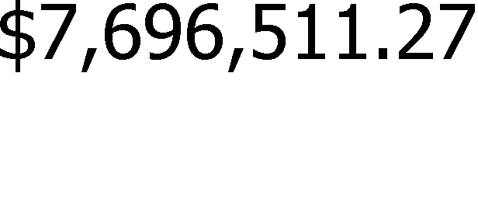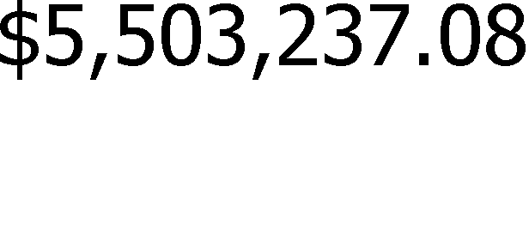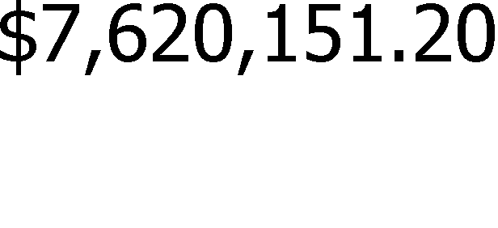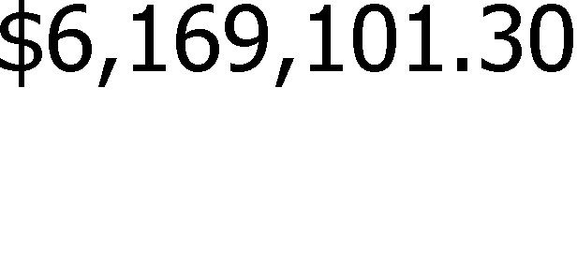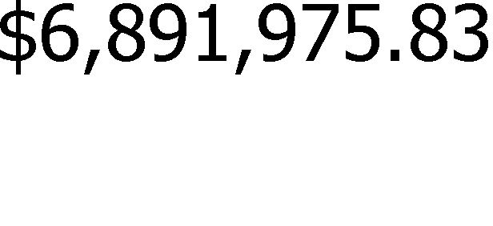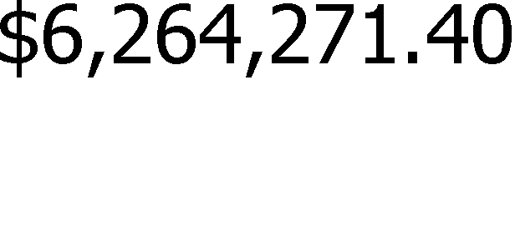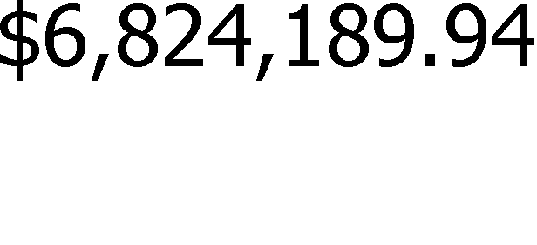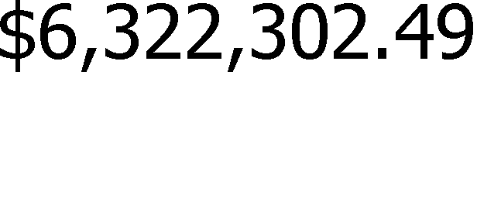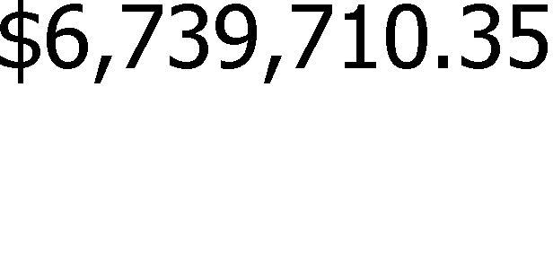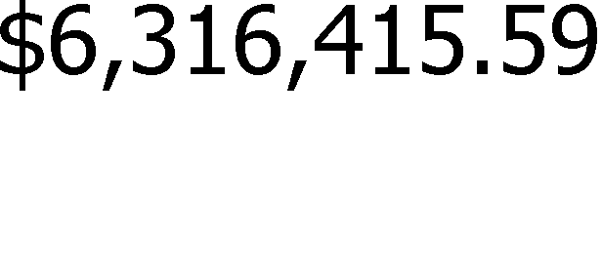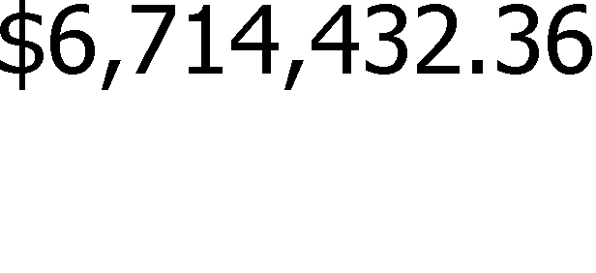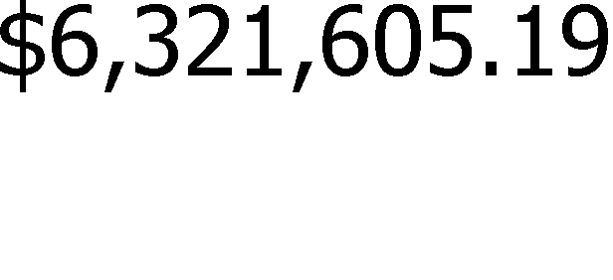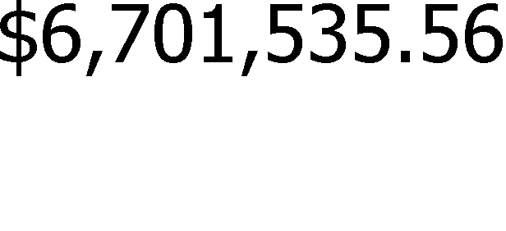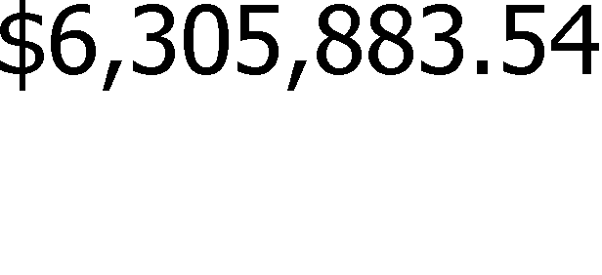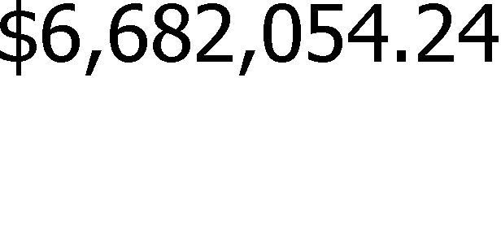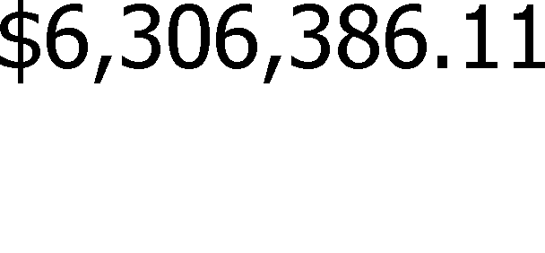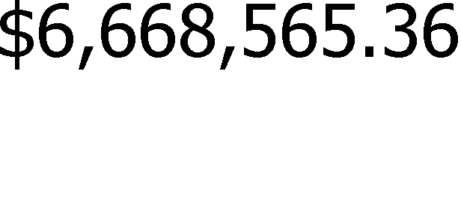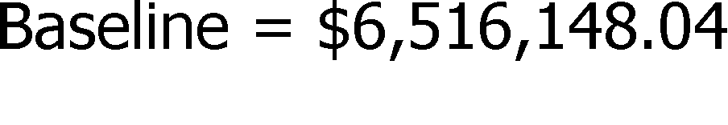

    - Summary of Uncertainty Analysis

A Monte Carlo analysis found that amending the proposed rule would result in a positive net benefit (e.g., savings) for all 10,000 simulations using either a 7-percent or a 3-percent discount rate. Given the uncertainties involved in obtaining these estimates, there is a reasonable basis for concluding that there is high reliability in an NRC finding that the proposed rule represents a socially efficient use of resources.

Independent Cost Estimate

In December 2014, the United States Government Accountability Office (GAO) published GAO-15–98, “Nuclear Regulatory Commission—NRC Needs to Improve Its Cost Estimates by Incorporating More Best Practices” (Ref. 27). The GAO report examined the extent to which NRC’s cost estimating procedures support development of reliable cost estimates and follow
specific best practices that are identified in GAO–09–3SP, “GAO Cost Estimating and Managing Capital Program Costs.” As a result of this audit, the GAO recommended that NRC align its cost estimating procedures with relevant cost estimating best practices stated in GAO–09–3SP (Ref. 28) in an effort to ensure that the future cost estimates of NRC are prepared in accordance with relevant cost estimating best practices. Additionally the GAO recommended that the NRC demonstrate credibility in its cost estimates by cross-checking their results with independent cost estimates (ICEs) that are developed by others and conducting sensitivity analysis to identify variables most affecting cost estimates (i.e. cost drivers).

In response to the GAO concerns and recommendations, the NRC tasked the Center for Nuclear Waste Regulatory Analyses (CNWRA) to perform an ICE for this proposed regulatory actions. The same cost estimating procedures that NRC staff uses (e.g., NUREG/BR-0058 and NUREG/BR-0184) were used, but the methods and techniques employed by CNWRA were independent of those used by the NRC staff. The results of both efforts were compared and the draft NRC regulatory analysis was revised to incorporate the following changes:

  - removed the incremental cost of Code Case N-666-1 and converted that to a one time cost,
  - added the electric power replacement cost due to shutdown of a nuclear unit for repair and maintenance,
  - added the cost impact due to routine occupational radiation dose,
  - added pump verification test costs to the OMN Code Cases, and
  - inputs (i.e., the number of labor hours and number of weld examinations) for generating the cost uncertainty statistics were revised.

Based on the ICE input, the NRC staff updated the regulatory analysis to incorporate these changes. The impact on the estimated costs are summarized in Table 22.

Table 22 Regulatory Analysis Estimate Changes for Alternative 2

Attribute | Net Benefit (Costs) (7% NPV)
Attribute | Pre-ICE NRC  estimate (A) | Revised NRC estimate  (B) | Percent change (A-B)/A
Industry Implementation | ($1,478,000) | ($1,932,922) | -31%
Industry Operation | $5,560,000 | $6,375,346 | -15%
Occupational Health (Routine) |  | ($227,178) | NMa
Replacement Power Cost |  | ($862,260) | NM
Total Industry Costs | $4,080,000 | $3,352,986 | 18%
NRC Implementation | ($640,000) | ($293,615) | 54%
NRC Operation | $2,734,000 | $2,444,212 | 11%
Total NRC Cost | $2,090,000 | $2,150,597 | -2%
Net Benefit | $6,176,000 | $5,503,582 | 11%
a Not meaningful

Summary

This regulatory analysis identifies and integrates both quantifiable and nonquantifiable benefits and costs that would emerge from incorporating the most recent regulatory guides listing
NRC-approved Code Cases by reference into the Code of Federal Regulations, in order to determine a net integrated benefit-cost figure.

    - Quantified Net Benefit

As shown in Table 23, the estimated total net benefit for Alternative 2 relative to the regulatory baseline over the six year time frame of the alternative, the quantitative benefit outweigh the costs by a range from approximately $5.5 million (7-percent NPV) to $6.5 million
(3-percent NPV).

Attribute | Total Averted Costs (Costs)
Attribute | Undiscounted | 7% NPV | 3% NPV
Industry Implementation | ($1,932,922) | ($1,932,922) | ($1,932,922)
Industry Operation | $7,771,207 | $6,375,346 | $7,124,134
Occupational Health (Routine) | ($276,961) | ($227,178) | ($253,704)
Replacement Power Cost | ($1,044,800) | ($862,260) | ($959,639)
Total Industry Costs | $4,516,524 | $3,352,986 | $3,977,869
NRC Implementation | ($293,615) | ($293,615) | ($293,615)
NRC Operation | $3,189,958 | $2,444,212 | $2,836,372
Total NRC Cost | $2,896,342 | $2,150,597 | $2,542,757
Net Benefit | $7,412,867 | $5,503,582 | $6,520,626
* There may be discrepancies in calculations due to rounding.
** All values are in 2016 dollars

    - Nonquantified Benefits

In addition to averted costs from the elimination of planned ASME Code Case alternative request submittals, public health (accident), occupational health (accident and routine), regulatory efficiency, and increase of knowledge produce a number of nonquantifiable benefits for industry and the NRC. For example, advancements in ISI and IST may provide an incremental reduction of the likelihood of a radiological accident, incrementally decrease the likelihood of post-accident plant worker exposure, and incrementally decrease plant worker radiological exposures during routine inspections or testing. Four nonquantifiable benefits from regulatory efficiency are that Alternative 2 would provide:

- licensees with flexibility and would decrease licensee’s uncertainty when making modifications or preparing to perform ISI or IST;
- consistency with the provisions of the NTTAA, which encourages Federal regulatory agencies to consider adopting voluntary consensus standards as an alternative to de novo agency development of standards affecting an industry;
- consistency with the NRC’s policy of evaluating the latest versions of consensus standards in terms of their suitability for endorsement by regulations and regulatory guides; and
- consistency with the NRC’s goal to harmonize with international standards to improve regulatory efficiency for both the NRC and international standards groups.

This consistent application resulting from the incorporation by reference of the latest revisions of three regulatory guides that include NRC-approved Code Cases into the Code of Federal Regulations provides this significant gain in the consistent application of these Code Cases and the consistency with the provisions of the NTTAA and the harmonizing with international standards. The NRC staff believes that NRC’s timely review and approval of Code Cases

maintains NRC’s role as an effective industry regulator that would otherwise be undetermined if outdated material would remain incorporated by reference in the Code of Federal Regulations.

Furthermore, the opportunity for staff to improve their knowledge results in increased job satisfaction. Developing greater knowledge and common understanding of the Code plus eliminating unnecessary work better enables industry and NRC staff to produce desired on-the-job results, which leads to pride in performance and increased job satisfaction.

    - Nonquantified Costs

As discussed in sections 5.6.1 and 5.8.1, the NRC staff believes that incorporation by reference the most recent RGs that list NRC-approved Code Cases into the Code of Federal Regulations would decrease industry and NRC operation costs. If the NRC staff underestimated the number of or the complexity of these eliminated submittals, than the averted costs would increase proportionally, causing the quantified net cost of Alternative 2 to decrease.

5.15. Safety Goal Evaluation

The proposed rule alternative (Alternative 2) would allow licensees and applicants to apply voluntarily NRC-approved Code Cases, sometimes with NRC-specified conditions, listed in three regulatory guides that are proposed to be incorporated by reference into 10 CFR 50.55a. The NRC’s safety goal evaluation is applicable only to regulatory initiatives considered to be generic safety enhancement backfits subject to the substantial additional protection standard at 10 CFR 50.109(a)(3). The NRC does not regard the approval of ASME Code Cases by rulemaking to be backfitting (the basis for this determination is set forth in the Federal Register notice of proposed rulemaking to amend 10 CFR 50.55a). Therefore, a safety goal evaluation is not needed for this regulatory analysis.

Decision Rationale

Table 24 provides the quantified and nonquantified costs and benefits for
Alternative 2 – incorporating by reference into 10 CFR 50.55a the latest revision of the regulatory guides listing Code Cased newly approved for use by the NRC. For the quantitative analysis, the best estimate values are used.

Table 24 Summary of Totals

Net Monetary Savings (or Costs) – Total Present Value | Non-Monetary Benefits or (Costs)
Alternative 1: No Action
$0 | None
Alternative 2: Incorporate by Reference NRC-Approved ASME BPV and OM Code Cases
Industry:  $3,352,986 using a 7% discount rate  $3,977,869 using a 3% discount rate  NRC: | Non-Monetary Benefits:  - Public Health (Accident) – the likelihood of a radiological accident may be reduced by allowing for advancements in ISI and IST that may result in earlier identification of material degradation that if

Net Monetary Savings (or Costs) – Total Present Value | Non-Monetary Benefits or (Costs)
$2,150,597 using a 7% discount rate  $2,542,757 using a 3% discount rate  Net Benefit (Cost):  $5,503,582 using a 7% discount rate  $6,520,626 using a 3% discount rate  The quantified results show that Alternative 2 is cost-beneficial. | undetected could result in further degradation that eventually results in a plant transient.  - Occupational Health (Accident) – advancements in ISI and IST may result in an incremental decrease in the likelihood of an accident resulting in post- accident worker exposure.  - Improvement in Knowledge – gain experience with new technology and ISI and IST advancements. On-the-job learning increases worker satisfaction.  Eliminating unnecessary work better enables staff to produce desired on-the-job results, which leads to pride in performance and increased job satisfaction.  - Regulatory Efficiency – licensees that wish to use NRC-approved ASME Code Cases would not require exemptions from NRC regulations. This practice is consistent with:  - the provisions of the NTTAA  - with NRC policy of evaluating the latest versions of consensus standards in terms of their suitability for endorsement by regulations and regulatory guides  - with NRC’s goal to harmonize with international standards to improve regulatory efficiency for both the NRC and international standards groups  Non-Monetary Costs: Industry and NRC Operation Costs – If the number of planned industry submittals or the effort to prepare these submittals are less than the NRC assumes within the regulatory analysis, than the averted quantified costs are overstated.  The NRC staff’s evaluation of nonquantitative benefits and costs show that Alternative 2 is justified.

The staff recommends Alternative 2. As shown in Table 24, Alternative 2 relative to the regulatory baseline is cost beneficial and would result in a net averted cost to the industry from
$3.35 million (7-percent NPV) to a $3.98 million (3-percent NPV). Relative to the regulatory baseline, the NRC would realize a net benefit of $2.15 million (7-percent NPV) to $2.54 million (3-percent NPV) in net benefits. The estimated net benefit is $5.5 million (7-percent NPV) to
$6.5 million (3-percent NPV). Alternative 2 is also justified when considering the non-monetized considerations. Alternative 2 has the benefit of meeting the NRC goal of ensuring the protection of public health and safety and the environment through the NRC’s approval of new ASME Code Cases that allow the use of the most current methods and technology. In addition, this alternative would help ensure that the NRC’s actions are effective, efficient, realistic, and timely by eliminating the need for the NRC review of plant-specific alternative requests. This alternative would also support the NRC’s goal of maintaining an open regulatory process

because approving ASME Code Cases demonstrates the NRC’s commitment to participate in the national consensus standards process. Based upon the uncertainty analysis discussed in Section 5.12, there is a reasonable basis for concluding that there is high reliability in an NRC finding that the final rule represents a socially efficient use of resources.

Other important considerations lead the NRC staff to recommend Alternative 2. These include the industry’s familiarity with the well-established process of approving Code Cases through NRC regulatory guides, the public perception that the Code Case approval process is consistent across the industry, and the public perception that the NRC would continue to support the use of the most updated and technically sound techniques developed by the ASME while continuing to provide adequate protection to the public.

The NRC finds Alternative 2 is justified regardless of whether the quantitative information is considered by itself, the non-quantitative information is considered by itself, or the quantitative and non-quantitative information are considered in an integrated fashion, and when considering the uncertainties in the information. Therefore, the NRC has determined that Alternative 2 should be selected, and the rule be adopted.

Implementation Schedule

The final rule would become effective 30 days after its publication in the Federal Register.

Regulatory Guides

The NRC has proposed revisions to Regulatory Guide 1.84, “Design and Fabrication Code Case Acceptability, ASME Section III” (Revision 37), Regulatory Guide 1.147, “Inservice Inspection Code Case Acceptability, ASME Section XI, Division 1” (Revision 18), and RG 1.192, “Operation and Maintenance Code Acceptability, ASME OM Code” (Revision 2). The proposed revisions to these regulatory guides identify those Code Cases that have been determined by the NRC to be acceptable alternatives to applicable parts of Section III, Section XI, and the
OM Code.

References

- U.S. Code of Federal Regulations, Title 10, Energy, Part 50, “Domestic Licensing of Production and Utilization Facilities.” Washington, D.C.

- Title 15 U.S. Code Chapter 63, “Technology Innovation,” Section 3701 (15 USC 3701). National Technology Transfer and Advancement Act of 1995.

- U.S. Department of Labor, Bureau of Labor Statistics, CPI Detailed Report,
December 2014, “Table 24. Historical Consumer Price Index for All Urban Consumers (CPI-U): U.S. City Average, All-Items,” December 2014. http://www.bls.gov/cpi/tables.htm, last accessed on April 16, 2015.

- United States Congressional Budget Office, The Budget and Economic Outlook: 2015 to 2025. “Table 2-1. CBO’s Economic Projections for Calendar Years 2015 to 2025,” January 2015. Web. Sept. 2015. http://www.cbo.gov/sites/default/files/cbofiles/attachments/49892-Outlook2015.pdf, last accessed on December 1, 2015.

- U.S. Department of Labor, Bureau of Labor Statistics, “NAICS Code: North American Industry Classification System Code, Utilities: NAICS 22,” January 20, 2015. Accessed on November 20, 2014 at http://www.bls.gov/iag/tgs/iag22.htm.

- U.S. Department of Labor, Bureau of Labor Statistics, “SOC Code: Standard Occupational Classification Code,” January 20, 2015. Accessed on January 6, 2015 at http://www.bls.gov/soc/home.htm.

- U.S. Department of Labor, Bureau of Labor Statistics, “NAICS Code: North American Industry Classification System Code,” January 20, 2015. Accessed on January 6, 2015 at http://www.bls.gov/bls/naics.htm.

- U.S. Nuclear Regulatory Commission; Generic Cost Estimates, NUREG/CR-4627, February 1992 (ADAMS Accession No. ML13137A259).

- U.S. Nuclear Regulatory Commission; 52 FR 38077 (October 14, 1987). “Commission Policy Statement on Deferred Plants.” Federal Register, U.S. Nuclear Regulatory Commission, Washington, D.C.

- U.S. Nuclear Regulatory Commission; Regulatory Analysis Technical Evaluation Handbook, NUREG/BR-0184; January 1997 (ADAMS Accession No. ML050190193).

- U.S. Nuclear Regulatory Commission; Regulatory Analysis Guidelines of the U.S. Nuclear Regulatory Commission, NUREG/BR-0058, Revision 4, September 2004 (ADAMS Accession No. ML042820192).

- U.S. Nuclear Regulatory Commission; U.S. NRC Regulations Handbook,
NUREG/BR-0053, Revision 6, September 2005 (ADAMS Accession No. ML052720461).

- U.S. Nuclear Regulatory Commission; 2015-2016 Information Digest (NUREG-1350, Volume 27), “Appendix H: U.S. Commercial Nuclear Power Reactor Operating Licenses - Expiration by Year, 2013–2049,” June 2015. Available at: http://www.nrc.gov/reading- rm/doc-collections/nuregs/staff/sr1350/, last accessed on November 19, 2015.

- U.S. Nuclear Regulatory Commission; Reassessment of NRC’s Dollar per Person-Rem Conversion Factor Policy, NUREG/BR-1350, Rev. 1 (draft), (ADAMS Accession
No. ML15237A211).

- U.S. Nuclear Regulatory Commission; Regulatory Guide-1.84, “Design, Fabrication, and Materials Code Case Acceptability, ASME Section III,” Revision 36 (ADAMS Accession No. ML13339A515).

- U.S. Nuclear Regulatory Commission; Regulatory Guide-1.147, “Inservice Inspection Code Case Acceptability, ASME Section XI, Division 1,” Revision 17 (ADAMS Accession No. ML13339A689).

- U.S. Nuclear Regulatory Commission; Regulatory Guide 1.192, “Operation and Maintenance Code Acceptability, ASME OM Code,” Revision 1 (ADAMS Accession No. ML13340A034).

- U.S. Nuclear Regulatory Commission; Draft Regulatory Guide-1295, “Design, Fabrication, and Materials Code Case Acceptability, ASME Section III,” (ADAMS Accession
No. ML15027A002).

- U.S. Nuclear Regulatory Commission; Draft Regulatory Guide-1296, “Inservice Inspection Code Case Acceptability, ASME Section XI, Division 1,” (ADAMS Accession
No. ML15027A202).

- U.S. Nuclear Regulatory Commission; Draft Regulatory Guide -1297, “Operation and Maintenance Code Acceptability, ASME OM Code,” (ADAMS Accession
No. ML15027A330).

- U.S. Office of the Federal Register; “Document Drafting Handbook: Chapter 6: What is Incorporation by Reference, and How do I do it?” April 2014 Revision. Accessed at http://archives.gov/federal-register/write/handbook/chapter-6.pdf.

- U.S. Office of Management and Budget; “Regulatory Analysis,” Circular No. A-4. September 17, 2003. Accessed at http://www.whitehouse.gov/omb/circulars_a004_a-4/.

- U.S. Office of Management and Budget Memorandum for the Heads of Departments and Agencies; “2015 Discount Rates for OMB Circular No. A-94,” M-15-05. January 21, 2015. Accessed at https://www.whitehouse.gov/sites/default/files/omb/memoranda/2015/m-15- 05.pdf.

- U.S. Nuclear Regulatory Commission (NRC). NUREG-1530, “Reassessment of NRC’s Dollar per Person-Rem Conversion Factor Policy,” 1995.

- U.S. Nuclear Regulatory Commission (NRC). NUREG-1530, Rev. 1 (draft) released for public comment, “Reassessment of NRC’s Dollar per Person-Rem Conversion Factor Policy,” (ADAMS Accession No. ML15237A211)

- International Atomic Energy Agency (IAEA) Power Reactor Information System: Country Statistics: USA, Accessed at https://www.iaea.org/PRIS/CountryStatistics/CountryDetails.aspx?current=US. Last update on December 2, 2015.

- U.S. General Accountability Office, GAO-15-98, “Nuclear Regulatory Commission Needs to Improve Its Cost Estimates by Incorporating More Best Practices,” December 2014, Accessed at http://www.gao.gov/products/GAO-15-98.

- U.S. General Accountability Office, GAO-09-3SP, “GAO Cost Estimating and Assessment Guide: Best Practices for Developing and Managing Capital Program Costs,” March 2009, Accessed at http://www.gao.gov/new.items/d093sp.pdf.

- Entergy Nuclear Operations, Inc. letter JAFP-15-0133, “Notification of Permanent Cessation of Power Operations,” November 18, 2015 (ADAMS Accession
No. ML15322A273.

Appendix A: Industry Labor Rates
Utilities (Sector 22) – Industry: Electric Power Generation, Transmission and Distribution (NAICS code 221100)
Position Title | Occupation (SOC code) | Hourly mean wage  (2014 dollars) | Hourly 25th percentile wage (2014 dollars) | Hourly 90th percentile wage (2014 dollars) | Source
Executiv e | Top Executives (111000) | $66.37 | $46.64 | $99.56 (1) | http://www.bls.gov/oes/c urrent/oes111011.htm
Executiv e | Chief Executives (111011) | $95.79 | $66.55 | $143.69 (1) | http://www.bls.gov/oes/c urrent/oes_nat.htm#11- 0000
Executiv e | Average | $81.08 | $56.60 | $121.62
Manager s | First-Line Supervisors of Production and Operating Workers (511011) | $41.40 | $32.23 | $58.83 | http://www.bls.gov/oes/c urrent/oes511011.htm
Manager s | First-Line Supervisors of Mechanics Installers and Repairers (491011) | $39.65 | $32.40 | $55.47 | http://www.bls.gov/oes/c urrent/oes491011.htm
Manager s | Industrial Production Managers(113051) | $56.26 | $43.58 | $80.87 | http://www.bls.gov/oes/c urrent/oes113051.htm
Manager s | General and Operations Managers (111021) | $63.76 | $45.77 | $95.64 (1) | http://www.bls.gov/oes/c urrent/oes111021.htm
Manager s | Average | $50.27 | $38.50 | $72.70
Technica l Staff | Nuclear Engineers(172161) | $48.84 | $40.42 | $65.51 | http://www.bls.gov/oes/c urrent/oes172161.htm
Technica l Staff | Nuclear Technicians(194051  ) | $37.25 | $30.76 | $49.71 | http://www.bls.gov/oes/c urrent/oes194051.htm
Technica l Staff | Nuclear Power Reactor Operators (518011) | $39.55 | $34.02 | $50.45 | http://www.bls.gov/oes/c urrent/oes518011.htm
Technica l Staff | Industrial Machinery Mechanics (499041) | $31.24 | $24.86 | $44.30 | http://www.bls.gov/oes/c urrent/oes499041.htm
Technica l Staff | Average | $39.22 | $32.52 | $52.49
Admin Staff | Office and Administrative Support Occupations (430000) | $23.15 | $16.72 | $35.83 | http://www.bls.gov/oes/c urrent/naics4_221100.ht m#43-0000
Admin Staff | First-Line Supervisors of Office and Administrative Support Workers (431011) | $34.61 | $25.99 | $51.79 | http://www.bls.gov/oes/c urrent/oes431011.htm

Position Title | Occupation (SOC code) | Hourly mean wage  (2014 dollars) | Hourly 25th percentile wage (2014 dollars) | Hourly 90th percentile wage (2014 dollars) | Source
 | Office Clerks General (439061) | $19.42 | $13.96 | $29.05 | http://www.bls.gov/oes/c urrent/oes439061.htm
 | Average | $25.73 | $18.89 | $38.89
Licensing Staff | Paralegals and Legal Assistants (232011) | $29.85 | $24.85 | $40.05 | http://www.bls.gov/oes/c urrent/oes232011.htm
Licensing Staff | Lawyers (231011) | $73.23 | $44.96 | $109.85 (1) | http://www.bls.gov/oes/c urrent/oes231011.htm
Licensing Staff | Average | $51.54 | $34.91 | $74.95
Total | Average | $49.57 | $36.28 | $72.13
Total | Average multiplied  by 2 | $118.96 | $87.07 | $173.11
Total | Value in 2016  Dollars | $122.91 | $89.97 | $178.87 | Consumer Price Index
Footnotes:
- The BLS wage is equal to or greater than $90.00 per hour or $187,199 per year without specifying a value. For this analysis, the NRC staff estimated that the 90th percentile is approximately 30% greater than the mean.
- SOC code: Standard Occupational Classification code -- see http://www.bls.gov/soc/home.htm
- NAICS code: North American Industry Classification System code -- see http://www.bls.gov/bls/naics.htm
- The BLS data was extracted using a custom query function accessible at http://www.bls.gov/oes/current/oes111011.htm. The query selected used multiple occupations for one industry. The industry sector selected was Sector 22 - Utilities and the industry selected was Industry 221100 - Electric Power Generation, Transmission, and Distribution. The table lists the occupation SOC codes. The NRC staff extracted the data on September 14, 2015.

Appendix B: Uncertainty Analysis Variables

Uncertainty Variable Description | Distribution | Low Estimate | Best Estimate | High Estimate | Mean Value
General
Number of reactor sites | Pert | 57 | 61 | 61 | 60.3
Number of reactor units | Pert | 100 | 104 | 104 | 103.3
Number of BWR sites | Pert | 20 | 23 | 23 | 22.5
Number of BWR units | Pert | 31 | 34 | 34 | 33.5
Number of PWR sites | Pert | 37 | 38 | 38 | 37.8
Number of PWR units | Pert | 69 | 70 | 70 | 69.8
Number of new reactor units |  |  |  |  | 4.0
Industry (one-time, per site)
Revise plant procedures (No. of procedures) | Pert | 40 | 50 | 60 | 50.0
Hours per procedure | Pert | 4 | 5 | 6 | 5.0
Industry (annually recurring, per site, Code Cases N-666-1 and N-789)
Average number of annual Code Case alternative request submitted16 | Pert | 26 | 30 | 38 | 30.7
Average number of hours to prepare and submit an alternative request | Pert | 304 | 380 | 456 | 380.0
Number of incremental hours to perform a Code Case N-666-1 test | Pert | 2 | 3 | 6 | 3.3
Number of incremental hours to perform a Code Case N-789 test | Pert | 0.33 | 1 | 1.5 | 1.0
Industry (annually recurring, per site, Code Case N-795)
Average number of annual Code Case alternative request submitted15 | Pert | 10 | 12 | 12 | 11.7
Hours to submit an alternative request | Pert | 96 | 120 | 144 | 120.0
No. of incremental hours to perform Code Case N-795 test | Pert | 0.5 | 0.75 | 1.0 | 0.75
Industry (annually recurring, per site, Code Case N-799)
Average number of annual Code Case alternative request submitted |  |  |  |  | 4.0

16 This line item is for the whole industry. The other variables in this subsection of this table are per site.

Uncertainty Variable Description | Distribution | Low Estimate | Best Estimate | High Estimate | Mean Value
Hours to submit an alternative request | Pert | 304 | 380 | 456 | 380
Number of incremental hours to perform a Code Case N-799 test | Pert | 5 | 10 | 25 | 11.7
NRC (one-time)
Issue final rule and supporting regulatory guides (hours) | Pert | 1888 | 2360 | 2832 | 2360
NRC (recurring)
Hours to disposition an alternative request | Pert | 96 | 120 | 144 | 120
Conversion Factors
Dollar per person-rem conversion | Pert | $2,000 | $3,550 | $5,100 | $3,550
Replacement power costs (MWe/hr) | Pert | $39,400 | $42,900 | $50,200 | $43,533
Labor Rates
Industry | Pert | $90 | $123 | $179 | $127
NRC | Pert | $120 | $124 | $130 | $124

ADAMS Accession No.: PKG: ML15041A817; Regulatory Analysis: ML15041A816 *via email

OFFICE | NRR/DPR/CA | NRR/DPR/CA | NRR/DPR/TL | NRR/DPR/BC | NRR/DPR/DD
NAME | MPurdie | CHowells | FSchofer | TInverso | AMohseni
DATE | 4/23/2015 | 10/30/2015 | 12/3/2015 | 12/16/2015 | 12/23/2015
OFFICE | NRR/DPR/D | OGC*
NAME | LKokajko | GMizuno
DATE | 1/5/2016 | 1/4/2016
OFFICIAL RECORD COPY

