Exhibit 42
(Par. 401)
Instructions for Completing CCC-576-1

A Completing CCC-576-1

Complete CCC-576-1 according to this table.

Item | Action
Part A - General Information
This part is to be completed by County Office.
1 | Enter County Office name, address, and telephone number.
2A | Enter NAP unit number and applicable planting period.  Example: Unit #1. Planting Period #3.  See paragraph 28 for the definition of NAP unit and paragraph 178 for defining planting periods.
2B | Enter NAP application number.  The County Office shall maintain a register of NAP application numbers. The register will begin with number 000001 for each crop year. At a minimum, the register will contain the application number, unit number, producer’s name, and date the notice of loss was filed. The same application number will be used for each notice of loss filed for a specific unit.
3 | Enter the name and address of producer associated with unit who is providing the notice of loss.
4 | For the producer identified in item 3, enter the producer’s telephone number (including area code). Enter e-mail address of applicant, if available.
5 | Enter the farm numbers associated with unit.
6 | Enter crop, type or variety, that suffered loss as result of disaster event. Use a separate CCC-576-1 for each type or variety of crop affected by disaster.
Part B - Appraisal or Report of Production
This part is to be completed by LA or FSA representative.
7 | Enter tract identification from photocopy or sketch map.
8 | Enter field identification from FSA-578 and attach photocopy or sketch map.
9 | Enter the number of preliminary appraised acres, in tenths, when producer requests release to put crop to another use. Determine acres, if applicable, when boundaries may not be determined later.

5-31-01 1-NAP (Rev. 1) Amend. 1 Page 1
Exhibit 42
(Par. 401)
Instructions for Completing CCC-576-1 (Continued)

A Completing CCC-576-1 (Continued)

Item | Action
10 | FOR... | ENTER...
10 | yield-based crops | the final acres associated with the type/variety, practice, and stage
10 | maple sap | the total number of taps
10 | honey | the total number of colonies
10 | Identify field on aerial photocopy. Final acres may be measured acres obtained through FSA measurement service as requested by producer or during FSA spot check of producer’s certified acres, or acres certified and signed by the producer on CCC-576. The LA or FSA representative shall review whether the reported crop acreage appears to be accurate. If crop acreage appears to be more than 5 percent different than reported crop acreage, the acreage shall be determined. See paragraph 154.
11 | Enter practice, such as “I” for irrigated and “NI” for nonirrigated.
12 | Enter the stage abbreviations according to Exhibit 41, such as:  - H - Harvested  - UH - Unharvested  - NP - Acreage eligible for prevented planting that was not planted to any crop intended for harvest in the same crop year.

5-31-01 1-NAP (Rev. 1) Amend. 1 Page 2
Exhibit 42
(Par. 401)
Instructions for Completing CCC-576-1 (Continued)

A Completing CCC-576-1 (Continued)

Item | Action
13 | Enter intended use from abbreviations in Exhibit 41.
14 | Enter per acre appraisal in bushels, pounds, cwt, or tons. Obtain information from appropriate appraisal worksheet.
15 | Enter potential production that is the result of multiplying each row of column 10 times each row in column 14.
16 | Enter ineligible causes of loss according to subparagraph 21 B, if applicable.
17 | Enter the amount of production loss attributable to the ineligible cause(s) identified in item 16.
18 | Enter total acres, to tenths, from all rows of column 10.
19 | Enter total potential production from all rows of column 15.
20 | Enter total production loss attributable to ineligible causes of loss from all rows of column 17.
Note: County Offices shall continue to determine losses using current RMA or State Office loss adjustment procedure. Transfer any appropriate information to CCC-576 for processing the individual’s application for payment.
21 | Enter bin number for farm stored commodity. For off-farm stored commodities, attach copies of warehouse receipts, etc., and enter data in subsequent rows, as appropriate. For the quantity of current crop year production fed to the producer’s livestock, used as seed on the producer’s farm, and sold, attach documentary evidence, that is, feeding records, planting records, etc., or copies of sales documents, etc., and enter data in subsequent rows, as appropriate.

5-31-01 1-NAP (Rev. 1) Amend. 1 Page 3
Exhibit 42
(Par. 401)
Instructions for Completing CCC-576-1 (Continued)

A Completing CCC-576-1 (Continued)

Item | Action
22 | Enter internal length measurement in feet, to tenths, of structural space occupied by crop, if rectangular or square. Enter diameter, if round.
23 | Enter internal width measurement in feet, to tenths, of structural space occupied by crop, if rectangular or square. Enter RND if round.
24 | Enter internal depth in feet, to tenths, of structural space occupied by crop.
25 | Enter cubic feet deduction, to tenths, for vents, crossties, etc.
26 | Enter shelled, ear, or ground silage, or other, if applicable.
27 | Enter gross production. Gross production is total production determined by measurement before applying adjustments or any factors, such as percent of shell or sugar, percent of moisture, test weight, percent of dockage, or other production not to count. Obtain gross production for the unit from the summary and/or settlement sheets, if needed.
28 | Enter shelling percentage factor for ear corn, rounded to whole percent. Leave blank if not applicable.
29 | Enter 4 place factor from grain moisture chart, if applicable.
30 | Enter 3 place factor from test weight chart, if applicable. Enter test weight only when storage structure measurements were entered in whole pounds or pounds to tenths after any foreign material is removed. If factor from test weight chart is not applicable, enter the result of dividing the actual test weight by the standard test weight (ear corn must be shelled for sample) to 3 decimal places. For corn silage, divide the actual test weight by 12. Refer to Loss Adjuster’s Handbook.

5-31-01 1-NAP (Rev. 1) Amend. 1 Page 4
Exhibit 42
(Par. 401)
Instructions for Completing CCC-576-1 (Continued)

A Completing CCC-576-1 (Continued)

Item | Action
31 | Enter dockage percentage, as applicable.
32 | Enter production not to count, when acceptable records identifying such production are available. Refer to paragraph:  - 174 on secondary use  - 327 on commingled production  - 333 on salvage value.  Examples:  - 50 acres reported with an intended use of oat grain. Producer suffers disaster and reports a loss. Producer elects to harvest oats as hay and harvest 50 tons of hay. Enter the 50 tons of hay harvested as production not to count. The actual hay value will be deducted from the unit’s gross NAP payment according to subparagraph 174 C.  - 10 acres of apples reported with an intended use of fresh. Because of freeze, apples are unmarketable as fresh or processed. Neighbor pays the producer $500 for 1,000 bushels of apples to be fed as hog feed. Enter 1,000 bushels as production not to count. The salvage value received for this crop shall be deducted from the NAP payment calculated for the crop of the commodity according to paragraph 333.  Enter any commingled production not to count when supporting documents are available and the unit production of a commodity is a matter of record before commingling according to paragraph 327.
33 | After calculating any adjustments indicated in items 28 through 31, enter production to count.
34 | Enter the total harvested production (total of all entries in column 33).

5-31-01 1-NAP (Rev. 1) Amend. 1 Page 5
Exhibit 42
(Par. 401)
Instructions for Completing CCC-576-1 (Continued)

A Completing CCC-576-1 (Continued)

Item | Action
35 | Enter the net production to count for the unit (totals of item 19 plus item 20 plus item 34).
Part C - Certification by LA or FSA Representative
36 | Enter signature, date signed, and code number of LA or FSA representative completing inspection/appraisal.
37 | Enter signature, date signed, and code number of LA or FSA representative completing subsequent inspection/appraisal.
38 | Enter signature(s) of producer and date(s) signed.  Notes: The date signed by the producer must be the same or later than the date signed by LA or FSA representative.  *--Signature by the producer or legal representative constitutes written agreement with Parts A and B for the commodity(ies) and unit(s) shown.--*

7-25-03 1-NAP (Rev. 1) Amend. 18 Page 6
Exhibit 42
(Par. 401)
Instructions for Completing CCC-576-1 (Continued)

B Example of CCC-576-1

This is an example of CCC-576-1.
*--
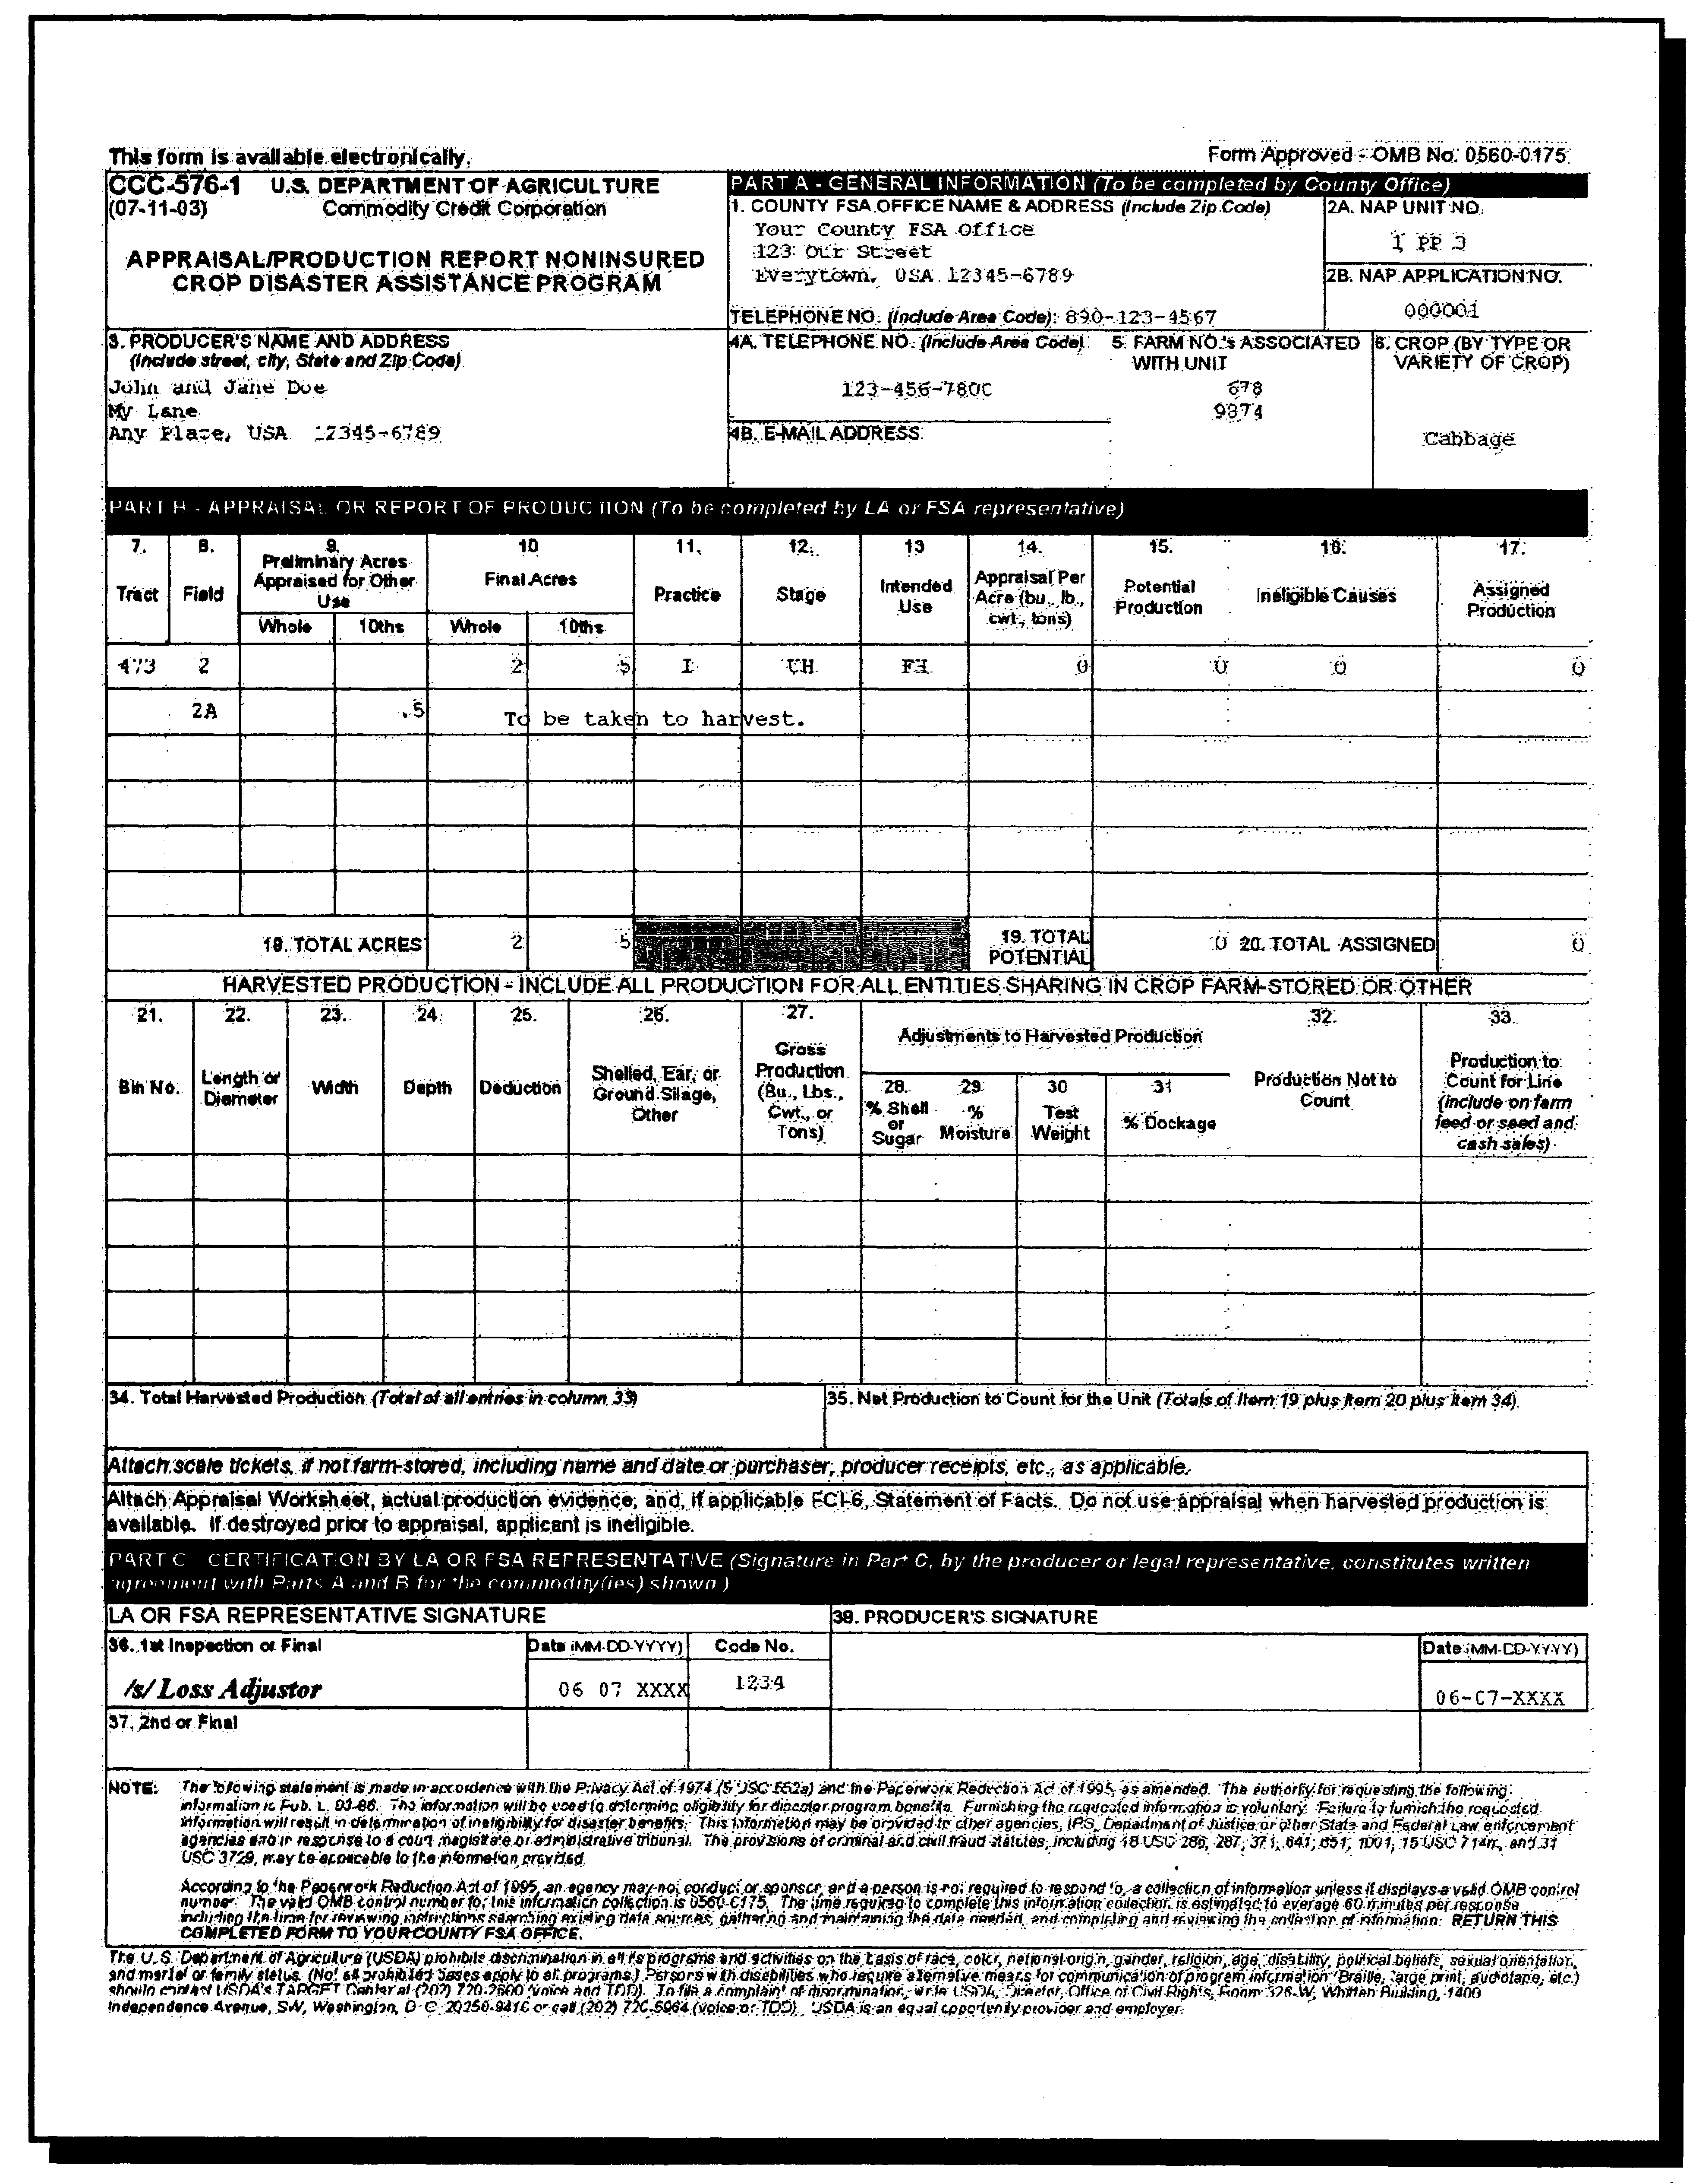
--*

7-25-03 1-NAP (Rev. 1) Amend. 18 Page 7

