Attachment E-4 Follow-up #1 Packet
RCC Follow-up Letter #1 with FAQs (excluding small RCCs)
[NCHS Letterhead]

Date
Name of Director
Name of Community
Community Address
Community city, state, zip code

Dear <NAME OF DIRECTOR >,

Recently, we invited you to participate in the 2016 National Study of Long-Term Care Providers (NSLTCP). The packet we sent asked you to complete and return the NSLTCP questionnaire. To date, we have not received your completed questionnaire.

We understand that you are very busy. Your responses are very important to help further the nation’s understanding of the long-term care needs of seniors and younger adults with disabilities in the United States. The information you provide will be used only for statistical purposes and held in the strictest confidence. See http://www.cdc.gov/nchs/nsltcp/nsltcp_products.htm for products using NSLTCP data.

To participate in this important study, please complete the questionnaire by web over a safe and secure network by going to this URL address and typing in your unique User ID and password:

URL:
User ID:
Password:

Benefits to completing by web include getting only the questions that apply to your community based on your responses—so it takes less time—and having the option to print a copy of your completed questionnaire for your records. However, if you prefer to use hardcopy, please complete the enclosed questionnaire and return it in the pre-addressed, postage-paid envelope provided.

Please submit your questionnaire by web or hardcopy by July 1, 2016 to avoid receiving another questionnaire for this community. If you are the director for more than one community selected for this study, you will receive and be asked to complete a separate questionnaire for each selected community. If you have already returned your completed questionnaire for the community located at the address on the questionnaire label, this letter and your package may have crossed in the mail; you do not have to complete the questionnaire a second time.

Completing the questionnaire will take 30 minutes on average. Before starting, please consult or have your records available to be prepared to answer questions on the number of residents (see question X), numbers of select types of staff (see question XX), and the demographic distribution, activities of daily living, health conditions, and health care use of the residents (see questions XX-XX).

These organizations join me in urging you to participate in this important study: the Center for Excellence in Assisted Living (CEAL), American Seniors Housing Association (ASHA), Assisted Living Federation of America (ALFA), LeadingAge, and the National Center for Assisted Living/American Health Care Association (NCAL/AHCA).

On the back of this letter are NSLTCP Frequently Asked Questions. If you need technical support or have further questions about this survey, visit http://www.cdc.gov/nchs/nsltcp.htm or call (XXX) XXX-XXXX.

Thank you for your help.
Sincerely,

Charles Rothwell
Director, National Center for Health Statistics
National Study of Long-Term Care Providers (NSLTCP)
Frequently Asked Questions

Why should I participate in this survey?
CDC’s National Center for Health Statistics (NCHS) recognizes that residential care communities are an important part of the long-term care spectrum in the United States. NCHS’ National Study of Long-Term Care Providers (NSLTCP) tracks trends, every two years, in the supply and use of five major types of long-term care providers—assisted living and similar residential care communities, adult day services centers, home health agencies, nursing homes, and hospices. When you participate in NSLTCP, you help ensure that the survey data for residential care communities are up-to-date and accurately portray your industry to health care planners and policymakers.

Should I complete a questionnaire if I participated in NSLTCP in 2012 or 2014?
Yes. Your participation in this 2016 survey is important. NSLTCP is conducted every two years to obtain accurate, up-to-date data about residential care communities, other long-term care providers, and the people they serve to detect changes in the long-term care services industry over time.

What other residential care communities are being contacted to participate in this survey?
The 2016 survey includes approximately [insert number] residential care communities operating in the United States. This is a random nationally representative sample. To protect the privacy of individual communities, their staff, and the residents they serve, we do not release the names of sampled communities to anyone.

Will the results be made public?
An overview report that will include survey data from the 2016 NSLTCP is anticipated for release in 2017 and will be made available online at http://www.cdc.gov/nchs/nsltcp.htm. If you would like to be informed of when it is available, you may join the Long-Term Care ListServ at http://www.cdc.gov/nchs/dhcs/longterm_listserv.htm. Identifying information about participants will not be contained in the summary report. At http://www.cdc.gov/nchs/nsltcp/nsltcp_products.htm you can see examples of products that include NSLTCP data.

Why can’t some other community take our place?
You represent other communities like yours. If you do not participate in NSLTCP, there is no guarantee that residential care communities like yours will be represented adequately and the representation of your community’s unique qualities may be lost. NCHS produces state estimates where possible, and your participation may allow us to produce estimates for your state.

Where did you get my name?
Individual state licensing agencies provided the names of all licensed, certified, or otherwise regulated residential care communities in their respective states.

Will my name and information be held confidential?
Yes. NSLTCP is authorized by Congress in Section 306 of the Public Health Service Act (42 USC 242K). All information collected in this survey will be held in the strictest confidence according to law [Section 308 (d) of the Public Health Service Act (42 United States Code 242m (d) and the Confidential Information Protection and Statistical Efficiency Act (PL 107-347)]. Information collected in this survey may be used only for statistical purposes. Any government staff, contractor, or agent who willfully discloses confidential information may be subject to a jail term or a $250,000 fine.

Who supports this study?
This survey is supported by the Center for Excellence in Assisted Living (CEAL), American Seniors Housing Association (ASHA), Assisted Living Federation of America (ALFA), LeadingAge, and the National Center for Assisted Living/American Health Care Association (NCAL/AHCA). The enclosed letter of support provides this specific information.

Where should I mail my completed hardcopy questionnaire?
Please return your completed questionnaire in the enclosed pre-addressed, postage-paid envelope. The address is:
NSLTCP, RTI International, One North Commerce Center, 5265 Capital Blvd., Raleigh, NC 27616.

If I choose to complete the web questionnaire, can I stop partway through and start again, at a later time, where I left off?
Yes. The answers you entered will be saved, and you can pick up, at a later time, where you left off. You will not need to start the web questionnaire from the beginning again.

RCC Follow-up Letter #1 with FAQs (Small RCCs only)
[NCHS Letterhead]

Date
Name of Director
Name of Community
Community Address
Community city, state, zip code

Dear <NAME OF DIRECTOR >,

This is a reminder to participate in the 2016 National Study of Long-Term Care Providers (NSLTCP). By now, you should have received an invitation to participate in the study. The packet we sent asked you to complete and return the NSLTCP questionnaire. To date, we have not received your completed questionnaire.

We understand that you are very busy. Your responses are very important, and it is essential that we hear from small residential care communities like yours. This is your opportunity to help further the nation’s understanding of the long-term care needs of seniors and younger adults with disabilities in the United States. The information you provide will be used only for statistical purposes and held in the strictest confidence.

To participate in this study, please complete the questionnaire by web over a safe and secure network by going to this URL address and typing in your unique User ID and password:

URL:
User ID:
Password:

Benefits to completing by web include getting only the questions that apply to your community based on your responses—so it takes less time—and having the option to print a copy of your completed questionnaire for your records. However, if you prefer to use hardcopy, please complete the enclosed questionnaire and return it in the pre-addressed, postage-paid envelope provided.

Please submit your questionnaire by web or hardcopy by July 15, 2016, otherwise you may receive a call to complete the questionnaire by telephone. If you are the director for more than one community selected for this study, you will receive and be asked to complete a separate questionnaire for each selected community. If you have already returned your completed questionnaire for the community located at the address on the questionnaire label, this letter and your package may have crossed in the mail; you do not have to complete the questionnaire a second time.

Completing the questionnaire will take 30 minutes on average. Before starting, please consult or have your records available to be prepared to answer questions on the number of residents (see question X), numbers of select types of staff (see question XX), and the demographic distribution, activities of daily living, health conditions, and health care use of the residents (see questions XX-XX).

These organizations join me in urging you to participate in this important study: the Center for Excellence in Assisted Living (CEAL), American Seniors Housing Association (ASHA), Assisted Living Federation of America (ALFA), LeadingAge, and the National Center for Assisted Living/American Health Care Association (NCAL/AHCA).

On the back of this letter are NSLTCP Frequently Asked Questions. If you need technical support or have further questions about this survey, visit http://www.cdc.gov/nchs/nsltcp.htm or call (XXX) XXX-XXXX.

Thank you for your help.
Sincerely,

Charles Rothwell
Director, National Center for Health Statistics
National Study of Long-Term Care Providers (NSLTCP)
Frequently Asked Questions

Why should I participate in this survey?
CDC’s National Center for Health Statistics (NCHS) recognizes that residential care communities are an important part of the long-term care spectrum in the United States. NCHS’ National Study of Long-Term Care Providers (NSLTCP) tracks trends, every two years, in the supply and use of five major types of long-term care providers—assisted living and similar residential care communities, adult day services centers, home health agencies, nursing homes, and hospices. When you participate in NSLTCP, you help ensure that the survey data for residential care communities are up-to-date and accurately portray your industry to health care planners and policymakers.

Should I complete a questionnaire if I participated in NSLTCP in 2012 or 2014?
Yes. Your participation in this 2016 survey is important. NSLTCP is conducted every two years to obtain accurate, up-to-date data about residential care communities, other long-term care providers, and the people they serve to detect changes in the long-term care services industry over time.

What other residential care communities are being contacted to participate in this survey?
The 2016 survey includes approximately [insert number] residential care communities operating in the United States. This is a random nationally representative sample. To protect the privacy of individual communities, their staff, and the residents they serve, we do not release the names of sampled communities to anyone.

Will the results be made public?
An overview report that will include survey data from the 2016 NSLTCP is anticipated for release in 2017 and will be made available online at http://www.cdc.gov/nchs/nsltcp.htm. If you would like to be informed of when it is available, you may join the Long-Term Care ListServ at http://www.cdc.gov/nchs/dhcs/longterm_listserv.htm. Identifying information about participants will not be contained in the summary report. At http://www.cdc.gov/nchs/nsltcp/nsltcp_products.htm you can see examples of products that include NSLTCP data.

Why can’t some other community take our place?
You represent other communities like yours. If you do not participate in NSLTCP, there is no guarantee that residential care communities like yours will be represented adequately and the representation of your community’s unique qualities may be lost. NCHS produces state estimates where possible, and your participation may allow us to produce estimates for your state.

Where did you get my name?
Individual state licensing agencies provided the names of all licensed, certified, or otherwise regulated residential care communities in their respective states.

Will my name and information be held confidential?
Yes. NSLTCP is authorized by Congress in Section 306 of the Public Health Service Act (42 USC 242K). All information collected in this survey will be held in the strictest confidence according to law [Section 308 (d) of the Public Health Service Act (42 United States Code 242m (d) and the Confidential Information Protection and Statistical Efficiency Act (PL 107-347)]. Information collected in this survey may be used only for statistical purposes. Any government staff, contractor, or agent who willfully discloses confidential information may be subject to a jail term or a $250,000 fine.

Who supports this study?
This survey is supported by the Center for Excellence in Assisted Living (CEAL), American Seniors Housing Association (ASHA), Assisted Living Federation of America (ALFA), LeadingAge, and the National Center for Assisted Living/American Health Care Association (NCAL/AHCA). The enclosed letter of support provides this specific information.

Where should I mail my completed hardcopy questionnaire?
Please return your completed questionnaire in the enclosed pre-addressed, postage-paid envelope. The address is:
NSLTCP, RTI International, One North Commerce Center, 5265 Capital Blvd., Raleigh, NC 27616.

If I choose to complete the web questionnaire, can I stop partway through and start again, at a later time, where I left off?
Yes. The answers you entered will be saved, and you can pick up, at a later time, where you left off. You will not need to start the web questionnaire from the beginning again.

ADSC Follow-up Letter #1 with FAQs
[NCHS Letterhead]

Date

Name of Director
Name of Center
Center Address
Center city, state, zip code

Dear <NAME OF DIRECTOR >,

Recently, we invited you to participate in the 2016 National Study of Long-Term Care Providers (NSLTCP). The packet we sent asked you to complete and return the NSLTCP questionnaire. To date, we have not received your completed questionnaire.

We understand that you are very busy. Your responses are very important to help further the nation’s understanding of the long-term care needs of seniors and younger adults with disabilities in the United States. The information you provide will be used only for statistical purposes and held in the strictest confidence. See http://www.cdc.gov/nchs/nsltcp/nsltcp_products.htm for products using NSLTCP data.

To participate in this study, please complete the questionnaire by web over a safe and secure network by going to this URL address and typing in your unique User ID and password:

URL:
User ID:
Password:

Benefits to completing by web include getting only the questions that apply to your center based on your responses—so it takes less time—and having the option to print a copy of your completed questionnaire for your records. However, if you prefer to use hardcopy, please complete the enclosed questionnaire and return it in the pre-addressed, postage-paid envelope provided.

Please submit your questionnaire by July 1, 2016 to avoid receiving another questionnaire for this center. If you are the director for more than one center, you will receive and be asked to complete a separate questionnaire for each of your centers. If you have already completed and returned your questionnaire for the community located at the address on the questionnaire label, this letter and your package may have crossed in the mail; you do not have to complete the questionnaire a second time.

Completing the questionnaire will take 30 minutes on average. Before starting, please consult or have your records available to be prepared to answer questions on the number of participants (see questions x-x), numbers of select types of staff (see question x), and the demographic distribution, activities of daily living, health conditions, and health care use of the participants (see questions x-x).

The National Adult Day Services Association (NADSA), LeadingAge, and the National Association of States United for Aging and Disabilities (NASUAD) join me in urging you to participate in this important study.

On the back of this letter are NSLTCP Frequently Asked Questions. If you need technical support or have further questions about this survey, visit http://www.cdc.gov/nchs/nsltcp.htm or call (XXX) XXX-XXXX.

Thank you for your help.
Sincerely,

Charles Rothwell
Director, National Center for Health Statistics
National Study of Long-Term Care Providers (NSLTCP)
Frequently Asked Questions

Why should I participate in this survey?
CDC’s National Center for Health Statistics (NCHS) recognizes that adult day services centers are an important component of the long-term care spectrum in the United States. NCHS’ National Study of Long-Term Care Providers (NSLTCP) tracks trends, every two years, in the supply and use of five major types of long-term care providers—adult day services centers, assisted living and similar residential care communities, home health agencies, nursing homes, and hospices. When you participate in NSLTCP, you help ensure that the survey data for adult day services centers are up-to-date and accurately portray your industry to health care planners and policymakers.

Should I complete a questionnaire if I participated in NSLTCP in 2012 or 2014?
Yes. Your participation in this 2016 survey is important. NSLTCP is conducted every two years to obtain accurate, up-to-date data about adult day services centers, other long-term care providers, and the people they serve to detect changes in the long-term industry over time.

What other adult day services centers are being contacted to participate in this survey?
The survey includes approximately [insert number] adult day services centers operating in the United States. To protect the privacy of individual centers, their staff, and the participants they serve, we do not release the names of these centers to anyone.

Will the results be made public?
An overview report that will include survey data from the 2016 NSLTCP is anticipated for release in 2017 and will be made available online at http://www.cdc.gov/nchs/nsltcp.htm. If you would like to be informed of when it is available, you may join the Long-Term Care ListServ at http://www.cdc.gov/nchs/dhcs/longterm_listserv.htm. Identifying information about participants will not be contained in the summary report. At http://www.cdc.gov/nchs/nsltcp/nsltcp_products.htm you can see examples of products that include NSLTCP data.

Why can’t some other center take our place?
You represent other centers like yours. If you do not participate in NSLTCP, there is no guarantee that adult day services centers like yours will be represented adequately and the representation of your center’s unique qualities will be lost. NCHS aims to produce state estimates where possible, and your participation may allow us to produce estimates for your state.

Where did you get my name?
A nonprofit association of adult day services centers, under contract to NCHS, compiled a list of all adult day services centers in the U.S.

Will my name and information be held confidential?
Yes. NSLTCP is authorized by Congress in Section 306 of the Public Health Service Act (42 USC 242K). All information collected in this survey will be held in the strictest confidence according to law [Section 308 (d) of the Public Health Service Act (42 United States Code 242m (d) and the Confidential Information Protection and Statistical Efficiency Act (PL 107-347)]. Information collected in this survey may be used only for statistical purposes. Any government staff, contractor, or agent who willfully discloses confidential information may be subject to a jail term or a $250,000 fine.

Who supports this study?
This survey is supported by the National Adult Day Services Association (NADSA), LeadingAge, and the National Association of States United for Aging and Disabilities (NASUAD). The enclosed letter of support provides this specific information.

Where should I mail my completed questionnaire?
Please return your completed questionnaire in the enclosed pre-addressed, postage-paid envelope. The address is:
NSLTCP, RTI International, One North Commerce Center, 5265 Capital Blvd., Raleigh, NC 27616.

If I choose to complete the web questionnaire, can I stop partway through and start again, at a later time, where I left off?
Yes. The answers you entered will be saved, and you can pick up, at a later time, where you left off. You will not need to start the web questionnaire from the beginning again.

ADSC Follow-up Letter #1 with FAQs (only 500 ADSC we are emailing too)
[NCHS Letterhead]

Date

Name of Director
Name of Center
Center Address
Center city, state, zip code

Dear <NAME OF DIRECTOR >,

Recently, we invited you to participate in the 2016 National Study of Long-Term Care Providers (NSLTCP). The packet we sent asked you to complete and return the NSLTCP questionnaire. You may have also received this material by email. To date, we have not received your completed questionnaire

We understand that you are very busy. Your responses are very important to help further the nation’s understanding of the long-term care needs of seniors and younger adults with disabilities in the United States. The information you provide will be used only for statistical purposes and held in the strictest confidence. See http://www.cdc.gov/nchs/nsltcp/nsltcp_products.htm for products using NSLTCP data.

To participate in this study, please complete the questionnaire by web over a safe and secure network by going to this URL address and typing in your unique User ID and password:

URL:
User ID:
Password:

Benefits to completing by web include getting only the questions that apply to your center based on your responses—so it takes less time—and having the option to print a copy of your completed questionnaire for your records. However, if you prefer to use hardcopy, please complete the enclosed questionnaire and return it in the pre-addressed, postage-paid envelope provided.

Please submit your questionnaire by July 1, 2016 to avoid receiving another questionnaire for this center. If you are the director for more than one center, you will receive and be asked to complete a separate questionnaire for each of your centers. If you have already completed and returned your questionnaire for the community located at the address on the questionnaire label, this letter and your package may have crossed in the mail; you do not have to complete the questionnaire a second time.

Completing the questionnaire will take 30 minutes on average. Before starting, please consult or have your records available to be prepared to answer questions on the number of participants (see questions x-x), numbers of select types of staff (see question x), and the demographic distribution, activities of daily living, health conditions, and health care use of the participants (see questions x-x).

The National Adult Day Services Association (NADSA), LeadingAge, and the National Association of States United for Aging and Disabilities (NASUAD) join me in urging you to participate in this important study.

On the back of this letter are NSLTCP Frequently Asked Questions. If you need technical support or have further questions about this survey, visit http://www.cdc.gov/nchs/nsltcp.htm or call (XXX) XXX-XXXX.

Thank you for your help.
Sincerely,

Charles Rothwell
Director, National Center for Health Statistics
National Study of Long-Term Care Providers (NSLTCP)
Frequently Asked Questions

Why should I participate in this survey?
CDC’s National Center for Health Statistics (NCHS) recognizes that adult day services centers are an important component of the long-term care spectrum in the United States. NCHS’ National Study of Long-Term Care Providers (NSLTCP) tracks trends, every two years, in the supply and use of five major types of long-term care providers—adult day services centers, assisted living and similar residential care communities, home health agencies, nursing homes, and hospices. When you participate in NSLTCP, you help ensure that the survey data for adult day services centers are up-to-date and accurately portray your industry to health care planners and policymakers.

Should I complete a questionnaire if I participated in NSLTCP in 2012 or 2014?
Yes. Your participation in this 2016 survey is important. NSLTCP is conducted every two years to obtain accurate, up-to-date data about adult day services centers, other long-term care providers, and the people they serve to detect changes in the long-term industry over time.

What other adult day services centers are being contacted to participate in this survey?
The survey includes approximately [insert number] adult day services centers operating in the United States. To protect the privacy of individual centers, their staff, and the participants they serve, we do not release the names of these centers to anyone.

Will the results be made public?
An overview report that will include survey data from the 2016 NSLTCP is anticipated for release in 2017 and will be made available online at http://www.cdc.gov/nchs/nsltcp.htm. If you would like to be informed of when it is available, you may join the Long-Term Care ListServ at http://www.cdc.gov/nchs/dhcs/longterm_listserv.htm. Identifying information about participants will not be contained in the summary report. At http://www.cdc.gov/nchs/nsltcp/nsltcp_products.htm you can see examples of products that include NSLTCP data.

Why can’t some other center take our place?
You represent other centers like yours. If you do not participate in NSLTCP, there is no guarantee that adult day services centers like yours will be represented adequately and the representation of your center’s unique qualities will be lost. NCHS aims to produce state estimates where possible, and your participation may allow us to produce estimates for your state.

Where did you get my name?
A nonprofit association of adult day services centers, under contract to NCHS, compiled a list of all adult day services centers in the U.S.

Will my name and information be held confidential?
Yes. NSLTCP is authorized by Congress in Section 306 of the Public Health Service Act (42 USC 242K). All information collected in this survey will be held in the strictest confidence according to law [Section 308 (d) of the Public Health Service Act (42 United States Code 242m (d) and the Confidential Information Protection and Statistical Efficiency Act (PL 107-347)]. Information collected in this survey may be used only for statistical purposes. Any government staff, contractor, or agent who willfully discloses confidential information may be subject to a jail term or a $250,000 fine.

Who supports this study?
This survey is supported by the National Adult Day Services Association (NADSA), LeadingAge, and the National Association of States United for Aging and Disabilities (NASUAD). The enclosed letter of support provides this specific information.

Where should I mail my completed questionnaire?
Please return your completed questionnaire in the enclosed pre-addressed, postage-paid envelope. The address is:
NSLTCP, RTI International, One North Commerce Center, 5265 Capital Blvd., Raleigh, NC 27616.

If I choose to complete the web questionnaire, can I stop partway through and start again, at a later time, where I left off?
Yes. The answers you entered will be saved, and you can pick up, at a later time, where you left off. You will not need to start the web questionnaire from the beginning again.

ADSC Follow-up Email Letter #1 with FAQs (only 500 ADSC we are emailing)
[NCHS Letterhead]

Date

Name of Director
Name of Center
Center Address
Center city, state, zip code

Dear <NAME OF DIRECTOR >,

Recently, we invited you to participate in the 2016 National Study of Long-Term Care Providers (NSLTCP). The packet we sent asked you to complete and return the NSLTCP questionnaire. You may have also received this material by US mail. To date, we have not received your completed questionnaire.

We understand that you are very busy. Your responses are very important to help further the nation’s understanding of the long-term care needs of seniors and younger adults with disabilities in the United States. The information you provide will be used only for statistical purposes and held in the strictest confidence. See http://www.cdc.gov/nchs/nsltcp/nsltcp_products.htm for products using NSLTCP data.

To participate in this study, please complete the questionnaire by web over a safe and secure network by going to this URL address and typing in your unique User ID and password:

URL:
User ID:
Password:

Benefits to completing by web include getting only the questions that apply to your center based on your responses—so it takes less time—and having the option to print a copy of your completed questionnaire for your records. However, if you prefer to use hardcopy, please complete the questionnaire received by U.S. mail and return it in the pre-addressed, postage-paid envelope provided.

Please submit your questionnaire by July 1, 2016 to avoid receiving another questionnaire for this center. If you are the director for more than one center, you will receive and be asked to complete a separate questionnaire for each of your centers. If you have already completed and returned your questionnaire for the community located at the address on the questionnaire label, this letter and your package may have crossed in the mail; you do not have to complete the questionnaire a second time.

Completing the questionnaire will take 30 minutes on average. Before starting, please consult or have your records available to be prepared to answer questions on the number of participants (see questions x-x), numbers of select types of staff (see question x), and the demographic distribution, activities of daily living, health conditions, and health care use of the participants (see questions x-x).

The National Adult Day Services Association (NADSA), LeadingAge, and the National Association of States United for Aging and Disabilities (NASUAD) join me in urging you to participate in this important study.

On the back of this letter are NSLTCP Frequently Asked Questions. If you need technical support or have further questions about this survey, visit http://www.cdc.gov/nchs/nsltcp.htm or call (XXX) XXX-XXXX.

Thank you for your help.
Sincerely,

Charles Rothwell
Director, National Center for Health Statistics
National Study of Long-Term Care Providers (NSLTCP)
Frequently Asked Questions

Why should I participate in this survey?
CDC’s National Center for Health Statistics (NCHS) recognizes that adult day services centers are an important component of the long-term care spectrum in the United States. NCHS’ National Study of Long-Term Care Providers (NSLTCP) tracks trends, every two years, in the supply and use of five major types of long-term care providers—adult day services centers, assisted living and similar residential care communities, home health agencies, nursing homes, and hospices. When you participate in NSLTCP, you help ensure that the survey data for adult day services centers are up-to-date and accurately portray your industry to health care planners and policymakers.

Should I complete a questionnaire if I participated in NSLTCP in 2012 or 2014?
Yes. Your participation in this 2016 survey is important. NSLTCP is conducted every two years to obtain accurate, up-to-date data about adult day services centers, other long-term care providers, and the people they serve to detect changes in the long-term industry over time.

What other adult day services centers are being contacted to participate in this survey?
The survey includes approximately [insert number] adult day services centers operating in the United States. To protect the privacy of individual centers, their staff, and the participants they serve, we do not release the names of these centers to anyone.

Will the results be made public?
An overview report that will include survey data from the 2016 NSLTCP is anticipated for release in 2017 and will be made available online at http://www.cdc.gov/nchs/nsltcp.htm. If you would like to be informed of when it is available, you may join the Long-Term Care ListServ at http://www.cdc.gov/nchs/dhcs/longterm_listserv.htm. Identifying information about participants will not be contained in the summary report. At http://www.cdc.gov/nchs/nsltcp/nsltcp_products.htm you can see examples of products that include NSLTCP data.

Why can’t some other center take our place?
You represent other centers like yours. If you do not participate in NSLTCP, there is no guarantee that adult day services centers like yours will be represented adequately and the representation of your center’s unique qualities will be lost. NCHS aims to produce state estimates where possible, and your participation may allow us to produce estimates for your state.

Where did you get my name?
A nonprofit association of adult day services centers, under contract to NCHS, compiled a list of all adult day services centers in the U.S.

Will my name and information be held confidential?
Yes. NSLTCP is authorized by Congress in Section 306 of the Public Health Service Act (42 USC 242K). All information collected in this survey will be held in the strictest confidence according to law [Section 308 (d) of the Public Health Service Act (42 United States Code 242m (d) and the Confidential Information Protection and Statistical Efficiency Act (PL 107-347)]. Information collected in this survey may be used only for statistical purposes. Any government staff, contractor, or agent who willfully discloses confidential information may be subject to a jail term or a $250,000 fine.

Who supports this study?
This survey is supported by the National Adult Day Services Association (NADSA), LeadingAge, and the National Association of States United for Aging and Disabilities (NASUAD). The enclosed letter of support provides this specific information.

Where should I mail my completed questionnaire?
Please return your completed questionnaire in the enclosed pre-addressed, postage-paid envelope. The address is:
NSLTCP, RTI International, One North Commerce Center, 5265 Capital Blvd., Raleigh, NC 27616.

If I choose to complete the web questionnaire, can I stop partway through and start again, at a later time, where I left off?
Yes. The answers you entered will be saved, and you can pick up, at a later time, where you left off. You will not need to start the web questionnaire from the beginning again.

2016 NSLTCP Card Insert for Questionnaire Packets

2016 National Study of Long-Term Care Providers
 | Please complete the questionnaire using the most convenient method for you: by web or by mailing in the hardcopy in the enclosed business reply envelope.
 | To complete by web:
User ID: | - Go to the secure study website at https://nsltcp2016.rti.org
Password: | - Enter your unique User ID and Password printed on the left side of this card.
 | Need assistance? For technical problems or general questions call toll-free 1-XXX-XXX-XXXX

2014 RESIDENT DATA BRIEF
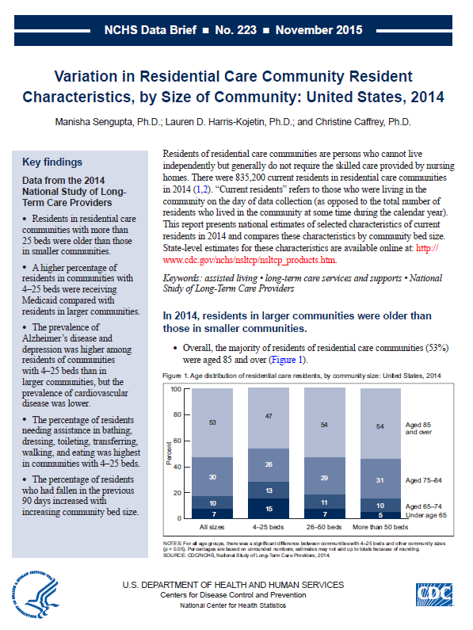

2014 PARTICIPANT DATA BRIEF
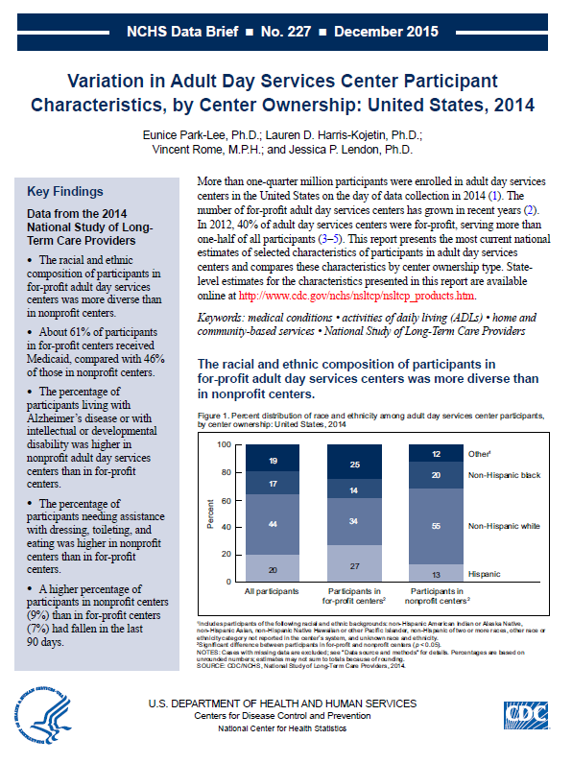

NCHS CONFIDENTIALITY BROCHURE
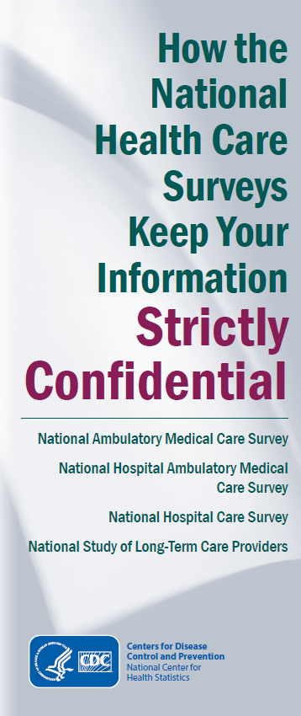
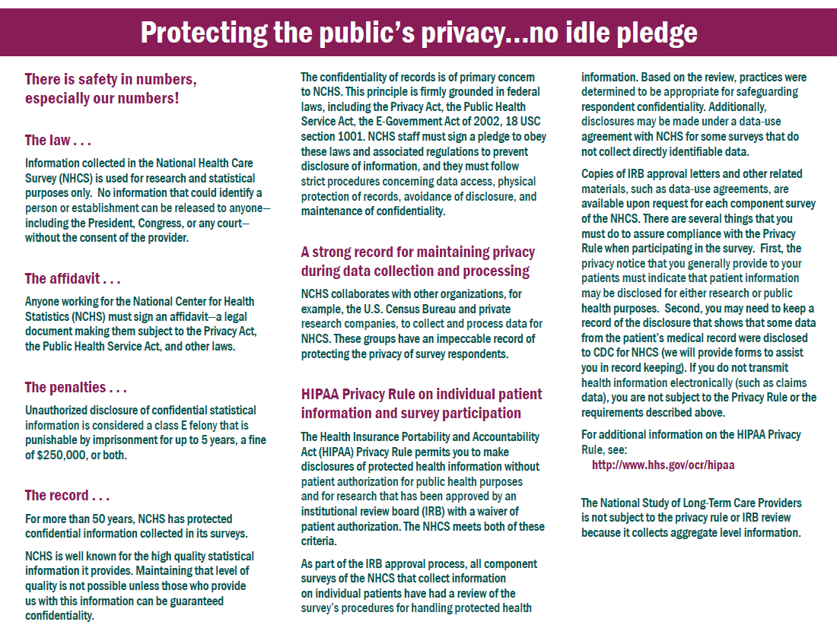

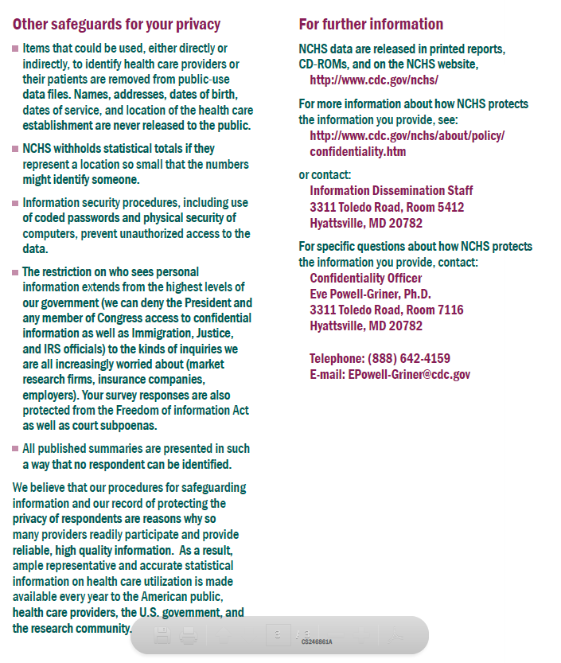

Draft PROVIDER ASSOCIATION LETTERS OF SUPPORT

RCC letter of support
