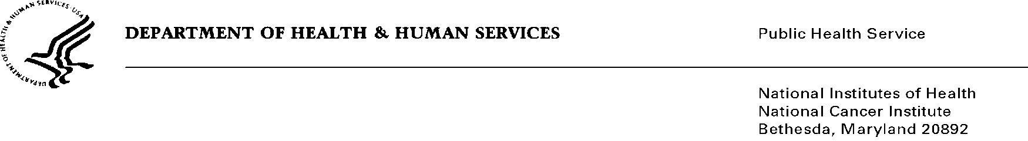
Date: September 5, 2014

To: Office of Management and Budget (OMB)

Through: Darius Taylor, Report Clearance Officer, HHS
Seleda Perryman, Project Clearance Officer, NIH
Karla Bailey, PRA OMB Project Clearance Liaison, NCI

From: Dr. Mike J. Montello, Pharm. D., CTEP (National Cancer Institute)

Subject: Nonmaterial/Non-substantive change request for:
Cancer Trials Support Unit (CTSU) Customer Satisfaction Surveys (NCI).
OMB #0925-0624, Expiration Date: 1/31/2017

This is a request for OMB to approve a nonmaterial/non-substantive change to the Cancer Trials Support Unit program. CTSU initially received approval on 12/30/2010, and received re-approval on 1/3/2014.

The Cancer Trials Support Unit (CTSU) is a contractor operated service offered by the National Cancer Institute - Cancer Therapy Evaluation Program (CTEP) - to enhance and facilitate access to cancer clinical trials in the United States and Canada. The CTSU maintains a broad menu of trials developed by NCI-funded sponsoring groups and other research consortia and works with these organizations to offer patient enrollment, data collection, data quality management, and regulatory support services to clinical sites entering patients in these trials. Westat is the prime contractor for this project.

As outlined in Supporting Statements A and B of the OMB package submitted in 2013 for the CTSU, a number of project specific forms are being used to facilitate data collection and processing. Forms are submitted by participating clinical sites to the CTSU as needed. On March 1, 2014 the National Cancer Institute launched the NCTN National Clinical Trials Network. The NCTN program consists of four adult U.S. Network Groups, one pediatric Group and one Canadian Collaborating Clinical Trials Group that generate trials for the Network. Institutions/sites participate in clinical trials led by one of these Network Groups and the CTSU supports these trials. The changes being requested to forms reflect the CTSU’s support of the new NCTN program and are summarized below. It is estimated that the burden of usage will not change. Thank you for giving this your utmost consideration.

Summary of Changes

Attachment 1b

References to facilitated review model on the form were removed as it is no longer applicable. Previous question in Box 15 was completely removed and the remaining questions on form were renumbered. Minor wording changes were made to questions 4 and 11 for clarification purposes.

Attachment 1c

Minor wording changes to correct typo on the form. Form previously stated questions #1-9 must be answer. Questions #1-16 must be answered.

Attachment 1d

Minor wording changes were made ‘Institution Name’ field to clarify form applies to institutions that will permanently close the study. References to the IRB Certification Form submittal requirement removed.

Attachment 1e

Minor wording changes were made to the form. The word “affiliate” was replaced with “new” and the word “institution” was added to several fields to match wording on other CTSU forms.

