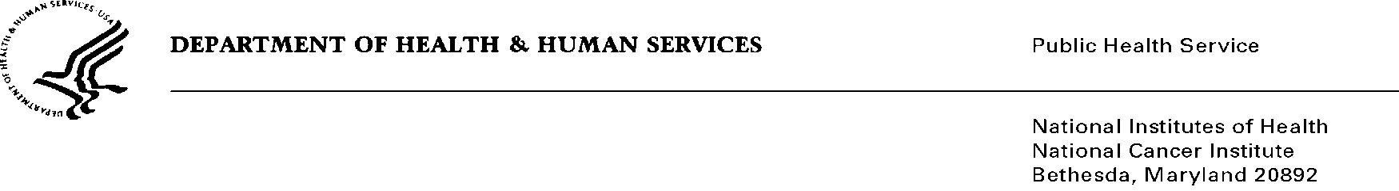
Date: December 18, 2014

To: Office of Management and Budget (OMB)

Through: Darius Taylor, Report Clearance Officer, HHS
Seleda Perryman, Project Clearance Officer, NIH
Karla Bailey, PRA OMB Liaison, NCI

From: Dr. Mike J. Montello, Pharm. D., CTEP (National Cancer Institute)
Susan Raitt, MA (Westat)

Subject: Nonmaterial/Non-substantive change request for:
Cancer Trials Support Unit (CTSU) TAILORx Data Transmittal Form
OMB #0925-0624, Expiration Date: 1/31/2017

This is a request for OMB to approve a nonmaterial/non-substantive change to the Cancer Trials Support Unit Program (CTSU). Based on a teleconference with OMB on 10/7/2010, a nonmaterial/non-substantive change is sufficient for this request as it does not change the purpose or objectives of the program or change the overall burden to the public.

The Cancer Trials Support Unit (CTSU) is a contractor operated service offered by the National Cancer Institute - Cancer Therapy Evaluation Program (CTEP) - to enhance and facilitate access to cancer clinical trials in the United States and Canada. The CTSU maintains a broad menu of trials developed by the NCI-funded sponsoring networks and works with these organizations to offer patient enrollment, data collection, data management, and regulatory support services to clinical sites entering patients in these trials. Westat is the prime contractor for this project.

The requested nonmaterial/non-substantive change is to approve the addition of the TailorX Data Transmittal Form (DTF). The TailorX DTF was previously approved under the 2010 OMB submission as the PACCT1 DTF, but was not included with the 2013 resubmission because of pending contract issues. There are no substantial changes to the original form and the template follows the Generic DTF template with site identifying information captured in the form header and study-specific case report form schedules in the lower section.

As outlined in Supporting Statements A and B of the OMB package submitted in 2013 for the CTSU, a number of project specific forms are being used to facilitate data collection and processing. Forms are submitted by participating clinical sites to the CTSU as needed. The use of study-study specific DTFs provides a useful reminder to sites of which forms need to be submitted versus use of the Generic DTF. Please note the addition of the TailorX DTF does not change the overall burden to sites as the development of study-specific DTF was accounted for under the burden of use estimates provided for the Generic DTF.

Summary of Changes

Attachment 1u

Addition of the TailorX DTF, please note the fax line and corresponding number were updated to a digital line.

