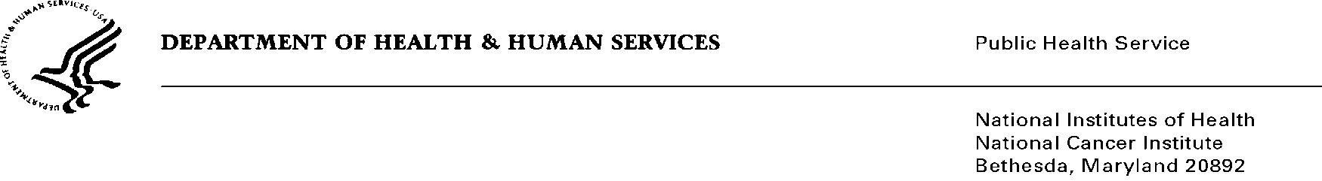

Date: April 19, 2016

To: Office of Management and Budget (OMB)

Through: Darius Taylor, Report Clearance Officer, HHS
Mikia Currie, Project Clearance Officer, NIH
Karla Bailey, PRA OMB Liaison, NCI

From: Dr. Mike J. Montello, Pharm. D., CTEP (National Cancer Institute)

Subject: Nonmaterial/Non-substantive change request for:
Cancer Trials Support Unit (CTSU) TAILORx Data Transmittal Form
OMB #0925-0624, Expiration Date: 1/31/2017

This is a request for OMB to approve a nonmaterial/non-substantive change to the Cancer Trials Support Unit Program (CTSU). Based on a teleconference with OMB on 10/7/2010, a nonmaterial/non-substantive change is sufficient for this request as it does not change the purpose or objectives of the program or change the overall burden to the public.

The Cancer Trials Support Unit (CTSU) is a contractor-operated service offered by the National Cancer Institute - Cancer Therapy Evaluation Program (CTEP) - to enhance and facilitate access to cancer clinical trials in the United States and Canada. The CTSU maintains a broad menu of trials developed by the NCI-funded sponsoring networks and works with these organizations to offer patient enrollment, data collection, data management, and regulatory support services to clinical sites entering patients in these trials. Westat is the prime contractor for this project.

As outlined in Supporting Statements A and B of the OMB package submitted in 2013 for the CTSU, a number of project specific forms are being used to facilitate data collection and processing. Forms are submitted by participating clinical sites to the CTSU as needed. The use of the Patient Enrollment Transmittal Form and Transfer Form facilitates processing of enrollment and patient transfer requests.

The requested nonmaterial/non-substantive change to the CTSU Patient Enrollment Transmittal Form and the CTSU Transfer Form are editorial in nature including a change in phone number and terminology. There are no substantial changes to these forms and similar changes to forms in the past were deemed by NIH to not require a change request.

Summary of Changes:

Attachment 1o
Minor editorial changes to the CTSU Patient Enrollment Transmittal Form include:
- Removed the registrar phone and cell phone numbers;
- Removed a boxed instruction that referenced the CTUS website regarding enrollment hours, which followed the sentence that contained CTSU patent enrollment hours and days;
- Removed question 10, which asked if the patient was ever enrolled on a Cooperative Group trial and to provide the Group name and Protocol number;
- Removed question 11, which asked for any specimen tracking ID or ancillary study ID previously assigned to this subject for this trial or a related study and to provide ID and ID Source;
- Removed reference to use of the word Cooperative, as this term is no longer valid; and
- Other editorial changes are highlighted in yellow on the form.

Attachment 1q
Minor editorial changes to the CTSU Transfer form include:
- Removed a sentence to allow clarification that use of the form is for transfers that cannot be completed in OPEN;
- Removed the registrar phone and cell phone numbers;
- Removed reference to use of the word Cooperative as this term is no longer valid; and
- Other editorial changes are highlighted in yellow on the form.

