Amended Tobacco Industry Applications

General PONL Log-in page:
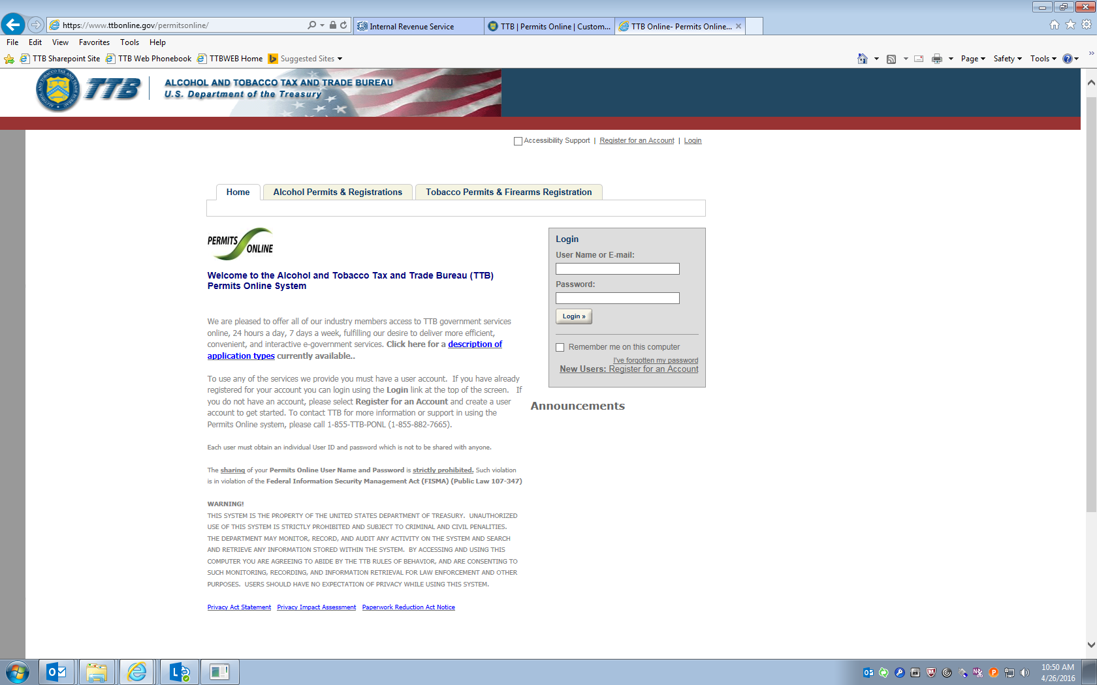

Amended Tobacco Industry Applications – the two drop-down menus shown below give access to the appropriate PONL application. These PONL applications are approved under various OMB control numbers:
Changes After Original Qualification – Tobacco and Firearms
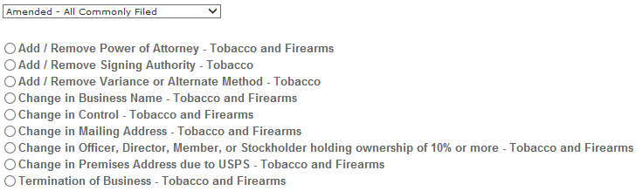

- Amended - All Commonly Filed - Select this option to see general amendments used by Tobacco and Firearms commodities:
- Add/Remove Power of Attorney - Tobacco and Firearms
- Add/Remove Signing Authority - Tobacco
- Add/Remove Variance or Alternate Method - Tobacco
- Change in Business Name - Tobacco and Firearms
- Change in Control - Tobacco and Firearms
- Change in Mailing Address - Tobacco and Firearms
- Change of Officer, Director, or Non-Managing LLC Member, or Stock Holder more than 10% - Tobacco and Firearms
- Change in Premise Address due to USPS - Tobacco and Firearms
- Termination of Business - Tobacco and Firearms
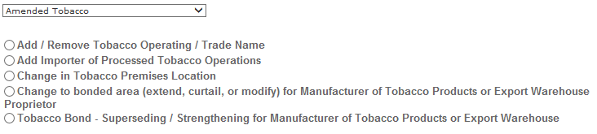
- Amended Tobacco - Select this option to see specific amendments for Tobacco permits:
- Add / Remove Tobacco Operating / Trade Name
- Add Importer of Processed Tobacco
- Change in Tobacco Premise Location
- Change to bonded area (extend, curtail, or modify) for Manufacture of Tobacco Products or Export Warehouse Proprietor
- Tobacco Bond - Superseding / Strengthening for Manufacture of Tobacco Products or Export Warehouse Proprietor

