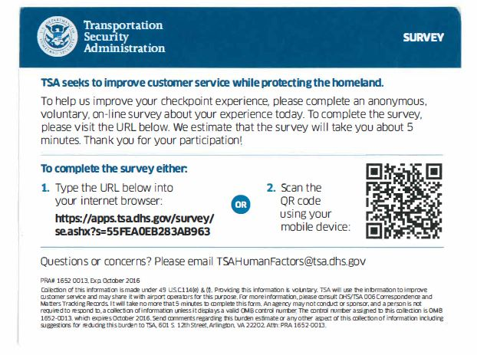

58

**OMB control number 1652-0058**

**Exp.: 07/31/2019**

Please answer each question to the best of your ability. Your answers will remain confidential and will not be traced back to you by any means.

|  |  |  |  |  |  |  |  |  |  |
| --- | --- | --- | --- | --- | --- | --- | --- | --- | --- |
| **1** | How old are you? | Under 18 | 18-20 | 20-29 | 30-39 | 40-49 | 50-59 | Over 60 |  |
| **2** | Prior to traveling today, I had a strong understanding of normal TSA screening processes. | Strongly Disagree | Disagree | Slightly Disagree | Neither Agree nor Disagree | Slightly Agree | Agree | Strongly Agree |  |
| **3** | The body scanner I went through today is different from the one I have been screened by in the past. | Yes | No |  |  |  |  |  | Not Applicable |
| **4** | How would you describe your experience using the body scanner today? | Overwhelmingly Negative | Negative | Slightly Negative | Neither Negative nor Positive | Slightly Positive | Positive | Overwhelmingly Positive |  |
| **5** | I felt more physically comfortable using the body scanner today than the version I have used in the past. | Strongly Disagree | Disagree | Slightly Disagree | Neither Agree nor Disagree | Slightly Agree | Agree | Strongly Agree | Not Applicable |
| **6** | I prefer the body scanner I used today over the one that I have used in the past. | Strongly Disagree | Disagree | Slightly Disagree | Neither Agree nor Disagree | Slightly Agree | Agree | Strongly Agree | Not Applicable |
| **7** | I was properly informed by TSOs about how to use the body scanner today. | Strongly Disagree | Disagree | Slightly Disagree | Neither Agree nor Disagree | Slightly Agree | Agree | Strongly Agree |  |
| **8** | It seemed more passengers received pat downs today than I've noticed in the past. | Strongly Disagree | Disagree | Slightly Disagree | Neither Agree nor Disagree | Slightly Agree | Agree | Strongly Agree | Not Applicable |
| **9** | How many times did you have to correct your positioning in the body scanner before the machine was able to get a proper scan? | 0 | 1 | 2 | 3 | 4 | 5+ |  |  |
| **10** | The Avatar showing the proper stance for the scanner was easy for me to understand. | Strongly Disagree | Disagree | Slightly Disagree | Neither Agree nor Disagree | Slightly Agree | Agree | Strongly Agree | Not Applicable |
| **11** | The Avatar showing the proper stance for the scanner helped me achieve the proper stance. | Strongly Disagree | Disagree | Slightly Disagree | Neither Agree nor Disagree | Slightly Agree | Agree | Strongly Agree | Not Applicable |
| **12** | The audio instructions from the scanner were useful for guiding me into the proper stance. | Strongly Disagree | Disagree | Slightly Disagree | Neither Agree nor Disagree | Slightly Agree | Agree | Strongly Agree | Not Applicable |

**PAPERWORK REDUCTION ACT STATEMENT**: TSA is collecting this information to identify ongoing improvement opportunities at TSA checkpoints. The public burden for collecting this information is estimated to be approximately 1.5 minutes. This is a voluntary collection of information. Send comments regarding this burden estimate or collection to: TSA-11, Attention: PRA 1652-0058 Passenger Perception of Enhanced Imaging Technology Survey, 601 South 12th Street, Arlington, VA 20598. An agency may not conduct or sponsor, and persons are not required to respond to a collection of information, unless it displays a valid OMB control number. The OMB control number assigned to this collection is 1652-0058, which expires 07/31/2019.