Section 1: General Use Questions

The Environmental Protection Agency would like to give you the opportunity to help improve the Toxics Release Inventory (TRI) Program website to better meet your needs. Please respond to the following questions to the best of your ability. Your responses will help us improve the TRI website user experience, and will not be sold or used for any other purpose. The information gathered will be confidential and non-attributable.

1. Please select the category that most closely fits with your use of TRI data, tools, and resources.
Industry affiliate
State/Local Government employee
Community group leader or member
University or academic affiliate
Concerned citizen
Other (please specify):

2. Is this your first visit to the TRI website?
Yes
No

3. How often do you use the TRI website?
Less than once a month.
On average once a month.
On average once a week.
More than once a week.

4. Which one of these factors most influences your decision to visit the TRI website?
A specific need for information on toxic chemical releases
A TRI-related press release issued by EPA
An email bulletin sent to you by the TRI Program
A news article that mentions the Toxics Release Inventory
Other (please specify)

5. Overall, do you find the TRI website to be a useful tool for increasing your understanding of toxic releases and the related resources provided by EPA?
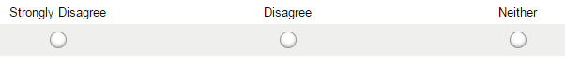

6. When you visit the Toxics Release Inventory website, what information are you primarily trying to find? (select all that apply)
General information on pollution
General information on the TRI Program
Information on compliance and enforcement
Information on new TRI initiatives and proposed regulations
Pollution prevention information
Access to TRI tools
Access to TRI data files
The National Analysis Report
Information and resources about the TRI reporting process for facilities
Other (please specify):

7. Do you regularly find (more than 75% of the time) what you are looking for on the site?
Yes
No
If not, what is the greatest challenge to finding information?

8. How would you rank your difficulty, from never difficult to extremely difficult, in finding needed information?
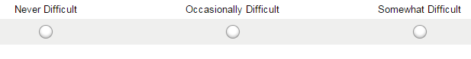

9. Is the information you are looking for currently available through the TRI website?
Yes
No

10. Is there information on another website that you think should be on the TRI site?
Yes
No
If yes, where is the information currently located and what subject does it address?

11. What component of the TRI website is most useful or helpful to you? (select all that apply)
TRI National Analysis
TRI Explorer
TRI Pollution Prevention (P2) Tool
Envirofacts
myRTK
Explore a TRI Facility
Print resources, such as the TRI Program factsheet
Spanish translated resources
Risk information
TRI initiatives for Tribes, Colleges and Universities, and Communities
Resources on reporting requirements for facilities
Other (please specify):

12. Do you find any TRI component difficult to use or incorrectly placed on the website? If yes, please select all that apply. If no, please select "not applicable."
TRI National Analysis
TRI Explorer
TRI Pollution Prevention (P2) Tool
Envirofacts
myRTK
Explore a TRI Facility
Print resources, such as the TRI Program factsheet
Spanish translated resources
Risk assessment information
TRI initiatives for Tribes, Colleges and Universities, and Communities
Resources on reporting requirements for facilities
Not applicable
Other (please specify):

13. Would having more website content available in Spanish be useful to you?
Yes
No
If yes, what additional content would you like to see translated?

Section 2: TRI Program Homepage

The following questions specifically address the TRI Program homepage at http://www.epa.gov/tri.

14. Review the three major categories on the homepage (About the TRI Program, TRI Resources, and Annual Reporting for Facilities). Do these categories reflect the information you want highlighted on the TRI homepage?
Yes
No
If not, what would you change?

15. From the homepage, how easy or difficult was it to identify where you needed to go next in order to find your desired information?
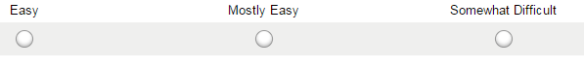

16. Look at the bottom section of the homepage (below the three main categories). Is it clear how to use the tools in this section to find TRI data for a specific location?
Yes
No
If not, what changes would improve this section?

17. Is there anything else you would like to share about your experiences with and opinions of the content or navigation of the TRI website?

