ICR 2010-0042, 2434.78
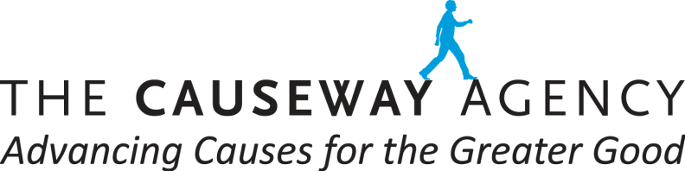
Northeast Organic Farmers Association: Survey
Summer Conference: Aug 12-13, 2017

Interview Questionnaire/Draft 1, July 27, 2017

Introduction:
Hello, my name is ________ and I am with CauseWay Research. We would appreciate just 5 minutes of your time so you can help us evaluate some ads.

Participant Profile:
Let me start with the type of crop(s) you grow, where your farm is located and the total number of workers you have:
- Crop Name(s):
- Farm Location (what state):
- Total number of Employees (full-time and part-time/seasonal):

- Do you use a contract labor manager to hire seasonal workers?

- Number of years in business:

Overarching Issues:

What are some of the most pressing issues you are dealing with your farming operation? Which ones are “keeping you up at night”?

_______________________________________________________________________
________________________________________________________________________

________________________________________________________________________

What MEDIA sources do you turn to regularly to keep up-to-date on farming-related information, issues and new technologies? Please list your TOP 3 Media Sources:

________________________________________________________________________
________________________________________________________________________

________________________________________________________________________

Awareness
On a scale of 1 to 5, with “5” being Very Familiar and “1” being Not at All Familiar, how familiar would you say you are with the U.S. EPA Worker Protection Standard?

For those with at least some awareness: What is the WPS about?

________________________________________________________________________
________________________________________________________________________
________________________________________________________________________
________________________________________________________________________

Advertising Concept Evaluation:
Please take a minute to review this print ad, then I will ask several questions: Note ads will be rotated.

(Concept 1: Version A)

- What caught your attention?
- What is the main message or idea of this ad?

- Did you learn anything new?
- Does the ad seem credible/believable?
- Would you be interested in learning more and going to the website mentioned?
- What are the ad’s strengths (likes)? Areas for improvements (dislikes)?

(Concept 1: Version B) REPEAT ABOVE

COMPARISON

- Looking at both versions, which of the ads is most effective in catching your attention, interests you in reading as well going to the website mentioned?

- Why? What are your Top 2 reasons?

REPEAT ABOVE FOR CONCEPTS 2 Version A and Version B
(Here is a different concept. Please take a minute to review this print ad concept, then I will ask several questions)

THANK YOU FOR YOUR TIME.

