Request for Approval under the “Generic Clearance for the Collection of Routine Customer Feedback” (OMB Control Number: 2010-0042)
TITLE OF INFORMATION COLLECTION:

Climate Adaptation Resource Center Website Survey

PURPOSE:

EPA’s Climate Change Adaptation Resource Center is a forthcoming interactive website to help local governments effectively deliver services to their communities even as the climate changes. It provides decision makers with an integrated package of information tailored specifically to their needs. Information is provided about the risks posed by climate change to the issues of concern to the user; relevant adaptation strategies; case studies illustrating how other communities have successfully adapted to those risks and tools to replicate their successes; and EPA funding opportunities.

DESCRIPTION OF RESPONDENTS:

The target audience of the website is local government, including mayors, county executives, and career local government environmental professionals.

TYPE OF COLLECTION: (Check one)

[ ] Customer Comment Card/Complaint Form [X ] Customer Satisfaction Survey
[ ] Usability Testing (e.g., Website or Software) [ ] Small Discussion Group
[ ] Focus Group [ ] Other: ______________________

CERTIFICATION:

I certify the following to be true:
- The collection is voluntary.
- The collection is low-burden for respondents and low-cost for the Federal Government.
- The collection is non-controversial and does not raise issues of concern to other federal agencies.
- The results are not intended to be disseminated to the public.
- Information gathered will not be used for the purpose of substantially informing influential policy decisions.
- The collection is targeted to the solicitation of opinions from respondents who have experience with the program or may have experience with the program in the future.

Name : Ken Munis

To assist review, please provide answers to the following question:

Personally Identifiable Information:
- Is personally identifiable information (PII) collected? [ ] Yes [X ] No
- If Yes, is the information that will be collected included in records that are subject to the Privacy Act of 1974? [ ] Yes [ ] No
- If Applicable, has a System or Records Notice been published? [ ] Yes [ ] No

Gifts or Payments:
Is an incentive (e.g., money or reimbursement of expenses, token of appreciation) provided to participants? [ ] Yes [ X ] No

BURDEN HOURS

Category of Respondent | No. of Respondents | Participation Time | Burden Hours
Local Government Representatives | 2,000 (~5%) | 2 - 5 minutes | 67 hours to  167 hours
Totals | 2,000 | 5 minutes | 167 Hours

FEDERAL COST: The estimated annual cost to the Federal government is 40 hrs * $120/hr = $4,800______________

If you are conducting a focus group, survey, or plan to employ statistical methods, please provide answers to the following questions:

The selection of your targeted respondents
- Do you have a customer list or something similar that defines the universe of potential respondents and do you have a sampling plan for selecting from this universe? [ ] Yes [ X ] No

If the answer is yes, please provide a description of both below (or attach the sampling plan)? If the answer is no, please provide a description of how you plan to identify your potential group of respondents and how you will select them?

We are not looking for a representative sample.

Administration of the Instrument
- How will you collect the information? (Check all that apply)
[X ] Web-based or other forms of Social Media
[ ] Telephone
[ ] In-person
[ ] Mail
[ ] Other, Explain
- Will interviewers or facilitators be used? [ ] Yes [X ] No

Please make sure that all instruments, instructions, and scripts are submitted with the request.

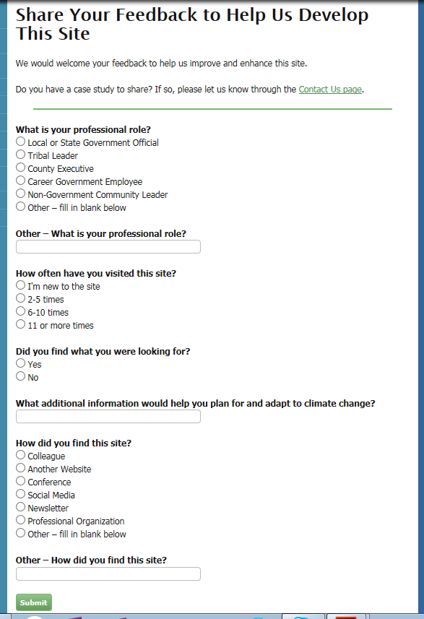

Contact Us Page

